**PRACTICAL-2**

**AIM:**

To implement file management tasks in Hadoop HDFS and perform Hadoop commands.

**IMPLEMENTATION:**

* There are many more commands in "$HADOOP_HOME/bin/hadoop fs" than are demonstrated here, although these basic operations will get you started. Running ./bin/hadoop dfs with no additional arguments will list all the commands that can be run with the FsShell system. Furthermore, $HADOOP_HOME/bin/hadoop fs -help commandName will display a short usage summary for the operation in question, if you are stuck.
* Firstly, start the Hadoop
* To check the Hadoop services are up and running, use the following command:

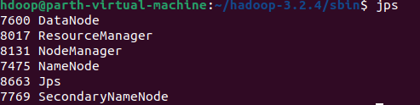

* The version command is used to find out the version of the Hadoop.



* The mkdir is used create a directory. In Hadoop dfs there is no home directory by default.
* the **ls** command is used to check for the directories in HDFS

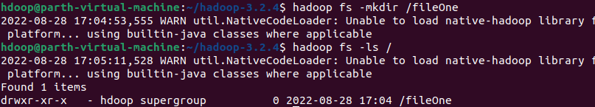

* The touchz command is to create an empty file.



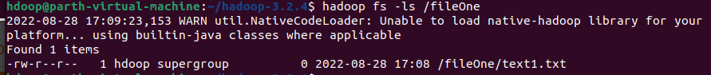

* The copyFromLocal /put is to copy files/folders from local file system to hdfs store. This is the most important command. Local filesystem means the files present on the OS.

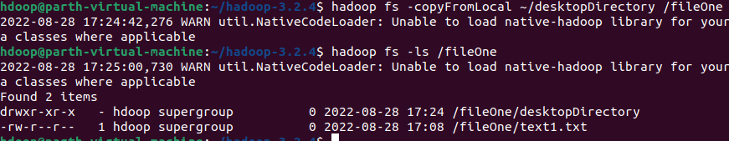

* The copyToLocal/get is used to copy files/folders from hdfs store to local file system.



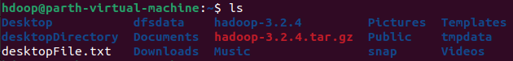

* The cp command is used to copy files within hdfs.

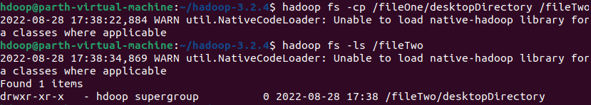

* The mv command is used to move files within hdfs.

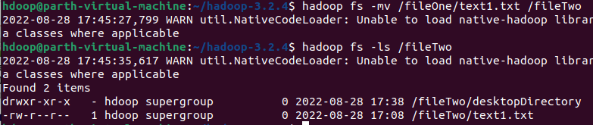

* The rm -r command deletes a file from HDFS recursively.

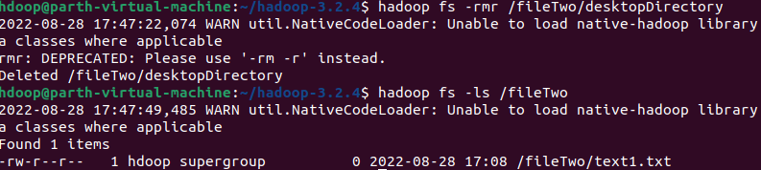

* The du command will give the size of each file in directory.



**CONCLUSION:**

In this practical, we learnt about basic commands in Hadoop file system.