**PRACTICAL-7**

**AIM:**

To develop a MapReduce application and implement a program that analyses weather data.

**CODE:**

MyMaxMin.java

// importing Libraries

import java.io.IOException;

import java.util.Iterator;

import org.apache.hadoop.fs.Path;

import org.apache.hadoop.io.LongWritable;

import org.apache.hadoop.io.Text;

import org.apache.hadoop.mapreduce.lib.input.FileInputFormat;

import org.apache.hadoop.mapreduce.lib.output.FileOutputFormat;

import org.apache.hadoop.mapreduce.lib.output.TextOutputFormat;

import org.apache.hadoop.mapreduce.lib.input.TextInputFormat;

import org.apache.hadoop.mapreduce.Job;

import org.apache.hadoop.mapreduce.Mapper;

import org.apache.hadoop.mapreduce.Reducer;

import org.apache.hadoop.conf.Configuration;

public class MyMaxMin {

public static class MaxTemperatureMapper extends

Mapper {

/**

* @method map

* This method takes the input as a text data type.

* Now leaving the first five tokens, it takes

* 6th token is taken as temp_max and

* 7th token is taken as temp_min. Now

* temp_max > 30 and temp_min < 15 are

* passed to the reducer.

*/

// the data in our data set with // this value is inconsistent data

public static final int MISSING = 9999;

@Override

public void map(LongWritable arg0, Text Value, Context context) throws IOException, InterruptedException

{ // Convert the single row(Record) to

// String and store it in String

// variable name line

String line = Value.toString();

// Check for the empty line if (!(line.length() == 0))

{ // from character 6 to 14 we have

// the date in our dataset

String date = line.substring(6, 14);

// similarly we have taken the maximum

// temperature from 39 to 45 characters

float temp_Max = Float.parseFloat(line.substring(39, 45).trim());

// similarly we have taken the minimum

// temperature from 47 to 53 characters

float temp_Min = Float.parseFloat(line.substring(47, 53).trim());

// if maximum temperature is

// greater than 30, it is a hot day

if (temp_Max > 30.0)

{

// Hot day

context.write(new Text("The Day is Hot Day :" + date),

new Text(String.valueOf(temp_Max)));

}

// if the minimum temperature is

// less than 15, it is a cold day

if (temp_Min < 15)

{

// Cold day

context.write(new Text("The Day is Cold Day :" + date),

new Text(String.valueOf(temp_Min)));

}

}

}

}

// Reducer

/*MaxTemperatureReducer class is static and extends Reducer abstract class having four Hadoop generics type Text, Text, Text, Text.

*/

public static class MaxTemperatureReducer extends Reducer {

/*

*

* @method reduce

* This method takes the input as key and

* list of values pair from the mapper,

* it does aggregation based on keys and

* produces the final context. */

public void reduce(Text Key, Iterator Values, Context context) throws IOException, InterruptedException {

// putting all the values in

// temperature variable of type String

String temperature = Values.next().toString();

context.write(Key, new Text(temperature));

}

}

/**

* @method main

* This method is used for setting

* all the configuration properties.

* It acts as a driver for map-reduce

* code.

*/

public static void main(String[] args) throws Exception {

// reads the default configuration of the

// cluster from the configuration XML files

Configuration conf = new Configuration();

// Initializing the job with the

// default configuration of the cluster

Job job = new Job(conf, "weather example"); // Assigning the driver class name

job.setJarByClass(MyMaxMin.class);

// Key type coming out of mapper

job.setMapOutputKeyClass(Text.class);

// value type coming out of mapper

job.setMapOutputValueClass(Text.class);

// Defining the mapper class name j

ob.setMapperClass(MaxTemperatureMapper.class);

// Defining the reducer class name

job.setReducerClass(MaxTemperatureReducer.class);

// Defining input Format class which is

// responsible to parse the dataset

// into a key value pair

job.setInputFormatClass(TextInputFormat.class);

// Defining output Format class which is

// responsible to parse the dataset

// into a key value pair

job.setOutputFormatClass(TextOutputFormat.class);

// setting the second argument

// as a path in a path variable

Path OutputPath = new Path(args[1]);

// Configuring the input path

// from the filesystem into the job

FileInputFormat.addInputPath(job, new Path(args[0]));

// Configuring the output path from

// the filesystem into the job

FileOutputFormat.setOutputPath(job, new Path(args[1]));

// deleting the context path automatically

// from hdfs so that we don't have

// to delete it explicitly

OutputPath.getFileSystem(conf).delete(OutputPath);

// exiting the job only if the

// flag value becomes false

System.exit(job.waitForCompletion(true) ? 0 : 1); }

}

**OUTPUT:**

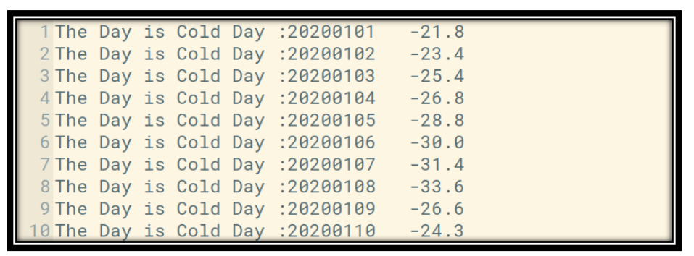

#### **CONCLUSION:**

In this practical, we learnt about analysis of data using mapreduce in Hadoop.