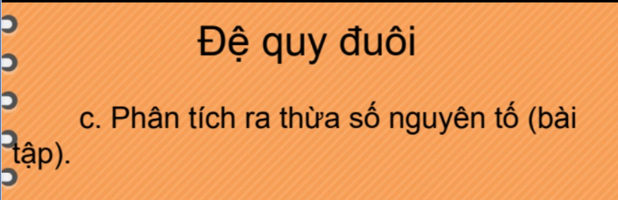

function primeFactors(n)
if n == 1 then
return []
end if
for i = 2 to n do
if n % i == 0 then
return [i] + primeFactors(n / i)
endif
endfor
end

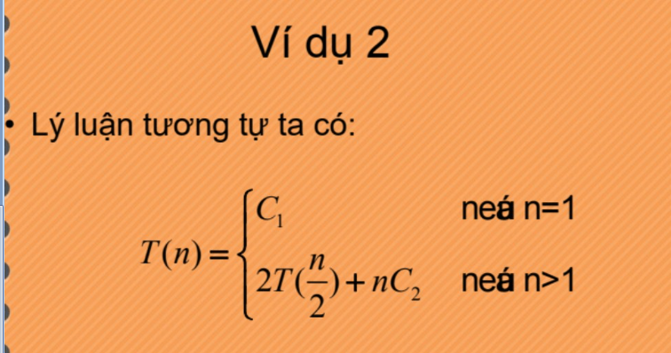
- Đăt k 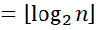
- Ta có n 