KHAYAL · خيال

KHAYAL · خيال

A Cinema Index — Database Systems Class Project
Live: movie-db-one-psi.vercel.app | Code: github.com/pnsw123/Movie-DB
Browse 7,400+ real films and 2,800+ TV series, rate them, write reviews, build watchlists, and run your own SQL queries against a live database.

Screenshots
Browse | Search
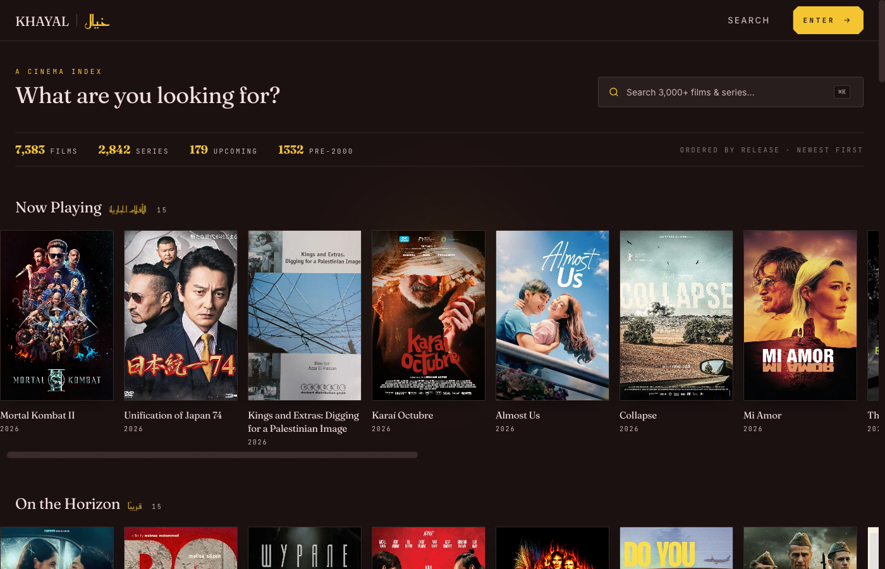 | 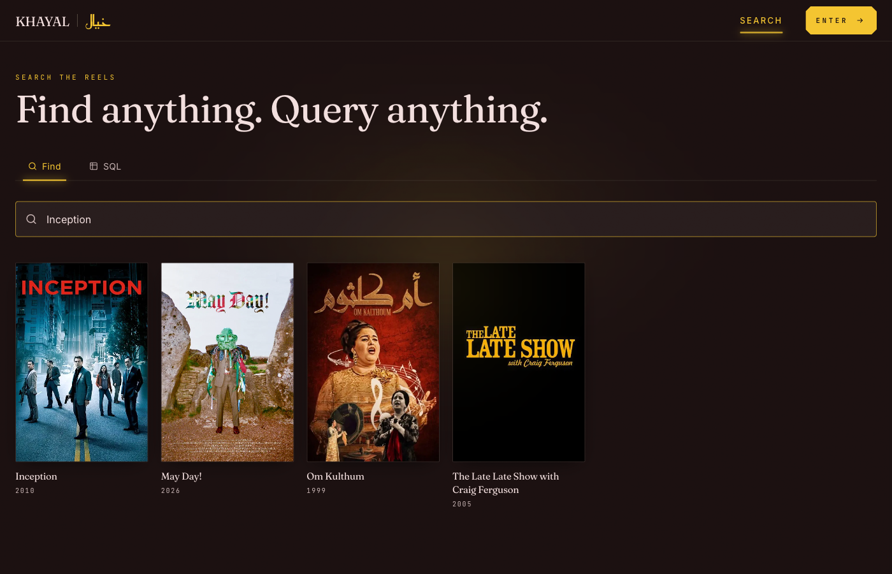

Movie Detail | Sign In
 | 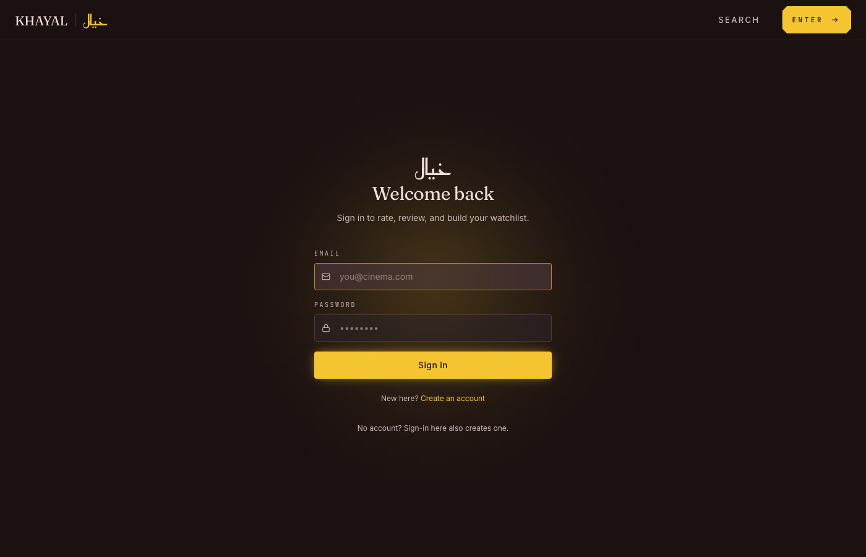

Tech Stack
Tool | Role
Next.js 15 + TypeScript | Frontend framework — server-rendered pages, App Router
Tailwind CSS | Styling
Supabase (PostgreSQL) | Database + authentication + Row-Level Security
TMDB API | Source of all movie & TV data — posters, trailers, metadata
Google Stitch | UI design & prototyping before any code was written
GitHub Actions | Nightly cloud sync — fetches new movies every night at 3 AM UTC
Vercel | Hosting — auto-deploys on every push to main
Python | Data pipeline — seeds and syncs 10,000+ titles from TMDB

Where the Data Comes From
All titles, posters, backdrops, and trailers come from TMDB — the same API used by Plex and Letterboxd.
TMDB API → Python scripts → Supabase (PostgreSQL) → Next.js app
A Python script fetches movies and TV shows and loads them into the database. A GitHub Actions cron job runs this automatically every night at 3 AM UTC — no computer needed.

Project Structure
KHAYAL/
├── khayal/ ← Next.js frontend (everything users see)
│ └── src/
│ ├── app/ ← Pages: /browse /search /movies/[slug] /profile…
│ ├── components/ ← movie-card, shelf, rate-widget, trailer, nav…
│ └── lib/ ← Supabase clients, auth helpers
│
├── scripts/ ← Python data pipeline
│ ├── daily_sync.py ← Nightly sync (runs on GitHub Actions cloud)
│ ├── test_daily_sync.py← 54 automated tests
│ └── seed_tmdb.py ← Initial bulk load from TMDB
│
├── supabase/migrations/ ← All SQL schema changes in order
└── .github/workflows/ ← daily-sync.yml — cloud cron job

Database — Supabase (PostgreSQL)
12 tables total.
Table | Contents
movies | 7,400+ films — title, poster, runtime, age rating, trailer
tv_series | 2,800+ shows — same fields + status (ongoing / ended)
movie_ratings | One rating (1–10) per user per movie
tv_series_ratings | Same for TV series
movie_reviews | User reviews for movies with spoiler toggle
tv_series_reviews | Same for TV series
user_lists | Watchlists — public or private
user_list_movies | Movies inside each watchlist
user_list_tv_series | TV series inside each watchlist
profiles | One row per signed-in user
recommendations | Pre-computed similar titles
saved_queries | User’s saved SQL queries from the explorer
Security: Row-Level Security (RLS) ensures users can only edit their own data. The SQL explorer tab only allows SELECT — no one can modify the database from the browser.

UI Design — Google Stitch
Google Stitch is a Google Labs AI design tool that generates full UI screens from text prompts — color systems, typography, layouts, and components in one shot.
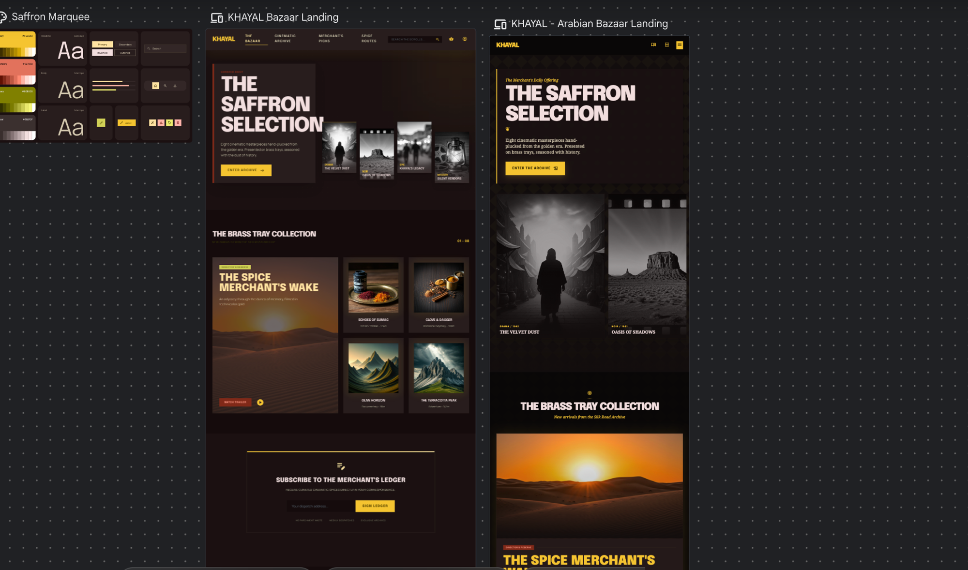
KHAYAL designed in Google Stitch
The KHAYAL design system and landing page variations generated inside the Stitch canvas.

Cloud Automation — GitHub Actions
Every night GitHub’s servers automatically: 1. Fetch movies released in the last 2 days from TMDB 2. Skip anything already in the database 3. Insert new titles with posters and metadata 4. Run 54 tests to confirm nothing broke
No local machine needed — fully independent of any computer.

KHAYAL uses the TMDB API but is not affiliated with TMDB.
خيال (khayāl) — Arabic for imagination

