- Creating and Renaming Files/Directories
  - mkdir test_dir – to create the empty directory named test_dir
  - touch example.txt – to create file named example.txt
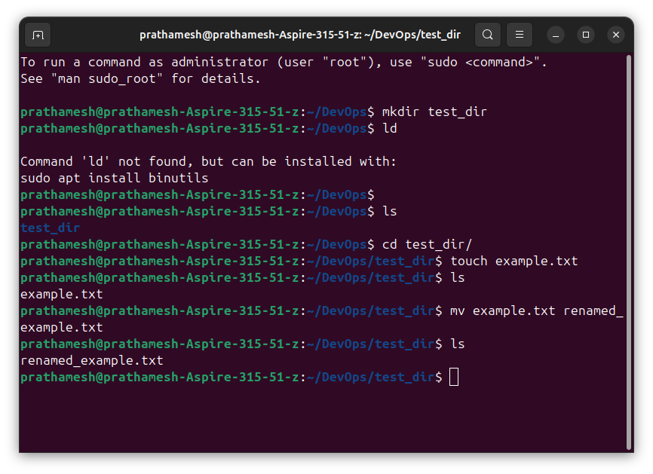
  - mv example.txt renamed_example.txt – to rename file example.txt to renamed_example.txt

- Viewing File Contents
  - cd ~ – to change working directory to root
  - cd etc – to change working directory to etc
  - cat passwd – to see content of passwd file
  - head -n 5 passwd – to see first five lines of passwd file
  - tail -n 5 passwd – to see last five lines of passwd file

- Searching for Patterns
  - grep root passwd – to find all lines containing the word "root"

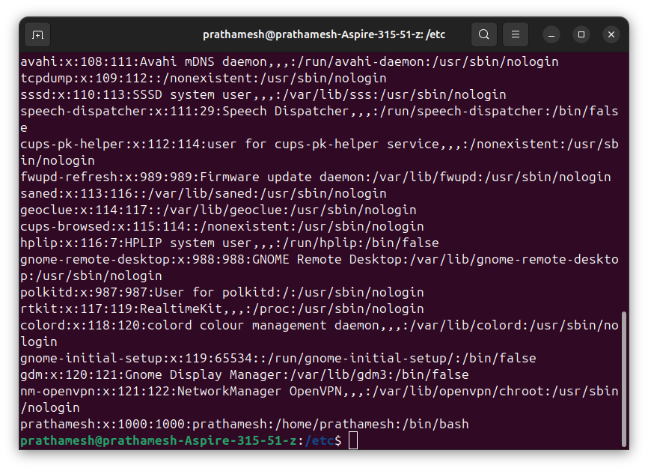
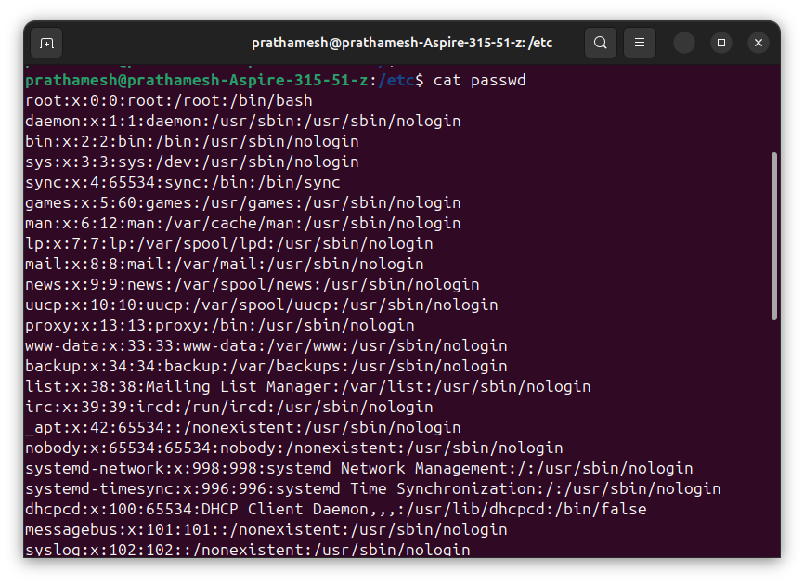
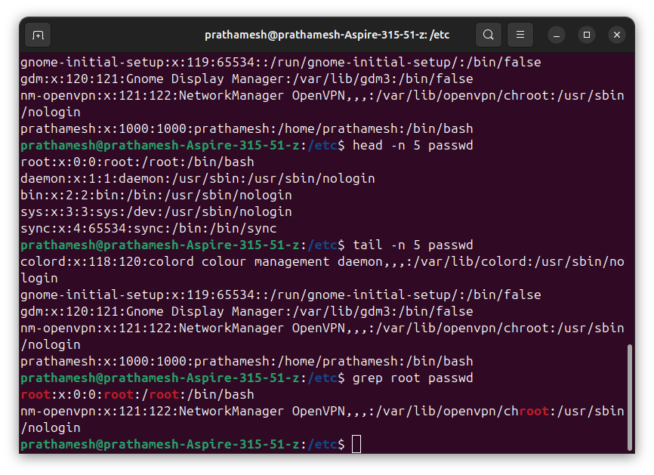

- Zipping and Unzipping
  - zip test_dir.zip test_dir – to zip directory named test_dir to test_dir.zip
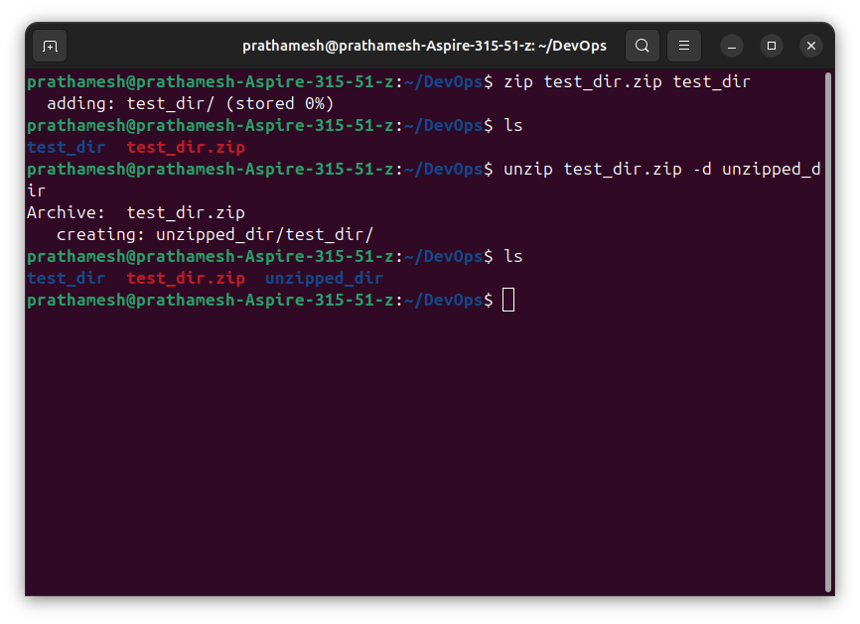
  - unzip test_dir.zip -d unzipped_dir – to unzip test_dir.zip to directory named unzipped_dir

- Downloading Files
  - wget https://example.com/sample.txt - to download file from link
Note: didn’t work as link is not reachable

- Changing Permissions
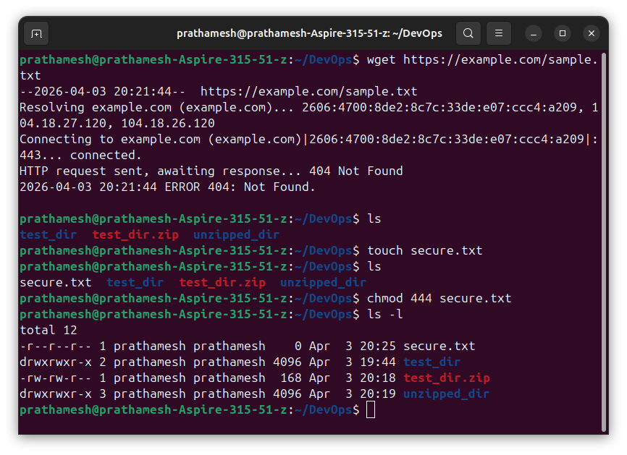
  - chmod 444 secure.txt – to change file permissions to read only for all the users

- Working with Environment Variables
  - export MY_VAR = "Hello, Linux!" – to set MY_VAR variable to "Hello, Linux!"
