Air Surveillance Thermal Camera
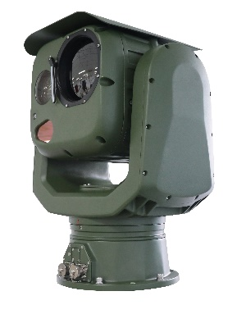

V.08.15 Specific cations subject to change without notice. Errors and misprints excepted. Pictures in this document may differ from these actual product. © 2015 Hope-Wish Technologies Inc.

This is our most advanced dual-sensor security system, combining a cooled or uncooled 640×512/1280x1024 resolution thermal sensor, a 1080p HD visible-light imaging sensor, and a high speed, precision pan/tilt system. The DMA integrates easily with DF3000 or IGS1000, as well as other major third-party video management systems, making it an extremely versatile solution for critical infrastructure protection in total darkness, bright sun, and adverse conditions.

It can track UAVs out to 5km. RGS1000 software provides advanced command and control (C2) capabilities. It allows individual control of sensors along with automated point and click or slew-to-cue functionality. The system can work radar to identify targets, classify threats, cue RF sensors, and streamline the decision cycle.

Product’s Highlights:

- 120°/s fast rotation speed and 0.01° accuracy can track land/air/sea target
- Front-end auto-tracking functions for high accuracy target tracking
- Function of life index recording for thermal camera
- WZ non-uniform image correction technology, good image uniformity and dynamic range.
- 2-axis gyro image stabilizer for stable image during wave and strong wind, accuracy≤2mrad
- Special IP66 design enable camera can work in salty/strong light/water spray/ 33m/s wind environment
- One IP address optional: Visible, thermal camera can view, set, and control by one IP address
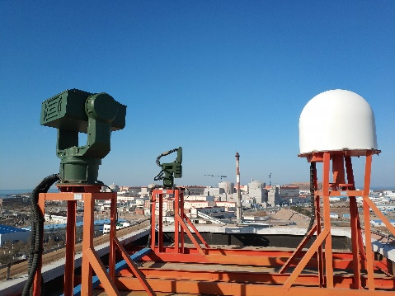
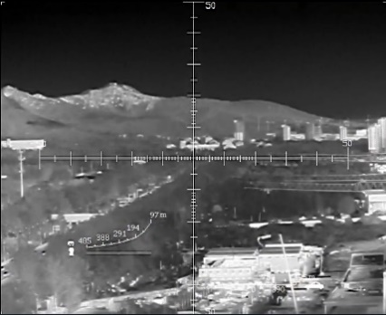
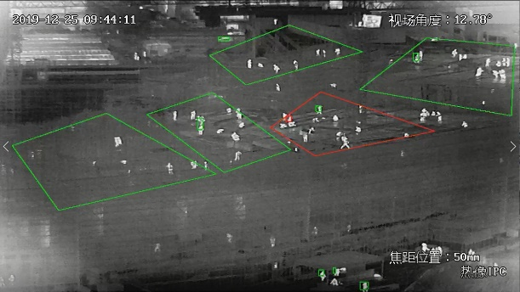

Auto-Patrol & Intrusion alarm
Ranging Scale
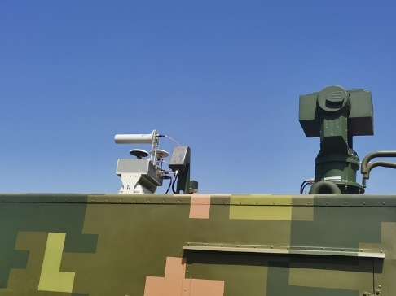
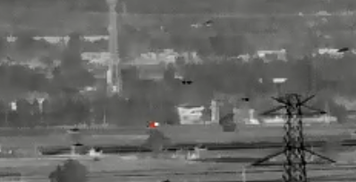
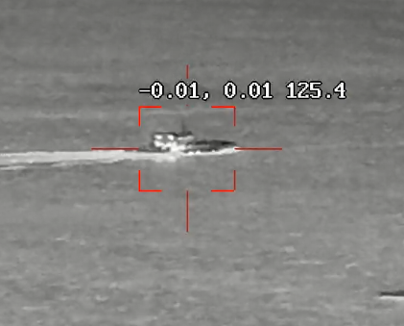

Hot Point Alarm & Tracking
Manual/Auto-Tracking

Model |  | HP-DMA-TVC6516-2132
Effective Distance  (DRI) | Vehicle (2.3*2.3m) | Detection: 13km; Recognition: 3.4km; Identification: 1.7km
 | Human (1.8*0.6m) | Detection: 4.8km; Recognition: 2.5km; Identification: 1.3km
 | Fire Detection | 10km (6km for 2*2m fire)
 | Drone Tracking | Visible Camera for 2.5km; Thermal Camera 1.5km @0.3x0.3m
 | IVS Range | 4.6km for Vehicle; 1.6km for Human
Thermal Sensor | Sensor | 7th generation uncooled FPA sensor
 | Effective Pixels | 640x512 50Hz
 | Pixel Size | 12μm
 | NETD | ≤30mK
 | Spectral Range | 7.5 ~ 14μm, LWIR
 | Bad Point Calibri | Manual calibration
 | SDE | Support SDE digital image processing
 | AGC | Automatic gain control, Manual/auto brightness and contrast set
 | Pseudo Color | 16 pseudo color and B/W, B/W inverse
 | Image Calibration | manual correction, background correction, adjustable Gamma correction parameters
Thermal Lens | Focal length | 31~155mm 5X
 | FOV (640*512) | 14.2°×11.4°～2.8°×2.3°
 | Angular radian | 0.55～0.05mrad
 | Digital Zoom | 1~8X Continuous Zoom (Step 0.1)
Visible Camera | Sensor | 1/1.8'' Star Level CMOS, Integrated ICR Dual Filter D/N Switch
 | Resolution | 2560(H)x1440(V)
 | Frame Rate | 32Kbps～16Mbps，60Hz
 | Min. Illumination | 0.0005Lux (Color), 0.0001Lux (B/W)
 | SD Card | Support
 | Image Setting | WDR, White balance, Strong light suppress, 2D/3D denoise
Visible Lens | Lens Size | 8~500mm 62X
 | Image Stabilization | Support
 | Defog | Support
 | Focus Control | Manual/Auto
 | Digital Zoom | 16X
Image | ROI | 4X
 | Private Mask | 16 presets with 8 areas
 | Image Flip | Up/Down, Center, Left/Right
 | Ranging Ruler | Support
Enhance | Strong Light Protect | Support
 | Temp Correction | Thermal imaging clarity is not affected by temperature.
 | Scene mode | Support multi-configuration scenarios, adapt to different environment
 | Lens Servo | Support lens preset, focal length returns and focal length location.
 | Security | User three-levels group; Mac/IP address back list and white list; log-in lock setting
 | Azimuth Information | support angle real-time return and positioning; azimuth video overlay real-time display.
 | Diagnostic Functions | Disconnection alarm, support IP conflict alarm, support illegal access alarm (illegal access times, lock time can be set), support SD card abnormal alarm (insufficient Space, error, no SD card), video masking alarm, anti-sun damage (threshold, masking time can be set).
 | Life Index Recording | Working time, shutter times, ambient temperature, core device temperature
 | Power off memory | Support, can restore power off state
 | Remote maintenance | remote restart, remote upgrade function, convenient system maintenance
Intelligent | Fire Detection | Threshold 255 levels, targets 1-16 can be set, hot spot tracking
 | AI Analysis | Support intrusion, boundary crossing, entering/leaving area, motion, wandering, people gathering, fast moving, target tracking, items left behind and items taken detection; people/vehicle target detection, face detection; and support 16 area settings; support intrusion detection people, vehicle filtering function; support target temperature filtering
 | Auto-tracking | Single/multi scene tracking; panoramic tracking; alarm linkage tracking
 | AR Fusion | 512 AR intelligent information fusion
 | Image fusion | Support 18 kinds of double light fusion mode, support picture-in-picture function
PTZ | Accuracy | 0.01°, pulse precision motor, digital angle measurement sensor servo
 | Locate Time | ≤2s
 | Rotation | Pan: 0～360°, tilt: -30～+60°
 | Speed | Pan: 0.01~120°/S, Tilt: 0.01~100°/S
 | Preset | 3000
 | Patrol | 16*Patrol Route, 256 Preset for each route
 | Day/Night Patrol | 1-40 preset for day; 41-80 preset for night
 | Enhance | Fan/Wiper/Heater attached
 | Split | Upper and lower split design, can be packaged and transported, combined quickly
 | Zero Setting | support the setting of pan and pitch zero
 | Position Time | less than 4s
 | Angle Feedback | support real-time / query return and positioning functions of horizontal and pitch angles
Video Audio  (Single IP) | Thermal Resolution | 1920×1080；1280×1024；1280×960；1024×768；1280×720；704×576；640×512；640×480；400×300；384×288；352×288；352×240
 | Visible Resolution | 2592×1520；2560×1440；1920×1080；1280×1024；1280×960；1024×768；1280×720；704×576；640×512；640×480；400×300；384×288；352×288；352×240
 | Record Rate | 32Kbps～16Mbps
 | Audio encoding | G.711A/ G.711U/G726
 | OSD settings | Support OSD display settings for channel name, time, gimbal orientation, field of view, focal length, and preset bit name settings
Interface | Ethernet | RJ45
 | Protocol | IPv4/IPv6, HTTP, HTTPS, 802.1x, Qos, FTP, SMTP, UPnP, SNMP, DNS, DDNS, NTP, RTSP, RTP, TCP, UDP, IGMP, ICMP, DHCP, PPPoE, ONVIF
 | Power | DC48V
 | Compression | H.265 / H.264 / MJPEG
Environmental | Operate Temp | -25℃～+55℃（-40℃ optional）
 | Storage Temp | -35℃～+75℃
 | Humidity | <95%
 | Ingress Protect | IP66
 | Housing | PTA three-resistance coating, Seawater corrosion resistance, Aviation waterproof plug
 | Glass | 4mm microcrystalline antireflective HLIN optical glass, transmittance>98%
 | Lighting Proof | 6000V
 | Wind resistance | spherical, anti-shake, anti-33m/s strong wind
 | Power | 350W (Peak);150W (Stable)
 | Anti-fog/salty | PH 6.5～7.2 (No less than 700 hours)
 | Weight | 40kg
 | Size | 420mm×358mm×540mm

DRI Range:

The number is only for reference and the performance may vary according to different environment.
The optimal detection, recognition, and identification distances are calculated according to Johnson’s Criteria.
*Detection Range: In order to distinguish an object from the background, the object must be covered by 1.5 or more pixels.
*Recognition Range: In order to classify the object (animal, human, vehicle, etc.), the object must be covered by 6 or more pixels.
*Identification Range: In order to identify the object and describe it in details, the object must be covered by 12 or more pixels.
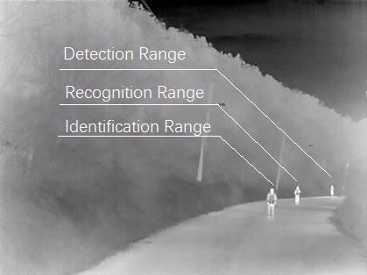

Software View (RGS1000):

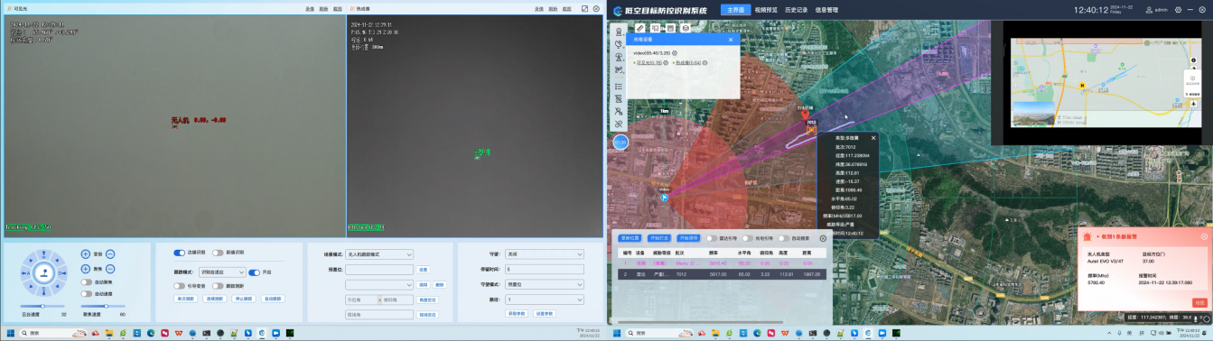

Anti-Drone Application View:
