Assignment 3: Software Design Document (SDD) with Security by Design (SBD)

Project Name:Raspberry Bin | Team ID:27 | Mentor(s):  Dan Ploeşteanu  Timo van den Berg

Instructions:
- Work on all sections below, including all essential Security by Design elements.
- Keep explanations concise but clear (use bullet points where helpful).
- Your work should reflect your actual project design and decisions.
- Choose only the most relevant diagrams (avoid overloading the report).
- Include at least one Prevention and one Mitigation measure from your threat modeling.
- The document should be 4–6 pages max (excluding diagrams, if needed).
- Ensure the checklist below is completed before submission.

- Security checklist (can be found in the end of this file)
- What to include:
  - A filled-up security checklist table (including comments).

- Introduction (0.5 page) - Briefly describe your project: what it does, and for whom.
The Raspberry Bin is an intelligent system for sorting waste that provides automatic separation of a variety of waste into PMD, organic/bio, general waste and paper. The system uses a PI camera to identify waste and drops into the right compartment automatically. To make it easier for users to throw away in the appropriate bin, and limiting the chances of throwing waste wrongly. The system employs Raspberry Pi 4B, Camera Module 2, sensors, servos, and solenoids, the software is written using Python, PyTorch, OpenCV, FastAPI, Vue.js and Tailwind CSS. We are making the bin as a general home appliance for people who have trouble with sorting their waste, but theoretically if it was built in a scaled up version, it could be applied in industries and big trash disposers such as Avalex.

- Revised Requirements (if any) – Only complete this section if your team changed project requirements after mentor consultation and did not include them in the Requirement Analysis. If no changes were made, briefly state that.
- What to include:
  - List 3 functional, 1 security, 1 non-functional, and 2 (unique to your solution) revised requirements, if any.
- Example:
  - Functional (Revised): Auto-upload data to the cloud every 15 minutes.
  - Security (Revised): Admin dashboard must require login authentication.
  - Non-functional (Revised): System should boot and be operational in under 60 seconds.

We do not have any revised requirements as our previous assignment requirements were sufficient and we believe as detailed as possible, therefore we did not have to make any changes after consulting our mentor.
- Architectural Design (1–1.5 pages) – Briefly describe your system’s structure and interactions using UML diagrams.
- What to include:
  - Choose at least 1 relevant diagram from: Use Case, Class, Activity, or Sequence.
  - Students must include a Data Flow Diagram (DFD)- mandatory. (diagram example: https://www.youtube.com/watch?v=6VGTvgaJllM; Data Flow Diagram is required to visualize the flow of data, input/output connections, and trust boundary. more information about it can be found in the project manual 3.3 Design section)
  - Or if some projects truly don’t suit DFD, students should justify why and propose an alternative with mentor approval.
  - For each diagram, provide a 1–2 sentence explanation describing what it shows and why it’s important for your system’s design and security.
  - Focus on key components, interactions, data flow, and security boundaries.
- Example: “Our system uses a Use Case diagram to show interactions between Admin, Student, and Cloud Server for attendance management. The Data Flow diagram illustrates how RFID data moves from the Raspberry Pi reader to the local database, then to the cloud, and finally to the admin dashboard.”
- Use tools like draw.io or Lucidchart to create clear and simple diagrams aligned with your actual system.
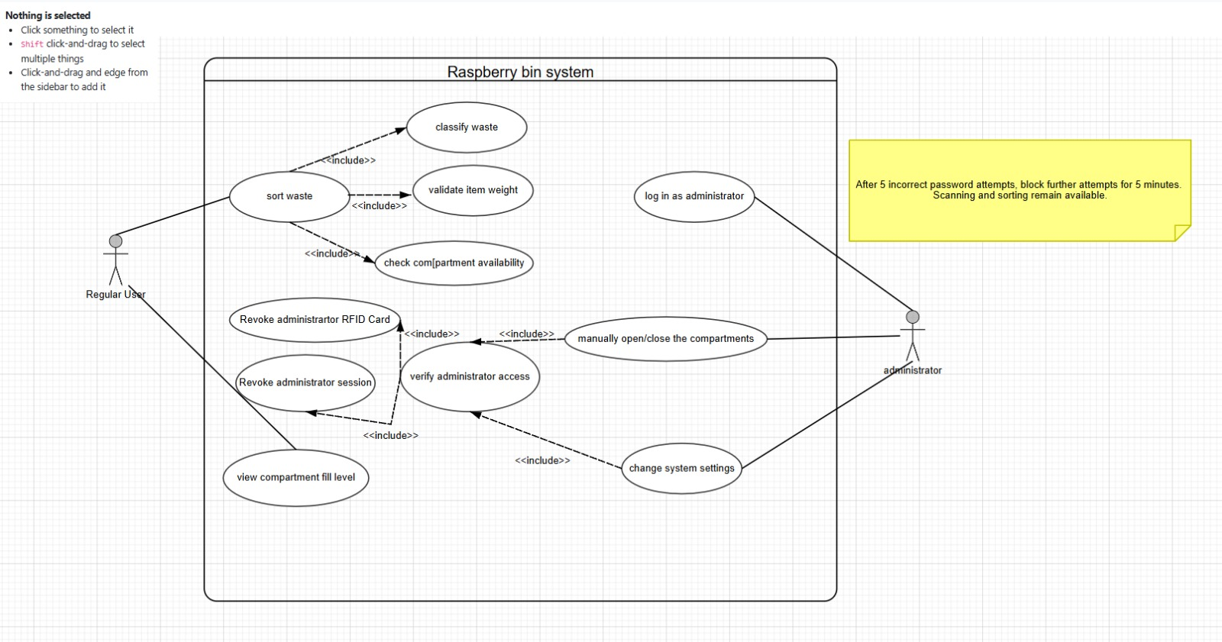
Our Use Case diagram models the system boundary and the functional interactions between users (Regular User and Administrator) and the Raspberry Bin system. It ensures only administrators have access to admin-specific actions such as manual control of the compartments and also changing the settings.
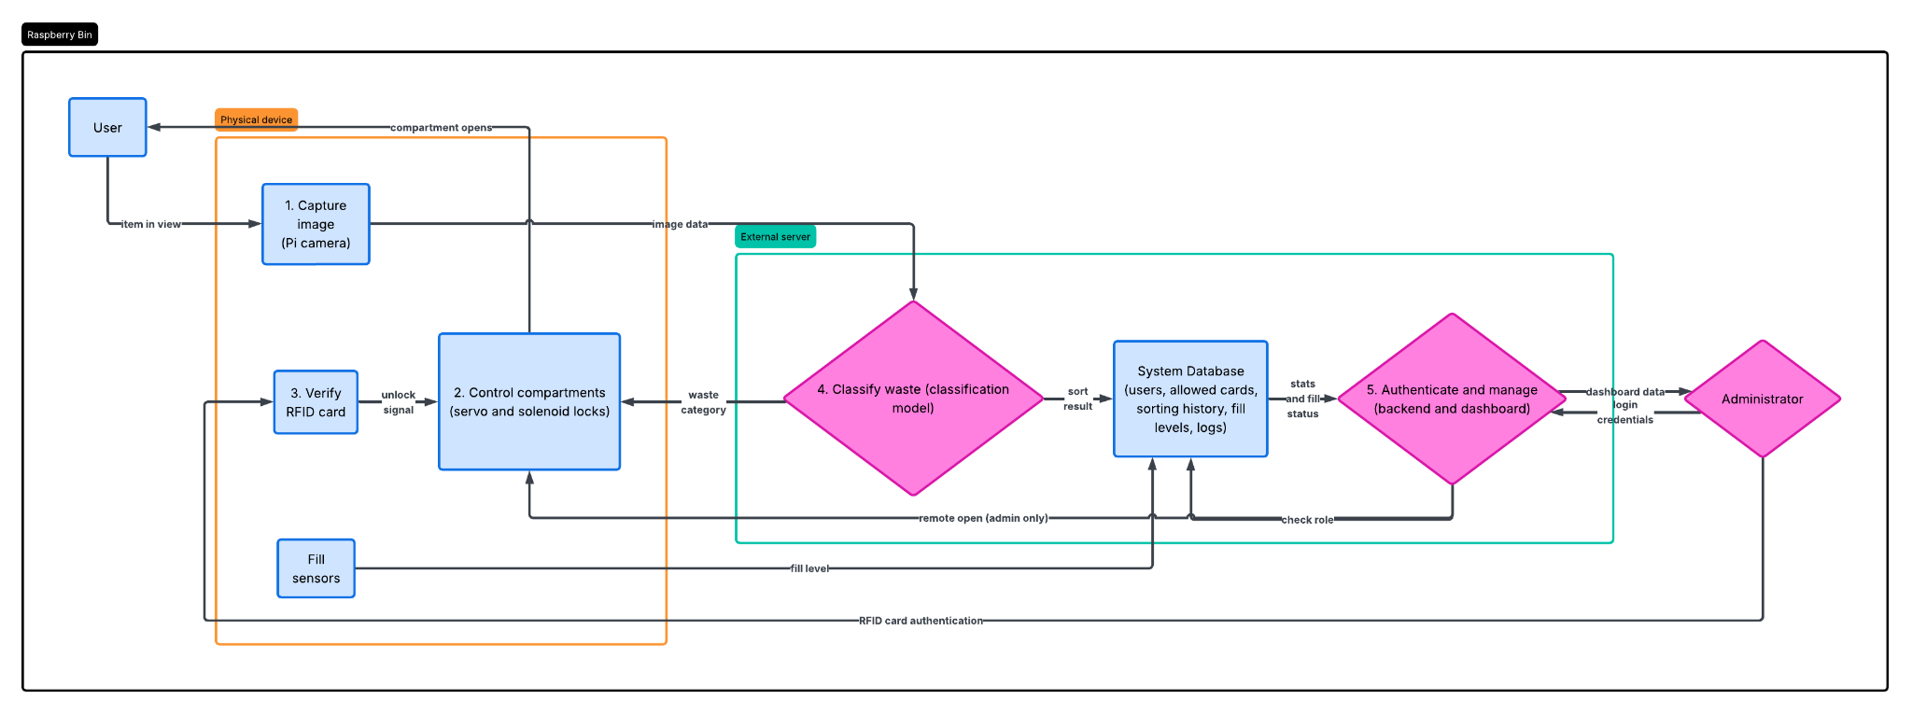
Our system uses a Data Flow Diagram to show how our camera data, RFID signals and sensor data transition between different trust boundaries such as physical device trust boundary and cloud external server boundary. We are using external clouds in our design due to constraints of having low RAM in the raspberry pi and the need for fast computation power due to our classification model.
- Product User Interface (0.5 page) – Describe the design of your application’s interface with simple illustrations.
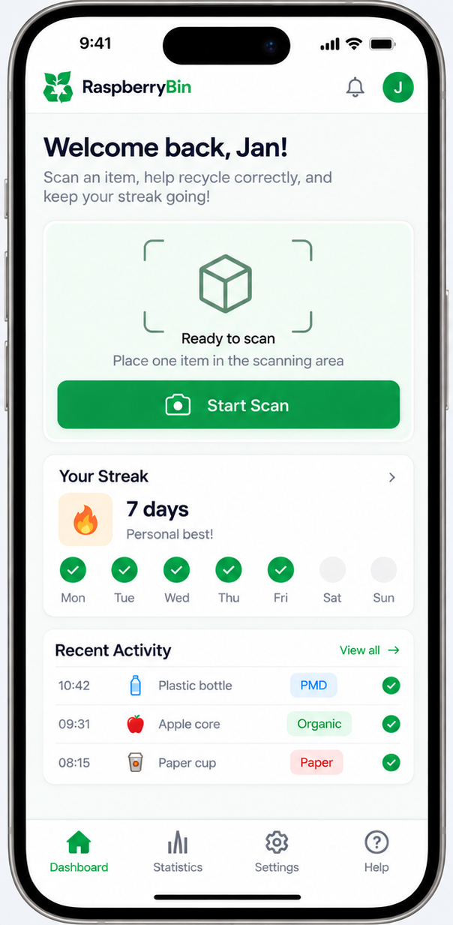
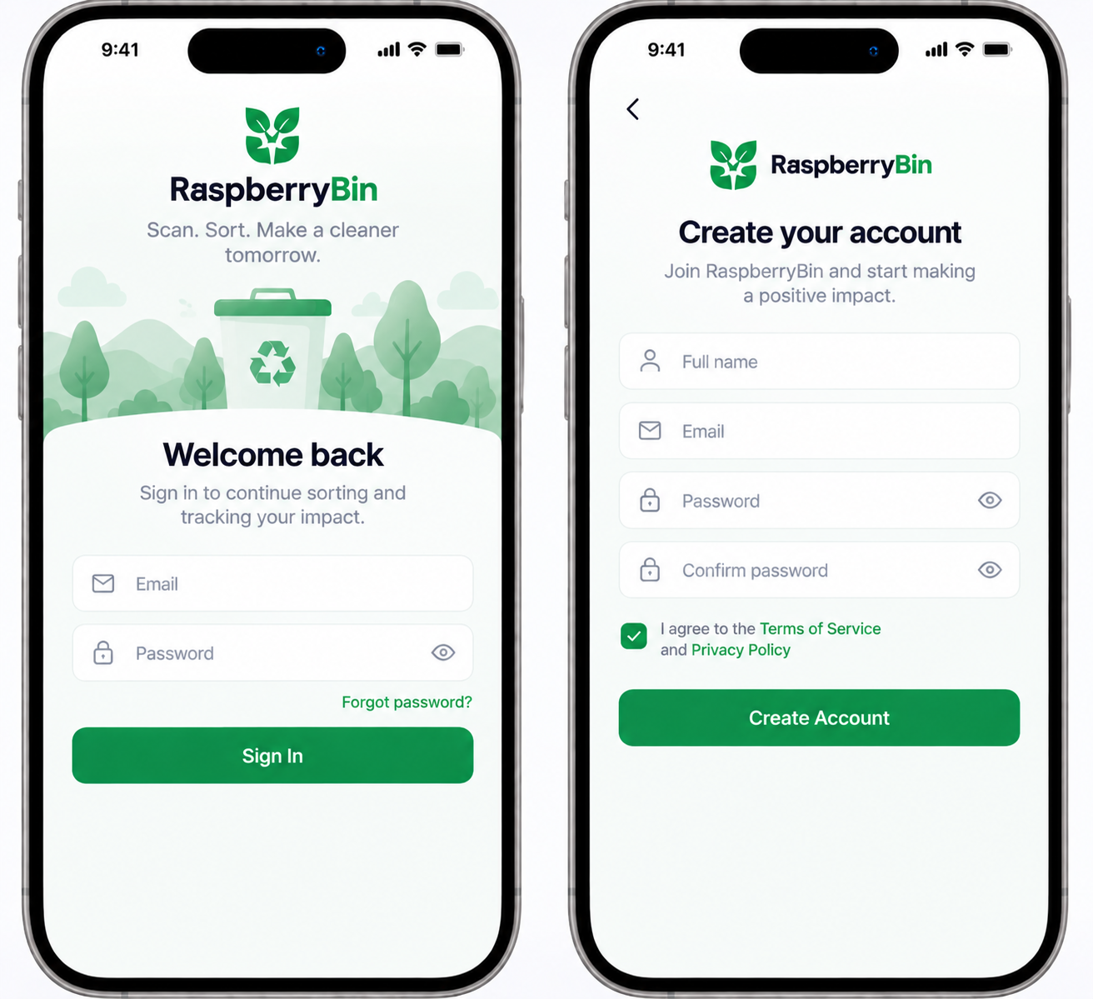
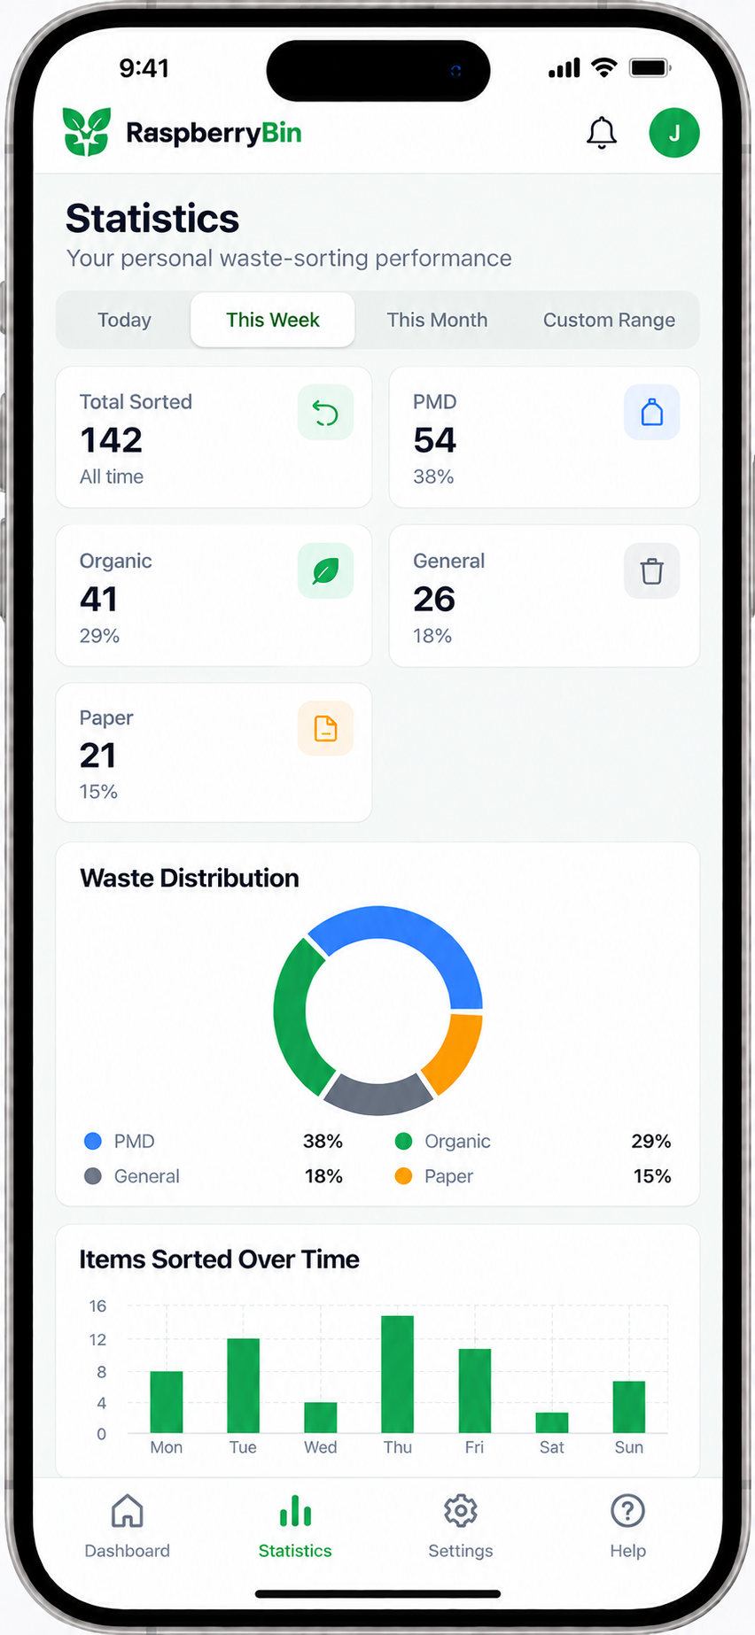

Figure 1-2. Raspberry Bin authentication interface with the screens for user login and account creation.
The authentication interface contains screens for user login and account creation. In order to create an account users type their email address, credentials, and visibility tools for password protection along with functions for account management to keep the authentication process running. The authentication of an admin is handled separately for accessing the restricted admin features.
Figure 3. Raspberry Bin regular user dashboard with the feature for waste tracking, sorting streak, activities done, and main navigation.
The dashboard is the main page where you can get started with the waste sorting and classification. The dashboard shows the sorting streak of the user with the last activity performed allowing fast access to previous sorting results. The bottom navigation provides links to the dashboard, statistics, settings, and help & support pages.
Figure 4. Raspberry Bin authentication interface for user login and registration.
The statistics section provides the user with an overview of the waste-sorting results through summary cards and visual diagrams, and It shows the total number of items sorted and their classification into PMD, organic food, general waste, and paper. Users may set time filters to look through statistics for different time periods.

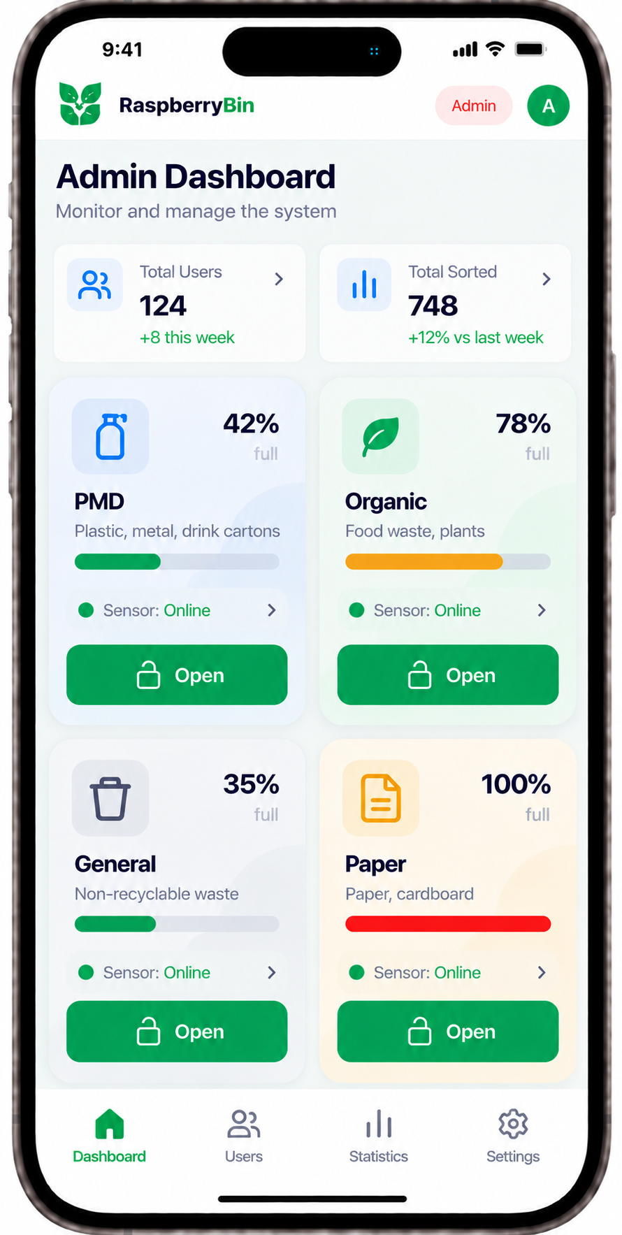
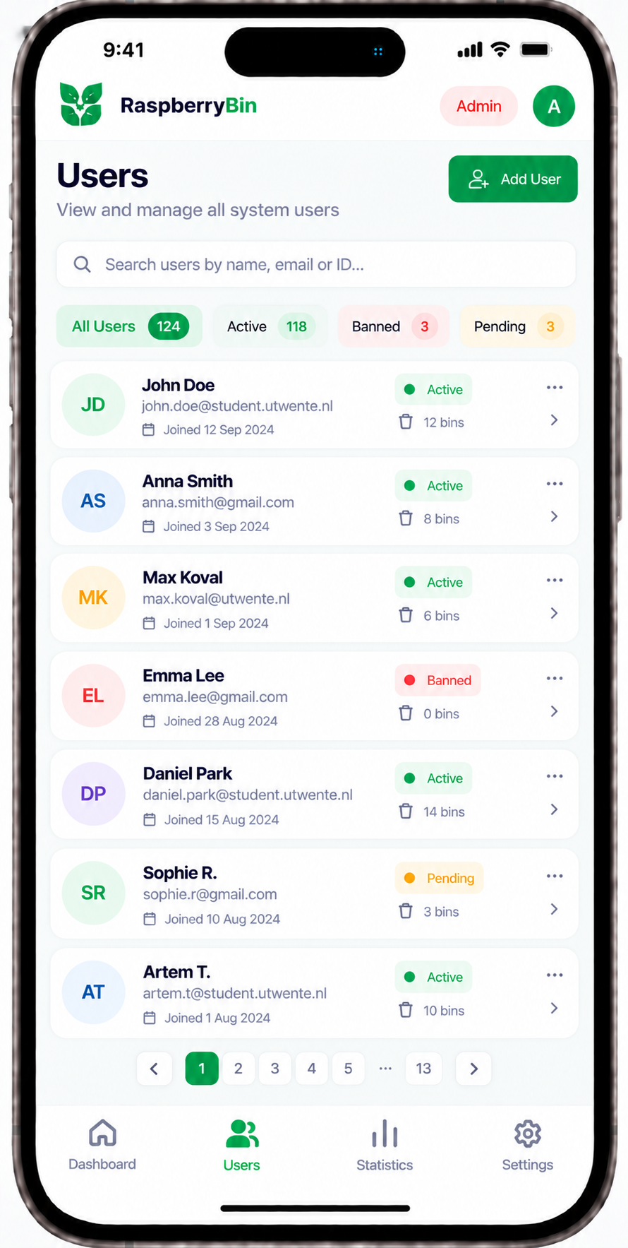

Figure 5. Raspberry Bin Admin Dashboard showing the system summary, the current status of bin filling, the working status of sensors, and the manual access to compartments.
From the admin dashboard, you can see a snapshot of the system showing the overall count of registered users and sorted items, as well as showing the current fill level of all the waste compartments and whether or not the sensors are working properly. The admin has a special button called open which is used to open the device and thus give access to all the compartmentsThe navigation bar at the base of the app consists of four sections: the Dashboard, Users, Statistics, and Settings.
Figure 6. The user interface of the Raspberry Bin displays user search filters and user account status option with account operation.
The users section provides access to administrators to review and control utilization of accounts by registered users. The screen encompasses a space for carrying out a search, filters for checking status of users like active, banned, or pending, and data about the registered users’ account status and their activity.

- Prevention / Mitigation Criteria (Security Controls) (0.5 page) – Explain at least one prevention and one mitigation strategy for security risks.

- Prevention: Access restriction for maintenance purposes
A regular user may attempt to open the bin's door or try to change system settings by sending direct requests to the server. In order to prevent this, the backend must authenticate the user's roles and permissions before executing any protected requests. Requests without valid permissions will be rejected before activating any locks or changing any settings. Normal processes such as scanning and sorting will remain available for all users and it won’t require any administrator’s permissions.

- Mitigation: Blocking stolen cards and sessions

If an administrator's RFID card is stolen or lost, authorized staff will be able to remove it from the list of allowed cards. If someone gets access to the administrator's web session, staff will be able to stop this session. After that, the system will reject further requests that are sent by this session or requests using blocked cards. Also, authorized staff can check whether any settings were changed or maintenance doors were opened without permission. This will help with stopping further and future issues, although it won’t be able to undo the things that have already been done

- Cost Involved (less than 0.5 page)
Implementing the security controls for the Raspberry Bin introduces specific time, financial, and resource trade-offs, which have been realistically estimated:

- The process of developing secure communication channels to transmit image data (e.g. safeguarding it with HTTPS or TLS encryption) and implementing API authentication has increased our total time spent on development and testing by about 15%. Also, we have carried out additional manual security testing to ensure secure data flow across network boundaries.

- Costs of Hardware: To reduce costs, we used various sources for our components. Our Raspberry Pi 4B and our PI Camera were provided by a member of the group. We can use as much plywood as needed using connections in the designlab alongside small electronics provided there, and the only cost will be around 30-35 euros for a few MG955 servos and a RFID module and some ultrasonic sensors for checking the fill level of each bin.

- Costs of Cloud / external evaluation: Since local image processing through OpenCV and PyTorch takes up a lot of resources and is thus too hard for Raspberry Pi, the work will have to be done on an external server. This means that there will be recurring costs due to the employment of cloud services or APIs.

- Resource limitations and trade-offs: Due to the restrictions of Raspberry Pi's computational abilities, we need to handle images externally. While using the connection over the web overcomes hardware limitations, it increases the risks for attacks. Therefore, we must allocate resources to ensure the secure information transfer over the internet in order to prevent data loss, resulting in a slight network delay which is a trade-off for ensuring the security of our system.
- Conclusion (less than 0.5 page) – Summarize your design decisions and any challenges faced.
- What to include:
  - Key highlights from your design phase.
  - Challenges or risks identified for the next phase.
- Example: “Our design ensures secure attendance tracking with encrypted data flow. Challenges include balancing performance with security.”

Our design integrates hardware and cloud processing to create a secure, smart and efficient waste-sorting system. Key highlights from our design include establishing clear trust boundaries between the raspberry and the external server, implementing a clear role-based access control and securing data transmission across the network. For the next phase we expect to run into some challenges with the actual physical implementation of the project and the actual combining of the hardware and the software in such a manner that our project is still secure.

- References– List research papers, articles, and tools referred to during your design.
We have used tools such as draw.io for our diagrams and also STORES | Product list | E.T.S.V. Scintilla for estimating the project cost and figma.com for our UI designs.
- Usage of AI Tools (less than 0.5 page)
Our team utilized AI tools, specifically ChatGPT/Gemini strictly for helping us with brainstorming for where to supply the parts for our raspberry bin and which parts can we use as alternatives to more expensive parts and also for reviewing the document and ensuring delivering the highest quality possible, however all use was only as assistance and no copy-pasting was done.
- Brainstorming and Document Review: We used AI to brainstorm potential security vulnerabilities, discuss trade-offs for our data flow, and review drafts of this Software Design Document for grammar, clarity, and formatting.
- Academic Integrity Compliance: These tools were used purely for assistance and not for generating large parts of the assignment, no text or code was copy-pasted, and all AI-generated suggestions were thoroughly reviewed and modified by the team in order for it to be applicable for the project. We take full responsibility for understanding and justifying all design decisions and implementations.
- Grading and Resit:
  - This is a pass/fail assignment. If you fail the assignment, you may only resubmit during the resit period.
  - You need a score of 7/10 or higher to pass the main attempt and 8/10 or higher to pass the resit.
  - Follow the rubric carefully to ensure your submission is complete and meets the required standards.
  - If you fail both attempts, it will result in failing the entire project.

Security by Design Checklist (To be completed by the team)

Sr. No. | Security Review Point | Completed (✔) | Comments | Security Controls | Completed (✔) | Comments
1 | Check trust boundaries (e.g., privilege levels) | ✔ | We checked and understood our different trust boundaries which is the physical hardware with raspberry pi being the untrusted physical environment and the external cloud server being the trusted network. | Prevention criteria identified | ✔ | We are going to enforce local hardware security measures and for the network transfers we are going to use HTTPS and other safe protocols such as role-based access control.
2 | Identify data flows from untrusted sources. | ✔ | We identified camera data uploading, RFID card scanning, sensor inputs and dashboard login attempts as an untrusted source. | Mitigation measures defined | ✔ | We are going to integrate rate-limiting for instance 5 failed attempts resulting in a 5 minute ban and an alert in the system as well as input validation for all our inputs.
3 | Review entry and exit points of the system | ✔ | Entry points are identified and reviewed which are the physical hardware such as the servos and solenoid locks being the entry points and the exit points are the backend, the server and the dashboard putting the log into the system. | Data flow diagram created | ✔ | Created the complete data flow diagram including the hardware, external server, trust boundaries and connections between them which is also added above in section 4.
4 | Completed architecture review | ✔ | We evaluated and checked the total system feasibility and safety, verifying that the majority of the security is dependent on the cloud functioning correctly and encrypting data and correct authentication and validation handling. | Cost analysis performed | ✔ | Cost-analysis is done and can be seen above.
Team members reviewed: (Sepehr Marjovi – Yes), (Mack Glass – Yes), (Omar Hassan – Yes), (Artem Novokhatnii – Yes), (Bohdan Sharloimov – Yes), (Ruslan Morozov– Yes)

