Celestial Navigation for OpenCPN
Principles, practical methods and plugin manual
Experimental v2 documentation
Celestial Navigation plugin 2.6 development fork
Documentation revision 15 August 2026
Designed for completely offline use at sea
About this manual
This manual has two purposes. First, it explains celestial navigation from its simplest underlying geometry. Secondly, it gives operating instructions for the Celestial Navigation plugin for OpenCPN, including its planning, running-fix, time-integrity, lunar-distance, coastal and eclipse tools.
The teaching order: first understand why one altitude creates a Circle of Equal Altitude. Then learn why that circle is usually treated as a Line of Position. Only after that do we introduce the intercept method, running fixes and specialist observations.
Navigation warning. This is experimental software and instructional material, not an approved primary means of navigation. Maintain an independent position, a proper dead-reckoning plot and all equipment and publications required for the voyage. Check results for plausibility. Never allow an attractive plot or numerical answer to override contrary navigational evidence.
The plugin performs its ordinary celestial calculations offline. The eclipse planner also works offline once its separate DE440 data has been imported. Optional LOLA lunar-limb data is not required for navigation or for ordinary eclipse plotting.

How to use the manual
- If celestial navigation is new to you, read Chapters 1–6 in order.
- For a first practical altitude sight, use the checklist in Chapter 8.
- For planning, running fixes or analysis, continue through Chapters 9–11.
- Lunar distance, joint lunar sequences, sextant checking, horizon events, coastal methods and eclipses are specialist workflows in Chapters 12–15.
- Use the notation table below for immediate help. The comprehensive alphabetical lists are in Appendices A and B.

Notation at a glance
Symbol | Meaning
AP | Assumed position used to calculate an expected altitude and azimuth.
DR | Dead-reckoning position obtained from the previous position and estimated motion.
GP | Geographic position: the point on Earth directly beneath a celestial body.
Hs | Sextant altitude: the angle read from the sextant.
Ha | Apparent altitude after index and horizon/dip corrections.
Ho | Observed altitude: the fully corrected measured altitude used for navigation.
Hc | Computed altitude predicted at the AP for the observation time.
Zn | Calculated true azimuth of the body, conventionally 000°–360° from true north.
COP | Circle of Position, here normally a Circle of Equal Altitude.
LOP | Line of Position: the local straight-line approximation to a COP.
GHA | Greenwich Hour Angle, measured westward from Greenwich to the body's hour circle.
LHA | Local Hour Angle, the body's hour angle relative to the observer's meridian.
UTC / UT1 | UTC is civil atomic time with leap seconds; UT1 follows Earth rotation and is the astronomical argument required by hour angle.

Contents
- The one idea behind celestial navigation
- One altitude gives a Circle of Equal Altitude
- From circles to Lines of Position
- From sextant reading Hs to observed altitude Ho
- Fixes, geometry and uncertainty
- Time, longitude and the astronomical triangle
- Plugin orientation and time integrity
- Entering an altitude sight
- Sun, Moon and Sight Planner
- Running fixes and moving observers
- Sight Sequence Analyzer, noon and Polaris
- Lunar distance, joint sequences and sextant checking
- Sunrise and sunset horizon events
- Coastal sextant methods
- Offline solar-eclipse planner
- Troubleshooting and validation
- Appendix A — abbreviations and symbols
- Appendix B — glossary
- Appendix C — formulae and sign conventions
- Appendix D — references and provenance

1. The one idea behind celestial navigation
A sextant does not directly measure latitude or longitude. It measures an angle. At a recorded time, the navigator measures the altitude of the Sun, Moon, a planet or a star above the visible horizon. An almanac or ephemeris provides the body's corresponding position in the sky.

1.1 The body's geographic position
Imagine a line from the centre of a distant celestial body through the centre of Earth. Where that line meets Earth's surface is the body's geographic position (GP). To an observer at the GP, the body is at the zenith: directly overhead. The GP moves as Earth rotates and as the body moves in its orbit. Its latitude is the body's declination; its longitude is obtained from its Greenwich Hour Angle.

1.2 Altitude and zenith distance
The corrected observed altitude Ho is the angle from the observer's horizontal plane up to the body. The complementary angle between the observer's zenith and the body is the zenith distance z.
z = 90° − Ho
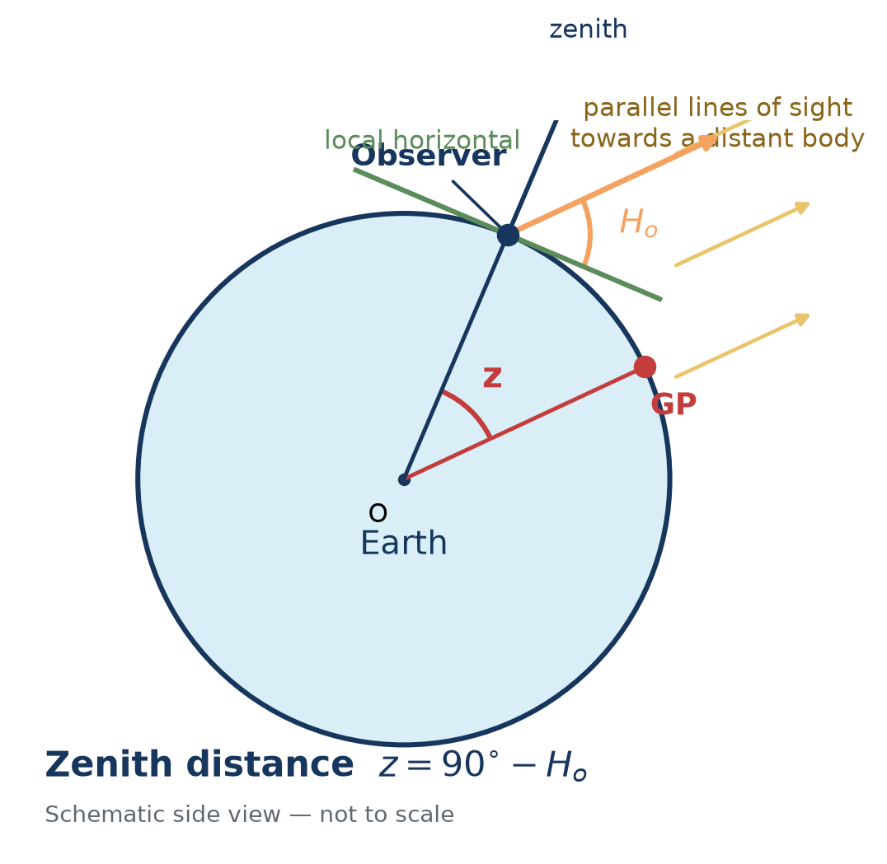 Figure 1. Altitude and zenith distance are complementary. The central angle from the observer to the body's GP equals the zenith distance.
The important geometric fact is that the angle at Earth's centre between the observer and the GP is also z. Therefore Ho tells us our angular distance from the GP. It does not yet tell us in which direction from the GP we lie.
Example. If Ho is 50°, then z is 40°. The observer is 40° of arc from the body's GP. Since one degree of arc is 60 nautical miles, that angular distance is approximately 2,400 NM.

2. One altitude gives a Circle of Equal Altitude
All positions that are the same angular distance from the GP form a small circle on Earth. Every observer on that circle sees the body at the same corrected altitude at that instant. This is the Circle of Equal Altitude, a type of Circle of Position.
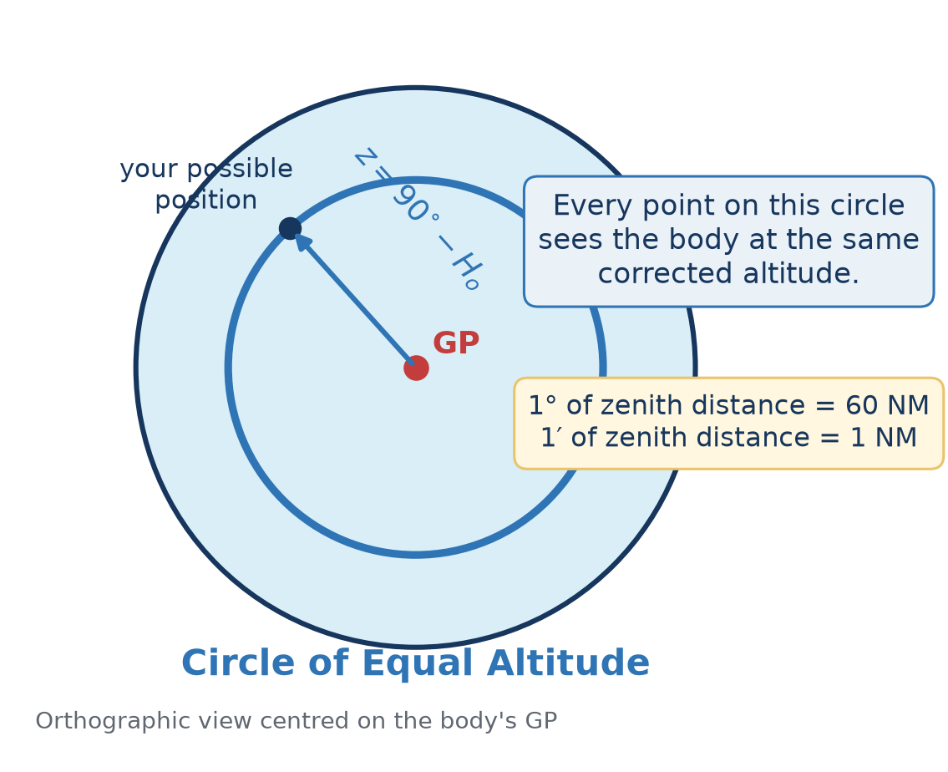 Figure 2. One corrected altitude defines a complete circle, not a unique position.
One altitude sight gives one position constraint. You are somewhere on its circle. A single ordinary altitude sight cannot, by itself, provide a complete two-dimensional fix.

2.1 Why minutes of arc become nautical miles
The nautical mile is tied to angular distance on Earth. For practical sight reduction, one minute of altitude difference corresponds to approximately one nautical mile measured along the direction to or from the GP. This is why a sextant error of one arcminute commonly appears as about one nautical mile of LOP displacement.

2.2 Intersecting circles
Two simultaneous sights of different bodies normally give two intersections. A DR position, hemisphere, third body or other evidence selects the intended one. A third independent circle also checks the consistency of the observations.
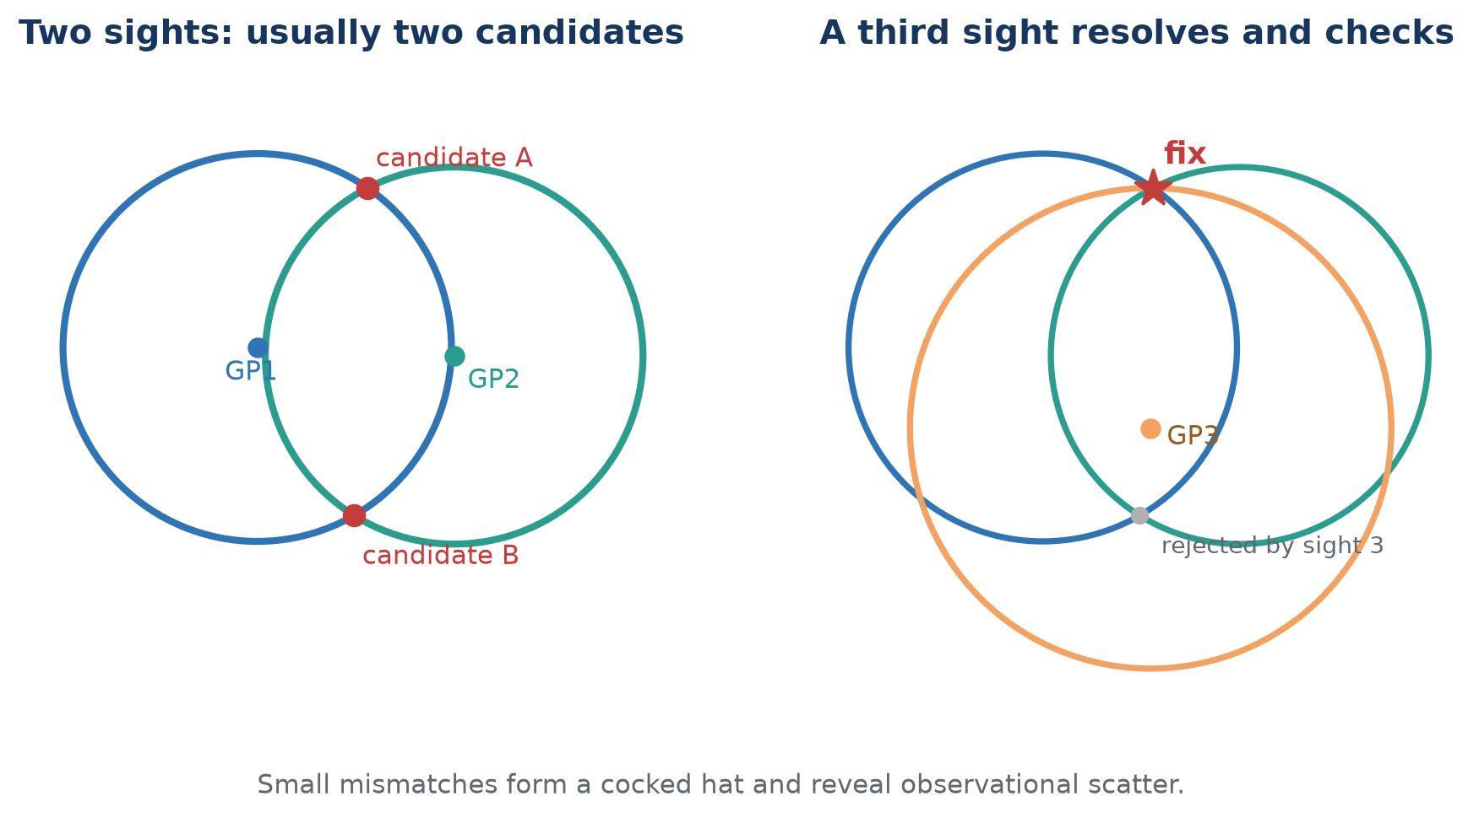 Figure 3. Two circles normally leave an ambiguity; a third sight resolves and checks it.
Real observations seldom meet at one mathematical point. Instrument error, horizon quality, timing, refraction, vessel motion and personal technique create a small triangle or more general scatter. The purpose of additional sights is not to make error disappear, but to expose and estimate it.

3. From circles to Lines of Position
A Circle of Equal Altitude can have a radius of thousands of miles. Over the small area of a normal plotting sheet, a short arc of that circle is nearly straight. Navigators therefore use a tangent Line of Position (LOP).

3.1 The altitude-intercept method
Choose an Assumed Position (AP) near the DR. For the observation time and body, calculate:
- Hc, the altitude the body would have if you were at the AP;
- Zn, the true azimuth from the AP towards the body's GP.
Compare the corrected observed altitude Ho with Hc. Their signed difference is the intercept.
a = Ho − Hc
- If Ho is greater than Hc, the body appeared higher: move the LOP towards the GP.
- If Ho is less than Hc, the body appeared lower: move the LOP away from the GP.
- The magnitude in arcminutes is the intercept distance in nautical miles.
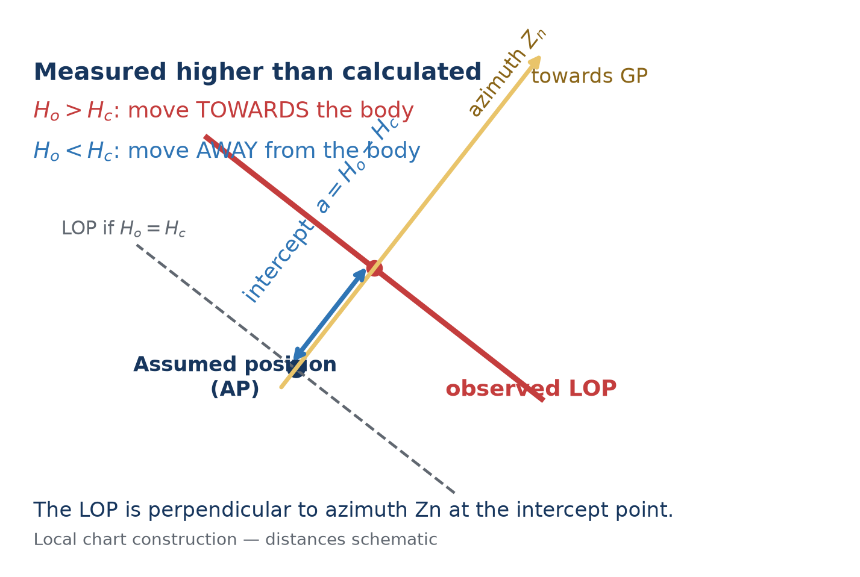 Figure 4. The observed LOP is perpendicular to Zn at a distance |Ho − Hc| from the AP.
Why the plugin can show circles. Historically, drawing a large spherical circle on a paper chart was inconvenient. OpenCPN can draw the COP directly. The circle and its local tangent LOP express the same observation; the full circle is especially helpful when the DR is poor or unknown.

4. From sextant reading Hs to observed altitude Ho
The sextant reading is not yet the altitude used to construct the circle. The plugin applies corrections appropriate to the body, limb, instrument, horizon and atmospheric conditions.
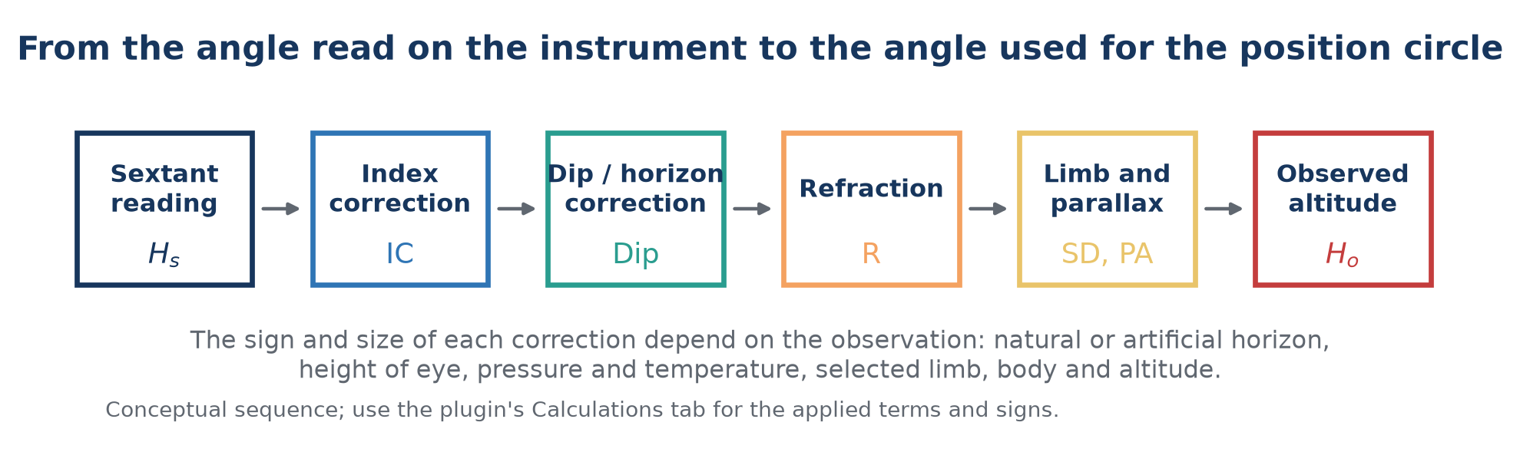 Figure 5. Conceptual correction sequence. The Calculations tab records the terms actually applied.

4.1 The principal terms
Term | Purpose
Index correction | Removes the sextant's zero error. “On the arc, take it off; off the arc, put it on” is the traditional mnemonic.
Dip | Corrects the visible sea horizon below the observer's true horizontal plane. It depends principally on height of eye.
Refraction | Corrects atmospheric bending, greatest near the horizon and dependent on altitude, pressure and temperature.
Semidiameter | Converts a selected upper or lower limb of the Sun or Moon to the body's centre.
Parallax in altitude | Converts the topocentric direction at the observer to the required geocentric direction. It is particularly important for the Moon.

4.2 Horizon choices
Natural horizon: enter height of eye and normal atmospheric conditions. Artificial horizon: the measured doubled angle must be handled by the selected workflow; dip is not applied as for a sea horizon. Dip short: use when the visible waterline is at a finite distance rather than the astronomical sea horizon. Back sight: use only when the observation geometry and sign are understood.

4.3 Record what was observed
Do not “improve” a raw observation to match an expected answer. Record the body, limb, Hs, watch time, horizon, eye height and environmental values. Let the correction and analysis stages remain reproducible.

5. Fixes, geometry and uncertainty

5.1 Near-simultaneous multi-body fix
A twilight fix normally uses two or more well-separated bodies observed in a short interval. Three bodies are preferable because they show scatter and reduce the risk of accepting the wrong two-circle intersection. Good azimuth spread matters more than collecting many bodies in one part of the sky.

5.2 A cocked hat is information
Three LOPs that do not meet form a cocked hat. Its size and shape reflect observation and model errors, but it is not automatically a confidence region with a fixed probability. Consider horizon quality, repeated-sight scatter, timing, geometry, and known systematic bias before assigning meaning to it.

5.3 Repeated observations
A run of sights can reveal blunders and personal trend. Retain the original readings. The Sight Sequence Analyzer can report residuals, scatter, trend, possible outliers and personal bias. Do not discard a point merely because a program labels it unusual; first look for a physical explanation.

5.4 Uncertainty fields
Measurement certainty controls the plotted band around a COP/LOP. Time certainty represents uncertainty in the observation epoch. These values should describe the observation honestly; reducing the number only draws a thinner line and does not improve the sight.

6. Time, longitude and the astronomical triangle

6.1 Why time is inseparable from longitude
The body's GP moves in longitude as Earth rotates. Earth turns approximately 15° per hour, 15′ of hour angle per minute and 15″ per second. A timing error therefore puts the calculated GP on the wrong meridian. The resulting position error depends on latitude, body motion, azimuth and the other sights—it is not always a simple one-for-one longitude correction.
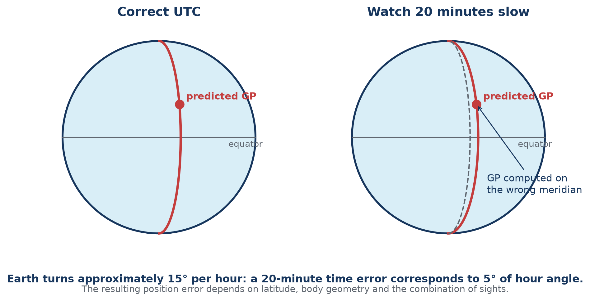 Figure 6. An uncorrected watch error displaces the predicted GP and every position circle derived from it.

6.2 UTC, UT1 and the system clock
UTC is the civil time broadcast by modern systems. UT1 follows actual Earth rotation and is the time argument underlying GHA. For ordinary sextant work the small UTC–UT1 difference is normally below other observational errors, but the distinction matters for rigorous prediction and eclipse timing. Future UTC cannot be known indefinitely because future leap seconds are not predictable.

6.3 The astronomical triangle
The formal calculation uses a spherical triangle whose vertices are the elevated pole, the observer/AP and the body's GP. Its sides are colatitude, polar distance and zenith distance; its angles include LHA and azimuth. The plugin solves this geometry numerically. Understanding the triangle explains where Hc and Zn come from, but table manipulation is not required to use the plugin.
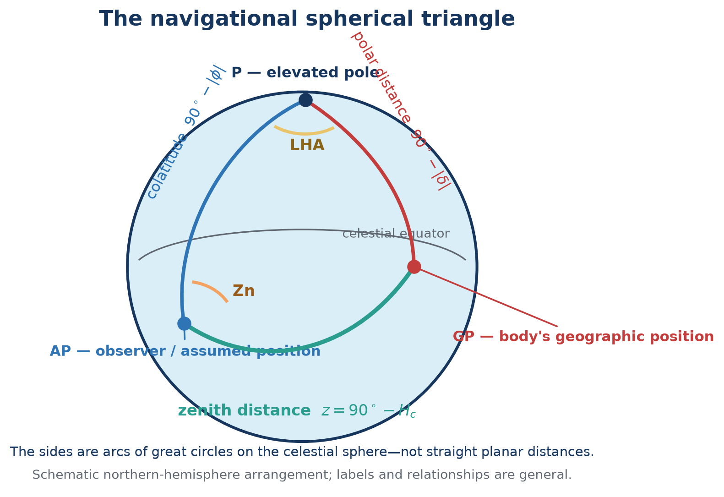 Figure 7. The navigational triangle names the three great-circle sides and the LHA and azimuth angles used to calculate Hc and Zn.
sin Hc = sin φ sin δ + cos φ cos δ cos LHA
Here φ is latitude and δ is declination. An atan2 form is used for azimuth to preserve the correct quadrant.

7. Plugin orientation and time integrity

7.1 Main Sights window
The main list contains stored observations. Its columns show sight type, body, UTC time, measurement and colour. The eye symbol controls whether a sight is plotted and included where a workflow uses visible sights.
Control | Purpose
New | Create an altitude, azimuth or lunar observation.
Fix… | Solve from suitable visible sights near a selected epoch.
Horizon Event… | Record observed sunrise or sunset timing and optional bearing.
Sun & Moon… | Open the offline event, body, best-sight, almanac, noon and Polaris planner.
Analyze Sights… | Analyze residuals and repeat-observation behaviour.
Lunar Tools… | Jointly solve several lunar observations, rank Moon–body pairs and check a sextant against computed angular distances.
Eclipses… | Search, plot and calculate offline solar-eclipse circumstances.
Coastal Sextant… | Use vertical-angle ranging or horizontal-sextant-angle fixing.
Duplicate / Edit / Delete | Manage a selected stored sight. Duplicate is useful for a run of sights.
Clock Offset | Apply a common correction to stored sight times.
Hide | Collapse or restore the sight list and controls.
Documentation | Open this completely offline manual.

7.2 Time integrity panel
The panel displays computer local time with time zone, UTC, GNSS/NMEA UTC when valid RMC or ZDA sentences have been received, the system-to-GNSS difference, and system clock synchronisation information. On systems using chrony, the plugin reports synchronisation state, estimated offset and source age where available.
Important: GNSS comparison is informational. It does not silently rewrite stored sight times or Clock Offset. “GNSS time unavailable” means no valid supported sentence has been received; it does not mean the computer clock is necessarily wrong.
Use the panel to decide how much confidence to place in a captured time and to synchronise a deck watch. Hide the panel when screen space is limited.

8. Entering an altitude sight

8.1 Before the observation
- Check sextant adjustment and determine index error.
- Measure height of eye above the actual waterline.
- Check the time source and record watch error or confirm the intended Clock Offset workflow.
- Use Sun & Moon… to select visible bodies with useful azimuth spread and altitude.
- Preset the sextant from an estimated altitude if helpful, while keeping the actual observation independent.

8.2 Create the sight
- Select New and choose Altitude.
- Select the body and, for Sun or Moon, the observed limb.
- Enter Hs in the accepted angle form. Verify the redisplayed value and hemisphere/sign conventions.
- Enter the exact UTC date and time of the observation. If entering watch time, apply the known convention consistently.
- Enter measurement and time uncertainty honestly.
- On Parameters, enter index error, height of eye, pressure, temperature and horizon type.
- Enter or select the DR/AP used for the calculation.
- Review the Calculations tab: Hs, applied corrections, Ho, Hc, Zn and intercept should tell a coherent story.
- Accept the sight and inspect its COP on the chart.

8.3 Common entry mistakes
- Entering local civil time in a field labelled UTC.
- Crossing midnight during time-zone conversion without changing the date.
- Applying watch error manually and again through Clock Offset.
- Using the wrong Sun/Moon limb or the wrong sign for index error.
- Entering west longitude without the expected sign or W designator.
- Using GPS position as “DR” while trying to conduct an independent no-GPS exercise.

9. Sun, Moon and Sight Planner
The planner is completely offline. Set a position and time context, then select Calculate / refresh.

9.1 Position and time context
Position can be manual, current boat position, chart cursor, selected sight DR or last calculated fix. Time can be now, the selected sight, or a manual date/time. Manual entry may be UTC or computer local time; displayed event times may independently be UTC, computer local time or a fixed offset. The calculation itself uses the correct internal time scale.

9.2 Events tab
Lists astronomical, nautical and civil dawn/dusk, sunrise, sunset, Moonrise, Moonset, local apparent noon and lunar transit when they occur. It reports UTC, selected display time, true bearing and observer position. High-latitude days may legitimately omit an event because the body does not cross the chosen altitude threshold.

9.3 Bodies & Best Sights
The body list and sky plot show altitude, azimuth and usability. Suggested pairs and triads rank geometry and visibility; they are aids, not commands. Weather, deck obstruction, brightness, horizon quality and a navigator's ability to identify a body remain decisive. Create selected sight… transfers the body and planning context to sight entry.

9.4 Almanac
Provides hourly GHA, SHA, declination, Hc and true Zn for the selected position/time context. Export CSV… creates a portable table for independent checking or a paper working sheet.

9.5 Time-tagged moving observer
Enable this option and enter true COG and SOG when event positions or sight planning should follow a vessel moving from the reference position and time. This is a constant-motion model. It cannot know future alterations, leeway or unmodelled current.

10. Running fixes and moving observers
Observations made at different times belong to different vessel positions. They cannot simply be intersected as though simultaneous. Advance each earlier LOP by the vessel displacement from its observation time to a common reference epoch.
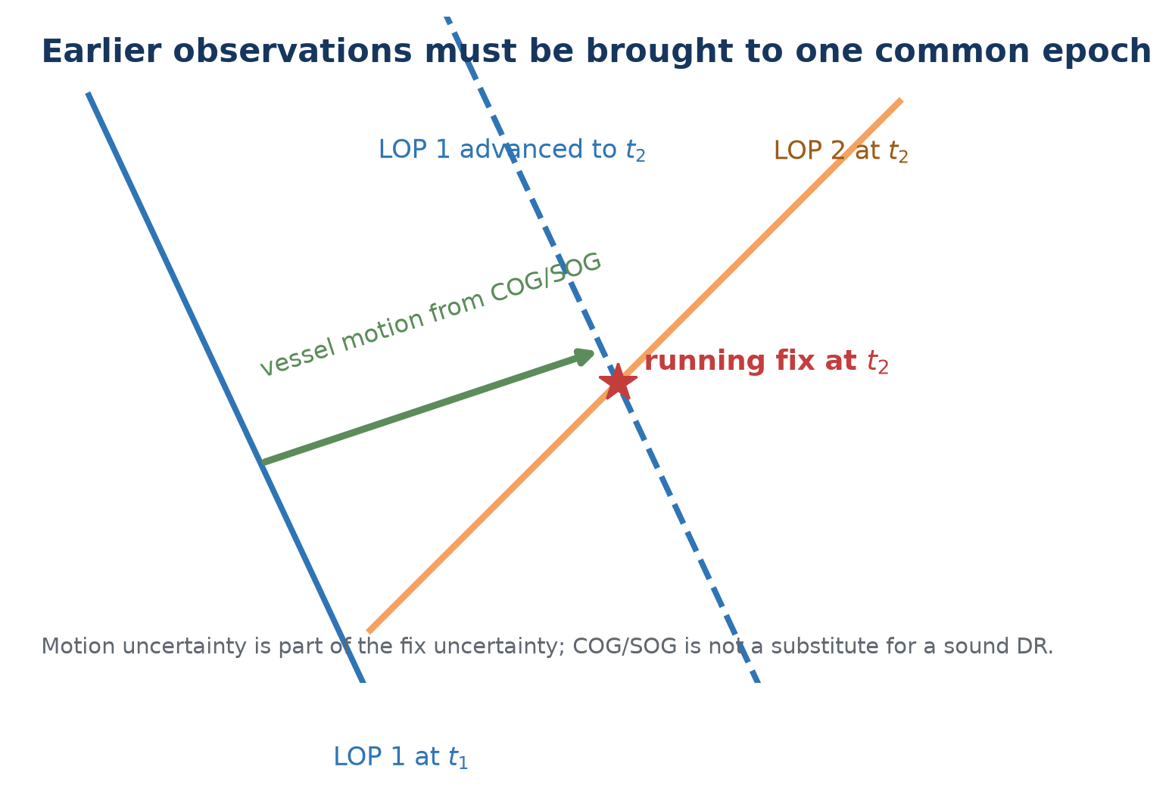 Figure 8. A numerical running fix advances the observation, not the celestial body, to a common vessel epoch.

10.1 Time-tagged numerical fix
- Preserve each observation's actual timestamp.
- Choose the fix reference epoch, normally the latest observation.
- Enter the best available true COG and SOG or equivalent displacement model.
- Solve, then examine residuals and whether the assumed motion was credible.
A long interval can improve azimuth crossing while increasing DR uncertainty. A morning-Sun/afternoon-Sun running fix is useful, but its precision depends as much on vessel motion as on the sextant observations.

11. Sight Sequence Analyzer, noon and Polaris

11.1 Sight Sequence Analyzer
Select the sights to display, open Analyze Sights…, choose whether to restrict analysis to the selected body, and set a stationary or moving observer model. The analyzer reports residuals, scatter, trend, possible outliers and estimated personal bias. A trend can indicate changing conditions, vessel motion, a systematic timing error or poor technique; it is not automatically a sextant error.

11.2 Local apparent noon
The planner predicts meridian passage. Around that time, observe a series of Sun altitudes and identify the maximum or fit the sequence. Enter the corrected Ho in Noon & Polaris → Sun at local apparent noon to solve latitude using declination and the meridian geometry. Noon primarily provides latitude; it is not by itself a normal two-dimensional fix.

11.3 Polaris latitude
Polaris is close to, but not exactly at, the north celestial pole. Select Polaris latitude, use a corrected Ho and the applicable time/position context. The helper applies the ephemeris rather than assuming that Ho equals latitude exactly. Polaris is a northern-hemisphere workflow.

12. Lunar distance, joint sequences and sextant checking
Lunar distance uses the Moon's rapid motion against the Sun, planets or stars as a celestial clock. The observed Moon-to-body angular distance is corrected (“cleared”) for limb, refraction and parallax, then compared with the geocentric ephemeris over a search interval.
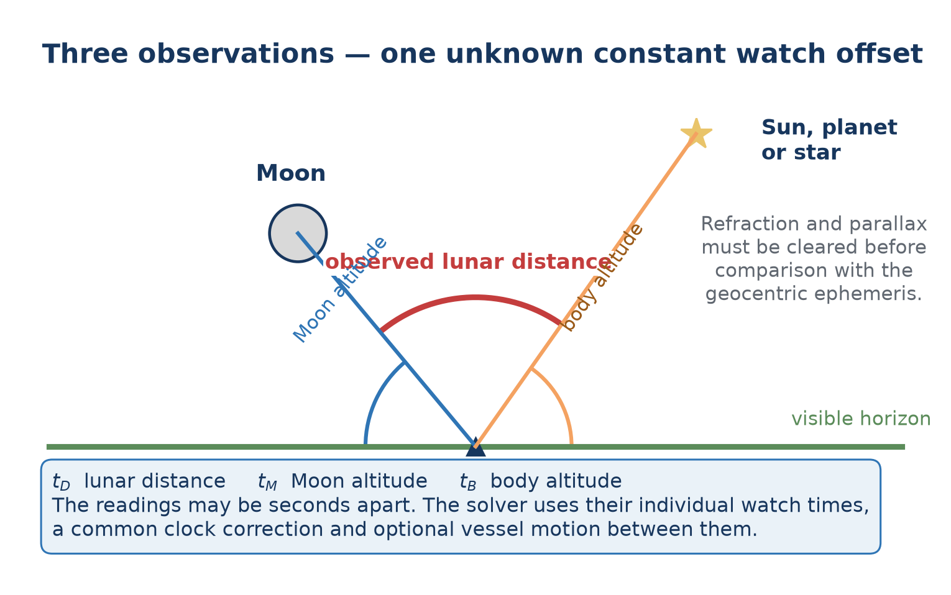 Figure 9. The three angles may be taken sequentially. Each retains its own watch time while sharing one unknown constant watch correction.

12.1 What to observe
- The lunar distance LDOpc from the selected Moon limb/contact to the second body.
- The Moon altitude above the horizon.
- The second-body altitude above the horizon.
- The watch time of every reading, plus index error, limb/contact and uncertainty.

12.2 Sequential observations
Enable The three angles have separate watch times when the readings were not simultaneous. The lunar-distance date/time is the reference epoch. Enter Moon-altitude and body-altitude watch times separately. Times near midnight are interpreted as the nearest occurrence within twelve hours of the reference reading.
If the vessel moved materially, enable Advance vessel between readings and enter true COG and SOG. The same unknown constant watch correction is applied to all three watch times; the intervals between them are preserved.

12.3 Solving
- Create a Lunar sight and select the second body.
- Enter LDOpc, near/centre/far contact and both body altitudes with correct limbs.
- Enter one time or enable separate times as actually observed.
- Set a plausible total UTC search span around the watch time.
- Select Time. Review all matching time candidates, clock correction, uncertainty and position candidates.
- Use rough DR, hemisphere, an additional altitude sight or independent evidence to select the physical solution.
Lunar accuracy is demanding. A lunar distance changes slowly enough that a small angular error can become a large time error. Sextant adjustment, side error, limb contact, refraction/parallax clearing and repeated observations matter substantially more than in an ordinary altitude sight.

12.4 Unknown UTC and longitude
The solver does not use the crude “15 degrees per hour” shortcut as a longitude answer. It searches clock correction and reference position jointly against the lunar distance and altitude constraints. More than one physical candidate can remain. Reported numerical convergence does not remove geometric ambiguity or observational uncertainty.

12.5 Joint lunar-sequence estimation
One lunar triple contains three measured angles and can solve three primary unknowns—constant watch correction, latitude and longitude—but it supplies almost no redundancy. Several timed triples are much more useful: one shared solution can reveal scatter, weak geometry, a competing time/position minimum or a reading that disagrees with the others.
- Save at least two complete Lunar sights. Use each sight's separate-time controls whenever the three angles were not simultaneous.
- Select Lunar Tools… → Lunar sequence and tick the observations belonging to one watch/session.
- Choose Recover time and position, or Recover time at known position for a clock check at a trustworthy position.
- Enter an initial/known position and a physically justified watch-correction search span. If the vessel moved over the session, enter true COG and SOG.
- Normally retain Robust fit. It reduces the leverage of a discrepant reading but still displays and flags every residual; it never deletes evidence.
- Solve, inspect all competitive candidates, angular and weighted RMS, formal uncertainties and every component residual before applying a watch correction.
The reported correction is additional to the correction already displayed by the plugin. Apply watch correction explicitly shows the resulting total and asks for confirmation. Raw watch timestamps remain in the observation record.
Do not select a pleasing minimum merely because it is numerical. A high condition number, large uncertainty, competitive alternate solution or residual beyond three stated standard uncertainties requires more evidence. The optional common residual index-bias parameter is an advanced diagnostic; with too few observations it can trade against clock correction and should not be treated as a sextant calibration.

12.6 Lunar pair planner
Lunar Tools… → Lunar planner ranks the offline body catalogue for a selected UTC and position. It displays Moon and body altitude, centre separation, distance rate in arcminutes per hour and the approximate time change corresponding to 0.1′ of distance. A small time value means useful time sensitivity. The quality text also penalises hidden/low bodies, awkward sextant angles, very unequal altitudes and faint stars.
The ranking is a planning aid, not a visibility guarantee. Cloud, Moon phase/glare, twilight, haze, telescope field, the chosen limb/contact and the observer's ability remain decisive. Recalculate at candidate times and choose a pair you can identify unambiguously.

12.7 Sextant observational checks and correction profiles
Lunar Tools… → Sextant check predicts the topocentric, refracted, apparent distance between two selected bodies for a stated UTC, position, pressure and temperature. Select centre-to-centre, near contact or far contact to match what was actually observed; limb contacts include the applicable semidiameters. Record repeated sextant readings, their uncertainty and any shade/note. The displayed correction is predicted minus observed: add it to the raw reading.
For checking scale or centering behaviour, prefer well-identified stars at similar, comfortable altitudes and away from the horizon. Star–star checks largely avoid limb and parallax ambiguity. Moon–star, Moon–planet and Sun/Moon pairs are valuable end-to-end checks, but incorrect UTC, position, limb choice or atmospheric conditions can masquerade as instrument error.
Build / save profile groups repeated checks by angular range and stores correction points, uncertainty, repeatability, instrument name and serial number in the plugin configuration. Select a saved profile to display its interpolated correction at the currently entered observed angle. Between tested angles the plugin uses straight-line interpolation; beyond the tested range it clearly marks the nearest endpoint rather than inventing a polynomial trend. The table is advisory and does not alter saved sights automatically, preserving the raw record and its provenance.
A computed profile is not mechanical adjustment. Follow the sextant maker's specified sequence—normally perpendicularity, side, collimation and index checks—before investigating graduation, centering or scale behaviour. A changing or irregular correction may indicate damage, technique, shades, temperature or an adjustment fault that software must not conceal.

13. Sunrise and sunset horizon events
The Horizon Event workflow records first upper-limb appearance at sunrise or final upper-limb disappearance at sunset. Timing gives an approximate altitude constraint. An optional bearing adds a rough directional constraint.
- Select sunrise or sunset and enter/capture the UTC date and time.
- Record time uncertainty and identify the time source.
- If a bearing was taken, select magnetic compass or true bearing.
- For a magnetic observation, enter magnetic variation and compass deviation using the displayed E+/W− convention.
- Enter bearing uncertainty, height of eye, pressure, temperature, horizon quality and horizon/refraction uncertainty.
- Read the estimated result and retain its stated limitations.
Without a sextant, the apparent instant is affected by waves, observer height, abnormal refraction, horizon definition, extinction, limb recognition and reaction time. A handheld magnetic bearing adds compass, variation and deviation errors. Treat the result as a broad constraint to combine with other evidence—not as a sextant-quality fix.

14. Coastal sextant methods
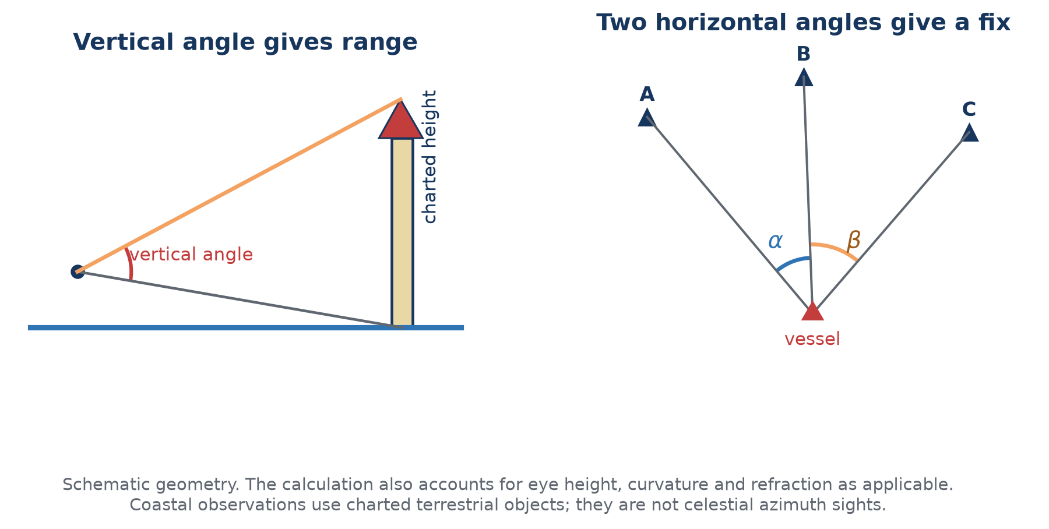 Figure 10. Coastal methods use charted terrestrial objects and different geometry from celestial altitude or azimuth sights.

14.1 Vertical angle and distance
Select Vertical angle / distance. Choose waterline-to-top when the object's waterline is visible or sea-horizon-to-top when it is beyond the horizon. Enter target coordinates, observed vertical angle, index error, charted top height, water level above the height datum and height of eye. Optionally add a corrected bearing observed at effectively the same epoch. Select Calculate and plot range.

14.2 Horizontal sextant angles
Select Horizontal angles / fix. Enter three charted objects in left–centre–right visual order and the included left-centre and centre-right angles. Enter uncertainty and an approximate vessel position to choose among ambiguous solutions. Select Solve and plot HSA fix.
If the two angles were taken sequentially while underway, enable Advance the vessel between the two HSA readings and enter the interval, true COG and SOG. This is distinct from the celestial Azimuth sight type.

15. Offline solar-eclipse planner
The eclipse planner is a separate specialist module within the plugin. It uses a locally imported JPL DE440s ephemeris to search events and calculate geometry without network access.

15.1 Data
- DE440s: required for eclipse searching, paths and local circumstances.
- Lunar orientation: optional orientation support for refined limb work.
- LOLA pack: optional lunar-topography refinement of contact timing; not required for ordinary eclipse use.

15.2 Find and plot an eclipse
- Open Eclipses… and confirm the data status.
- Choose search years (the UI intentionally limits searches to 2100) and select Find eclipses.
- Select an event. Enable the central line and totality/annularity limits and, if desired, partial-magnitude contours.
- Select Plot selected. Use Clear plot to remove overlays.
- For local circumstances, enter coordinates or use boat position, then select Calculate.
- Enable LOLA contact refinement only when the optional data is installed and its extra detail is wanted.
Local contact times are reported on the astronomical time basis stated in the dialog. Future UTC can differ because future leap seconds and Earth rotation cannot be known exactly years in advance. Eclipse planning is not a celestial-navigation fix.

16. Troubleshooting and validation
Symptom | Checks
No COP is visible | Confirm the eye icon is enabled; zoom out; check UTC/date, body, Hs and limb; increase plotted certainty temporarily; verify the circle is not far from the current viewport.
Hc or Zn is implausible | Check AP/DR latitude and longitude signs, UTC conversion, selected body, and whether “boat position” moved after the sight.
Intercept is enormous | Check degrees/minutes entry, west/east longitude, upper/lower limb, time zone/date rollover and double-applied clock correction.
Sunrise/sunset differs by about an hour | Distinguish UTC from local civil time and daylight-saving time. Verify the planner's independent entry-time and display-time selectors.
GNSS UTC unavailable | Confirm a valid NMEA RMC or ZDA sentence is reaching OpenCPN. The plugin does not infer GNSS time from position alone.
Chrony status unavailable | The computer may use another synchronisation service, chrony may not be installed, or its query interface may be unavailable. UTC display still uses the system clock.
Lunar solver finds several times | Narrow the search only when justified; check contact/limbs and altitudes; use DR/hemisphere or another sight to resolve candidates.
Lunar solution is unstable | Review distance and altitude uncertainties, sextant side/index error, body geometry, separate timestamps and vessel motion.
Joint lunar solution has alternates | Do not choose by RMS alone. Add observations with different bodies/geometry, narrow the time range only from independent evidence, and compare the candidate positions with DR or known hemisphere.
Joint lunar residual is flagged | Check transcription, contact/limb, individual timestamps, uncertainty and conditions. Robust mode retains the reading; investigate before excluding it from a new solution.
Sextant check predicts “unavailable” | One body is below the usable horizon, the bodies are identical, or the entered UTC/position is wrong. Select another pair/time and check UTC rather than local civil time.
Correction profile varies unexpectedly | Repeat the check, use similar-altitude star pairs, keep shades/technique identified, verify mechanical adjustment and compare only within the measured angular range.
Running fix is poor | Check the reference epoch, COG/SOG, set and drift, leeway, course alterations and observation geometry.
Eclipse controls unavailable | Import DE440s and recheck data status. LOLA is optional and should not block ordinary eclipse plotting.

16.1 Independent checks
- Compare selected almanac values with an official Nautical Almanac or USNO data for the same UT1/AP.
- At a known position, compare Ho with Hc and examine the residual rather than forcing agreement.
- Test time-zone handling at dates near midnight and daylight-saving transitions.
- Use synthetic test sights with known answers before relying on advanced lunar or running-fix workflows.
- Keep the raw observation record so any result can be reconstructed independently.

Appendix A — Abbreviations and symbols
Abbreviation | Expansion and use
A4 | International standard paper size used for the printable manual.
AP | Assumed Position.
BIPM | International Bureau of Weights and Measures; maintains international atomic time scales.
C1–C4 | First through fourth local eclipse contacts.
COG | Course Over Ground; use true degrees where the plugin says COG true.
COP | Circle of Position.
CSV | Comma-Separated Values file.
DE440 / DE440s | JPL Development Ephemeris 440 and its compact short-span kernel.
Dec, δ | Declination; celestial latitude north or south of the celestial equator.
DOCX | Office Open XML word-processing document; the editable contributor edition of this manual.
DR | Dead Reckoning (historically also “deduced reckoning”).
DUT1 | UT1 − UTC.
GHA | Greenwich Hour Angle.
GNSS | Global Navigation Satellite System.
GP | Geographic Position of a celestial body.
GPS | Global Positioning System; one GNSS constellation and a common shorthand for a satellite-derived position.
Ha | Apparent altitude after index and dip/horizon corrections.
Hc | Computed altitude at the AP.
Ho | Observed, fully corrected altitude.
HP | Horizontal parallax.
Hs | Sextant altitude.
HSA | Horizontal Sextant Angle.
HTML | HyperText Markup Language; the offline edition opened by the plugin's Documentation button.
IC | Index Correction.
IE | Index Error.
IERS | International Earth Rotation and Reference Systems Service.
JPL | Jet Propulsion Laboratory.
LAN | Local Apparent Noon.
LD / LDOpc | Lunar Distance / observed raw lunar-distance measurement with selected contact.
LDc | Cleared lunar distance.
LHA | Local Hour Angle.
LOLA | Lunar Orbiter Laser Altimeter.
LOP | Line of Position.
NMEA | National Marine Electronics Association; commonly refers to marine data sentence/protocol families.
NM | Nautical mile.
PA | Parallax in Altitude.
PCK | Planetary Constants Kernel used for body orientation data.
PDF | Portable Document Format; the fixed-layout display and printable edition of this manual.
RA | Right Ascension.
RMC | NMEA Recommended Minimum Navigation Information sentence.
RMS | Root Mean Square; a summary measure of residual size. It does not by itself establish that a solution is correct.
SD | Semidiameter.
SHA | Sidereal Hour Angle.
SOG | Speed Over Ground in knots.
TAI | International Atomic Time.
TT | Terrestrial Time, used in ephemeris calculations.
UI | User Interface.
USNO | United States Naval Observatory.
UT | Universal Time; use the specifically stated form where precision matters.
UT1 | Universal Time derived from Earth rotation.
UTC | Coordinated Universal Time.
WMM | World Magnetic Model.
ZD | Zone Description in traditional nautical time notation; do not confuse with zenith distance z.
ZDA | NMEA Time & Date sentence.
Zn | True azimuth, normally 000°–360° clockwise from true north.
z | Zenith distance, 90° − altitude.
ΔT | TT − UT1, required when relating dynamical ephemeris time to Earth rotation.

Appendix B — Glossary
Almanac
Tabulation or computation of celestial coordinates and supporting navigation data for stated times.
Altitude
Angular height of a body above the observer's horizon, measured along a vertical circle.
Apparent altitude (Ha)
In this manual, Hs after index and dip/horizon correction, before the main body/atmospheric corrections.
Artificial horizon
A reflecting horizontal surface used when no natural sea horizon is available. The observed angle is normally doubled by reflection geometry.
Assumed Position
A convenient position near the DR at which Hc and Zn are computed. It is a calculation origin, not a claim that the vessel is there.
Azimuth
Horizontal direction of a body. Zn is true azimuth clockwise from true north; a raw compass bearing is not Zn until corrected.
Back sight
A sextant observation made with geometry opposite the normal forward observation, requiring correct interpretation of the angle and horizon.
Calculated altitude (Hc)
The altitude predicted for the selected body, time and AP.
Celestial equator
Earth's equatorial plane extended to the celestial sphere.
Celestial sphere
A conceptual sphere on which directions to celestial bodies are represented. Distance to the body is irrelevant to the angular coordinate construction.
Centering error
Sextant arc error caused when the index-arm pivot is not exactly at the geometric centre of the graduated arc; it may vary with measured angle.
Chronometer / deck watch
A clock used to carry a known time reference. Rate stability and known error are more important than displaying an apparently exact value.
Circle of Equal Altitude
The locus of positions from which a body has the same corrected altitude at one instant; centred on the body's GP.
Circle of Position
Any circular position locus. An equal-altitude circle is the normal celestial COP.
Clearing a lunar distance
Converting the observed limb-to-limb/topocentric distance to the equivalent geocentric centre-to-centre angular distance by applying limb, refraction and parallax corrections.
Clock correction
The value applied to a displayed watch time to obtain the required reference time. State the sign convention; do not confuse it with “watch error.”
Collimation error
Sextant telescope/line-of-sight misalignment relative to the instrument plane. Correct it mechanically according to the maker's instructions.
Compass deviation
Error of the vessel's magnetic compass caused by the vessel and onboard fields. It varies with heading and installation.
Computed altitude
See Hc.
Correction profile
A documented set of angle-dependent corrections derived from repeated checks of one identified instrument. It supplements, and must not replace, proper mechanical adjustment.
Dead reckoning
Advancing a known position by courses and distances without using a new position observation. Set, drift and leeway must be considered separately or incorporated.
Declination
Angular distance north or south of the celestial equator. It is the latitude of the body's GP.
Dip
Angle between the observer's horizontal and the visible sea horizon, principally a function of height of eye and refraction.
Dip short
Horizon correction when the waterline used as a horizon is at a finite known distance.
Ephemeris
A table or numerical model giving celestial-body positions, and sometimes velocities, as functions of time.
Epoch
The stated instant to which a position, observation or running-fix line refers.
Fix
A position determined from two or more independent position constraints referred to a common epoch.
Geocentric
Referred to Earth's centre.
Geographic Position
The point on Earth where a celestial body is at the zenith at a stated instant.
Great circle
A circle on a sphere whose plane passes through the sphere's centre; the shortest surface route between non-antipodal points lies on one.
Greenwich Hour Angle
Angle measured westward from the Greenwich meridian to the body's hour circle, 0°–360°.
Height of eye
Observer's eye (effectively sextant telescope) height above the water surface used to calculate dip.
Horizon
The reference from which altitude is measured. Distinguish visible/sensible, celestial/true, artificial and finite-distance horizons.
Hour angle
Angular measure related to rotation from a reference meridian to a body's hour circle.
Index correction
The correction equal in magnitude and opposite in sign to index error.
Index error
Non-zero sextant reading when the index and horizon mirrors should indicate zero angle.
Intercept
Signed difference Ho − Hc. Plot its magnitude in NM towards the body if positive and away if negative.
Latitude
Angular distance north or south of Earth's equator.
Leeway
Sideways displacement through the water caused principally by wind; it can make heading differ from course through water.
Limb
Visible edge of the Sun or Moon. A semidiameter correction converts a limb observation to the centre as required.
Line of Position
A line on which the observer lies. In intercept sight reduction it is the local tangent approximation to the equal-altitude circle.
Local apparent noon
Instant when the apparent Sun crosses the observer's meridian, normally reaching its greatest altitude for that passage.
Local Hour Angle
Hour angle relative to the observer's local meridian, formed from GHA and longitude with the stated sign convention.
Longitude
Angular displacement east or west of the Greenwich meridian.
Lunar distance
Angular separation of the Moon from a selected Sun, planet or star, historically and computationally usable as a time reference.
Magnetic compass
A direction instrument aligned approximately with the local magnetic field; its reading requires deviation and variation corrections to obtain true bearing.
Magnetic variation
Angle between true north and magnetic north at a place and date. Also called magnetic declination; kept distinct here from celestial declination.
Meridian passage
Crossing of a body over the observer's meridian. Upper meridian passage is normally used for noon/maximum-altitude work.
Nautical mile
A distance of exactly 1,852 metres. One minute of arc along a great circle is one nautical mile by navigational convention to the working accuracy of ordinary plotting.
Observed altitude (Ho)
The corrected altitude used for comparison with Hc and for constructing the COP.
Parallax
Difference in apparent direction caused by observing from Earth's surface rather than its centre; large for the nearby Moon.
Personal bias
A repeatable tendency in an observer's sights. It must be established from sufficient independent data, not inferred from one sequence.
Polar distance
90° minus declination, a side of the navigational triangle.
Rate
The amount a watch gains or loses per unit time. A stable known rate allows its correction to be carried between checks.
Refraction
Atmospheric bending that raises the apparent position of a body, with the strongest and least predictable effects near the horizon.
Residual
Observed value minus the value predicted by a fitted solution, using the sign convention stated by the workflow.
Robust fit
An estimator that limits the leverage of discrepant data while retaining them for inspection; it is not permission to ignore an outlier's cause.
Running fix
A fix combining observations made at different times after advancing them by estimated vessel motion to a common epoch.
Scale error
Angle-dependent sextant reading error associated with graduation, centering or scale geometry after ordinary adjustments have been made.
Semidiameter
Apparent angular radius of an extended body such as Sun or Moon.
Set and drift
Direction towards which a current carries the vessel and the current's speed; together they contribute to motion over the ground.
Sextant altitude (Hs)
The angle read directly from the sextant before navigational corrections.
Sidereal Hour Angle
Angle measured westward from Aries to a star's hour circle; approximately constant for a catalogued star over short periods.
Sight reduction
Conversion of a timed sextant observation and almanac data into a COP/LOP, intercept and azimuth.
Small circle
A circle on a sphere whose plane does not pass through the centre. A non-degenerate Circle of Equal Altitude is a small circle.
Spherical triangle
A triangle on a sphere bounded by three great-circle arcs; celestial sight reduction uses the pole–observer–body triangle.
Topocentric
Referred to the observer's actual position on or near Earth's surface.
Twilight
Period when the horizon and suitable bodies may both be visible. Civil, nautical and astronomical twilight use different Sun-altitude thresholds.
Vertical circle
Great circle of the celestial sphere through the zenith and nadir. Altitude is measured along it.
Visible horizon
The apparent boundary between sea and sky used by a marine sextant; it is depressed below the observer's horizontal by dip.
Watch error
Difference between watch indication and reference time. Always state whether “fast” or “slow” and how the correction is applied.
Zenith
Direction directly above the observer, opposite the local gravity direction.
Zenith distance
Angular distance from zenith to body, z = 90° − altitude.

Appendix C — Formulae and sign conventions

C.1 Core relationships
z = 90° − Ho
a (NM) = Ho (minutes) − Hc (minutes)
sin Hc = sin φ sin δ + cos φ cos δ cos LHA

C.2 Position signs
- Latitude: north positive, south negative when decimal signs are used.
- Longitude in plugin decimal fields: east positive, west negative unless a field explicitly accepts hemisphere notation.
- Declination: north positive, south negative in formula form.
- Azimuth Zn: 000°–360° clockwise from true north.

C.3 Magnetic conversion fields
The Horizon Event and coastal bearing workflows display their convention: variation and deviation use east positive / west negative. Enter the raw compass observation only in a field labelled magnetic compass, then allow the workflow to display the effective true bearing. Do not pre-correct a bearing and also enter the same corrections.

C.4 Time scales
Scale | Role
UTC | Civil time used for observation records; discontinuous from TAI by an integer number of leap seconds.
UT1 | Earth-rotation time used for hour angle and stated eclipse circumstances.
TT | Uniform terrestrial time used for ephemerides.
ΔT | TT − UT1; modelled for future epochs when no observed value exists.

Appendix D — References and provenance
The manual's diagrams are original deterministic drawings generated from explicit geometry in docs/v2/generate_diagrams.py. They were checked against the coordinate definitions and sight-reduction geometry in the following primary or authoritative references. Online examples were used for comparison, not copied.
- National Geospatial-Intelligence Agency, Pub. No. 9, The American Practical Navigator (Bowditch), 2019/maintained digital edition, especially Chapters 14–20. https://msi.nga.mil/Publications/APN
- United States Naval Observatory, Celestial Navigation Data for Assumed Position and Time. https://aa.usno.navy.mil/data/celnav
- United States Naval Observatory, Computing Altitude and Azimuth from Greenwich Apparent Sidereal Time. https://aa.usno.navy.mil/faq/alt_az
- USNO and HM Nautical Almanac Office, The Nautical Almanac. https://aa.usno.navy.mil/publications/na
- His Majesty's Nautical Almanac Office, overview and astronomical navigation services. https://www.gov.uk/government/organisations/hm-nautical-almanac-office/about
- OpenCPN Celestial Navigation plugin source and automated regression tests in this repository.
This v2 manual is intended for contributor review. Corrections to navigation practice, notation, workflow or presentation are welcomed. The HTML, editable DOCX and printable PDF should always be generated from the same reviewed source revision.

