**Using string templates**

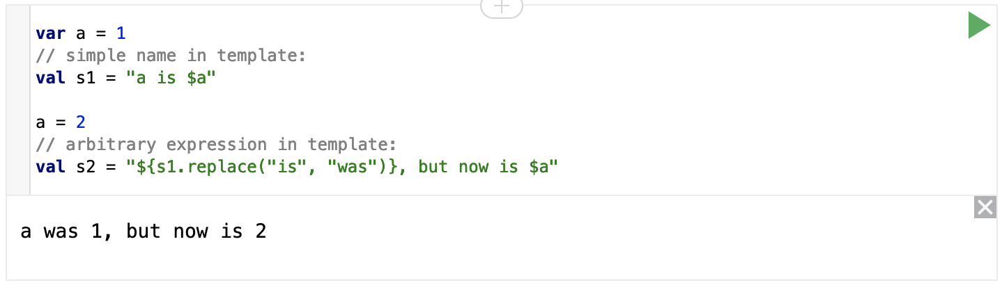

**Using conditional expressions**

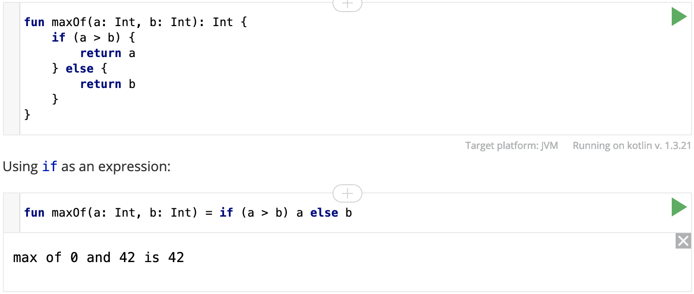

**Constructors**

A class in Kotlin can have a primary constructor and one or more secondary constructors.

* **Primary Constructors**

The primary constructor is part of the class header: it goes after the class name.

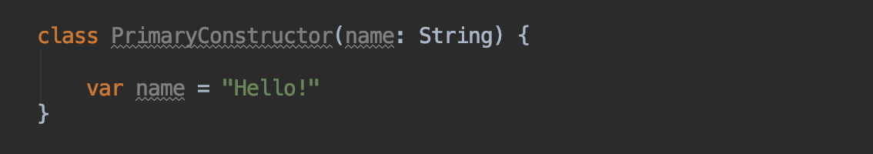

* **Secondary Constructors**

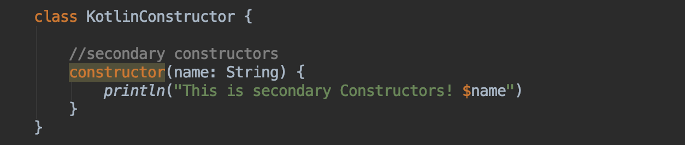

**Note**: The primary constructor cannot contain any code. Initialization code can be placed in **initializer blocks.** During an instance initialization, the initializer blocks are executed in the same order as they appear in the class body

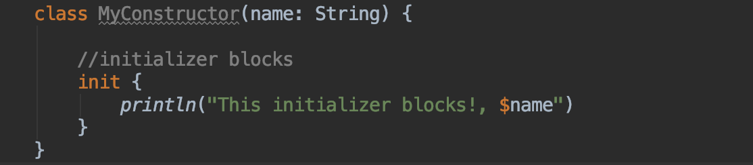

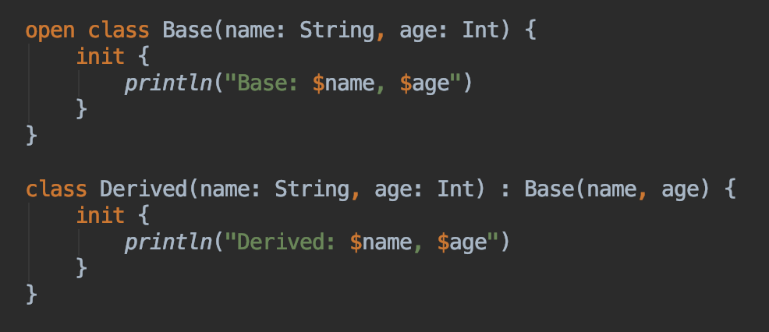

**Any** is not java.lang.Object; in particular, it does not have any members other than equals(), hashCode() and toString().

**Using sequences and Creating sequences**

**Sequences** enable you to easily operate upon collections of elements by chaining pure function, a concept quite similar to Java 8 Streams.

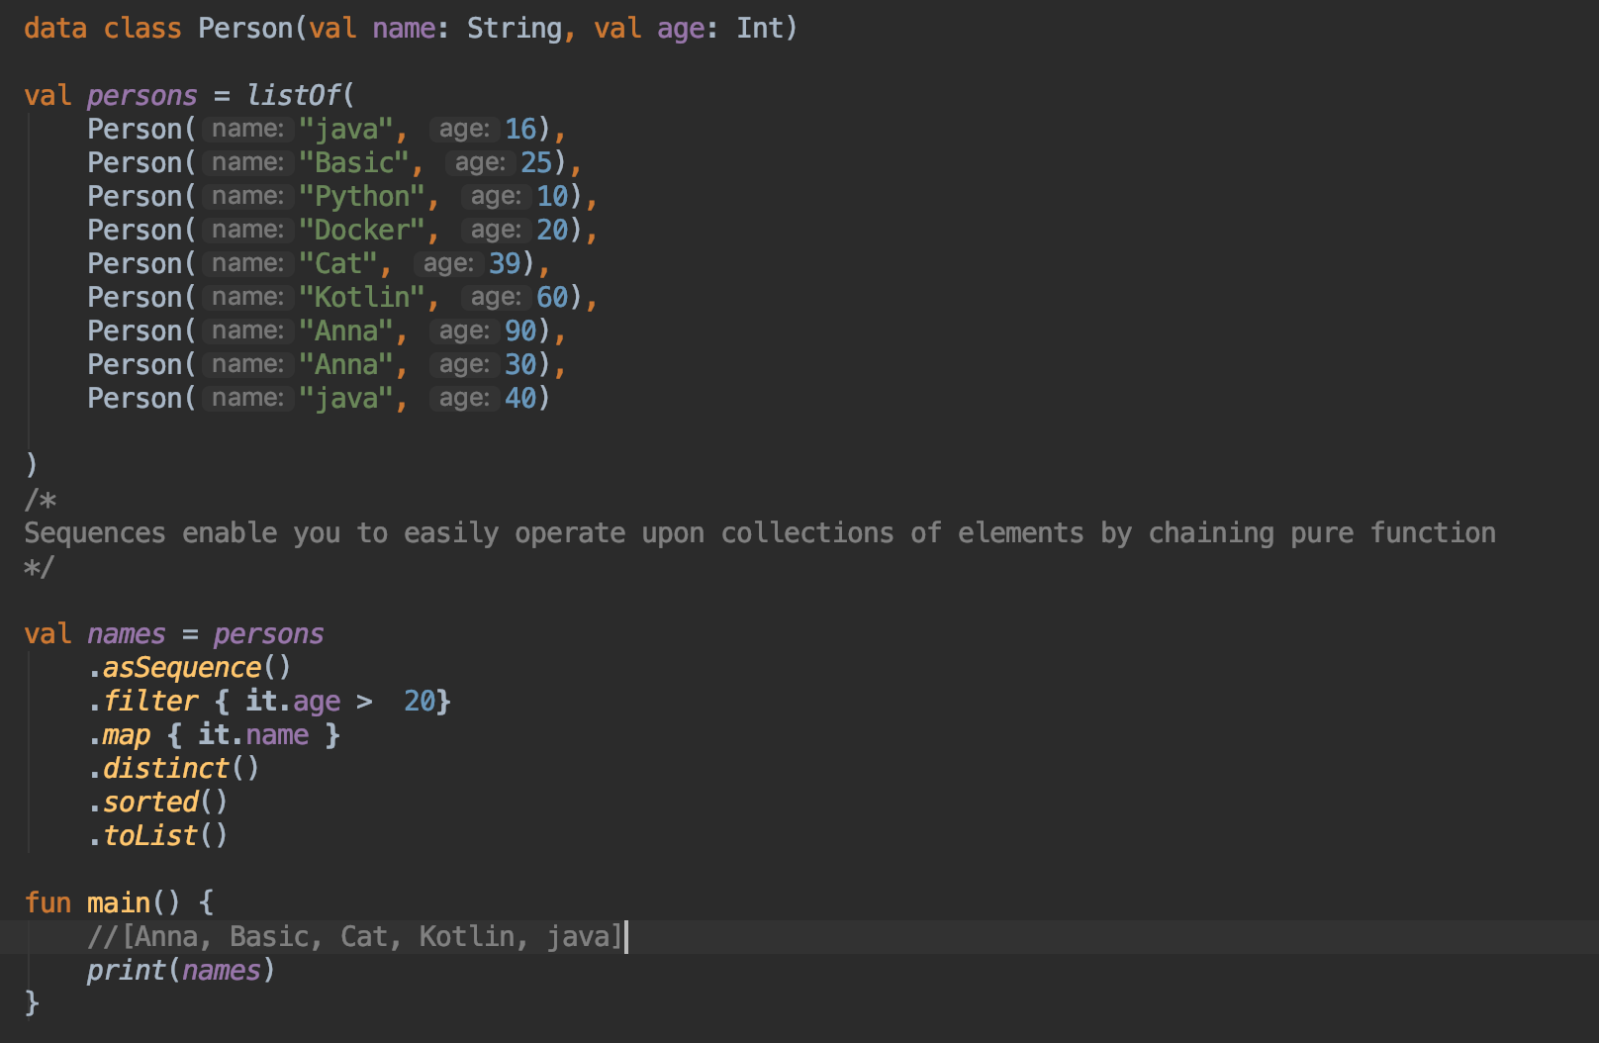

**Sequences** can be created in various different ways. The most common usecase is to create a sequence from a collection of elements by calling the method asSequence

