var otherName : String?

otherName = null *//set up for building a jar file*

How you can write a function

Understanding and Creating Classes in Kotlin

Building a RESTful Web Service with Gradle structure in IntelliJ (In a Gradle build file)

*//set up for building a jar file*apply **plugin**: **'war'**bootWar {  
 baseName = **'KotlinH2API'** version = **'0.1.0'**}  
*//set up for building a war file*bootWar {  
 baseName = **'KotlinH2API'** version = **'0.1.0'**}

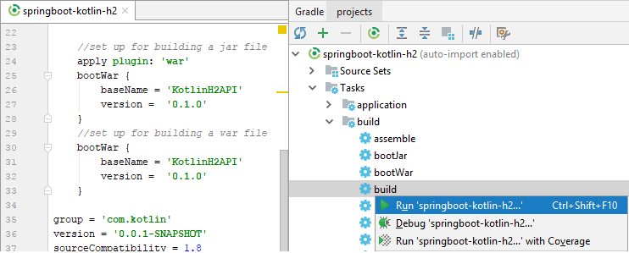

Creating a

