AWS Identity Access management Users Creation

|  |  |  |
| --- | --- | --- |
| Title | Group | Effective date |
| Procedure Providing the user access to new members | Cloud Infra Team | 24/12/2020 |

Purpose :-

To create the users to accessing the AWS account to give their permissions what they need to work.

Scope

Users to accessing the AWS Account with their work environment

References

AWS Documents

<https://docs.aws.amazon.com/iam/>

Definitions

Introduces you to AWS Identity and Access Management, helps you set up users and groups, and shows you how to protect your resources with access control policies. Also shows how to connect to other identity services to grant external users access to your AWS resources.

Roles and responsibilities

Describes the API operations for IAM Access Analyser. Also provides sample requests, responses, and errors for the supported web services protocols.

Team Members are

|  |  |
| --- | --- |
| Name | Mail |
| S.Mahender | [mahi1263@gmail.com](mailto:mahi1263@gmail.com) |
| K.KamalanadhaReddy | Kallitlakamal995@gmail.com |
| Y.NageshwarReddy | [yarrakondaka@gmail.com](mailto:yarrakondaka@gmail.com) |

Creating the User and giving the permissions

Go to the IAM service it’s under the Security, Identity, & Compliance

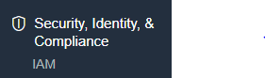

1. We need to login through AWS credentials then its go the IAM dashboard

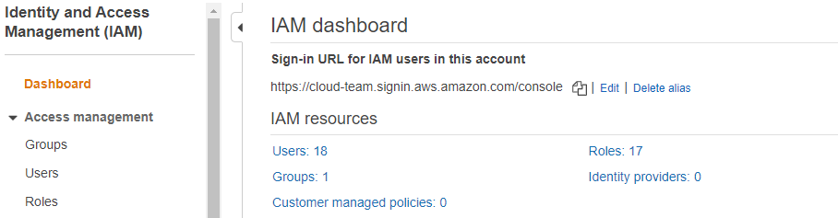

1. Under the IAM dashboard select the users

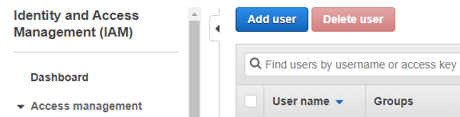

1. Under the users tab we have add user go to the add users and perfom below checks

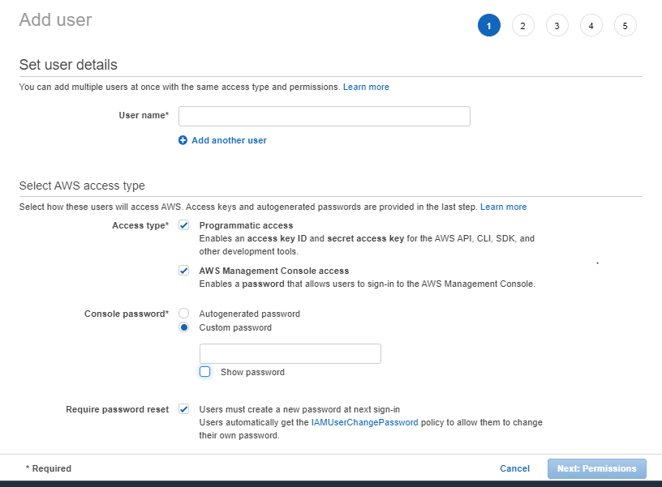

1. Give the details and permissions to the user to login credentials.
2. Add the group, if the user under the team member adding the group. With the group permissions.

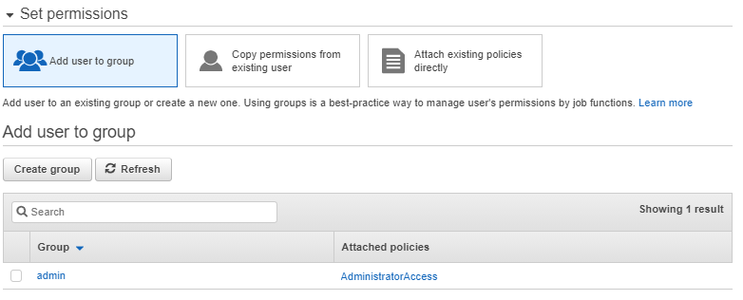

1. If you want to copy permissions from existing user.

Then do the process.

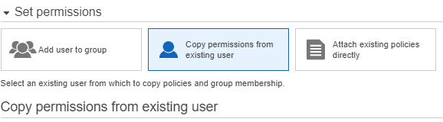

1. If the user not under the group then give them to separate policies.

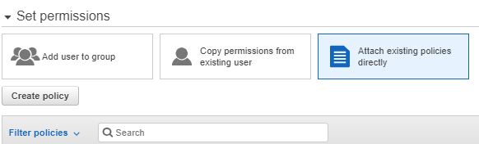

1. Add the tags for the user.

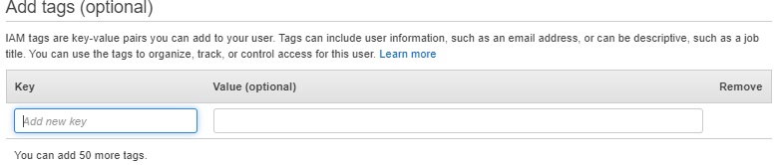

1. At finally we check the user review screen what we given to them like permission etc…

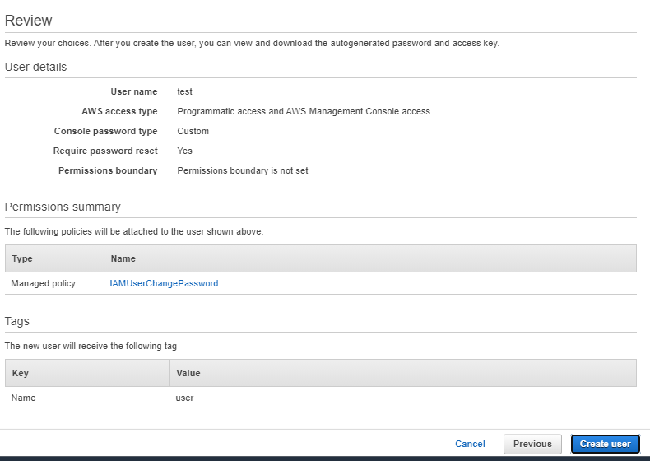

Over the creation of the users and giving and give them to login credentials

Once we given the credentials to the user then they login to the use the link

<https://signin.aws.amazon.com/signin?redirect_uri=https%3A%2F%2Fconsole.aws.amazon.com%2Fconsole%2Fhome%3Fstate%3DhashArgs%2523%26isauthcode%3Dtrue&client_id=arn%3Aaws%3Aiam%3A%3A015428540659%3Auser%2Fhomepage&forceMobileApp=0&code_challenge=WbqCQJTWQYowFKsBFIPCO7OUCMQ2b874tJ97qQVY6dc&code_challenge_method=SHA-256>

For the user Login use the IAM user option

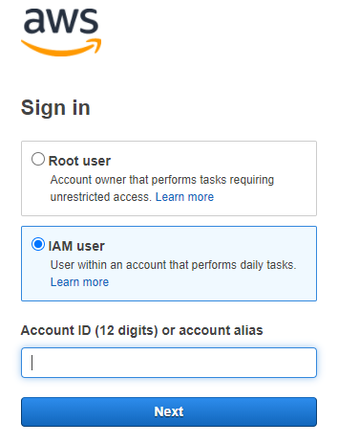

For the login use the credentials like the

**Sing in as IAM user**

* **Account ID (12 digits) or account alias**
* **IAM user name**
* **password**

