**Setup**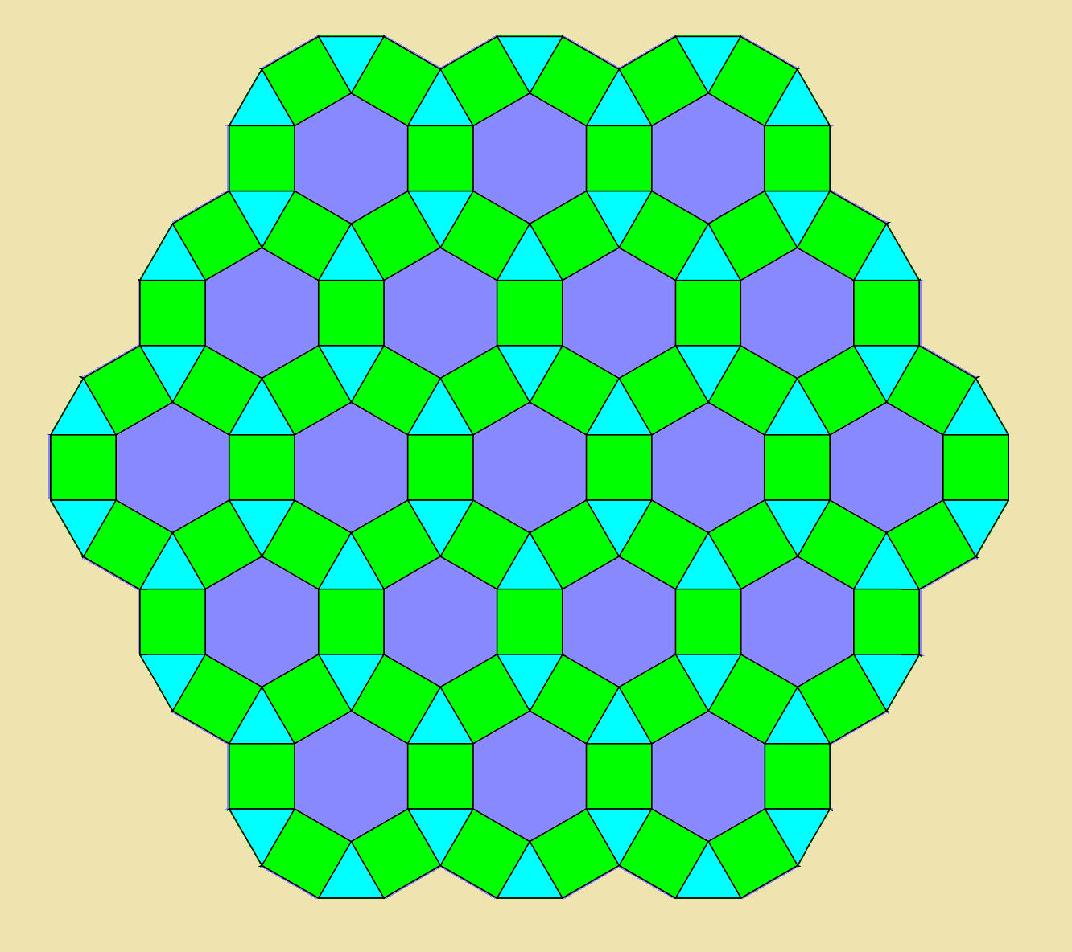

The game is played on this board. Each player starts on one of the four corners, and begins with a total of 6 resource tiles: one hex, along with the adjacent 3 squares and 2 triangles closest to the edge of the board.

**Gameplay**

On every turn, a player takes the following actions:

* Roll to determine which tiles generate resources
* Trade resources with other players
* Build and explore

**Rolling for resources**

At the start of a player’s turn, he/she rolls a D12 and a D6 to determine what shapes of tiles and what specific resource will generate, respectively. All resource tiles of that type will generate that resource that turn, and every player who has settled a tile of that type will collect that resource, i.e. all squares that produce food will produce food on that turn.

Use these charts to determine what dice rolls will generate which resources:

**Rolling the D12**

|  |  |
| --- | --- |
| Tile Type | Die Roll to Generate Resources |
| Hex | 8-12 |
| Square | 4-7 |
| Triangle | 1-3 |

**Rolling the D6**

|  |  |
| --- | --- |
| Resource Type | Die Roll to Generate |
| Food | 1 |
| Wood | 2 |
| Stone | 3 |
| Metal | 4 |
| Livestock | 5 |
| All Resources | 6 |

**Trading resources**

On a player’s turn, they may offer to trade any resource with any other player. They cannot force a trade with another player, however, 4 of a single type of resource may be exchanged for 1 of another type.

**Building and exploring**

Once resources have been collected on a turn, the player may use their resources to develop their civilization. A player may explore adjacent unclaimed territories, i.e. no player controls them, or build on their own explored territories. A player can then upgrade an explored territory to a settlement, and a settlement to a city. Developing territories has different costs depending on the tile type: triangles are the cheapest but least likely to produce resources, hexes are the most expensive but most reliable, and squares are a balance in the middle. A player may also spend their resources to pass the Inner Gate.

**Inner Gate**

Just before the inner circle of hex tiles, there is an Inner Gate. A player may not explore or build on these tiles or anywhere else within this line until he or she pays a tribute of 1 of each resource type. Each player only needs to pay the tribute once in the game, and then the player is open to everywhere within the inner gate for the duration of the game.

**Ending the Game**

The game ends when a player is no longer able to explore any resource tiles, since all unexplored territories are either claimed or barred to them because they cannot afford to pay the Inner Gate tribute. At this point, each player takes one final turn before Civilization Points are counted. Civilization Points are earned based on how many territories a player has explored, settled and upgraded to cities. Points are counted as such:

* Each tile that a player controls, i.e. has explored, grants 1 Civilization Point
* Each tile that has been upgraded to a settlement grants 1 additional Civilization Point, for a total of 2 for the tile.
* Each tile that has been upgraded to a city grants 1 additional Civilization Point, for a total of 3 for the tile.
* Paying the Inner Gate tribute grants 1 Civilization Point

The player with the most Civilization Points wins the game.