Mov1lab
Technical Design Document
TABLE OF CONTENTS
1 Introduction 1
2 Components 2
3 Application description and configuration 3
3.1 Hl7Converter 3
3.2 MiddleMan 4
4 System Design 5
4.1 Design Method and Standards 5
4.2 Documentation Standards 7
4.3 Naming conventions 7
4.4 Programming Standards 7
4.5 Software development tools 8
4.6 Outstanding Issues 8
4.7 Decomposition Description 8
5 Component Description 9
5.1 Component Identifier 10
6 Software Requirements Traceability Matrix 13

Introduction
This document provides a description of the different components that form part of the move1lab system and different configuration steps that need to be taken into account to install the application.
The first part of this document will show in a graphic way all the components that form part of the system.
The second part will describe each application and how to configure them.
The last part will show some possible problems and how to solve them.

Components
Mov1Lab is composed by 3 applications:
- Hl7Converter: this is an application made in c# and his main responsibility is receive the messages sent by cobas 1000, transform them in an appropriate way to send them later to the client through another application, called “middleman”. In the code repository this application can be found in source->HL7ConverterServer.
- MiddleMan: this application is responsible of getting the messages sent by HL7Converter and sends them to the client. The application communicates with HL7Converter through TCP and with the client through HTTP. In the code repository this application can be found in source->messageSender.
- Client: also known as mov1lab, this is the web client application. His only responsibility is to show the messages to the users. The application only communicates with the middleman. For the client to be able to see all the messages first he has to login into the application. If he has a valid user, he will access the system and see al the messages. In the code repository this application can be found in source->mov1lab.
In a graphic way, all the components can be think like the following graphic:

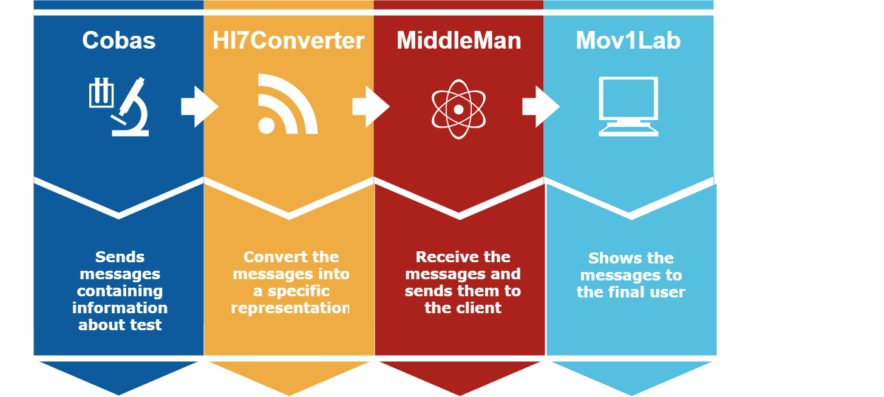

Application description and configuration

Hl7Converter
This application is compose by two classes:
- Program.cs: is the class containing the main method, and the method responsible to get the message sent by cobas.
Once the message is received the method “ConvertMessage” is invoked. This method will call the method responsible for transforming the message into a form that will later be interpreted by the middleman.
Most converted message will have the form:
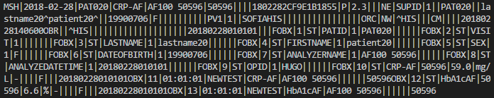
After transforming the message, the method “SendMessage” is invoked, and it is sent to the middleman.
- HL7Converter: this class contains the method responsible of formating the message. When the “ConvertMessage” is invoked, it calls the static method “ConvertToXml” who will format the message in the appropiate way and return it.
For the message to be sent to the middleman, his location needs to be know by the application. The ip and port used to establis the comunication can be found in the App.config file.
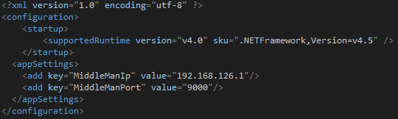
If the middleman if moved to another computer or server, the HL7Converter needs to know his location, and to do that, the values of the MiddleManIp and MiddleManPort needs to be fixed

MiddleMan
This application contains one principal script called app.js. This script will receive the message from the HL7Converter and send it to the client. We could think of the middleman like a server application, and the HL7Converter and client, are clients applications.

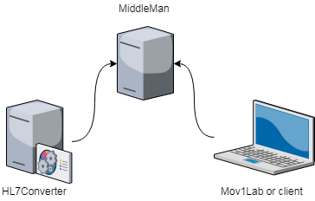
For the middleman to work properly two main things need to be configured:
- The port where he will listen for messages coming from cobas. By default the port 9000 has being established. If this need to be changed remember to change it also in the HL7Converter config file.

/**
* Default port to listen for messages coming from cobas
*/
const Port = 9000;

- The port where the middleman is going to send messages to the client. By default the port 3006 has being stablished.

/**
* Listen for new client connections on port 3006.
*/
http.listen(3006, function(){
console.log('listening on *:3006');
});

The middleman needs to be aware if the HL7Converter and the clients are alive. In order to do so, the HL7Converter emits a heartbeat (a particular message ) and every time the middleman hears it, it store in a variable the exact time when it was receive.

if(mensaje == 'Ping')
{
lastTimeHeartBeatWasReceived = new Date();
console.log(lastTimeHeartBeatWasReceived);
console.log('Hl7Converter is alive');
}

Every 10 seconds a method is executed automatically to check when was the last time a heartbeat was received, if more than 20 seconds have passed we can consider that the HL7Converter is down and needs to be restarted.

/**
* This method gets executed every 10 seconds to check when was
* the last time that a heartbeat was received. If the interval
* of time is bigger than 20 seconds, we asume the server is
* down.
*/
setInterval(function(){
var now = new Date();
var timeSinceLastHeartBeatReceived = now - lastTimeHeartBeatWasReceived
if(timeSinceLastHeartBeatReceived > 20000)
{
console.log('Server down!');
io.emit('disconnect');
}
},10000);

The client knows that the middleman in alive because a ping interval is set.

/**
* Used to signal the client that the middleman is alive
*/
var io = require('socket.io')(http,{pingInterval: 1000, pingTimeout:5000});

All this information is used to set proper connection status icon in the footer of the client.

Mov1Lab or client

The client application contains several archives and the file structure looks like this:

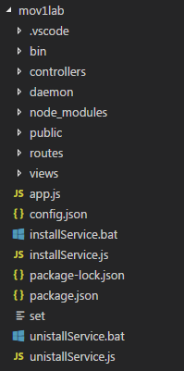

- The controller folder contains the controller of the login view. Its where the username and password of the user are validated. If everything is correct, the system will redirect the user to the message view, if not, a proper message will appear indicating the user what went wrong. The username and password needed to access the system can be found in the file “config.json”.
- The daemon folder is created automatically by the application installer. Is where all the needed files are going to be located when the service is installed. This folder doesn’t contain any code.
- The node_modules folder contains all the references needed by the project.
- The public folder contains the images, JavaScript and stylesheets used by the application. It has the following structure
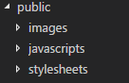
In the javascripts folder the most important scrip of the application is located. The “messageReceiver” script is the responsible for getting the messages sent by the middleman. Once a message is received it is parsed to get the parts that will be show to the user, a new row is added to the table of the view and the data is filled into it.
The method responsible of parsing the message is “parseHl7message”.

function parseHl7message(msg) {
var splitMsg = msg.split("|");
return {
Datetime: splitMsg[DatetimePosition] == '' ? "-" : splitMsg[DatetimePosition],
Patient: hidePatientId(splitMsg[PatientPosition] == '' ? "-" : splitMsg[PatientPosition]),
Test: splitMsg[TestPosition] == '' ? "-" : splitMsg[TestPosition],
Instrument: splitMsg[InstrumentPosition] == '' ? "-" : splitMsg[InstrumentPosition],
Serial: splitMsg[SerialPosition] == '' ? "-" : splitMsg[SerialPosition]
};
};

If for any reason the message doesn’t have the part that is being searched, the application will automatically put a “-“ in the proper cell.
We know the exact position of the parts that need to be shown to the user because we know the configuration of cobas and how the messages get form.
This is very important to understand, how cobas gets configured can affect the way the data is display. To simplify this, make sure cobas is configured like so

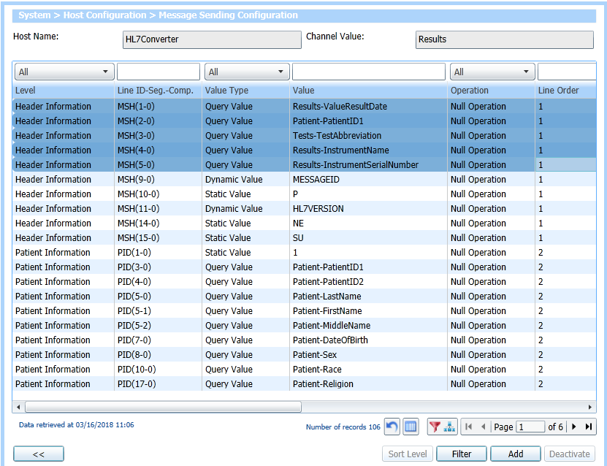

Make sure all the messages configured in your system contains the first five values (the ones highlighted in blue) configured exactly like in the image. If your configuration is different, the messages could be displayed in the wrong form.

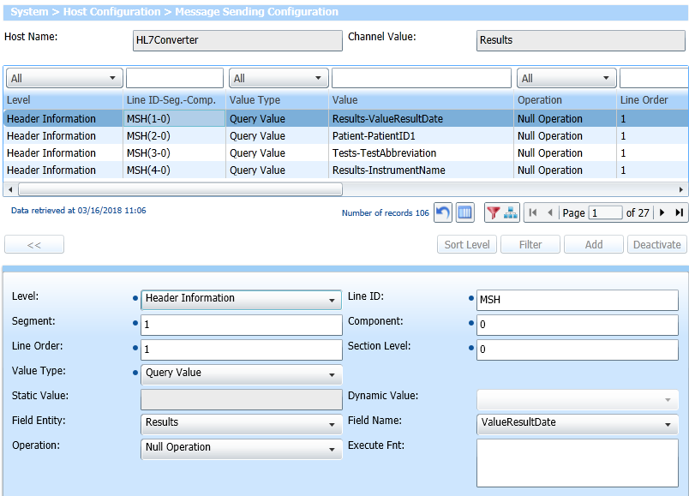
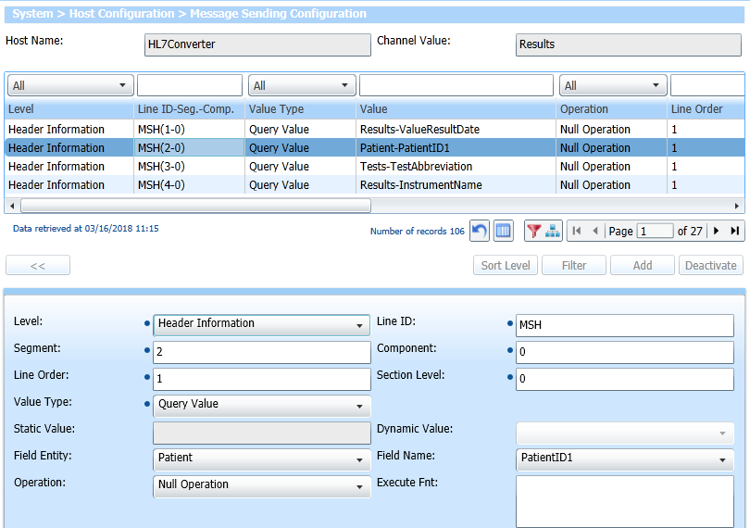
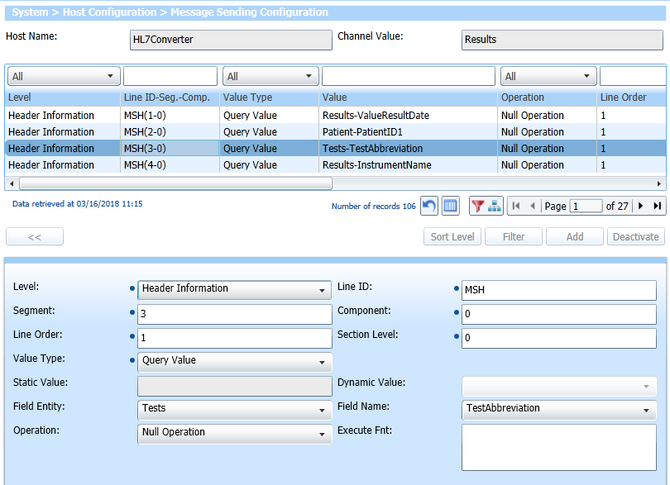
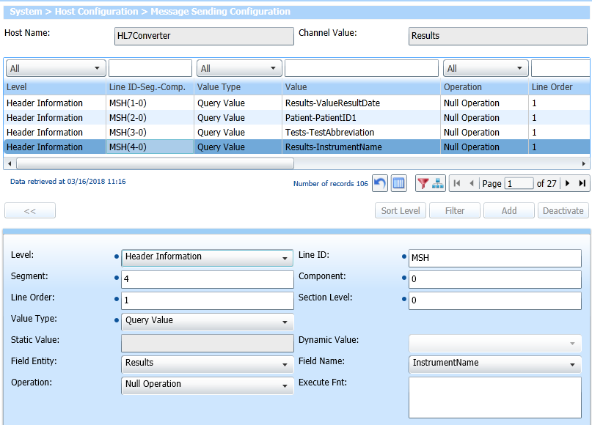
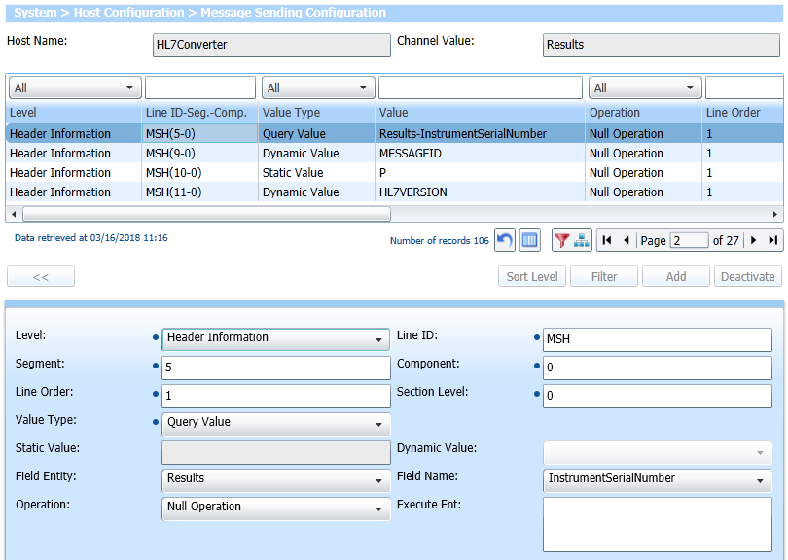

The client knows where to find the values in the message because in the “messageReceiver” we can specify this in a set of variables

const DatetimePosition = 1;
const PatientPosition = 2;
const TestPosition = 3;
const InstrumentPosition = 4;
const SerialPosition = 5;

If for any reason you need to change the messages configuration, remember to change this values in the client application.
The application will only show 20 messages and it will show the newest message on top of the list. If you want to change the amount of messages displayed on the screen you need to change the value of the variable “MaxRows”

const MaxRows = 20;
- The routes folder contains the routers. This files indicates how the application responds to a user request.
- The views folder contains all the views of the system

System Design
- This and the following section should provide sufficient information for a developer to produce the system. The detailed content will depend upon the approach to the design process that is to be used.
- According to one source there are over 30 different object design methodologies and notations of which UML is perhaps the best known.
- If the project is to follow the traditional waterfall approach, its documentation will differ from a development approach based on RAD or DSDM. Moreover, an OOD based philosophy for the design using UML would be different from one based on another design methodology such as SSADM or Yourdon. Depending upon the approach to be taken the software may be produced using coding statements or it may be automatically generated by an application development tool or a mixture of both.
- For the example presented in the rest of this section we will assume that new IDA projects move towards the use of UML and OOD based methodologies. One goal of OOD is to create a collection of reusable software objects that can be reused across other IDA projects, in effect offering some significant savings in development costs. With the proposal to create a IDA Reference Architecture a central library of objects could be reused across projects that have similar aims and objectives ‘to collect information’ but whose application areas (health, tourism, employment, environment, Customs, etc) vary.

Design Method and Standards
- The design method used should be named and referenced. A brief description may be added to aid readers not familiar with the method. Any deviations and extensions of the method should be explained and justified.
- In this paper we give an example of how client-server technologies can be developed on the basis of a given design paradigm that enables web technologies to be applied to IDA projects offering ease of maintenance and savings in life cycle costs.
- The design standard might need to be different if more than one method or programming language is involved: for example, if some Javascript design and programming takes place in an HTML project.
- IDA projects are vulnerable to legislative and political change. For example, an agreement might be reached to focus upon a specific health issue across Europe – where concerted action may be agreed – but which requires the data being collected to change. A key feature of moving towards an OOD-based approach is that it facilitates system change.
- A key feature of the design process is to attempt to isolate the various ‘layers’ that make up the overall architecture to ensure that changes in one layer have a minimal effect upon other layers in the system, such as for example in the business layer.
- In following an OOD-based approach it is vital that the design process is able to discriminate between ‘objects’ and ‘classes’. An ‘object’ is a specific instance, containing a set of data and the methods to process the data. A ‘class’ is a generalised description of a group of objects that have the same data item(s) and method organisation.
- In designing objects there are four important ‘cardinal points’ to be remembered. These are:
          - attributes – what the object knows
          - methods – what the object does
          - states – the changes that occur due to process flow
          - events – responses to the outside world.
- Object definitions should be annotated with these items. This will provide the beginnings of a detailed specification document. In addition, each object should be put into a UML diagram set, as this helps summarise the information into small, tight representations of each object in a standard format – there are nine UML diagrams as referenced in Section 1.3. In the course of the process the diagrams will be transformed into a class diagram that represents the relationship between the objects – in effect a blueprint for the structure of the business objects.
- One area where careful attention to design can reap rewards in the longer term is in the interface between the client and the so-called presentation layer. From its earliest inception in projects using the Smalltalk language the Model View Controller (MVC) paradigm has been one of the most implemented solutions in client-server computing. In implementations based on web technologies, such as JavaServer Pages (JSP) there is much to be gained from separating out elements of the application server architecture. One approach to this is given in an implementation of the MVC paradigm using Servlets or JavaServer Pages.
- For example, a Servlet (a Java class that operates on the server side to generate output in response to a client request) could be viewed as a ‘controller’ that is responsible for processing the request from the client – we may assume this request arrives in HTTP or HTTP (S) format. The ‘model’ is the representation of the data stored in the database or persistence store and the ‘view’ is the code that decides what to display next in response to the output from the controller. This is described here to encourage readers to look at the MVC paradigm as an example of a way to break out the components of the client-server architecture into building blocks that can be easily modified and maintained, and gain the benefits from an OOD-based approach to the design of the system.

Documentation Standards
- For a software implementation, this section should contain the standard module header (if necessary) and contain instructions for its completion. In addition this section should define or reference guidelines on the ration of lines of code to comment statements. It may be that these rules highlight specific areas of code where the commentary should be literally line-by-line, as this is a particularly difficult area. Other areas, which may be less difficult, could be commented on a ratio of five lines of code to one line of commentary.

Naming conventions
- This section should explain all naming conventions used, and draw attention to any points a maintenance programmer would not expect. A table of the file types and the permitted names or extensions for each is recommended for quick reference.
- Conventions for naming files, programs, modules, and possibly other structures such as variables and messages, should all be documented here.

Programming Standards
- This section should define the project programming standards. Whatever languages or standards are chosen, the aim should be to create a convenient and easily usable method for writing good-quality software. If an application development tool is used there may be other conventions that need to be defined, e.g. colour schemes.
- When programming in any new language, a standard for its use should be written to provide guidance for programmers. This standard may be referenced or included here.
- Where there are external interfaces, the programming standards for the interfaces required should be referenced.
- In general, the programming standard should define a consistent and uniform programming style. Specific points to cover are:
          - modularity and structuring;
          - headers and commenting;
          - indenting and layout;
          - library routines to be used;
          - language constructs to use;
          - language constructs to avoid.

Software development tools
- This section should list the tools chosen to assist software development, including testing. The actual software chosen will be heavily dependent upon the language in which the system will be implemented.
- The list may include:
          - an application development too;
          - a configuration manager / builder;
          - HTML authoring tools;
          - a word processor for documentation;
          - a tool for drawing diagrams;
          - automated testing tools.
- Prototyping projects might make use of an interpretative tool, such as an incremental compiler/interpreter/debugger.
- External interfaces may require some of the modules to be pre-compiled.

Outstanding Issues
- Provide details of any design issues that remain unresolved at the date of issue of this document. Explain options, pros and cons, and give an estimate of which option is most likely. Outline impact of each option on the rest of the design.

Decomposition Description
- The software components should be summarised. This should be presented as structure charts or object diagrams showing the hierarchy, control flow and data flow between the components.
- If the UML paradigm is used then the decomposition description should make extensive use of the nine ‘UML Diagrams’ that in effect define the operation of the system.

Component Description
- For a software implementation, this and the previous section should provide sufficient information for a programmer to produce the software, and for a maintainer, who may not be the developer, to make subsequent changes. The detailed content will depend upon the software tool to be used. The software may be produced using coding statements written by an application programmer. In contrast, it may be automatically generated by an application development tool, or indeed a mixture of both.
- It is worth reflecting for a moment on the term ‘component’ and giving some definition as to what a ‘component’ might entail. The following definitions are offered to the reader:
- Client-Based Components – User-centric graphical interface classes and widgets (e.g. Java Advanced Windowing Toolkit, Motif, Swing, Java Beans) implemented with automated tools like GUI builders and testers.
- Implementation Components – General-purpose language libraries or bindings that aid in the implementation of a design in a particular language (e.g. JDK, container classes, middleware wrappers, data portability streams), implemented through tools like UML code generators and repositories.
- Infrastructure Components – General-purpose processes built for a particular middleware architecture (e.g. CORBA, EJB, and TUXEDO) that can be customised for a specific task (e.g. logging, transactions, queuing), implemented through service and servant modelling tools (e.g. Rational Rose or BEA Webgain Studio).
- Architecture Components – Reusable architectural and configuration concepts that are documented and ready for reapplication (e.g. publish/subscribe, Store & Forward, Push) implemented through automated tools like UML modelling tools.
- Component-based design offers a great economy of effort by encapsulating functionality at the right level. Application components offer re-use and can easily be enhanced. Re-useable components capture the repeated functionality of common system behaviour (such as infrastructure services).
- The descriptions of the components should be laid out hierarchically. There should be subsections dealing with the following aspects of each component:
- 5.n Component identifier
- 5.n.1 Type
- 5.n.2 Purpose
- 5.n.3 Function
- 5.n.4 Subordinates
- 5.n.5 Dependencies
- 5.n.6 Interfaces
- 5.n.7 Resources
- 5.n.8 References
- 5.n.9 Processing
- 5.n.10 Data
- The number 'n' should relate to the place of the component in the hierarchy.

Component Identifier
- Each component should have a unique identifier. The identifiers to be used for components should be defined by the project and described elsewhere.

Type
- This section should describe the type of component, e.g. task, subroutine, subprogram, package, file.
- The contents of some component description sections depend on the component type. For the purpose of this template the categories: executable, i.e. contains computer instructions, or non-executable, i.e. contains only data, are used.

Purpose
- The purpose of a component should be defined by tracing it to the software requirements that it implements.
- Backwards traceability depends upon each component description explicitly referencing the requirements that justify its existence.

Function
- The function of a component must be defined in this document. This should a short description of what the component does and will depend upon the component type e.g. it may be a description of the process or of the data to be stored or transmitted.
- More detail will be provided in Processing (see below).

Subordinates
- This section should list the modules that are ‘called by’ this component. The subordinates of a database could be the files that ‘compose’ it. The subordinates of an object are the objects that are ‘used by’ it.

Dependencies
- The dependencies of a component should be defined by listing the constraints placed upon its use by other components. For example:
- what operations have to have taken place before this component is called?
- what operations are excluded when this operation is taking place?
- what components have to be executed after this one?

Interfaces
- Both control flow and data flow aspects of an interface need to be specified. Data aspects of 'non-executable' components should be defined in Subsection 5.n.10.
- The control flow to and from a component should be defined in terms of how this component is to be executed, e.g. subroutine call, and how it is to be terminated, e.g. return. This may be implicit in the definition of the type of component, and a description may not be necessary. Control flows may also take place during execution, e.g. interrupt, and these should be defined, if they exist.
- The data flow input to and output from the component must be detailed. Data structures should be identified that:
          - are associated with the control flow, e.g. call argument list;
          - interface components through common data areas and files.
- If a component interfaces to components in the same system then the interface description should be defined. If a component interfaces to components in other systems, the interface description should be defined in an interface document.

Resources
- The resources a component requires should be defined by itemising what the component needs from its environment to perform its function. Items that are part of the component interface are excluded. Examples of resources that might be needed by a component are displays, printers and buffers.

References
- Explicit references should be inserted where a component description uses or implies material from another document.

Processing
- The processing should be defined by summarising the control and data flow within it. For some kinds of component, e.g. files, there is no such flow. Techniques of process specification include Program Design Language, Pseudo Code and Flow Charts.
- Any specific algorithms to be used should be stated or referenced.

Data
- The data internal to a component should be defined. The amount of detail required depends strongly on the type of component. The logical and physical data structure of files that interface major components should be defined in detail.
- Data structure definitions must include the:
          - description of each element, e.g. name, type, dimension;
          - relationships between the elements, i.e. the structure;
          - range of possible values of each element;
          - initial values of each element.

Software Requirements Traceability Matrix
- This section should contain a table that summarises how each software requirement has been met in this document. The tabular format permits one-to-one and one-to-many relationships to be shown.

System Req. Number | System Ref. Item | Component Identifier | Component Item

Document Control
Title: | Technical Design Document
Issue: | Issue 1
Date: | 17 January 2001
Author: | Dr Dave Sloggett
Distribution: | EC DG Enterprise – Gavino Murgia  Project Team
Reference: | IDA-MS-TD
Filename: | 0000.doc
Control: | Reissue as complete document only
Document Signoff
Nature of Signoff | Person | Signature | Date | Role
Authors | Dr Dave Sloggett |  |  | Project Member
Reviewers | Mark Pillatt |  |  | Consultant
Document Change Record
Date | Version | Author | Change Details
02 January 2001 | Issue 1 Draft 2 | Dave Sloggett | First complete draft
08 January 2001 | Issue 1 Draft 3 | Mark Pillatt | Review and update
10 January 2001 | Issue 1 Draft 4 | Sue Turner | Updating format
17 January 2001 | Issue 1 | Mark Pillatt | Apply review comment and issue

