**Name: Tareq Shams**

**Course Name: DIPTI- STQA-2ND BATCH**

**Course Instructor: Mr. Mohammad Akter Ul Alam Suvro**

**Date: 02/10/2024**

**Test Case Design For Below Form:**

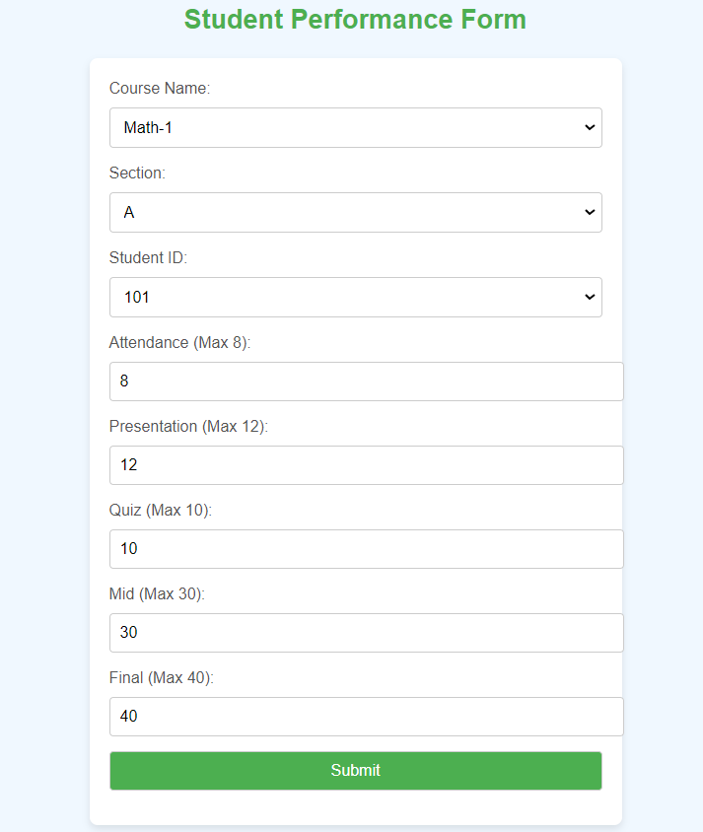

Test Case Design for Equivalence Partitioning :

|  |  |  |  |  |  |
| --- | --- | --- | --- | --- | --- |
| Test Case ID | Test Case Name | Field | Input Type | Steps | Expected Result |
| 1 | Course Name Valid Selection | Course Name | Valid (Math-1, English-1) | 1. Open Form  2. Select ‘Math-1’ from dropdown.  3. Submit | Successful |
| 2 | Course Name Invalid Selection | Course Name | Invalid (not in dropdown) | 1. Open Form  2. Enter other value eg. ‘GED-1’  3. Submit | Error |
| 3 | Attendance Range Valid | Attendance | Valid (0-8) | 1. Enter value 4  2. Submit | Successful |
| 4 | Attendance Range Invalid | Attendance | Invalid (negative value or greater than 8) | 1. Enter value -1  2. Submit | Error |
| 5 | Presentation Range valid | Presentation | Valid (0-12) | 1. Enter 8  2. Submit | Successful |
| 6 | Presentation Range invalid | Presentation | Invalid (negative value or greater than 12) | 1. Enter 16  2. Submit | Error |
| 7 | Quiz Range valid | Quiz | Valid (0-10) | 1. Enter 2  2. Submit | Successful |
| 8 | Quiz Range invalid | Quiz | Invalid (negative value or greater than 10) | 1. Enter 25  2. Submit | Error |
| 9 | Mid Range Valid | Mid | Valid (0-30) | 1. Enter 17  2. Submit | Successful |
| 10 | Mid Range invalid | Mid | Invalid (negative value or greater than 30) | 1. Enter -9  2. Submit | Error |
| 11 | Final Range valid | Final | Valid (0-40) | 1. Enter 39  2. Submit | Successful |
| 12 | Final Range invalid | Final | Invalid (negative value or greater than 40) | 1. Enter 43  2. Submit | Error |

Test Case Design for Boundary Value Analysis:

|  |  |  |  |  |
| --- | --- | --- | --- | --- |
| Test Case ID | Field | Boundary Condition | Test Data | Expected Result |
| 1 | Attendance | Lower Boundary | 0 | Successful |
| 2 | Attendance | Just below lower boundary | -1 | Error |
| 3 | Attendance | Upper Boundary | 8 | Successful |
| 4 | Attendance | Just above upper boundary | 9 | Error |
| 5 | Presentation | Lower Boundary | 0 | Successful |
| 6 | Presentation | Just below lower boundary | -1 | Error |
| 7 | Presentation | Upper Boundary | 12 | Successful |
| 8 | Presentation | Just above upper boundary | 13 | Error |
| 9 | Quiz | Lower Boundary | 0 | Successful |
| 10 | Quiz | Just below lower boundary | -1 | Error |
| 11 | Quiz | Upper Boundary | 10 | Successful |
| 12 | Quiz | Just above upper boundary | 11 | Error |
| 13 | Mid | Lower Boundary | 0 | Successful |
| 14 | Mid | Just below lower boundary | -1 | Error |
| 15 | Mid | Upper Boundary | 30 | Successful |
| 16 | Mid | Just above upper boundary | 31 | Error |
| 17 | Final | Lower Boundary | 0 | Successful |
| 18 | Final | Just below lower boundary | -1 | Error |
| 19 | Final | Upper Boundary | 40 | Successful |
| 20 | Final | Just above upper boundary | 41 | Error |