Text S5: Derivation of iterative CPA
The solution to the corrected projection method is calculated by
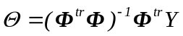S5. 1
where 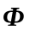is the matrix (T x f) by n matrix
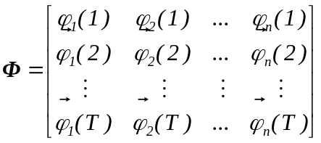 S5. 2
Here, for the sake of a simple notation, we assume that the matrix 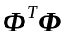has an inverse, which is the case for the large enough f number of dimensions (see Text S2). Nevertheless, the following derivation can be straightforwardly generalized by replacing the inverse with the infinitesimal definition of the Moore-Penrose pseudo inverse introduced in Text S2.
The derivation of a iterative algorithm is similar to the algebraic manipulations necessary to derive the Kalman filter equations. For an example, see chapter 2 of (Astrom and Wittenmark 1995).
The matrix is updated every time that a measurement 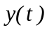 is made, and a set of projections into the dictionary B (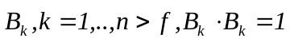) is calculated. We can write the projections at time t into an f by n matrix that we call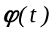:
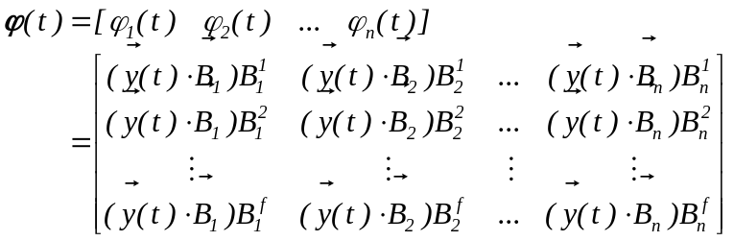S5. 3
We can rewrite the matrix generated by T measurements as the (T x f) by n matrix:
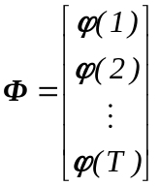S5. 4
The n by n matrix P after T measurements is defined as:
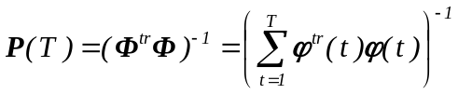S5. 5
which means that
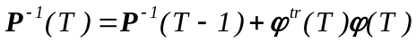 S5. 6
The estimate of the parameters after T measurements is
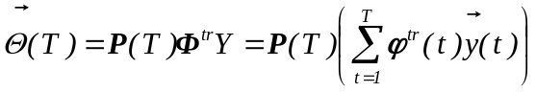S5. 7
where is a f-dimensional column vector and Y is an (T x f)-dimensional vector (see S2.3).
By expanding the summation in S5.7, we obtain
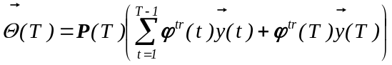S5. 8
We will now write the estimate after T measurements 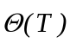 as a function of the previous estimate (after T-1 measurements) 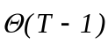.
The estimated parameters at time T-1 was
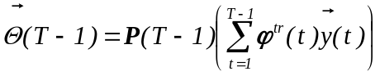S5. 9
By multiplying both sides by the inverse of the square matrix P(T-1), we obtain
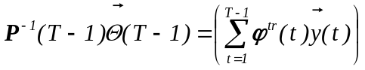S5. 10
By replacing S5.6 into S5.10, we obtain
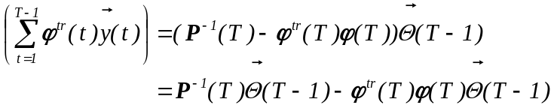 S5. 11
By replacing S5.11 into S5.8, we obtain
S5. 12
This equation can be simplified into:
S5. 13
Simplifying this expression, we obtain:
S5. 14
which can be written as:
S5. 15
where K(T) is the n by f matrix:
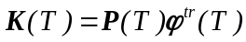S5. 16
We also need to be able to estimate P(T) based on the elements P(T-1).
By taking the inverse of equation S5.6, we obtain
S5. 17
where I is an identity matrix of f by f dimensions.
Using the property of matrix inversion
S5. 18
and defining
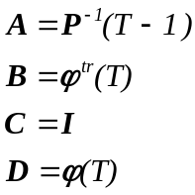S5. 19
we can therefore write S5.17 as:
S5. 20
We can summarize the algorithm as:
S5. 21
where
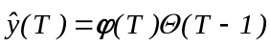.
The recurrent implementation requires the inversion of the f by f matrix 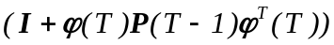 . The non-recurrent implementation requires the inversion of an n by n matrix. In the case where the number n of vectors of the dictionary is much larger than the dimensions of the signal f, it simplifies calculations, in terms of computational complexity as well as in numerical stability.
We can use the approximation
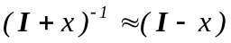
to simplify the expression for 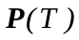
S5. 22
In this case, iterative CPA does not need a matrix inversion and the algorithm can be implemented using multiplication and additions, which are operations that can be performed by neural elements.

Astrom, K. J. and B. Wittenmark (1995). "Adaptive Control, Second Edition." Prentice Hall.

