Project 1

Riddle Game

CIS-5

42641

16 April 2017

Leah Omaiye

**Introduction**

This game was actually inspired by call-to-action banners on websites from the early 00s that forced you to click the OK button numerous times (or shut off the computer) to exit the website. This program will loop until the user is able to correctly solve 10 riddles. This game serves as an excellent brain exercise.

**Gameplay & Rules**

This riddle game requires the user to solve 10 riddles. The user has three tries per riddle and each riddle has a hint to aid the user. The riddles increase in difficulty as the game progresses. After the 10th riddle, there is a secret message. If the user fails to solve a riddle after 3 tries, the program loops and they must start from the beginning.

**Development Summary**

Project Size:

* 310 Lines
* 10 variables

I designed this project as a way to practice doing loops. Although I thought of many different ways of designing the code, I wanted to start with something simple, of my own design, and develop it further for the second project. As we progress throughout the course, I will be adding more to this project based on what I learn.

**Flowchart**

Can be found here: [link to flowchart](https://raw.githubusercontent.com/pockymonsta/OmaiyeLeah_CIS5_42641/master/proj/Project_1/Riddle_Game_Project_v3_flowchart.jpg)

**Project Checkoff Sheet**

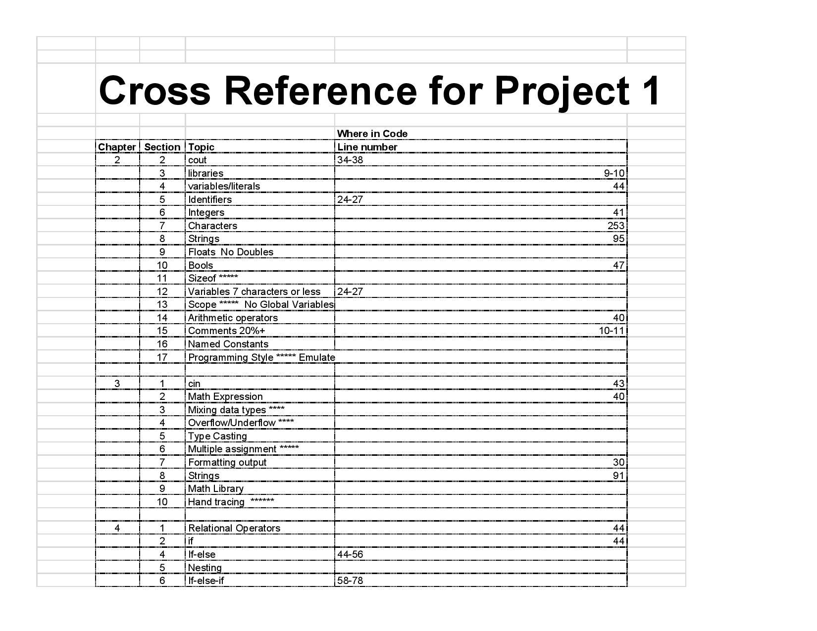

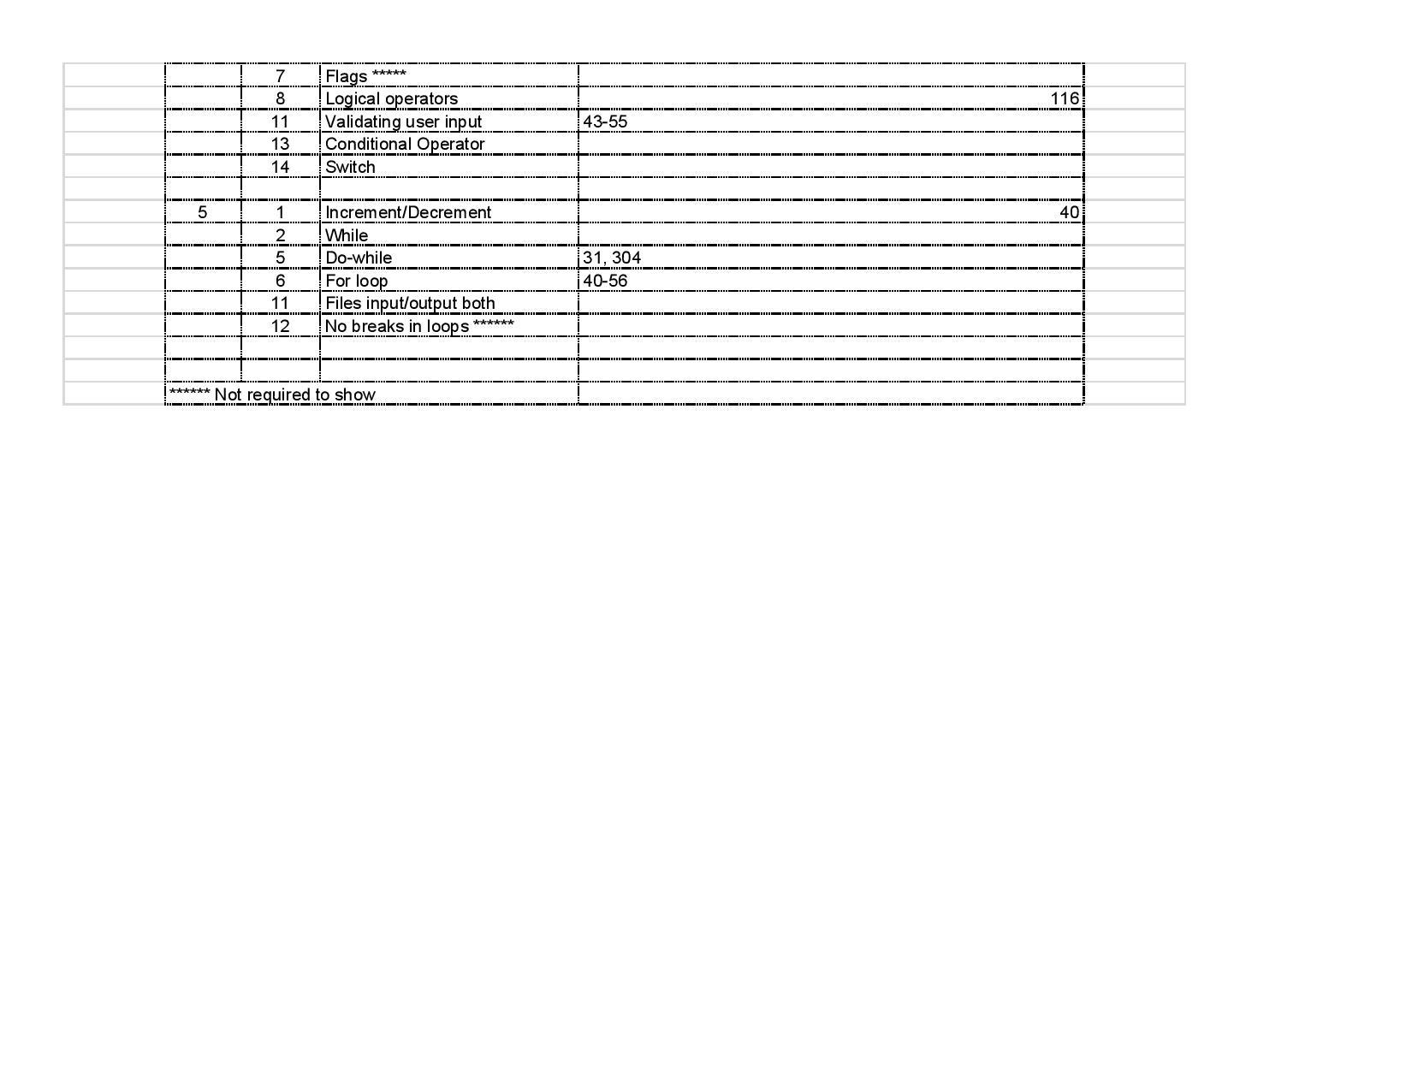

**Pseudo Code**

*//System Libraries //Input - Output Library*

*// input string answers & process strings*

*//Name-space under which system libraries exist*

*//User Libraries*

*//Global Constants*

*//Function Prototypes*

*//Execution begins here*

*//Declare and initialize variables*

*//riddle number and answer for number answers*

*//riddle number and answer for word answers*

*//riddle number and answer for yes/no answer*

*//completed program, continue to next statement*

*//Input data*

*//loop the program until user answers all 10 riddles correctly*

*//game introduction*

*//output riddle 1*

*//Map inputs to outputs or process the data*

*//user has 3 tries to answer a riddle before the program loops to beginning*

*//input answer for riddle 1*

*//program will continue to next riddle if user answers correctly*

*//program will continue to next riddle if user has not used all 3 tries*

*//program will not continue if user has used all 3 tries*

*//output number of tries left*

*//program continues if user answers previous riddle correctly, otherwise, it loops to beginning*

*//output riddle 2*

*//input answer for riddle 2*

*//program will continue to next riddle if user has not used all 3 tries; this is the same for all following riddles (riddles 3-10)*

*//program will loop if user has used all 3 tries; this is the same for all following riddles (riddles 3-10)*

*//Output the transformed data*

*//if user answers riddle 10 correctly, winning message will be displayed*

*//winning message will not be displayed if user uses all 3 tries*

*//program will loop back to beginning if user uses all 3 tries*

*//program will exit once user answers all 10 riddles correctly*

*//loop the program if the user does not complete the 10 riddles*

*//program will exit once user answers all 10 riddles correctly*

*//Exit stage right!*

**Program Code**

//System Libraries

#include <iostream> //Input - Output Library

#include <string> // allow user to input string answers & process strings

using namespace std; //Name-space under which system libraries exist

//User Libraries

//Global Constants

//Function Prototypes

//Execution begins here

int main(int argc, char** argv) {

//Declare and initialize variables

int r1Ans, r2Ans, r5Ans, r7Ans, r8Ans, r10Ans; //riddle number and answer for number answers

string r3Ans, r4Ans, r6Ans; //riddle number and answer for word answers

char r9Ans; //riddle number and answer for yes/no answer

bool comp, cont; //completed program, continue to next statement

//Input data

cout << "\nThis is the Ultimate Riddle Game. \n";

do //loop the program until user answers all 10 riddles correctly

{

cout << "\nAnswer all ten riddles to exit the game...\n...or be doomed to loop the program forever...\n";

cout << "Riddle 1: What number do you get when you multiply all of the numbers on a telephone number pad? \n";

cout << "HINT: multiply all numbers from 0-9.\n";

//Map inputs to outputs or process the data

for (int count = 3; count > 0; count--) //user has 3 tries

{

cin >> r1Ans;

if (r1Ans == 0)

{

cout << "Correct!\n" ;

cont = true; //program will continue to next riddle if user answers correctly

count = -1; //program will continue to next riddle if user has not used all 3 tries

}

else

{

cont = false; //program will not continue if user has used all 3 tries

cout << "Wrong! You have " << count - 1 << " tries left.\n"; // tries left are displayed

}

}

if (cont == true) //program continues if user answers previous riddle correctly

{

cout << "Riddle 2: When was the latest year that is the same upside down?\n";

cout << "HINT: it's after 1960.\n";

for (int count = 3; count > 0; count--)

{

cin >> r2Ans;

if (r2Ans == 1961)

{

cout << "Correct!\n";

cont = true;

count = -1;

} //program will continue to next riddle if user has not used all 3 tries; this is the same for all following riddles

else

{

cont = false;

cout << "Wrong! You have " << count - 1 << " tries left.\n";

} //program will loop if user has used all 3 tries; this is the same for all following riddles

}

}

if (cont == true)

{

cout << "Riddle 3: What is a seven letter word containing dozens of letters?\n";

cout << "HINT: Think of your local mailman.\n";

for (int count = 3; count > 0; count--)

{

cin >> r3Ans;

if (r3Ans == "mailbox")

{

cout << "Correct!\n";

cont = true;

count = -1;

}

else

{

cout << "Wrong! You have " << count - 1 << " tries left.\n";

cont = false;

}

}

}

if (cont == true)

{

cout << "Riddle 4: You walk into a room with a rabbit holding a carrot, a pig eating slop, and a chimp holding a banana.\n";

cout << "Which animal in the room is the smartest?\n";

cout << "HINT: Consider all four animals present.\n";

for (int count = 3; count > 0; count--)

{

cin >> r4Ans;

if (r4Ans == "you" || r4Ans == "me")

{

cout << "Correct!\n";

cont = true;

count = -1;

}

else

{

cout << "Wrong! You have " << count - 1 << " tries left.\n";

cont = false;

}

}

}

if (cont == true)

{

cout << "Riddle 5: How many eggs can you fit into an empty basket?(Enter an integer).\n";

cout << "HINT: The basket is no longer empty once you add eggs.\n";

for (int count = 3; count > 0; count--)

{

cin >> r5Ans;

if (r5Ans == 1)

{

cout << "Correct!\n";

cont = true;

count = -1;

}

else

{

cout << "Wrong! You have " << count - 1 << " tries left.\n";

cont = false;

}

}

}

if (cont == true)

{

cout << "Riddle 6: What is a six letter word that tastes better than it smells?\n";

cout << "HINT: Think of the 5 senses.\n";

for (int count = 3; count > 0; count--)

{

cin >> r6Ans;

if (r6Ans == "tongue")

{

cout << "Correct!\n";

cont = true;

count = -1;

}

else

{

cout << "Wrong! You have " << count -1 << " tries left.\n";

cont = false;

}

}

}

if (cont == true)

{

cout << "Riddle 7: What digit is the most frequent between the numbers 1 and 1,000 (inclusive)?\n";

cout << "HINT: The digits 0 through 9 all follow the same pattern there is exactly 1 occurrence of each digit for every ten numbers.\n";

for (int count = 3; count > 0; count--)

{

cin >> r7Ans;

if (r7Ans == 1)

{

cout << "Correct!\n";

cont = true;

count = -1;

}

else

{

cout << "Wrong! You have " << count - 1 << " tries left.\n";

cont = false;

}

}

}

if (cont == true)

{

cout << "Riddle 8: You are going to visit your grandmother on Mother's day. You want to give her two cakes. However, to get to her house you must cross seven bridges.\n;";

cout << "At each bridge is a troll who demands ½ of all of your cakes as the price to pass. However, this troll, being a nice troll, feels bad and gives you back 1 of the cakes that he took.\n";

cout << "HINT: Write and solve an equation for the first instance.\n";

for (int count = 3; count > 0; count--)

{

cin >> r8Ans;

if (r8Ans == 2)

{

cout << "Correct!\n";

cont = true;

count = -1;

}

else

{

cout <<"Wrong! You have " << count - 1 << " tries left.\n";

cont = false;

}

}

}

if (cont == true)

{

cout << "Riddle 9: An ant gets onto one end of a tight rope that is 1 meter long.\n";

cout << "The ant is traveling at 1 centimeter per second, but the entire rope is being stretched an extra 1 meter per second (it can be stretched forever).\n";

cout << "Will the ant ever reach the other end of the rope (y/n)?\n";

cout << "HINT: Both sides of the rope will stretch.\n";

for (int count = 3; count > 0 ; count--)

{

cin >> r9Ans;

if (r9Ans == 'y')

{

cout << "Correct!\n";

cont = true;

count = -1;

}

else

{

cout <<"Wrong! You have " << count - 1 << " tries left.\n";

cont = false;

}

}

}

if (cont == true)

{

cout << "Riddle 10: How many people do you need to have a 50% chance of two people having the same birthday?(Enter an integer)\n";

cout << "HINT: Calculate the probability for a sample group of n number of people for 365 birthdays. \n";

for (int count = 3; count > 0; count--)

{

cin >> r10Ans;

if (r10Ans == 23)

{

cout << "Correct!\n";

cont = true;

count = -1;

}

else

{

cout << "Wrong! You have " << count - 1 << " tries left.\n";

cont = false; //winning message will not be displayed if user uses all 3 tries

comp = false; //program will loop back to beginning if user uses all 3 tries

}

}

}

//Output the transformed data

if (cont == true)

{

cout << "CONGRATULATIONS! YOU'VE WON.\n";

cout << "You get a cookie!\n";

cout << " . - - .\n";

cout << " .' * '.\n";

cout << " / * ' \n";

cout << " : ;\n";

cout << " |* * * |\n";

cout << " : :\n";

cout << " ` * /\n";

cout << " `. * .'\n";

cout << " `~ ~ ~ `\n";

comp = true; //program will exit once user answers all 10 riddles correctly

}

} while (comp == false); //loop the program if the user does not complete the 10 riddles

//Exit stage right!

return 0;

}