Design and synthesis of oxime esters as photoinitiators using quantum chemical calculations and machine learning

Yuya Watanabe, ª Fuka Takahata, ^{b} Mahiko Utoguchi, ^{b} Takuya Sekizawa, ^{b} Haruka Nagano, ^{b} Shunichi Himori, ^{b} Akihiko Yamada, ^{b} and Hiroaki Gotoh ^{*,a}
ªDepartment of Applied Chemistry, Yokohama National University, 79-5 Tokiwa-Dai, Hodogaya-Ku, Yokohama 240-8505, Japan
^{b}Air Water Performance Chemical, Inc., Research & Development Center, 1-2 Chidori-Cho, Kawasaki-Ku, Kawasaki 210-0865, Japan
*Corresponding author. Email: gotoh-hiroaki-yw@ynu.ac.jp

Content
Attached File List 3
Machine Learning 9
Dense Neural Network 9
ABT-MPNN 9
GPT 10
Detail of Assembly Method 11
Evaluation functions in the Generative method 11
Symmetry Score 11
Fused Ring Count Score 11
Number of Aromatic Heterocycle Score 12
Max Ring Size Score 12
Oxime Activation Part Score 12
Oxime Ester Property Score 12
Generated Compounds’ quantum chemical calculation result 13
F-01 13
F-02 14
A-01 15
A-02 18
G-01 21
G-02 24
Synthetic Routes and NMR 26
F-01 26
F-02 27
A-01 27
A-02 28
G-01 29
G-02 29
NMR Spectrum 31
F-01 31
F-02 31
A-01 32
A-02 32
G-01 33
G-02 33

Attached File List
1. Training dataset for the oxime ester prediction model: all_SMILES.csv
Contains SMILES strings used for model training and testing, as well as the T₁, S₁, and S₁ oscillator intensities.
2. Oxime ester dataset converted from Aldrich to Ketones: filter_SMILES.csv
Contains T₁, S₁, and S₁ oscillator intensities predicted by the optimized ABT-MPNN prediction model.
3. Molecules generated by Assembly: Assembly_SMILES.csv
Lists T₁, S₁, and S₁ oscillator intensities predicted by the optimized ABT-MPNN prediction model.
4. Oxime ester dataset generated by the generative model: generative_SMILES.csv
Contains T₁, S₁, and S₁ oscillator intensities predicted by the optimized ABT-MPNN prediction model.

- Experimental
  - Dataset
Table S1 presents a detailed breakdown of the datasets used for creating the predictive models and implementing the Filter, Assembly, and Generative methods.
A total of 385 compounds, including commercial, known, and virtual (small-molecule) compounds were used to train the models for predicting the physicochemical indices. The commercial products were 200 oxime esters sourced from Aldrich reagents in PubChem (retrieved on 2022.10.11).¹⁹ The known compounds were 134 oxime esters synthesized and reported in 19 studies.^{1,3,4,11–13,15–18,20–28} These compounds were retrieved through a literature search. The virtual molecules were 51 small oxime esters with a broad range of light absorption. Additional details are provided in the ESI (all_SMILES.csv).
For the Filter method, we designed ready-to-use oxime esters that could be synthesized from commercially available ketones. The commercial dataset included 251,394 compounds from Aldrich. Ketones were extracted and converted into oxime esters following the procedure described in Section 2.3.4, resulting in 1293 oxime esters.
The dataset used for the Assembly method was the same as the dataset of 385 oxime esters used in the prediction model described in Section 2.3.
In the Generative approach, commercially available compounds were used for pretraining, and a dataset of known oxime esters was used for finetuning. Specifically, the Aldrich dataset (25,1394 compounds) was used for pretraining, whereas 64 oxime esters were used for finetuning, as described in Section 2.3.6.
Table S1 Dataset composition
Method | Compound Group | Composition | Total
Filter | Ketone | Aldrich^{a)} (1293) | 1293
Assembly | Oxime Ester | Aldrich^{a)} (200), Literature review^{b)} (134), Virtual molecules^{c)} (51) | 385
Generative (Pretrained) | General | Aldrich^{a)} (251,394) | 251,394
Generative (Finetuned) | Oxime Ester | After hierarchical clustering Oxime esters^{b,d)} (64) | 64
a) retrieved from PubChem; b) derived from 19 reports through a literature search; c) molecules exhibiting low-wavelength light absorption; d) oxime esters categorized by hierarchical clustering: the oxime ester dataset from b) was categorized using hierarchical clustering based on a Levenshtein distance matrix constructed for Simplified Molecular Input Line Entry System (SMILES) strings

  - Quantum Chemical Calculation
Quantum chemical calculations were performed to calculate physicochemical indices for the 385 molecules used in the Assembly method. Gaussian 16²⁹ software was used for these calculations: First, 10,000 initial conformations were generated using RDKit’s³⁰ ETKDG³¹ method. Structural optimizations were performed in the Merck molecular force field (MMFF94).³² The most stable conformation was further optimized using PM6 and B3LYP /6-31G(d) computations, followed by vibrational analysis and single-point energy calculations for excited states using B3LYP /6-31G(d). From these calculations, T₁ energy, S₁ energy, and oscillator strength of the compounds were obtained. For compounds to be synthesized, the same process was followed, with final single-point energy calculations conducted using cam-B3LYP/6-31G(3d2f, 2d2g) to determine the physicochemical indices.

  - Machine Learning
Quantum chemical calculations of the 385 oxime esters were used to train the predictive models. The prediction models included a fully connected neural network³³, a graph-based neural network (atom-bond transformer-based message passing neural network, ABT-MPNN³⁴), and a GPT-based neural network³⁵. The objective variables were T₁ energy, S₁ energy, and oscillator intensity. The oscillator intensity was log-transformed, as numerous molecules exhibited vibrational intensities ranging from 10⁻² to 10⁻⁴:

$$y= -\log_{10}{(x + {10}^{-8})}$$

where x and y denote the oscillator intensities before and after the transformation, respectively.
Cross-validation was performed for model validation. The dataset was randomly divided into five parts, with 80% used for training and 20% for testing. To compare models under the same conditions, the same split data were used for each training session, using the mean squared error function for evaluation.

    - Fully Connected Neural Network
This model was implemented in Pytorch³⁶ (ver. 2.0.0), training Morgan Fingerprints³⁷ (nBits = 2048, radius = 3) as descriptors. The model involved 13 layers, with a learning rate of 1×10⁻⁵.

    - Graph-based Neural Network
ABT-MPNN served as the graph-based neural network, trained with five layers at a rate of 1×10⁻⁵. The descriptors included the adjacency, distance, and Coulomb matrices. Bonding information between intramolecular atoms (conjugation system, bond order, etc.) and intramolecular atomic features (atomic number, aromaticity, etc.) were calculated using RDKit. L₁ loss was used as the loss function.

    - GPT-based Neural Network
This model was established to make predictions from SMILES strings, based on the generative pretrained transformer (GPT) used in natural language processing. As the output layer of the typical GPT model is a SoftMax function, we replaced the output layer with a linear layer to apply it to the regression task.

    - Filter Method
A total of 1293 ketones were obtained by extracting molecules with molecular weights exceeding 50, aromatic rings, and one ketone skeleton from Aldrich’s commercially available drug data set (251,394 ketones). Ketone to oxime ester conversion was performed using the RDKit library. The process involved identifying the ketone moiety in the molecule and converting the ketone to the oxime ester structure. From the 1293 datapoints, the prediction model described in Section 2.3 was used to extract compounds with S₁ energy < 3.5 eV, T₁ energy > 2.7 eV, and S1 oscillator intensity > 1.0.

    - Assembly Method
The 385 molecules in the dataset described in Section 2.1 were split into side chains and main skeletons using the MurckoScaffold function in RDKit. These components were shuffled. Gasteiger charges³⁸ of the aromatic atoms of the main frame containing aromatic rings were calculated, and the molecule was designed by introducing side chains containing oxime esters at the positions of aromatic atoms with low Gasteiger charges. This approach resulted in a molecular structure containing one to three oxime ester active sites.

    - Generative Model
Transformer-based language models and Taiga³⁹ with reinforcement learning were used as generative models. To train the model on SMILES⁴⁰ strings, pretraining was performed on the Aldrich (25,294) dataset. The dataset of 385 oxime esters was used to create a Levenshtein distance matrix^{41,42} for SMILES strings. Hierarchical clustering (AgglomerativeClustering) using Scikit-Learn⁴² was applied to group 64 oxime esters. This clustering was required to address the presence of several pairs of similar SMILES strings in the dataset, which could hinder the generation of diverse SMILES strings. Reinforcement learning was conducted to optimize the physical properties. The rewards functions included the following: 1) Symmetry score: molecular symmetry); 2) Fused ring count score: Number of rings in the fused ring containing the most alkyl rings in the molecule; 3) Num aromatic heterocycle score: Number of aromatic heterocycle rings; 4) Molecular weight score; 5) Number of oxime ester prop score: Number of oxime ester parts; and 6) Oxime ester prop score. Table S2 lists the target values for these rewards functions. Details of the evaluation functions can be found in the ESI.
The generated SMILES outputs were characterized by molecular weights between 300 and 600, structural similarity (based on the standardized Levenshtein distance) of less than 0.7 with the training data, and reasonable SMILES structures.

Table S2 Reward functions for reinforcement learning
Physical property | Target
Symmetry | 0.6
Fused ring count | 3
Number of aromatic heterocycles | 3
Maximum ring size | 5, 6
Number of oxime parts | 3
Oxime ester property | 2.5

  - Synthesis of Oxime Esters
The oxime esters generated using the Filter, Assembly, and Generative methods were synthesized following the route shown in Figure S1. First, Friedel–Crafts acylation was performed to convert the chromophore to a ketone. Subsequently, the ketone body was converted to ketoxime through ketoximation. The ketoxime was reacted with an alkyl chloride to obtain the oxime ester. If chromophore synthesis was required, it was performed using known protcols.⁴ The synthesized oxime esters were identified through proton nuclear magnetic resonance (¹H-NMR; ECA 500, 500 MHz). Details of the synthetic route can be found in the ESI. UV–visible (UV–Vis) absorption spectra of the oxime esters were measured at 300–800 nm in acetonitrile solvent.
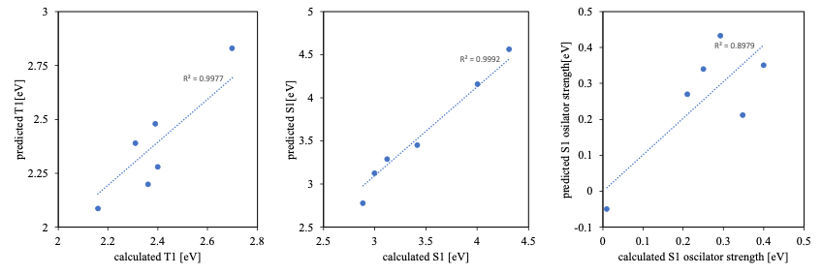
Figure S1 Relation between predicted oxime ester scores and quantum calculated oxime ester scores. Each physicochemical indices (T₁, S₁, oscillator strength at S₁) were predicted by using ABT-MPNN model. Quantum chemical calculation exec with B3LYP/6-31G(d) condition.

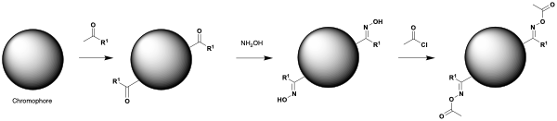
Scheme S1 Synthetic route of oxime ester

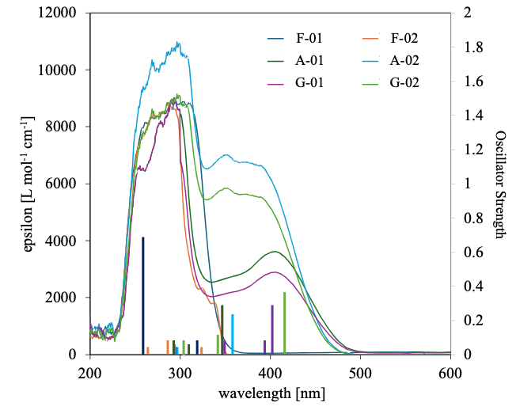
Figure S2 UV–Vis spectra of synthesized oxime esters, measured in acetonitrile solvent. Left axis shows the molar extinction coefficient, and right axis shows the oscillator strength computed by quantum chemical calculations (cam-B3Lyp 6-31G(3d2f, 2d2p)).

  - Measurements
The polymerization performance, in terms of heat flow and monomer conversion, of the synthesized oxime esters and comparative molecule OXE01 (BASF) was assessed through photo-differential scanning calorimetry (Photo-DSC; XDSC-7000, Hitachi High-Tech, Japan).^{43,44} Trimethylolpropane triacrylate (TMPTA) (Tokyo Kasei Kogyo) was used as the monomer. Samples (0.5 or 1.0 mg, corresponding to 0.5–1.0 wt% photoinitiator in TMPTA) were analysed under a nitrogen atmosphere, with measurements obtained at a film thickness of ~500 μm, a wavelength of 405 nm (Hg lamp, h-line), and an intensity of 50 mW cm⁻². The measurement was commenced 30 s before the start of irradiation and lasted for 0.5–5.5 min. The conversion of vinyl groups (C, %) was determined as

$\text{C}\text{ = 100\% × ∆}{\text{H}}_{\text{t}}\text{/∆}{\text{H}}_{\text{M}}^{\text{theory}}$ (1)

where ΔH_{t} is the heat release at time t, obtained by exothermic peak integration; and ΔH_{M}^{theory} is the theoretical heat release for complete conversion. As TMPTA has three acrylate residues, ΔH_{M}^{theory} was calculated as
$\text{∆}{\text{H}}_{\text{M}}^{\text{theory}}\text{=}\frac{\text{3×∆}{\text{H}}_{\text{P}}^{\text{theory}}}{{\text{M}}_{\text{m}}}\text{= 797.71 }\text{mJ}\text{ mg}\text{-1}$ (2)

where M_{m} is the molecular weight of TMPTA, and ΔH_{P}^{theory} = 78.2 kJ mol⁻¹ is the theoretical heating value^{.47}

Machine Learning
We modeled and made predictions for S1, S1 oscillator intensity, and T1, with DenseNeutralNetowrk and ABT-MPNN performing well with R² greater than 0.7 for all indices (Figure S3).
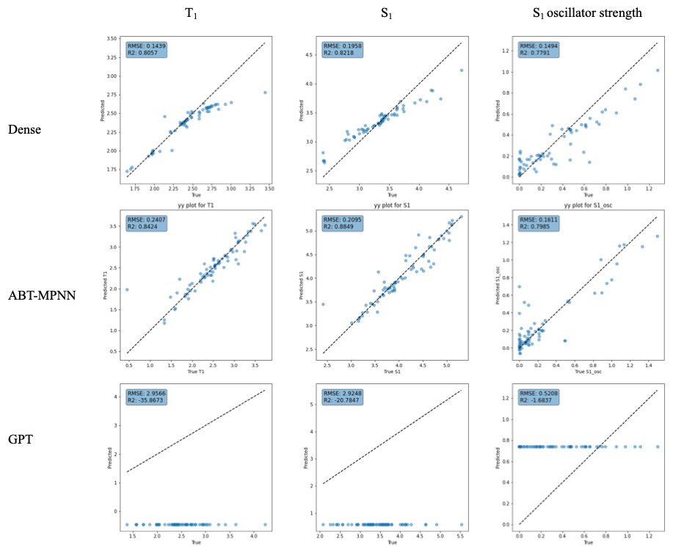
Figure S3 Training results: The x- and y-axes represent the predicted values and values derived through quantum chemical calculations. Each model was evaluated using test data. Dense: fully connected neural network, ABT-MPNN: atom-bond transformer-based message passing neural network.
.

Dense Neural Network
The results of training evaluation by cross-validation are shown in Figure S4. Some results showed that R² was lower than 0.6. However, many results show high prediction performance, which can be evaluated as good learning.
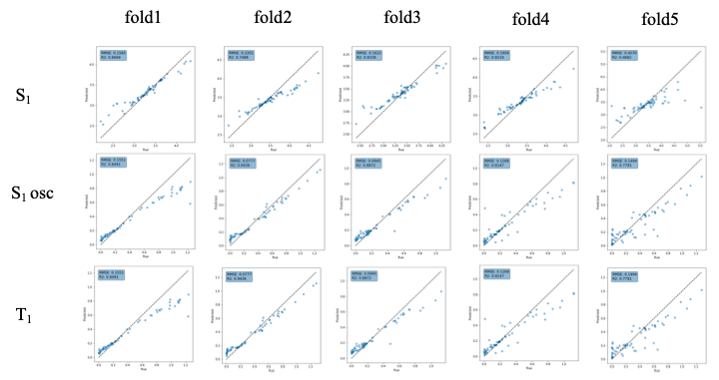
Figure S4 Training results of dense neural network

ABT-MPNN
The results of training evaluation by cross-validation are shown in Figure S5. Some results showed that R² was lower than 0.6. However, many results show high prediction performance, which can be evaluated as good learning.

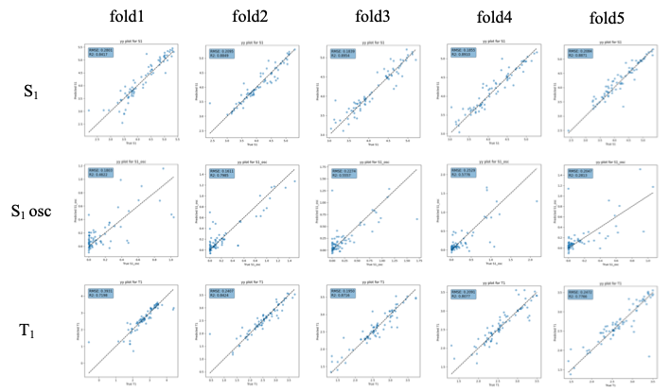
Figure S5 Training results of ABT-MPNN

GPT
The results of training evaluation by cross-validation are shown in Figure S6. In all results, R2 was less than 0.6, a poor prediction. This is consistent with the SMILES-based approach having several inherent limitations. The representational constraints of SMILES, which captures only 2D molecular structure while omitting crucial 3D stereochemical information, likely contributed to the model's inability to accurately predict properties that depend on spatial arrangements. Additionally, the complexity of the target properties, which are influenced by multiple factors beyond what can be encoded in simple SMILES strings, presents a fundamental challenge to the prediction task.
The model's performance may have also been impacted by data quality issues. Our training dataset, while extensive, likely contained imbalances in the representation of certain structural features and functional groups, leading to biased predictions particularly for compounds containing rare molecular frameworks. The applicability domain of our model is necessarily limited to chemical space similar to that covered in the training set, which explains the particularly poor performance on novel scaffolds.
Furthermore, the black-box nature of our deep learning approach makes it difficult to interpret which molecular features were driving the predictions, hindering our ability to systematically improve the model. The single-point predictions also fail to adequately convey prediction uncertainty, which would be valuable information for practical applications of the model.
Future work should explore alternative molecular representations that better capture 3D information, implement uncertainty quantification methods, and develop more interpretable models to overcome these limitations.

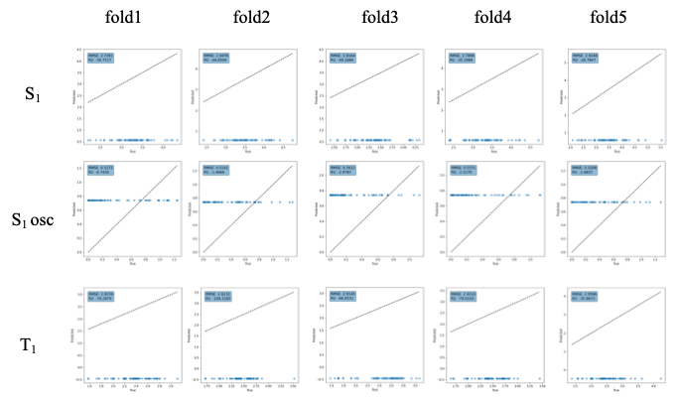
Figure S6 Training results of GPT model.

Descriptors for ABT-MPNN
The inputs to the ABT-MPNN include the interatomic feature matrix, bond feature matrix, adjacency matrix, Coulomb matrix, and molecular descriptors.

Inter-atomic feature matrix
This matrix represents a feature vector of physical and chemical properties of atoms within each molecule. The inputs include atomic number, formal charge, and atomic chirality.

Bond feature matrix
This matrix encodes intramolecular bonding information, including the type of bond, conjugation, and whether the bond is part of a ring structure.

Adjacency matrix
This matrix represents the connection information of atoms, indicating which atoms in the molecule are bonded to each other.

Distance matrix
This matrix indicates the spatial distances between atoms, calculated from the RDKit-generated conformers.

Coulomb Matrix
The Coulomb matrix describes the electrostatic interactions between atoms in a molecule.

Molecular Descriptor
These descriptors describe the characteristics of the molecule as a whole. In this study, molecular descriptors generated using RDKit were employed.

Detail of Assembly Method
The molecule was split into side chains and the main backbone using the MurckoScaffold function. The split side chains and main skeleton were shuffled. The Gasteiger charges³⁸ of the aromatic atoms of the main frame containing aromatic rings were calculated, and the molecule was designed by introducing side chains containing oxime esters at the positions of aromatic atoms with low Gasteiger charges. This resulted in a molecular structure containing 1–3 oxime ester active sites.

https://github.com/poclab-web/DesignOximeEster/tree/main/oxime_ester_assembling

Evaluation functions in the Generative method

Symmetry Score
The Symmetry Score assigns canonical ranks to all atoms in a given molecule and counts the number of occurrences of each rank. Using this information, the total number of equivalent atom pairs is calculated, which is then normalized by the number of all atom pairs in the molecule to calculate the Symmetry Score. The Symmetry Score takes values between 0 and 1, with values approaching 1 indicating higher 2-dimensional symmetry of the molecule.
The reward function based on the Symmetry Score, SR, is shown below. SS is the molecule for which the aforementioned symmetry score (m) is input.

$$\left\{\begin{aligned}SR\left(m\right)= SS\left(m\right) if SS\left(m\right)>0.6 \\ SR\left(m\right)=0 ≤0.6\end{aligned}\right.$$

The Symmetry Score is introduced because molecules with higher symmetry are more likely to contain multiple active sites. Specifically, a higher symmetry of the chromophore indicates a higher ease for performing Friedel-Crafts acylation over multiple sites.

Fused Ring Count Score
This score indicates the number of fused rings in a molecule and determines the number of alkyl rings within the largest fused ring. The reward function, FR, is defined as follows, where FS is the fused ring count score, and m is the input molecule.

$$\left\{\begin{aligned}FR\left(m\right)=FS\left(m\right) if FS\left(m\right)>2 \\ FR\left(m\right)=0 if FS\left(m\right)≤2\end{aligned}\right.$$

A larger fused ring has a higher potential to host multiple active sites; therefore, they are prioritized.

Number of Aromatic Heterocycle Score
This score indicates the number of aromatic heterocycles in the molecule. The reward function NR is defined as follows, where NS is the Num Aromatic Heterocycle Score, and m is the input molecule.

$$\left\{\begin{aligned}NR\left(m\right)=NS\left(m\right) if NS\left(m\right)>2 \\ NR\left(m\right)=0 if NS\left(m\right)≤2\end{aligned}\right.$$

Max Ring Size Score
This score indicates the largest ring size in the molecule. The reward function MR is set as follows, where MS is the Max Ring Size Score, and m is the input molecule.

$$\left\{\begin{aligned}MR\left(m\right)=MS\left(m\right) if MS\left(m\right)=5 or 6 \\ MR\left(m\right)=0 if MS\left(m\right)≠5 or 6\end{aligned}\right.$$

This constraint prevents the model from designing excessively large cyclic alkyl structures.

Oxime Activation Part Score
This score indicates the number of active sites of oxime esters. The reward function NOR is defined as follows, where
m is the molecule, and NO is the number of oxime ester active sites.

$$NOR\left(m\right)=NO(m)$$

Oxime Ester Property Score
This score evaluates the oxime ester physical properties for a given molecule: first excited triplet energy ( T₁ energy), first excited singlet energy (S₁ energy), and S₁ oscillator strength. As quantum chemical calculations of these values for each individual product molecule would be computationally expensive, the ABT-MPNN model is used to predict these values.
The reward function, OR, is set as follows, where ABTMPNN_{T1} is the T₁ energy output by ABTMPNN, ABTMPNN_{S1} is the S₁ energy output by ABTMPNN, and ABTMPNN_{S1osc} is the S₁ oscillator strength output by ABTMPNN. Although the model simultaneously outputs these values, they are represented as separate terms for notational convenience. Specifically, these functions do not exist independently and are strictly one function.

$$OR\left(m\right)=ABTMPNN_{T1}\left(m\right)[eV]+ABTMPNN_{S1}\left(m\right)[eV]+ABTMPNN_{S1osc}(m)$$

Generated Compounds’ quantum chemical calculation result

F-01
---------------------------------------------------------------------
Center Atomic Atomic Coordinates (Angstroms)
Number Number Type X Y Z
---------------------------------------------------------------------
1 6 0 -6.126015 -2.404352 0.207614
2 6 0 -5.428195 -1.099045 -0.103270
3 8 0 -5.934529 -0.109756 -0.558116
4 8 0 -4.094813 -1.231162 0.225828
5 7 0 -3.346640 -0.054267 -0.016471
6 6 0 -2.102904 -0.207180 0.280519
7 6 0 -1.480778 -1.470623 0.820204
8 6 0 -1.251294 0.994364 0.052401
9 6 0 -1.805480 2.178450 -0.471249
10 6 0 -1.000536 3.291377 -0.679249
11 6 0 0.366022 3.250726 -0.387944
12 6 0 0.925344 2.083824 0.140621
13 16 0 2.663355 2.114232 0.590206
14 6 0 3.222158 0.453699 0.203619
15 6 0 3.105841 -0.081100 -1.088173
16 6 0 3.605018 -1.349925 -1.365280
17 6 0 4.256271 -2.109883 -0.380147
18 6 0 4.822610 -3.471934 -0.705730
19 6 0 4.375836 -1.559640 0.899914
20 6 0 3.858513 -0.296528 1.197186
21 6 0 0.113965 0.964857 0.366602
22 1 0 -5.668841 -3.225293 -0.354469
23 1 0 -6.032222 -2.641757 1.272483
24 1 0 -7.179538 -2.315106 -0.059120
25 1 0 -0.663276 -1.801067 0.169865
26 1 0 -2.216138 -2.269141 0.896401
27 1 0 -1.053415 -1.290208 1.813363
28 1 0 -2.862332 2.204625 -0.710018
29 1 0 -1.433710 4.199709 -1.089174
30 1 0 0.994658 4.116112 -0.577108
31 1 0 2.620790 0.496384 -1.869402
32 1 0 3.500718 -1.753933 -2.370122
33 1 0 5.713096 -3.390197 -1.342567
34 1 0 4.096887 -4.089809 -1.247429
35 1 0 5.114530 -4.011455 0.200683
36 1 0 4.869841 -2.129323 1.683687
37 1 0 3.945358 0.105531 2.202304
38 1 0 0.562880 0.071921 0.785107
---------------------------------------------------------------------

F-02
---------------------------------------------------------------------
Center Atomic Atomic Coordinates (Angstroms)
Number Number Type X Y Z
---------------------------------------------------------------------
1 6 0 5.621446 -0.632521 0.029880
2 6 0 4.155532 -1.005125 0.050489
3 8 0 3.703125 -2.116882 0.094416
4 8 0 3.412359 0.155441 0.008873
5 7 0 2.015785 -0.079628 0.053904
6 6 0 1.344094 1.014758 -0.049414
7 6 0 1.939301 2.393695 -0.193584
8 6 0 -0.136299 0.855328 -0.016247
9 6 0 -0.985150 1.995146 0.078751
10 6 0 -2.353374 1.858971 0.114691
11 6 0 -2.965231 0.580334 0.054933
12 6 0 -4.374007 0.402096 0.086524
13 6 0 -4.924264 -0.858188 0.025061
14 6 0 -4.090513 -2.001311 -0.071646
15 6 0 -2.722481 -1.862263 -0.105218
16 6 0 -2.120554 -0.574036 -0.042526
17 6 0 -0.716944 -0.403580 -0.076036
18 1 0 5.868384 -0.012212 0.897856
19 1 0 6.219031 -1.544489 0.046213
20 1 0 5.855763 -0.051146 -0.867881
21 1 0 3.015880 2.342845 -0.345216
22 1 0 1.744195 2.989534 0.706388
23 1 0 1.482767 2.919881 -1.038569
24 1 0 -0.553685 2.989131 0.130775
25 1 0 -2.985353 2.740614 0.190920
26 1 0 -5.011963 1.279752 0.160585
27 1 0 -6.003499 -0.982629 0.050413
28 1 0 -4.539247 -2.989731 -0.119101
29 1 0 -2.078831 -2.735325 -0.178798
30 1 0 -0.077141 -1.277123 -0.151170
---------------------------------------------------------------------

A-01
---------------------------------------------------------------------
Center Atomic Atomic Coordinates (Angstroms)
Number Number Type X Y Z
---------------------------------------------------------------------
1 6 0 9.780428 -7.052157 1.058548
2 6 0 9.494313 -5.991744 -0.009558
3 6 0 8.542807 -4.887717 0.470698
4 6 0 8.254513 -3.829859 -0.603586
5 6 0 7.403422 -2.640817 -0.124819
6 6 0 5.995225 -2.981383 0.392278
7 6 0 5.088542 -3.645398 -0.668497
8 6 0 3.684503 -3.881430 -0.156525
9 7 0 3.312253 -4.928193 0.499612
10 8 0 4.390394 -5.840409 0.661293
11 6 0 4.009324 -7.017362 1.267859
12 6 0 5.231601 -7.894732 1.426538
13 8 0 2.890263 -7.290313 1.609579
14 6 0 2.618024 -2.868620 -0.364251
15 6 0 1.276918 -3.159930 -0.063321
16 6 0 0.278909 -2.210171 -0.229235
17 6 0 0.566532 -0.925353 -0.724829
18 6 0 1.902925 -0.640789 -1.059794
19 6 0 2.906160 -1.587302 -0.856797
20 16 0 2.324796 0.883353 -1.876405
21 6 0 1.098651 1.947245 -1.145472
22 6 0 1.382251 3.299703 -1.017865
23 6 0 0.401193 4.220568 -0.602496
24 6 0 0.719254 5.670815 -0.512995
25 6 0 -0.249860 6.620395 0.160466
26 6 0 -0.276516 6.477682 1.702421
27 6 0 1.018297 6.889365 2.422256
28 6 0 1.300762 8.397844 2.416784
29 6 0 2.572187 8.774957 3.188829
30 6 0 2.849917 10.281709 3.199041
31 7 0 1.854016 5.999393 -1.030862
32 8 0 2.113572 7.388155 -0.900314
33 6 0 3.316288 7.762096 -1.463397
34 6 0 3.485219 9.255132 -1.288940
35 8 0 4.093456 7.016249 -1.994534
36 6 0 -0.868529 3.714559 -0.298998
37 6 0 -1.147667 2.351876 -0.385123
38 6 0 -0.173287 1.435664 -0.804994
39 7 0 -0.447655 0.049756 -0.892153
40 6 0 -1.822251 -0.374462 -0.830297
41 6 0 -2.518594 -0.600114 -2.022502
42 6 0 -3.845950 -1.011686 -1.993175
43 6 0 -4.511548 -1.211982 -0.769079
44 6 0 -5.935935 -1.648970 -0.747804
45 6 0 -6.579538 -2.145575 0.527995
46 6 0 -7.319994 -1.023862 1.292163
47 6 0 -7.917298 -1.479248 2.633381
48 6 0 -9.041151 -2.518841 2.521814
49 6 0 -9.668509 -2.875801 3.876078
50 6 0 -10.789784 -3.913987 3.767433
51 7 0 -6.542378 -1.544802 -1.880040
52 8 0 -7.887786 -1.973727 -1.778319
53 6 0 -8.547764 -1.969839 -2.993151
54 6 0 -9.976649 -2.404973 -2.760634
55 8 0 -8.052530 -1.670390 -4.044591
56 6 0 -3.802347 -0.982140 0.420548
57 6 0 -2.472171 -0.563560 0.392019
58 1 0 10.463978 -7.823292 0.685354
59 1 0 8.857813 -7.552873 1.378317
60 1 0 10.237859 -6.604446 1.949446
61 1 0 10.440316 -5.536802 -0.335793
62 1 0 9.068032 -6.474924 -0.900485
63 1 0 7.601682 -5.347266 0.804225
64 1 0 8.974530 -4.397994 1.356829
65 1 0 9.209584 -3.435629 -0.978598
66 1 0 7.774623 -4.312283 -1.466981
67 1 0 7.944133 -2.119227 0.677464
68 1 0 7.313623 -1.917910 -0.948291
69 1 0 6.056785 -3.643182 1.263697
70 1 0 5.519738 -2.057204 0.744948
71 1 0 5.052346 -3.022748 -1.568650
72 1 0 5.511310 -4.608615 -0.962980
73 1 0 4.929403 -8.847177 1.863300
74 1 0 5.710729 -8.065073 0.457043
75 1 0 5.966406 -7.407915 2.076765
76 1 0 1.024312 -4.143758 0.315249
77 1 0 -0.741235 -2.474551 0.019345
78 1 0 3.923614 -1.303792 -1.103502
79 1 0 2.372213 3.664923 -1.268393
80 1 0 0.000967 7.643747 -0.120684
81 1 0 -1.255777 6.426322 -0.229308
82 1 0 -0.511810 5.437500 1.957874
83 1 0 -1.109784 7.085419 2.081326
84 1 0 1.870994 6.354844 1.980979
85 1 0 0.953370 6.547438 3.464766
86 1 0 1.391719 8.755174 1.382649
87 1 0 0.441416 8.928933 2.853948
88 1 0 3.430707 8.246155 2.750829
89 1 0 2.489594 8.412183 4.223252
90 1 0 2.970956 10.671471 2.180140
91 1 0 2.024654 10.834339 3.664880
92 1 0 3.764420 10.517399 3.755072
93 1 0 2.622415 9.791459 -1.696299
94 1 0 4.395280 9.569618 -1.800944
95 1 0 3.558404 9.506392 -0.225199
96 1 0 -1.667919 4.375558 0.016995
97 1 0 -2.140863 2.003635 -0.131050
98 1 0 -2.006690 -0.454138 -2.968728
99 1 0 -4.384855 -1.186945 -2.917389
100 1 0 -5.817205 -2.594198 1.173784
101 1 0 -7.285297 -2.937203 0.265898
102 1 0 -8.113472 -0.626250 0.647320
103 1 0 -6.625549 -0.193342 1.474243
104 1 0 -7.115404 -1.877116 3.273381
105 1 0 -8.306566 -0.592848 3.153662
106 1 0 -8.661049 -3.437793 2.053804
107 1 0 -9.823193 -2.135158 1.849375
108 1 0 -8.885227 -3.251900 4.549492
109 1 0 -10.059057 -1.961723 4.345464
110 1 0 -10.421214 -4.852540 3.335375
111 1 0 -11.604163 -3.552842 3.127254
112 1 0 -11.216755 -4.145434 4.749743
113 1 0 -10.003623 -3.400249 -2.305182
114 1 0 -10.502056 -2.420863 -3.715951
115 1 0 -10.477332 -1.714738 -2.073625
116 1 0 -4.283277 -1.117511 1.383323
117 1 0 -1.934826 -0.385154 1.318823
---------------------------------------------------------------------

A-02
---------------------------------------------------------------------
Center Atomic Atomic Coordinates (Angstroms)
Number Number Type X Y Z
---------------------------------------------------------------------
1 6 0 -4.723809 -6.063769 0.577153
2 6 0 -5.035479 -4.933671 -0.409215
3 6 0 -4.852478 -3.539114 0.202253
4 6 0 -5.175241 -2.406741 -0.796364
5 6 0 -4.998658 -1.029239 -0.194544
6 7 0 -5.909182 -0.405829 0.474659
7 8 0 -7.098416 -1.179347 0.555751
8 6 0 -8.132626 -0.514674 1.176669
9 6 0 -9.324500 -1.444126 1.246776
10 8 0 -8.084623 0.612834 1.588965
11 6 0 -3.710542 -0.301911 -0.320347
12 6 0 -3.597180 1.041514 0.076391
13 6 0 -2.390289 1.720102 -0.011770
14 6 0 -1.235304 1.097929 -0.520967
15 6 0 -1.354294 -0.236601 -0.951445
16 6 0 -2.560020 -0.924460 -0.827033
17 16 0 -0.000037 -1.029813 -1.793319
18 6 0 1.354196 -0.236571 -0.951440
19 6 0 2.559943 -0.924391 -0.827016
20 6 0 3.710434 -0.301800 -0.320309
21 6 0 4.998568 -1.029090 -0.194489
22 6 0 5.175341 -2.406400 -0.796694
23 6 0 4.852749 -3.539107 0.201598
24 6 0 5.035970 -4.933458 -0.410275
25 6 0 4.724460 -6.063890 0.575761
26 7 0 5.908955 -0.405802 0.475011
27 8 0 7.098213 -1.179287 0.556072
28 6 0 8.132342 -0.514675 1.177198
29 6 0 9.324283 -1.444050 1.247156
30 8 0 8.084242 0.612751 1.589704
31 6 0 3.597029 1.041622 0.076424
32 6 0 2.390114 1.720170 -0.011749
33 6 0 1.235167 1.097954 -0.520963
34 7 0 -0.000070 1.784293 -0.603060
35 6 0 -0.000045 3.216939 -0.448973
36 6 0 0.000130 3.818128 0.810952
37 6 0 0.000171 5.209080 0.940294
38 6 0 0.000051 6.011360 -0.208618
39 8 0 0.000084 7.372150 -0.202501
40 6 0 0.000237 8.043451 1.049597
41 6 0 -0.000099 5.408813 -1.476689
42 6 0 -0.000141 4.025396 -1.592693
43 1 0 -4.864426 -7.046927 0.114080
44 1 0 -5.376497 -6.012928 1.457156
45 1 0 -3.687141 -6.006899 0.930838
46 1 0 -6.067800 -5.036450 -0.772301
47 1 0 -4.390317 -5.030755 -1.294090
48 1 0 -5.502596 -3.430891 1.079421
49 1 0 -3.821553 -3.429343 0.565480
50 1 0 -6.212209 -2.509131 -1.127855
51 1 0 -4.544111 -2.503690 -1.685690
52 1 0 -9.604848 -1.784712 0.244764
53 1 0 -9.079264 -2.331703 1.839590
54 1 0 -10.160253 -0.914789 1.705527
55 1 0 -4.470911 1.549339 0.468630
56 1 0 -2.343522 2.752826 0.310029
57 1 0 -2.585257 -1.960537 -1.147136
58 1 0 2.585225 -1.960468 -1.147115
59 1 0 6.212327 -2.508547 -1.128212
60 1 0 4.544224 -2.503183 -1.686048
61 1 0 3.821805 -3.429603 0.564851
62 1 0 5.502843 -3.431037 1.078801
63 1 0 4.390834 -5.030384 -1.295186
64 1 0 6.068311 -5.035974 -0.773377
65 1 0 4.865234 -7.046891 0.112404
66 1 0 5.377128 -6.013205 1.455788
67 1 0 3.687778 -6.007282 0.929449
68 1 0 9.605292 -1.783567 0.244961
69 1 0 10.159696 -0.915036 1.706898
70 1 0 9.078830 -2.332268 1.838910
71 1 0 4.470740 1.549476 0.468671
72 1 0 2.343296 2.752895 0.310048
73 1 0 0.000232 3.195404 1.701132
74 1 0 0.000299 5.649444 1.930453
75 1 0 0.000237 9.109240 0.815728
76 1 0 -0.895052 7.800496 1.636409
77 1 0 0.895644 7.800454 1.636213
78 1 0 -0.000181 6.047422 -2.354111
79 1 0 -0.000256 3.556437 -2.571980
---------------------------------------------------------------------

G-01
---------------------------------------------------------------------
Center Atomic Atomic Coordinates (Angstroms)
Number Number Type X Y Z
---------------------------------------------------------------------
1 6 0 -0.867394 9.598191 2.433490
2 6 0 -0.805658 8.816059 1.117603
3 6 0 -0.687107 7.300242 1.321924
4 6 0 -0.625999 6.509849 0.008372
5 6 0 -0.506981 4.994718 0.217306
6 6 0 -0.450032 4.226540 -1.113357
7 7 0 -0.336004 2.775972 -0.977634
8 6 0 -1.481855 1.978174 -0.847602
9 6 0 -2.780135 2.494876 -0.709418
10 6 0 -3.887107 1.657426 -0.613909
11 6 0 -3.747426 0.262183 -0.639797
12 6 0 -4.930792 -0.625956 -0.525866
13 6 0 -4.806827 -2.116208 -0.760003
14 6 0 -4.563904 -2.902482 0.548172
15 6 0 -4.488572 -4.419423 0.344031
16 6 0 -4.321526 -5.219067 1.650202
17 6 0 -3.920534 -6.632155 1.182597
18 6 0 -3.143082 -6.421885 -0.151439
19 6 0 -3.296531 -4.917952 -0.501456
20 7 0 -6.027982 -0.029490 -0.199051
21 8 0 -7.100913 -0.957325 -0.106536
22 6 0 -8.314809 -0.355016 0.137237
23 6 0 -9.367083 -1.434622 0.266920
24 8 0 -8.496055 0.829242 0.229757
25 6 0 -2.446612 -0.260311 -0.761767
26 6 0 -1.349259 0.577156 -0.864571
27 8 0 -0.116456 -0.028432 -1.017025
28 6 0 1.007770 0.761808 -0.871324
29 6 0 2.222761 0.105556 -0.775212
30 6 0 3.427148 0.824089 -0.660547
31 6 0 4.734930 0.130930 -0.553780
32 6 0 4.841810 -1.361526 -0.780769
33 6 0 4.714849 -2.169086 0.530626
34 6 0 4.801734 -3.684990 0.322173
35 6 0 4.611096 -4.508129 1.610589
36 6 0 5.100911 -5.910478 1.217878
37 6 0 6.322431 -5.651342 0.298272
38 6 0 6.160224 -4.193102 -0.225585
39 7 0 5.728796 0.891598 -0.237525
40 8 0 6.933251 0.141622 -0.150086
41 6 0 8.041077 0.925973 0.080327
42 6 0 9.249182 0.023188 0.203474
43 8 0 8.037414 2.124478 0.166797
44 6 0 3.348003 2.224075 -0.634859
45 6 0 2.123612 2.878916 -0.723674
46 6 0 0.920766 2.166390 -0.854472
47 1 0 -1.731126 9.292186 3.036461
48 1 0 0.033002 9.430478 3.037157
49 1 0 -0.951797 10.675936 2.254035
50 1 0 -1.703295 9.031684 0.520741
51 1 0 0.047884 9.168768 0.521327
52 1 0 -1.540503 6.946512 1.919013
53 1 0 0.211349 7.083387 1.918301
54 1 0 0.226979 6.864999 -0.589208
55 1 0 -1.524855 6.727581 -0.587837
56 1 0 0.392116 4.768109 0.804731
57 1 0 -1.357213 4.631264 0.808735
58 1 0 0.397070 4.571751 -1.714866
59 1 0 -1.343589 4.435311 -1.710482
60 1 0 -2.937219 3.566084 -0.672216
61 1 0 -4.877361 2.086073 -0.512687
62 1 0 -5.733100 -2.471752 -1.220290
63 1 0 -3.999342 -2.308146 -1.472242
64 1 0 -3.634582 -2.554691 1.021243
65 1 0 -5.375434 -2.667231 1.247612
66 1 0 -5.420741 -4.751548 -0.141239
67 1 0 -5.222993 -5.212822 2.273735
68 1 0 -3.513184 -4.770249 2.245422
69 1 0 -3.329486 -7.166770 1.933589
70 1 0 -4.819916 -7.233454 1.003634
71 1 0 -2.087825 -6.698861 -0.056245
72 1 0 -3.559206 -7.053278 -0.944110
73 1 0 -2.393654 -4.366830 -0.201254
74 1 0 -3.430025 -4.750397 -1.575703
75 1 0 -9.137499 -2.087674 1.115607
76 1 0 -9.389792 -2.058949 -0.632101
77 1 0 -10.339852 -0.965242 0.417124
78 1 0 -2.254327 -1.326812 -0.779634
79 1 0 2.198568 -0.977849 -0.793226
80 1 0 4.071493 -1.681906 -1.489934
81 1 0 5.810006 -1.571320 -1.241608
82 1 0 5.508609 -1.849702 1.218508
83 1 0 3.762374 -1.921646 1.018398
84 1 0 4.009873 -3.984392 -0.383216
85 1 0 5.244996 -4.093435 2.408159
86 1 0 3.577687 -4.495715 1.976324
87 1 0 4.311176 -6.428997 0.658946
88 1 0 5.345950 -6.538194 2.081396
89 1 0 7.257154 -5.751651 0.861208
90 1 0 6.371932 -6.379255 -0.518387
91 1 0 6.212354 -4.136199 -1.318028
92 1 0 6.968530 -3.557874 0.160328
93 1 0 10.137657 0.638024 0.350980
94 1 0 9.127815 -0.659660 1.051057
95 1 0 9.365060 -0.587799 -0.697583
96 1 0 4.260000 2.801737 -0.539165
97 1 0 2.112209 3.961523 -0.686989
---------------------------------------------------------------------

G-02
---------------------------------------------------------------------
Center Atomic Atomic Coordinates (Angstroms)
Number Number Type X Y Z
---------------------------------------------------------------------
1 6 0 10.185154 -3.676892 1.019457
2 6 0 9.115491 -2.607548 1.051083
3 8 0 9.230308 -1.497973 1.496821
4 8 0 7.972382 -3.120707 0.477542
5 7 0 6.901952 -2.192615 0.449081
6 6 0 5.841976 -2.701857 -0.079259
7 6 0 5.719350 -4.107639 -0.613347
8 6 0 4.672009 -1.790895 -0.144362
9 6 0 4.736731 -0.483461 0.365882
10 6 0 3.637051 0.361333 0.320622
11 6 0 2.422178 -0.049079 -0.259301
12 6 0 2.366558 -1.345251 -0.804144
13 6 0 3.461490 -2.203232 -0.720265
14 16 0 0.939314 -1.864480 -1.734544
15 6 0 -0.313967 -0.966719 -0.842618
16 6 0 -1.605088 -1.488132 -0.791443
17 6 0 -2.670100 -0.752332 -0.251518
18 6 0 -4.048456 -1.300334 -0.228398
19 6 0 -4.283863 -2.744723 -0.595339
20 7 0 -4.963238 -0.458981 0.114835
21 8 0 -6.252417 -1.044787 0.081129
22 6 0 -7.206454 -0.263238 0.693071
23 8 0 -6.968816 0.741501 1.317077
24 6 0 -8.566811 -0.843516 0.494515
25 6 0 -8.818213 -1.943628 -0.338110
26 6 0 -10.118300 -2.425936 -0.480358
27 6 0 -11.171861 -1.817210 0.205523
28 6 0 -10.924991 -0.719539 1.034263
29 6 0 -9.628404 -0.232954 1.177197
30 6 0 -2.385940 0.525459 0.258271
31 6 0 -1.094178 1.032023 0.248446
32 6 0 -0.024355 0.297598 -0.296267
33 7 0 1.295933 0.807442 -0.302059
34 6 0 1.488671 2.201360 0.013368
35 6 0 1.531011 2.639180 1.365063
36 6 0 1.715678 3.971444 1.653156
37 6 0 1.866867 4.931642 0.615826
38 6 0 2.058989 6.313484 0.881902
39 6 0 2.201761 7.214896 -0.148902
40 6 0 2.158937 6.775798 -1.495101
41 6 0 1.974146 5.443129 -1.786625
42 6 0 1.823638 4.487750 -0.746116
43 6 0 1.631698 3.105938 -1.014009
44 1 0 11.093492 -3.282907 1.476388
45 1 0 9.851891 -4.566606 1.563803
46 1 0 10.390795 -3.979874 -0.012523
47 1 0 4.908014 -4.639451 -0.103658
48 1 0 5.476700 -4.089248 -1.682172
49 1 0 6.644727 -4.663228 -0.475190
50 1 0 5.661682 -0.138222 0.813562
51 1 0 3.723803 1.357624 0.736064
52 1 0 3.358117 -3.199435 -1.137033
53 1 0 -1.771663 -2.474212 -1.212284
54 1 0 -4.172028 -2.889217 -1.677198
55 1 0 -3.551623 -3.389515 -0.099702
56 1 0 -5.285453 -3.062160 -0.309384
57 1 0 -8.000931 -2.411150 -0.875392
58 1 0 -10.309894 -3.276721 -1.128477
59 1 0 -12.184058 -2.196627 0.092891
60 1 0 -11.743491 -0.243668 1.567202
61 1 0 -9.413370 0.620103 1.812168
62 1 0 -3.191948 1.115114 0.680122
63 1 0 -0.912875 2.014405 0.666468
64 1 0 1.415863 1.908691 2.160419
65 1 0 1.748091 4.306164 2.687004
66 1 0 2.091458 6.648147 1.915903
67 1 0 2.348210 8.269585 0.066945
68 1 0 2.272923 7.497810 -2.298863
69 1 0 1.940827 5.103188 -2.818757
70 1 0 1.597135 2.756402 -2.042118
---------------------------------------------------------------------

Synthetic Routes and NMR

F-01
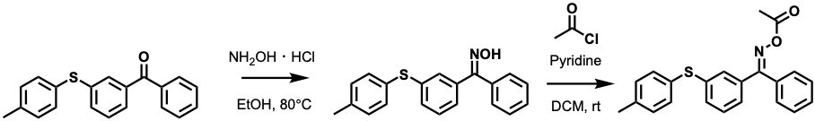
Schema S2 Synthesis root of F-01

For the first step of the synthesis, the starting 4-methylbenzophenone derivative is dissolved in ethanol, followed by the addition of hydroxylamine hydrochloride (NH₂OH•HCl). The reaction mixture is heated to 80°C and maintained at this temperature until the reaction reaches completion. After cooling to room temperature, the intermediate amine product is isolated and purified.
In the second step, the purified amine intermediate is dissolved in dichloromethane (DCM). Pyridine is added as a base to the solution. The acyl chloride is then added dropwise to the reaction mixture, which is stirred at room temperature. Upon completion of the reaction, standard workup procedures are performed, and the final N-acylated product is purified using appropriate methods.
Throughout both steps, reaction progress should be carefully monitored using appropriate analytical methods. Standard inert atmosphere techniques may be employed if the reagents are moisture sensitive. Care should be taken during the acyl chloride addition to control the exothermic nature of the reaction.

F-02
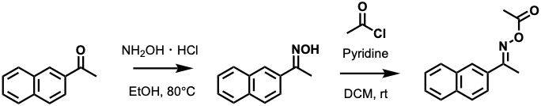
Schema S3 Synthesis root of F-02

The synthesis begins with 2-acetonaphthone dissolved in ethanol. To this solution, hydroxylamine hydrochloride (NH₂OH•HCl) is added, and the reaction mixture is heated to 80°C. The reaction is maintained at this temperature until completion, yielding the corresponding oxime intermediate. After cooling to room temperature, the oxime product is isolated and purified.
For the second step, the purified oxime intermediate is dissolved in dichloromethane (DCM). Pyridine is added to the solution as a base. The acetyl chloride is then carefully added dropwise to the reaction mixture at room temperature. The reaction is stirred until completion, followed by appropriate workup procedures. The final N-acetylated oxime product is then isolated and purified using suitable methods.
Throughout the synthesis, the reaction progress should be monitored using appropriate analytical techniques. The addition of acetyl chloride should be performed carefully to control the exothermic nature of the reaction.

A-01
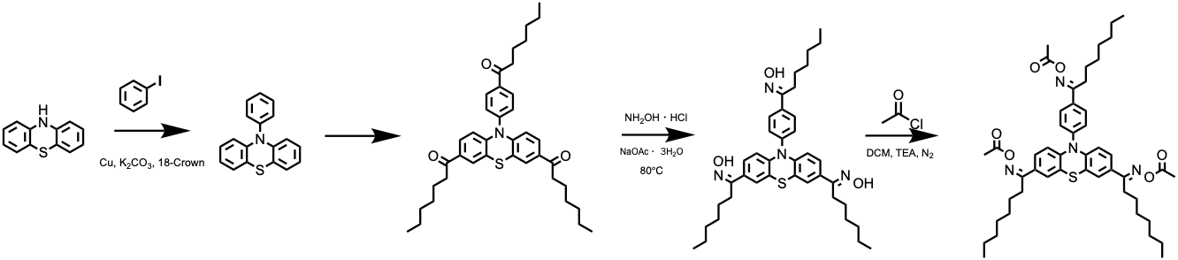
Schema S4 Synthesis root of A-01
The synthesis begins with phenothiazine, which undergoes an aryl iodide coupling reaction. The phenothiazine is combined with 4-iodotoluene in the presence of copper(I) chloride and potassium carbonate. The reaction mixture is heated to reflux in N-methyl-2-pyrrolidone for the cross-coupling reaction to proceed, yielding the N-arylated phenothiazine intermediate.
In the second step, the N-arylated phenothiazine intermediate undergoes a Friedel-Crafts acylation. The substrate is treated with hexanoyl chloride under appropriate conditions to introduce two hexanoyl groups at the 3 and 7 positions of the phenothiazine core, producing the diketone intermediate.
The third step involves the conversion of both ketone groups to oximes. The diketone intermediate is dissolved in ethanol, and hydroxylamine hydrochloride (NH₂OH•HCl) is added. The reaction mixture is heated to 80°C until the conversion is complete, forming the dioxime product.
In the final step, both oxime groups are acetylated. The dioxime intermediate is dissolved in dichloromethane (DCM), and triethylamine (TEA) is added as a base. Acetyl chloride is then carefully added dropwise at room temperature. The reaction is stirred until completion, yielding the final bis-N-acetylated oxime product.
Each step requires appropriate workup and purification procedures. The reaction progress should be monitored throughout using suitable analytical methods. Care should be taken during the addition of acetyl chloride in the final step due to the exothermic nature of the reaction.

A-02
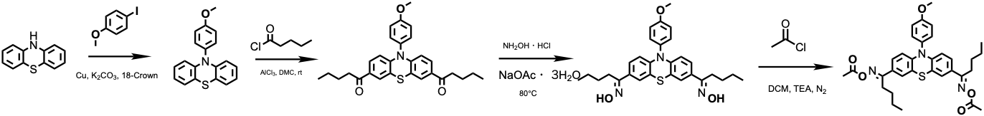
Schema S5 Synthesis root of A-02

The synthesis starts with phenothiazine and 4-iodofluorobenzene. These compounds are combined with copper(I) chloride and potassium carbonate as catalysts, and the reaction mixture is heated at reflux in N-methyl-2-pyrrolidone. This Ullmann-type coupling reaction yields the N-(4-fluorophenyl)phenothiazine intermediate.
In the second step, the fluorinated phenothiazine intermediate undergoes a Friedel-Crafts acylation. The substrate is dissolved in dichloromethane (DCM), and aluminum chloride is added as a Lewis acid catalyst. Butyryl chloride is then carefully added to the reaction mixture at 0°C. After warming to room temperature, the reaction proceeds to form the dibutyryl product with acylation occurring at the 3 and 7 positions of the phenothiazine core.
The third step involves the conversion of both ketone groups to oximes. The diketone intermediate is dissolved in ethanol, and a mixture of hydroxylamine hydrochloride (NH₂OH•HCl) and sodium acetate trihydrate is added. The reaction mixture is heated to 80°C and maintained at this temperature until the conversion to the dioxime is complete.
In the final step, both oxime groups are acetylated. The dioxime intermediate is dissolved in dichloromethane (DCM), and triethylamine (TEA) is added as a base. Acetyl chloride is then carefully added dropwise at room temperature. The reaction is stirred until completion to yield the final bis-N-acetylated oxime product.
Throughout the synthesis, each step requires appropriate workup and purification procedures. Reaction progress should be monitored using suitable analytical methods such as TLC or NMR spectroscopy. Special attention should be paid to maintaining anhydrous conditions during the Friedel-Crafts acylation and controlling the temperature during the addition of reagents.

G-01
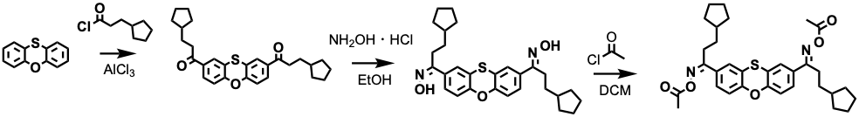
Schema S6 Synthesis root of G-01

The synthesis begins with phenoxathiin as the starting material. In the first step, the phenoxathiin undergoes a Friedel-Crafts acylation reaction. The substrate is dissolved in dichloromethane (DCM), and aluminum chloride is added as a Lewis acid catalyst. Cyclopentylacetyl chloride is then carefully added to the reaction mixture at 0°C. After warming to room temperature, the reaction proceeds to form the diacylated product with acylation occurring at the 2 and 8 positions of the phenoxathiin core, introducing two cyclopentylacetyl groups.
In the second step, both ketone groups are converted to oximes. The diketone intermediate is dissolved in ethanol, and hydroxylamine hydrochloride (NH₂OH•HCl) is added. The reaction mixture is heated to reflux temperature and maintained until the conversion to the dioxime is complete. Upon cooling, the dioxime product is isolated and purified.
The final step involves the acetylation of both oxime groups. The dioxime intermediate is dissolved in dichloromethane (DCM), and acetyl chloride is added carefully at room temperature. The reaction is stirred until completion to yield the final bis-N-acetylated oxime product.
Throughout each step of the synthesis, appropriate workup and purification procedures should be performed. The reaction progress should be monitored using suitable analytical methods such as TLC or NMR spectroscopy. Particular attention should be paid to maintaining anhydrous conditions during the Friedel-Crafts acylation step and controlling the temperature during the addition of reagents.

G-02
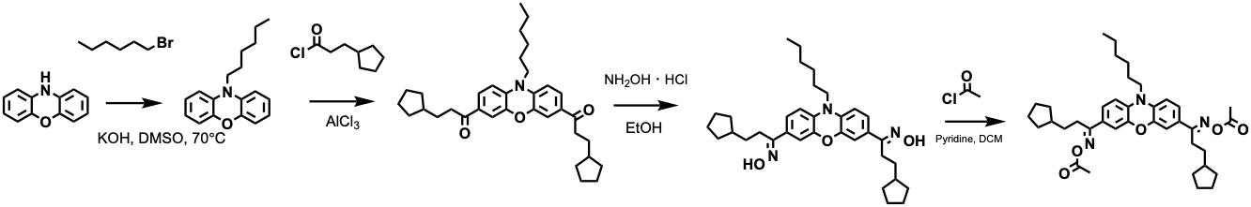
Schema S7 Synthesis root of G-02

The synthesis begins with phenoxazine as the starting material. In the first step, the N-alkylation of phenoxazine is performed using 1-bromohexane. The phenoxazine is dissolved in DMSO, and potassium hydroxide is added as a base. The reaction mixture is heated to 70°C, and 1-bromohexane is added. The reaction is maintained at this temperature until the N-alkylated phenoxazine product is formed.
In the second step, the N-alkylated phenoxazine undergoes a Friedel-Crafts acylation. The substrate is dissolved in an appropriate solvent, and aluminum chloride is added as a Lewis acid catalyst. Cyclopentylacetyl chloride is then carefully added to the reaction mixture. The reaction proceeds to form the diacylated product with acylation occurring at the 2 and 8 positions of the phenoxazine core, introducing two cyclopentylacetyl groups.
The third step involves the conversion of both ketone groups to oximes. The diketone intermediate is dissolved in ethanol, and hydroxylamine hydrochloride (NH2OH•HCl) is added. The reaction mixture is heated until the conversion to the dioxime is complete. Upon cooling, the dioxime product is isolated and purified.
In the final step, both oxime groups are acetylated. The dioxime intermediate is dissolved in dichloromethane (DCM), and pyridine is added as a base. Acetyl chloride is then carefully added dropwise at room temperature. The reaction is stirred until completion to yield the final bis-N-acetylated oxime product.
Throughout the synthesis, each step requires appropriate workup and purification procedures. The reaction progress should be monitored using suitable analytical methods such as TLC or NMR spectroscopy. Particular attention should be paid to maintaining anhydrous conditions during the Friedel-Crafts acylation step and controlling the temperature during the addition of reagents.

NMR Spectrum

F-01
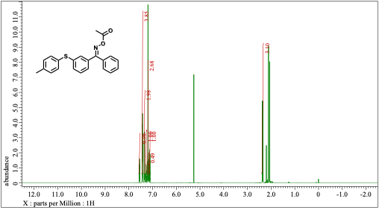
Figure S6 NMR spectra of F-01

F-02
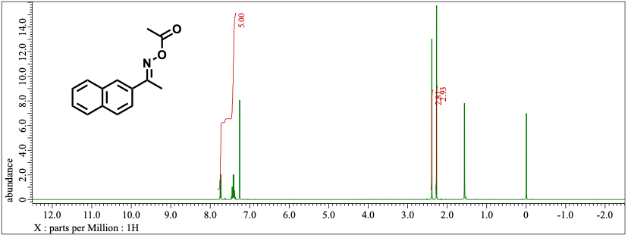
Figure S7 NMR spectra of F-02

A-01
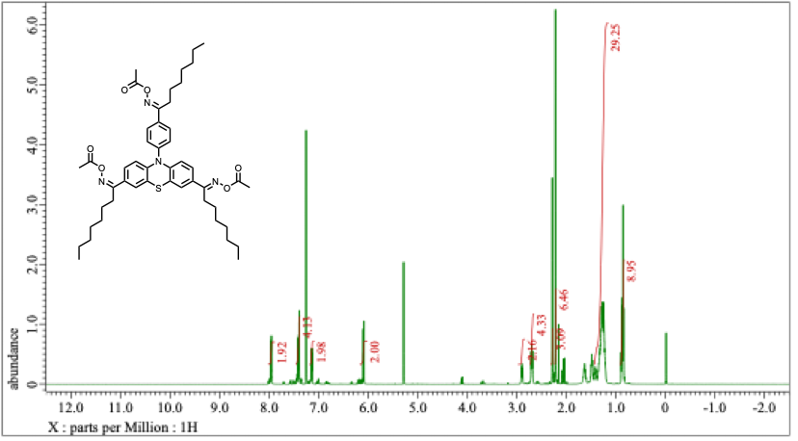
Figure S8 NMR Spectra of A-01

A-02
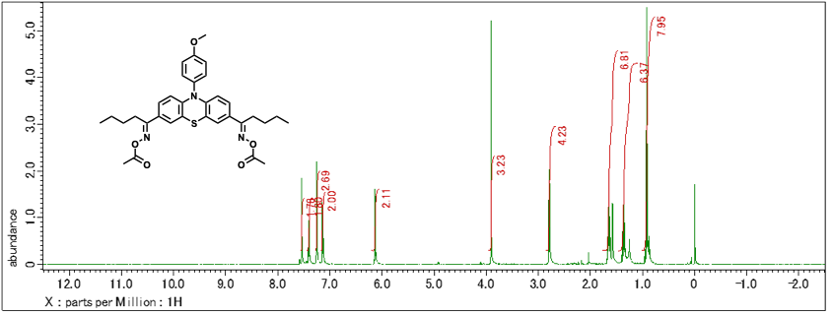
Figure S9 NMR Spectra of A-02

G-01
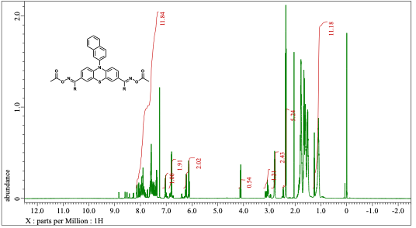
Figure S10 NMR Spectra of G-01

G-02
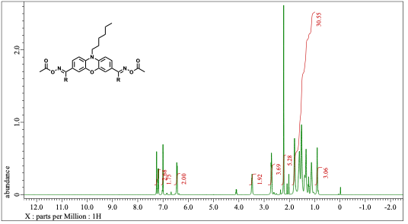
Figure S11 NMR Spectra of G-02

References
- X. Wu, S. Gong, Z. Chen, J. Hou, Q. Liao, Y. Xiong, Z. Li, and H. Tang, Dyes Pigments, 2022, 205, 110556.
- Y. H. Wu, B. Graff, J. Lalevée and Y. C. Chen, Eur. Polym. J., 2024, 217, 113300.
- F. Hammoud, A. Hijazi, M. Schmitt, F. Dumur and J. Lalevée, Eur. Polym. J., 2023, 188, 111901.
- W. J. Lee, H. S. Kwak, D. Lee, C. Oh, E. Yum, Y. An, M. D. Halls, and C. Lee., Chem. Mater., 2022, 34, 116–127.
- Z. J. Baum, X. Yu, P. Y. Ayala, Y. Zhao, S. P. Watkins, and Q. Zhou, J. Chem Inf. Model., 2021, 61, 3197–3212.
- V. Bagal, R. Aggarwal, P. K. Vinod and U. Deva Priyakumar, J. Chem. Inf. Model, 2022, 62, 2064.
- S. Ishida, T. Aasawat, M. Sumita, M. Katouda, T. Yoshizawa, K. Yoshizoe, K. Tsuda, and K. Terayama, Wiley Interdiscip. Rev. Comput. Mol. Sci., 2023, 13, e1680.
- P. Ertl and A. Schuffenhauer, J. Cheminform., 2009, 1, 1–11.
- G. Skoraczyński, M. Kitlas, B. Miasojedow and A. Gambin, J. Cheminform., 2023, 15, 1–9.
- O. O. Grygorenko, D. S. Radchenko, I. Dziuba, A. Chuprina, K. E. Gubina, and Y. S. Moroz, iScience, 2020, 23.
- S. Liu, N. Giacoletto, M. Schmitt, M. Nechab, B. Graff, F. Morlet-Savary, P. Xiao, F. Dumur, and J. Lalevee, Macromolecules, 2022, 55, 2475–2485.
- R. Zhou, H. Pan, D. Wan, J. P. Malval and M. Jin, Prog. Org. Coat., 2021, 157.
- F. Hammoud, Z. Lee, B. Graff, A. Hijazi, J. Lalevée, and Y. Chen, J. Polym. Sci., 2021, 59, 1711–1723.
- W. Wang, M. Jin, H. Pan and D. Wan, Dyes Pigments, 2021, 192.
- W. Wang, M. Jin, H. Pan and D. Wan, Prog. Org. Coat., 2021, 151, 106019.
- S. Liu, B. Graff, P. Xiao, F. Dumur and J. Lalevée, Macromol. Rapid Commun., 2021, 42.
- M. Rahal, H. Bidotti, S. Duval, B. Graff, T. Hamieh, J. Toufaily, F. Dumur, J. Lalevée, Eur. Polym. J., 2022, 177.
- Z. Li, X. Zou, G. Zhu, X. Liu and R. Liu, ACS Appl. Mater. Interfaces, 2018, 10, 16113–16123.
- S. Kim, J. Chen, T. Cheng, A. Gindulyte, J. He, S. He, Q. Li, B. A. Shoemaker, P. A. Thiessen, B. Yu, L. Zaslavsky, J. Zhang, Nucleic Acids Res., 2023, 51, D1373–D1380.
- M. Ibrahim-Ouali and F. Dumur, Eur. Polym. J., 2021, 158.
- F. Hammoud, N. Giacoletto, G. Noirbent, B. Graff, A. Hijazi, M. Nechab, D. Gigmes, F. Dumur, and J. Lalevée, Mater. Chem. Front., 2021, 5, 8361–8370.
- Y. Ding, S. Jiang, Y. Gao, J. Nie, H. Du, and F. Sun, Macromolecules, 2020, 53, 5701.
- Z. H. Lee, S. Yen, F. Hammoud, A. Hijazi, B. Graff, J. Lalevée, and Y. Chen, Polymers (Basel), 2022, 14, 5261.
- Z. Liu and F. Dumur, Eur. Polym. J., 2022, 177.
- X. Guo, W. Wang, D. Wan and M. Jin, Eur. Polym. J., 2021, 156, 110617.
- W. Qiu, P. Hu, J. Zhu, R. Liu, Z. Li, Z. Hu, Q. Chen, K. Dietliker, and R. Liska, ChemPhotoChem, 2019, 3, 1090–1094.
- F. Hammoud, N. Giacoletto, M. Nechab, B. Graff, A. Hijazi, F. Dumur, and J. Lalevée, Macromol. Mater. Eng., 2022, 307, 2200082.
- Y. Zhang, F. Morlet-Savary, M. Schmitt, B. Graff, A. Rico, M. Ibrahim-Ouali, F. Dumur, and J. Lalevée, Dyes Pigments, 2023, 215, 111202.
- M. J. Frisch et al., Gaussian 16, Revision A.03, Gaussian, Inc., Wallingford, CT, USA, 2016, Preprint.
- G. A. Landrum, RDKit: Open-source cheminformatics, 2010. Preprint.
- S. Riniker and G. A. Landrum, J. Chem. Inform. Model., 2015, 55, 2562.
- T. Halgren, J. Comput. Chem., 1996, 17, 5/6.
- D. E. Rumelhart, G. E. Hinton and R. J. Williams, Nature, 1986, 323, 533–536.
- C. Liu, Y. Sun, R. Davis, S. T. Cardona and P. Hu, J. Cheminform., 2023, 15, 1–14.
- A. Radford, J. Wu, R. Child, D. Luan, D. Amodei, and I. Sutskever, OpenAI Blog, 2019, 1, 9.
- A. Paszke, S. Gross, F. Massa, A. Lerer, J. Bradbury, G. Chanan, T. Killeen et al., Adv. Neural Inform. Process. Systems, 2019, 32.
- H. L. Morgan, J. Chem. Doc., 1965, 5, 107–113.
- J. Gasteiger and M. Marsili, Tetrahedron, 1980, 36, 3219–3228.
- E. Mazuz, G. Shtar, B. Shapira and L. Rokach, Sci. Rep., 2023, 13, 8799.
- D. Weininger, J. Chem. Inf. Comput. Sci., 1988, 28, 31–36.
- V. I. Levenshtein, Sov. Phys. Dokl., 1966, 10, 707–710.
- F. Pedregosa, M. Eickenberg, P. Ciuciu, B. Thirion, and A. Gramfort, J. Mach. Learn. Res., 2011, 12, 2825–2830.
- M. C. Rusu, C. Block, G. Van Assche and B. Van Mele, J. Therm. Anal. Calorim., 2012, 110, 287–294.
- J. Bachmann, E. Gleis, S. Schmölzer, G. Fruhmann and O. Hinrichsen, Anal. Chim. Acta, 2021, 1153, 338268.

