**El Nino data analysis extension for NASA WorldView**

This application implements an extension to NASA WorldView interactive interface for full resolution remote sensing data visualization. Specifically it consists of two components:

* **Backend API**

This is a server-side Python FastCGI application that listens to HTTP GET requests. The application performs the following actions:

WMS:

* access GIBS WMS services from https://gibs.earthdata.nasa.gov/wms
* obtain styled gridded data for a bounding box and time
* transform it into Pandas datasets using color maps
* perform statistical analysis on the data (mean, minimum, maximum and standard deviation)

Underlying GHRSST:

* access GHRSST MUR25 data source through OPeNDAP from https://podaac-opendap.jpl.nasa.gov/opendap
* obtain daily gridded SST data as xarray objects
* transform it into Pandas datasets
* perform statistical analysis on the data (mean, minimum, maximum and standard deviation)

Currently the API is capable to handle GHRSST Sea Surface Temperature data, but the architecture of the application makes it possible to analyze any GIBS datasets where a color map is available.

Sample request and response:

|  |
| --- |
| /get_stats?minx=-160&miny=-5&maxx=-150&maxy=0& timestamp=20210713 |

* **Frontend**

The vanilla NASA WorldView application has been extended to include two map controls: El Niño zones analytics control and free box control. These controls have been implemented by extending WorldView OpenLayers control model.

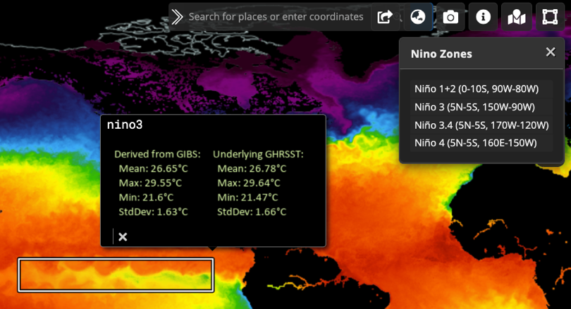The El Niño zones analytics control visualizes Niño 1+2, Niño 3, Niño 3.4, ONI, Niño 4 zones on the map and runs the backend API to obtain and visualize data analytics for the zone and for the point in time defined by the main time selection slider. The free box control allows creation of a custom bounding box, and then calculates calls the backend API to calculate and display statistics for the drawn bounding box and point in time.