WEEK 3 – FRONT-END DEVELOPMENT
OF E-GOVERNANCE APPLICATION
Interactive UI Planning, Technology Selection,
Code Structure and Backend Integration

Field | Details
Prepared By | Harsha vardhan. P
Task | Week 3 – Front-End Development of User Interface
Deliverable | Front-End Development Planning and Documentation
Status | Planning and Implementation Design

Purpose
This document converts the static prototype concept from Week 2 into a practical front-end development plan. It defines the proposed technology stack, page and component structure, responsive behavior, interaction model, state management, API integration points, security, validation, testing, accessibility, and development workflow. The scope is deliberately planning-oriented, matching the Week 3 requirement to establish a strong implementation foundation rather than complete a production application.

Contents
- 1. Executive Summary
- 2. Objectives and Scope
- 3. Technology Selection and Justification
- 4. Front-End Architecture
- 5. Layout and Page Structure
- 6. Responsive Design Strategy
- 7. Interactive Elements and User Events
- 8. State Management Strategy
- 9. Code Structure Planning
- 10. Backend/API Integration Plan
- 11. Authentication and Security
- 12. Validation and Error Handling
- 13. Representative Code and Pseudocode
- 14. Testing Strategy
- 15. Performance and Accessibility
- 16. Development Workflow
- 17. Risks and Mitigations
- 18. 30–35 Hour Work Plan
- 19. Conclusion
- 20. References
- Appendix A – Front-End Definition of Done

1. Executive Summary
The proposed front end is a responsive single-page web application for citizens accessing government digital services. The interface will support service discovery, eligibility checking, online application submission, document upload, application tracking, account functions, help, and feedback. React with TypeScript is selected as the primary implementation approach because it supports reusable components, predictable composition, strong tooling, and scalable project organization. Vite will provide a lightweight development and build workflow, while React Router will manage page navigation. Form validation will use React Hook Form with Zod schemas, and TanStack Query will be used for server-state fetching, caching, loading states, and synchronization.
The design follows a component-first approach. Shared UI elements such as buttons, fields, alerts, cards, progress indicators, and status timelines are separated from feature-specific application logic. The browser communicates with backend services through an API client over HTTPS. Production authentication, authorization, business rules, document processing, persistence, and audit controls remain backend responsibilities.

2. Objectives and Scope
- Transform the Week 2 static prototype into an implementable interactive front-end plan.
- Select and justify modern front-end technologies suitable for an e-governance portal.
- Define responsive layouts for mobile, tablet, and desktop screens.
- Specify interactive forms, buttons, menus, validation, feedback, navigation, and user-event behavior.
- Define component boundaries, state management, code organization, and API integration points.
- Document security, accessibility, performance, testing, and error-handling considerations.
- Provide representative TypeScript/React code and pseudocode to demonstrate implementation direction.
Scope boundary: Week 3 focuses on planning and front-end implementation design. It does not claim that a production backend, database, authentication service, or complete deployed product has already been implemented.

3. Technology Selection and Justification
Technology | Purpose | Reason for Selection
React | UI component framework | Reusable components, mature ecosystem, clear component composition, suitable for complex interactive portals.
TypeScript | Typed JavaScript | Reduces interface mistakes, improves maintainability, and documents data contracts through types.
Vite | Build/development tool | Fast local development, modern bundling, and simple project setup.
React Router | Client-side navigation | Supports route-based pages and nested service/application flows.
React Hook Form | Form state | Efficient handling of large forms with reduced unnecessary re-renders.
Zod | Schema validation | Centralizes validation rules and provides a clear typed boundary for form/API data.
TanStack Query | Server state | Handles API loading, caching, retries, refetching, and mutation state.
Vitest + Testing Library | Testing | Supports fast unit/component tests and user-focused UI testing.
ESLint + Prettier | Code quality | Keeps code consistent and catches common issues before review.
CSS Modules + design tokens | Styling | Provides locally scoped styles and reusable spacing, typography, and component tokens.

Technology Alternatives Considered
Option | Strengths | Why Not Selected for This Plan
Angular | Opinionated structure, TypeScript-first, strong enterprise features | More framework overhead than necessary for the planned prototype-to-front-end transition.
Vue.js | Approachable syntax, progressive adoption, component model | Strong option, but React offers the preferred component ecosystem and team familiarity assumed for this plan.
Plain JavaScript + HTML/CSS | Minimal dependencies | Becomes harder to organize and reuse as service forms, tracking, authentication, and multiple pages grow.

Conclusion: React + TypeScript is the recommended stack, supported by focused libraries rather than a large all-in-one framework. The selection is intended to balance maintainability, accessibility, responsiveness, developer productivity, and future integration.

4. Front-End Architecture
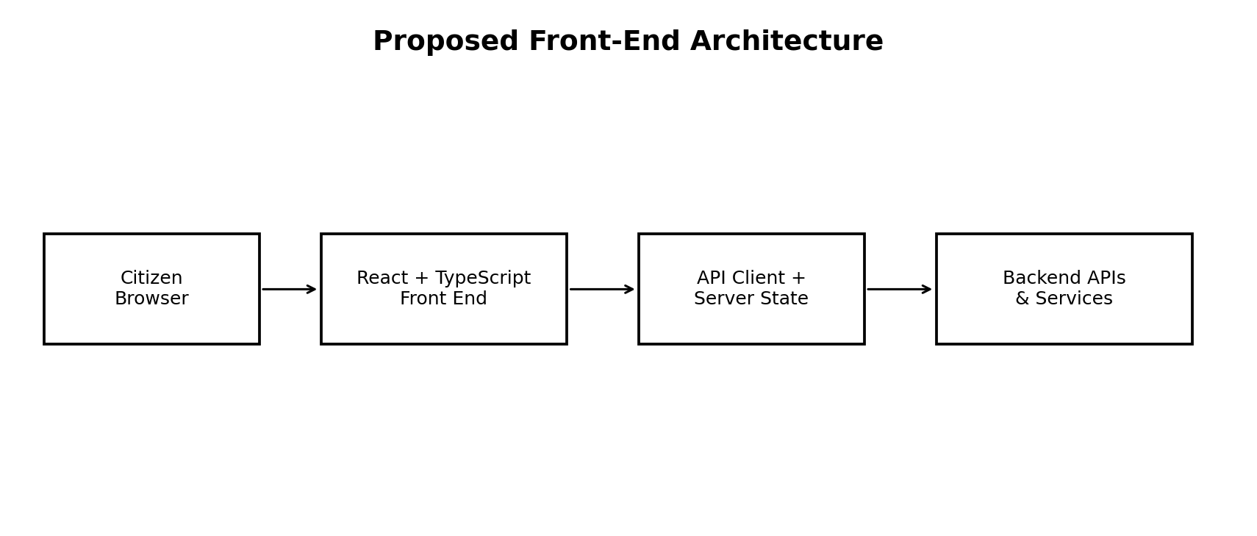
The architecture separates presentation, client-side state, server-state communication, and backend services. The UI should not directly contain business rules that belong to the backend. API calls should be centralized through an API client so authentication headers, error normalization, timeouts, and request identifiers can be handled consistently.

5. Layout and Page Structure
Page / Area | Main UI Elements | Primary Interaction
Home | Header, search, service categories, popular services, help links | Search, category selection, open service
Service Details | Title, description, eligibility, required documents, CTA | Check eligibility / Start application
Eligibility | Questions, radio/checkbox/select controls, progress | Answer questions and view result
Application Form | Step indicator, grouped fields, save draft, navigation | Enter, validate, save, continue
Documents | Upload cards, file status, document requirements | Select, upload, replace, remove
Review | Read-only summary, edit links, declarations | Review and submit
Confirmation | Reference number, status, next steps | View application / return home
My Applications | Filters, status cards/table, search | Open and track applications
Application Details | Status timeline, submitted data, messages | Track progress and respond where allowed
Help / Feedback | FAQs, contact options, feedback form | Search help or submit feedback
Account | Profile, session controls, preferences | View/update allowed profile information

6. Responsive Design Strategy
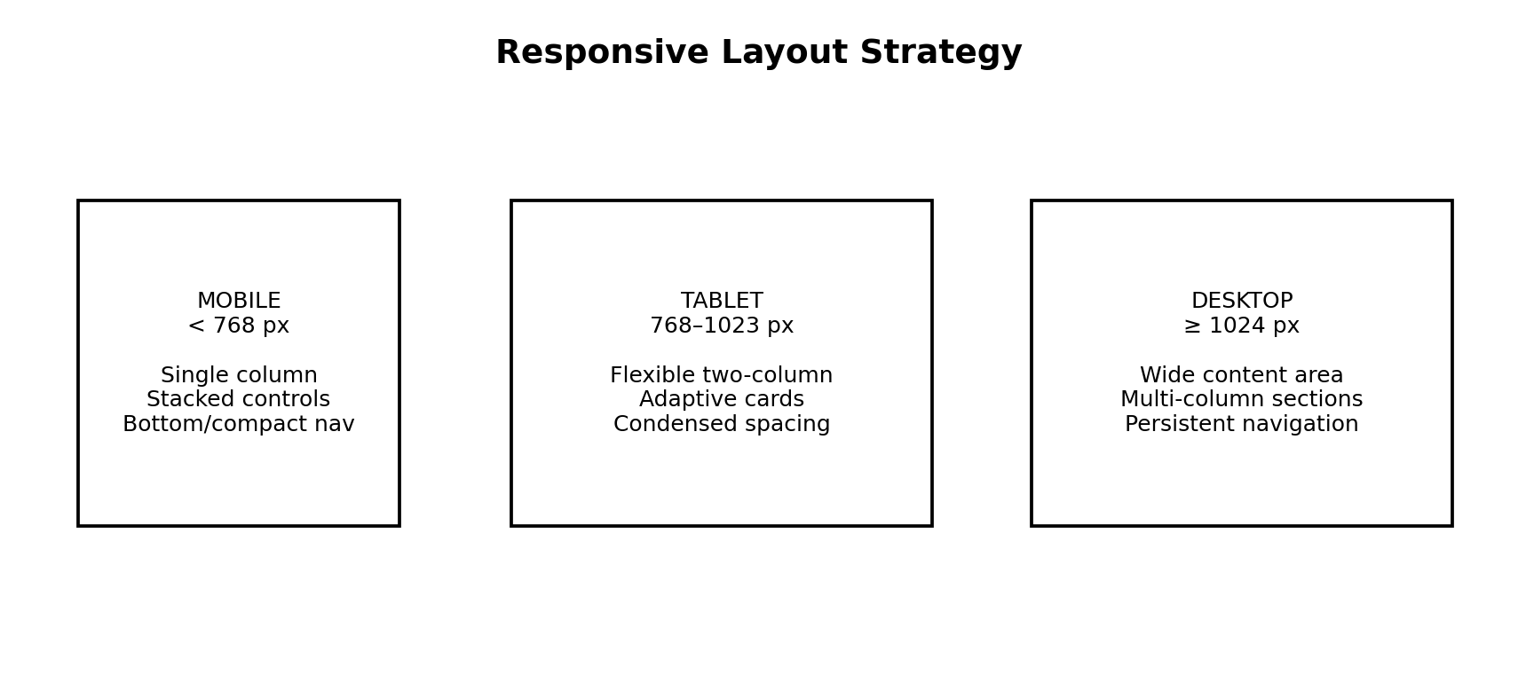
Breakpoint | Layout Approach | Key Considerations
Mobile: < 768 px | Single-column content, stacked forms, compact header/navigation | Large touch targets, short labels, no horizontal scrolling, readable error messages.
Tablet: 768–1023 px | Flexible two-column sections where useful | Balance content density with touch-friendly controls.
Desktop: ≥ 1024 px | Wider content container, multi-column cards/forms, persistent navigation where appropriate | Efficient scanning without excessive empty space.

Responsive behavior should be based on content and usability rather than a single device model. Forms should reflow without losing field order, validation messages must remain attached to the relevant control, and important actions should remain visible and understandable at all widths.

7. Interactive Elements and User Events
Component | User Event | Expected Behavior
SearchBar | Typing / submit | Debounce optional search, show matching services, display empty-state guidance.
ServiceCard | Click / keyboard activation | Open service details while preserving accessible focus behavior.
EligibilityQuestion | Select answer | Update form state, validate when appropriate, show progress.
TextField | Input / blur | Update form state, run field validation, show clear error/help text.
FileUpload | Select file | Validate type/size, show progress/status, allow retry or replacement.
ProgressStepper | Next / Back | Move between steps while preserving valid draft state.
Save Draft | Click | Validate saveable fields and persist draft through API.
Submit | Click | Run final validation, show confirmation state, submit once, handle response.
StatusTimeline | View | Present chronological application status clearly.
Modal / Alert | Open / close | Provide focused information without blocking unrelated content unnecessarily.
FeedbackForm | Submit | Validate message, send feedback, show confirmation or retry.

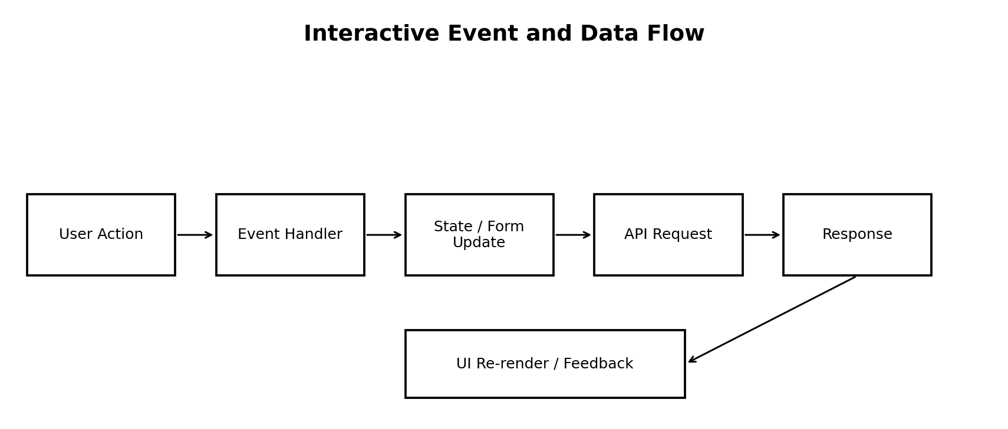

8. State Management Strategy
State Type | Examples | Recommended Handling
Local UI state | Modal open, selected tab, menu state | React useState/useReducer
Form state | Name, address, declarations, answers | React Hook Form + Zod
Server state | Service list, application status, API responses | TanStack Query
Session state | Authenticated user/session status | Auth provider/context or secure session integration
Draft state | Partially completed application | Backend draft endpoint plus local recovery only when appropriate

State should have a single clear owner. Server data should not be duplicated into many unrelated local states. Sensitive data should not be unnecessarily persisted in browser storage. The backend remains authoritative for application status and business rules.

9. Code Structure Planning
src/
├── app/
│ ├── router/
│ ├── providers/
│ └── config/
├── components/
│ ├── ui/
│ ├── forms/
│ ├── service/
│ └── application/
├── pages/
│ ├── Home/
│ ├── Services/
│ ├── Application/
│ ├── Tracking/
│ ├── Account/
│ └── Support/
├── features/
│ ├── authentication/
│ ├── services/
│ ├── applications/
│ ├── documents/
│ └── feedback/
├── hooks/
├── services/
│ ├── apiClient.ts
│ ├── servicesApi.ts
│ └── applicationsApi.ts
├── schemas/
├── types/
├── utils/
├── styles/
└── tests/
Component assignment principle: shared visual primitives belong in components/ui; reusable form controls belong in components/forms; domain-specific workflows belong under features; page composition belongs in pages; API calls belong in services; validation schemas belong in schemas; shared data contracts belong in types.

10. Backend/API Integration Plan
The following are illustrative integration points for production planning; exact endpoint names and payloads would be agreed with the backend team.
Method / Endpoint | Purpose | Front-End Usage
GET /api/services?query=... | Search/list services | Home and service discovery
GET /api/services/{id} | Service details | Service Details page
POST /api/services/{id}/eligibility | Evaluate eligibility | Eligibility flow
POST /api/applications | Create application/draft | Start application
PATCH /api/applications/{id} | Save changes | Save Draft
POST /api/applications/{id}/documents | Upload document | Documents step
POST /api/applications/{id}/submit | Submit application | Final submission
GET /api/applications/{id} | Get application | Tracking/details
POST /api/applications/{id}/messages | Application communication | Allowed user messages
POST /api/feedback | Submit feedback | Feedback form

Integration sequence:
- User performs an action in the UI.
- Client-side validation checks basic format and required fields.
- API client sends an HTTPS request with the approved authentication/session mechanism.
- Backend authenticates the request and applies authorization and business rules.
- Backend returns a success or structured error response.
- Front end updates server state/cache and presents confirmation, errors, or next steps.
- Application status is treated as backend-authoritative.
Illustrative normalized error response:
{
"code": "VALIDATION_ERROR",
"message": "Some information needs correction.",
"fields": {
"fullName": "Enter your full name."
},
"requestId": "REQ-EXAMPLE"
}

11. Authentication and Security
- Use the organization's approved authentication mechanism; do not invent a parallel login system in the front end.
- Use HTTPS for all production API communication.
- Enforce authorization on the backend; hiding a UI button is not a security control.
- Minimize sensitive information stored in browser storage and avoid storing secrets in source code.
- Do not log passwords, tokens, document contents, or unnecessary personal information.
- Handle session expiry consistently and redirect the user to a safe re-authentication flow.
- Validate uploaded file type and size on both client and server; scan/process files according to production policy.
- Use security headers and a suitable Content Security Policy in production.
- Use audit logging on the backend for important application actions.

12. Validation and Error Handling
Scenario | Front-End Response
Required field missing | Show field-level message and focus the first invalid field where appropriate.
Invalid format | Explain the expected format without blaming the user.
Invalid/oversized document | Reject early with clear allowed-format/size guidance.
Network failure | Show retry option and preserve safe local form state.
401 / session expired | Pause protected action and use the approved sign-in flow.
403 / not permitted | Show a clear permission message; do not expose protected details.
404 / unavailable resource | Show a helpful not-found state and navigation back to a safe location.
409 / conflicting update | Refresh authoritative data and explain that the record changed.
500 / server failure | Show a generic error, request ID if appropriate, and retry/support guidance.

13. Representative Code and Pseudocode
Example React + TypeScript component:
type ServiceCardProps = {
title: string;
description: string;
serviceId: string;
onOpen: (serviceId: string) => void;
};
export function ServiceCard({
title, description, serviceId, onOpen
}: ServiceCardProps) {
return (
<article>
<h3>{title}</h3>
<p>{description}</p>
<button onClick={() => onOpen(serviceId)}>
View service
</button>
</article>
);
}
Application submission pseudocode:
WHEN user selects Submit:
validate visible fields
IF validation fails:
show field-level errors
focus first invalid field
STOP
show submitting state
send application data to API
IF API succeeds:
invalidate/refetch application status
show confirmation and reference number
ELSE:
normalize error
show safe error message
allow retry
Document upload pseudocode:
WHEN user selects a document:
check file type and size
IF invalid:
show requirement message
STOP
request upload authorization if required
upload using approved API flow
show progress
IF successful:
mark document as uploaded
ELSE:
show retry option

14. Testing Strategy
Test Level | Focus | Example
Unit | Utilities, validators, mapping functions | Eligibility rule input validation
Component | UI behavior and accessibility | Form field error, button state, modal behavior
Integration | API/client and state interaction | Create draft → upload document → refresh status
Accessibility | Keyboard, focus, labels, semantics, contrast | Complete application without a mouse
Responsive | Viewport and layout behavior | Check form at mobile/tablet/desktop widths
End-to-End | Critical citizen journey | Search service → eligibility → application → confirmation
Security checks | Safe handling of auth/errors/uploads | No secrets in client bundle or logs

Core acceptance criteria:
- Every primary task is reachable by keyboard and has a clear focus state.
- Required fields show understandable validation messages.
- Loading, success, empty, and error states are defined for API-driven screens.
- Layout remains usable on mobile, tablet, and desktop widths.
- Application data is not assumed to be valid merely because client-side validation passed.
- API failures do not expose stack traces, secrets, or internal implementation details.

15. Performance and Accessibility
- Use semantic HTML elements and meaningful headings.
- Associate labels and error messages with form controls.
- Ensure keyboard navigation and visible focus states.
- Use responsive images and lazy loading where appropriate.
- Split or lazy-load large routes when useful.
- Keep JavaScript bundles and third-party dependencies under review.
- Debounce search input where frequent requests would be wasteful.
- Use loading indicators that do not cause confusing layout shifts.
- Test with browser accessibility tools and keyboard-only navigation.

16. Development Workflow
- Create the React + TypeScript project and establish linting/formatting.
- Build shared design tokens and basic UI primitives.
- Implement routing and page shells.
- Implement service discovery and service details.
- Implement eligibility and application form components.
- Add document upload and review/confirmation states.
- Add application tracking and account/support pages.
- Connect the API client to approved backend endpoints.
- Add validation, loading, empty, and error states.
- Run unit, component, responsive, accessibility, and integration checks.

17. Risks and Mitigations
Risk | Impact | Mitigation
Backend contract changes | Integration rework | Define typed API contracts and centralize API calls.
Large forms become difficult to maintain | Higher defect rate | Break forms into reusable sections and validation schemas.
Inconsistent UI across pages | Poor usability | Use shared UI components and design tokens.
Sensitive data stored unnecessarily | Privacy/security risk | Minimize browser persistence and follow approved security architecture.
Mobile layout overlooked | Accessibility/usability issues | Design mobile-first and test multiple widths early.
Unclear error states | User confusion | Define loading, empty, validation, permission, conflict, and server-error states.
Scope expansion | Schedule risk | Keep Week 3 focused on front-end planning and critical citizen journeys.

18. 30–35 Hour Work Plan
Activity | Hours
Technology research and stack selection | 4.0
Architecture and code-structure planning | 4.0
Layout and responsive planning | 4.0
Components and interactive behavior | 5.0
State management and API integration plan | 4.0
Security, accessibility and validation | 3.0
Code examples and testing strategy | 3.5
Documentation, review and final organization | 4.0
Total | 31.5

The plan fits the required 30–35 hour effort and prioritizes analysis, documentation, and implementation readiness rather than full product completion.

19. Conclusion
Week 3 establishes the bridge between the Week 2 prototype and an actual front-end implementation. The recommended React + TypeScript architecture provides reusable components, typed data contracts, structured routing, validated forms, managed server state, and a clear path to backend integration. Responsive layout rules ensure the portal remains usable across mobile, tablet, and desktop screens. Security, accessibility, error handling, testing, and performance are included as design requirements rather than being postponed until the end of development. This plan provides a practical baseline for moving from static screens to an interactive e-governance user interface.

20. References
- GOV.UK Design System – Homepage – https://design-system.service.gov.uk/
- GOV.UK Design System – Patterns – https://design-system.service.gov.uk/patterns/
- GOV.UK Design System – Start using a service – https://design-system.service.gov.uk/patterns/start-using-a-service/
- GOV.UK Design System – Navigate a service – https://design-system.service.gov.uk/patterns/navigate-a-service/
- Digital India – UMANG – https://www.digitalindia.gov.in/initiative/umang/
- React Documentation – https://react.dev/
- TypeScript Documentation – https://www.typescriptlang.org/docs/
- Vite Documentation – https://vite.dev/
- React Router Documentation – https://reactrouter.com/
- TanStack Query Documentation – https://tanstack.com/query/latest
- React Hook Form Documentation – https://react-hook-form.com/
- Zod Documentation – https://zod.dev/

Appendix A – Front-End Definition of Done
- Pages and routes are defined and connected.
- Shared components have documented props and expected behavior.
- Forms have client-side validation and clear server-error handling.
- Responsive behavior is tested at mobile, tablet, and desktop widths.
- Keyboard navigation and focus behavior are checked.
- API calls are centralized and typed where practical.
- Loading, empty, success, and error states are implemented or explicitly planned.
- No credentials, tokens, or sensitive data are hard-coded.
- Unit/component/integration test coverage is planned for critical flows.
- Code is formatted, linted, reviewed, and documented sufficiently for handoff.

