WEEK 4 – BACKEND INTEGRATION
AND API TESTING STRATEGY
API Specification, Integration Workflow, Security and Automated Testing Plan
Field | Details
Prepared By | Harsha vardhan. P
Task | Week 4 – Backend Integration and API Testing Strategy
Deliverable | API Integration Plan and API Testing Strategy
Status | Planning, Simulation and Test Design

Contents
- 1. Executive Summary
- 2. Objectives and Scope
- 3. Backend Integration Architecture
- 4. API Specification
- 5. Data Formats and API Contracts
- 6. Front-End Integration Strategy
- 7. Request/Response Workflow
- 8. Authentication and Authorization
- 9. API Security Controls
- 10. Error Handling
- 11. API Testing Strategy
- 12. API Test Cases
- 13. Automation Strategy
- 14. Performance Testing
- 15. Test Data and Environment
- 16. Defect Management and Reporting
- 17. 30–35 Hour Work Plan
- 18. Risks and Mitigations
- 19. Conclusion
- 20. References
- Appendix A – API Readiness Checklist

1. Executive Summary
This report presents a practical backend integration and API testing strategy for the E-Governance Digital Service application. The Week 3 front-end plan established the React/TypeScript client, reusable components, forms, state management and API-client boundary. Week 4 extends that plan by defining how the client would communicate with simulated backend services through secure REST-style APIs and how those APIs would be tested before production integration.
The proposed API layer covers authentication/session handling, service discovery, service details, eligibility, application creation and updates, document handling, application submission, application tracking, messages and feedback. JSON is used for normal application data, while document uploads use multipart/form-data or an approved upload mechanism.
The testing strategy combines unit, integration, contract, functional, negative, security-focused, performance and end-to-end testing. Automated tests are intended to run consistently in a controlled test environment and can be integrated into a CI pipeline. This report is a planning and simulation guide and does not claim that real government APIs, production databases or real citizen information are connected.

2. Objectives and Scope
- Define an implementation-ready API integration plan between the Week 3 front end and simulated backend services.
- Specify core endpoints, methods, request formats, response formats, status codes and error structures.
- Explain client-to-server data flow for key citizen journeys.
- Define authentication, authorization, encryption and secure data-handling considerations.
- Create realistic API test cases covering positive, negative, boundary and failure scenarios.
- Plan automated unit, integration, contract and performance testing.
- Define measurable validation criteria for API correctness, reliability and performance.
- Provide a 30–35 hour work plan matching the internship task requirement.

Scope Boundary
Week 4 focuses on integration design and API testing strategy. A simulated/mock backend may be used for development and testing. Production government infrastructure, real personal data, live identity services, payment systems and production credentials are outside the scope of this task.

3. Backend Integration Architecture
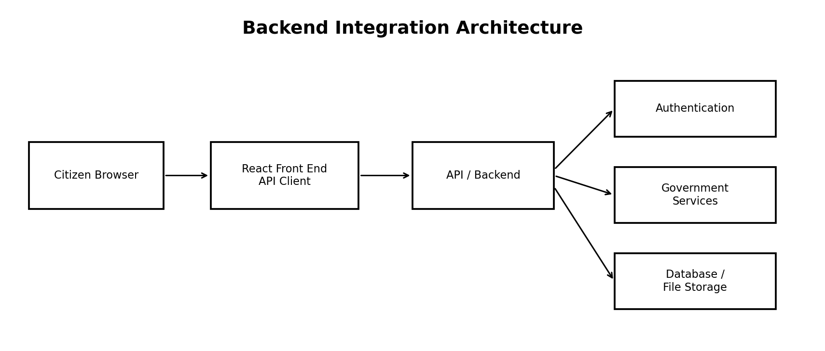
The front end communicates with an API layer rather than directly accessing a database. The API layer validates requests, authenticates users, checks authorization, invokes the appropriate service, accesses approved data stores, and returns a consistent response. This separation improves security, testability and maintainability.
Layer | Responsibility
React Front End | Collect input, display data, manage UI state and present API results.
API Client | Build requests, apply approved session/auth handling, parse responses and normalize errors.
API / Backend | Authentication, authorization, business rules, validation, workflow and service orchestration.
Government Service Layer | Service-specific processing and approved departmental integrations.
Data Store | Persistent service/application data and controlled document metadata/storage.
Audit / Monitoring | Operational logs, audit events, metrics and security monitoring.

4. API Specification
ID | Method | Endpoint | Purpose
API-01 | POST | /api/auth/login | Start simulated/approved authentication flow.
API-02 | POST | /api/auth/logout | End current session.
API-03 | GET | /api/services | Retrieve/search government services.
API-04 | GET | /api/services/{id} | Retrieve service details and requirements.
API-05 | POST | /api/services/{id}/eligibility | Evaluate eligibility inputs.
API-06 | POST | /api/applications | Create application/draft.
API-07 | PATCH | /api/applications/{id} | Update draft application.
API-08 | POST | /api/applications/{id}/documents | Submit document upload.
API-09 | POST | /api/applications/{id}/submit | Submit completed application.
API-10 | GET | /api/applications/{id} | Retrieve application status/details.
API-11 | GET | /api/applications | List authenticated user's applications.
API-12 | POST | /api/applications/{id}/messages | Send permitted application message.
API-13 | POST | /api/feedback | Submit service feedback.

4.1 Endpoint Inputs and Outputs
Endpoint | Illustrative Input | Successful Output
POST /api/auth/login | Approved simulated credentials/session request | Session/auth result.
GET /api/services?query=&page= | Search and pagination parameters | Service list + metadata.
GET /api/services/{id} | Service ID | Service details, eligibility and documents.
POST /api/services/{id}/eligibility | JSON answers | Eligibility result + next step.
POST /api/applications | JSON service ID + initial data | Application ID + draft status.
PATCH /api/applications/{id} | JSON changed fields | Updated application metadata.
POST /api/applications/{id}/documents | Multipart file/upload reference | Document ID + processing status.
POST /api/applications/{id}/submit | Declaration/confirmation data | Reference number + submitted status.
GET /api/applications/{id} | Application ID | Summary + status timeline.
GET /api/applications | Filters + pagination | Application list.
POST /api/feedback | JSON rating/comment/service reference | Feedback acknowledgement.

5. Data Formats and API Contracts
JSON is proposed for normal API requests and responses. Date/time values should use an agreed standard, preferably ISO 8601 at the API boundary. IDs should be treated as opaque strings by the front end.
Example service response:
{
"id": "SERVICE-001",
"name": "Example Government Service",
"description": "Service description",
"eligibility": ["Eligibility condition"],
"documents": ["Identity proof", "Supporting document"],
"status": "ACTIVE"
}
Example application response:
{
"applicationId": "APP-EXAMPLE",
"referenceNumber": "REF-EXAMPLE",
"status": "SUBMITTED",
"submittedAt": "2026-09-13T12:00:00Z"
}
Standard error response:
{
"code": "VALIDATION_ERROR",
"message": "Some information needs correction.",
"fields": {"fullName": "Enter your full name."},
"requestId": "REQ-EXAMPLE"
}
Status | Meaning | Front-End Handling
200 | Successful request | Render returned data.
201 | Created | Store returned identifier and continue.
204 | Success without body | Show completion.
400 | Malformed/invalid request | Show validation guidance.
401 | Authentication required/expired | Use approved re-authentication.
403 | Not permitted | Show permission message.
404 | Not found | Show safe not-found state.
409 | Conflict | Refresh authoritative data.
422 | Semantic validation | Map errors to form.
429 | Rate limited | Back off/retry per server guidance.
500 | Server failure | Safe generic error.
503 | Unavailable | Temporary outage/retry state.

6. Front-End Integration Strategy
- Define typed request and response models.
- Create a centralized API client for base URL, headers, request IDs, timeouts and error normalization.
- Keep API functions separate from page components.
- Use server-state management for service/application data.
- Connect form handlers to API mutations.
- Show loading, success, empty and error states.
- Invalidate/refetch affected data after successful mutations.
- Never treat client validation as a replacement for server validation.
- Use mock responses until approved backend endpoints are available.

6.1 Screen-to-API Mapping
Front-End Screen | API Dependency | Result
Home / Search | GET /api/services | Service list populated.
Service Details | GET /api/services/{id} | Requirements displayed.
Eligibility | POST /api/services/{id}/eligibility | Eligibility result displayed.
Application | POST/PATCH /api/applications | Create/save draft.
Documents | POST /api/applications/{id}/documents | Upload status.
Review / Submit | POST /api/applications/{id}/submit | Confirmation/reference.
My Applications | GET /api/applications | List and filters.
Tracking | GET /api/applications/{id} | Status timeline.
Feedback | POST /api/feedback | Acknowledgement.

7. Request/Response Workflow
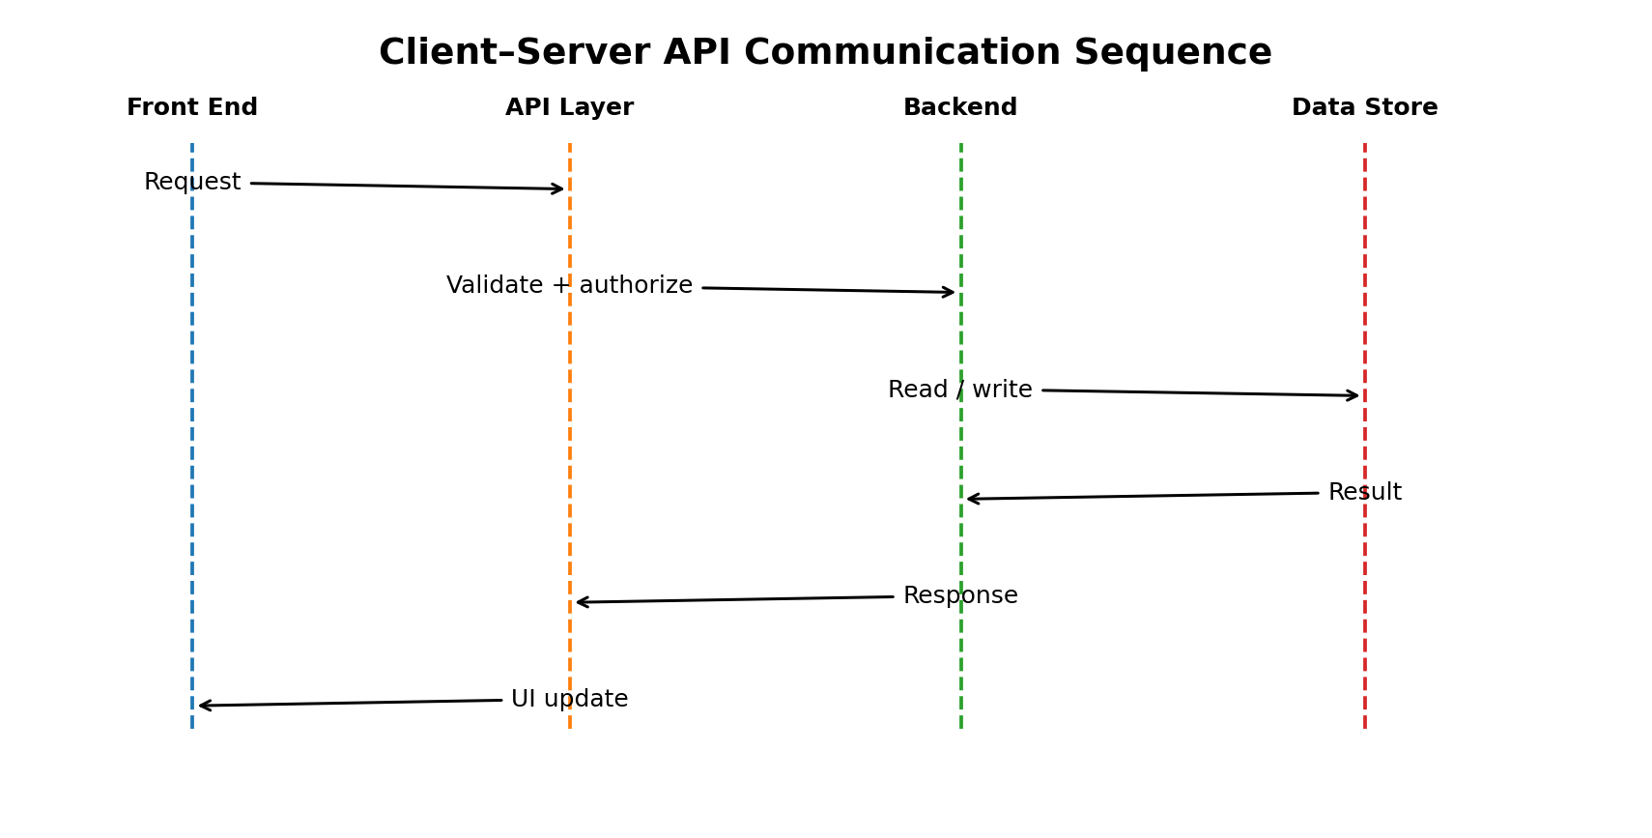
- Citizen performs an action in the browser.
- React validates basic client-side input.
- API client creates the request.
- Backend authenticates and authorizes the request.
- Backend validates business rules and invokes required service.
- Controlled data services read/write data.
- Backend returns standardized response and HTTP status.
- API client parses and normalizes failures.
- Server-state/UI state is updated.
- Citizen receives confirmation, status, validation guidance or safe error.

8. Authentication and Authorization
- Use the organization's approved identity architecture for production.
- Use dummy credentials only for simulated Week 4 testing.
- Authentication establishes identity; authorization controls permitted operations.
- Protected endpoints must enforce authorization server-side.
- Session/token handling must follow approved architecture and never expose secrets in source code.
- Handle session expiry predictably without silently losing safe work.
- Administrative endpoints require appropriate roles and must not rely only on hidden UI controls.

8.1 Example Roles
Role | Typical Permissions
Citizen | View services, manage own applications, upload permitted documents, track applications, submit feedback.
Service Administrator | Manage approved service configuration and permitted operational data.
Government Officer | Process assigned applications according to department permissions.
System Administrator | Manage approved users/system configuration and operational functions.

9. API Security Controls
Control | Planned Measure
Transport | HTTPS/TLS in production.
Authentication | Approved identity/session mechanism.
Authorization | Server-side role/resource checks.
Input validation | Type, length, range, schema and business validation.
Output handling | Return only authorized data.
Rate limiting | Limits for authentication and high-cost operations.
File security | Type/size controls, scanning and controlled storage.
Secrets | Never hard-code credentials or keys.
Logging | Structured logs without unnecessary personal data.
Audit | Record important workflow/security actions.
Error safety | No stack traces or internal details to clients.
CORS | Allow only approved production origins.
Security headers | Use approved CSP and browser security protections.

10. Error Handling
- Use consistent status codes and error structures.
- Map field errors to the correct form controls.
- Provide retry only when retry is safe.
- Prevent duplicate submission through UI state and appropriate server controls.
- Preserve safe user-entered information after recoverable network failures.
- Keep technical diagnostics in controlled logs, not citizen-facing responses.
- Never expose credentials, internal exceptions, database errors or infrastructure details.

11. API Testing Strategy
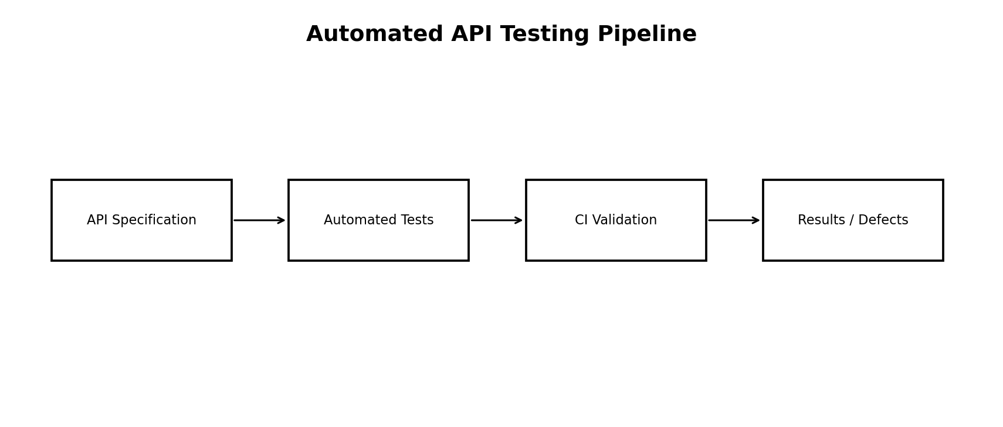
Test Type | Purpose | Suggested Approach
Unit | Validators, mappers, API helpers | Vitest/equivalent
Component | UI behavior around API states | Testing Library + mocked API
Functional API | Endpoint behavior/contracts | Postman/Newman or equivalent
Integration | Front end + API + simulated backend | Mock server/test backend
Contract | Request/response compatibility | OpenAPI-style schema + contract tests
Negative | Invalid input/permission failures | Automated test data
Security | Auth, authorization, common API weaknesses | OWASP-aligned checks
Performance | Latency, throughput, error rate | k6/JMeter or equivalent
End-to-End | Complete citizen journeys | Playwright/Cypress or equivalent

12. API Test Cases
ID | Scenario | Condition | Expected Result
TC-001 | GET services | Valid query | 200; valid schema; results returned.
TC-002 | GET service details | Existing ID | 200; required fields present.
TC-003 | GET service details | Unknown ID | 404; safe error.
TC-004 | Eligibility | Valid answers | 200; expected simulated result.
TC-005 | Eligibility | Missing answer | 422; validation error.
TC-006 | Create application | Valid authenticated request | 201; unique application ID.
TC-007 | Create application | Unauthenticated | 401; no record created.
TC-008 | Update application | Owner updates draft | 200; updated state.
TC-009 | Update application | Other user's application | 403/404; no data leakage.
TC-010 | Document upload | Valid simulated file | 200/201; document status.
TC-011 | Document upload | Invalid/oversized file | 400/422; rejected.
TC-012 | Submit | Complete draft | 200/201; reference + submitted status.
TC-013 | Submit | Incomplete draft | 422; submission rejected.
TC-014 | Tracking | Authorized application | 200; timeline returned.
TC-015 | Tracking | Unauthorized application | 403/404; no private data.
TC-016 | Feedback | Valid feedback | 200/201; acknowledgement.
TC-017 | Rate limit | Excessive requests | 429; retry behavior.
TC-018 | Server failure | Simulated outage | 500/503; safe error.

12.1 Boundary and Negative Tests
- Empty mandatory fields.
- Very long strings.
- Wrong JSON data types.
- Invalid enumeration values.
- Malformed IDs.
- Expired session.
- Missing authentication.
- Cross-user resource access.
- Duplicate submission.
- Unsupported document extension/size.
- Timeout and slow response.
- Malformed simulated backend response.

13. Automation Strategy
- Run unit/API tests locally.
- Run linting, unit and API tests on pull requests.
- Start a disposable simulated backend/test data store in CI.
- Execute front-end/API integration tests.
- Collect reports and logs as build artifacts.
- Block merge/release according to project policy when critical tests fail.
- Run broader performance/security suites on scheduled or release pipelines.
- Use synthetic test data only.
- Reset test state when isolation is required.
- Store test configuration securely.
- Assert status codes and response schemas.
- Test failure paths as well as success paths.
- Map important tests to requirements/acceptance criteria.

14. Performance Testing
The following are proposed planning thresholds for a simulated environment, not claims about a production government system.
Scenario | Metric | Illustrative Target
Service search | p95 latency | ≤ 800 ms under agreed test load
Service details | p95 latency | ≤ 800 ms
Create/update draft | p95 latency | ≤ 1000 ms
Application status | p95 latency | ≤ 1000 ms
Error rate | Failed requests | < 1% under normal test load
Sustained load | Throughput | Set from agreed traffic model
Spike test | Recovery | Recover without data corruption

Performance reports should include request count, throughput, average and percentile latency, error rate, resource behavior where available, and the exact load profile.

15. Test Data and Environment
Environment | Purpose | Data Policy
Local | Developer testing | Synthetic/local-only data.
Integration | Front-end/API testing | Controlled synthetic accounts and services.
Staging | Pre-release validation | Synthetic or approved masked data only.
Production | Real operations | Not used for this Week 4 exercise.

- Create test users for citizen, officer, administrator and unauthorized scenarios.
- Use predictable synthetic IDs.
- Include valid, invalid, boundary and incomplete data.
- Ensure resets do not affect production.

16. Defect Management and Reporting
Severity | Example | Handling
Critical | Authentication bypass or cross-user exposure | Immediate escalation and release block.
High | Submission corrupts/loses data | Fix before release + regression.
Medium | Incorrect validation/status | Planned fix + regression.
Low | Minor wording/non-blocking issue | Track and prioritize.

Each defect should include endpoint, conditions, expected/actual result, status/response where safe, environment, severity, reproducibility and request/correlation ID. Never include passwords, secrets or unnecessary personal information.

17. 30–35 Hour Work Plan
Activity | Hours
API specification and endpoint design | 4.5
Data contracts and error model | 3.5
Front-end integration workflow | 3.5
Authentication and API security | 4.0
Functional and negative test design | 5.0
Automation and CI strategy | 3.5
Performance test planning | 2.5
Diagrams, documentation and review | 4.0
Final quality and submission preparation | 1.5
Total | 32.0

18. Risks and Mitigations
Risk | Impact | Mitigation
API contract mismatch | Integration failures | Typed contracts and contract tests.
Authentication architecture changes | Rework/security risk | Confirm approved architecture before production.
Inconsistent errors | Poor UX/automation | Standard status and error model.
Shared test state | Flaky tests | Synthetic isolated data and reset.
Unrealistic performance target | Misleading results | Agree workload and targets with stakeholders.
Sensitive test data | Privacy risk | Synthetic data only.
External service outage | Blocked tests | Mock dependencies and failure scenarios.

19. Conclusion
Week 4 establishes a complete strategy for connecting the planned front end to simulated backend services and validating the integration through systematic API testing. The API plan defines service operations, request/response formats, status codes, error handling and security boundaries. The integration workflow separates UI responsibilities from backend business rules and persistence.
The testing strategy covers unit, component, functional, integration, contract, negative, security, performance and end-to-end testing. Synthetic data, repeatable automated tests and controlled CI execution provide a practical foundation for finding integration defects before production deployment.

20. References
- OWASP API Security Project – https://owasp.org/www-project-api-security/
- OWASP API Security Top 10 – https://owasp.org/API-Security/editions/2023/en/0x11-t10/
- OWASP Application Security Verification Standard – https://owasp.org/www-project-application-security-verification-standard/
- Postman Learning Center – https://learning.postman.com/docs/
- k6 Documentation – https://grafana.com/docs/k6/latest/
- OpenAPI Specification – https://spec.openapis.org/oas/latest.html
- MDN HTTP Status Codes – https://developer.mozilla.org/en-US/docs/Web/HTTP/Reference/Status
- React Documentation – https://react.dev/
- TanStack Query Documentation – https://tanstack.com/query/latest

Appendix A – API Readiness Checklist
- All required endpoints have documented methods and purposes.
- Request/response schemas are defined.
- Authentication and authorization requirements are identified.
- Expected HTTP status codes are documented.
- Standard error response is defined.
- Screen-to-endpoint mapping is complete.
- Positive and negative test cases are documented.
- Automated testing approach is defined.
- Performance metrics and workload assumptions are documented.
- Synthetic test data is used.
- Sensitive information is excluded from logs/reports.
- Production integration is clearly separated from Week 4 simulation.

