WEEK 2 – PROTOTYPE DESIGN
FOR E-GOVERNANCE APPLICATION
UI/UX Research, Wireframes, High-Fidelity Mockups and User Flows
Field | Details
Prepared By | Harsha vardhan. P
Task | Week 2 – Prototype Design for E-Governance Application
Deliverable | High-Fidelity Prototype Design Report
Status | Prototype Design Phase

Executive Summary
This report documents the Week 2 prototype design for the proposed E-Governance Digital Service Application. The prototype translates the Week 1 requirements into a concrete citizen-facing experience and supporting official workflows. It includes UI/UX research, information architecture, low-fidelity wireframes, high-fidelity mockup concepts, annotated interaction descriptions, user-flow diagrams, design rationale, accessibility considerations and a usability-testing plan.
The design emphasizes task completion, clear service information, predictable navigation, visible application status, understandable validation feedback, document-upload guidance, multilingual readiness and accessible interaction. The prototype uses a consistent visual hierarchy, restrained color use, reusable components and progressive disclosure so that citizens can focus on one task at a time.
Public design-system research was used as inspiration rather than copied as a production interface. UMANG is referenced as an Indian public-service context, while GOV.UK Design System guidance provides documented government-service patterns for starting a service, navigation, forms, eligibility checks and accessibility. The proposed prototype is intentionally platform-neutral and can later be implemented in Figma or another prototyping tool.

Contents
- Introduction and Objectives
- UI/UX Research
- Design Principles and Information Architecture
- Personas and User Needs
- Low-Fidelity Wireframes
- High-Fidelity Mockups
- Annotated Screen Specifications
- User Flow Diagrams
- Design Rationale
- Accessibility and Responsive Design
- Usability Testing Plan
- Prototype Components
- Risks and Design Improvements
- 30–35 Hour Work Plan
- Conclusion
- References

1. Introduction and Objectives
The Week 1 planning established the core requirements for citizen service discovery, application submission, document handling, status tracking, official processing, notifications, grievances, administration and reporting. Week 2 turns these requirements into a testable interface concept.
- Reduce cognitive load for citizens with clear labels and short task sequences.
- Make service eligibility and required documents visible before application.
- Provide a predictable application journey with progress indication.
- Make status and next actions easy to understand.
- Support accessibility, localization and mobile use from the beginning.
- Create reusable components that can scale across multiple government services.

2. UI/UX Research
The research considered public e-governance interfaces and government design-system guidance. UMANG describes itself as providing access to government services and schemes in one place, supporting the idea of a consolidated service discovery experience. citeturn0search3
The GOV.UK Design System provides reusable accessible components and patterns for government services, including forms, navigation, file upload, error messages, feedback, task lists and service start points. citeturn0search0turn0search7
A particularly relevant pattern is the 'check a service is suitable' approach: users answer simple questions to determine eligibility before investing time in an application. citeturn0search10
The research also supports a task-focused navigation strategy. GOV.UK guidance recommends simplifying journeys and using task lists for clear multi-step transactions rather than adding unnecessary navigation. citeturn0search5

2.1 Research Findings → Design Decisions
Finding | Prototype Decision
Users need confidence that they are in the correct service. | Clear service name, short description, eligibility and required-document summary.
Long forms create uncertainty. | Break forms into short logical steps with progress indicator.
Eligibility should be known early. | Place eligibility check before full application where appropriate.
Users need reassurance after submission. | Show confirmation page, reference number and next steps.
Status is a frequent need. | Provide dedicated tracking with simple lifecycle stages.
Government services must be accessible. | Keyboard-friendly structure, labels, clear errors, readable text and responsive layout.
Multiple languages may be needed. | Language switch is visible but does not change the core information architecture.
Feedback helps improve services. | Provide contextual feedback/support entry points.

3. Design Principles and Information Architecture
Principle | Application in Prototype
Citizen first | Use plain language and focus each screen on one primary task.
Progressive disclosure | Show essential information first; provide details when needed.
Consistency | Reuse buttons, cards, alerts, fields, status indicators and spacing.
Transparency | Explain eligibility, documents, processing expectations and status.
Accessibility | Semantic structure, labels, focus states, keyboard operation and readable contrast.
Trust | Use clear government-service identity, security messaging and contact/help information.
Error prevention | Validate inputs early and explain how to correct problems.
Mobile first | Design content blocks that adapt to small screens without horizontal scrolling.

3.1 Proposed Information Architecture
Primary Area | Key Screens
Home | Service search, popular services, announcements, help
Services | Categories, search results, service details, eligibility
Application | Start, personal information, service details, documents, review, confirmation
My Applications | Active applications, completed applications, application details
Support | FAQs, feedback, grievance, contact
Account | Profile, language, notification preferences, security
Official Portal | Queue, case details, document review, clarification, decision
Admin Portal | Services, workflows, roles, audit, reports

4. Personas and User Needs
Persona | Primary Task | UX Need
Priya – Citizen | Apply for a certificate | Simple eligibility check, clear form steps, upload guidance and tracking.
Arun – Official | Process applications | Queue prioritization, document preview, decision controls and audit visibility.
Meena – Service Admin | Configure service | Structured configuration, preview and version history.
Ravi – Manager | Monitor performance | Dashboard with volume, backlog and SLA indicators.
Karthik – Support | Help citizens | Controlled search and contextual application information.

5. Low-Fidelity Wireframes
The wireframes focus on layout, hierarchy, navigation and interaction before visual styling. They are intentionally simple so that content and task sequence can be tested early.
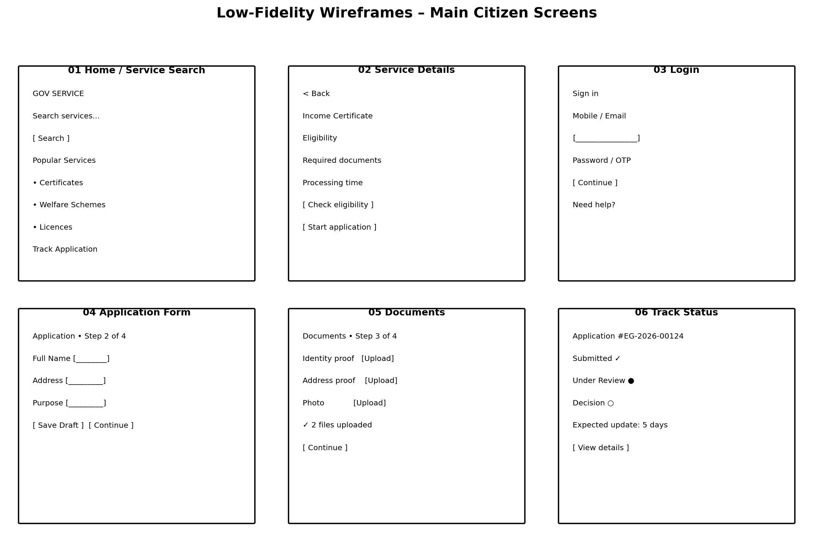
Figure 1. Low-fidelity wireframe sheet

5.1 Wireframe Screen Inventory
Screen | Purpose | Primary Action
Home / Service Search | Find a relevant government service. | Search or select a category.
Service Details | Understand eligibility and requirements. | Check eligibility / Start application.
Login | Securely enter protected area. | Continue with approved authentication.
Application Form | Collect service information. | Save draft / Continue.
Documents | Collect supporting evidence. | Upload / Replace / Continue.
Track Status | Explain current application state. | View details / Respond if action required.

6. High-Fidelity Mockups
The high-fidelity concepts introduce a polished visual hierarchy, consistent spacing, card-based service discovery, status indicators and clear primary actions. The final production design would validate exact colors, typography and branding against the implementing department's identity guidelines.
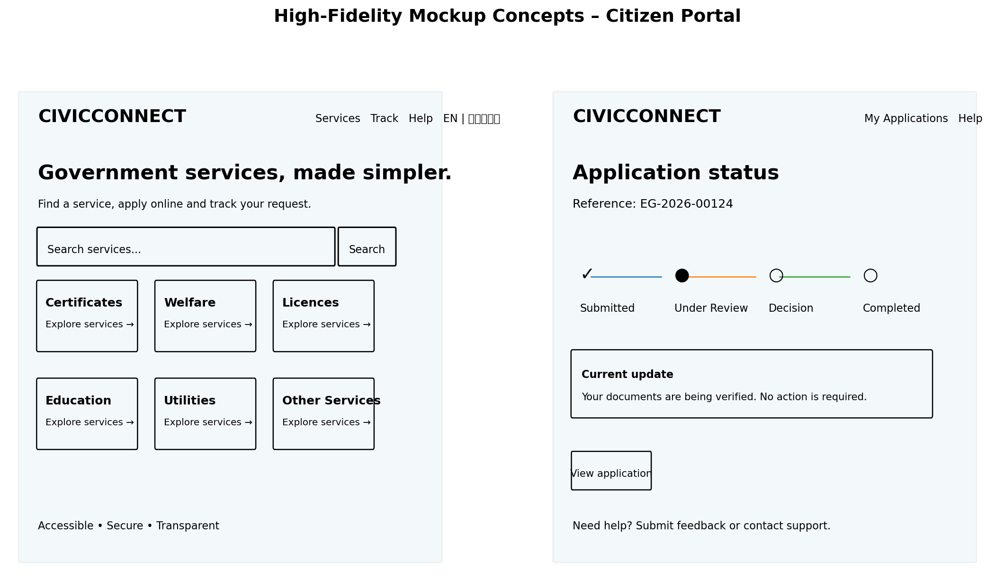
Figure 2. High-fidelity mockup concepts

6.1 Visual Design Specification
Element | Proposed Treatment | Rationale
Brand/header | Compact service identity with clear utility navigation. | Establish trust without consuming too much vertical space.
Typography | High-legibility sans-serif; strong heading hierarchy. | Improves scanning and readability.
Primary action | One visually dominant action per screen. | Reduces decision overload.
Cards | Used for service categories and summaries. | Supports quick scanning.
Status | Text label + visual indicator; never color alone. | Improves accessibility and comprehension.
Forms | Labels above fields, helpful hints, inline validation. | Reduces errors and uncertainty.
Alerts | Short, specific messages near relevant content. | Makes important information actionable.
Footer | Help, privacy, accessibility, contact and policies. | Supports trust and recovery.

7. Annotated Screen Specifications
ID / Screen | Annotation
A1 – Home | Search is the primary discovery action; popular categories reduce effort; tracking is available without forcing users to search again.
A2 – Service Details | Service name, eligibility, required documents and expected processing information appear before the primary Start action.
A3 – Login | Authentication is presented only when needed; help/recovery is visible without distracting from sign-in.
A4 – Application Form | A progress indicator communicates where the user is; Save Draft reduces fear of losing work.
A5 – Documents | Each document has a clear purpose and upload control; uploaded files show confirmation and allow replacement.
A6 – Tracking | The status timeline answers 'what happened?', 'what is happening now?' and 'what happens next?'.
A7 – Clarification | If action is required, the message states exactly what is missing, the deadline if applicable and how to respond.
A8 – Decision/Output | Outcome and next steps are presented clearly, with secure access to the official output where applicable.

8. User Flow Diagrams
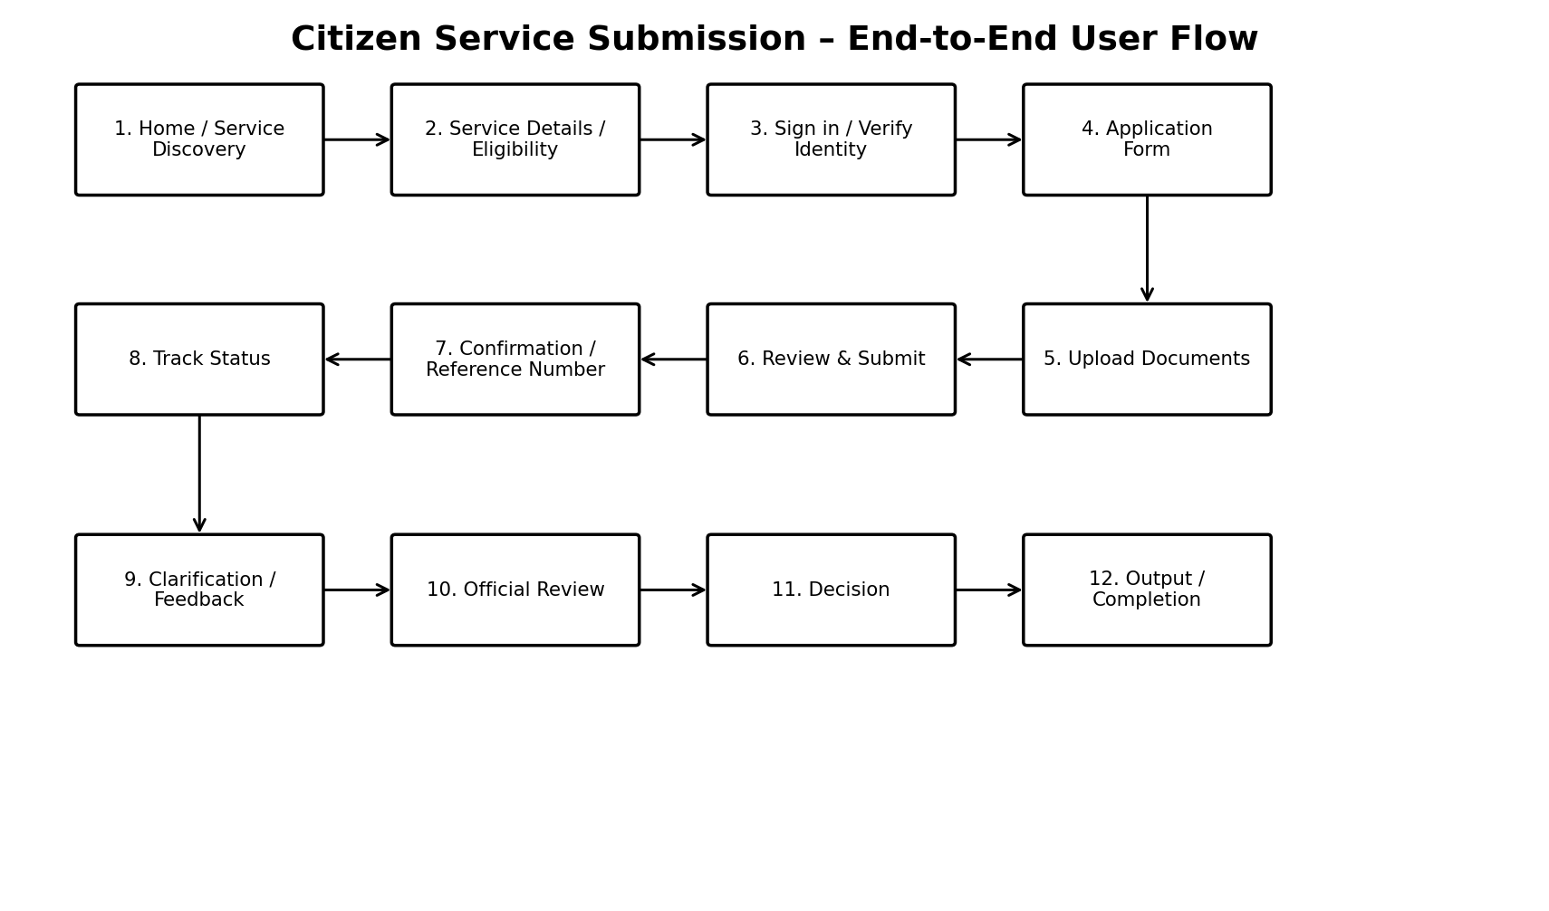
Figure 3. Annotated citizen service submission flow

8.1 Application Submission Flow
- Discover service
- Review eligibility and requirements
- Authenticate
- Complete application
- Upload documents
- Review answers
- Submit
- Receive reference number
- Track status
- Respond to clarification if needed
- Receive decision/output
- Provide feedback

8.2 Application Tracking Flow
- User selects My Applications.
- System shows active and completed applications.
- User selects an application.
- System shows current status, timeline, submitted information and permitted actions.
- If clarification is pending, a clear action card is displayed.
- If completed, the output/download or next official step is shown.

8.3 Feedback Flow
- Open Feedback from Help or completed service.
- Select rating or issue category.
- Enter optional comments.
- Submit feedback.
- System confirms submission and provides reference where a response is expected.

9. Design Rationale
Decision | Reason
Service-first home page | Citizens usually begin with a need, not a department name; search and categories help them find the service.
Eligibility before long form | Avoids wasted effort and reduces invalid applications.
Step-based form | Makes complex transactions manageable and communicates progress.
Save draft | Supports interrupted sessions and unreliable connectivity.
Visible reference number | Creates a reliable identifier for future tracking/support.
Timeline status | Transforms opaque processing into an understandable journey.
Plain-language errors | Helps users fix problems without contacting support.
Consistent components | Reduces cognitive load and makes future services faster to design.
Feedback after completion | Captures experience while the task is still fresh.

10. Accessibility and Responsive Design
- All meaningful controls should have accessible names and labels.
- Keyboard users should be able to reach and operate every interactive control.
- Focus state must remain visible and logically ordered.
- Do not communicate meaning through color alone; pair status color with text/iconography.
- Error messages should identify the field and explain how to correct it.
- Touch targets should be comfortable on mobile devices.
- Content should remain usable at increased text size and on narrow screens.
- Language switching should preserve the user's current task where practical.
- Important notices should use clear headings and concise language.
- Prototype usability testing should include users with varied digital literacy and accessibility needs.

10.1 Responsive Breakpoints – Concept
Viewport | Layout
Mobile | Single-column content; stacked cards; bottom or compact action area; collapsible secondary navigation.
Tablet | Two-column service cards where useful; wider form fields; persistent progress indicator.
Desktop | Constrained reading width; multi-column dashboards; larger navigation area; side-by-side summary panels.

11. Usability Testing Plan
Test | Task | Success Measure
UT-01 | Find a certificate service. | User finds correct service without assistance.
UT-02 | Check eligibility. | User understands result and next step.
UT-03 | Start and complete application. | User completes core fields without confusion.
UT-04 | Upload documents. | User understands file requirements and sees upload confirmation.
UT-05 | Track an application. | User identifies current status and next action.
UT-06 | Respond to clarification. | User locates request and submits response.
UT-07 | Submit feedback. | User understands whether feedback was successfully submitted.
UT-08 | Accessibility navigation. | Keyboard/assistive technology user can complete representative tasks.

11.1 Prototype Evaluation Metrics
- Task completion rate
- Time on task
- Critical error count
- Assistance requests
- User confidence rating
- Post-task satisfaction
- Accessibility issue count

12. Prototype Components
Component | States / Variants | Use
Header | Default, logged-in, mobile | Identity and global navigation.
Search | Empty, active, no results | Service discovery.
Service Card | Default, featured | Service catalogue.
Button | Primary, secondary, disabled | Actions.
Text Field | Default, focused, error, disabled | Form entry.
File Upload | Empty, uploading, uploaded, error | Document collection.
Status Tag | Submitted, review, clarification, completed | Application lifecycle.
Timeline | Current, completed, future | Tracking.
Alert | Info, warning, error, success | System feedback.
Progress Indicator | Steps 1–4 | Application journey.
Feedback Panel | Rating, comment, confirmation | Service feedback.

13. Risks and Design Improvements
Risk | Potential Effect | Mitigation
Too much information on service pages | Users may miss key actions. | Prioritize summary, eligibility and requirements; place detail behind progressive disclosure.
Complex government terminology | Misunderstanding and support requests. | Use plain language and user-tested labels.
Low bandwidth | Slow or failed uploads. | Compress where appropriate, show progress, allow retry and save drafts.
Accessibility gaps | Some users cannot complete tasks. | Accessibility checks throughout design and testing.
Department-specific branding conflicts | Prototype may not match final identity. | Keep visual system token-based and adaptable.
Overloaded dashboards | Managers cannot identify priority issues. | Use progressive drill-down and role-specific KPIs.

14. 30–35 Hour Work Plan
Activity | Hours | Output
UI/UX research and reference review | 4.0 | Research notes and design findings.
Information architecture and task mapping | 3.5 | Navigation and screen inventory.
Low-fidelity wireframes | 6.0 | Core citizen screens.
High-fidelity mockup design | 7.0 | Visual prototype concepts.
User-flow and annotations | 4.0 | Flow diagrams and interaction notes.
Accessibility/responsive design review | 2.5 | Design checklist and responsive approach.
Usability testing plan and refinement | 2.5 | Test scenarios and evaluation metrics.
Documentation and quality review | 3.5 | Final Word report.
Total | 33.0 | Within estimated 30–35 hours.

15. Conclusion
The Week 2 prototype converts the requirements from Week 1 into a tangible user experience for an e-governance platform. The proposed design prioritizes service discovery, eligibility clarity, short step-based forms, reliable document handling, transparent tracking and accessible feedback. The wireframes establish structure, while the high-fidelity concepts demonstrate how reusable components can create a consistent visual language across the platform.
The prototype should be validated with representative users before implementation. Feedback from citizens and officials should be used to revise content, navigation, form sequence, terminology and accessibility. Once validated, the screens can be recreated in a dedicated prototyping tool and connected to the technical architecture planned in Week 1.

16. References
Source | Use | URL
UMANG | Government services and schemes platform, National e-Governance Division / MeitY. | https://web.umang.gov.in/
GOV.UK Design System | Styles, components and patterns for government digital services. | https://design-system.service.gov.uk/
GOV.UK Design System – Patterns | Patterns for service start points, forms, navigation, eligibility and feedback. | https://design-system.service.gov.uk/patterns/
GOV.UK – Start using a service | Guidance for service start points and user journeys. | https://design-system.service.gov.uk/patterns/start-using-a-service/
GOV.UK – Check a service is suitable | Eligibility/check-before-start pattern. | https://design-system.service.gov.uk/patterns/check-a-service-is-suitable/
GOV.UK – Navigate a service | Navigation guidance for government services. | https://design-system.service.gov.uk/patterns/navigate-a-service/
GOV.UK Design System – Components | Accessible reusable components including forms, file upload, alerts and task lists. | https://design-system.service.gov.uk/components/

Appendix A – Prototype Handoff Checklist
- All primary screens identified
- All primary actions named
- Validation/error states identified
- Loading/empty states identified
- Mobile behavior described
- Accessibility requirements documented
- User flows connected to screens
- Design rationale recorded
- Usability tests defined
- Open questions recorded for Week 3 development

