EV Handbook
aka how to do battery related calculations
Michal Podhradsky, michal.podhradsky@pdx.edu

Introduction
Some of the common calculations that come handy when dealing with electric cars and batteries in general

Battery capacity
The charge [C] that the LiPo battery can store depends on the internal chemistry and cell structure. It has to be measured in the laboratory. It is typically defined in Amp-hours [Ah].
in other words battery with capacity 1Ah can deliver 1A current during 1 hour.

For example Enerdel battery cell has capacity of 16Ah (http://www.enerdel.com/cp160-365-moxie-prismatic-cell/ )

Battery power
Power is calculated as:
Again, for Enerdel cell (http://www.enerdel.com/cp160-365-moxie-prismatic-cell/) the nominal capacity is 16Ah, and nominal voltage of 3.65[V]. So the instantaneous power is depending on the current being drawn and the voltage. Indeed voltage is dependent on current and X other factors, but we don’t have to be that precise here.

For example, imagine we drain our cell at 16A and its nominal voltage, so the instantaneous power is
Not much, but it is a single cell - but you could still use it for a small heating element for example.

Battery energy
We typically want to measure battery capacity in [kWh]. Wikipedia says:
The kilowatt hour, or kilowatt-hour, (symbol kWh, kW·h, or kW h) is a unit of energy equal to 1,000 watt-hours, or 3.6 megajoules.

1 Joule = W*s = C*V=A*V*s

Our single cell stores energy (assuming it keeps its nominal voltage during whole discharge)of:
That would equal to

In case we have 96 cells in the car (4 modules) we have total energy of which is comparable to other cars in the competition. Or more conveniently - one enderdel module (12S2P) contains 24 cells, so 5.46[MJ] or 1.5184[kWh]. You can see that with all 6 modules we would have 9.1[kWh] of energy.

Battery configuration
Rather than copying somebody else, READ this article: http://batteryuniversity.com/learn/article/serial_and_parallel_battery_configurations
In short, we have batteries in series, because we can already provide enough current (up to 480A burst) that we are reaching limits of the motor and the controller. Also note that no matter what is your configuration, the amount of energy stored is the same.

Parallel vs Serial configuration
What are the benefits? Well, in layman terms, we can say that current [A] delivers motor torque, while Voltage[V] delivers motor RPM. So hight voltage/low current motors will generally spin faster, while high current low voltage motors will spin slow but with high torque.
As an example, here is our Remy motor, look at lines for 200V [purple] and 300V [blue].
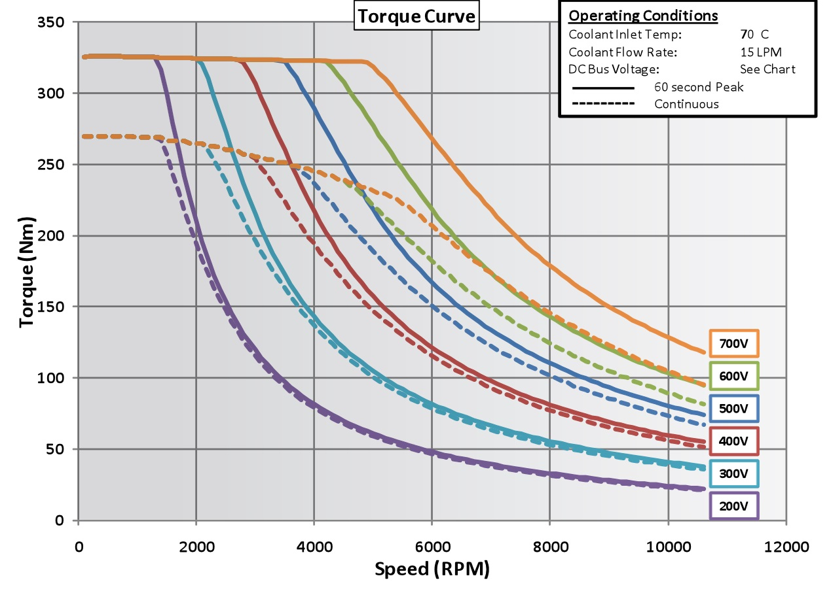
You will notice that higher voltage means that you can deliver the same torque for wider range of RPMS. Beneficial? Maybe, depends on the application…

Energy consumption example
So lets say we determined we are using 4 modules (5.6[kWh]) and are racing in a way that we draw 221[A] average current at 177[V] nominal.
- Instantaneous power is 221*177 = 39.117 [kW]
- If we race for one hour, we would need 39.117 [kWh]
- If we race for 20 minutes (estimated endurance) we would need 39.117*⅓[h] = 13.039[kWh]
- With our current consumption we could race only for 5.6[kWh]/39.117[kW] = 0.14[h]=8.5 [min]
So we probably have to scale down the energy requirements, which will probably compromise the performance.

Example: comparison of other teams
Lets have a look at other teams:
- Brazil: 5.6 kWh, 297V, 620 lb car, 80 second lap times
- McGill: 4.3 kWh, 109Vmax, 620 lb car, 90 second lap times
- UC Davis: 6 kWh, 116Vmax, 750 lb car with driver.
Brazil - looks like they have very similar setup to us (with 6 modules), except they scaled down their consumption (maybe a smaller motor) and weight (definitely a smaller motor)- so their lap time is good, but still beyond IC cars.
McGill - lower voltage system, less battery capacity. Probably very small motor (compared to ours), so their consumption is small. You can see their time is way worse.
UC Davis - similar setup to Brammo (low voltage, high capacity), probably there is some limitation on motor voltage for smaller motors, or something like that. Without driver their car should be lighter than 620lbs, and I would guess that their lap time was comparable to McGill.

It is good to know though that we are in the same ballpark with the other teams - regarding the car weight, battery capacity and voltage.

Note that a watt-hour is power of 1000 Watts being delivered for one hour.
which is not true, but close enough approximation
Brazil: 5.6 kWh, 297V, 620 lb car, 80 second lap times McGill: 4.3 kWh, 109Vmax, 620 lb car, 90 second lap times UC Davis: 6 kWh, 116Vmax, 750 lb car with driver.

