ERD  
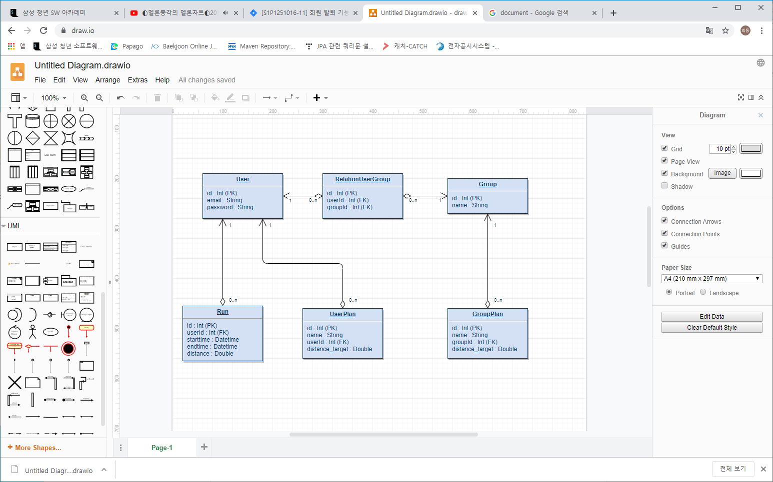

User : 사용자의 데이터 (로그인, 회원가입 등)

Group : 팀의 데이터 (팀 생성, 팀에 사용자 추가 등)

Run : 사용자의 러닝 데이터

* starttime : 러닝 시작 시간 (YY/MM/DD HH:MM:SS)
* endtime : 러닝 종료 시간
* distance : 러닝 거리

UserPlan : 사용자의 목표 데이터 (목표 생성 등)

* distance_target : 목표 거리

GroupPlan : 팀의 목표 데이터 (목표 생성 등)

UseCase Diagram

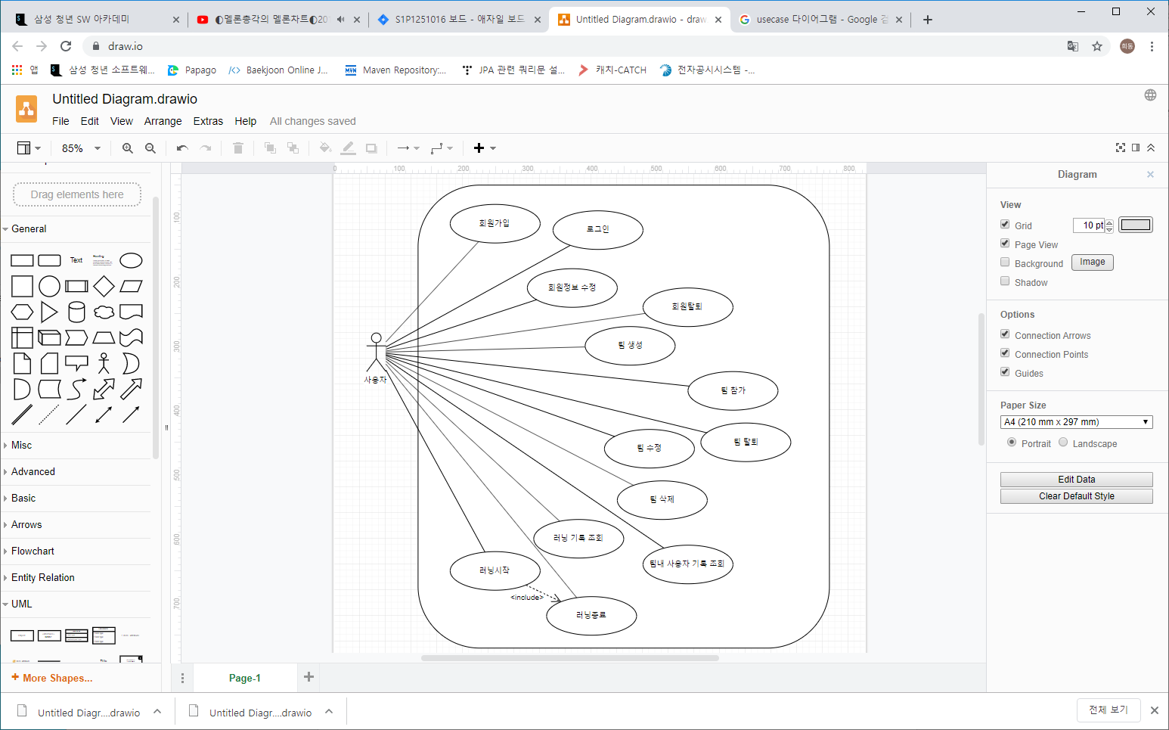

REST 정보

UserController

|  |  |
| --- | --- |
| 회원가입 | |
| url | POST - /signup.run |
| Parameters | User  String : email  String : password |
| Return | Boolean |

|  |  |
| --- | --- |
| 로그인 | |
| url | POST - /login.run |
| Parameters | User  String : email  String : password |
| Return | User  Int : uid  String : email  List<UserPlan> : userPlans  List<Group> : groups  List<Running> : runningData |

// 아직 정보가 없음 추후에 Parameters 추가

|  |  |
| --- | --- |
| 회원 정보 수정 | |
| url | PUT - /updateUser.run |
| Parameters | User  Int : uid  String : email  String : password |
| Return | User  Int : uid  String : email  List<UserPlan> : userPlans  List<Group> : groups  List<Running> : runningData |

|  |  |
| --- | --- |
| 회원 탈퇴 | |
| url | DELETE - /deleteUser.run |
| Parameters | User  Int : uid  String : email  String : password |
| Return | Boolean |

|  |  |
| --- | --- |
| 러닝 데이터 조회 | |
| url | GET - /findRunning.run |
| Parameters | User  Int : uid |
| Return | User  Int : uid  String : email  List<UserPlan> : userPlans  List<Group> : groups  List<Running> : runningData |

|  |  |
| --- | --- |
| 아이디 중복 체크 | |
| url | POST - /overlap.run |
| Parameters | User  Int : uid  String : email  String : password |
| Return | Boolean |

GroupController

|  |  |
| --- | --- |
| 그룹 생성 | |
| url | POST - /createTeam.run |
| Parameters | UserGroup  User  Int : uid  Group  String : name |
| Return | Boolean |

|  |  |
| --- | --- |
| 그룹 수정 | |
| url | PUT - /updateTeam.run |
| Parameters | Group  Int : gid  String : name |
| Return | Boolean |

|  |  |
| --- | --- |
| 그룹 삭제 | |
| url | DELETE - /deleteTeam.run |
| Parameters | Group  Int : gid |
| Return | Boolean |

|  |  |
| --- | --- |
| 그룹에 참가 | |
| url | POST - /joinTeam.run |
| Parameters | UserGroup  User  Int : uid  Group  Int : gid |
| Return | Boolean |

|  |  |
| --- | --- |
| 그룹 탈퇴 | |
| url | POST - /outTeam.run |
| Parameters | UserGroup  User  Int : uid  Group  Int : gid |
| Return | Boolean |

|  |  |
| --- | --- |
| 전체 그룹 정보 조회 | |
| url | GET - /findAllTeam.run |
| Parameters |  |
| Return | List<Group> : groups  +  Group  Int : gid  String : name  List<GroupPlan> : groupPlans  List<User> : users |

PlanController

|  |  |
| --- | --- |
| 유저 계획 생성 | |
| url | POST - /createUserPlan.run |
| Parameters | UserPlan  String : name  String : distanceTarget  LocalDate : startDate (yyyy-MM-dd)  LocalDate : endDate (yyyy-MM-dd)  Int : userId |
| Return | UserPlan  Int : id  String : name  String : distanceTarget  LocalDate : startDate (yyyy-MM-dd)  LocalDate : endDate (yyyy-MM-dd)  Int : userId |

|  |  |
| --- | --- |
| 팀 계획 생성 | |
| url | POST - /createTeamPlan.run |
| Parameters | GroupPlan  String : name  String : distanceTarget  LocalDate : startDate (yyyy-MM-dd)  LocalDate : endDate (yyyy-MM-dd)  Int : groupId |
| Return | GroupPlan  Int : id  String : name  String : distanceTarget  LocalDate : startDate (yyyy-MM-dd)  LocalDate : endDate (yyyy-MM-dd)  Int : groupId |

RunningController

|  |  |
| --- | --- |
| 러닝 시작 | |
| url | POST - /start.run |
| Parameters | Running  Int : userId |
| Return | Running  Int : rid  Int : userId  LocalDateTime : starttime (yyyy-MM-dd HH:mm:ss) |

|  |  |
| --- | --- |
| 러닝 종료 | |
| url | PUT - /end.run |
| Parameters | Running  Int : rid  Int : userId  Double : distance  LocalDateTime : starttime (yyyy-MM-dd HH:mm:ss) |
| Return | Running  Int : rid  Int : userId  Double : distance  LocalDateTime : starttime (yyyy-MM-dd HH:mm:ss)  LocalDateTime : endtime (yyyy-MM-dd HH:mm:ss) |