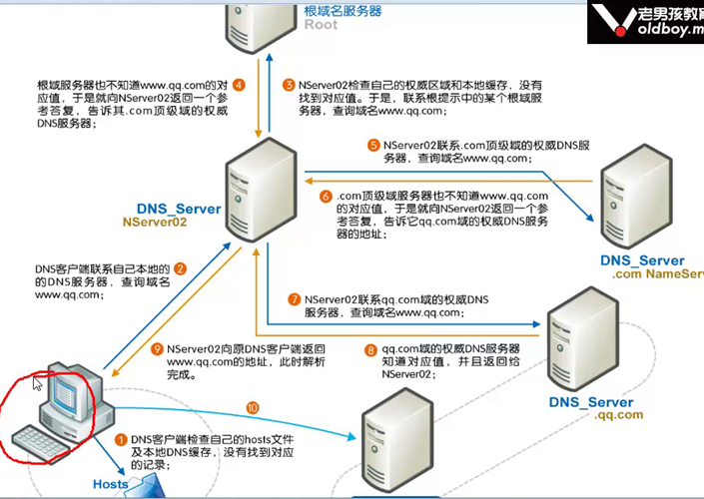

[leo@centos6-server ~]$ dig @8.8.8.8 www.baidu.com +trace

[leo@centos6-server ~]$ netstat -rn

Kernel IP routing table

Destination Gateway Genmask Flags MSS Window irtt Iface

192.168.137.0 0.0.0.0 255.255.255.0 U 0 0 0 eth0

169.254.0.0 0.0.0.0 255.255.0.0 U 0 0 0 eth0

0.0.0.0 192.168.137.1 0.0.0.0 UG 0 0 0 eth0

[leo@centos6-server ~]$ route -n

Kernel IP routing table

Destination Gateway Genmask Flags Metric Ref Use Iface

192.168.137.0 0.0.0.0 255.255.255.0 U 0 0 0 eth0

169.254.0.0 0.0.0.0 255.255.0.0 U 1002 0 0 eth0

0.0.0.0 192.168.137.1 0.0.0.0 UG 0 0 0 eth0

## 删除网关：

[root@centos6-server ~]# route del default gw 192.168.137.1

## 添加网关

[root@centos6-server ~]# route add default gw 192.168.137.1

<http://oldboy.blog.51cto.com/2561410/974194>

## 辅助IP：

[root@centos6-server ~]# ifconfig eth0:0 192.168.1.110/24 up #重启失效

[root@centos6-server ~]# ifconfig

eth0 Link encap:Ethernet HWaddr 00:0C:29:93:BB:DB

inet addr:192.168.137.71 Bcast:192.168.137.255 Mask:255.255.255.0

inet6 addr: fe80::20c:29ff:fe93:bbdb/64 Scope:Link

UP BROADCAST RUNNING MULTICAST MTU:1500 Metric:1

RX packets:27639 errors:0 dropped:0 overruns:0 frame:0

TX packets:12819 errors:0 dropped:0 overruns:0 carrier:0

collisions:0 txqueuelen:1000

RX bytes:7160394 (6.8 MiB) TX bytes:1963730 (1.8 MiB)

eth0:0 Link encap:Ethernet HWaddr 00:0C:29:93:BB:DB

inet addr:192.168.1.110 Bcast:192.168.1.255 Mask:255.255.255.0

UP BROADCAST RUNNING MULTICAST MTU:1500 Metric:1



## 网络及服务故障排查：

a) ping [www.baidu.com](http://www.baidu.com) icmp 协议

b) traceroute [www.baidu.com](http://www.baidu.com) 基础检查 # windows: tracert –d www.qq.com

c) telnet 10.0.0.25 80 检查端口是不是通的

nmap 10.0.0.25 –p 80

nc

