Linux NFS

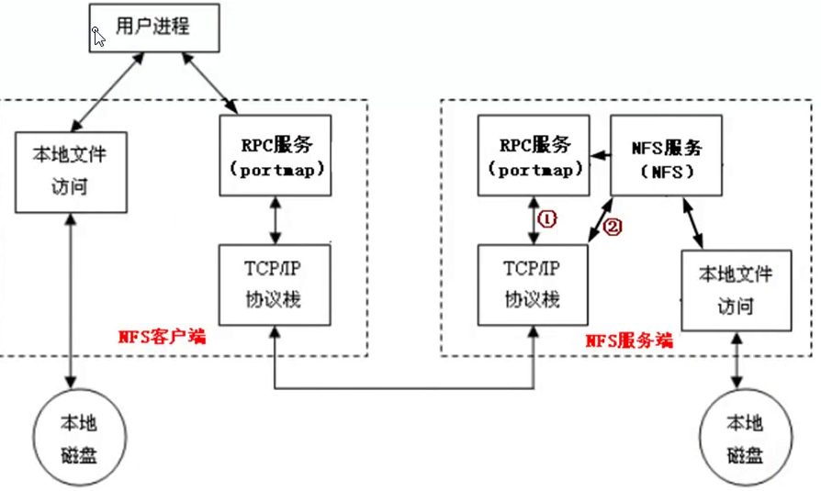

# 服务器端环境准备

## 服务器划分

|  |  |  |
| --- | --- | --- |
| 操作系统 | 角色 | IP |
| CentOS 6.6 x86_64 | NFS 服务器(NFS-server) | 192.168.1.71 |
| CentOS 6.6 x86_64 | NFS Client1 | 192.168.1.81 |
| CentOS 6.6 x86_64 | NFS Client2 | 192.168.1.82 |

服务器环境信息：

[leo@centos6-server ~]$ cat /etc/redhat-release

CentOS release 6.6 (Final)

[leo@centos6-server ~]$ uname -r

2.6.32-504.el6.x86_64

## 2. NFS 软件列表

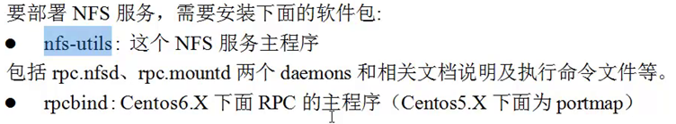

[leo@centos6-server ~]$ rpm -qa nfs-utils rpcbind

## 软件安装

在三台机器上同时安装：

[root@centos6-server ~]# yum install nfs-utils rpcbind –y

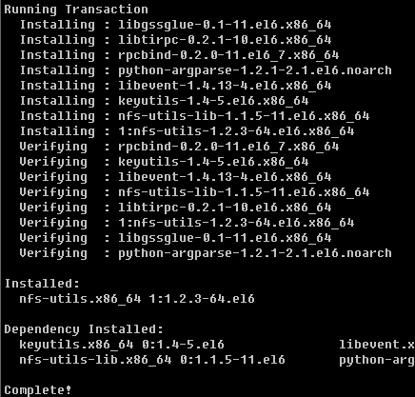

## 启动NFS相关服务

[root@centos6-server ~]# /etc/init.d/rpcbind start

Starting rpcbind: [ OK ]

[root@centos6-server ~]# /etc/init.d/rpcbind status

rpcbind (pid 1453) is running...

[root@centos6-server1 ~]# lsof -i :111

COMMAND PID USER FD TYPE DEVICE SIZE/OFF NODE NAME

rpcbind 1453 rpc 6u IPv4 11521 0t0 UDP *:sunrpc

rpcbind 1453 rpc 8u IPv4 11524 0t0 TCP *:sunrpc (LISTEN)

rpcbind 1453 rpc 9u IPv6 11526 0t0 UDP *:sunrpc

rpcbind 1453 rpc 11u IPv6 11529 0t0 TCP *:sunrpc (LISTEN)

开机启动：

[root@centos6-server ~]# chkconfig --list|grep rpcbind

rpcbind 0:off 1:off 2:on 3:on 4:on 5:on 6:off



[root@centos6-server1 ~]# rpcinfo -p localhost

program vers proto port service

100000 4 tcp 111 portmapper

100000 3 tcp 111 portmapper

100000 2 tcp 111 portmapper

100000 4 udp 111 portmapper

100000 3 udp 111 portmapper

100000 2 udp 111 portmapper

[root@centos6-server ~]# /etc/init.d/nfs start

Starting NFS services: [ OK ]

Starting NFS quotas: [ OK ]

Starting NFS mountd: [ OK ]

Starting NFS daemon: [ OK ]

Starting RPC idmapd: [ OK ]

[root@centos6-server1 ~]# netstat -tunpl|grep :2049

tcp 0 0 0.0.0.0:2049 0.0.0.0:* LISTEN -

tcp 0 0 :::2049 :::* LISTEN -

udp 0 0 0.0.0.0:2049 0.0.0.0:* -

udp 0 0 :::2049 :::*

[root@centos6-server ~]# ps -ef|egrep "rpc|nfs"

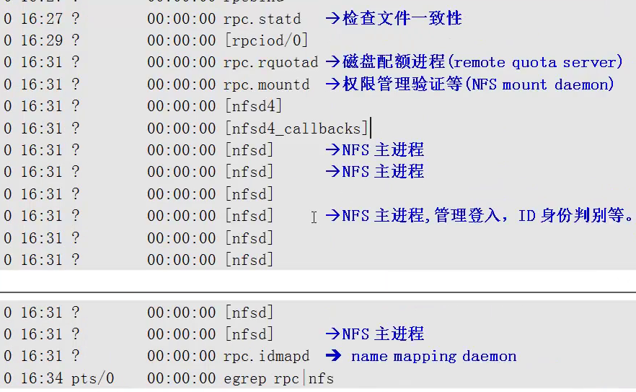

## NFS 配置文件 /etc/exports

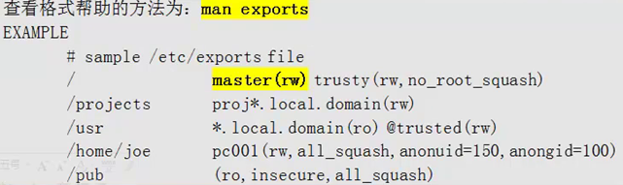

[root@centos6-server ~]# showmount -e localhost

Export list for localhost:

/data 192.168.137.*

[root@centos6-server ~]# mount -t nfs 192.168.137.71:/data /mnt

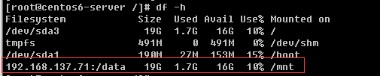

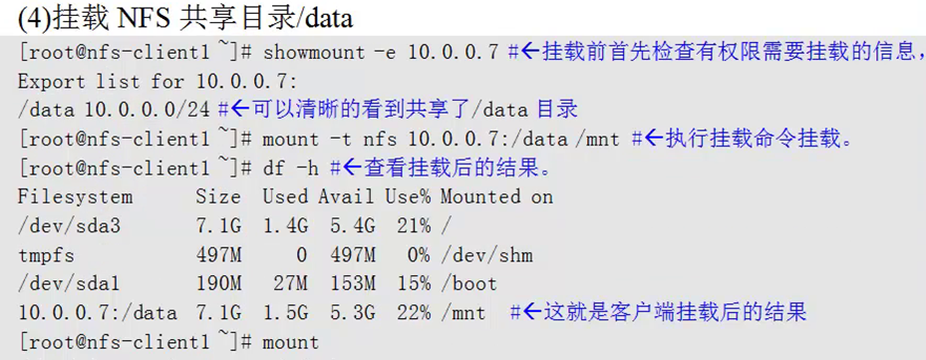

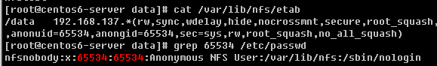

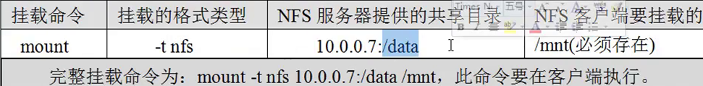

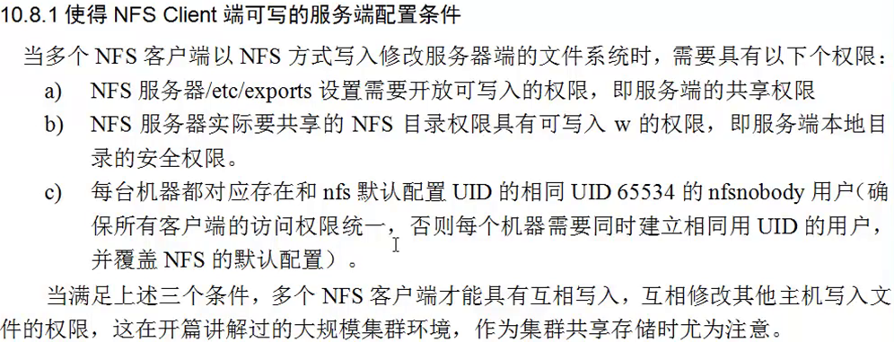

man nfs 查看相关选项

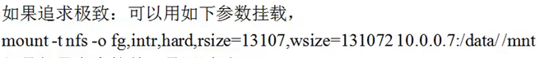



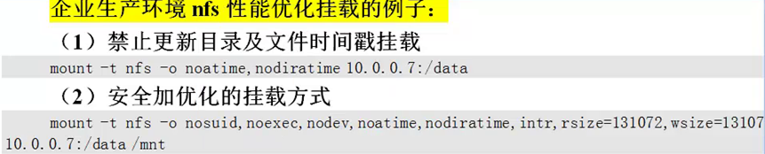



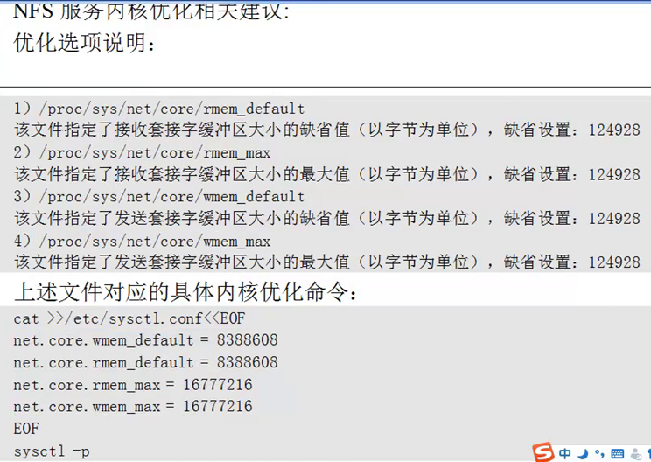

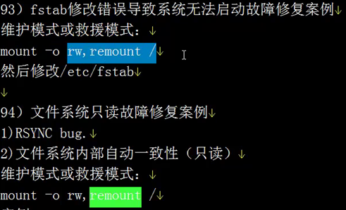





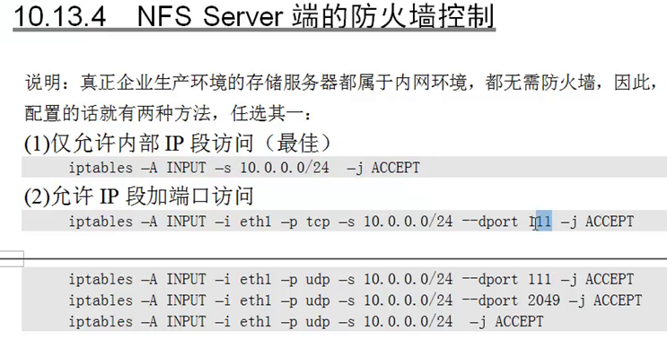

参考文献：

