# 一．服务器用户权限管理改造



## 1.问题现状

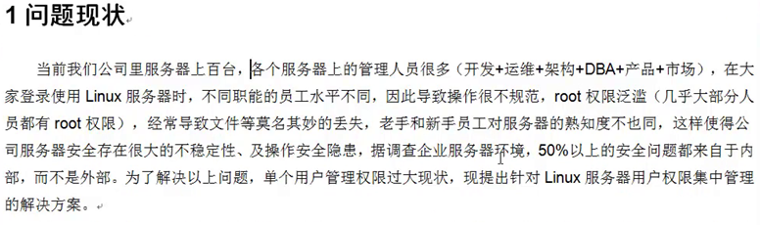

## 2.项目需求

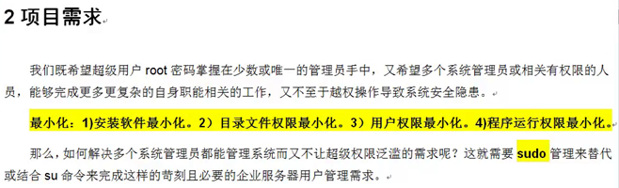

## 3.具体实现

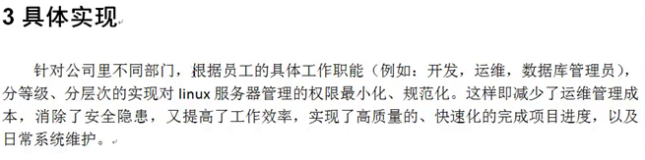

## 4．实施方案

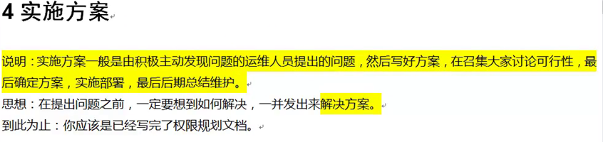

### 4.1 信息采集

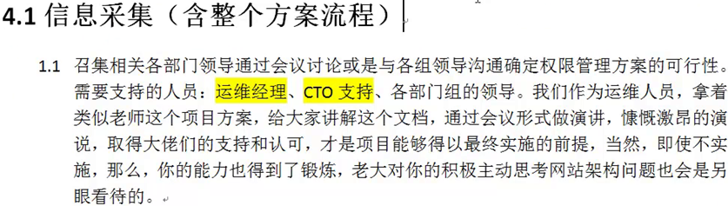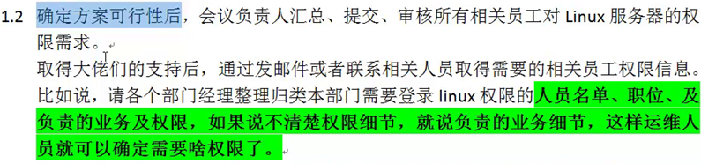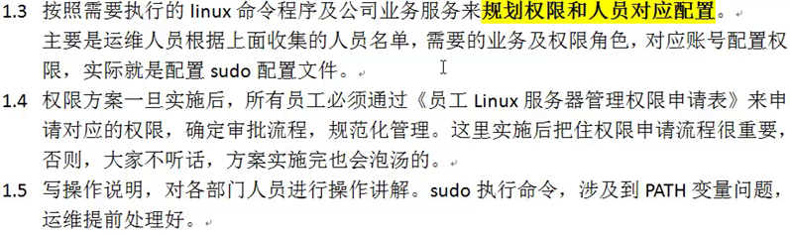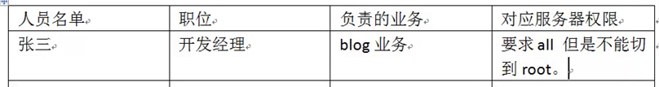

### 4.2 收集员工职能和对应权限

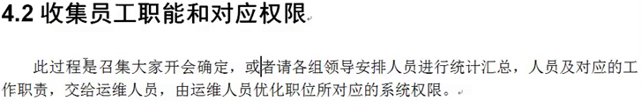

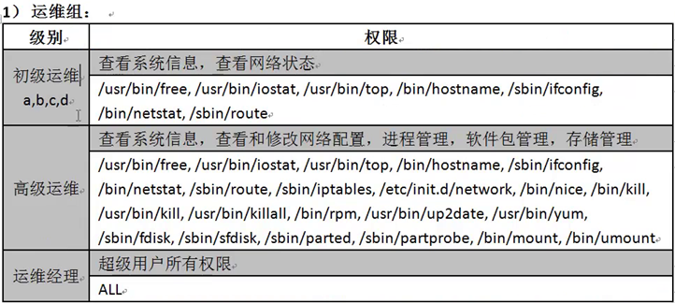

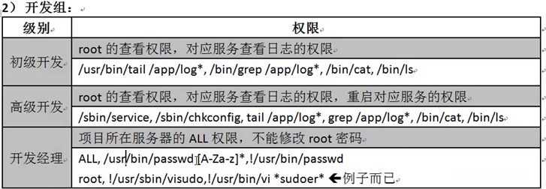

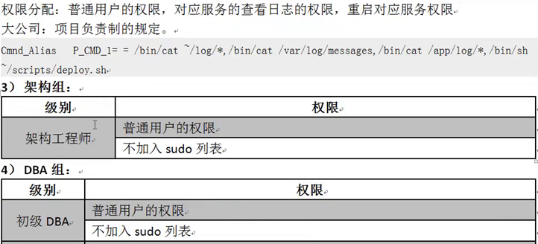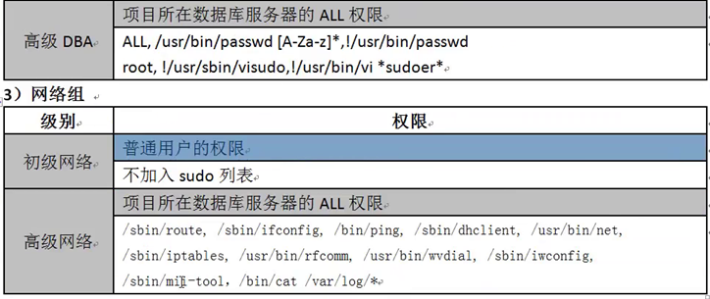

## 5. 模拟创建用户角色



[root@centos6-server ~]#

for user in chuji001 chuji002 chuji003 net001 seniro001 manager001

do

useradd $user

echo "111111"|passwd --stdin $user

done



[root@centos6-server ~]#

for n in `seq 5`; do useradd -g phpers php00$n; echo "111111"|passwd --stdin php00$n; done

[root@centos6-server ~]#

for n in kaifamanager001 senirophper; do useradd $n; echo "111111"|passwd --stdin $n; done

sudoer 配置内容

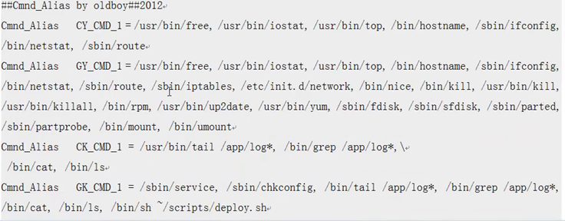

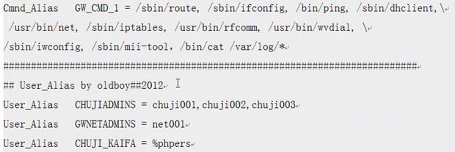 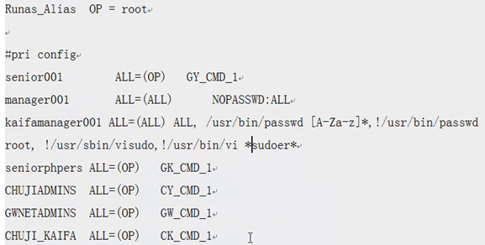

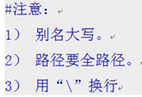

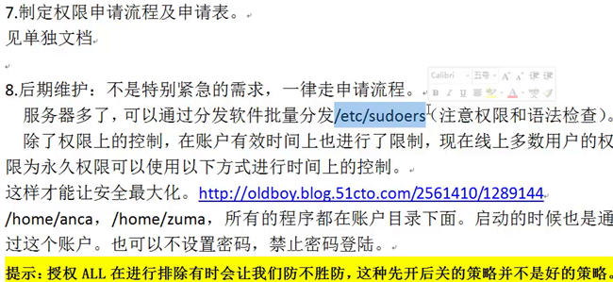

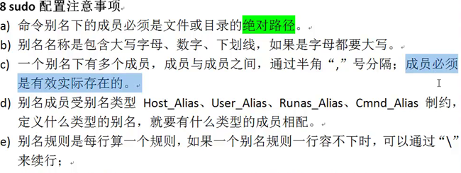

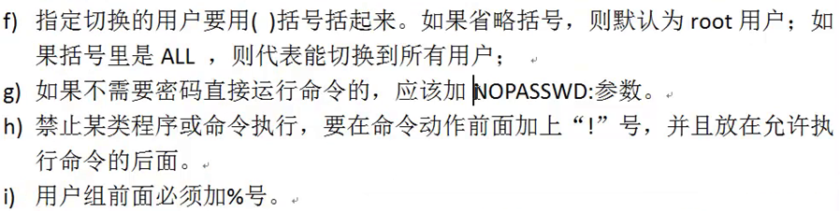

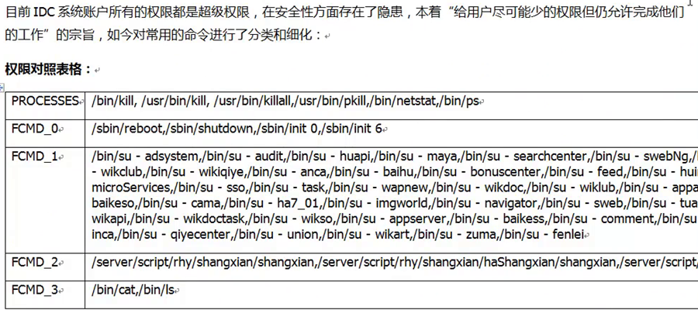

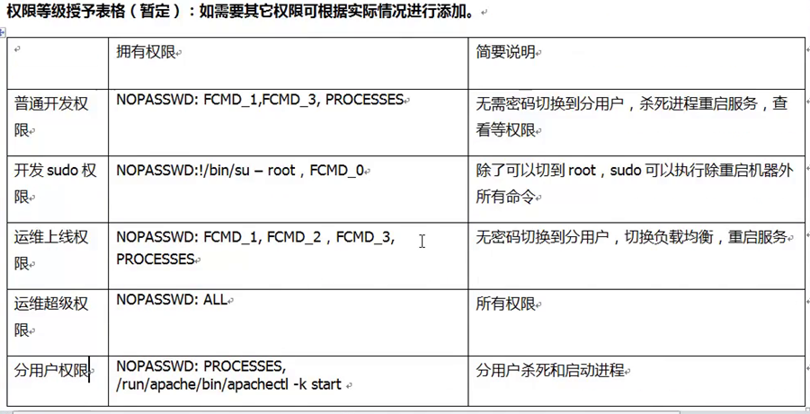

# 二．日志审计

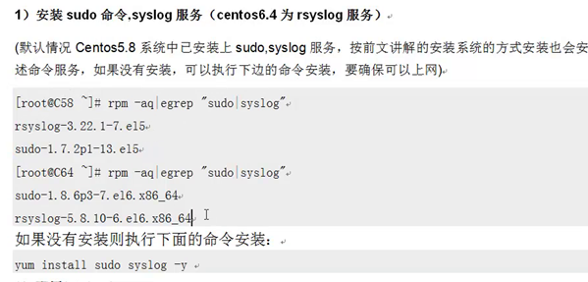

1. 添加日志显示

[root@centos6-server ~]# echo "Defaults logfile=/var/log/sudo.log" >>/etc/sudoers

[root@centos6-server ~]# tail -1 /etc/sudoers

[root@centos6-server ~]# visudo -c

/etc/sudoers: parsed OK

配置rsyslog

[root@centos6-server ~]# echo "local2.debug /var/log/sudo.log">>/etc/rsyslog.conf

[root@centos6-server ~]# tail -1 /etc/rsyslog.conf

local2.debug /var/log/sudo.log

重启rsyslog 服务，生成日志文件 /var/log/sudo.log

[root@centos6-server ~]# /etc/init.d/rsyslog restart

Shutting down system logger: [ OK ]

Starting system logger: [ OK ]

