**CounterOnUs: You date, we remember V1.0**

**Screens:** (1)

* Home -- counter
* Special events – more than one event

Home screen

* a counter that counts the days (2)(3)
* for people that are in relation and want to install the app the possibility to set the day (de când) are together (5.1)(5.2)

Special events

* a page with all the events (ex: first kiss, first hug etc.)
* adding events (5.1)(5.2)
* every event should have the date and the days left until that event (3)
* OPTIONAL: every event could be sorted by importance(set by the user)

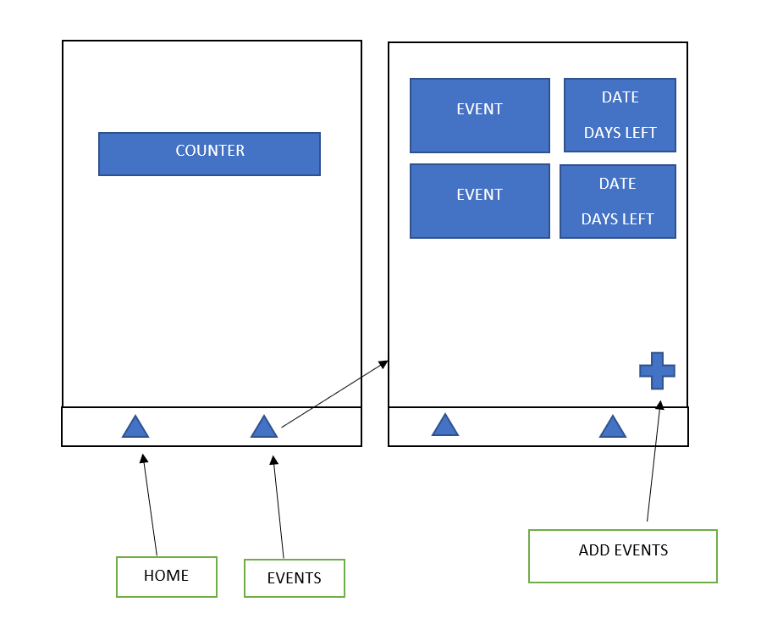

**To be added:**

* To remember when app is closed (4)
* Slide to left to delete an event
* Auto add the first event – anniversary – and when the user change the date so the event date in event screen should change
* Notifications
* More customization for the events
* Sorting by importance
* Notes, to note important things

**Documentation:**

* (1) <https://reactnavigation.org/docs/getting-started>
* (2) <https://github.com/vydimitrov/use-count-up>
* (3) <https://aboutreact.com/react-native-get-current-date-time/>
* (4) <https://docs.expo.dev/versions/latest/sdk/securestore/>
* (5.1) <https://reactnative.dev/docs/textinput>
* (5.2) <https://reactnative.dev/docs/handling-text-input>