Immutable

1. withMutations : use when 2< operations
2. withMutations : parameter name = map
3. 1 op : no enter, 2 op : all with new line
4. With reducer:

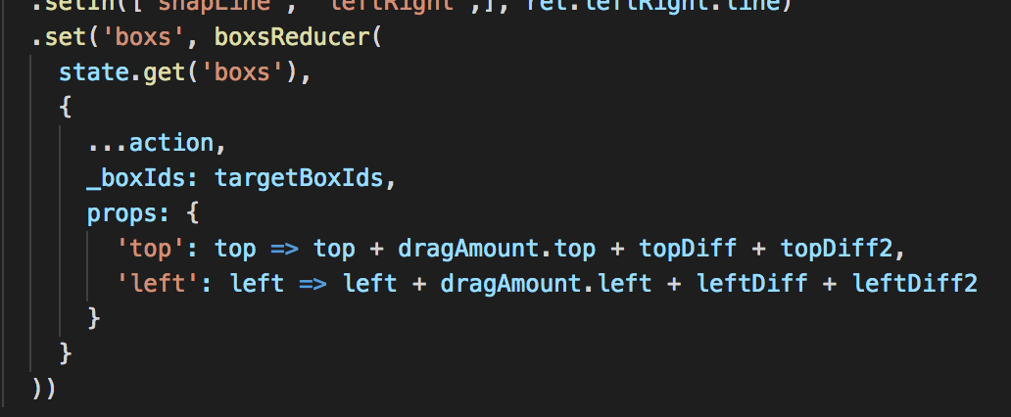

1. Minimize toJS, map

Reducers

1. Use _ in state name like _boxIds, _targetBox
2. Parameters should not be immutableJS
3. (todo) make another action file for new reducer
4. Return with state. No return newState!
5. Parameter destructuring (no action.xx usage)
6. (todo) make reducers…

Components

1. Use handler(do event something in it)
2. Destructuring
3. (todo) consider code conventions