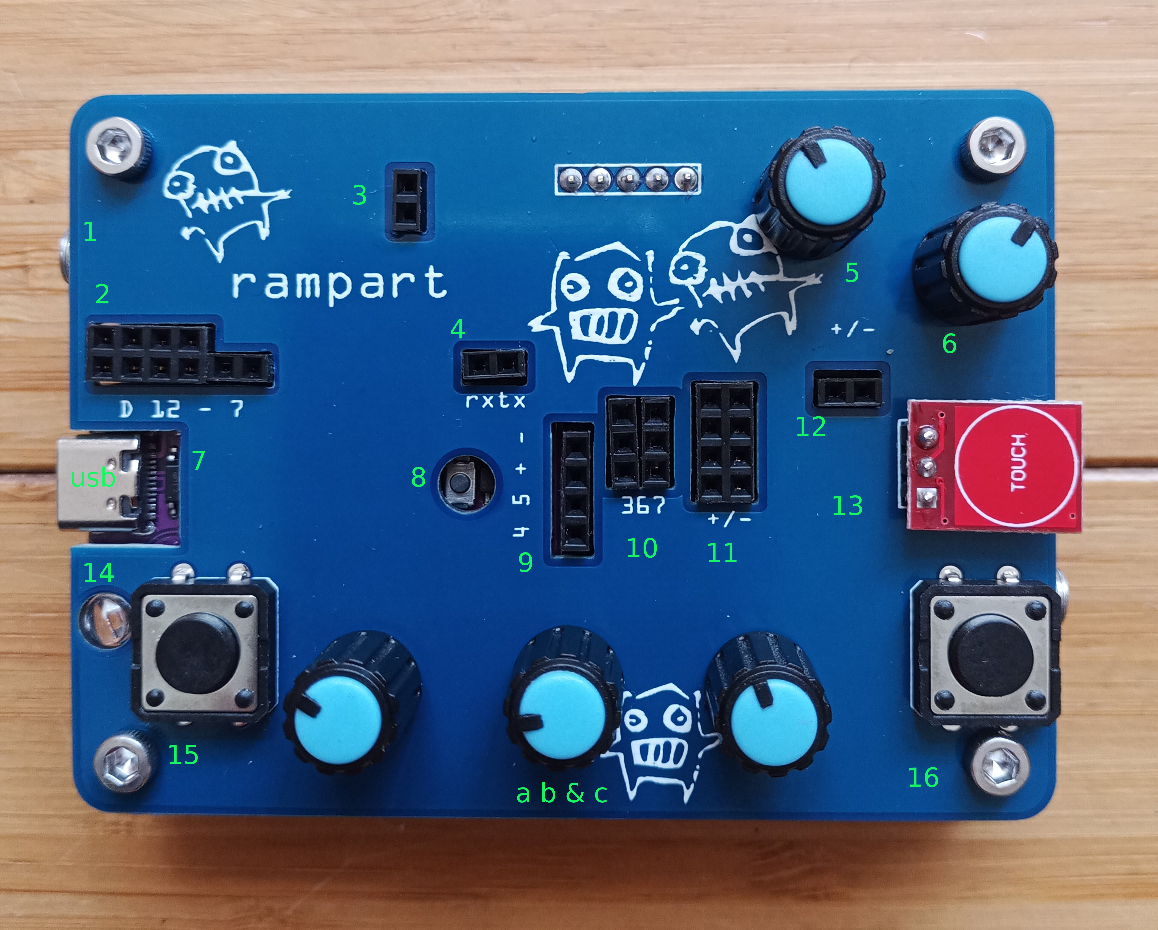
# Rampart, bytebeats guide

## Connections overview
Since rampart is more platform than any given instrument, this overview tries to cover ground that isnt’ just relevant to the bytebeats sketch.

1. - audio (right channel) & clock (left) input. Pocket-operator can be directly connected .Clock comes out at 4 (tx) and can be plugged into 10 (inputs 3, 6 or 7).
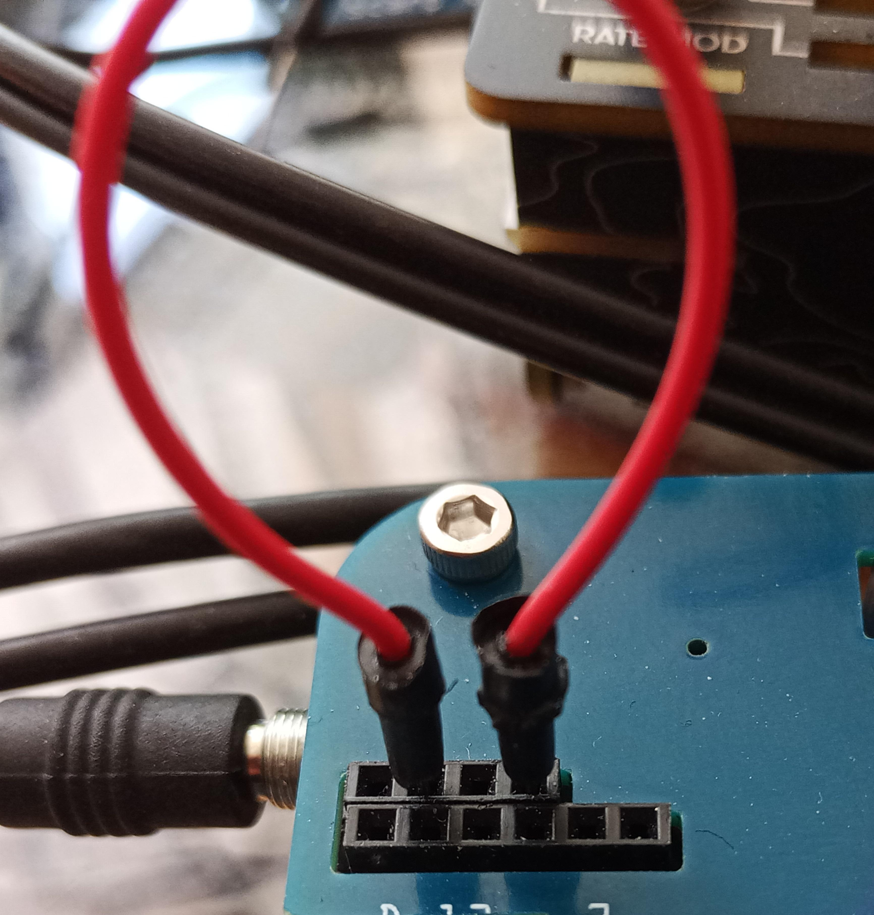
2. digital input/outputs. For bytebeats, 11 needs to be wired to 9 (second from left to 4th from left)
3. touch output (from 13). Can be used on the digital pins, (11!) or 3,6 or 7 (at 10).
4. two pins rx and tx (receive and transmit) The clock signal from 1 goes to tx on the right pin at 4. Bytebeats connect to 3,6 or 7 to modulate a b & c (in addition to the pots a b & c)
5. encoder / button: a) turning will increase or decrease the frequency, starting on boot at 8000 HZ, steps of 64 HZ. b) Push and hold down and turn left, play backwards at increasing frequency; turn right and forwards increasing frequency (doubling). c) single click: bank 1 of formulas, double click: bank 2, triple click :bank 3
6. volume/filter it’s advisable to start bytebeats with this at 12 o’clock to avoid harsher high end. Will also mix the relative loudness of input from 1 vs. the ramparts internal audio.
7. usb power/programming and 8 reset button, if rampart should hang which happens rarely, but can at higher frequencies
9. Two analog inputs (4&5) and + /- power. Not directly used in the bytebeats sketch
10. analog inputs 3, 6 and 7 (rows 2x3, 2x6, 2x7) used to modify bytebeats params a/b/c in addition to the pots labeled a b & c at the bottom.
11. +/- power columns which aren’t used for the bytebeats sketch, but one can, for instance put a capacitor from + to inputs at 10 to create a contral voltage. Very fun with a 1uf Elko.
12. +/ - sides of the audio output. You can plug in additional signals or tap the output
13. Touch button with LED, see 3
15/16. Left & Right buttons select previous and next program of bank
Bottom right, barely visible is the audio out. You can plug-in headphones, but turn down 6, vol. First. If you plug in stereo audio to the input, it will feed through but moving the encoder or pushing buttons will make noises. A PO or Scarp signal will be clean (split clock).

