Software System Design
Document Specification

Zamora’s Retail

Christopher Zamora

Nujoma Halls

Giovanni Vacirca

Table of Contents

Introduction 3
Application Architecture 5
System Functions 6
User Interface 7
Components 10
Database 11
Required Hardware and Software 12
Appendix A 14

1. Introduction
Our application is going to gather data from our Database in order to display our inventory to our user’s where they will be able to select and buy items as well as filter them by their preference.
2. Application Architecture
Describe application components, structures and interconnections. Provide information for major component functions and major technologies used on the application.
We will be implementing the Models Views Controllers (MVC) model. We will create an express web application via node.js. The Models would be handled by the MySQL database. The Views will use handlebars templating engine, and we will use JavaScript for the Controllers (URL routes).
3. Required System Functions
We will need a user login system. To implement this we will use bcrypt to hash our passwords before passing them to the database. We will also use passport.js (middleware application) to create our authentication system for user login.
4. User Interface
The following user-interface is what the user will be seeing most of the time while on our website:
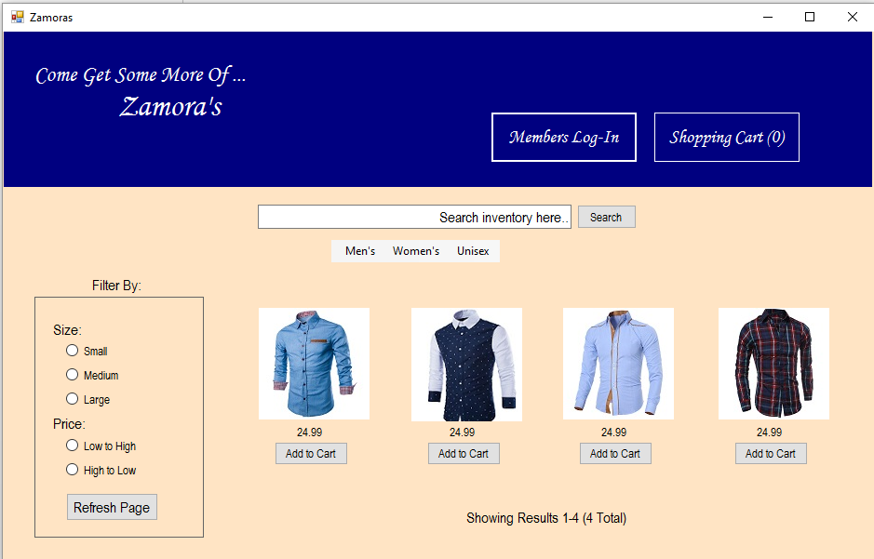
We tried to make the interface very user-friendly and make the application very easy to understand and use. Included to the interface we have several components the user can interact with:
- A search bar which will allow the user to type in key-words to search our inventory
- A list of options to filter their search. This could either be by size or price. If by size the user will click on their respective size (small, medium, or large) and click the “Refresh Page” button. Same with price.
- There is also several menu options, the primary three being Men’s clothing, Women’s clothing, and Unisex clothing. When opening each of these the user will be given more options to click and browse through, this filters all of our clothes by gender as well as what type of clothing it is (shirts, pants, dresses, etc.).
- If the user clicks on the “Shopping-Cart” button they will be displayed all of the items they previously added to their “Shopping-Cart” and will then have the option to complete the order.
5. System Components
List of system components or modules, their functions and how they interact with each other.
Name | Function Description | Input Data | Output Data | Dependencies
Search bar | Searches our inventory and displays results | Key-word such as “shirts” or “pants” | Displays our inventory, if matches were found | Items in our database
Filter-buttons | Filters the results to users liking. | Clicking a button | Displays our inventory, matching filter results | Items in our database
Refresh Button | Refreshes the results displayed based on changes in the filters | Clicking the refresh button | Redisplays our inventory based on filter options | Items in our database
Add to Cart | Button that adds the respective item to the user’s shopping-cart | Clicking the button | Adds item to shopping-cart | Items in our database

6. Database
Our program will be based on the following ER Diagram where entities are displayed as rectangles and their attributes as ovals, and relationships as diamonds.

ER Diagram

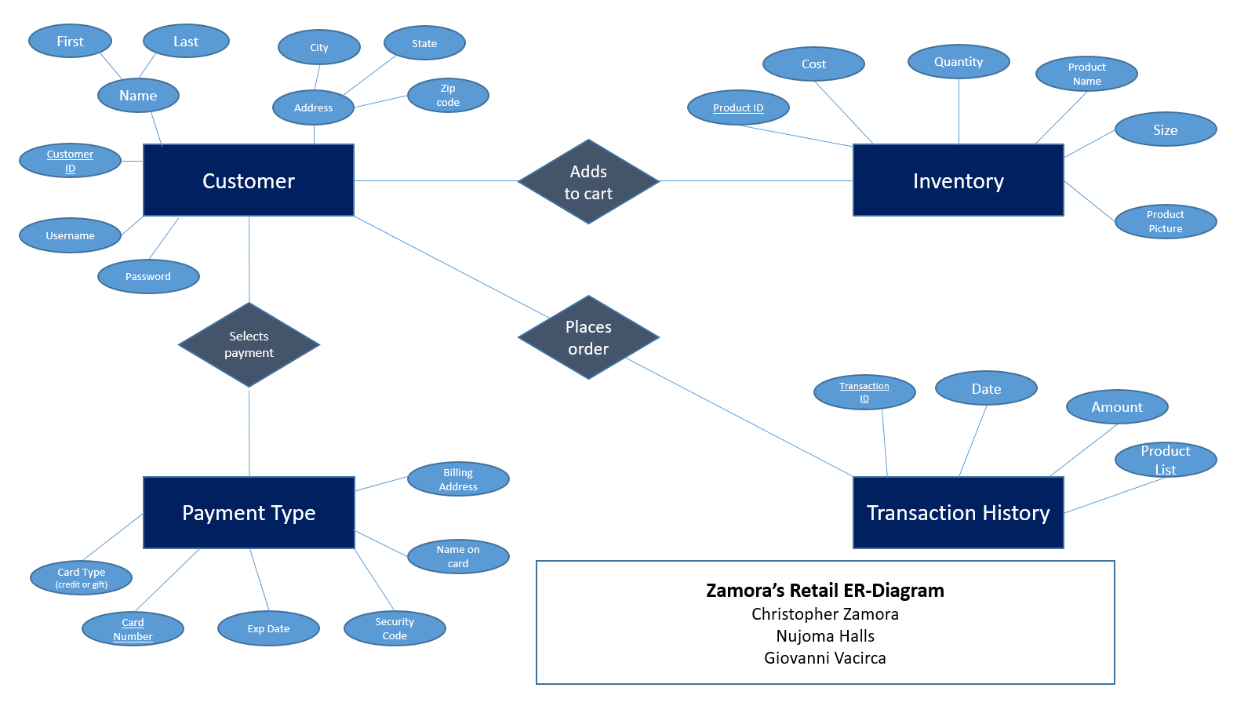

From the above diagram we came up with the following:
Relational Schema
Customer (Customer_id, FirstName, LastName, City, State, Street, ZipCode, username, password)

Inventory (Product_id, Cost, Quantity, ProductName, Size, ProductPicture)

PaymentType (Card_number, CardType, ExpDate, SecurityCode, NameOnCard, BillingAddress, Customer_ID)

TransactionHistory (Transaction_id, Date, Amount, ProductList, Customer_id)

AddsToCart (Customer_id, Product_ID)

7. Required Software and Hardware
Node.js
MySQL (for the database)
Bcrypt and passport.js (for user login)

