Zamora’s Retail

Software Requirements Document

Version: 1.2

Date: 11/6/2016

Prepared by:

Christopher Zamora

Nujoma Halls

Giovanni Vacirca

Table of Contents

1. Preface 4
1.1. Modification History 4
1.2. Intended Audience 4
2. Introduction 4
3. Glossary 4
4. User Requirement Definition 4
5. System Requirements Specification 5
6. System Architecture 5
7. System Models 5
7.1. Use Case Diagram 5
7.2. Sequence diagram 5
7.3. Class diagram 5
8. System Evolution 5
9. Appendices 5
10. Index 5

Table of Figures

Figure 1 Use Case Diagram ……………………………………………………………… 6
Figure 2 Sequence Diagram ………………………………………………………………7
Figure 3 UML Class Diagram …………………………………………………………….8

Preface

This business requirements document is intended to clearly outline the needs of the business. In this case, we want to make sure that we understand exactly what the retail store wants us to design so that we can deliver a satisfactory product. There were no major changes between versions since the information gathered from the initial requirements discussion was very thorough..

Modification History

Date | Version | Author | Summary of changes
11/4/2016 | V1.0 | Christopher Zamora | Started document
11/5/2016 | V1.1 | Nujoma Halls | Edited document
11/6/2016 | V1.2 | Giovanni Vacirca | Completed document

Intended Audience
This document is intended for all stakeholders of the retail business.

Introduction
This software system is an online store in which customers will be able to purchase clothing.

Purpose of the requirements document
The requirements document will help our stakeholders understand the functionality behind our system. It states what our system finds absolutely necessary to be able to run.

Scope of the product
Upon running our application our customers will use our program to access our database and display articles of clothing matching their filter search. The customer will be able to purchase items using multiple payment options, have it shipped to them, and if there is an issue they should be able to return said item for refund/replacement.

Reference
We will use online documentation for node.js in order to help us build our application.

Overview of the remainder of the document
We go into specific details of the user requirements and system requirements, and justify our method of system architecture.

Glossary
Define technical terms used in the document.

Term | Meaning
Product users | These are users who interact with the system directly. In this case, the primary users will be customers who desire to shop at the online store.

User Requirement Definition
Non-functional:
  - The products on the website should look nice and presentable to entice the users into wanting to spend their money.
  - We could offer weekly discounts on specific products. There could be a separate web page dedicated to showing all the current items on sale.
Functional:
- The customer should be able to purchase an item online by providing the info below:

System Requirements Specification
  - Website should provide a login form where customer can enter their username and password
  - There should be a search field where customer could search for the specific item that they want. This will connect with the Store Database.
  - There should be an “Add to cart” button where customer can add the item they want to the shopping cart.
  - There should be a new page that pops up that displays the items in their shopping cart, and the shipping address
  - The customer should be able to select the credit card they want to use to pay with from a drop-down menu
  - Customer can finalize their decision by clicking the “Place your order” button
  - Information about the order will be sent to the Customer Database where we keep track of all their purchases.

System Architecture
The architectural model we will be using is a Multi-layer model. This is due to the user-friendly interface we wish to use. Our software also requires us to have a database storing the information of our customers as well as the information of our products in stock. We also want our software to be able to be accessed over the internet as to allow our customers the comfort of shopping from their home.
We prefer the Multi-layer model over the mainframe model due to the fact that the mainframe model lacks the user-friendly interface we would like to present to our customers. Also the client server model lacks the functionality that our company and customers will need to access information over a web server.
Another main strength of the Multi-layer model is that the modularity makes it easier to fix problems that arise. It is much easier to isolate a problem with your application since the different aspects of the application are separated, and you don't waste too much time debugging. It is also easier to separate tasks between the different members of our team in the multi-layer model. This gives everyone clear responsibilities and concrete goals, which is crucial during the sprints if you're using the AGILE methodology.

System Models
The following few diagrams should give a decent representation of exactly how we want our software to run and interact with the customer and our databases.

Use Case Diagram
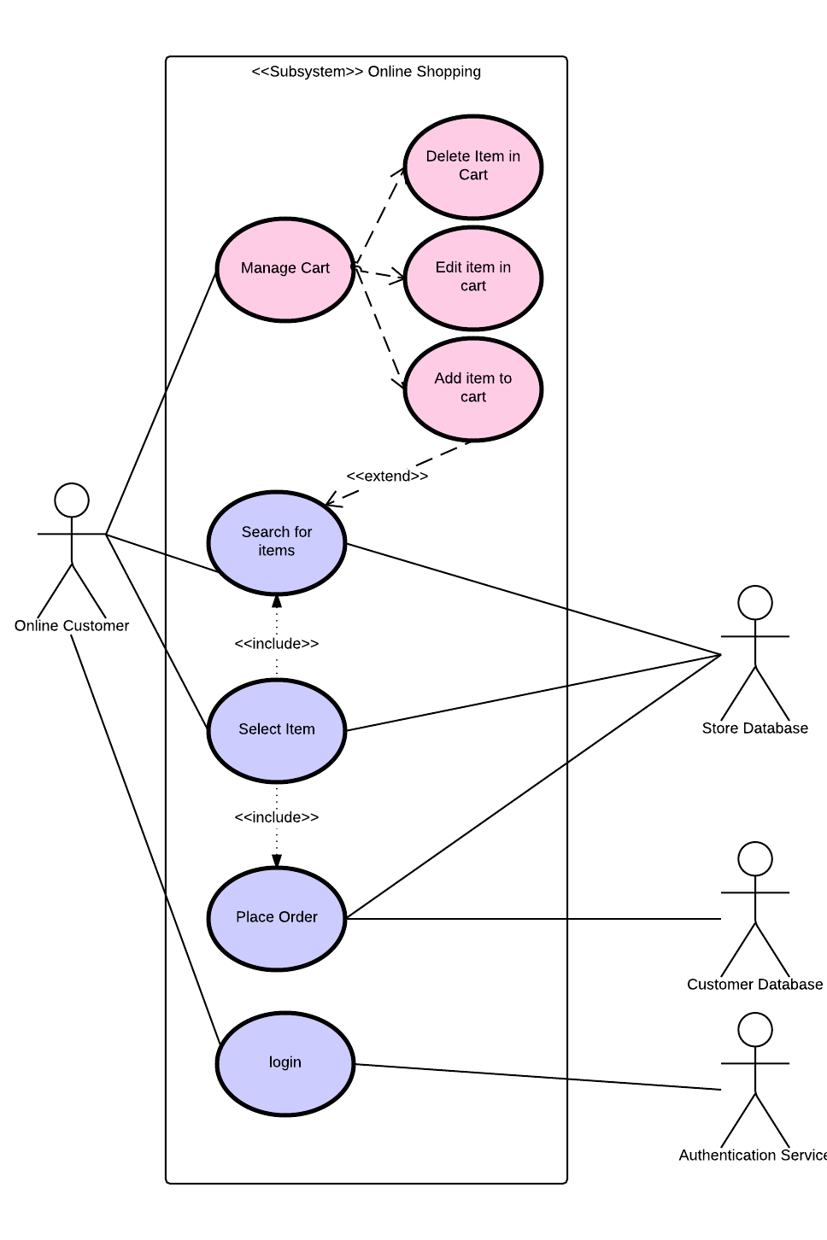

Sequence diagram
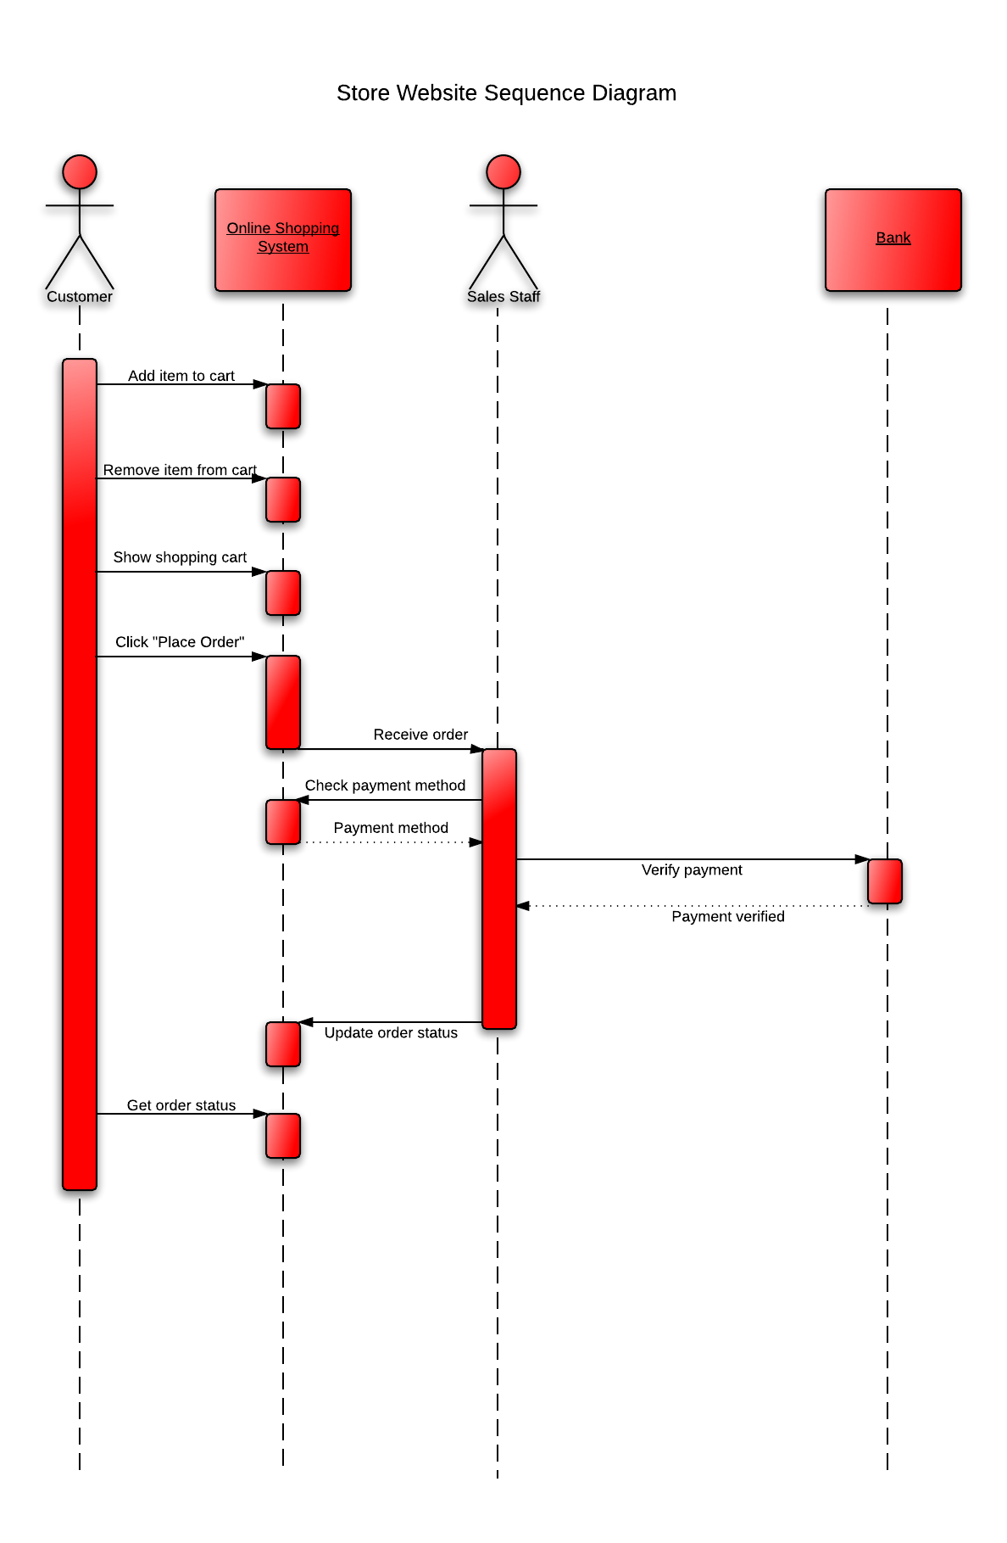

Class diagram
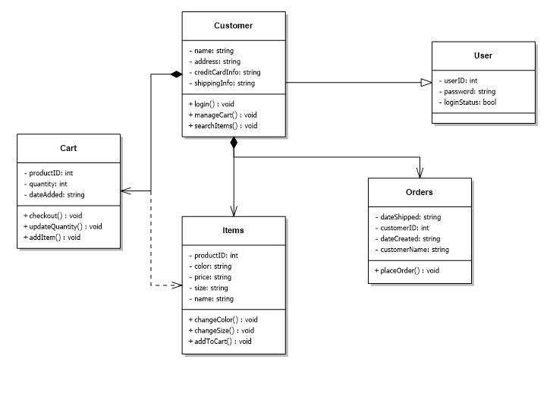

System Evolution
Due to the nature of our software we will always need to constantly update our databases as to make sure that our quantity for each item is correct. Also if we ever add a new item into our inventory our database will need to be aware of this change and we will need to manually add this in.

Appendices
We will employ Postgres for our database and use sequelize for database queries. We will also add a templating engine (handlebars) for the html views.

