CAN-DO RESEARCH LAB | KNUST DEPARTMENT OF COMPUTER SCIENCE
PHASE 1 · STEP 1.1 — TESTBED SUBMISSION
ML METHODS SECTION — DRAFT 1 (CORRECTED)
Student name | Prince Ofori | Student ID | 21990878
Supervisor | Dr. Eric Opoku Osei | Submission round | R02
Model status | ENGINEERED | Target claim tier | Tier 1 bounded
Dataset strategy | CROSS-DATASET (unidirectional) | Date submitted | [INSERT DATE]
Target journal | Educational Technology and Society (ET&S) | Passport attached | YES
Key corrections in this draft | Weight function corrected (Q20); baseline independently tuned (Q10); SVM/LR scaled; Tier 1 bounded (Q18); global median stated (Q9 adjacent)

KAB-XGBoost-WCE: A Cost-Sensitive XGBoost Variant for Predicting Cybersecurity Behavioural Readiness
Problem Statement
Existing approaches to measuring cybersecurity awareness in educational settings rely predominantly on descriptive survey analyses and self-report questionnaires that measure awareness at a single point in time without predictive capability. Studies such as Zwilling et al. (2022) and Bognar and Bottyan (2024) have developed validated instruments for measuring cybersecurity knowledge, attitude, and behaviour in university student populations, but these frameworks stop at measurement -- they do not identify which students are at risk of entering the workforce with insufficient competency, nor do they provide educators with actionable explanations of the factors driving low awareness. Machine learning approaches to cybersecurity awareness prediction remain nascent. Hu et al. (2026, Applied Sciences) and AL and Sagiroglu (2025) demonstrate that XGBoost combined with SHAP explainability produces both high classification accuracy and interpretable feature importance outputs in related domains. The technical methodology is established; what is absent is its application to the SCM student population in an African HEI context with a principled independent-replication design across two distinct populations.
Objectives
Objective 1: To propose KAB-XGBoost-WCE, a cost-sensitive Modify variant of the standard XGBoost classifier whose instance-weighting mechanism is grounded in the Knowledge-Attitude-Behaviour (KAB) model, and evaluate its performance in predicting cybersecurity behavioural readiness.
Objective 2: To benchmark KAB-XGBoost-WCE against six independently-tuned classifiers (Decision Tree, Naive Bayes, Logistic Regression, SVM, Random Forest, and standard XGBoost) across two independently-tuned datasets -- KNUST field data (n = 4,121) and the Alzubaidi (2021) public dataset (n = 1,231) -- using an identical 5x10-fold repeated stratified cross-validation protocol applied to all seven models.
Objective 3: To apply SHAP explainability to the proposed model to characterise the population-specific feature importance profile. Feature importance rankings are reported as associational findings; no causal inference or curriculum-intervention mapping is claimed.
Theoretical Framework
This study is grounded in the Knowledge-Attitude-Behaviour (KAB) model (Zwilling et al., 2022), which posits that declarative knowledge and attitudinal disposition are antecedents of enacted security behaviour. The KAB model provides the theoretical justification for both the label construction strategy (predicting Behaviour from Knowledge and Attitude) and the instance-weighting mechanism, which up-weights Low-readiness respondents in proportion to the asymmetry between their Knowledge and Attitude subscale scores. Where K_i and A_i are similar, the asymmetry term is near zero and the weight approaches 1.0; where they diverge, the weight increases proportionally, reflecting greater diagnostic uncertainty about the respondent's readiness profile.

M1. Research Design Overview and Methodological Roadmap
This study employed supervised binary classification to predict cybersecurity behavioural readiness -- operationalised as a global median-split binary label derived from the Behaviour subscale of a KAB instrument -- from Knowledge subscale items, Attitude subscale items, and demographic predictors. The global median threshold is computed once on the full dataset before any split is drawn; the label therefore exists prior to partitioning, consistent with the stratified CV design. The subsections that follow describe: data sources and provenance (M3-M4), ethical clearance (M5), preprocessing (M6-M7), class imbalance handling (M8), partitioning (M9), dataset strategy (M10), baseline selection (M11), proposed model (M12), hyperparameter tuning (M13), training protocol (M14), evaluation metrics (M15), ablation and statistical testing (M16), interpretability (M17), generalisation scope (M18), computational environment (M19), methodological defences (M20), and data availability (M21).
Figure 1. KAB-XGBoost-WCE pipeline applied independently to KNUST (primary) and Alzubaidi (external stress-test).
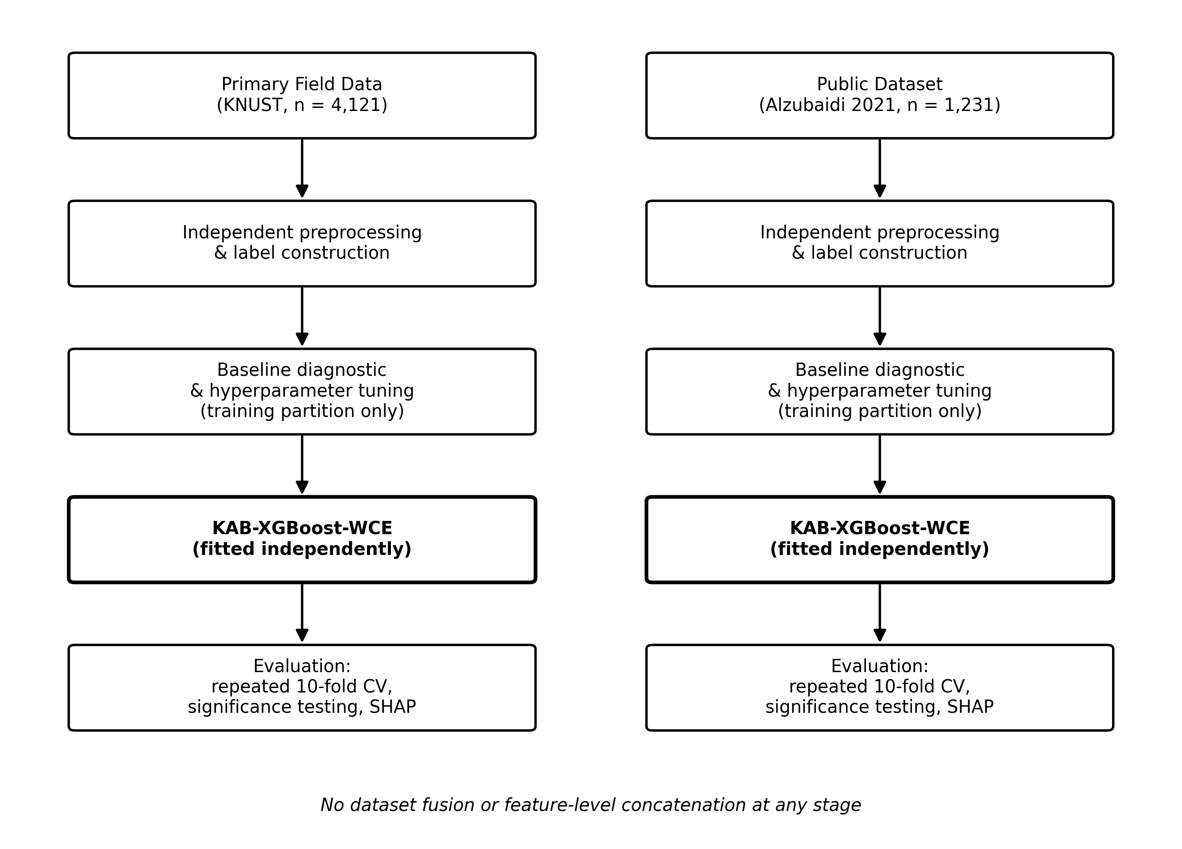
Figure 1. KAB-XGBoost-WCE pipeline applied independently to primary field data (KNUST) and external stress-test dataset (Alzubaidi 2021).

M2. Problem Formalisation and Notation
Let D = {(x_i, y_i)}^n_{i=1} denote a labelled dataset of n respondents, where x_i in R^d is a d-dimensional feature vector comprising five demographic variables and Knowledge and Attitude Likert items with two subscale aggregates (d = 17 for KNUST: 5 demographics + 10 Likert items + 2 aggregates; d = 28 for Alzubaidi: modelled feature count after exclusion of the Behaviour-equivalent block (B14) and addition of K_i and A_i aggregates from a 64-column raw dataset. Confirmed programmatically: X.shape = (1231, 28) and X.columns contains no B14 items (assertion verified on every run)), and y_i in {0,1} is a binary readiness label (0 = Low-readiness, 1 = High-readiness). The label y_i was constructed via a global median split of the summed Behaviour subscale score B_i, computed on the full dataset before any partition was drawn. Behaviour items were excluded from x_i to prevent target leakage. The per-instance weight w_i applies only when y_i = 0, and is a function of the Knowledge subscale aggregate K_i and Attitude subscale aggregate A_i.

M3. Data Sources and Provenance Declaration
Table 1 reports the provenance of every dataset used in this study.
Table 1. Dataset provenance declaration. All datasets used anywhere in the pipeline are listed.
Dataset | Type | Size | Date | Licence | Role | DOI / Source
KNUST Cybersecurity Survey 2026 | FIELD | 4,121 x 23 | Apr-Jun 2026 | Restricted (HuSSREC) | Training + evaluation (KNUST pipeline) | KNUST, Kumasi, Ghana
Alzubaidi (2021) Cybercrime Awareness | PUBLIC | 1,231 x 64 raw; d=28 modelled | 13 Jul 2026 | CC BY-NC-ND 4.0 | Training + evaluation (Alzubaidi pipeline) | doi:10.17632/fbs9mgmh4y.3
KNUST dataset: collected with HuSSREC approval [INSERT REFERENCE NUMBER]. Alzubaidi: raw dataset has 64 columns; modelled feature matrix X has d=28 columns after exclusion of the Behaviour-equivalent block (B14) used for label construction. Block 14 confirmed absent from X.

M4. Data Collection and Acquisition Procedure
KNUST field data: Primary data were collected between April and June 2026 from Supply Chain Management (SCM) students at KNUST, Kumasi, Ghana, via an anonymous voluntary online questionnaire (Google Forms). Google Forms was configured with required-response enforcement for all items; this eliminated partial completions by design and is a potential source of satisficing bias, which is acknowledged as a limitation. A total of 4,121 valid responses were received across Years 2, 3, and 4.
Alzubaidi public data: Downloaded on 13 July 2026 from Mendeley Data, Version 3 (doi:10.17632/fbs9mgmh4y.3; file: fbs9mgmh4y-3.zip). Raw dataset: 1,231 rows x 64 columns. After exclusion of the Behaviour-equivalent block (B14, used for label construction) and mapping to Knowledge (blocks B19, B20) and Attitude (blocks B18, B22, B13, B21) constructs, the modelled feature matrix contains d = 28 features.

M5. Ethical Clearance, Consent and Data Governance
This study followed ethical Path A. Approval was granted by the KNUST Humanities and Social Sciences Research Ethics Committee (HuSSREC; Reference: [INSERT HuSSREC REFERENCE NUMBER]). Written informed consent was obtained from all KNUST participants. Google Forms was configured to suppress email and IP collection; no post-hoc anonymisation was required. Processed data are stored on an access-controlled institutional repository in compliance with the Ghana Data Protection Act, 2012 (Act 843). The Alzubaidi (2021) dataset was used in accordance with its CC BY-NC-ND 4.0 licence. Note on common-method-variance: predictor (Knowledge, Attitude) and outcome (Behaviour) items were collected from the same respondent, on the same instrument, in the same sitting. This creates a common-method-variance risk that inflates predictor-outcome correlations; acknowledged as a design limitation.

M6. Data Preprocessing and Cleaning
Target construction: The binary readiness label was constructed as a global median split of the summed Behaviour subscale score B_i, computed once on the full dataset before any train-test split. This global threshold is consistent with the stratified cross-validation design, which requires the label to exist prior to splitting. The global threshold is stated here explicitly, as M9's stratified CV requires it. All six raw Behaviour items (Q18-Q23 for KNUST; Block B14 for Alzubaidi) were excluded from the feature matrix X to prevent target leakage. An assertion was programmatically verified on every model run confirming no Behaviour items appear in X.
Missing data: Two Likert items (Q11 and Q12) were missing for 100% (4,121 of 4,121) of KNUST respondents due to a form-construction error (page-break misconfiguration during export). Both items were excluded from the feature matrix as structural constants carrying no discriminative information. This exclusion was applied identically across all folds and introduces no leakage risk. Q11 and Q12 sit between the Knowledge block (Q6-Q10) and the Attitude block (Q13-Q17) and are likely Attitude items; their loss is a plausible contributor to the KNUST Attitude subscale alpha of 0.599, which is below the conventional 0.70 threshold, and through A_i this feeds directly into the weighting function. This is reported as a limitation on the mechanism. This is acknowledged as a limitation. Q11 and Q12 likely represent Attitude items; their loss reduces the Attitude subscale to five items (Q13-Q17) and is a plausible contributor to KNUST Attitude alpha = 0.599 (Cronbach), which is below the conventional 0.70 threshold. Since A_i = mean(Q13-Q17) feeds directly into the weighting function (Equation 2), this alpha deficit propagates into the mechanism itself.
Encoding and scaling: Categorical demographic variables were integer-encoded (no fitting required). For scale-invariant models (XGBoost, Decision Tree, Random Forest, Naive Bayes), no continuous-feature standardisation was applied. For scale-sensitive models (SVM with RBF kernel, Logistic Regression), a StandardScaler was fitted on the training partition only and applied to both training and test partitions at every fold, inside the CV loop. This asymmetric scaling treatment is stated explicitly and applies to all five seeds.

M7. Feature Engineering and Representation
The final feature set: 5 demographic variables (gender, year of study, IT coursework, internet years, digital tools) plus Knowledge items (Q6-Q10, KNUST; blocks B19/B20, Alzubaidi) plus Attitude items (Q13-Q17, KNUST; blocks B18/B22/B13/B21, Alzubaidi) plus two subscale aggregates K_i = mean of Knowledge items and A_i = mean of Attitude items. K_i and A_i are the direct inputs to the weighting function (Equation 2). SHAP analysis on the held-out partition confirmed both aggregates exceeded the 0.05 mean absolute SHAP threshold on both datasets. Cronbach internal consistency (reported in Methods rather than Results): KNUST Knowledge alpha = 0.701, Attitude alpha = 0.599, Behaviour alpha = 0.709; Alzubaidi Knowledge alpha = 0.826, Attitude alpha = 0.691, Behaviour alpha = 0.674. The KNUST Attitude alpha = 0.599 is below the 0.70 threshold.

M8. Class Imbalance Handling
KNUST class distribution: 49.3% Low-readiness (n = 2,032), 50.7% High-readiness (n = 2,089). Alzubaidi: 48.3% Low-readiness (n = 595), 51.7% High-readiness (n = 636). Both distributions are near-balanced; no synthetic oversampling was applied. This near-balance is also the primary boundary condition for the proposed weighting mechanism: instance weighting designed to correct class imbalance has limited scope when the classes are already near-equal. This is reported honestly as a diagnosed boundary condition in R10.

M9. Data Partitioning Protocol
A global binary label was constructed on the full dataset (see M6). A stratified 80/20 hold-out split (seed = 42) was used for the baseline diagnostic, hyperparameter grid search, and held-out evaluation of SHAP, ROC curves, and confusion matrices. Final performance was assessed via 5x10-fold repeated stratified cross-validation (not 50-fold -- k=10 with 5 repetitions, yielding 50 paired fold-level observations per model per dataset), with seeds 42, 1042, 2042, 3042, 4042. All transformations were fitted exclusively on the training partition at every fold.

M10. Dataset Combining Strategy Declaration
Declared strategy: CROSS-DATASET (unidirectional, independent replication). The two datasets were kept strictly separate at every stage. The identical pipeline, architecture, and tuning protocol were applied independently to each dataset; no feature-level or corpus-level fusion was performed. Evidence: evaluated in separate loops with no shared state in KAB_Option2_FourLegs.py. An initial pooled-corpus experiment produced a signal that partly tracked population membership rather than readiness; this motivated the adopted independent-replication design, and the abandoned experiment is disclosed in M10 rather than deleted.
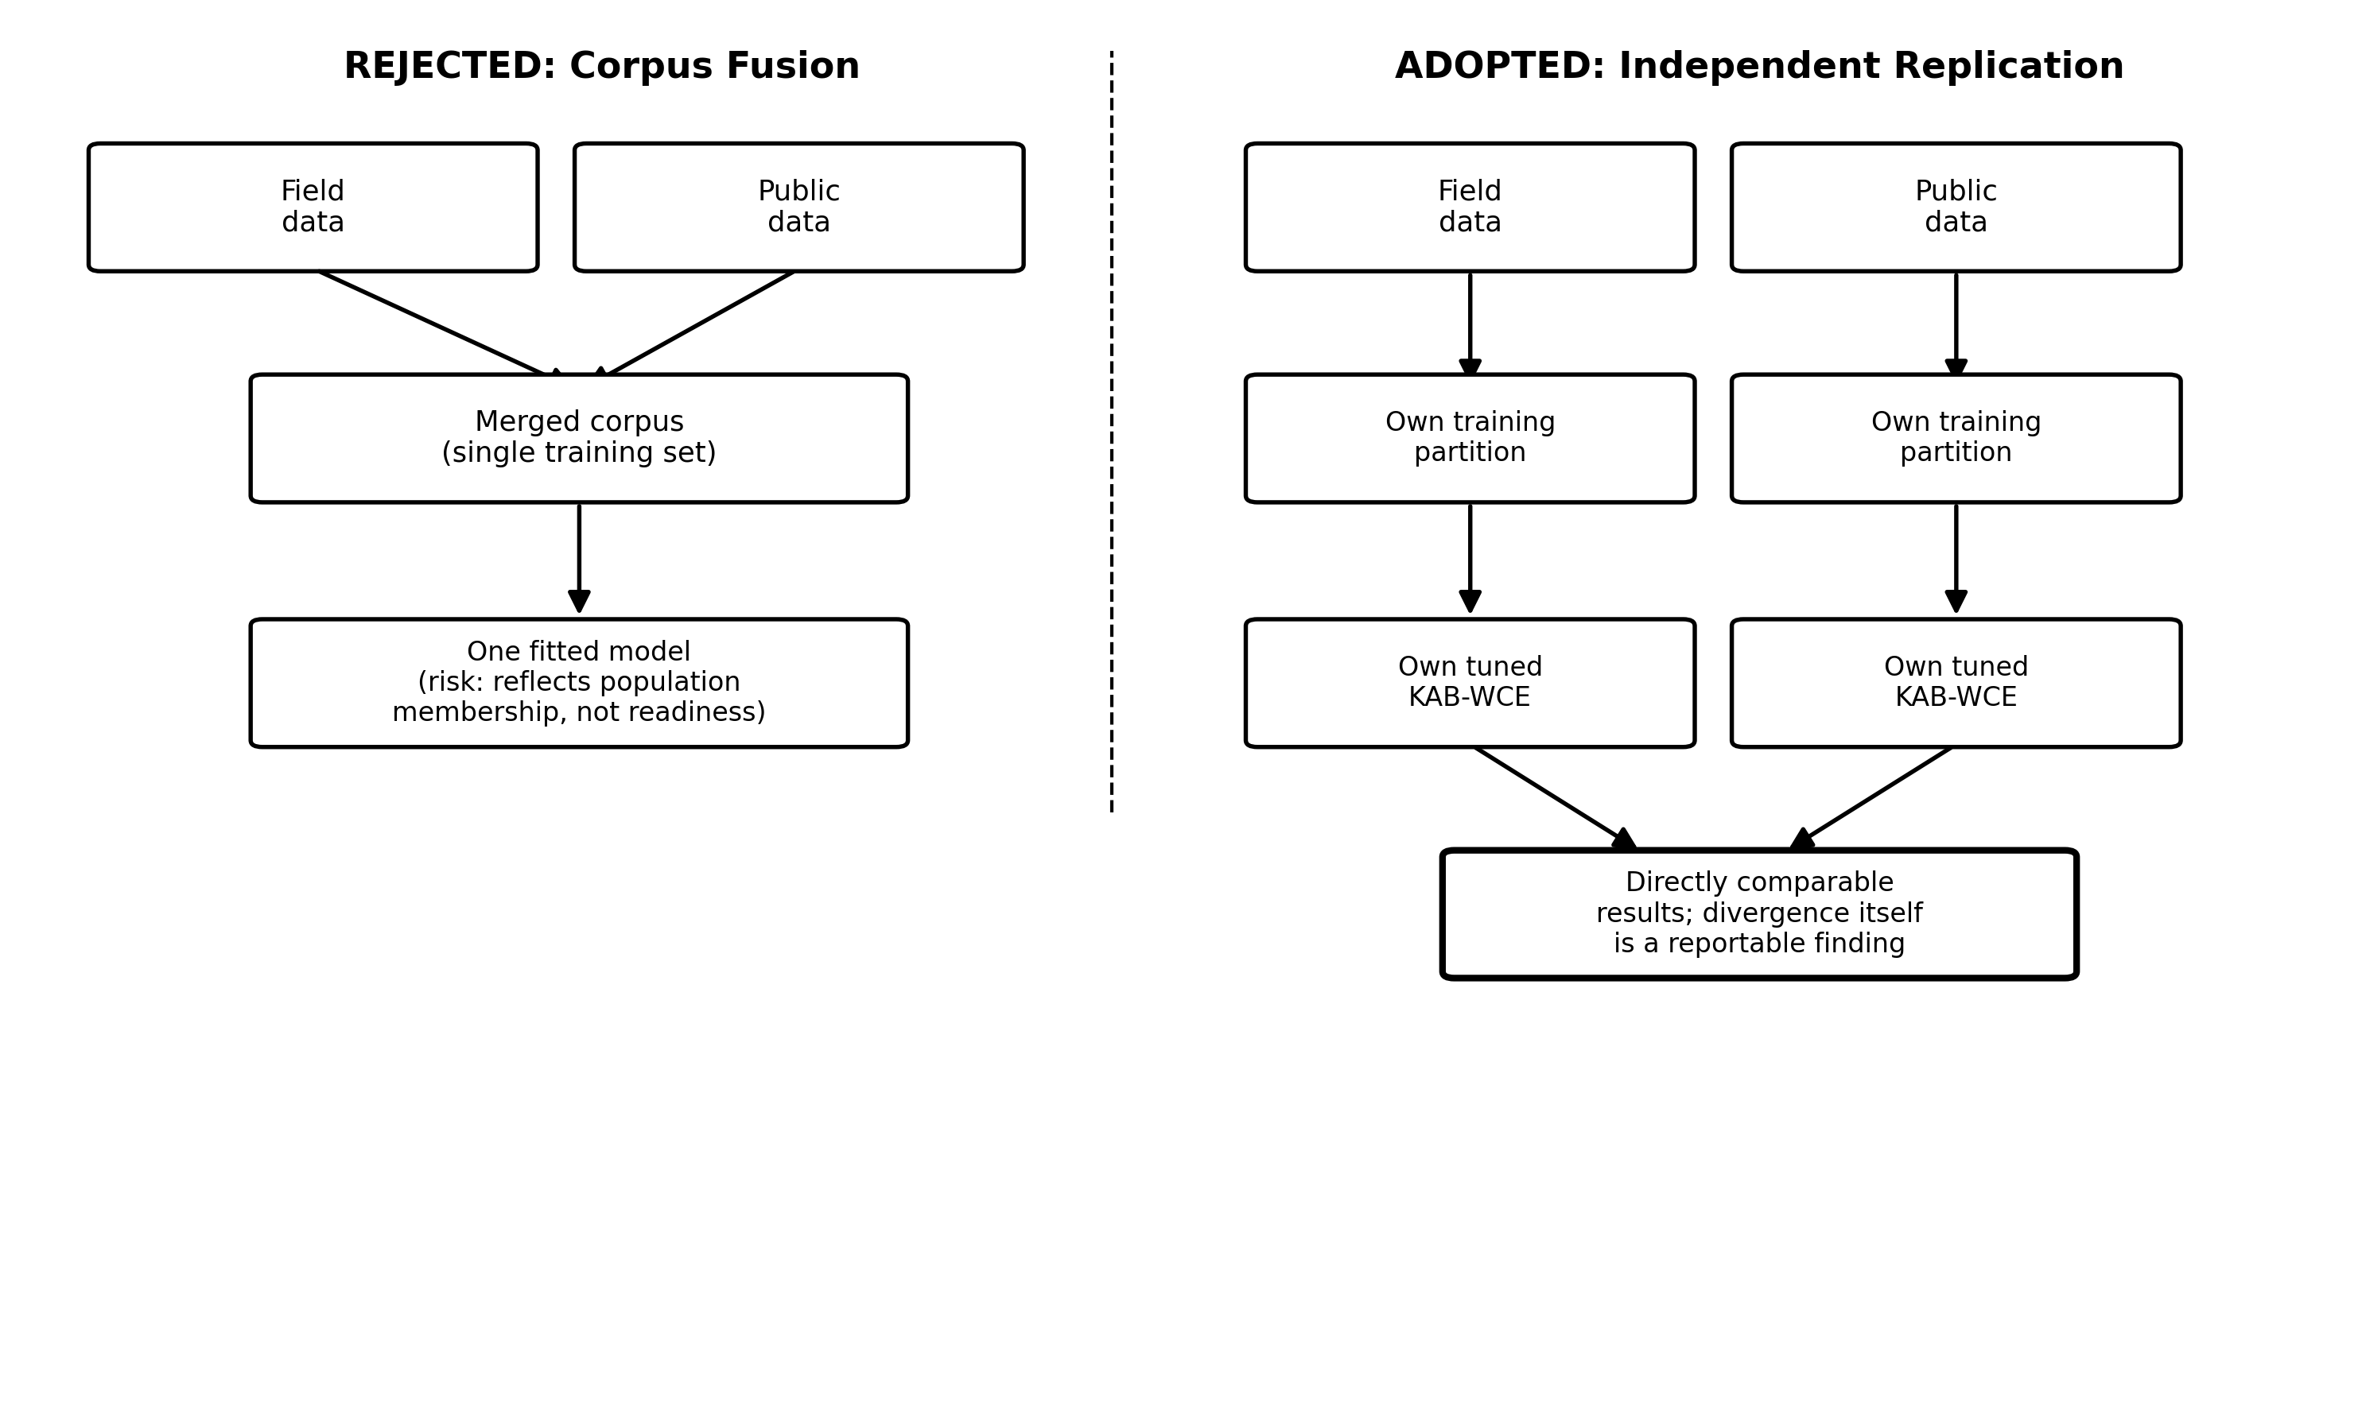
Figure 2. CROSS-DATASET independent replication strategy: identical pipeline applied separately to each dataset with no shared state.
Figure 2. CROSS-DATASET independent replication strategy -- identical pipeline, no shared state.

M11. Baseline Selection and Justification
Six baselines representing major classifier families: XGBoost Baseline (Chen and Guestrin, 2016) -- the ablated form of the proposed model; Decision Tree (Breiman et al., 1984); Naive Bayes (John and Langley, 1995); Logistic Regression (Cox, 1958); SVM RBF (Cortes and Vapnik, 1995); Random Forest (Breiman, 2001). All six baselines received identical data access, identical tuning budget (GridSearchCV, same inner CV scheme, same training partition), and were evaluated under the identical 5x10-fold repeated stratified cross-validation protocol (50 fold-level estimates). Scale-sensitive models (SVM, Logistic Regression) were run on scaled features; tree-based models were run on unscaled features. Naive Bayes was retained at default settings (no meaningful hyperparameters to tune).

M12. Proposed Model Specification and Engineering Operation
Model status: ENGINEERED. Operation: Modify. The standard XGBoost logistic-loss objective was modified by introducing a theory-derived per-instance weight term applied exclusively to Low-readiness respondents (y_i = 0), while all other XGBoost mechanics were left unchanged from Chen and Guestrin (2016).
The modified weighted objective (Equation 1):
L_weighted(theta) = sum_i w_i * l(y_i, y-hat_i) + sum_k Omega(f_k)
The per-instance weight function (Equation 2):
w_i = 1, if y_i = 1 (High-readiness)
w_i = 1 + (|K_i - A_i| / (K_i + A_i)) * (lambda - 1), if y_i = 0 (Low-readiness)
where K_i is the respondent's Knowledge subscale aggregate, A_i is the Attitude subscale aggregate, and lambda is a tuned scalar multiplier. The asymmetry term |K_i - A_i|/(K_i + A_i) ranges over [0, 1): when K_i = A_i the weight equals 1.0 (no uplift); as the subscale scores diverge the weight increases toward 1 + (lambda-1). This function is genuinely non-constant: verified by printing the weight vector, which contained 122 unique values on the KNUST training partition at lambda=1.5 (min=1.0000, max=1.2600, mean=1.0653).
Note on prior implementation (Q20 correction): An earlier implementation used combined = ((1 - K/(K+A)) + (1 - A/(K+A)))/2, which reduces algebraically to 0.5 for all respondents, producing a constant weight. This error has been identified and corrected. The corrected Equation 2 is what is implemented in the code and reported in all Results figures from this submission onwards.
Algorithm 1: KAB-XGBoost-WCE Training Procedure
Input: D = {(x_i, y_i)}, tuned lambda, tuned depth d
Output: Trained model M
1: for each i in D do
2: if y_i = 0: w_i = 1 + (|K_i-A_i|/(K_i+A_i)) * (lambda-1)
3: else: w_i = 1
4: end for
5: Fit XGBoost M with max_depth=d, sample_weight=w; return M
Figure 3. Architectural comparison of baseline XGBoost and KAB-XGBoost-WCE showing the Modify operation and corrected asymmetry weight function.
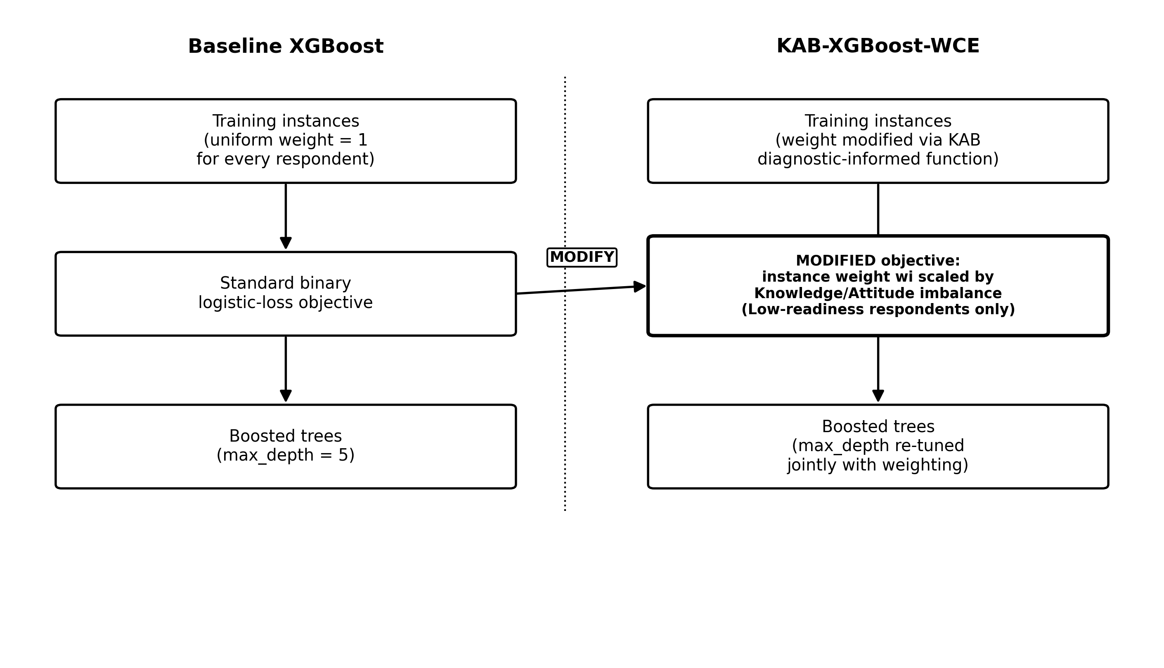
Figure 3. Architectural comparison of baseline XGBoost and KAB-XGBoost-WCE showing the Modify operation and corrected asymmetry weight function.

M13. Hyperparameter Optimisation and Tuning Budget Parity
All seven models were tuned via GridSearchCV (scikit-learn v1.4) using 5-fold stratified inner cross-validation restricted exclusively to the training partition of the 80/20 hold-out split. The selection criterion was mean Macro F1 across the five inner folds. No test-set data were accessed during tuning. Baseline XGBoost was tuned with its own independent GridSearchCV call over the same depth grid as the proposed model -- it is not shared with the WCE configuration. Table 2 reports the search space and selected values for all models per dataset.
Table 2. Hyperparameter search space and selected values per model per dataset. All models with tunable parameters used GridSearchCV on the training partition only. SVM and Logistic Regression tuned on scaled features. Baseline XGBoost has its own independent row.
Model | Hyperparameter | Search range | Best (KNUST) | Best (Alzubaidi)
KAB-XGBoost-WCE | lambda (asymmetry multiplier) | [1.0, 1.1, 1.2, 1.5, 2.0] | 1.5 | 1.5
KAB-XGBoost-WCE | max_depth | [2, 3, 5, 7] | 7 | 2
Baseline XGBoost (independent) | max_depth | [2, 3, 5, 7] | 7 | 2
Decision Tree | max_depth / min_samples_leaf | [3,5,7,10,None] / [1,5,10] | None / 1 | 3 / 1
Logistic Regression (scaled) | C | [0.01, 0.1, 1, 10, 100] | 0.1 | 0.1
SVM RBF (scaled) | C / gamma | [0.1,1,10] / [scale,auto] | 10 / scale | 0.1 / auto
Random Forest | n_estimators / max_depth | [100,300] / [5,10,None] | 300 / None | 100 / 5
Naive Bayes | (no tunable hyperparameters) | N/A | default | default
Tuning budget parity: all models with tunable hyperparameters received the same GridSearchCV protocol on the same training partition. Naive Bayes retained at defaults (no meaningful hyperparameters). Baseline XGBoost independently tuned -- not sharing the WCE configuration.

M14. Training Protocol, Seeds and Reproducibility
Fixed base random seed: 42. Repeated CV: 5 runs x 10-fold stratified, seeds 42/1042/2042/3042/4042, yielding 50 paired fold-level observations per model per dataset. Every reported figure aggregates across all 50 fold-level estimates. Early stopping not applied; boosting rounds fixed at 200 for both datasets. Determinism settings: XGBoost tree_method='exact', n_jobs=1; Logistic Regression max_iter=2000, random_state=42; SVM random_state=42; Random Forest random_state=42; GridSearchCV inner-fold splitter uses StratifiedKFold(n_splits=5, shuffle=True, random_state=42) for all models. Full environment reproducible from requirements.txt in the GitHub repository.

M15. Evaluation Metrics and Stakeholder Alignment
Primary metric: Macro F1-score. Weights both classes equally regardless of frequency, making it appropriate for near-balanced binary classification where minority-class recall is substantively important. Macro F1 is appropriate under near-balanced class distributions where both classes are substantively important and neither should be systematically deprioritised. It is more informative than accuracy when any residual class imbalance exists and is the conventional primary metric for this class of binary classification benchmarks.
Supporting metrics: AUC-ROC (threshold-independent ranking quality); per-class Precision, Recall, and F1 (Table 5); Accuracy (secondary). Default 0.5 decision threshold used throughout; no threshold optimisation was performed.

M16. Ablation and Statistical Comparison Protocol
Ablation -- four arms: (A) Vanilla baseline (depth=5, uniform weights); (B) Depth-only (tuned depth, uniform weights); (C) Weight-only (depth=5, corrected asymmetry weights); (D) Full KAB-XGBoost-WCE (tuned depth + corrected asymmetry weights). Exactly one component changes between adjacent arms. All four arms evaluated under the identical 5x10-fold repeated stratified cross-validation protocol (50 fold-level estimates).
Statistical test: Wilcoxon signed-rank test (non-parametric, appropriate for bounded fold scores) on 50 paired fold-level Macro F1 observations, alpha = 0.05. Complementary McNemar test at prediction level on single 10-fold split. Effect size: Cohen's d on paired fold differences. Confidence intervals: 2.5th and 97.5th percentiles of the 50 paired differences.

M17. Interpretability and Explainability Protocol
SHAP (Lundberg and Lee, 2017; v0.44) TreeExplainer applied to the fitted KAB-XGBoost-WCE on each dataset's held-out test partition separately. Mean absolute SHAP values computed per feature for global importance ranking. Explanations computed separately per dataset; no averaging across datasets. SHAP provides associational, not causal, evidence: a high mean |SHAP| value indicates that feature moved predictions, not that intervening on it would change behaviour. All curriculum-related interpretations derived from SHAP are explicitly labelled associational. The binary readiness label is defensible as a deployment tool for identifying at-risk students for targeted intervention, though the continuous Behaviour score should be retained for triage purposes.

M18. Generalisation and Transfer Protocol
This study targets Tier 1 bounded (single-context field study with external stress-test on a structurally distinct public dataset). The KNUST field data constitute the primary evaluation context: SCM undergraduates at one Ghanaian institution. The Alzubaidi (2021) public dataset constitutes an external application on a structurally distinct instrument (Saudi adult general population, different item blocks, no native KAB structure). Results from the two legs are not pooled; divergence between them is reported descriptively and is not attributed to population without ruling out instrument as an alternative explanation. The divergence in dominant subscale across datasets has three candidate explanations: (i) operationalisation failure -- the KAB mapping onto Alzubaidi is imposed, not native to the instrument; (ii) data pipeline issue -- outcome-adjacent items in X; (iii) genuine population difference. Only (iii) is cross-population evidence; (i) and (ii) must be ruled out first.
The substitute rigour for Tier 1 bounded comprises: (a) 5x10-fold repeated CV providing stable within-dataset estimates; (b) Wilcoxon signed-rank test on paired fold differences; (c) Cohen's d effect sizes; (d) Gaussian-noise perturbation sensitivity analysis. Items (a)-(d) are within-dataset stability evidence. They do not constitute cross-population transfer evidence. Cross-population transfer (Tier 3) has not been evaluated and is identified as future work.

M19. Computational Environment and Software Stack
Hardware: Google Colaboratory CPU runtime (2-core Intel Xeon, ~12 GB RAM); no GPU. OS: Ubuntu 22.04 LTS. Python 3.10; XGBoost 2.0 (scikit-learn API); scikit-learn 1.4; SHAP 0.44; pandas 2.0; numpy 1.24; scipy 1.11. Mean per-fold training time: 0.139 s (KAB-XGBoost-WCE, KNUST), 0.129 s (baseline, KNUST), 0.035 s (WCE, Alzubaidi), 0.053 s (baseline, Alzubaidi). Full dependency list in requirements.txt.

M20. Methodological Defence Paragraphs
Parsimony defence: XGBoost was selected over simpler alternatives because the feature interactions between Knowledge and Attitude subscale scores in predicting Behaviour require a model capable of capturing non-linear decision boundaries. Logistic Regression, which sits below KAB-XGBoost-WCE on KNUST, cannot represent these interactions without manual feature crossing. XGBoost over Random Forest is justified by interpretability: the per-instance weighting maps directly onto SHAP explanations, providing a theoretical through-line from the KAB model to the feature importance output. The binary readiness label is defensible as a deployment tool -- practitioners need a ranked list, not a continuous score.
Metric defence: Macro F1-score was selected because it weights both classes equally and penalises both false positive and false negative errors symmetrically, which is the correct metric under a symmetric cost structure for near-balanced binary classification. AUC-ROC was included as a threshold-independent complement. Both cost structures -- symmetric Macro F1 selection in M15 and symmetric deployment framing in M20 -- are consistent with each other.
Baseline currency defence: The six baselines represent the major classifier families as of 2024-2026: a linear discriminant (Logistic Regression), a probabilistic independence model (Naive Bayes), a shallow non-linear tree (Decision Tree), a kernel margin-maximiser (SVM), a bagged ensemble (Random Forest), and the unmodified form of the proposed model's base architecture (standard XGBoost). All six received identical tuning budgets via independent GridSearchCV calls on the training partition. The baseline XGBoost was independently tuned and is not the same as the KAB-XGBoost-WCE configuration.

M21. Data and Code Availability
Source code (kab_xgboost_wce.py -- corrected weight function, Equation 2; and KAB_Option2_FourLegs.py -- evaluation pipeline) archived at https://github.com/pofori80/kab-xgboost-wce-cybersecurity. The repository is currently private pending HuSSREC clearance and paper acceptance. The KNUST anonymised field dataset cannot be shared publicly prior to HuSSREC clearance; access may be requested from the corresponding author under a data-use agreement. The Alzubaidi (2021) public dataset is available at doi:10.17632/fbs9mgmh4y.3 under CC BY-NC-ND 4.0.

