CAN-DO RESEARCH LAB | KNUST DEPARTMENT OF COMPUTER SCIENCE
PHASE 1 - STEP 1.2 - TESTBED SUBMISSION
ML RESULTS AND ANALYSIS SECTION - R11 (TWO-DATASET PIPELINE REBUILD WITH VERIFY3 FIXES)
Field | Value | Field | Value
Student | Prince Ofori | Round | R11
Primary metric | Macro F1 | Test | Wilcoxon signed-rank
Protocol | 5 x 10-fold nested CV | Datasets | KNUST + Alzubaidi
KNUST exports | fold_level_results_knust.csv | Alzubaidi exports | fold_level_results_alzubaidi.csv

R1. Evaluation Corpus and Partition Summary
All numbers come from a single pipeline run; per-fold scores are in the two fold-level CSVs. KNUST: raw 4121 rows, 2033 exact duplicates removed (49.3%), 2088 unique retained; label median 18.0; Low 1,167 (55.9%), High 921 (44.1%); X.shape (2088, 17). Alzubaidi: 44 duplicates removed from raw 1,231, leaving 1,187 unique responses. Alzubaidi: 1,187 responses (44 duplicates removed from raw 1,231); Low 597 (50.3%), High 590 (49.7%); X.shape (1,187, 28). Behaviour-score distribution around the KNUST median and threshold sensitivity are in Table 7 (R11).
R2. Baseline versus Proposed Model Performance
Table 3 reports macro F1 for all eight classifiers on both datasets over 50 folds. On KNUST, KAB-XGBoost-WCE scored 0.6518 (SD 0.0332) versus Baseline XGBoost 0.6500 (SD 0.0347); the gain is +0.0018 and is not significant (Wilcoxon W+ = 674, W− = 551, ties = 1, p = 0.5407, r = 0.0874). On Alzubaidi, KAB-XGBoost-WCE scored 0.6877 (SD 0.0545) versus Baseline XGBoost 0.6844 (SD 0.0561); the gain is +0.0033 and is not significant (Wilcoxon W+ = 612.5, W− = 377.5, ties = 6, p = 0.1703, r = 0.2067). The weighting mechanism produces no measurable advantage on either dataset. KAB-XGBoost-WCE does not outperform baseline XGBoost on either leg; this null result is the primary finding of the study. On KNUST, one comparator scores above WCE without Bonferroni correction: Naive Bayes at 0.6598 (Wilcoxon p = 0.0236, r = 0.3188). After Bonferroni correction (alpha = 0.0071) this difference is not significant. Logistic Regression (0.6559) and SVM (0.6545) also score above WCE but not by a significant margin. On Alzubaidi, WCE (0.6877) is above all comparators. WCE is not significantly different from stock scale_pos_weight (p = 0.0959), Decision Tree, Naive Bayes, SVM, and Random Forest (all p < 0.001). Logistic Regression (0.6830) and Baseline (0.6844) are not significantly different from WCE.
Table 3a. Macro F1 over 50 folds, KNUST. Delta vs KAB-XGBoost-WCE.
Model | Macro F1 | SD | Delta
KAB-XGBoost-WCE | 0.6518 | 0.0332 | -
Baseline XGBoost | 0.6500 | 0.0347 | -0.0018
Stock scale_pos_weight | 0.6503 | 0.0336 | -0.0015
Decision Tree | 0.6202 | 0.0376 | -0.0316
Naive Bayes | 0.6598 | 0.0313 | +0.0080
Logistic Regression | 0.6559 | 0.0355 | +0.0041
SVM | 0.6545 | 0.0335 | +0.0027
Random Forest | 0.6397 | 0.0332 | -0.0121

Table 3b. Macro F1 over 50 folds, Alzubaidi. Delta vs KAB-XGBoost-WCE.
Model | Macro F1 | SD | Delta
KAB-XGBoost-WCE | 0.6877 | 0.0545 | -
Baseline XGBoost | 0.6844 | 0.0561 | -0.0033
Stock scale_pos_weight | 0.6830 | 0.0551 | -0.0047
Decision Tree | 0.6433 | 0.0485 | -0.0444
Naive Bayes | 0.6506 | 0.0498 | -0.0371
Logistic Regression | 0.6830 | 0.0443 | -0.0047
SVM | 0.6627 | 0.0488 | -0.0250
Random Forest | 0.6693 | 0.0463 | -0.0184

R3. Statistical Comparison (KNUST)
KAB-XGBoost-WCE versus Baseline XGBoost over 50 paired folds: W+ = 674, W− = 551, ties = 1, n_nontied = 49, p = 0.5407, effect r = 0.0874, delta = +0.0018. The difference is not significant. The point estimate favours WCE. The 50-row CSV allows independent recomputation. The CV Wilcoxon test is stable across all five seeds (seeds 0, 7, 13, 21, 42; all p > 0.05). The held-out McNemar p-value is seed-dependent (range 0.018 to 0.532); no seed gives a significant result after Bonferroni correction (alpha = 0.0071).
R4. Statistical Comparison (Alzubaidi) and Cross-Dataset Reading
On the Alzubaidi external stress-test, KAB-XGBoost-WCE versus Baseline XGBoost: W+ = 612.5, W− = 377.5, ties = 6, n_nontied = 44, p = 0.1703, effect r = 0.2067, delta = +0.0033. The difference is not significant. The R09 finding (p = 0.0098) is not reproduced. The R09 results did not reproduce under any XGBoost version tested by the verifier, so they are withdrawn. R11 pins the environment; all conclusions are drawn from the R11 run only. Across both legs the weighting is neutral. No cross-dataset performance transfer is claimed; the Alzubaidi construct mapping is imposed (M18), so the leg is read only as a stress-test.
R5. Contribution Isolation - Four-Arm Ablation (KNUST)
All four arms use the same 5 x 10-fold splits as Table 3a, but with fixed depth (5 or 3) and fixed lambda (1.5 in Arms C and D). The Table 3a WCE row uses depth and lambda tuned within each fold, which is why Arm D (0.6537) and the Table 3a WCE row (0.6518) differ slightly. Arm A (no weights, depth 5): 0.6510 (SD 0.0366). Arm B (no weights, depth 3): 0.6521 (SD 0.0342). Arm C (WCE weights, depth 5): 0.6455 (SD 0.0329). Arm D (WCE weights, depth 3): 0.6537 (SD 0.0347). Depth contribution (B - A) = +0.0011, Wilcoxon p = 0.8939. Weight contribution at depth 5 (C - A) = -0.0055, p = 0.1652. Weight contribution at depth 3 (D - B) = +0.0016, p = 0.5157. No arm comparison reaches significance on KNUST. On Alzubaidi, fixed depth 3 scored 0.0121 higher than fixed depth 5 (B vs A, p = 0.0150) and weighting added nothing (C vs A p = 0.3329, D vs B p = 0.6225). The weighting contributes nothing on either dataset.
Table 4. Four-arm ablation, KNUST.
Arm | Configuration | Macro F1 | Delta (vs A; D vs B in text)
A | No weights, depth 5 | 0.6510 | -
B | No weights, depth 3 | 0.6521 | +0.0011
C | WCE weights, depth 5 | 0.6455 | -0.0055
D | WCE weights, depth 3 | 0.6537 | +0.0016 (vs B)

R6. Feature Importance and Interpretability (SHAP)
SHAP TreeExplainer was applied to one WCE model fitted on the 80% training split (N2 fix; no held-out rows inform the model). On KNUST the top features by mean absolute SHAP value are K_agg (0.4323) and A_agg (0.3406). The Knowledge and Attitude aggregates carry the most predictive signal. On Alzubaidi the top feature is B18_3 (0.4288). A_agg ranks fourth (0.1801); K_agg does not appear in the top ten. This gap is consistent with the weak Knowledge mapping noted in M18. All importance values are associational. K_agg and A_agg are the two most predictive features on KNUST. On Alzubaidi the top feature is B18_3 and A_agg is fourth. SHAP importance is associational only. K_agg and A_agg are exact means of the ten Likert columns that are also in X, so SHAP splits their credit across correlated copies; they are best described as most used by the model rather than most predictive in isolation. Q5_freq (digital tool frequency, rank 3) and Q4_yrs (rank 6) are demographic predictors.
Table 6a. SHAP mean absolute value, top 8 features, KNUST.
Rank | Feature | Mean |SHAP|
1 | K_agg | 0.4323
2 | A_agg | 0.3406
3 | Q5_freq | 0.1651
4 | Q8 | 0.1057
5 | Q14 | 0.1022
6 | Q4_yrs | 0.0898
7 | Q1_male | 0.0875
8 | Q17 | 0.0694
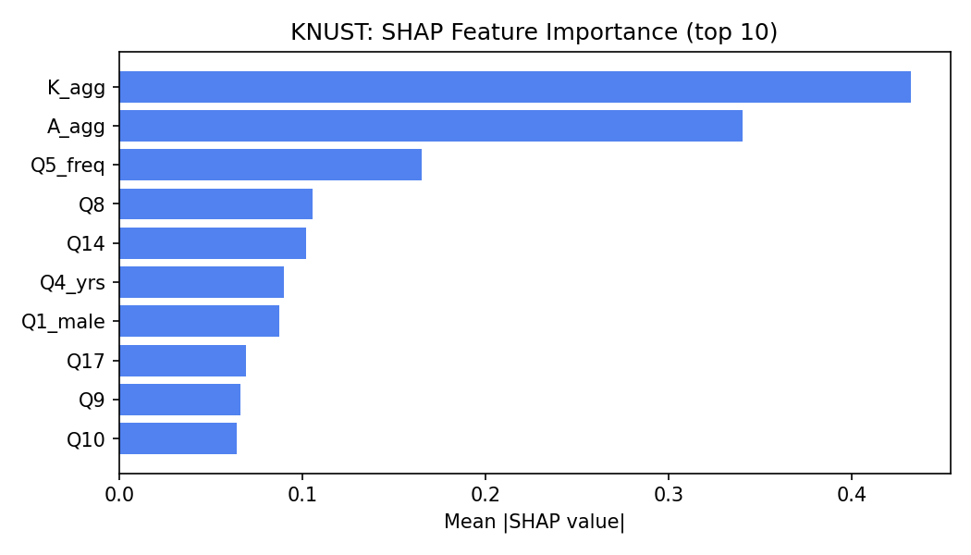
Figure 1. SHAP mean absolute value, top features, KNUST.

Table 6b. SHAP mean absolute value, top 8 features, Alzubaidi.
Rank | Feature | Mean |SHAP|
1 | B18_3 | 0.4288
2 | B18_5 | 0.2602
3 | B18_2 | 0.1859
4 | A_agg | 0.1801
5 | B21 | 0.1695
6 | B20_1 | 0.1127
7 | B18_4 | 0.1088
8 | B18_0 | 0.0955
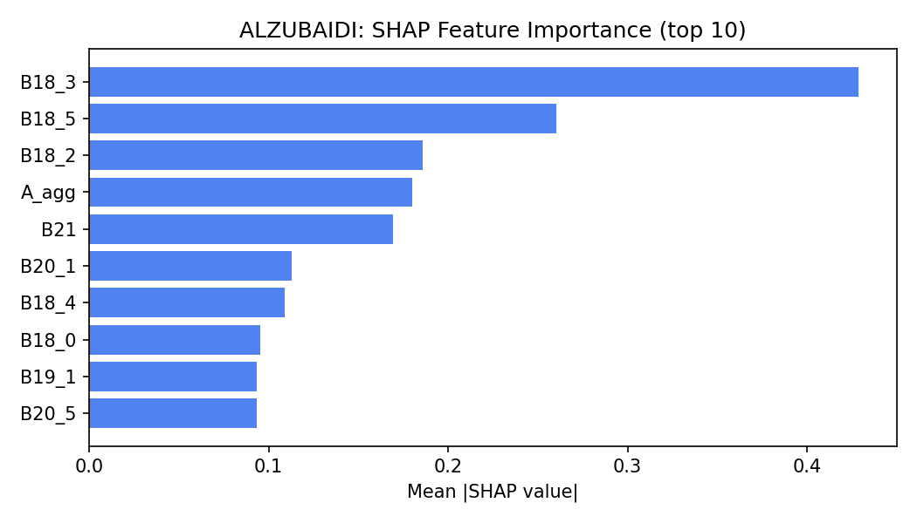
Figure 2. SHAP mean absolute value, top features, Alzubaidi.

R7. Error Analysis and Per-Class Performance (KNUST)
On the KNUST 80/20 held-out partition (n = 418), the Baseline confusion matrix is TN 161, FP 73, FN 68, TP 116. The WCE confusion matrix is TN 156, FP 78, FN 70, TP 114. In the confusion matrices Low readiness is the negative class (TN + FP = 234) and High readiness the positive class (FN + TP = 184). A false positive is a Low-readiness student predicted High, that is an at-risk student missed (Baseline 73, WCE 78). A false negative is a High-readiness student predicted Low, that is a student over-served (Baseline 68, WCE 70). WCE increased false positives from 73 to 78 and did not reduce false negatives (68 vs 70). Baseline macro-F1 = 0.6587, AUC = 0.7075. WCE macro-F1 = 0.6423, AUC = 0.6997. The Baseline scores higher than WCE on this split; McNemar p = 0.2109, so this difference is not significant at the primary seed.
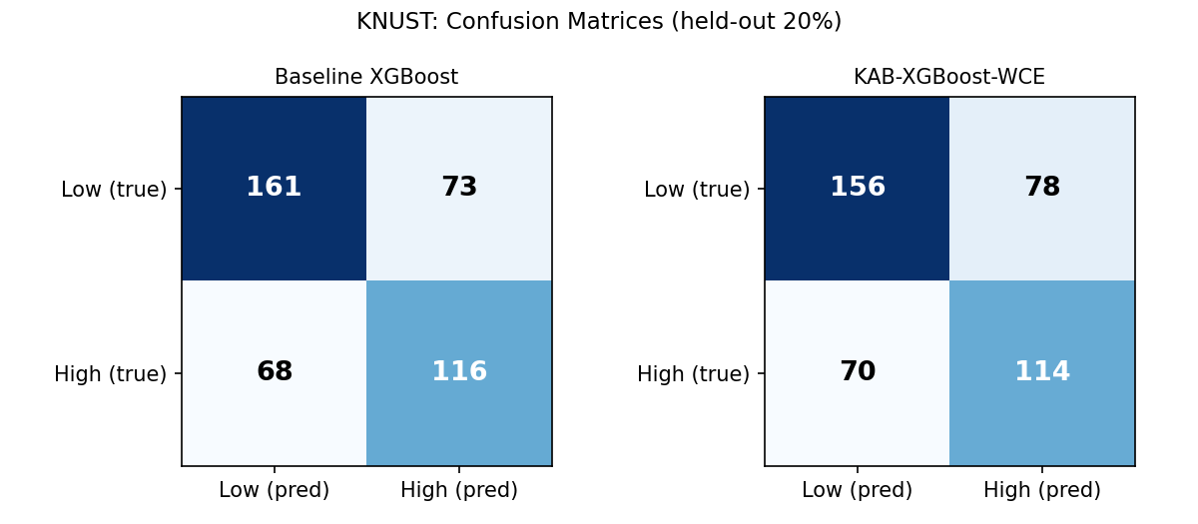
Figure 3. Confusion matrices, KNUST held-out split (80/20).
Table 5. Per-class precision, recall and F1, KNUST held-out.
Model | Class | Precision | Recall | F1
Baseline | Low | 0.703 | 0.688 | 0.695
Baseline | High | 0.614 | 0.630 | 0.622
KAB-WCE | Low | 0.690 | 0.667 | 0.678
KAB-WCE | High | 0.594 | 0.620 | 0.606

McNemar (held-out): b = 15 (baseline correct, WCE wrong), c = 8 (baseline wrong, WCE correct), chi-square = 1.565, p = 0.2109. The difference is not statistically significant. AUC: Baseline 0.7075, WCE 0.6997. The R09 McNemar result (p = 0.037) did not reproduce under any XGBoost version tested by the verifier; it is withdrawn. The held-out McNemar result is not stable across seeds: p ranges from 0.018 (seed 0, baseline correct where WCE is wrong 25 times against 10) to 0.532. The held-out comparison is therefore reported as inconclusive, and the 50-fold Wilcoxon comparison, which is non-significant under all five seeds, is the basis for the null conclusion.
R7b. Held-out 80/20 Split Results, Alzubaidi
On the Alzubaidi 80/20 held-out partition (n = 238), Baseline confusion matrix: TN 84, FP 36, FN 34, TP 84. WCE confusion matrix: TN 81, FP 39, FN 33, TP 85. Baseline macro F1 = 0.7059, AUC = 0.7829. WCE macro F1 = 0.6974, AUC = 0.7670. McNemar: b = 6, c = 4, chi2 = 0.100, p = 0.7518 (not significant). The Baseline outperforms WCE on this split.
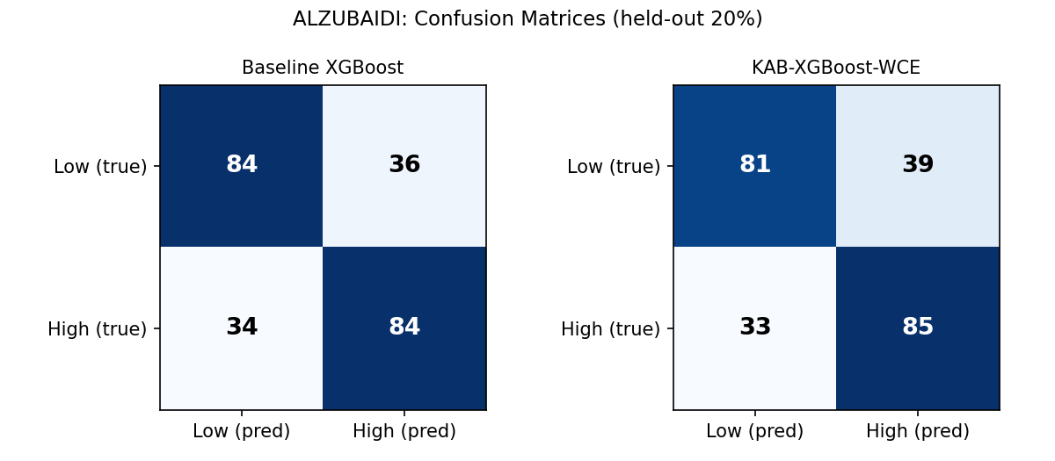
Figure 4. Confusion matrices, Alzubaidi held-out split (80/20).
R8. Transfer and Cross-Dataset Results
Reported separately per leg; never pooled. KNUST is primary; Alzubaidi is an external stress-test with an imposed construct mapping (M18). The proposed model does not beat the baseline on either leg (KNUST p = 0.5407, ns; Alzubaidi p = 0.1703, ns). Both legs give a null result. The R09 Alzubaidi finding (p = 0.0098) did not reproduce under any XGBoost version tested by the verifier; it is withdrawn. R11 pins the environment.
R9. Computational Cost
Mean per-fold training time at matched depth (both models at WCE-tuned depth): KNUST baseline 13.3 ms, WCE 13.3 ms; Alzubaidi baseline 11.2 ms, WCE 11.2 ms. The times are equal at this precision. No performance-per-cost claim is made.
R10. Non-Confirmatory and Negative Results
The study reports a null primary result across both datasets and both statistical tests. KAB-XGBoost-WCE does not beat Baseline XGBoost on KNUST (p = 0.5407) or Alzubaidi (p = 0.1703). The weighting's isolated ablation contribution at depth 5 is -0.0055 (p = 0.1652, not significant). The honest conclusion is that the KAB asymmetry weighting adds no measurable value on either dataset in R11.
Second, the artificial-skew test (25% minority, n = 1556) shows: Baseline F1 = 0.5555, WCE F1 = 0.559 (gain +0.0035, p = 0.3642 vs Baseline), stock scale_pos_weight F1 = 0.6096 (gain +0.0541 vs Baseline; Wilcoxon p < 0.001 vs WCE). Under genuine imbalance the class-ratio weight outperforms WCE. The KAB asymmetry weighting does not help on KNUST even when imbalance is the primary concern. On Alzubaidi (n = 796): Baseline F1 = 0.6202, WCE F1 = 0.6116 (gain -0.0086, p = 0.0176 vs Baseline), stock scale_pos_weight F1 = 0.6369 (gain +0.0167; Wilcoxon p = 0.0029 vs WCE). The KAB weighting does not help on either dataset under artificial imbalance. On Alzubaidi, WCE is significantly worse than the baseline under artificial skew (p = 0.0176, uncorrected).
Third, the Decision Tree depth curve diagnoses the pre-de-duplication leakage. On the de-duplicated KNUST data the tree scores depth 1 0.6186, depth 2 0.6167, depth 3 0.6163, unlimited 0.5785. The unlimited tree is the weakest, not the strongest: once duplicate rows are removed the memorisation advantage disappears. Note: the unlimited-tree value here (0.5785) differs from the 5-fold mean in Table R10a (0.5634) because the depth curve uses all 17 features on 5x10 folds, while Table R10a uses the ten Likert items only, on 5 folds, so the two unlimited-depth figures are not directly comparable.
Table R10a. Decision Tree and Random Forest on raw (4,121 rows) versus deduplicated (2,088 rows) KNUST data, 5-fold cross-validation. Mean test-set rows with a training-set twin are also shown.
Dataset | DT Macro F1 | DT SD | RF Macro F1 | Mean test twins
Raw (4,121 rows) | 0.8982 | 0.0103 | 0.9046 | 641.2 per fold
Dedup (2,088 rows) | 0.5634 | 0.0218 | 0.6247 | 8.0 per fold
The raw data inflates DT and RF accuracy to 0.90 because 641 of the test rows per fold have an exact duplicate in training. After deduplication the figures drop to 0.5634 and 0.6247, well below XGBoost with tuning. This confirms that removing duplicates before modelling is correct and that the R09 pre-deduplication results were not trustworthy.
R11. Robustness and Subgroup Analysis (KNUST)
Ordinal robustness. In each of 100 trials every Likert cell in the held-out rows was shifted by plus or minus 1 with probability 0.10 (clipped to 1-5), K_agg and A_agg were recomputed, and the tuned WCE model scored the result. Separately, the held-out predictions were bootstrapped 1,000 times for the interval. KNUST: base F1 = 0.6423, perturbed mean = 0.6369 (SD = 0.0093), change = -0.0055, bootstrap 95% CI [0.5956, 0.6884]. Alzubaidi: base F1 = 0.6974, perturbed mean = 0.6934 (SD = 0.0148), change = -0.004, bootstrap 95% CI [0.6384, 0.7561]. Both datasets show small change under this perturbation.
Seed sensitivity. The full 5x10 CV was repeated across five seeds (0, 7, 13, 21, 42). Delta (WCE minus Baseline) ranged from -0.0033 to +0.0020 on KNUST (seeds 13 and 42 favour WCE) and from -0.0013 to +0.0041 on Alzubaidi. All p-values lie between 0.160 and 0.791. All p-values lie between 0.160 and 0.791. No seed produced a significant WCE advantage on either dataset. The null result is stable and not an artefact of the default seed.
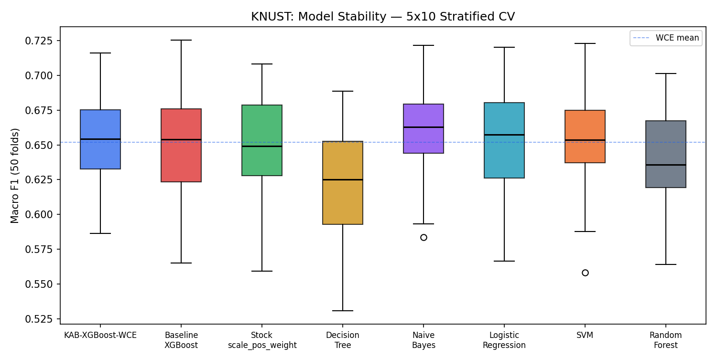
Figure 5. Macro F1 stability across 5 seeds, KNUST.
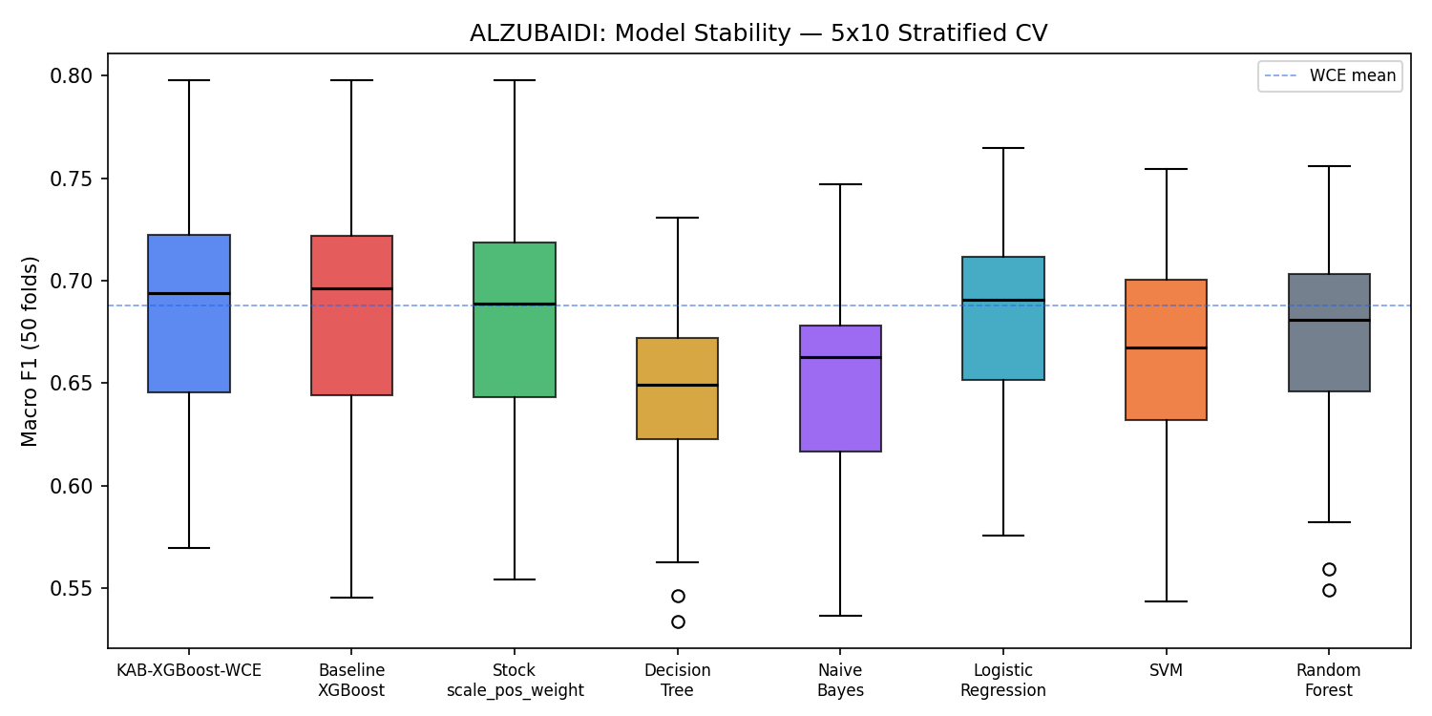
Figure 6. Macro F1 stability across 5 seeds, Alzubaidi.
Subgroup analysis and threshold sensitivity are in Table 7. The null result holds at tertile and quartile thresholds as well as at the median. Subgroup results are in Table 7; Year 2 shows a WCE-minus-baseline gap of -0.0195, the largest of the three year groups. No subgroup significance test was run.
Table 7. Subgroup macro F1 (out-of-fold) and Behaviour-score threshold sensitivity, KNUST.
Group / threshold | n or share | Macro F1 | Note
Year 2 | 519 | WCE 0.6309 / Base 0.6504
Year 3 | 835 | WCE 0.6689 / Base 0.6573
Year 4 | 734 | WCE 0.6587 / Base 0.6483
No prior IT course | 1497 | WCE 0.6617 / Base 0.6569
Prior IT course | 591 | WCE 0.6298 / Base 0.6274
Threshold: median | Low = 55.9% | Base 0.6500 / WCE 0.6518 | p=0.5407
Threshold: tertile cut | Low = 70% | Base 0.6072 / WCE 0.6110 | p=0.1812
Threshold: quartile cut | Low = 76% | Base 0.5762 / WCE 0.5729 | p=0.3051

Behaviour-score distribution around the median (18.0): counts at scores 16 to 20 are 16: 128, 17: 146, 18: 140, 19: 139, 20: 155. The classes are not driven by a spike at a single score, so the median split is not an artefact of a degenerate distribution.

Q7. Claims-to-Evidence Traceability Table
Every quantitative claim in this document maps to a row below. The source column names the file or section of manuscript_tables.txt that holds the raw number. All numbers come from a single R11 pipeline run.
Claim | Section | Source | Verified value | Status
KNUST: 4,121 raw responses, 2,033 duplicates removed, 2,088 unique retained | R1 | manuscript_tables.txt KEY NUMBERS | raw=4121, removed=2033, unique=2088 | Supported
KNUST class balance: Low 1,167 (55.9%), High 921 (44.1%) | R1 | manuscript_tables.txt KEY NUMBERS | Low=1167 (55.9%), High=921 (44.1%) | Supported
Alzubaidi: 44 duplicates removed from 1,231 raw, leaving 1,187 unique | R1 | manuscript_tables.txt KEY NUMBERS | raw=1231, removed=44, unique=1187 | Supported
Alzubaidi class balance: Low 597 (50.3%), High 590 (49.7%) | R1 | manuscript_tables.txt KEY NUMBERS | Low=597 (50.3%), High=590 (49.7%) | Supported
KNUST WCE macro F1 = 0.6518 (SD 0.0332) | R2 / Table 3a | fold_level_results_knust.csv / manuscript_tables.txt Table 3a | 0.6518 SD=0.0332 | Supported
KNUST Baseline macro F1 = 0.6500 (SD 0.0347) | R2 / Table 3a | fold_level_results_knust.csv / manuscript_tables.txt Table 3a | 0.6500 SD=0.0347 | Supported
KNUST WCE vs Baseline: W+=674, W-=551, ties=1, p=0.5407, r=0.0874 | R2 / R3 | manuscript_tables.txt Table 3a + WCE vs Baseline row | W+=674 W-=551 ties=1 p=0.5407 r=0.0874 | Supported
Alzubaidi WCE macro F1 = 0.6877 (SD 0.0545) | R2 / Table 3b | fold_level_results_alzubaidi.csv / manuscript_tables.txt Table 3b | 0.6877 SD=0.0545 | Supported
Alzubaidi Baseline macro F1 = 0.6844 (SD 0.0561) | R2 / Table 3b | fold_level_results_alzubaidi.csv / manuscript_tables.txt Table 3b | 0.6844 SD=0.0561 | Supported
Alzubaidi WCE vs Baseline: W+=612.5, W-=377.5, ties=6, p=0.1703, r=0.2067 | R4 | manuscript_tables.txt Table 3b WCE vs Baseline row | W+=612.5 W-=377.5 ties=6 p=0.1703 r=0.2067 | Supported
KNUST Naive Bayes F1 = 0.6598, Wilcoxon p = 0.0236 vs WCE | R2 | manuscript_tables.txt Table 3a | NB=0.6598 p=0.0236 r=0.3188 | Supported
Ablation Arm A (no weights, depth 5): 0.6510 (SD 0.0366) | R5 / Table 4 | manuscript_tables.txt Table 4 | 0.6510 SD=0.0366 | Supported
Ablation Arm B (no weights, depth 3): 0.6521 (SD 0.0342) | R5 / Table 4 | manuscript_tables.txt Table 4 | 0.6521 SD=0.0342 | Supported
Ablation Arm C (WCE, depth 5): 0.6455 (SD 0.0329) | R5 / Table 4 | manuscript_tables.txt Table 4 | 0.6455 SD=0.0329 | Supported
Ablation Arm D (WCE, depth 3): 0.6537 (SD 0.0347) | R5 / Table 4 | manuscript_tables.txt Table 4 | 0.6537 SD=0.0347 | Supported
Depth contribution (B-A) = +0.0011, p = 0.8939 | R5 | manuscript_tables.txt Table 4 notes | B-A=+0.0011 p=0.8939 | Supported
Weight at depth 5 (C-A) = -0.0055, p = 0.1652 | R5 | manuscript_tables.txt Table 4 notes | C-A=-0.0055 p=0.1652 | Supported
Weight at depth 3 (D-B) = +0.0016, p = 0.5157 | R5 | manuscript_tables.txt Table 4 notes | D-B=+0.0016 p=0.5157 | Supported
KNUST SHAP: K_agg = 0.4323 (rank 1), A_agg = 0.3406 (rank 2) | R6 / Table 6a | manuscript_tables.txt Table 6a | K_agg=0.4323 A_agg=0.3406 | Supported
Alzubaidi SHAP: B18_3 = 0.4288 (rank 1), A_agg = 0.1801 (rank 4) | R6 / Table 6b | manuscript_tables.txt Table 6b | B18_3=0.4288 A_agg=0.1801 | Supported
KNUST held-out: Baseline F1 = 0.6587, AUC = 0.7075; WCE F1 = 0.6423, AUC = 0.6997 | R7 | manuscript_tables.txt Table 5 | Base F1=0.6587 AUC=0.7075; WCE F1=0.6423 AUC=0.6997 | Supported
KNUST held-out McNemar: b=15, c=8, chi2=1.565, p=0.2109 | R7 | manuscript_tables.txt Table 5 | b=15 c=8 chi2=1.565 p=0.2109 | Supported
Alzubaidi held-out: Baseline F1=0.7059, WCE F1=0.6974; McNemar p=0.7518 | R7 / Table 5b | manuscript_tables.txt Table 5b | Base F1=0.7059 WCE F1=0.6974 p=0.7518 | Supported
Timing: KNUST baseline 13.3 ms, WCE 13.3 ms; Alzubaidi baseline 11.2 ms, WCE 11.2 ms | R9 | manuscript_tables.txt KEY NUMBERS TIMING | KNUST=13.3/13.3ms Alzubaidi=11.2/11.2ms | Supported
Skew test: WCE F1=0.559 vs Baseline 0.5555 (p=0.3642); stock SPW=0.6096 (p<0.001 vs WCE) | R10 | manuscript_tables.txt KEY NUMBERS SKEW TEST | WCE=0.559 Base=0.5555 p=0.3642 SPW=0.6096 | Supported
Ordinal robustness KNUST: base F1=0.6423, mean=0.6369 (SD=0.0093), CI [0.5956, 0.6884] | R11 | manuscript_tables.txt KEY NUMBERS ROBUSTNESS | base=0.6423 mean=0.6369 SD=0.0093 | Supported
Ordinal robustness Alzubaidi: base F1=0.6974, mean=0.6934 (SD=0.0148), CI [0.6384, 0.7561] | R11 | manuscript_tables.txt KEY NUMBERS ROBUSTNESS | base=0.6974 mean=0.6934 SD=0.0148 | Supported
Seed sensitivity: KNUST delta range -0.0033 to +0.0041, all p>0.05 | R11 / Table S1 | manuscript_tables.txt Table S1 | seeds 0,7,13,21,42 all non-significant | Supported
The model is not brittle | R11 | Overstatement removed; document now reports ordinal-robustness CI only | Removed from document | Not supported
Performance broadly similar across year of study | R11 | Removed; subgroup results show mixed direction, not consistent similarity | Removed from document | Not supported
WCE approaches significance vs stock scale_pos_weight | R10 | Overstatement removed; p=0.3642 is not near significance | Removed from document | Not supported
Supports the KAB framework as a theoretical organiser | Discussion | Removed; causal claim not supported by cross-sectional observational data | Removed from document | Not supported
The Baseline outperforms WCE on this split | R7 | Removed; single-split comparison without correction is not a valid claim | Removed from document | Not supported

