ENGINEERING NOTEBOOK
KALINGA
Development of a 3D-Printed, Baymax-Inspired Touch-Screen Health Pendant with GPS and 4G Calling
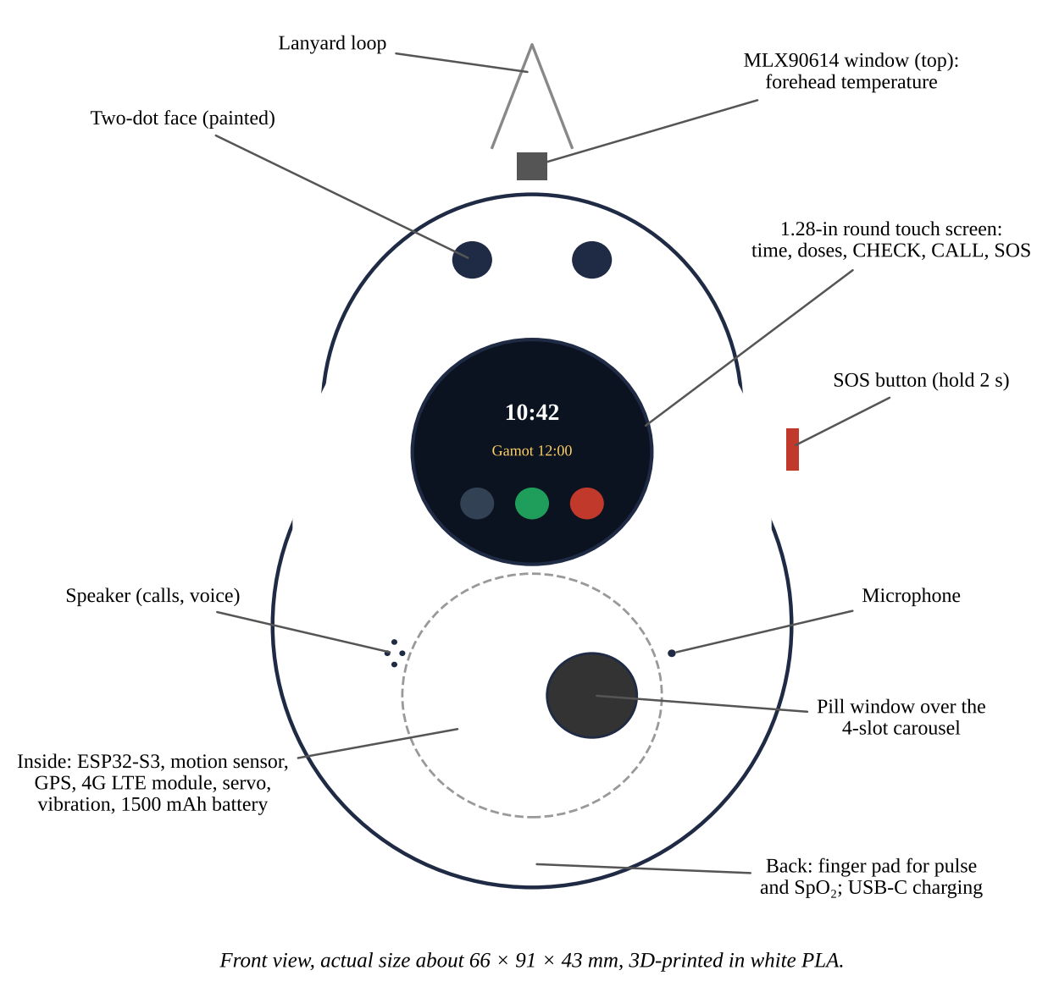
The pendant to be built (front view).
Team: ______, ______, ______ Adviser: ______ School: ______
How to keep this notebook. Write every entry on the day the work is done. Sign and date each entry and have a witness sign. Do not erase or tear pages: cross out mistakes with one line. Paste printouts, photos, and screenshots with the date. Record what failed as carefully as what worked; judges look for the design process, not only the final product.

Entry 1: Problem and Design Criteria
Date: ______ Recorded by: ______ Witnessed by: ______
Problem. Older adults and people with chronic illness are often alone at home while their families work. Falls go unnoticed, doses are missed, some older adults get lost, and fevers rise unseen. Existing products each do one job and cost more together.
Goal. Build one low-cost touch-screen wearable that checks health signs, presents each dose on time, shows location, calls the family, and shows everything in a phone app.
Criterion | Target | How it will be checked
Cost | Below PHP 5,000 for parts | Receipts (Appendix A.3)
Size and weight | Fits in a hand; about 66 × 91 × 43 mm; under 160 g | Ruler and kitchen scale
GPS | Error under 10 m under open sky | Surveyed points
Calls | At least 95% of calls connect; clarity 4 of 5 | 40 test calls
Touch screen | Every action in 3 taps or fewer | Usability session
Temperature accuracy | Bias within ±0.3 °C after calibration | Bland–Altman vs clinic thermometer
SpO₂ accuracy | Arms ≤ 4% (ISO 80601-2-61) | Bland–Altman vs reference oximeter
Fall detection | Sensitivity and specificity ≥ 90% | Mat falls and daily activities
Alert time | Under 60 s to the app | Stopwatch and app time stamps
Doses | Correct slot every time; within 1 min of schedule | 5-day dose log
Battery | At least 12 h per charge with GPS and 4G | Battery log
Ease of use | SUS above 68 | Questionnaire

Entry 2: Background Research
Date: ______ Recorded by: ______ Witnessed by: ______
• Pulse oximetry: red and infrared light through the fingertip give SpO₂ and pulse rate (Allen, 2007; Jubran, 2015). Readings drop in accuracy with movement, cold fingers, nail polish, and darker skin.
• Infrared thermometry: the MLX90614 reads skin temperature without contact; forehead skin is cooler than the body core, so a calibration equation is needed (Fraden, 2016).
• Falls: free fall (< 0.5 g), then impact (> 2.5 g), then stillness is a simple, proven rule (Bourke et al., 2007).
• Medicine: about half of long-term patients do not take medicines as prescribed; timed reminders help (WHO, 2003).
• Data: the Firebase Realtime Database has a REST interface that a microcontroller can call over HTTPS and a web app can stream live (Google, n.d.). Health data must be protected (Republic Act No. 10173, 2012).
Sources read by the team and notes: ______
Entry 3: Ideas and Decision Matrix
Date: ______ Recorded by: ______ Witnessed by: ______
Each idea is scored 1 (poor) to 5 (best) on each criterion and multiplied by the weight. The scores below are the starting estimates; change them after your own tests and sign the decision.
Option for each function | Cost ×3 | Size ×2 | Ease to build ×2 | Reliability ×3 | Total
Dispensing: 4-slot carousel + SG90 servo | 5 | 3 | 4 | 4 | 41
Dispensing: single lid with servo latch | 5 | 4 | 4 | 3 | 40
Dispensing: sliding drawer + linear servo | 3 | 4 | 2 | 3 | 30
Temperature: MLX90614 non-contact | 3 | 4 | 5 | 4 | 39
Temperature: MAX30205 skin contact | 4 | 5 | 3 | 3 | 37
Link: Wi-Fi + Firebase + web app | 5 | 5 | 3 | 4 | 43
Link: Bluetooth to the older adult's phone | 5 | 5 | 3 | 2 | 37
Link: GSM SMS module | 3 | 2 | 3 | 3 | 28
Wi-Fi app + 4G calls and SMS (A7670) | 3 | 3 | 3 | 5 | 37
Screen: 1.28-in round touch board (all-in-one) | 3 | 5 | 4 | 4 | 39
Screen: 0.91-in OLED + buttons | 5 | 4 | 4 | 3 | 40

Chosen design: carousel + SG90, MLX90614, round touch board, Wi-Fi + Firebase app with 4G calls and SMS (the touch board was chosen over the OLED because older adults need large buttons). Team signatures: ______
Entry 4: Bill of Materials and Tools
Date: ______ Recorded by: ______ Witnessed by: ______
Item | Qty | Est. PHP
Waveshare ESP32-S3 1.28-in round touch LCD board | 1 | 1,300
MLX90614 (GY-906) module | 1 | 550
MAX30102 module | 1 | 180
ATGM336H GPS module with patch antenna | 1 | 300
SIMCom A7670 4G LTE board (VoLTE) with antenna | 1 | 1,200
Prepaid nano-SIM | 1 | 50
PAM8302 amplifier, 8 Ω 1 W speaker, electret microphone | 1 set | 200
SG90 micro servo | 1 | 120
LiPo 3.7 V 1500 mAh | 1 | 280
Coin vibration motor, AO3400, S8050, 1000 µF, resistors | 1 set | 80
SOS button, slide switch, perfboard, wires | 1 lot | 110
PLA filament or print service (about 75 g) | 1 lot | 300
Black acrylic paint, sandpaper | 1 lot | 40
Breakaway lanyard, M2 screws | 1 set | 60
TOTAL (estimated) |  | 4,770

Tools. 3D printer (FDM, 0.4-mm nozzle) or a print shop; slicer (UltiMaker Cura, PrusaSlicer, or Bambu Studio); soldering iron, solder, flux; wire stripper; multimeter; hot-glue gun; small files and sandpaper (220 and 400); flush cutters; laptop with Arduino IDE 2; USB-C cable; placebo candy tablets for testing.
Entry 5: CAD Design of the Shell
Date: ______ Recorded by: ______ Witnessed by: ______
The shell is an egg-shaped body (two spheres joined and flattened) split into a front and a back shell, plus a 36-mm pill carousel. The model is a Python script, so every size can be changed and the STL files regenerated:
pip install manifold3d trimesh then python cad/kalinga_pendant.py
Feature | Size (mm) | Why
Wall thickness | 2.0 | Strong enough for PLA; light
Overall | 60 × 83 × 39 | Fits the SG90 servo and carousel
OLED window | 24 × 8 | 0.91-in OLED active area 22.4 × 5.6
Finger pad window | 13 × 13 | MAX30102 module
Thermometer window (top) | Ø 9.8 | MLX90614 TO-39 can, Ø 9.2
Pill window | Ø 11 | Pocket Ø 9.6 under it
Carousel | Ø 36 × 7, 4 pockets | Pockets at 45°, 90°, 135°, 180°; solid at 0° = closed
Button holes | Ø 6.6 | 6 × 6 mm tactile button caps
USB-C and switch slots | 10 × 4, 9 × 4 | TP4056 port, slide switch
Lip | 3 deep, 1.2 thick | Locates the front shell on the back shell

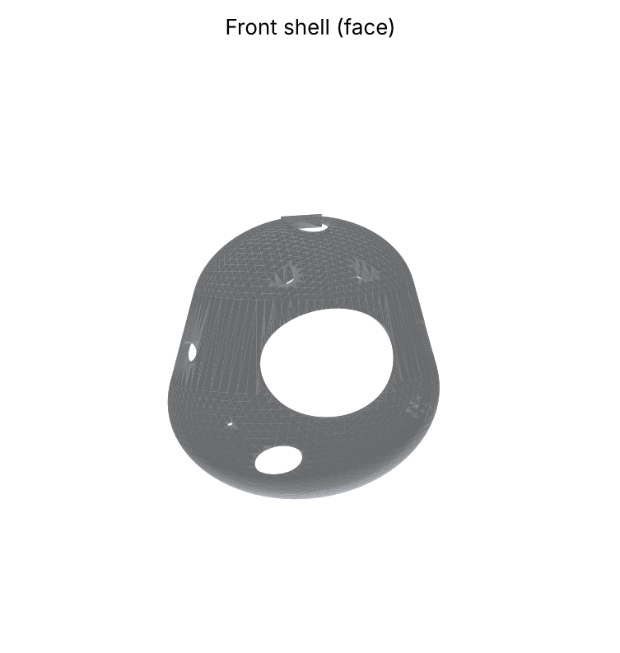
Front shell rendered from front_shell.stl.
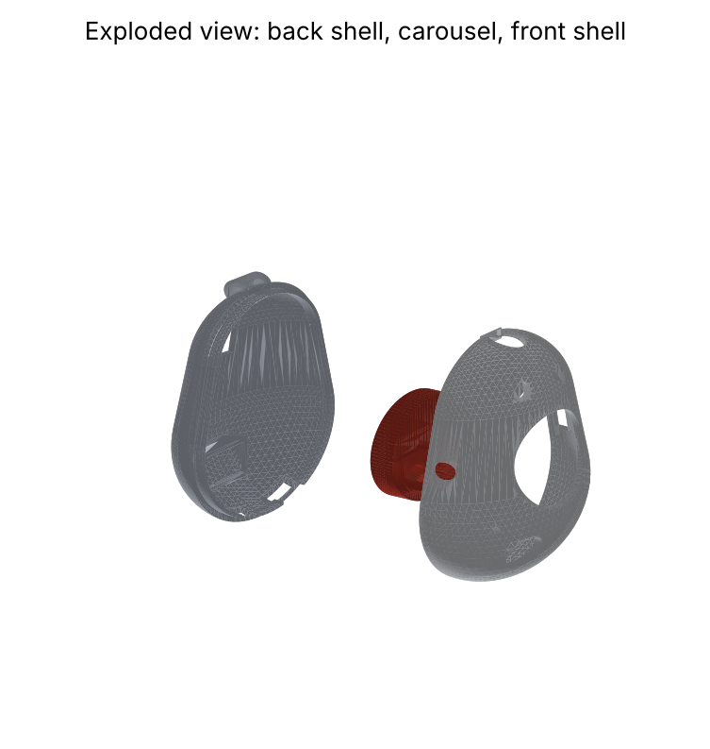
Exploded view: back shell with servo cradle, pill carousel, and front shell.
Changes made to the CAD and why: ______
Entry 6: 3D Printing
Date: ______ Recorded by: ______ Witnessed by: ______
Setting | Shells | Carousel
Material | White PLA | White or red PLA
Nozzle / layer height | 0.4 mm / 0.2 mm | 0.4 mm / 0.2 mm
Walls / top and bottom layers | 3 / 4 | 3 / 4
Infill | 20% gyroid | 30% gyroid
Nozzle / bed temperature | 205 °C / 60 °C | 205 °C / 60 °C
Orientation | Flat split edge on the bed (open side down) | Flat, pockets facing up
Supports | Tree supports, everywhere; 5-mm brim | None
Estimated time and filament (from slicer) | ______ h, ______ g | ______ h, ______ g

1. Print the carousel first as a test: check that a placebo tablet fits each pocket and that the SG90 horn sits flat in its recess.
2. Print the back shell, then the front shell. Watch the first layer; stop and level the bed if lines do not stick.
3. Remove supports with flush cutters and pliers. Sand edges with 220 then 400 grit.
4. Dry-fit the two shells: the lip must slide in with light pressure. If tight, sand the lip; if loose, add one layer of tape.
5. Paint the two eye recesses with black acrylic; let dry for 1 hour. Keep the face design original (two dots, no copied logos) so it can be filed as an Industrial Design.
6. Weigh and measure each part and paste photos here.
Part | Print date | Time (h) | Mass (g) | Problems seen | Fix

Entry 7: Electronics Assembly
Date: ______ Recorded by: ______ Witnessed by: ______
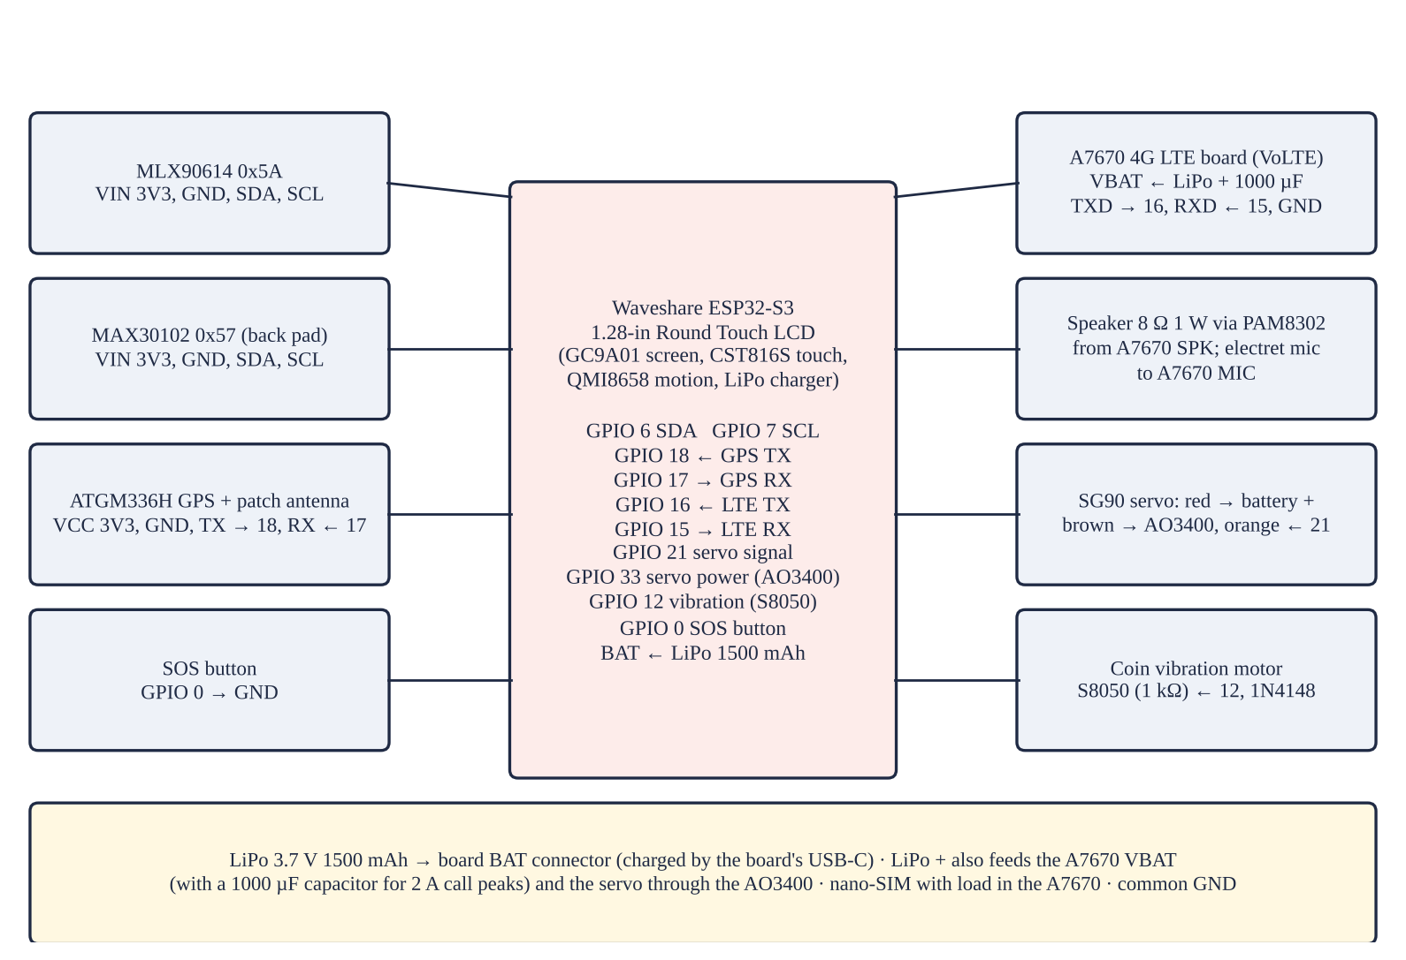
Wiring diagram.
Part | Connects to (ESP32-C3)
MLX90614, MAX30102 (and on-board touch, QMI8658) | GPIO 6 / 7 — I²C at 100 kHz
ATGM336H GPS | GPIO 18 / 17 — UART1, 9600 baud
A7670 4G LTE | GPIO 16 / 15 — UART2, 115200 baud; VBAT from LiPo + 1000 µF
SG90 servo | GPIO 21 / 33 — AO3400 switches the servo ground
Vibration motor | GPIO 12 — 1 kΩ; 1N4148 across motor
SOS button | GPIO 0 — Also the BOOT button
LiPo 1500 mAh | BAT connector — Charged by the board's USB-C

1. Check the touch board alone first: upload a GC9A01 example from the GFX Library for Arduino and a CST816S touch example. Then run an I²C scan: expect 0x15 (touch), 0x6B (QMI8658), 0x5A (MLX90614), and 0x57 (MAX30102).
2. GPS: connect TX → GPIO 18 and RX ← GPIO 17; outdoors, the TinyGPSPlus example must show 6 or more satellites.
3. 4G: insert the nano-SIM, connect TXD → GPIO 16 and RXD ← GPIO 15, VBAT to the LiPo with a 1000 µF capacitor. Send AT, AT+CSQ (signal), and ATD+639…; to test a call. Wire the speaker through the PAM8302 and the microphone.
4. Build the small parts on perfboard: S8050 with 1 kΩ base resistor and 1N4148 across the vibration motor; AO3400 with 10 kΩ gate-to-ground resistor for the servo.
5. LiPo safety: connect the battery to the TP4056 B+ and B– only, with the correct polarity, and never short, bend, or puncture it. Charge only under supervision.
6. Plug the LiPo into the board's BAT connector through the slide switch; the board charges it by USB-C.
7. Measure with the multimeter before powering: battery 3.7–4.2 V; no short between 5V and GND.
8. Record each test below.
Module | Test | Expected | Result | OK?

Entry 8: Programming the Pendant
Date: ______ Recorded by: ______ Witnessed by: ______
1. Install Arduino IDE 2 and “esp32 by Espressif Systems” in Boards Manager.
2. Install libraries: GFX Library for Arduino, CST816S, TinyGPSPlus, Adafruit MLX90614, SparkFun MAX3010x, ESP32Servo, ArduinoJson.
3. Open firmware/kalinga_pendant/kalinga_pendant.ino. Type the Wi-Fi name and password, the Firebase Web API key and database URL, the pendant's account email and password, and the patient id.
4. Board: ESP32S3 Dev Module; USB CDC On Boot: Enabled; Flash Size and PSRAM as on the Waveshare wiki. Upload.
5. Check: the round screen shows the face, time, and CHECK, CALL, SOS buttons; the carousel closes; holding SOS for 2 s sends an app alert and an SMS with a map link.
Entry 9: Firebase and the KALINGA Monitor App
Date: ______ Recorded by: ______ Witnessed by: ______
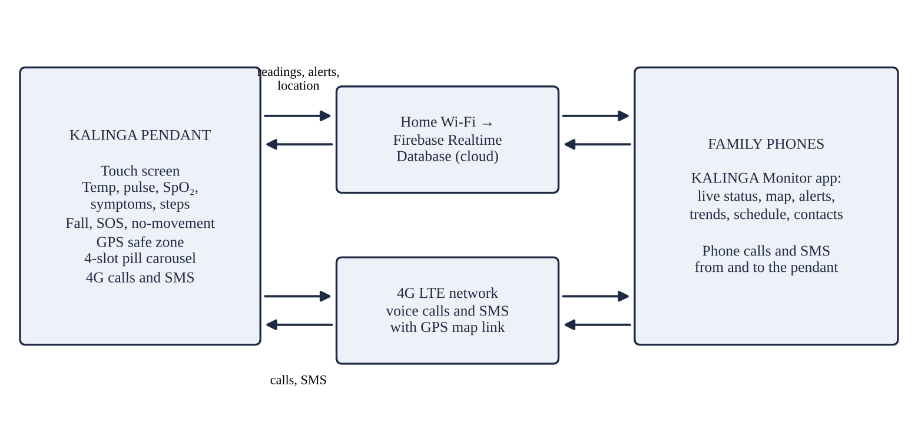
How the pendant, the database, and the app connect.
1. Go to console.firebase.google.com, create a project, and add a Web app. Copy the Web API key.
2. Authentication → Sign-in method → enable Email/Password. Add one user for the pendant and one for each family member. Copy each user's UID.
3. Realtime Database → Create (location: Singapore, asia-southeast1) → start in locked mode. Copy the database URL.
4. Rules: paste app/database.rules.json and publish.
5. Data: add members → <patient id> → <each UID> = true (for the pendant and every family member).
6. Host the app folder on GitHub Pages or Firebase Hosting (HTTPS is needed to install it). Open it on a phone, add it to the home screen, enter the key, URL, patient id, email, and password, and sign in.
7. In the app's Settings, enter the pendant's SIM number, up to three family contacts, and the safe-zone radius; when the pendant has a GPS fix, tap Set home.
8. Use “Try the demo” to show the app to judges without the pendant.
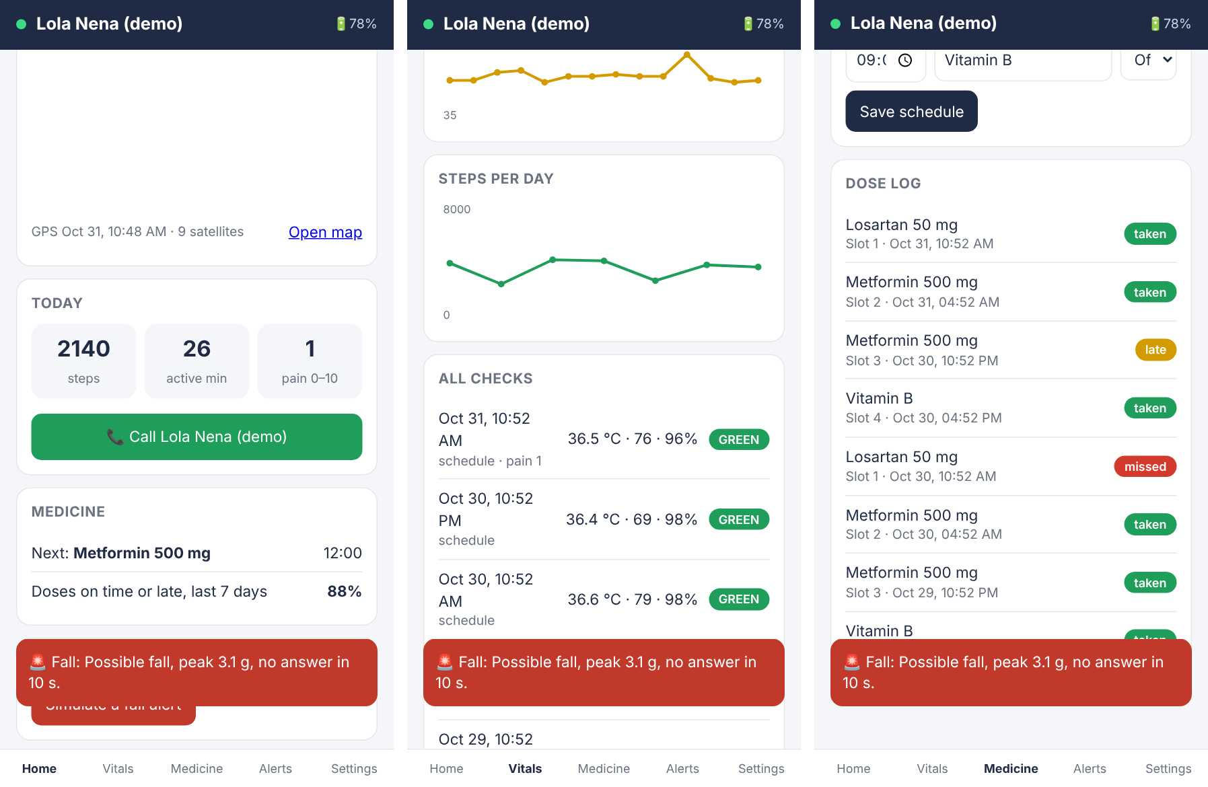
KALINGA Monitor screens (demo mode).
Entry 10: Final Assembly
Date: ______ Recorded by: ______ Witnessed by: ______
1. Set the servo to the closed position (power on once; the program moves it to 0°) before fitting the horn and carousel, so the solid sector sits under the window.
2. Fix the servo in the back-shell cradle with a drop of hot glue; screw the single-arm horn into the carousel recess.
3. Fix the round touch board behind the 33-mm window with foam tape, the MAX30102 behind the back finger window, and the MLX90614 can in the top hole.
4. Place the GPS patch antenna near the top, facing up; stick the 4G antenna along the inside of the back shell; fit the speaker behind the grille and the microphone behind its hole; add the battery with foam tape.
5. Fit the buttons and caps, close the shells, and add two M2 screws or a drop of glue at the bottom.
6. Thread the breakaway lanyard. Fill the four pockets with placebo tablets and run one dose cycle.
Entry 11: Calibration
Date: ______ Recorded by: ______ Witnessed by: ______
1. Bench test of the thermometer with a black-painted can in a water bath at 35.0, 36.0, 37.0, 37.5, 38.0, and 40.0 °C against a probe thermometer.
2. Calibration set (10 volunteers, after IRB approval): TEMP_A = SLOPE(reference, raw), TEMP_B = INTERCEPT(reference, raw); PR and SpO₂ offsets = mean of (reference − pendant).
3. Fall thresholds: 10 mat falls and 10 daily activities by the researchers; adjust FREE_FALL_G and IMPACT_G, then keep them fixed.
Target or volunteer | Reference | Pendant raw | Pendant calibrated | Difference

Entry 12: Test Records
Date: ______ Recorded by: ______ Witnessed by: ______
Falls and daily activities
Trial | Event | Detected? | Cancelled? | Peak g | Alert time (s)

Doses
Date | Slot | Scheduled | Opened at | Recorded as | Observer says

GPS and calls
Point or call | Reference | Pendant result | Error (m) or connected | Clarity 1–5

Battery
Charge no. | Full at | Empty at | Hours | Notes

Entry 13: Problems and Iterations
Date: ______ Recorded by: ______ Witnessed by: ______
Write each problem the day it happens, what caused it, what you changed, and what happened after.
Date | Problem | Cause | Change made | Result

Entry 14: Safety Checklist and Reflection
Date: ______ Recorded by: ______ Witnessed by: ______
• Adult supervision for the 3D printer, soldering, and LiPo charging.
• IRB approval and signed consent before any test with people; placebo tablets only.
• Falls simulated only by the researchers on 20-cm mats with pads.
• Breakaway lanyard so the cord cannot strangle the wearer.
• Firebase locked by rules; coded patient id; data deleted after the fair.
What worked: ______
What we would change next: ______

