BUHAY: Buildings-and-Bridges Unit-cost Hybrid Analytics and Yardstick for Standards-Based Start Quotation and Over-Budget Anomaly Detection via a Blueprint-Driven Hybrid Machine Learning System

Enrique Miguel C. Buban
Lead Researcher

Mathematical and Computational Sciences
2026

ABSTRACT
Public buildings and bridges are where padded prices cost the most: an overpriced classroom is a classroom another community does not get, and a bridge built below specification can fail within weeks of opening, as the ₱1.225-billion Cabagan–Santa Maria Bridge did in February 2025. The Philippines scored 32 out of 100 in the 2025 Corruption Perceptions Index, and a review of ₱545.64 billion in flood-control projects found that about one-fifth went to only 15 contractors. Existing machine-learning screens, including the road-focused CORA system, learn only from past contract prices, so they inherit whatever overpricing those prices contain and cannot say what a project should cost. This study developed BUHAY, a system that reads a building or bridge plan, performs a standards-based quantity take-off under NSCP 2015, the DPWH Standard Specifications and AASHTO LRFD, prices it with DPWH pay items, and returns a lean start quotation, a standard fair estimate and a ceiling following the indirect-cost rules of DPWH D.O. 197 s. 2016 and D.O. 30 s. 2025. A hybrid layer of Multiple Linear Regression, XGBoost, Isolation Forest and SHAP is combined with the over-budget ratio into the BUHAY Risk Index. On a 300-project simulated benchmark of Bicol Region V buildings and bridges with 36 injected overpricing cases, the standard estimate reached a mean absolute percentage error of 5.21% for buildings and 7.67% for bridges against fair awarded costs. XGBoost outperformed Multiple Linear Regression on bridges (MAPE 19.18% vs. 65.65%), while the linear model stayed competitive on buildings (13.43% vs. 13.94%). The BUHAY Risk Index flagged 94.4% of padded contracts (F1 = 0.764, AUC = 0.987), compared with 27.8% for an Isolation Forest alone, and the lean start quotation averaged 14.4% below the standard estimate for buildings while keeping code minimums. BUHAY was deployed as an installable mobile application, an Android package and a download website with an interactive project map.
Keywords: Construction Cost Estimation, Quantity Take-Off, Over-Budget Detection, XGBoost, Isolation Forest, SHAP, Public Procurement Transparency, Buildings and Bridges

TABLE OF CONTENTS
ABSTRACT i
TABLE OF CONTENTS ii
LIST OF FIGURES iv
LIST OF TABLES v
LIST OF EQUATIONS vi
LIST OF APPENDICES vii
INTRODUCTION 1
Background of the Study 1
Research Gap and Rationale 4
Objective of the Study 5
Significance of the Study 6
Scope and Delimitation 7
Definition of Terms 8
FRAMEWORK 11
Theoretical Framework 11
Conceptual Framework 13
Mathematical Framework 14
Plan Acquisition and Variable Extraction 15
Standards Codification and Price Book 17
Quantity Take-Off and Quotation Engine 18
Simulated Benchmark Dataset (SBD-300) 20
Model Development 21
Model Validation 24
3D Visualization 25
App and Website Development 25
FINDINGS 26
Plan Variables and Derived Indicators Extracted from Building and Bridge Plans 26
a.) Physical Properties 26
b.) Structural System and Foundation 27
c.) Location, Price Year and Project Budget 28
Accuracy of the Standards-Based Quantity Take-Off Engine 28
a.) Lean Start Quotation, Standard Fair Estimate and Ceiling 29
b.) Accuracy against Fair Awarded Costs 30
Development of Machine Learning Models to Predict Construction Cost 31
a.) Multiple Linear Regression 32
b.) Extreme Gradient Boosting 35
Detection of Over-Budgeted Contracts 38
Deployment of BUHAY as a Mobile Application and Download Website 40
a.) Mobile Application 41
b.) Download Website with Interactive Map 50
c.) Parametric 3D Visualization and SHAP Explanations 52
CONCLUSION 54
RECOMMENDATIONS 55
REFERENCES 56
APPENDICES 61

LIST OF FIGURES
Figure 1. Theoretical Paradigm 12
Figure 2. Conceptual Paradigm 14
Figure 3. Methodological Paradigm 15
Figure 4. Model Integration Framework 24
Figure 5. System Architecture of BUHAY 26
Figure 6. Distribution of the Over-Budget Ratio for Injected and Non-Injected Projects 31
Figure 7. Global SHAP Values of the XGBoost Building Model 37
Figure 8. Global SHAP Values of the XGBoost Bridge Model 37
Figure 9. ROC Curves of the Screening Signals, All 300 Projects 39
Figure 10. Home Screen of the BUHAY Application 41
Figure 11. Quote Screen with the Three Quotation Tiers and the ABC 42
Figure 12. Bill of Quantities Generated from the Plan 43
Figure 13. Plan Panel after Importing the Sample DXF Floor Plan 44
Figure 14. Check Screen Screening a Padded Contract 46
Figure 15. Line-Item Check of a Contractor's Bill of Quantities 47
Figure 16. Project Map of the BUHAY Application 48
Figure 17. Library Screen with Reference Plans and the Unit Price Book 49
Figure 18. Download Website of BUHAY 50
Figure 19. Interactive Project Map on the Website 51
Figure 20. Download Section of the Website 52
Figure 21. Parametric 3D Model of a 2-Storey 4-Classroom School Building 52
Figure 22. Parametric 3D Model of a Three-Span RCDG Bridge 53
Figure 23. Parametric 3D Model of a 50 m Steel Truss Bridge 53

LIST OF TABLES
Table 1. Plan Variables Extracted by BUHAY 15
Table 2. Location Factors and Yearly Cost Index 16
Table 3. Selected Pay Items and Direct Unit Costs in the BUHAY Price Book 17
Table 4. Indirect Cost Brackets under DPWH D.O. 197 s. 2016 and D.O. 30 s. 2025 18
Table 5. Quotation Tier Settings 20
Table 6. Simulation Parameters of the SBD-300 Benchmark 21
Table 7. XGBoost Hyperparameter Search and Selected Values 22
Table 8. Descriptive Statistics of the Physical Properties of Buildings (n = 160) 26
Table 9. Descriptive Statistics of the Physical Properties of Bridges (n = 140) 27
Table 10. Structural System and Foundation Composition of the Benchmark 27
Table 11. Project Budget Characteristics of the Benchmark 28
Table 12. Quotations of the Reference Plans (Albay, 2025 Prices) 29
Table 13. Accuracy of the Standards-Based Estimate against Fair Awarded Costs 30
Table 14. Variance Inflation Factor of the Building Predictors 32
Table 15. Variance Inflation Factor of the Bridge Predictors, Full and Reduced Models 32
Table 16. Ordinary Least Squares Results for Buildings 33
Table 17. Ordinary Least Squares Results for Bridges 33
Table 18. Performance of the Multiple Linear Regression Models under LOOCV 34
Table 19. XGBoost Feature Importance (Gain Share) 35
Table 20. Performance of the XGBoost Models under LOOCV 35
Table 21. Comparison of Multiple Linear Regression and XGBoost 36
Table 22. Detection Performance against Injected Overpricing 38
Table 23. Highest-Risk Contracts Flagged by BUHAY 40

LIST OF EQUATIONS
Equation 1. Isolated Footing Size 18
Equation 2. Reinforcing Steel Mass 18
Equation 3. Estimated Direct Cost 19
Equation 4. Approved Budget for the Contract 20
Equation 5. Over-Budget Ratio 20
Equation 6. Simulated Awarded Cost 21
Equation 7. Multiple Linear Regression Formula 21
Equation 8. Variance Inflation Factor 22
Equation 9. XGBoost Additive Model and Regularized Objective 22
Equation 10. Isolation Forest Anomaly Score 23
Equation 11. SHAP Additive Feature Attribution 23
Equation 12. BUHAY Risk Index 23
Equation 13. BUHAY Risk Index Component Scores 23
Equation 14. Root Mean Square Error 24
Equation 15. Coefficient of Determination 24
Equation 16. Mean Absolute Percentage Error 24
Equation 17. Precision, Recall and F1-Score 25

LIST OF APPENDICES
Appendix A. Sample Records of the Simulated Benchmark Dataset (SBD-300) 61
Appendix B. BUHAY Unit Price Book 62
Appendix C. Bill of Quantities of a 2-Storey 4-Classroom School Building 64
Appendix D. Cost Summary of a Three-Span RCDG Bridge 65
Appendix E. Snippets of Methodology (Quantity Take-Off Engine) 66
Appendix F. Snippets of Methodology (Model Training) 67
Appendix G. Multiple Linear Regression: Actual vs. Predicted Cost 68
Appendix H. Extreme Gradient Boosting: Actual vs. Predicted Cost 69
Appendix I. Isolation Forest: Cost Residual vs. Anomaly Score 70
Appendix J. User Guide of the BUHAY Application 71

INTRODUCTION
Background of the Study
A building can pass inspection on paper and still cost the public far more than it should. Across the world, construction is consistently ranked among the sectors most exposed to corruption, and the Infrastructure Transparency Initiative estimates that 10% to 30% of investment in publicly funded infrastructure is lost to corruption, mismanagement and inefficiency (CoST, n.d.; Kenny, 2007). Large, one-off public projects are especially vulnerable because the client, the designer and the contractor hold very different information about what the work really requires (Locatelli et al., 2017), and cost estimates for public works are often shaped by strategic misrepresentation rather than honest error (Flyvbjerg et al., 2002). For this reason, procurement oversight has moved toward red-flag indicators that can be computed from contract data at scale instead of case by case (Fazekas & Tóth, 2016; OECD, 2016).
The Philippines shows the same pattern. Its score in the 2025 Corruption Perceptions Index fell to 32 out of 100, ranking 120th of 182 countries and the lowest since the current scoring method was adopted (Transparency International, 2026; Philstar, 2026). The decline followed a year dominated by public works. In August 2025 the President reported that flood-control projects implemented from July 2022 to May 2025 totalled ₱545.64 billion and that about 20% of this amount went to only 15 contractors (DZRH News, 2025; Philippine Center for Investigative Journalism [PCIJ], 2025). Executive Order No. 94, s. 2025 then created the Independent Commission for Infrastructure to investigate anomalies and misuse of funds in flood-control and other infrastructure projects (Interaksyon, 2025). Overpricing does not always come from hidden deals; sometimes it sits in the arithmetic of the budget itself. In its 2022 audit of Cebu City, the Commission on Audit found the Cebu City Medical Center building overstated by about ₱62.64 million, partly because value-added tax was computed at 12% instead of the 5% prescribed by DPWH Department Order No. 197, s. 2016 (Cebu Daily News, 2023).
Buildings and bridges carry a particular weight in this problem. School buildings, health stations and evacuation centers are the facilities communities rely on during typhoons, and bridges are the links that keep them reachable. When the ₱1.225-billion Cabagan–Santa Maria Bridge in Isabela partially collapsed on 27 February 2025, less than a month after its official completion, investigators were asked to look into possible corruption alongside questions of design and overloading (Philstar, 2025). For buildings, every peso of padding is a classroom or a clinic room that is not built. Yet the estimate behind every public project, the program of works and the Detailed Unit Price Analysis that produce the Approved Budget for the Contract (ABC), is prepared project by project inside the implementing office, and outside reviewers such as local officials, auditors, journalists and citizens rarely have the means to rebuild an estimate from the plans.
Bicol Region V faces these concerns directly. The region lies in NSCP Seismic Zone 4 and in the path of frequent typhoons, so its public works program builds many school buildings, evacuation centers, health facilities and bridges. Earlier work on Bicol road contracts documented Commission on Audit findings on DPWH-Bicol projects worth ₱13 billion with lapses, and a 2025 Senate hearing that questioned farm-to-market road projects priced 68% above benchmark (Buban, 2026). These findings show that cost checks against an independent estimate are needed, but that they currently happen late, one project at a time, and mostly after funds have been released.
Machine learning has opened a way to screen many contracts at once. Regression has long been used for early cost estimates of construction projects (Mahamid, 2011), and recent reviews show tree ensembles and other parametric models becoming the standard tools for construction cost prediction (Elmousalami, 2020). Larocque et al. (2025) applied explainable machine learning to 11,646 road contracts, while Coffie and Cudjoe (2024) paired Extreme Gradient Boosting (XGBoost) with Shapley additive explanations (SHAP) to predict construction cost overruns. For anomaly detection, Isolation Forest isolates unusual records without requiring labelled fraud cases (Liu et al., 2008). Locally, the CORA system combined Multiple Linear Regression, XGBoost and Isolation Forest on 90 completed DPWH road contracts in Bicol, reaching an R² of 0.8723 and a MAPE of 29.20% and flagging three contracts for review (Buban, 2026).
These tools, however, share one blind spot: they learn what similar projects have cost, not what a project should cost. If past prices are padded, the model learns the padding. They also cannot give a contractor, a local government or a citizen a defensible starting price for a new building or bridge. Cost engineering has long answered the second question with bottom-up, "should-cost" estimates built from quantities and unit rates (U.S. Government Accountability Office [GAO], 2020), and the DPWH already prices projects this way through its pay items and Detailed Unit Price Analysis. What is missing is an independent, open tool that does this from the plan, under the same standards, and then uses machine learning as a second opinion rather than as the only reference.
To close that gap, this study develops BUHAY (Buildings-and-Bridges Unit-cost Hybrid Analytics and Yardstick). Given the plan of a public building or bridge, BUHAY performs a parametric quantity take-off following the National Structural Code of the Philippines (NSCP) 2015, the DPWH Standard Specifications, the AASHTO LRFD Bridge Design Specifications and the National Building Code, prices the bill of quantities with DPWH pay items, and builds an ABC in three tiers: a lean start quotation, a standard fair estimate and a ceiling. When a contract amount is entered, the system compares it with the ceiling, with an XGBoost estimate learned from past projects, and with an Isolation Forest score, and combines the three into the BUHAY Risk Index. The name buhay, Filipino for "life", reflects both the research brought to life as a working application and the lives that depend on honest public infrastructure. Like CORA, BUHAY is a screening layer: a flag calls for review and is never treated as proof of wrongdoing.
Research Gap and Rationale
Four gaps motivate this study. First, there is a scope gap. Local cost-screening research has focused on roads, and CORA itself recommended extending the approach to buildings, bridges and other project types (Buban, 2026). Buildings and bridges have very different cost structures from pavements: vertical structural frames, masonry and finishes, mechanical, electrical, plumbing and fire protection works, piles, girders and substructures. A road model cannot price them.
Second, there is a reference gap. Data-driven models are top-down. They estimate cost from what comparable contracts were awarded for, so they are only as clean as their training data and they cannot produce an itemized quotation. Bottom-up estimates based on standards are the professional norm for fair pricing (GAO, 2020), but no open tool in the Philippines generates one from a plan and puts it beside a machine-learning check.
Third, there is a validation gap. Anomaly detectors in procurement are rarely tested against cases whose truth is known. CORA could report which contracts Isolation Forest flagged but not how many padded contracts it missed, and it recommended validating the flags (Buban, 2026). Without known positives, precision and recall cannot be measured.
Fourth, there is an access gap. Most models stay in notebooks or desktop dashboards. The people closest to a project, such as barangay and municipal officials, school heads, auditors and reporters, need a tool on their phones that works with a plan and a contract amount and that explains its answer in plain terms.
BUHAY addresses these gaps by (1) covering public buildings and bridges, (2) pairing a standards-based yardstick with machine learning so that each checks the other, (3) validating detection on a benchmark in which overpricing was injected deliberately and is therefore known, and (4) delivering the system as an installable mobile application and a download website with a project map.
Objective of the Study
This study aimed to develop BUHAY, a blueprint-driven quantity take-off and hybrid machine-learning system that produces standards-based start quotations and detects over-budgeted public buildings and bridges in Bicol Region V. Specifically, it sought to answer the following research questions:
1. What plan variables and derived indicators can be extracted from building and bridge plans and engineering standards to estimate construction cost, in terms of: (a) physical properties; (b) structural system and foundation; and (c) location and price year?
2. How accurately does the standards-based quantity take-off engine estimate the construction cost of public buildings and bridges, in terms of: (a) the lean start quotation, standard fair estimate and ceiling; and (b) the mean absolute percentage error and coefficient of determination against fair awarded costs?
3. How do (a) Multiple Linear Regression and (b) Extreme Gradient Boosting perform in predicting the construction cost of buildings and bridges, in terms of R², root mean square error and mean absolute percentage error under leave-one-out cross-validation?
4. How effectively do (a) the over-budget ratio, (b) the XGBoost cost residual, (c) the Isolation Forest, and (d) the hybrid BUHAY Risk Index detect over-budgeted contracts, in terms of precision, recall, F1-score and area under the ROC curve?
5. How can the system be deployed as (a) a mobile application, (b) a download website with an interactive project map, and (c) an explainable interface with parametric 3D models and SHAP explanations?
Significance of the Study
This study supports transparent and accountable spending on public buildings and bridges in Bicol by giving anyone with a plan an itemized, standards-based price and a fast way to see whether a contract amount is defensible. It extends its benefits to the following:
DPWH and Implementing Offices. District engineering offices can cross-check programs of works and ABCs against an independent take-off before bidding, and catch errors such as wrong markups or VAT rates early.
Government Auditing and Investigating Bodies. The Commission on Audit, the Office of the Ombudsman and the Independent Commission for Infrastructure can rank contracts by risk and focus field inspections on the projects that need them most.
Local Government Units, DepEd and DOH Facility Owners. Offices that request school buildings, health stations and evacuation centers obtain a start quotation to plan budgets and to question estimates that exceed the ceiling.
Contractors. Honest contractors gain a public reference that rewards fair bids and helps them defend their pricing.
Filipino Taxpayers, Civil Society and Media. Citizens and journalists can check a project on their phones, see the bill of quantities behind a price and view flagged projects on a map.
SDG 16.5, 16.6 and 16.10 Alignment. The system targets corruption and bribery in public contracting, supports effective, accountable and transparent institutions, and widens public access to cost information (United Nations, 2015).
SDG 9.1 and 11.5 Alignment. Fair pricing protects the quality of resilient infrastructure and of the facilities that reduce disaster losses in a typhoon- and earthquake-prone region.
SDG 12.7 and 4.a Alignment. The lean, code-compliant start quotation supports sustainable public procurement under Republic Act No. 12009 and stretches school-building funds to more classrooms.
Academe and Future Researchers. The study contributes a reproducible pipeline, a benchmark with known overpricing and an open price book that future work can validate with actual contract records and extend to other project types.
Scope and Delimitation
This study covers public buildings and bridges in the six provinces of Bicol Region V (Albay, Camarines Norte, Camarines Sur, Catanduanes, Masbate and Sorsogon) with price years from 2022 to 2026. Buildings include school buildings, government offices, health facilities, multi-purpose halls and evacuation centers, dormitories and public markets built as reinforced-concrete frames of up to six storeys; taller buildings are priced indicatively. Bridges include reinforced-concrete box culverts, reinforced-concrete deck girder (RCDG), prestressed concrete girder (PSCG) and steel truss bridges on spread footings, driven precast piles or bored piles.
Roads (covered by CORA), flood-control structures, water supply systems, ports, land acquisition, right-of-way, design and supervision fees, furniture and equipment are excluded. Unit costs are indicative direct costs for 2025 based in Albay, adjusted by province location factors and a yearly cost index, and are meant to be replaced by the implementing office's current Detailed Unit Price Analysis or regional price data. Plan input accepts dimensions, reference plans and two-dimensional DXF outlines; building information models and scanned drawings are not parsed.
Because machine-readable plans and itemized bills of quantities for awarded DPWH buildings and bridges are not publicly available in bulk, the models were trained and the detectors validated on a 300-project simulated benchmark (SBD-300). Each simulated project carries hidden site and market variation that the plan-level estimate cannot see, and 12% of projects carry injected overpricing whose size is known. The reported accuracy and detection figures therefore describe performance under the stated simulation assumptions and must be re-validated on actual contracts before operational use. Lastly, BUHAY is a screening tool: it does not replace the Commission on Audit, the Office of the Ombudsman, the Independent Commission for Infrastructure or any official audit procedure, and a flag is not evidence of irregularity, error or fraud.
Definition of Terms
The following terms are defined conceptually and operationally to ensure a common understanding of the key concepts used in this study:
Approved Budget for the Contract (ABC). The ceiling price a procuring entity sets for a contract. In this study, it is the estimated direct cost plus OCM, profit and VAT computed under DPWH D.O. 197 s. 2016 and D.O. 30 s. 2025, produced for each quotation tier.
Anomaly Score. A value from 0 to 1 produced by the Isolation Forest; the higher the score, the easier a contract is to isolate from the others and the more unusual it is.
BUHAY Risk Index (BRI). A score from 0 to 100 that combines the over-budget ratio, the XGBoost cost residual and the anomaly score. A BRI of 30 or more is a high-risk flag; 20 to 30 calls for review.
Ceiling Estimate. The highest price that can still be defended for a plan, computed with upper-bound reinforcement, premium finishes and a scope contingency. Amounts above it are flagged as over budget.
Detailed Unit Price Analysis (DUPA). The DPWH breakdown of the material, labor and equipment cost of one unit of a pay item. The BUHAY price book holds the resulting direct unit costs.
Estimated Direct Cost (EDC). The sum of all pay-item quantities times their unit costs, adjusted for location and price year, before indirect costs.
Extreme Gradient Boosting (XGBoost). A gradient-boosted tree algorithm used as the primary data-driven cost model, trained on the logarithm of awarded cost from plan features (Chen & Guestrin, 2016).
Isolation Forest. An unsupervised algorithm that isolates records through random splits and scores unusual records by their short average path length, without labelled examples (Liu et al., 2008).
Lean Start Quotation. The lowest code-compliant price of a plan, computed with code-minimum reinforcement and basic finishes while keeping all NSCP, DPWH and PD 1096 requirements; the recommended starting price.
Leave-One-Out Cross-Validation (LOOCV). A validation method in which each project is predicted by a model trained on all other projects, used here to measure prediction error on unseen projects.
Multiple Linear Regression (MLR). A statistical model that expresses awarded cost as a weighted sum of plan features; the interpretable baseline of this study.
Over-Budget Ratio (OBR). The contract amount divided by the BUHAY standard fair estimate. A ratio of 1.00 means the contract equals the standard estimate.
Parametric 3D Visualization. A 3D model generated directly from the plan variables and the engine's geometry, tinted by the screening result.
Plan (Blueprint). The architectural and engineering drawings of a building or bridge. Operationally, the set of plan variables in Table 1, entered by the user, taken from a reference plan or read from a DXF file.
Price Book. The table of DPWH pay items and their direct unit costs used by the engine, editable by the user.
Progressive Web Application (PWA). A web application that can be installed on a phone or computer and works offline; the form in which BUHAY is delivered.
Quantity Take-Off (QTO). The measurement of work quantities, such as cubic meters of concrete and kilograms of reinforcing steel, from a plan. In BUHAY it is computed parametrically from the plan variables using engineering standards.
Reference Plan. One of 19 typical configurations of DPWH-implemented buildings and bridges stored in the application as a starting point, the "previous plans" library.
SHAP (SHapley Additive exPlanations). A method that splits each model prediction into the contributions of its input features, shown in the application as the reasons behind the expected cost (Lundberg & Lee, 2017).
Simulated Benchmark Dataset (SBD-300). The 300 simulated projects (160 buildings, 140 bridges) used to train and validate the models, with known true costs and 36 injected overpricing cases.
Standard Fair Estimate. The ABC of a plan computed with typical DPWH design intensities and standard finishes; the reference for the over-budget ratio.
FRAMEWORK
Theoretical Framework
The theoretical framework rests on four theories that explain how a fair price can be established, how deviations from it arise, how a model can learn expected cost from data, and how its predictions can be explained. Each contributes a component of BUHAY.
Agency Theory, formulated by Jensen and Meckling (1976), describes the relationship between a principal who delegates work and an agent whose interests and information differ. In public construction, the public and the oversight bodies are the principals, while implementing offices and contractors are the agents who know more about the true quantities and costs. The resulting information asymmetry is what padding exploits. In this study, the gap between a contract amount and an independent standards-based estimate, the over-budget ratio, is the measurable form of that asymmetry, and a large gap triggers review rather than accusation.
Should-Cost (Engineering Cost Estimating) Theory holds that a fair price for a defined scope can be built bottom-up from the quantities of work and the unit cost of each item, plus justified indirect costs (GAO, 2020). Flyvbjerg et al. (2002) showed that public works estimates drift from such fundamentals when incentives reward misrepresentation. In this study, the theory grounds the quantity take-off engine: quantities come from the plan through NSCP, DPWH and AASHTO rules, and the ABC follows the DPWH indirect-cost structure, producing the lean, standard and ceiling tiers that serve as the yardstick.
Statistical Learning Theory, developed by Vapnik (1998), treats prediction as learning a function from a finite sample and judges it by its error on unseen cases. It guides the data-driven layer: Multiple Linear Regression serves as an interpretable baseline, XGBoost learns non-linear patterns, and leave-one-out cross-validation measures generalization error. Isolation Forest applies the same learning view to anomalies, which are few and different and therefore easy to isolate (Liu et al., 2008).
Cooperative Game Theory provides the Shapley value, which divides a coalition's payout among its members in proportion to their contribution (Shapley, 1953). Lundberg and Lee (2017) adapted it into SHAP, where each feature is a player and the predicted cost is the payout. In this study, SHAP shows auditors which plan features drove the expected cost of a project, so that a flag can be explained. Together these theories support the development of BUHAY, as shown in Figure 1.
Figure 1.
Theoretical Paradigm
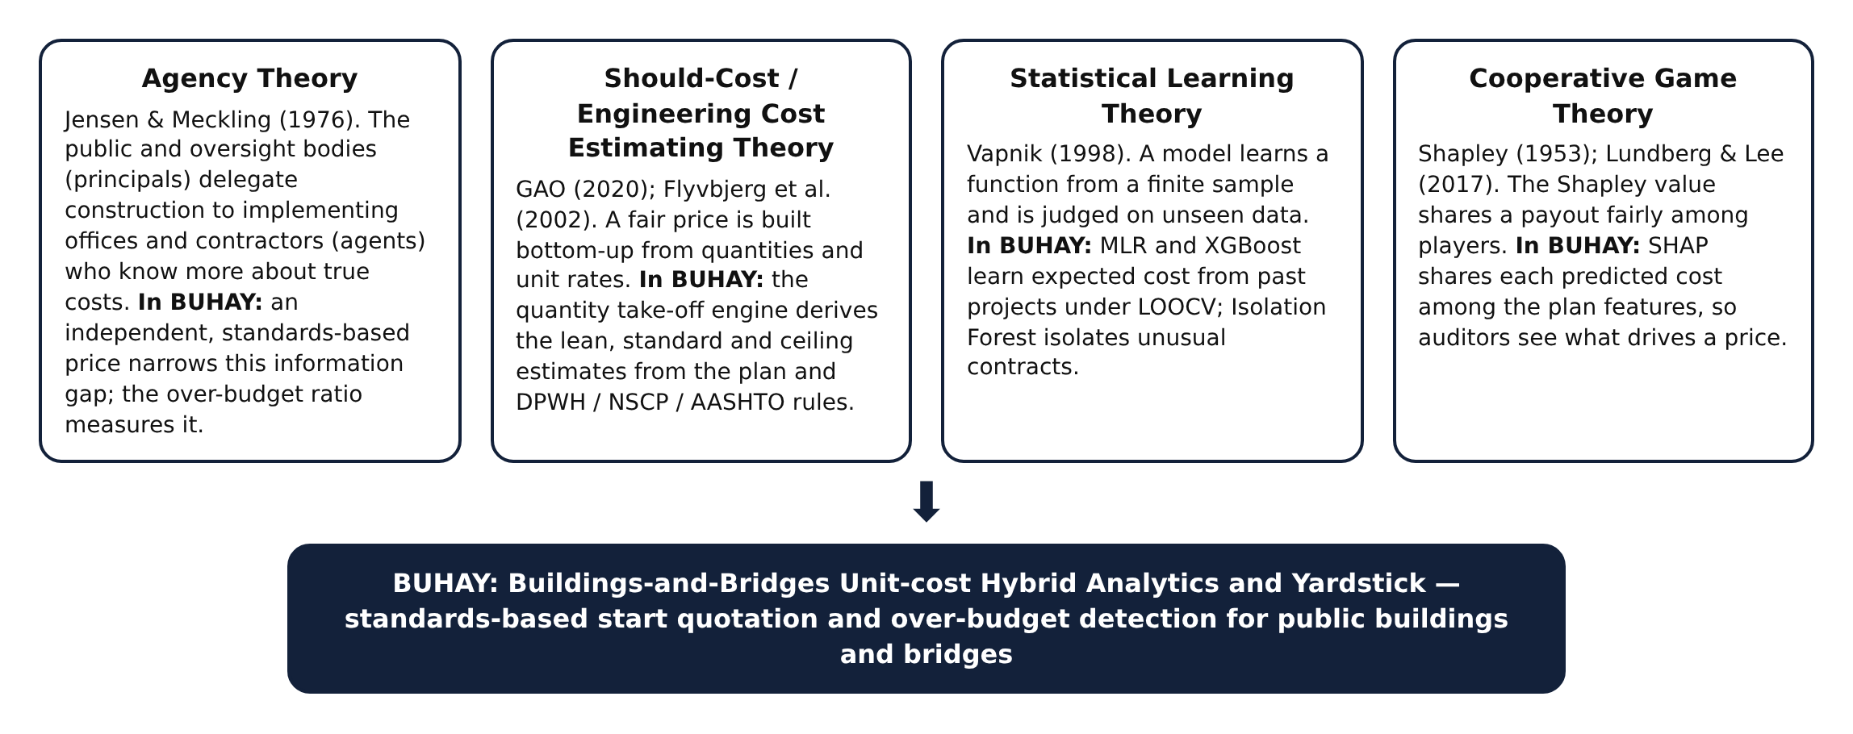
Conceptual Framework
This study was anchored on the Input-Process-Output-Feedback model, which shows how plans, standards and data are transformed into quotations and flags. The model fits the study because it makes explicit which inputs come from the plan, which from the standards and which from historical data, and how the outputs are fed back to improve the system.
The input consists of building and bridge plans, whether reference plans, DXF floor plans or dimensions typed by the user; the plan variables they contain; the DPWH pay items and unit costs in the BUHAY price book; the engineering standards that turn plans into quantities; and the contract amounts of past projects used to train the models.
The process begins with the parametric quantity take-off, which converts plan variables into concrete, reinforcing steel, formwork, masonry, roofing, finishes, piles and girders. Quantities are priced into an estimated direct cost and an ABC in three tiers. In parallel, Multiple Linear Regression and XGBoost estimate the expected cost from past projects, Isolation Forest scores how unusual a contract is, SHAP explains the expected cost, and the BUHAY Risk Index combines the signals.
The output includes the lean start quotation, standard fair estimate and ceiling with a full bill of quantities; over-budget flags with their risk index, drivers and line-item variances; validated accuracy and detection metrics; and the deployed mobile application, offline package and download website with a project map. The feedback loop returns residuals, confirmed flags, user updates to the price book and saved checks to refine the price book, thresholds and models.
Figure 2.
Conceptual Paradigm
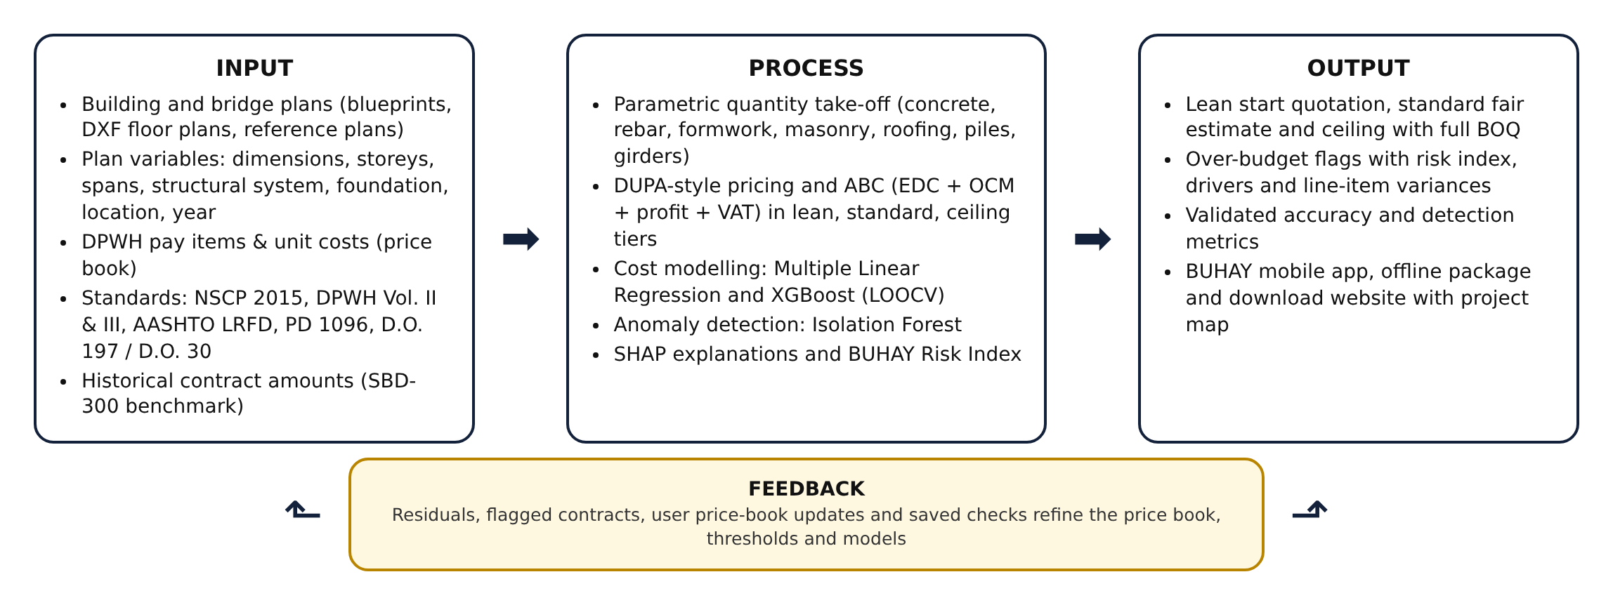
Mathematical Framework
This study used a quantitative developmental research design combined with a simulation-based computational experiment. The developmental part designed and built the quantity take-off engine, the hybrid models and the application. The experimental part generated a benchmark of 300 projects in which the true cost and the presence and size of overpricing are known, so that estimation accuracy and detection performance could be measured directly. Model performance was measured through leave-one-out cross-validation (LOOCV) and reported as R², RMSE and MAPE, while detection was reported as precision, recall, F1-score and the area under the ROC curve (AUC).
The system was developed in Python 3 with pandas, NumPy, scikit-learn, statsmodels, XGBoost, SHAP and matplotlib (Pedregosa et al., 2011; Seabold & Perktold, 2010; Chen & Guestrin, 2016; Lundberg & Lee, 2017), and in JavaScript with the Leaflet mapping library for the application. The methods are as follows: Plan Acquisition, Standards Codification, Quantity Take-Off and Quotation, Simulated Benchmark Generation, Model Development, Model Validation, Explanation and Risk Scoring, and App and Website Development.
Figure 3.
Methodological Paradigm
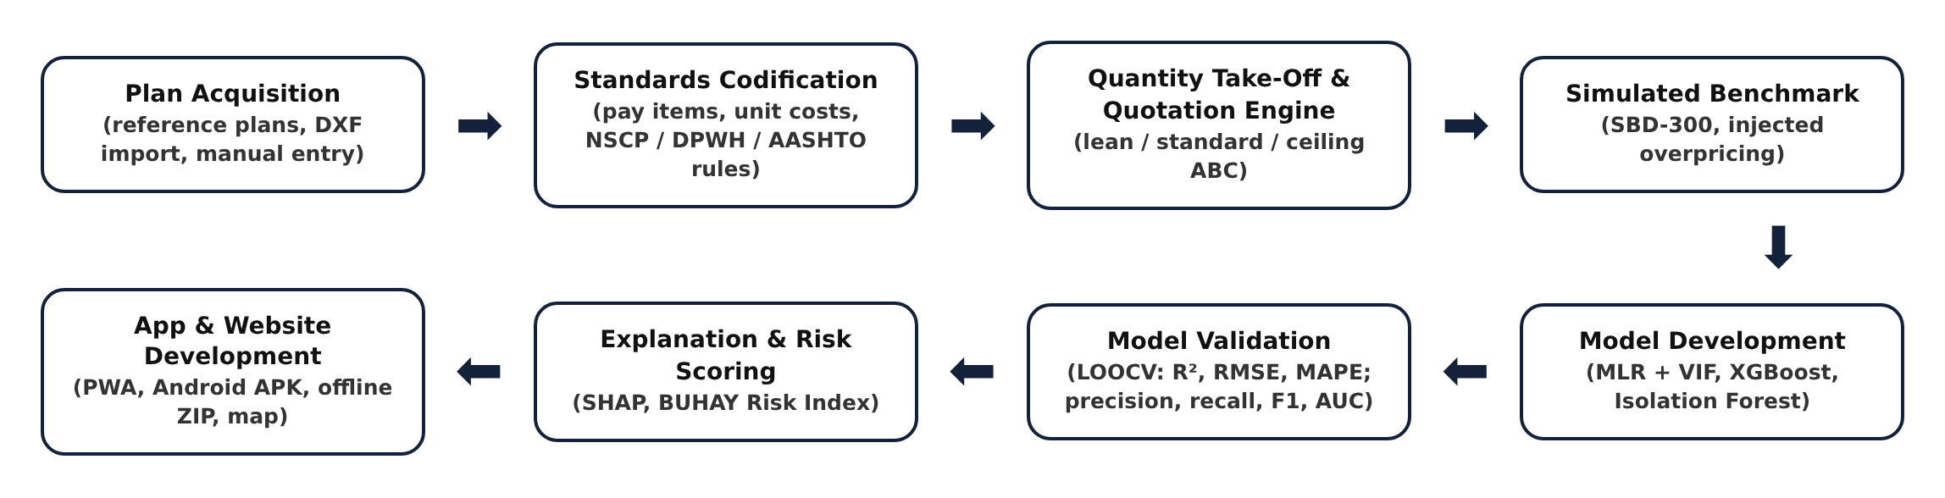
Plan Acquisition and Variable Extraction
BUHAY accepts a plan through three routes. A user can start from one of 19 reference plans, which are typical configurations of DPWH-implemented facilities such as one- to four-storey school buildings, health stations, evacuation centers, offices, markets, box culverts and girder and truss bridges; import a floor plan in DXF format; or type the dimensions. For DXF files, the largest closed polyline is read as the building outline, its area is computed with the shoelace formula and its perimeter from the vertex distances, and lines on layers named like WALL or PARTITION are measured as interior walls, halved when walls are drawn with two lines. Drawing units are read from the $INSUNITS header or inferred from the drawing extent. Table 1 lists the plan variables used.
Table 1.
Plan Variables Extracted by BUHAY
VARIABLE | ASSET | UNIT | SOURCE IN PLAN
Length, width, footprint, perimeter | Building | m, m² | Floor plan / DXF outline
Number of storeys, floor-to-floor height | Building | –, m | Sections, elevations
Column spacing (both directions) | Building | m | Structural grid
Facility type, roof system | Building | category | Title block, roof framing plan
Allowable soil bearing, seismic zone | Building | kPa, zone | Geotechnical report, NSCP map
Interior wall length | Building | m | Floor plan / DXF wall layers
Total length, number of spans | Bridge | m, – | General plan and elevation
Carriageway and sidewalk widths | Bridge | m | Typical deck section
Pier and abutment heights | Bridge | m | Substructure details
Superstructure and foundation type, pile length | Bridge | category, m | General notes, pile schedule
Province and price year | Both | category, year | Project location, program year

Derived indicators were then computed. For buildings, gross floor area (GFA) is footprint area times the number of storeys and the structural span is the larger bay dimension. For bridges, deck width is the carriageway plus both sidewalks plus 0.60 m of railing and curb, deck area is total length times deck width, and span length is total length divided by the number of spans. Categorical systems were encoded as ordinal indices: facility type by MEPF intensity (evacuation center 1 to health facility 6), superstructure by structural complexity (box culvert 1 to steel truss 4) and foundation by depth (spread footing 1 to bored pile 3). A location factor captures freight and barge premiums on island provinces, and a cost index brings each price year to 2025 levels (Table 2).
Table 2.
Location Factors and Yearly Cost Index
PROVINCE | LOCATION FACTOR | PRICE YEAR | COST INDEX
Albay (base) | 1.00 | 2022 | 0.90
Camarines Sur | 1.00 | 2023 | 0.94
Camarines Norte | 1.03 | 2024 | 0.97
Sorsogon | 1.03 | 2025 (base) | 1.00
Masbate | 1.10 | 2026 | 1.03
Catanduanes | 1.12 | – | –

Standards Codification and Price Book
The engineering standards were codified as take-off rules, and the unit costs as a price book keyed to DPWH pay items: Volume III (2019) item numbers for building works, adopted through D.O. No. 42, s. 2021, and Volume II (2013) item numbers for bridge works. Each rate is a direct cost covering materials, labor and equipment for Bicol in 2025, and every rate can be edited in the application so that implementing offices can load their own Detailed Unit Price Analysis. Table 3 shows selected entries; the full price book is in Appendix B.
Table 3.
Selected Pay Items and Direct Unit Costs in the BUHAY Price Book
PAY ITEM | DESCRIPTION | UNIT | RATE (₱)
900 (1)c | Structural concrete, fc′ 20.7 MPa (3000 psi), 28 days | m³ | 7,900
902 (1) | Reinforcing steel bars, deformed, Gr. 40/60, incl. tie wire | kg | 82
903 (2) | Formworks and falseworks | m² | 850
1046 (3) | CHB masonry 150 mm, reinforced & grouted (exterior) | m² | 1,080
1046 (2) | CHB masonry 100 mm (partitions) | m² | 880
1027 (1) | Cement plaster finish | m² | 360
1047 (3) | Structural steel trusses & purlins, fabricated & installed | kg | 140
1013 (2) | Pre-painted long-span metal roofing 0.50 mm, incl. accessories | m² | 760
1018 (2) | Ceramic floor tiles 600 × 600 mm | m² | 1,180
1008 (1) | Aluminum-framed glass windows | m² | 6,200
1010 | Doors complete with jamb & hardware | set | 13,500
803 (1)a | Structure excavation, common soil | m³ | 380
405 (1)a | Structural concrete Class A — deck & girders, incl. forms | m³ | 13,500
405 (1)b | Structural concrete Class A — abutments, piers, walls, incl. forms | m³ | 11,200
405 (1)c | Structural concrete Class A — footings, pile caps, approach slabs | m³ | 9,400
404 (1) | Reinforcing steel Gr. 60, incl. tie wire | kg | 84
406 (1)b | Precast PSC girder AASHTO Type IV — supply, fabricate, launch | m | 42,000
403 (1) | Structural steel, fabricated, painted & erected | kg | 210
400 (11) | Precast RC piles 450 × 450 mm, furnished & driven | m | 11,500
400 (17) | Bored piles 1.0 m Ø, drilling incl. temporary casing | m | 28,000
412 (1) | Elastomeric bearing pads | pc | 16,500
505 (2) | Grouted riprap, Class A (slope protection) | m³ | 3,100

Indirect costs follow DPWH Department Order No. 197, s. 2016, whose overhead, contingencies and miscellaneous (OCM) and profit percentages are carried into D.O. No. 30, s. 2025 for estimates from 2026. Both are applied as a share of the estimated direct cost (EDC) by bracket, and value-added tax is 5% of the sum of EDC, OCM and profit (Table 4). BUHAY also uses these caps to check submitted ABCs for excessive markups or a wrong VAT rate.
Table 4.
Indirect Cost Brackets under DPWH D.O. 197 s. 2016 and D.O. 30 s. 2025
ESTIMATED DIRECT COST | OCM | PROFIT | TOTAL MARKUP
Up to ₱5 million | 15% | 10% | 25%
Above ₱5 million up to ₱50 million | 12% | 8% | 20%
Above ₱50 million up to ₱150 million | 10% | 8% | 18%
Above ₱150 million | 8% | 8% | 16%
Value-added tax | 5% of (EDC + OCM + profit)

Quantity Take-Off and Quotation Engine
For buildings, the engine lays out the column grid from the plan dimensions and bay spacing and sizes the reinforced-concrete frame from the number of storeys. Columns are 300 mm square for up to two storeys, the NSCP 2015 minimum for special moment frames (Section 418.7.2.1), 400 mm for three to four storeys and 500 mm for five to six. Beam depth is the larger of 0.40 m and span/12, slabs are 125 mm for short spans up to 4.5 m and 150 mm beyond, and isolated footings are sized from the service load on each column and the allowable soil bearing:
Eq. 1.
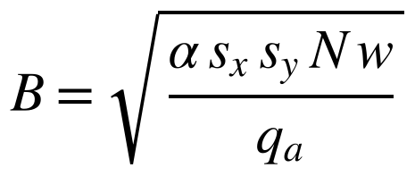
where α = 0.75 accounts for edge and corner columns, s_{x} and s_{y} are the bay dimensions, N is the number of storeys, w is the service load per floor (10.0 to 13.0 kPa by facility type) and q_{a} is the allowable bearing pressure. Reinforcing steel is computed from element volumes and intensities:
Eq. 2.
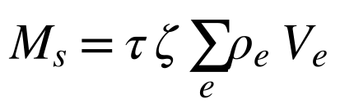
where ρ_{e} is the reinforcement intensity of element e in kg/m³ (footings 90, columns 220, beams 190, slabs 100, stairs 100 at the standard tier), V_{e} is the concrete volume, ζ is 1.00 for Seismic Zone 4 and 0.88 for Zone 2, and τ is the tier factor in Table 5. Masonry, plaster, painting, ceilings and floor finishes follow from wall and floor areas, window area is kept at no less than 10% of floor area as required for natural light by PD 1096, roof steel is taken as 14 + 0.6W kg per m² of footprint plus 5.5 kg/m² of purlins, and electrical, plumbing, fire protection and mechanical works are priced as allowances per m² of GFA by facility type, with sprinklers required for buildings of three or more storeys and for health facilities, markets and dormitories under RA 9514.
For bridges, deck slabs are 200 mm (220 mm on steel trusses). RCDG girders are spaced at about 2.1 m with depth of the larger of 0.90 m and span/13 + 0.10 m. PSCG girders are spaced at about 2.4 m and selected by span: AASHTO Type III up to 24 m, Type IV up to 32 m and bulb-tee BT-1600 beyond. Steel truss weight is (55 + 4.2S) kg per m² of deck for span S. Abutment stems are 0.50 + 0.06H m thick on footings 0.55H + 1.2 m wide for height H, piers have two or three circular columns of 1.0 to 1.2 m diameter under a coping, and pile counts follow the pile-cap footprint at 1.2 m spacing for 450 mm driven piles and 3.0 to 3.5 m for 1.0 m bored piles. Bearings, expansion joints, railings, approach slabs, slope protection, approach pavement, mobilization, occupational safety and health, traffic management and testing complete the bill of quantities.
Every quantity Q_{i} is multiplied by its unit rate r_{i} and by the location and year factors to give the estimated direct cost, which is then marked up into the ABC:
Eq. 3.
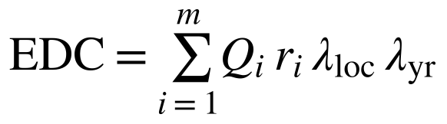
Eq. 4.
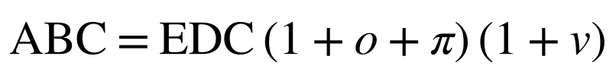
where o and π are the OCM and profit rates of the EDC bracket and v is the 5% VAT rate. The engine runs three times per plan with the tier settings in Table 5. The lean tier is the start quotation: it keeps every code requirement but uses code-minimum reinforcement and basic finishes. The ceiling tier is the highest price that can still be defended for the scope.
Table 5.
Quotation Tier Settings
SETTING | LEAN (START QUOTATION) | STANDARD (FAIR ESTIMATE) | CEILING
Reinforcement factor τ | 0.80 | 1.00 | 1.25
Structural steel factor | 0.92 | 1.00 | 1.15
Floor finish | Cement topping | Ceramic tiles | Porcelain / granite
MEPF allowance factor | 0.85 | 1.00 | 1.25
Mobilization / OSH | 1.0% / 1.0% | 1.2% / 1.5% | 1.5% / 2.0%
Scope contingency | – | – | 8% of works

A contract amount is compared with the standard estimate through the over-budget ratio:
Eq. 5.
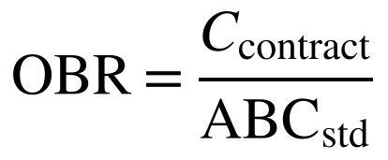
An OBR above 1.10 marks a contract for review, and an amount above the ceiling marks it as an over-budget flag.
Simulated Benchmark Dataset (SBD-300)
To measure accuracy and detection against a known truth, a benchmark of 160 buildings and 140 bridges was generated with a fixed random seed. Plans were sampled from realistic ranges for each facility and bridge type (Table 6), provinces were weighted toward the larger provinces, award years were drawn from 2022 to 2025, and each project was placed at a random point inside its province boundary. Each project then received a hidden reality the plan does not show: unit prices per cost category varied log-normally with a 7% standard deviation, reinforcement intensity by ±10%, concrete by ±6%, formwork by ±8%, earthworks by +5% ± 15%, MEPF by ±10%, and pile lengths by a factor of 0.95 to 1.35 reflecting geotechnical surprises. The true cost was priced by the same engine with these hidden adjustments, and the awarded amount was:
Eq. 6.
where η represents bid competition and μ is the markup. For 88% of projects μ = 1 except for 4% aggressive low bids (μ = 0.78 to 0.88). For the remaining 12%, 36 projects in all, overpricing was injected: half moderate (μ = 1.20 to 1.40) and half severe (μ = 1.40 to 2.10). The plan seen by the estimator is the declared plan, so the benchmark tests whether the yardstick and the models can see through realistic noise.
Table 6.
Simulation Parameters of the SBD-300 Benchmark
ELEMENT | BUILDINGS (n = 160) | BRIDGES (n = 140)
Types | School 40%, office 14%, health 12%, evacuation 16%, dormitory 6%, market 12% | Box culvert 18%, RCDG 42%, PSCG 30%, steel truss 10%
Size | 1–4 storeys; 2–5 classrooms; 10–50 m long | 1–5 spans; 2–70 m spans; 4.0–13.4 m carriageway
Hidden price variation | log-normal, σ = 0.07 per cost category | log-normal, σ = 0.07 per cost category
Hidden quantity variation | rebar ±10%, concrete ±6%, MEPF ±10% | rebar ±10%, concrete ±6%, piles ×0.95–1.35
Bid competition | e^{η}, η ~ N(−0.02, 0.045²) | e^{η}, η ~ N(−0.02, 0.045²)
Injected overpricing | 20 projects | 16 projects

Model Development
The machine-learning layer was built separately for buildings and bridges and chained so that each stage fed the next. Multiple Linear Regression served as the interpretable baseline:
Eq. 7.
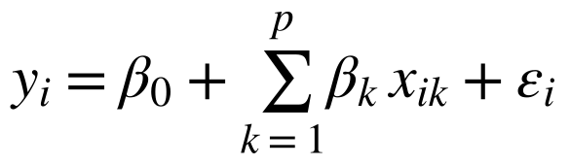
where y_{i} is the awarded cost of project i, x_{ik} is its k-th predictor, β_{k} the coefficients and ε_{i} the error. Multicollinearity was checked with the variance inflation factor, and the composite variable (deck area or footprint) and then the predictor with the highest VIF were removed until all VIFs fell at or below the conventional threshold of 10 (Kutner et al., 2004; O'Brien, 2007):
Eq. 8.
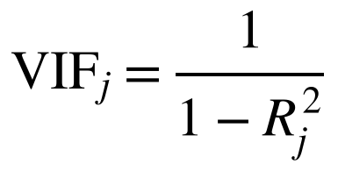
Extreme Gradient Boosting served as the primary cost model. It adds regression trees that each correct the previous ones and penalizes tree complexity (Chen & Guestrin, 2016):
Eq. 9.
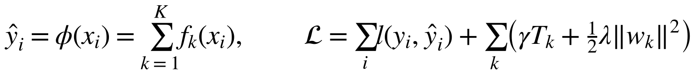
The model was trained on the natural logarithm of cost so that small culverts and large bridges carry comparable weight, and tuned by randomized search over 40 settings of tree depth, number of trees, learning rate, L1 and L2 penalties, minimum child weight, row subsampling and column subsampling, scored by five-fold MAPE (Table 7).
Table 7.
XGBoost Hyperparameter Search and Selected Values
HYPERPARAMETER | SEARCH SPACE | SELECTED (BUILDINGS) | SELECTED (BRIDGES)
max_depth | 2, 3, 4, 5 | 2 | 2
n_estimators | 100–400 | 300 | 300
learning_rate | 0.02–0.10 | 0.05 | 0.05
reg_alpha | 0–2.0 | 0.2 | 0.2
reg_lambda | 0.5–3.0 | 3.0 | 3.0
min_child_weight | 1, 2, 3, 5 | 5 | 5
subsample | 0.7–1.0 | 0.7 | 0.7
colsample_bytree | 0.6–1.0 | 0.9 | 0.9

Isolation Forest then screened for unusual contracts. Its inputs were the standardized plan features, the XGBoost residual ln(actual / predicted) and the log over-budget ratio, with 200 trees and a contamination of 0.10. Each record receives an anomaly score from its average path length (Liu et al., 2008):
Eq. 10.
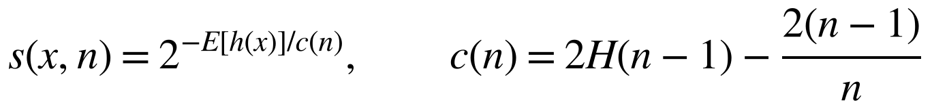
where E[h(x)] is the average path length of record x across trees, c(n) is the average path length of an unsuccessful search in a tree of n records and H is the harmonic number. As in CORA, a statistically unusual contract was reported only if its cost was also above both the model and the standards-based estimates. SHAP values were computed on the final XGBoost model with the exact tree path-dependent algorithm (Lundberg et al., 2018), so that each prediction splits into a base value and feature contributions:
Eq. 11.
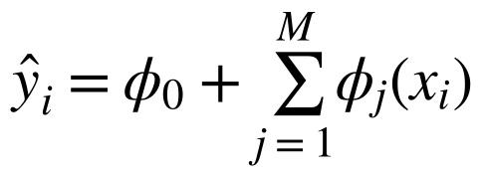
Finally, the three signals were combined into the BUHAY Risk Index, which weights the standards-based evidence most heavily because it does not depend on past prices:
Eq. 12.
Eq. 13.
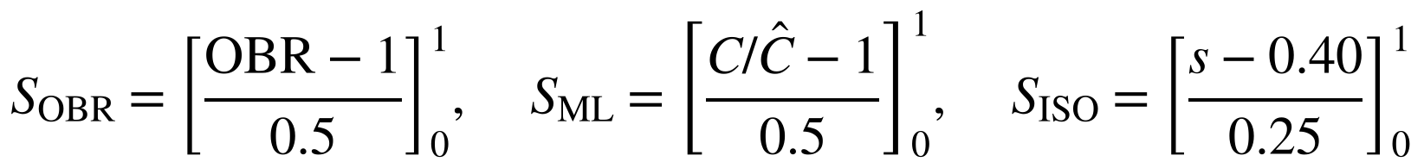
where [·]₀¹ clips a value to the range 0 to 1, C is the contract amount, Ĉ is the XGBoost expected cost and s is the anomaly score. A BRI of 30 or more is a high-risk flag and 20 to 30 marks a contract for review. Figure 4 shows how the components fit together.
Figure 4.
Model Integration Framework
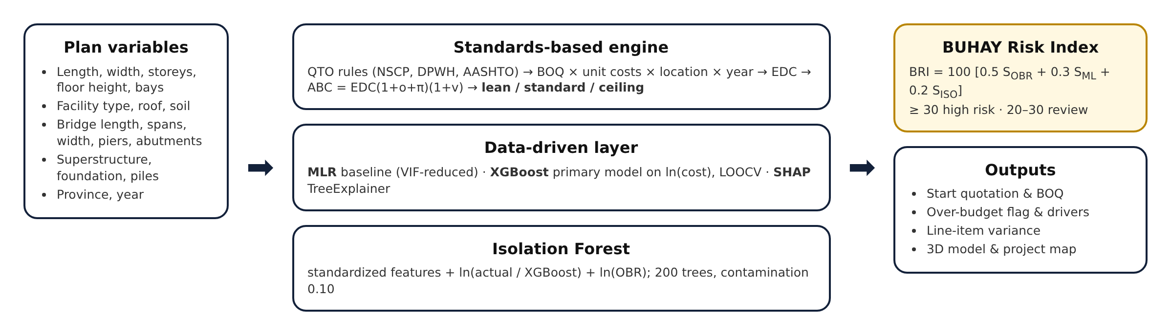
Model Validation
Given the moderate sample sizes, a single train-test split would give an unstable estimate, so leave-one-out cross-validation was used for both regression models (Molinaro et al., 2005): each project was held out once and predicted by a model trained on all the others. Three metrics evaluated cost prediction. RMSE gives the typical error in pesos, R² gives the share of variance explained, and MAPE expresses error as a percentage of each project's cost so that culverts and long bridges can be compared:
Eq. 14.

Eq. 15.
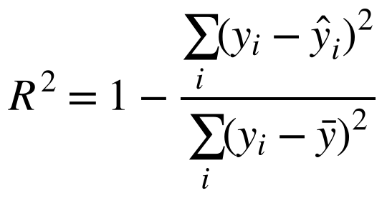
Eq. 16.
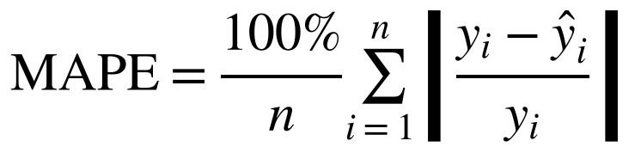
Detection was evaluated against the injected labels with precision, recall and the F1-score, and threshold-free performance with the area under the ROC curve:
Eq. 17.
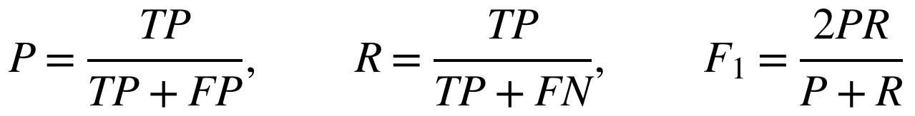
Four screening rules were compared: the standards-based rule (amount above the ceiling), the model residual rule (amount more than 1.25 times the XGBoost LOOCV prediction), the CORA-style Isolation Forest flag, and the BUHAY Risk Index at 30.
3D Visualization
Each plan is rendered as a parametric 3D model built directly from the geometry the engine computes rather than from generic shapes, following the logic of parametric BIM dashboards. Buildings show the column grid, slabs, walls with window bands and the gable or flat roof; bridges show the deck, girder lines or truss panels, piers, abutments, railings, approaches and the waterway. The renderer uses an orthographic projection with flat shading on a 2D canvas so that it runs on low-end phones without a graphics library, and the model is tinted green, amber or red by the screening result.
App and Website Development
The system was delivered as a progressive web application that can be installed on Android, iOS and desktop and works offline after the first load. The cost engine is a single JavaScript file shared by the application and the Python research pipeline, so the app and the paper produce the same numbers. The trained XGBoost trees and the Isolation Forest were exported to JSON and evaluated in the browser, with exact TreeSHAP ported from the reference implementation; parity tests against Python matched XGBoost predictions within 1×10⁻⁵ in log cost, Isolation Forest scores to machine precision and SHAP values within 2×10⁻⁷. An Android package is built automatically from the same files with Capacitor through GitHub Actions, an offline ZIP package runs from a local folder, and a download website with an interactive project map is published from the same repository. Plans, saved checks and price-book edits stay on the user's device.
Figure 5.
System Architecture of BUHAY
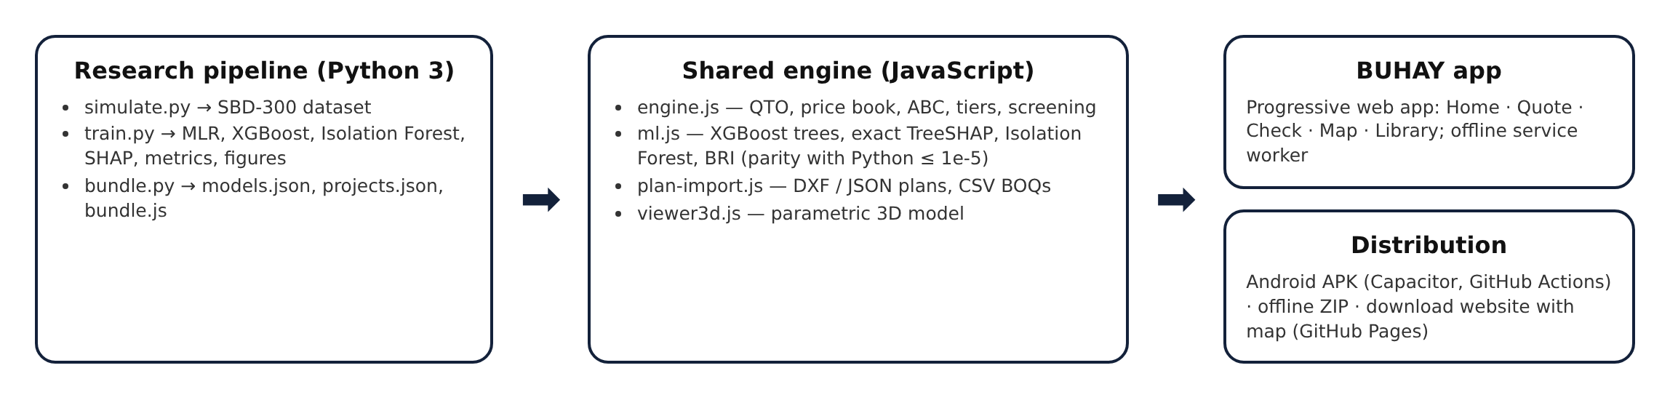
FINDINGS
This section presents the results of the study in the order of the research questions, from the plan variables and the accuracy of the standards-based engine to the machine-learning models, the detection benchmark and the deployed system.
Plan Variables and Derived Indicators Extracted from Building and Bridge Plans
The first research question identified the variables that can be read from plans and standards and used to estimate cost. Nine variables describe each building and eleven describe each bridge (Table 1), grouped into physical properties, structural system and foundation, and location and price year.
a.) Physical Properties
Table 8.
Descriptive Statistics of the Physical Properties of Buildings (n = 160)
VARIABLE | x̄ | SD | MIN | 25% | 50% | 75% | MAX
Gross Floor Area (m²) | 672.33 | 373.44 | 116.58 | 383.30 | 614.88 | 873.00 | 1,991
Footprint Area (m²) | 381.30 | 204.00 | 116.58 | 253.17 | 349.05 | 425.56 | 1,380
Storeys | 1.89 | 0.89 | 1.00 | 1.00 | 2.00 | 2.00 | 4.00
Structural Span (m) | 6.26 | 1.64 | 3.67 | 4.84 | 5.82 | 7.09 | 10.20
Floor Height (m) | 3.67 | 0.73 | 2.91 | 3.19 | 3.33 | 4.07 | 5.88

Table 8 shows that gross floor area averaged 672.3 m² and ranged from 116.6 m² to 1,990.8 m², with a median of 614.9 m². Because the mean is above the median, the distribution is right-skewed: most projects are one- and two-storey facilities, with a few large multi-storey buildings and markets. Storeys ranged from 1 to 4, structural spans from 3.67 m to 10.20 m, and floor heights from 2.91 m to 5.88 m, the tallest belonging to evacuation centers and markets.
Table 9.
Descriptive Statistics of the Physical Properties of Bridges (n = 140)
VARIABLE | x̄ | SD | MIN | 25% | 50% | 75% | MAX
Total Length (m) | 40.86 | 38.88 | 2.00 | 12.25 | 31.20 | 53.90 | 189.50
Deck Width (m) | 8.79 | 1.94 | 4.60 | 7.92 | 8.80 | 9.70 | 16.40
Deck Area (m²) | 369.79 | 357.08 | 9.20 | 110.62 | 261.90 | 551.20 | 1,684
Span Length (m) | 20.57 | 15.60 | 2.00 | 9.62 | 16.05 | 31.48 | 68.90
Pier Height (m) | 3.94 | 3.89 | 0.00 | 0.00 | 4.71 | 6.53 | 11.53
Abutment Height (m) | 5.31 | 1.56 | 2.03 | 4.05 | 5.42 | 6.72 | 7.99

For bridges (Table 9), total length averaged 40.9 m but ranged from 2.0 m for single-cell culverts to 189.5 m, and deck area from 9.2 m² to 1,684.2 m². The standard deviation of length is close to its mean, so bridge size varies far more than building size, which later explains why bridges were harder to model. Deck width was more uniform, with half of the bridges between 7.92 m and 9.70 m, reflecting the standard two-lane carriageway.
b.) Structural System and Foundation
Table 10.
Structural System and Foundation Composition of the Benchmark
CATEGORY | COUNT | SHARE
School buildings | 67 | 41.9%
Multi-purpose / evacuation centers | 22 | 13.8%
Government offices | 19 | 11.9%
Health facilities | 22 | 13.8%
Public markets | 20 | 12.5%
Dormitories | 10 | 6.2%
RCDG bridges | 70 | 50.0%
PSCG bridges | 31 | 22.1%
RC box culverts | 24 | 17.1%
Steel truss bridges | 15 | 10.7%
Bridges on spread footings / driven piles / bored piles | 42 / 55 / 43 | –

Table 10 summarizes the structural systems. School buildings made up the largest building group, consistent with the classroom program, and 9 buildings used reinforced-concrete roof decks instead of steel trusses. Among bridges, RCDG and PSCG girders dominated; most piled bridges used bored piles, which carry the largest geotechnical uncertainty in the benchmark.
c.) Location, Price Year and Project Budget
Table 11.
Project Budget Characteristics of the Benchmark
ITEM | BUILDINGS | BRIDGES
Dependent variable | Awarded contract cost (₱) | Awarded contract cost (₱)
Range | ₱5.37 million – ₱56.77 million | ₱1.00 million – ₱179.23 million
Median | ₱16.54 million | ₱36.66 million
Total value | ₱3,002.53 million | ₱6,290.43 million
Provinces / years | 6 provinces / 2022–2025 | 6 provinces / 2022–2025
Sample | 160 projects | 140 projects

Table 11 shows the budgets. Building contracts ranged from ₱5.37 million to ₱56.77 million, about 11 times, while bridge contracts ranged from ₱1.00 million to ₱179.23 million, about 180 times. This wide range is why the study reports MAPE, which expresses error relative to each project's cost, alongside RMSE in pesos.
Accuracy of the Standards-Based Quantity Take-Off Engine
The second research question examined how well the engine prices buildings and bridges from their plans. Table 12 lists the three tiers for the 19 reference plans, priced for Albay at 2025 levels.
a.) Lean Start Quotation, Standard Fair Estimate and Ceiling
Table 12.
Quotations of the Reference Plans (Albay, 2025 Prices)
REFERENCE PLAN | LEAN | STANDARD | CEILING | STANDARD / m² | LEAN SAVING
1-storey 2-classroom school building | ₱4.63M | ₱5.31M | ₱6.41M | ₱32,797/m² | 12.9%
2-storey 4-classroom school building | ₱7.88M | ₱9.10M | ₱11.49M | ₱26,612/m² | 13.5%
3-storey 9-classroom school building | ₱17.28M | ₱20.03M | ₱25.37M | ₱26,036/m² | 13.7%
4-storey 12-classroom school building | ₱29.08M | ₱33.80M | ₱42.89M | ₱24,709/m² | 14.0%
Barangay health station | ₱3.07M | ₱3.66M | ₱4.63M | ₱45,711/m² | 16.0%
2-storey rural health unit / birthing facility | ₱12.83M | ₱15.66M | ₱20.08M | ₱32,634/m² | 18.1%
Multi-purpose evacuation center, 600 m² | ₱14.00M | ₱16.13M | ₱20.34M | ₱26,884/m² | 13.2%
2-storey municipal office building | ₱15.03M | ₱18.20M | ₱23.21M | ₱27,076/m² | 17.4%
3-storey provincial office building | ₱38.16M | ₱46.87M | ₱60.09M | ₱24,109/m² | 18.6%
Public market, 1-storey | ₱23.49M | ₱27.13M | ₱34.42M | ₱28,258/m² | 13.4%
3-storey dormitory | ₱24.51M | ₱28.47M | ₱36.23M | ₱26,358/m² | 13.9%
Single-cell RC box culvert 3.0 × 3.0 m | ₱1.73M | ₱1.87M | ₱2.20M | ₱62,874/m² | 7.2%
Double-barrel RC box culvert 2 × (3.0 × 2.5 m) | ₱2.48M | ₱2.68M | ₱3.16M | ₱46,990/m² | 7.4%
Single-lane farm-to-market RCDG bridge 1 × 12 m | ₱5.78M | ₱6.22M | ₱7.19M | ₱92,518/m² | 7.1%
Two-lane RCDG bridge 1 × 18 m | ₱18.39M | ₱19.41M | ₱22.64M | ₱122,561/m² | 5.3%
Two-lane RCDG bridge 3 × 20 m | ₱39.07M | ₱42.04M | ₱50.12M | ₱79,615/m² | 7.1%
Two-lane PSCG bridge 2 × 30 m (AASHTO Type IV) | ₱56.28M | ₱59.00M | ₱67.09M | ₱105,735/m² | 4.6%
Two-lane PSCG bridge 4 × 35 m | ₱119.21M | ₱124.62M | ₱143.72M | ₱95,712/m² | 4.3%
Two-lane steel truss bridge 1 × 50 m | ₱62.19M | ₱65.79M | ₱79.88M | ₱149,527/m² | 5.5%

For buildings, the standard estimate ranged from ₱24,109 to ₱45,711 per m² of gross floor area, with the smallest buildings, such as the barangay health station, costing most per m² because fixed items like septic tanks, ramps and plumbing are spread over less floor area. The 2-storey 4-classroom school building came to ₱9.10 million, or about ₱2.28 million per classroom, and its lean start quotation was ₱7.88 million. For multi-span bridges, the standard estimate ranged from ₱0.70M to ₱1.32M per linear meter, rising from RCDG to PSCG to steel truss as spans lengthen. The lean saving was larger for buildings (12% to 19%) than for bridges (4% to 8%), because buildings carry finishes and MEPF allowances that can be specified leanly, whereas a bridge's cost is dominated by structural quantities that the codes already fix. Appendix C shows the full bill of quantities of the 2-storey 4-classroom school building.
b.) Accuracy against Fair Awarded Costs
Table 13.
Accuracy of the Standards-Based Estimate against Fair Awarded Costs
MEASURE (NON-INJECTED PROJECTS) | BUILDINGS (n = 140) | BRIDGES (n = 124)
MAPE, standard estimate | 5.21% | 7.67%
R², standard estimate | 0.9799 | 0.9801
RMSE, standard estimate | ₱1,229,130 | ₱5,160,512
MAPE, XGBoost (LOOCV) | 11.82% | 17.24%
Lean start quotation ≤ awarded cost | 94.3% | 81.5%
Awarded cost ≤ ceiling | 100.0% | 88.7%
Mean lean saving vs. standard | 14.4% | 5.9%

Table 13 compares the standard estimate with the awarded cost of the projects without injected overpricing. The engine reached a MAPE of 5.21% for buildings and 7.67% for bridges, with R² of 0.9799 and 0.9801. This is less than half the error of the XGBoost model on the same projects (11.82% and 17.24%), showing the value of pricing from the plan instead of from comparable contracts. The lean start quotation stayed at or below the fair awarded cost for 94.3% of buildings and 81.5% of bridges, so it behaves as an efficient floor, and the ceiling covered 100.0% of fair building contracts and 88.7% of fair bridge contracts. The lower bridge coverage comes from hidden pile lengths of up to 35% beyond the plan: a bridge whose piles must go deeper than designed can legitimately exceed the plan-based ceiling. This agrees with the long-standing observation that ground conditions are the largest source of cost uncertainty in substructures and shows why geotechnical data should accompany a bridge check.
Because the benchmark was generated with the same engine plus hidden variation, these figures measure how robust the plan-level estimate is to unseen site and market conditions of the stated size, not its accuracy on actual DPWH contracts, which remains to be validated (see Recommendations).
Figure 6.
Distribution of the Over-Budget Ratio for Injected and Non-Injected Projects
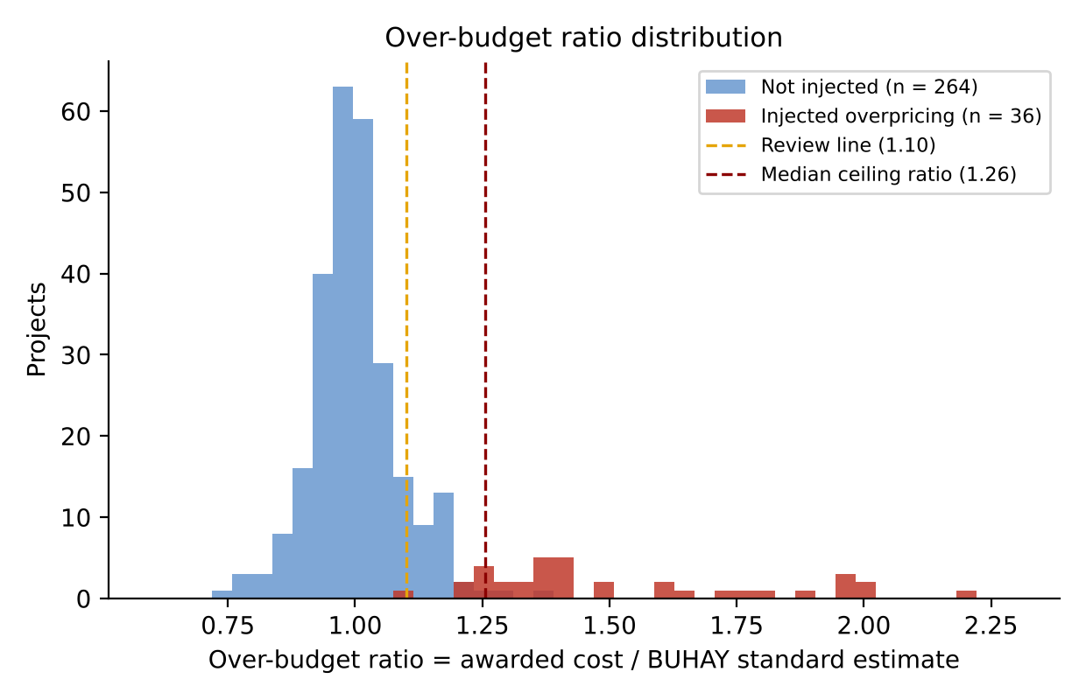
Figure 6 shows the over-budget ratio of all 300 projects. Fair projects cluster around 1.0, while injected projects sit to the right of the review line, most of them beyond the ceiling. The overlap between the two groups is small for buildings and larger for bridges, which anticipates the detection results.
Development of Machine Learning Models to Predict Construction Cost
The third research question compared Multiple Linear Regression and XGBoost as data-driven predictors of awarded cost, trained on all 300 benchmark projects including the padded ones, as an auditor would face in practice.
a.) Multiple Linear Regression
Table 14.
Variance Inflation Factor of the Building Predictors
FEATURE | VIF
Gross Floor Area | 7.4348
Footprint Area | 5.7900
Number of Storeys | 5.8024
Structural Span | 1.0707
Floor Height | 1.9786
Facility Type Index | 1.3686
RC Roof Deck | 1.1039
Location Factor | 1.0522
Cost Index (Year) | 1.0741

Table 14 shows that all building predictors stayed below the threshold of 10. Gross floor area (7.43), number of storeys (5.80) and footprint area (5.79) were the most correlated, as expected since gross floor area is footprint times storeys, but their overlap was moderate because footprints vary widely at every storey count. No predictor was removed.
Table 15.
Variance Inflation Factor of the Bridge Predictors, Full and Reduced Models
FEATURE | VIF (FULL MODEL) | VIF (REDUCED MODEL)
Total Length | 44.4445 | 3.4172
Deck Width | 2.3229 | 1.0743
Deck Area | 44.3983 | removed
Span Length | 10.4170 | 2.9914
Pier Height | 1.8396 | 1.8395
Abutment Height | 1.4483 | 1.3780
Superstructure Type Index | 12.1095 | removed
Foundation Type Index | 3.5079 | 3.3669
Pile Length | 2.5744 | 2.5213
Location Factor | 1.1048 | 1.0836
Cost Index (Year) | 1.0237 | 1.0115

For bridges (Table 15), total length (44.44) and deck area (44.40) showed severe multicollinearity, structurally expected because deck area is total length times deck width, the same pattern CORA found between road length and pavement area (Buban, 2026). Superstructure type (12.11) was also collinear with span length because span determines the girder system. Removing Deck Area and Superstructure Type Index brought every VIF to 3.42 or below.
Table 16.
Ordinary Least Squares Results for Buildings
VARIABLE | COEFFICIENT | STD. ERROR | t | P > |t| | [0.025 | 0.975]
Constant | -46,114,581 | 11,702,924 | -3.940 | <0.001* | -69,238,450 | -22,990,711
Gross Floor Area | 20,379 | 2,347 | 8.683 | <0.001* | 15,741 | 25,016
Footprint Area | 8,496 | 3,791 | 2.241 | 0.027* | 1,004 | 15,988
Number of Storeys | 1,260,755 | 865,717 | 1.456 | 0.147 | -449,820 | 2,971,330
Structural Span | 126,306 | 202,355 | 0.624 | 0.533 | -273,529 | 526,140
Floor Height | 234,911 | 622,591 | 0.377 | 0.706 | -995,270 | 1,465,091
Facility Type Index | 463,310 | 226,326 | 2.047 | 0.042* | 16,112 | 910,508
RC Roof Deck | 1,403,944 | 1,461,220 | 0.961 | 0.338 | -1,483,289 | 4,291,178
Location Factor | 18,028,194 | 7,380,574 | 2.443 | 0.016* | 3,444,878 | 32,611,510
Cost Index (Year) | 25,035,073 | 9,020,962 | 2.775 | 0.006* | 7,210,505 | 42,859,641

Table 16 presents the building model (R² = 0.8449, adjusted R² = 0.8356, F = 90.79, p < 0.001). Gross floor area was the strongest predictor (t = 8.683): holding the others constant, each additional m² adds about ₱20,379 to the contract. Significant predictors at the 5% level were Gross Floor Area, Footprint Area, Facility Type Index, Location Factor, Cost Index (Year). Storeys, span, floor height and roof type were not significant once floor area was included, so their signs should not be read as independent effects. The large negative constant has no physical meaning on its own, since a building with zero floor area lies outside the data.
Table 17.
Ordinary Least Squares Results for Bridges
VARIABLE | COEFFICIENT | STD. ERROR | t | P > |t| | [0.025 | 0.975]
Constant | -141,342,353 | 39,111,477 | -3.614 | <0.001* | -218,719,732 | -63,964,973
Total Length | 630,763 | 53,583 | 11.772 | <0.001* | 524,756 | 736,769
Deck Width | 2,545,124 | 602,620 | 4.223 | <0.001* | 1,352,912 | 3,737,336
Span Length | 274,632 | 124,921 | 2.198 | 0.030* | 27,491 | 521,773
Pier Height | -2,613 | 393,175 | -0.007 | 0.995 | -780,463 | 775,237
Abutment Height | 1,313,775 | 849,695 | 1.546 | 0.124 | -367,246 | 2,994,795
Foundation Type Index | 8,727,086 | 2,644,518 | 3.300 | 0.001* | 3,495,222 | 13,958,949
Pile Length | 340,928 | 171,104 | 1.993 | 0.048* | 2,419 | 679,437
Location Factor | 71,540,128 | 24,680,609 | 2.899 | 0.004* | 22,712,494 | 120,367,761
Cost Index (Year) | 30,119,933 | 30,007,182 | 1.004 | 0.317 | -29,245,688 | 89,485,553

Table 17 presents the reduced bridge model (R² = 0.8866, adjusted R² = 0.8787, F = 112.91, p < 0.001). Total length (t = 11.772) and deck width (t = 4.223) were the strongest predictors: each additional meter of length adds about ₱630,763 and each meter of width about ₱2,545,124. Foundation type, pile length, span length and location were also significant, while pier height and price year were not.
Substituting the coefficients into the general model gives the reduced working equations, rounded to four significant digits:
Cost_{building} = 20,380 GFA + 8,496 Footprint + 1,261,000 Storeys + 126,300 Span + 234,900 FloorHeight + 463,300 Type + 1,404,000 RoofRC + 18,030,000 Location + 25,040,000 Year − 46,110,000
Cost_{bridge} = 630,800 Length + 2,545,000 Width + 274,600 Span − 2,613 PierHeight + 1,314,000 AbutmentHeight + 8,727,000 Foundation + 340,900 PileLength + 71,540,000 Location + 30,120,000 Year − 141,300,000
Table 18.
Performance of the Multiple Linear Regression Models under LOOCV
METRIC (LOOCV) | BUILDINGS | BRIDGES
R-squared | 0.8112 | 0.8640
Root Mean Square Error | ₱4,330,581 | ₱14,021,603
Mean Absolute Percentage Error | 13.43% | 65.65%

Under LOOCV (Table 18), the building model reached an R² of 0.8112 with a MAPE of 13.43%, within the 13% to 31% range Mahamid (2011) reported for regression models of construction cost. The bridge model explained a similar share of variance (R² = 0.8640) but its MAPE rose to 65.65%. The linear model fits the large bridges that dominate the variance but badly over-predicts small culverts, where a few million pesos of error is a large percentage; the negative intercept even pushes some small culverts toward zero or below. Linear regression is therefore a fair baseline for buildings but not for bridges.
b.) Extreme Gradient Boosting
Table 19.
XGBoost Feature Importance (Gain Share)
FEATURE | IMPORTANCE (BUILDINGS) | FEATURE | IMPORTANCE (BRIDGES)
Gross Floor Area | 0.3937 | Superstructure Type Index | 0.8570
Number of Storeys | 0.3848 | Foundation Type Index | 0.0428
Footprint Area | 0.1010 | Total Length | 0.0383
Cost Index (Year) | 0.0264 | Pile Length | 0.0232
Location Factor | 0.0260 | Deck Area | 0.0171
Floor Height | 0.0210 | Span Length | 0.0145
Facility Type Index | 0.0189 | Deck Width | 0.0024
Structural Span | 0.0175 | Cost Index (Year) | 0.0015
RC Roof Deck | 0.0107 | Abutment Height | 0.0015
 |  | Location Factor | 0.0009
 |  | Pier Height | 0.0007

Table 19 shows the share of total gain contributed by each feature. For buildings, gross floor area (0.3937) and storeys (0.3848) account for about 78% of the model's splitting gain. For bridges, superstructure type dominates (0.8570): once the tree knows whether a crossing is a culvert, an RCDG, a PSCG or a truss, most of the cost level is set, and length, foundation and pile length refine it. The tree model thus retains the superstructure type that the linear model had to drop because of collinearity.
Table 20.
Performance of the XGBoost Models under LOOCV
METRIC (LOOCV) | BUILDINGS | BRIDGES
R-squared | 0.7874 | 0.8630
Root Mean Square Error | ₱4,594,791 | ₱14,070,696
Mean Absolute Percentage Error | 13.94% | 19.18%

Table 20 shows that XGBoost reduced the bridge MAPE from 65.65% to 19.18%, a 71% reduction, with a nearly identical R² (0.8630). Training on log cost and splitting by superstructure type let it price culverts and long bridges on their own terms. For buildings, however, XGBoost (MAPE 13.94%, R² = 0.7874) did slightly worse than linear regression, because building cost in this benchmark is close to linear in floor area and a tree ensemble approximates a straight line with steps. This differs from CORA, where XGBoost outperformed regression on every metric for roads (Buban, 2026), and it supports Elmousalami's (2020) observation that the best model depends on the cost structure of the asset.
Table 21.
Comparison of Multiple Linear Regression and XGBoost
ASPECT | MULTIPLE LINEAR REGRESSION | EXTREME GRADIENT BOOSTING
Buildings: R² / MAPE | 0.8112 / 13.43% | 0.7874 / 13.94%
Bridges: R² / MAPE | 0.8640 / 65.65% | 0.8630 / 19.18%
Collinear predictors | Must be removed (deck area, superstructure) | Retained
Small vs. large projects | Errors grow on small projects | Log target balances sizes
Explanation | Coefficients and p-values | SHAP values per project
Role in BUHAY | Interpretable baseline | Primary expected cost and residual

Figures 7 and 8 show how each feature drives the XGBoost predictions. Each dot is one project; its position is the SHAP value on the log-cost scale and its color the feature value.
Figure 7.
Global SHAP Values of the XGBoost Building Model
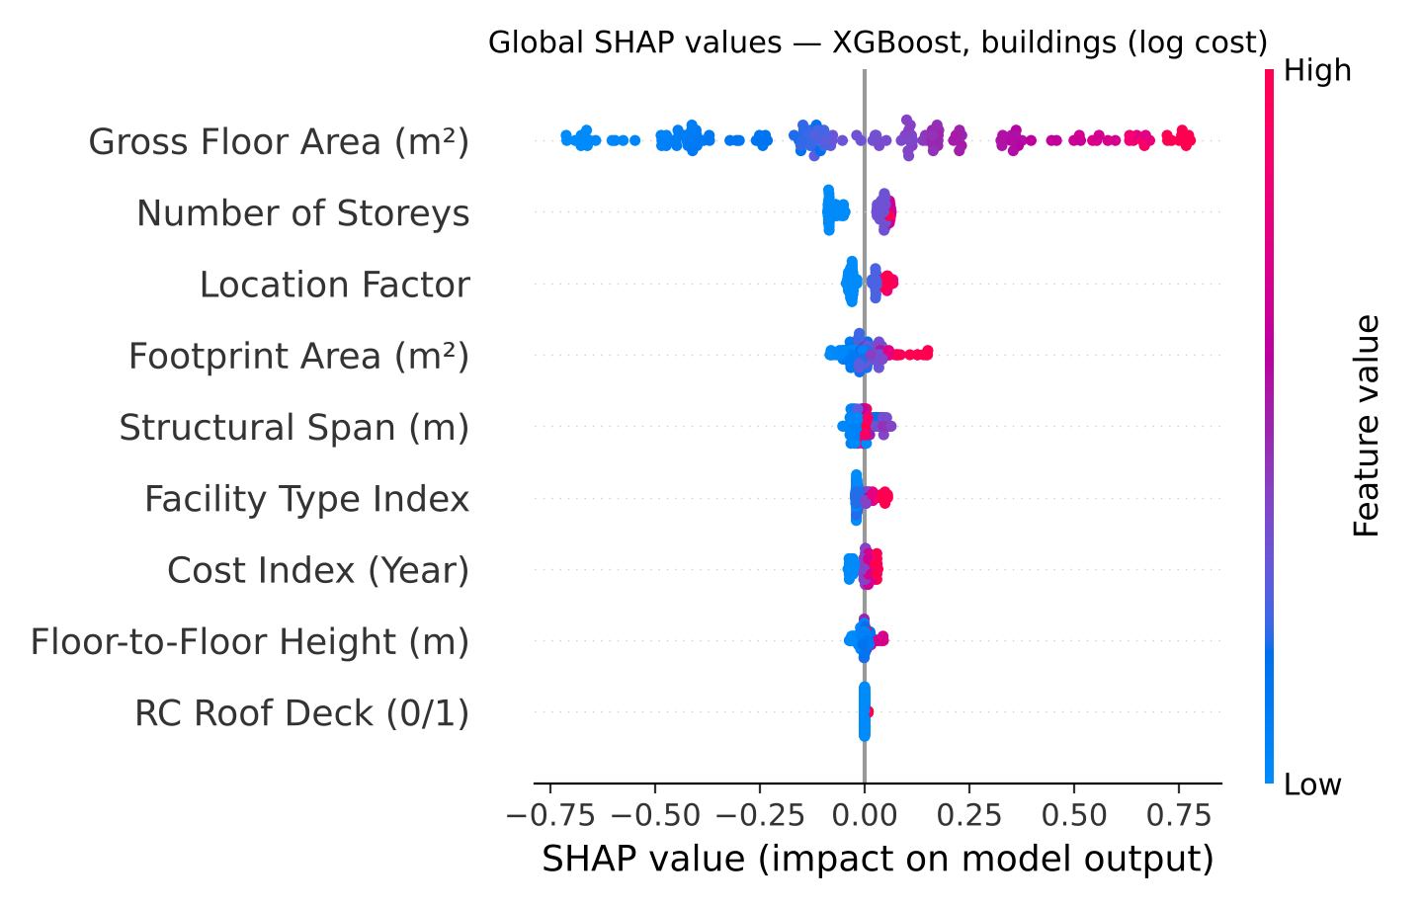
Figure 8.
Global SHAP Values of the XGBoost Bridge Model
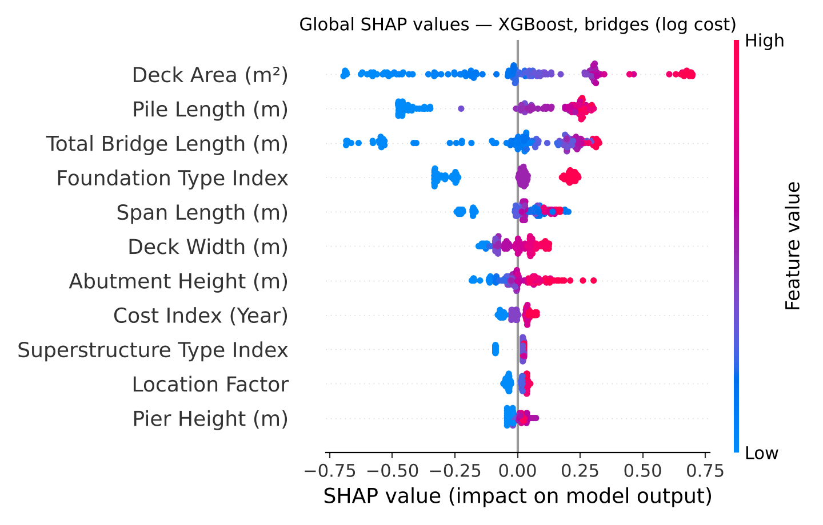
For buildings, gross floor area dominates (mean |SHAP| = 0.343 in log cost), far above storeys (0.058) and location (0.035); high floor areas push cost up and small ones pull it down. For bridges the picture is broader: deck area (0.301), pile length (0.257), total length (0.223) and foundation type (0.163) all matter. SHAP also reveals what gain importance hides: although superstructure type wins most splits, the per-project contributions are spread across size and foundation, which is exactly what an auditor needs to explain a single price. These explanations are shown for every checked project in the application.
Detection of Over-Budgeted Contracts
The fourth research question measured how well each screening rule finds the 36 contracts with injected overpricing. Table 22 reports the results per asset class and for all 300 projects.
Table 22.
Detection Performance against Injected Overpricing
SCOPE AND RULE | PRECISION | RECALL | F1 | AUC | TP / FP / FN
Buildings: standards-based rule (above ceiling) | 1.000 | 0.750 | 0.857 | 1.000 | 15 / 0 / 5
Buildings: XGBoost residual (> 1.25 × predicted) | 0.929 | 0.650 | 0.765 | 0.972 | 13 / 1 / 7
Buildings: Isolation Forest (CORA-style) | 0.750 | 0.300 | 0.429 | 0.802 | 6 / 2 / 14
Buildings: BUHAY Risk Index (≥ 30) | 0.905 | 0.950 | 0.927 | 0.999 | 19 / 2 / 1
Bridges: standards-based rule (above ceiling) | 0.517 | 0.938 | 0.667 | 0.982 | 15 / 14 / 1
Bridges: XGBoost residual (> 1.25 × predicted) | 0.550 | 0.688 | 0.611 | 0.939 | 11 / 9 / 5
Bridges: Isolation Forest (CORA-style) | 0.400 | 0.250 | 0.308 | 0.646 | 4 / 6 / 12
Bridges: BUHAY Risk Index (≥ 30) | 0.469 | 0.938 | 0.625 | 0.972 | 15 / 17 / 1
All projects: standards-based rule (above ceiling) | 0.682 | 0.833 | 0.750 | 0.994 | 30 / 14 / 6
All projects: XGBoost residual (> 1.25 × predicted) | 0.706 | 0.667 | 0.686 | 0.955 | 24 / 10 / 12
All projects: Isolation Forest (CORA-style) | 0.556 | 0.278 | 0.370 | 0.731 | 10 / 8 / 26
All projects: BUHAY Risk Index (≥ 30) | 0.642 | 0.944 | 0.764 | 0.987 | 34 / 19 / 2

Across all projects, the BUHAY Risk Index caught 34 of 36 padded contracts (recall 0.944) with 19 false alarms, for the highest F1-score (0.764). The standards-based rule alone was the strongest single signal: its continuous ratio reached the highest AUC (0.994) and its ceiling rule had good precision (0.682) but missed 6 contracts whose padding stayed under the ceiling. The XGBoost residual rule found 66.7% of the cases; because it learns from prices that include padding, part of the overpricing becomes "normal" to it. The CORA-style Isolation Forest found only 27.8% (AUC 0.731): a padded contract for an ordinary building is not unusual in its plan features, so isolation alone cannot see it. This answers the validation gap that CORA left open and shows why a standards-based reference is needed.
By asset class, buildings were screened almost perfectly (BRI F1 = 0.927, recall 0.950). Bridges kept a high recall (0.938) but lower precision (0.469), because fair bridges with deeper-than-planned piles look over budget against a plan-based estimate. A sensitivity check found that the F1-maximizing threshold is about 24 for buildings (F1 = 0.952) and 58 for bridges (F1 = 0.839), which suggests class-specific thresholds once real data are available. Recall was 90% for moderate and 100% for severe building cases, and 88% and 100% for bridges.
Figure 9.
ROC Curves of the Screening Signals, All 300 Projects
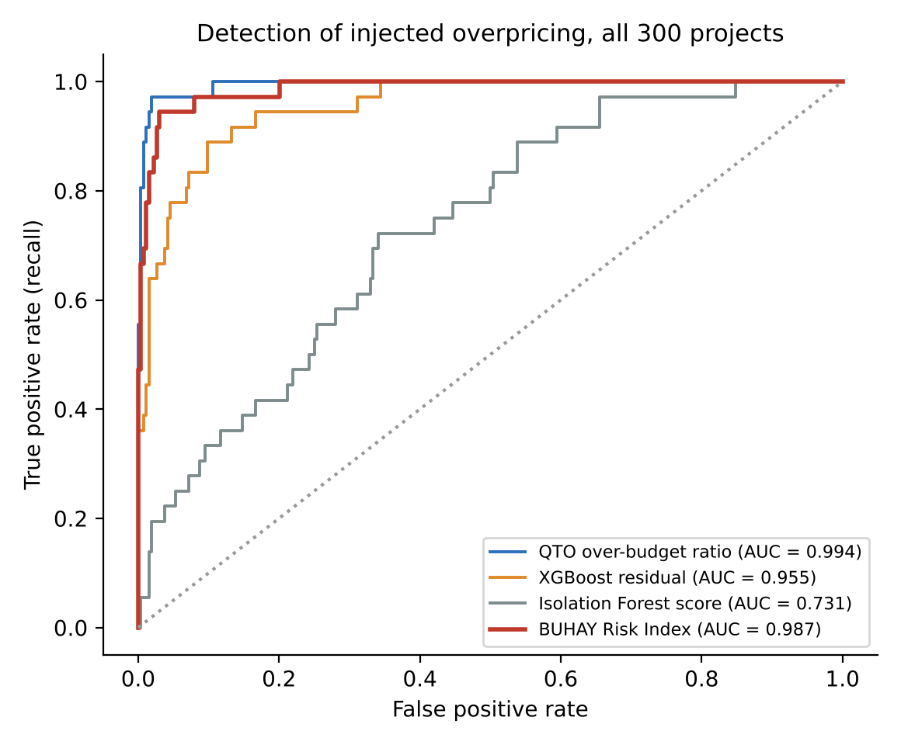
Table 23.
Highest-Risk Contracts Flagged by BUHAY
ID | PROJECT | AWARDED | OBR | BRI | PRIMARY DRIVER | INJECTED
SIM-B-143 | 3-storey government office building | ₱56.77M | 1.89 | 97.4 | RC Roof Deck (0/1) | Yes
SIM-B-024 | 1-storey public market | ₱48.81M | 1.59 | 97.3 | Footprint Area (m²) | Yes
SIM-B-110 | 2-storey dormitory | ₱24.65M | 1.80 | 93.4 | Over-Budget Ratio (vs. QTO) | Yes
SIM-B-035 | 2-storey multi-purpose / evacuation center | ₱46.62M | 1.49 | 91.2 | Floor-to-Floor Height (m) | Yes
SIM-B-044 | 1-storey school building | ₱11.04M | 2.00 | 91.1 | Over-Budget Ratio (vs. QTO) | Yes
SIM-R-032 | RCDG bridge, 8.4 m (1 span) | ₱16.58M | 1.97 | 95.3 | XGBoost Cost Residual | Yes
SIM-R-129 | RCDG bridge, 41.9 m (2 spans) | ₱59.43M | 2.20 | 93.8 | Over-Budget Ratio (vs. QTO) | Yes
SIM-R-049 | RCDG bridge, 12.6 m (1 span) | ₱64.28M | 1.99 | 90.6 | Over-Budget Ratio (vs. QTO) | Yes
SIM-R-125 | RCDG bridge, 63.9 m (3 spans) | ₱119.10M | 1.95 | 90.2 | Over-Budget Ratio (vs. QTO) | Yes
SIM-R-030 | RCDG bridge, 17.8 m (1 span) | ₱49.07M | 1.97 | 88.1 | Over-Budget Ratio (vs. QTO) | Yes

Table 23 lists the five highest-risk buildings and bridges. All were injected cases, with over-budget ratios from about 1.5 to 2.2. The primary driver, the input with the largest standardized deviation, was most often the over-budget ratio itself or the XGBoost residual, and occasionally an unusual plan feature such as a reinforced concrete roof deck or a large footprint, which tells a reviewer where to look first. In pesos, the flagged contracts exceeded their ceilings by ₱339.62 million and their standard estimates by ₱656.05 million, against ₱517.25 million of padding injected in total. These amounts illustrate the scale a screening tool can bring to attention; they are not findings about any real contract.
Deployment of BUHAY as a Mobile Application and Download Website
The fifth research question concerned how the system reaches its users. BUHAY was deployed as an installable mobile application with five screens (Home, Quote, Check, Map and Library), an Android package, an offline ZIP package and a download website.
a.) Mobile Application
Figure 10.
Home Screen of the BUHAY Application
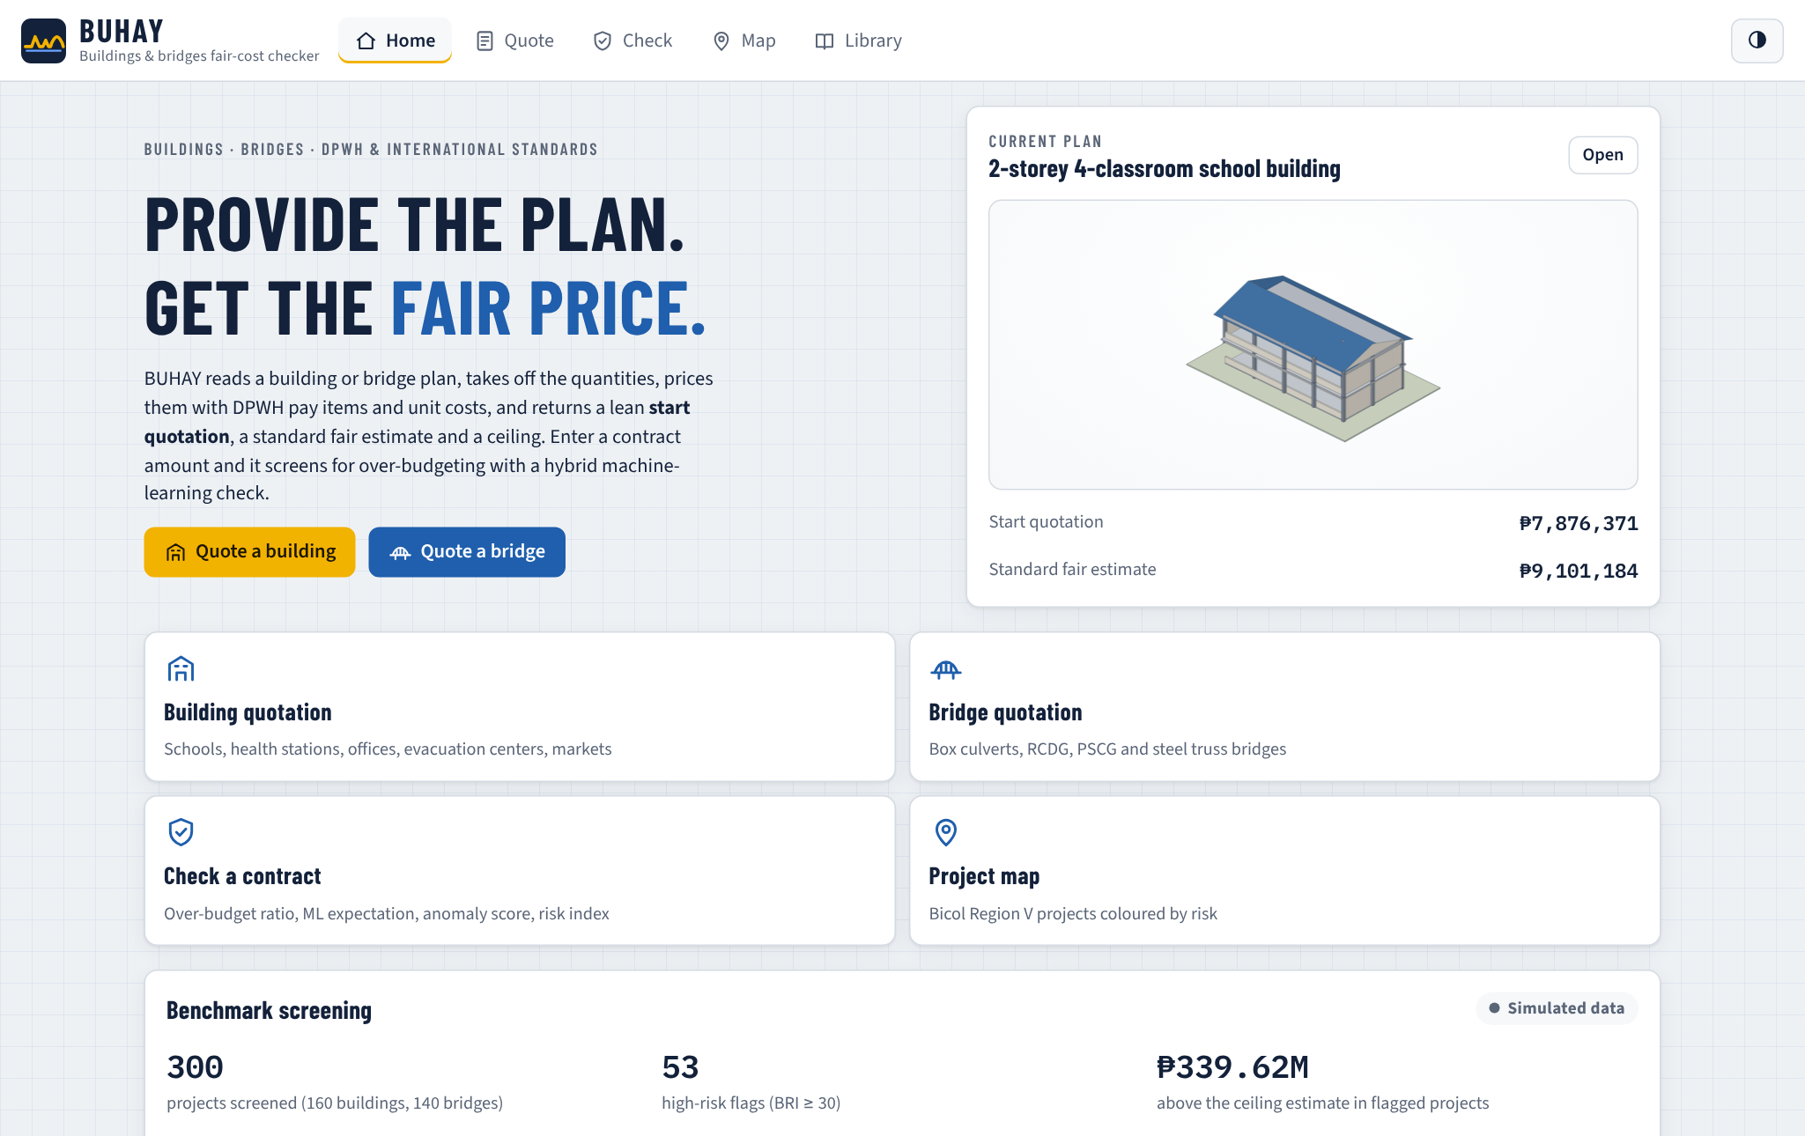
The home screen states the purpose of the system, shows the current plan as a 3D model with its start quotation and standard estimate, and offers four actions: a building quotation, a bridge quotation, a contract check and the project map. It also summarizes the benchmark screening, clearly labelled as simulated data.
Figure 11.
Quote Screen with the Three Quotation Tiers and the ABC
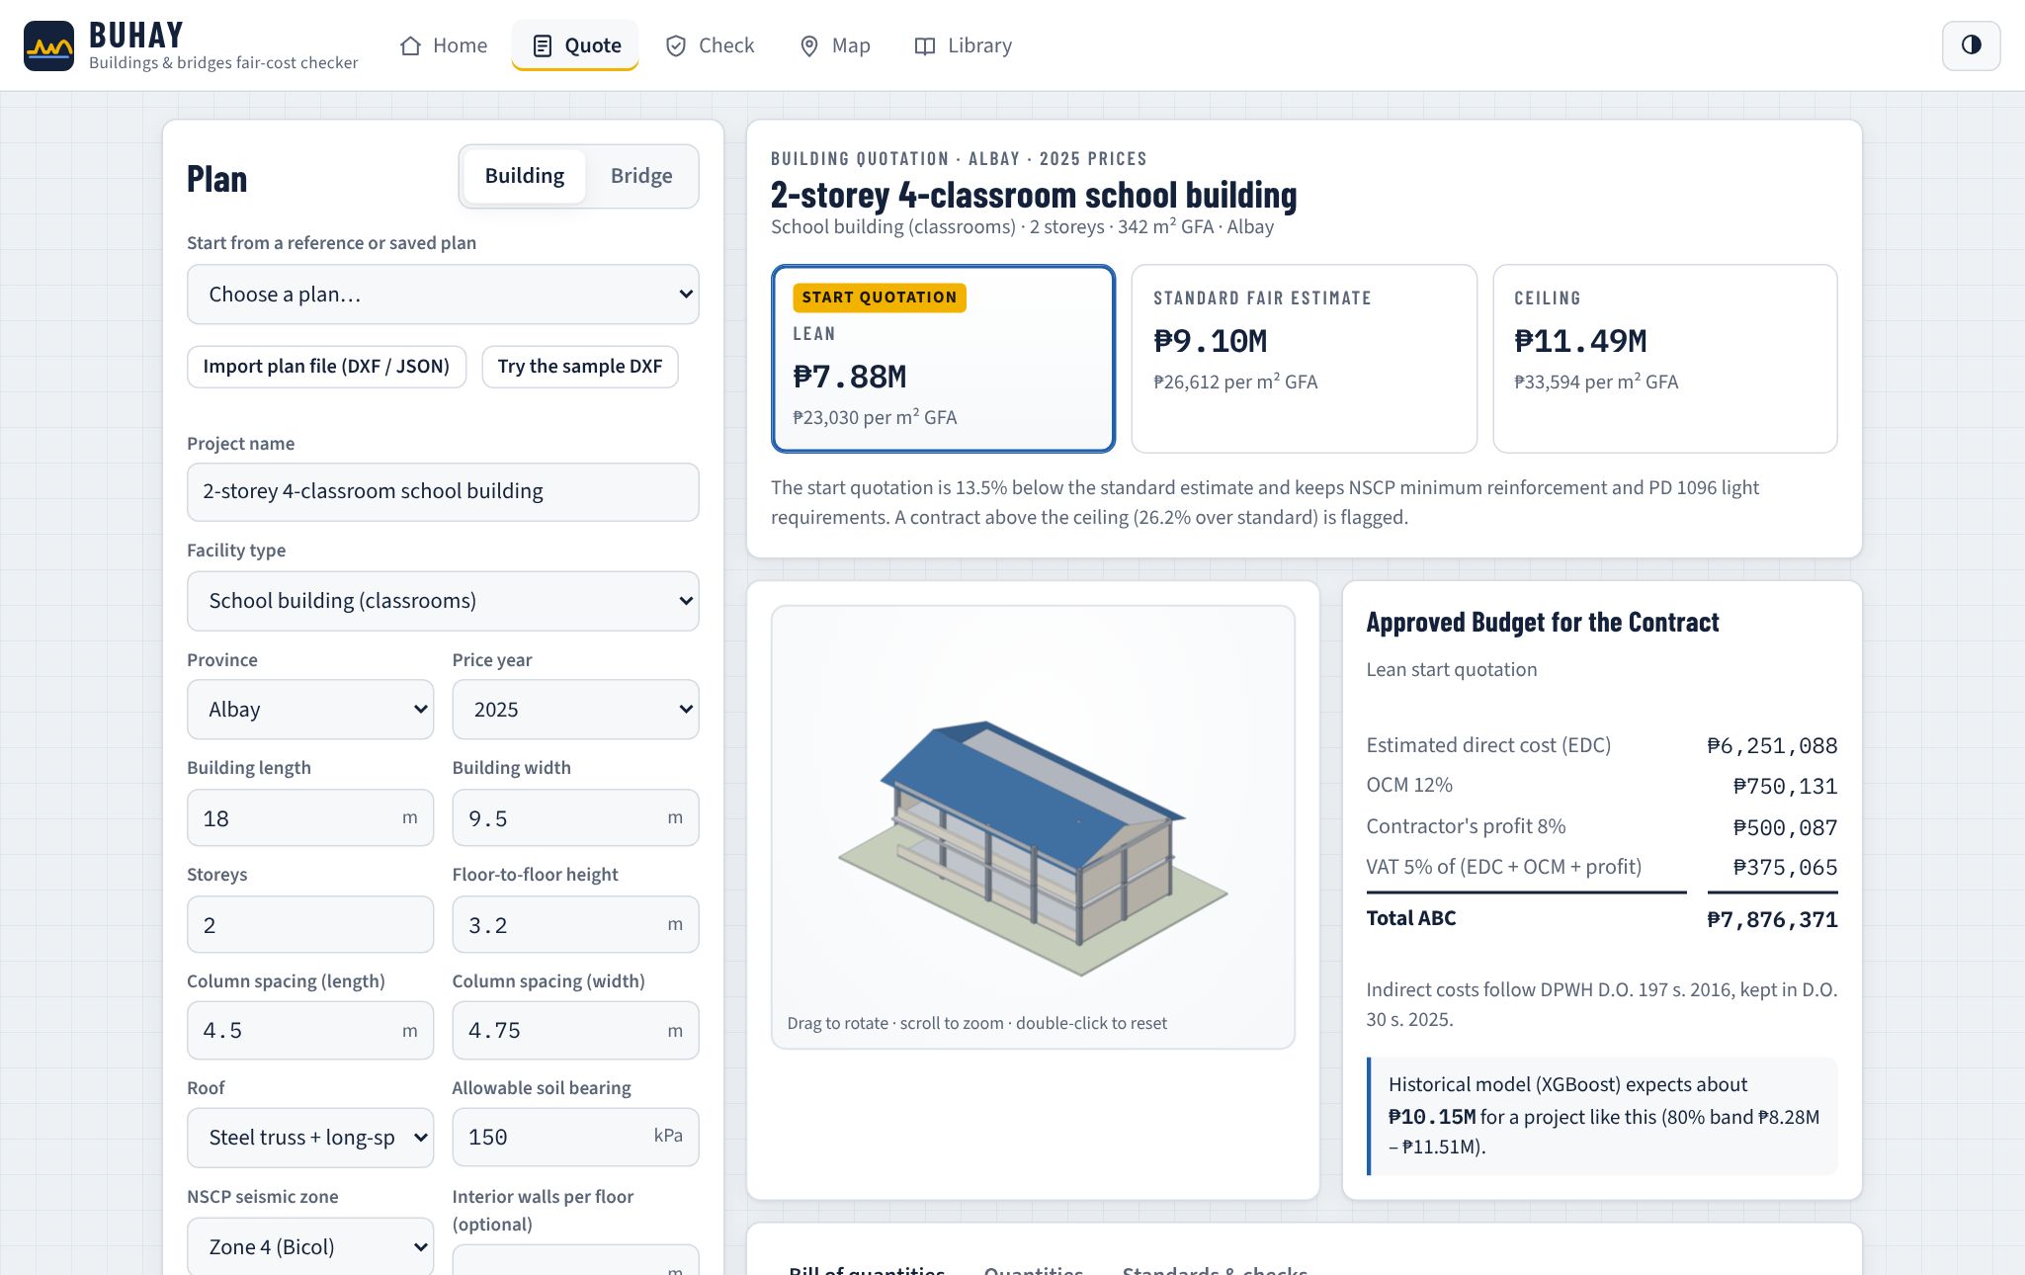
On the Quote screen, the user picks a reference or saved plan, imports a DXF or plan file, or types the plan variables. The three tiers update as the user types, with the lean start quotation highlighted. Beside the 3D model, the ABC is broken down into estimated direct cost, OCM, profit and VAT, and the XGBoost expectation with its 80% band is shown as a second opinion.
Figure 12.
Bill of Quantities Generated from the Plan
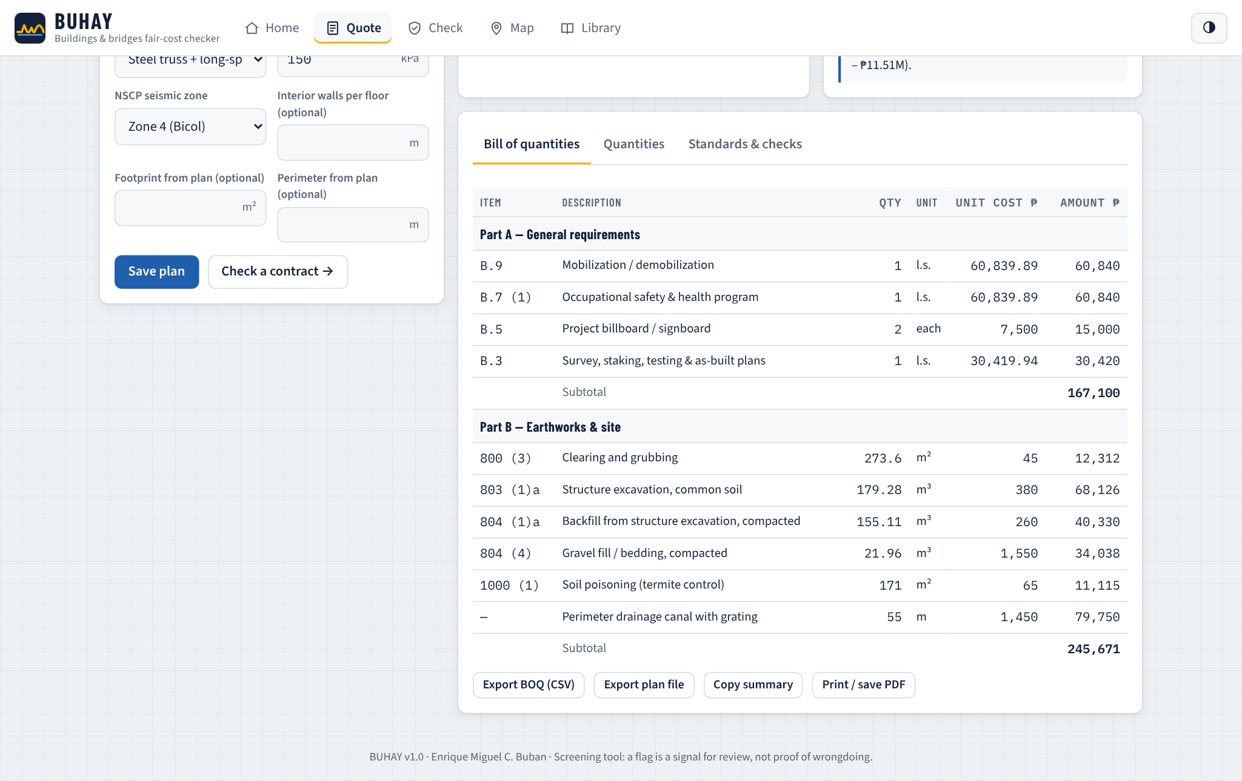
The bill of quantities lists every pay item with its quantity, unit, unit cost and amount, grouped into DPWH parts with subtotals. It can be exported as CSV for spreadsheets, the plan can be saved or exported as a plan file, and the quotation can be printed to PDF. Further tabs show the quantity summary and the standards and code checks applied.
Figure 13.
Plan Panel after Importing the Sample DXF Floor Plan
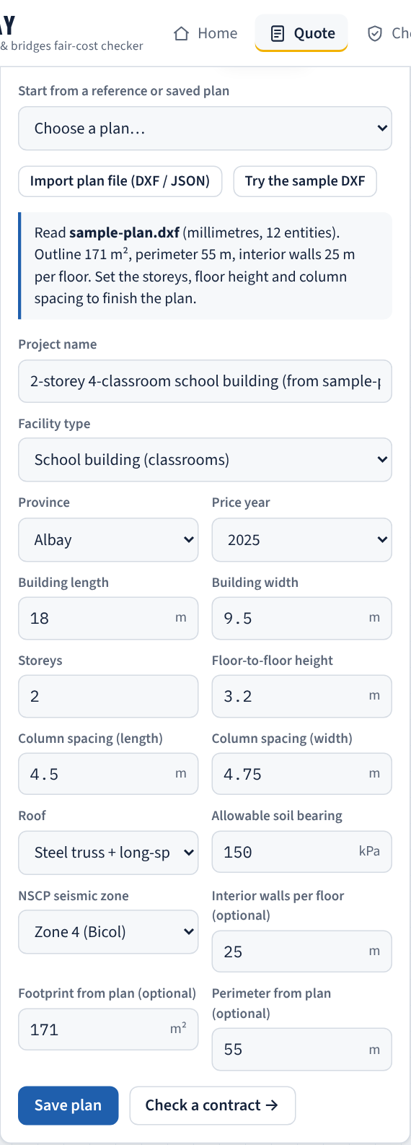
Importing the sample DXF plan of a two-classroom school building read an outline of 171 m², a perimeter of 55 m and 25 m of interior walls, which the engine used in place of a rectangular estimate.
Figure 14.
Check Screen Screening a Padded Contract
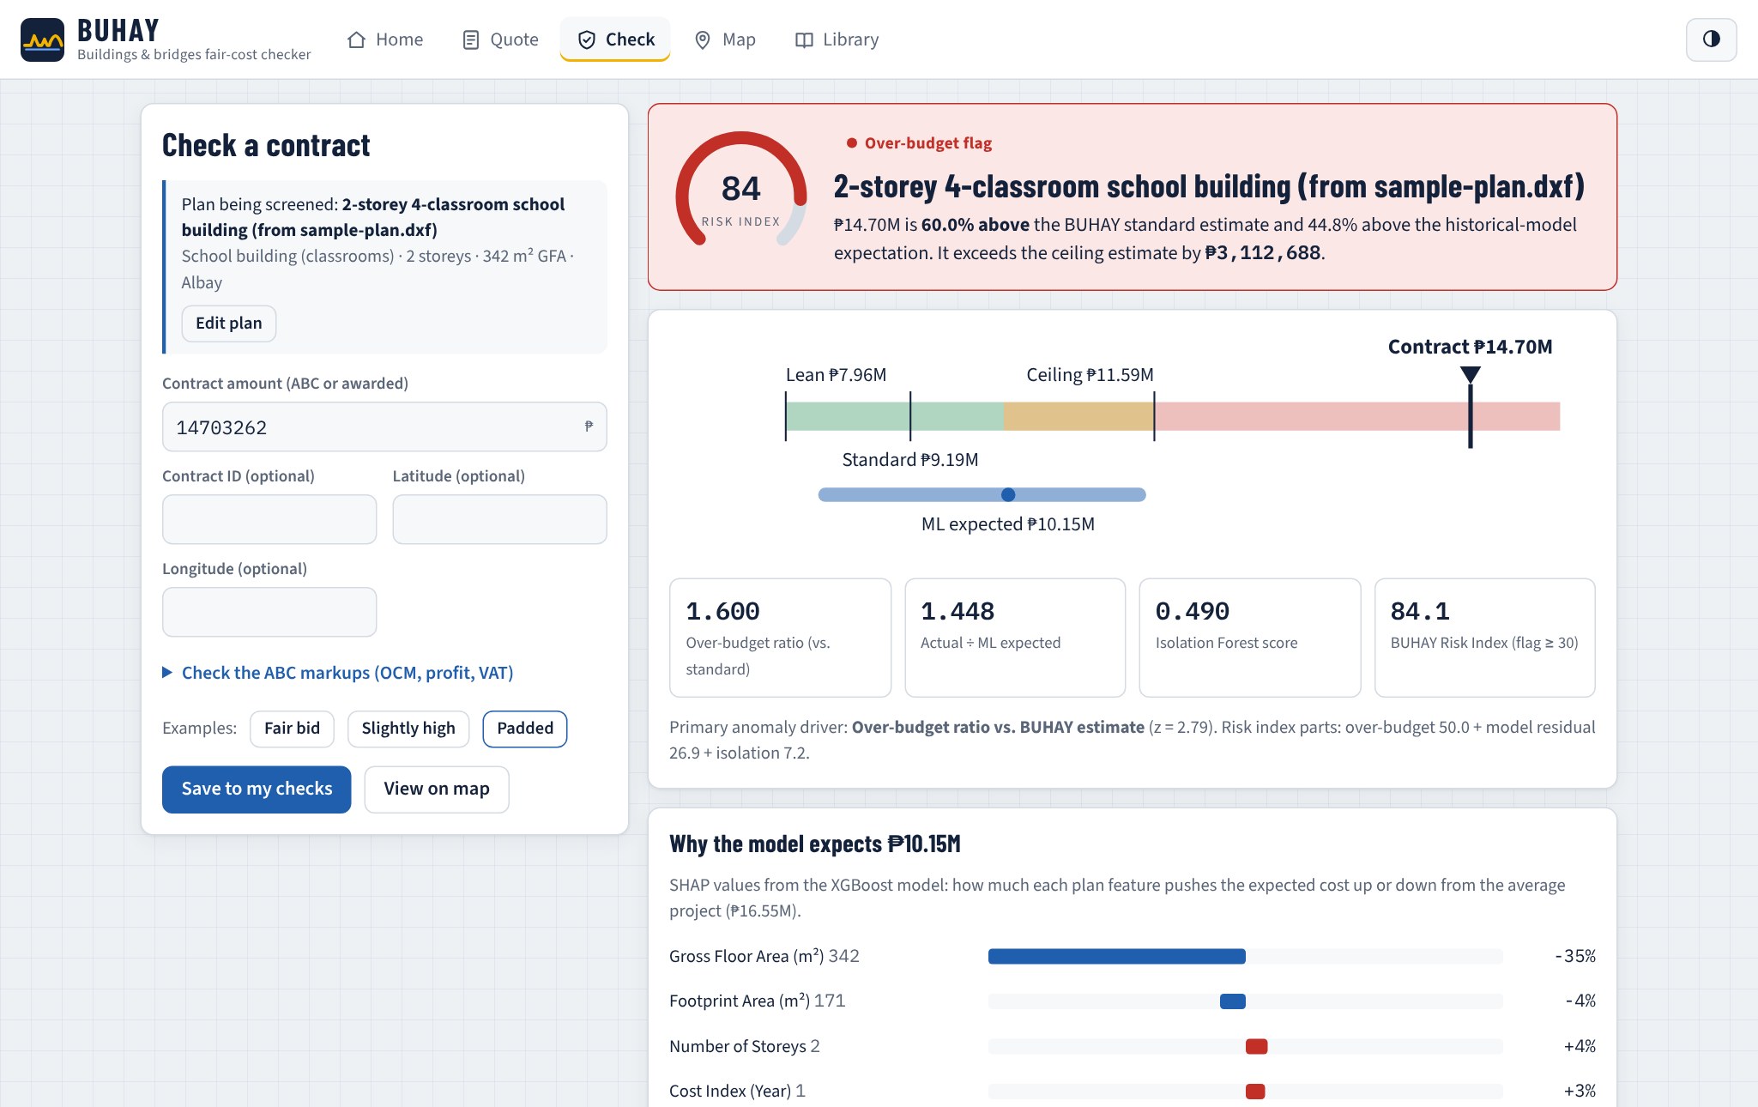
On the Check screen, the user enters the contract amount. The verdict shows the risk index on a gauge, a range strip places the amount against the lean, standard and ceiling estimates and the model's band, and four metrics give the over-budget ratio, the model ratio, the anomaly score and the risk index. In the example, an amount 60% above the standard estimate was flagged with a risk index above 80. The SHAP panel then explains the expected cost, the ABC markup checker tests submitted OCM, profit and VAT rates against the DPWH caps, and a note reminds users that a flag calls for review by the implementing office, COA, the Ombudsman or the ICI.
Figure 15.
Line-Item Check of a Contractor's Bill of Quantities
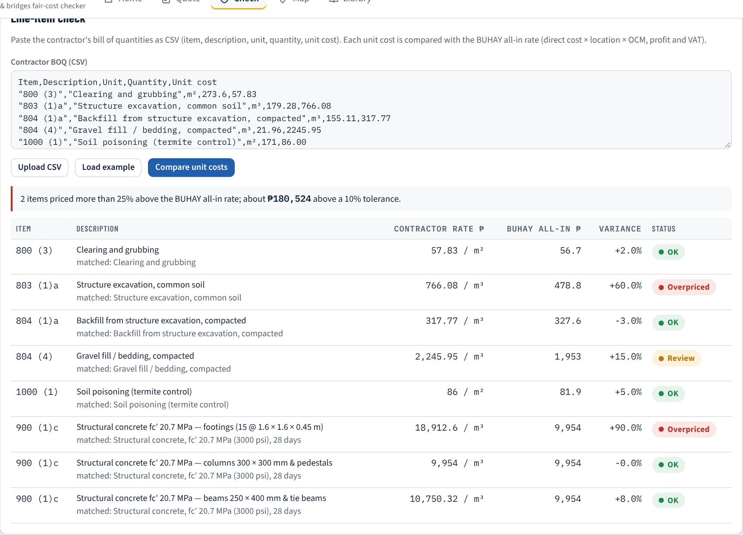
The line-item check compares each unit cost in a contractor's bill of quantities with the BUHAY all-in rate (direct rate × location × OCM, profit and VAT). Items more than 25% above the rate are marked overpriced and their excess over a 10% tolerance is totalled, so that a reviewer sees which items carry the padding.
Figure 16.
Project Map of the BUHAY Application
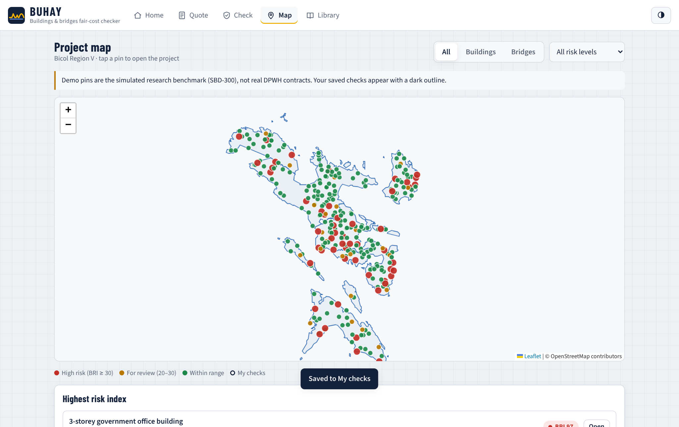
The Map screen plots projects on the provinces of Bicol, colored by risk, with filters for asset type and risk level. Tapping a pin opens the project in the Check screen. The demo pins are the simulated benchmark, labelled as such, and the user's own saved checks appear with a dark outline. The province boundaries are bundled so the map works offline, with street tiles added when online.
Figure 17.
Library Screen with Reference Plans and the Unit Price Book
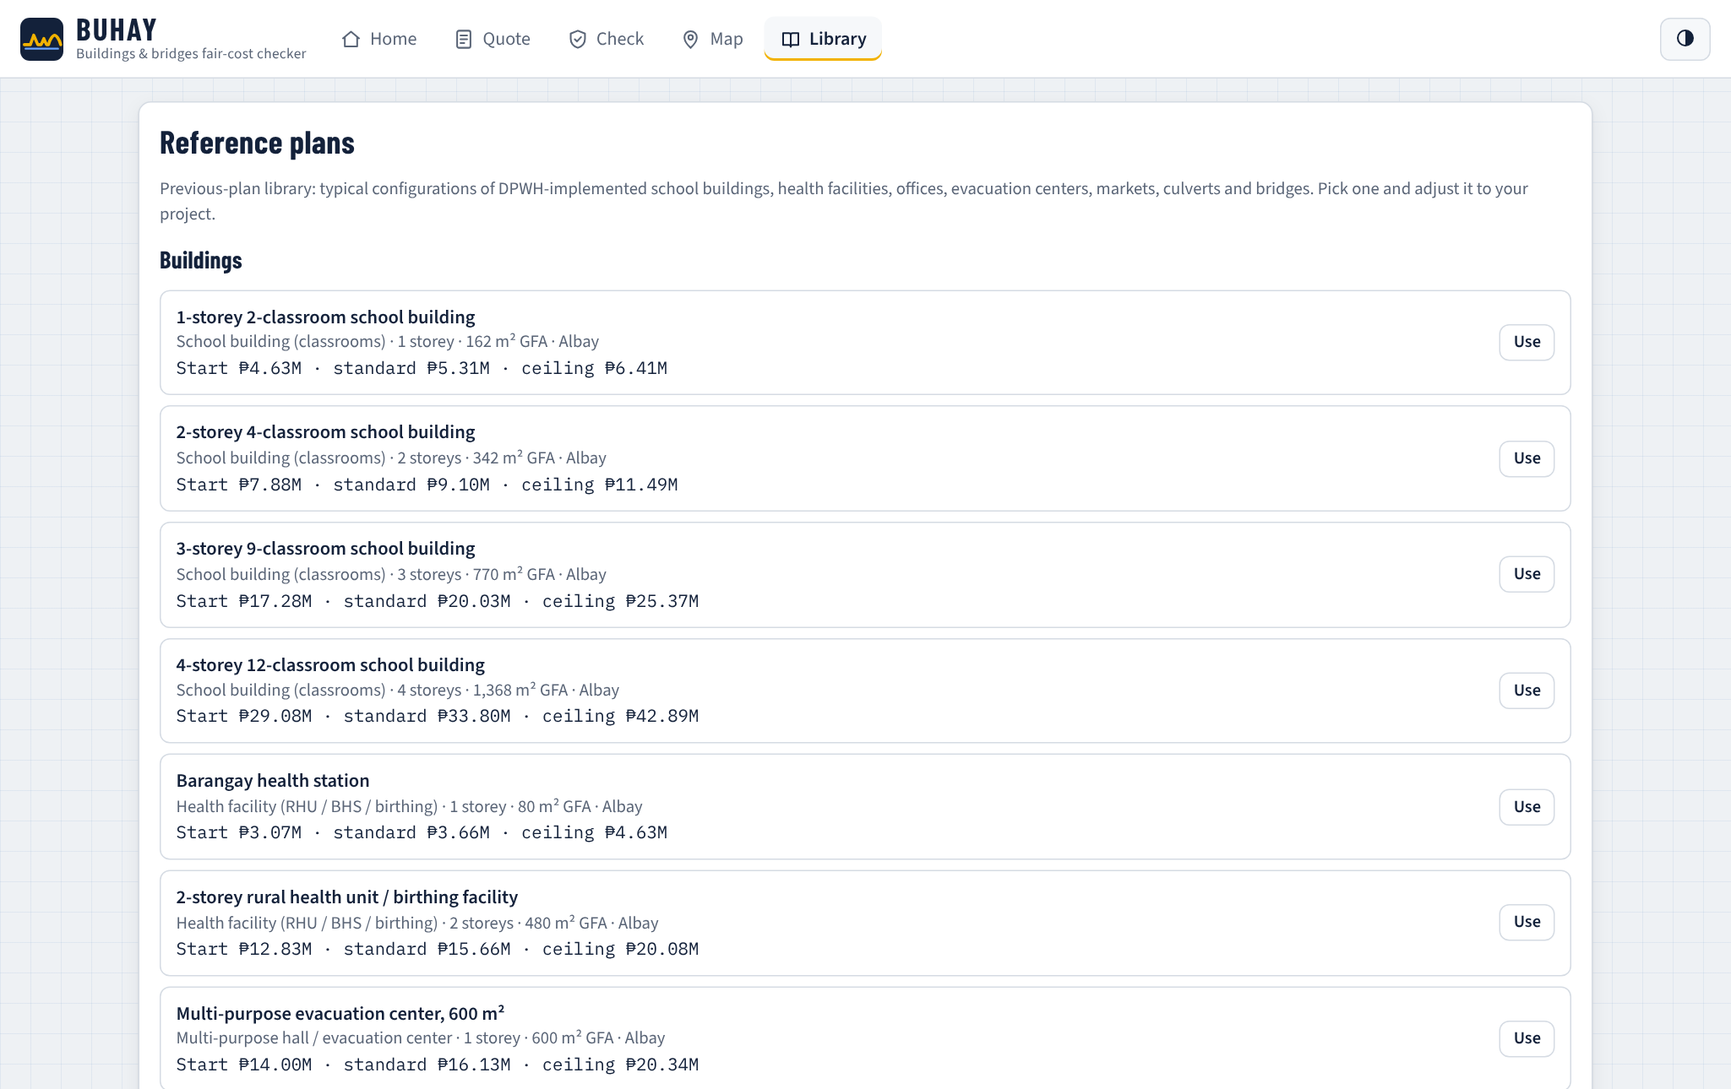
The Library holds the 19 reference plans, the user's saved plans and checks, and the editable unit price book, where an implementing office can load its own rates so that every quotation follows them.
b.) Download Website with Interactive Map
Figure 18.
Download Website of BUHAY
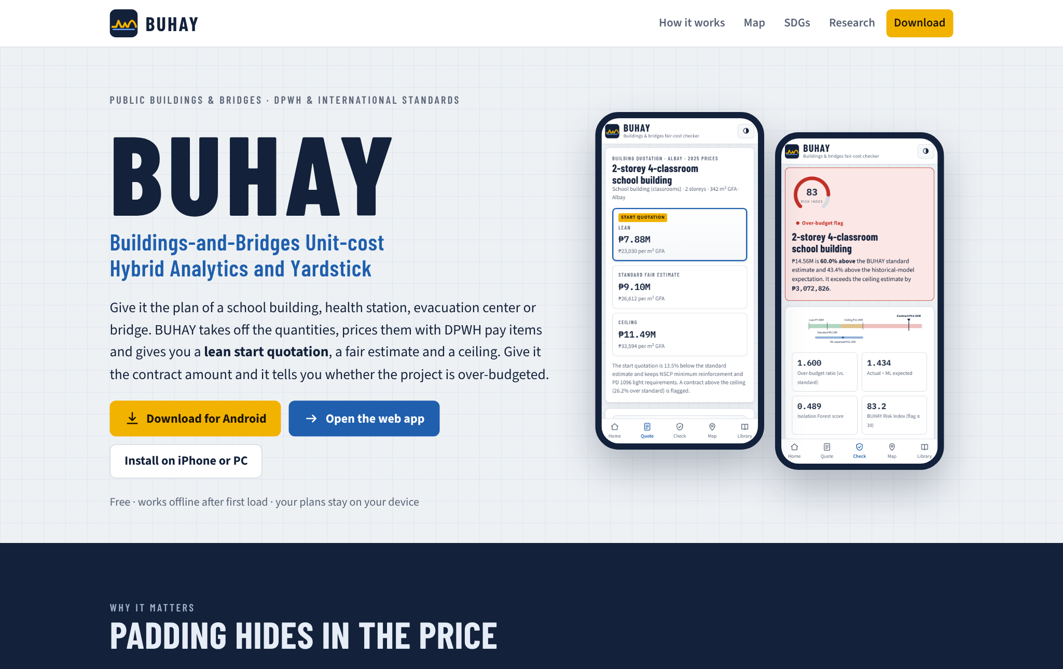
The download website introduces BUHAY, explains the four-step method, presents a live quotation computed in the browser by the same engine, and links to the Android package, the installable web application, the offline package, the sample plan and the research paper.
Figure 19.
Interactive Project Map on the Website
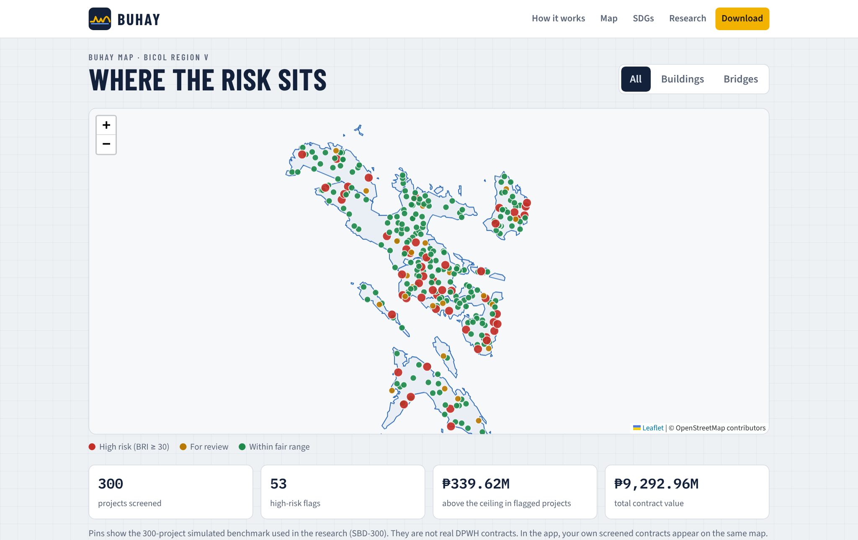
Its interactive map shows the screened projects with summary figures for the number of projects, high-risk flags and the amount above the ceiling, and it can be filtered by buildings and bridges.
Figure 20.
Download Section of the Website
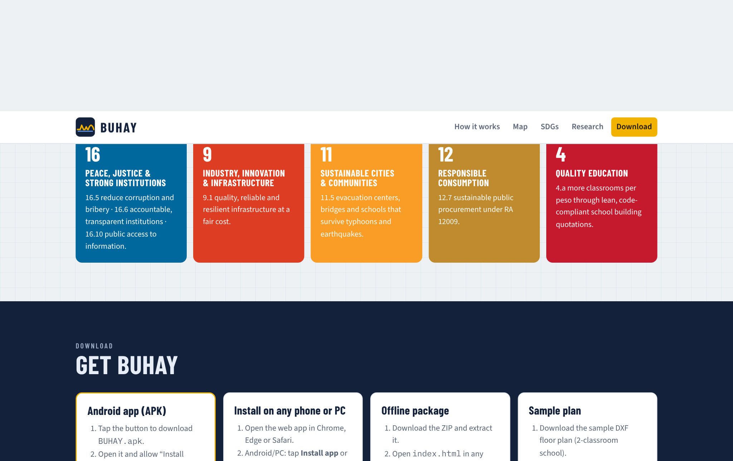
c.) Parametric 3D Visualization and SHAP Explanations
Figure 21.
Parametric 3D Model of a 2-Storey 4-Classroom School Building
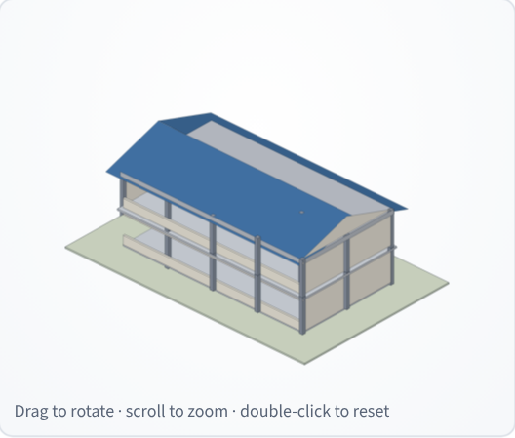
Figure 22.
Parametric 3D Model of a Three-Span RCDG Bridge
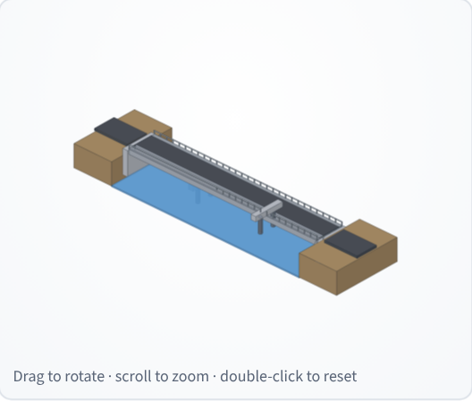
Figure 23.
Parametric 3D Model of a 50 m Steel Truss Bridge
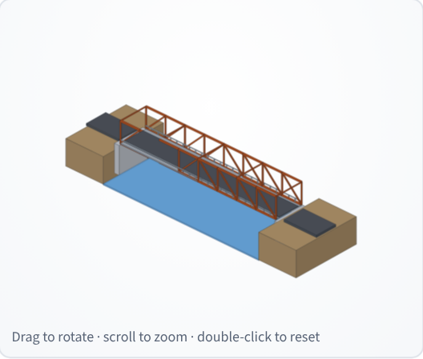
The 3D models are drawn from the engine's geometry: the school building shows its 3 × 5 column grid, two slabs, window bands and gable roof; the RCDG bridge shows four girder lines on two piers between abutments; and the truss bridge shows its panels, chords and portal bracing. Because the models follow the plan variables, a change in the number of storeys, spans or girders is visible at once, and the tint shows the screening result. Together with the SHAP panel, they let non-engineers see what they are paying for and why the expected cost is what it is.
CONCLUSION
In pursuit of developing a blueprint-driven quantity take-off and hybrid machine-learning system for standards-based start quotations and over-budget detection in public buildings and bridges, the study concludes the following:
1. Nine plan variables for buildings (gross floor area, footprint, storeys, span, floor height, facility type, roof system, location factor and cost index) and eleven for bridges (total length, deck width, deck area, span length, pier and abutment heights, superstructure and foundation types, pile length, location factor and cost index) can be read from plans and standards and are sufficient to price a project. Bridge sizes and costs varied far more than building sizes and costs, with contracts from ₱1.00 million to ₱179.23 million.
2. The standards-based engine produced itemized lean, standard and ceiling quotations that came within a MAPE of 5.21% for buildings and 7.67% for bridges of fair awarded costs in the benchmark, less than half the error of the best data-driven model. The lean start quotation averaged 14.4% below the standard estimate for buildings and 5.9% for bridges while keeping code minimums, and stayed below the fair cost in most projects.
3. a.) Multiple Linear Regression: no building predictor exceeded a VIF of 10, while deck area and superstructure type were removed from the bridge model. Under LOOCV, the building model reached R² = 0.8112 and MAPE = 13.43%, and the bridge model R² = 0.8640 and MAPE = 65.65%. b.) XGBoost: the model reached R² = 0.7874 and MAPE = 13.94% for buildings and R² = 0.8630 and MAPE = 19.18% for bridges, a large gain on bridges and a small loss on buildings, so the better model depends on the asset class.
4. The BUHAY Risk Index detected 94.4% of injected overpricing with an F1-score of 0.764 and an AUC of 0.987, the best balance among the four rules. The standards-based ratio was the strongest single signal, the XGBoost residual partly absorbed padding from its training data, and an Isolation Forest alone found only 27.8%. These flags identify contracts for review and do not establish irregularity, error or fraud.
5. BUHAY was deployed as an installable offline-capable mobile application, an Android package, an offline ZIP package and a download website with an interactive project map, integrating plan import, itemized quotations, parametric 3D models, SHAP explanations, line-item checks and over-budget screening that run entirely on the user's device.
RECOMMENDATIONS
Based on these findings, the researcher recommends the following:
1. Validate on actual contracts. Replace the simulated benchmark with completed DPWH building and bridge contracts from the DPWH Transparency Portal, PhilGEPS and COA reports, including their programs of works, and re-estimate the accuracy and detection figures.
2. Add geotechnical data for bridges. Since unseen pile lengths caused most false alarms, include borehole logs and design pile tips in the plan input, or widen the bridge ceiling by a site-class allowance.
3. Connect current price data. Load regional DPWH unit costs and the PSA construction materials price indices automatically so the price book stays current.
4. Calibrate thresholds by asset class. Set separate BUHAY Risk Index thresholds for buildings and bridges, about 24 and 58 in the benchmark, once real cases are confirmed.
5. Extend plan import. Read IFC building information models and scanned PDF plans through optical character recognition, and support multi-storey DXF layers.
6. Extend to other project types. Apply the same engine and models to flood-control structures, water systems and roads, joining CORA and BUHAY in one screening tool.
7. Pilot with oversight bodies and publish open data. Test BUHAY with a district engineering office, COA auditors and a local government, run a usability study, and publish screened records following the Open Contracting Data Standard and the CoST Infrastructure Data Standard.
REFERENCES
American Association of State Highway and Transportation Officials. (2020). AASHTO LRFD bridge design specifications (9th ed.).
Association of Structural Engineers of the Philippines. (2016). National structural code of the Philippines 2015: Volume I, buildings, towers and other vertical structures (7th ed.).
Buban, E. M. C. (2026). CORA: Computational outlier recognition and analytics for road construction cost prediction and potential anomaly detection via a hybrid machine learning system [Unpublished research paper].
Cebu Daily News. (2023, July 21). COA: CCMC project contract price was bloated by P62M. https://cebudailynews.inquirer.net/517377/coa-ccmc-project-contract-price-was-bloated-by-p62m
Chen, T., & Guestrin, C. (2016). XGBoost: A scalable tree boosting system. In Proceedings of the 22nd ACM SIGKDD International Conference on Knowledge Discovery and Data Mining (pp. 785–794). https://doi.org/10.1145/2939672.2939785
Coffie, G. H., & Cudjoe, S. K. F. (2024). Using extreme gradient boosting (XGBoost) machine learning to predict construction cost overruns. International Journal of Construction Management, 24(16), 1742–1750. https://doi.org/10.1080/15623599.2023.2289754
CoST – The Infrastructure Transparency Initiative. (n.d.). Why infrastructure transparency matters. https://infrastructuretransparency.org/
Department of Public Works and Highways. (2013). DPWH standard specifications for highways, bridges and airports (Vol. II).
Department of Public Works and Highways. (2016). Department Order No. 197, series of 2016: Guidelines on the preparation of the approved budget for the contract.
Department of Public Works and Highways. (2021). Department Order No. 42, series of 2021: Adoption of the DPWH standard specifications for public works structures, Volume III, 2019 edition.
Department of Public Works and Highways. (2025). Department Order No. 30, series of 2025.
DZRH News. (2025, August 11). 20 percent of the entire P545-B flood control project went to 15 contractors — Pres. Marcos. https://dzrh.com.ph/
Elmousalami, H. H. (2020). Artificial intelligence and parametric construction cost estimate modeling: State-of-the-art review. Journal of Construction Engineering and Management, 146(1), 03119008. https://doi.org/10.1061/(ASCE)CO.1943-7862.0001678
Fazekas, M., & Tóth, I. J. (2016). From corruption to state capture: A new analytical framework with empirical applications from Hungary. Political Research Quarterly, 69(2), 320–334. https://doi.org/10.1177/1065912916639137
Flyvbjerg, B., Holm, M. S., & Buhl, S. (2002). Underestimating costs in public works projects: Error or lie? Journal of the American Planning Association, 68(3), 279–295. https://doi.org/10.1080/01944360208976273
Interaksyon. (2025, September 11). Philippines forms independent body to probe anomalies in infrastructure projects. https://interaksyon.philstar.com/politics-issues/2025/09/11/302050/
Jensen, M. C., & Meckling, W. H. (1976). Theory of the firm: Managerial behavior, agency costs and ownership structure. Journal of Financial Economics, 3(4), 305–360. https://doi.org/10.1016/0304-405X(76)90026-X
Kenny, C. (2007). Construction, corruption, and developing countries (Policy Research Working Paper No. 4271). World Bank.
Kutner, M. H., Nachtsheim, C. J., & Neter, J. (2004). Applied linear regression models (4th ed.). McGraw-Hill/Irwin.
Larocque, R., Boulé, A.-M., & Cappart, Q. (2025). Estimating road construction costs with explainable machine learning. INFORMS Journal on Applied Analytics, 55(2), 137–153. https://doi.org/10.1287/inte.2023.0027
Liu, F. T., Ting, K. M., & Zhou, Z.-H. (2008). Isolation forest. In 2008 Eighth IEEE International Conference on Data Mining (pp. 413–422). IEEE. https://doi.org/10.1109/ICDM.2008.17
Locatelli, G., Mariani, G., Sainati, T., & Greco, M. (2017). Corruption in public projects and megaprojects: There is an elephant in the room! International Journal of Project Management, 35(3), 252–268. https://doi.org/10.1016/j.ijproman.2016.09.010
Lundberg, S. M., Erion, G. G., & Lee, S.-I. (2018). Consistent individualized feature attribution for tree ensembles (arXiv:1802.03888). https://arxiv.org/abs/1802.03888
Lundberg, S. M., & Lee, S.-I. (2017). A unified approach to interpreting model predictions. Advances in Neural Information Processing Systems, 30. https://arxiv.org/abs/1705.07874
Mahamid, I. (2011). Early cost estimating for road construction projects using multiple regression techniques. Australasian Journal of Construction Economics and Building, 11(4), 87–101. https://doi.org/10.5130/AJCEB.v11i4.2195
Molinaro, A. M., Simon, R., & Pfeiffer, R. M. (2005). Prediction error estimation: A comparison of resampling methods. Bioinformatics, 21(15), 3301–3307. https://doi.org/10.1093/bioinformatics/bti499
O'Brien, R. M. (2007). A caution regarding rules of thumb for variance inflation factors. Quality & Quantity, 41(5), 673–690. https://doi.org/10.1007/s11135-006-9018-6
OECD. (2016). Preventing corruption in public procurement. OECD Publishing.
Pedregosa, F., Varoquaux, G., Gramfort, A., Michel, V., Thirion, B., Grisel, O., Blondel, M., Prettenhofer, P., Weiss, R., Dubourg, V., Vanderplas, J., Passos, A., Cournapeau, D., Brucher, M., Perrot, M., & Duchesnay, É. (2011). Scikit-learn: Machine learning in Python. Journal of Machine Learning Research, 12, 2825–2830.
Philippine Center for Investigative Journalism. (2025, August 31). 5 reveals from the flood control data. https://pcij.org/2025/08/31/5-reveals-from-the-flood-control-data/
Philstar. (2025, March 1). Newly opened P1.2 billion Isabela bridge collapses. https://www.philstar.com/headlines/2025/03/01/2425019/newly-opened-p12-billion-isabela-bridge-collapses
Philstar. (2026, February 12). Philippines falls in corruption index, among worst in SEA. https://www.philstar.com/headlines/2026/02/12/2507429/philippines-falls-corruption-index-among-worst-sea
Presidential Decree No. 1096. (1977). National building code of the Philippines.
Republic Act No. 9514. (2008). Fire code of the Philippines of 2008.
Republic Act No. 12009. (2024). New government procurement act.
Seabold, S., & Perktold, J. (2010). Statsmodels: Econometric and statistical modeling with Python. In Proceedings of the 9th Python in Science Conference (pp. 92–96).
Shapley, L. S. (1953). A value for n-person games. In H. W. Kuhn & A. W. Tucker (Eds.), Contributions to the theory of games (Vol. 2, pp. 307–317). Princeton University Press.
Transparency International. (2026). Corruption perceptions index 2025. https://www.transparency.org/en/cpi/2025
United Nations. (2015). Transforming our world: The 2030 agenda for sustainable development (A/RES/70/1).
U.S. Government Accountability Office. (2020). Cost estimating and assessment guide: Best practices for developing and managing program costs (GAO-20-195G).
Vapnik, V. N. (1998). Statistical learning theory. Wiley.
APPENDICES
Appendix A. Sample Records of the Simulated Benchmark Dataset (SBD-300)
ID | PROVINCE | YEAR | PLAN | STANDARD (₱M) | AWARDED (₱M) | INJECTED
SIM-B-001 | Sorsogon | 2023 | 2-st school, 27.0×9.1 m | 13.74 | 13.53 | No
SIM-B-002 | Camarines Sur | 2022 | 1-st market, 40.9×19.7 m | 20.57 | 19.03 | No
SIM-B-003 | Camarines Sur | 2024 | 1-st health, 30.8×8.2 m | 9.78 | 9.48 | No
SIM-B-004 | Masbate | 2024 | 2-st school, 45.0×9.8 m | 23.77 | 22.11 | No
SIM-B-005 | Masbate | 2022 | 2-st school, 27.0×9.5 m | 14.71 | 16.00 | No
SIM-B-006 | Camarines Sur | 2024 | 2-st evacuation, 31.9×12.8 m | 19.00 | 31.25 | Yes
SIM-B-007 | Camarines Sur | 2023 | 1-st office, 15.6×14.0 m | 6.77 | 8.55 | Yes
SIM-B-008 | Masbate | 2025 | 2-st school, 27.0×8.8 m | 14.27 | 14.29 | No
SIM-B-009 | Albay | 2025 | 3-st school, 36.0×9.1 m | 25.21 | 25.34 | No
SIM-B-010 | Catanduanes | 2024 | 1-st evacuation, 26.4×14.9 m | 12.21 | 11.97 | No
SIM-R-001 | Catanduanes | 2022 | box_culvert, 2.5 m, 1 span(s) | 1.51 | 1.42 | No
SIM-R-002 | Camarines Sur | 2024 | pscg, 79.3 m, 3 span(s) | 67.59 | 69.05 | No
SIM-R-003 | Camarines Sur | 2022 | rcdg, 18.1 m, 1 span(s) | 10.20 | 10.48 | No
SIM-R-004 | Masbate | 2022 | pscg, 111.9 m, 4 span(s) | 103.52 | 110.73 | No
SIM-R-005 | Masbate | 2022 | pscg, 28.6 m, 1 span(s) | 46.97 | 45.09 | No
SIM-R-006 | Camarines Sur | 2022 | rcdg, 36.8 m, 2 span(s) | 28.98 | 35.83 | Yes
SIM-R-007 | Albay | 2023 | rcdg, 24 m, 2 span(s) | 26.68 | 26.15 | No
SIM-R-008 | Albay | 2022 | pscg, 111.8 m, 3 span(s) | 87.78 | 123.09 | Yes
The full dataset (300 records, 40 columns) is in research/data/buhay_sbd300.csv.

Appendix B. BUHAY Unit Price Book (Direct Costs, Bicol Region V, 2025)
PAY ITEM | DESCRIPTION | UNIT | RATE (₱)
B.9 | Mobilization / demobilization | l.s. | allowance / %
B.7 (1) | Occupational safety & health program | l.s. | allowance / %
B.5 | Project billboard / signboard | each | 7,500
B.8 | Traffic management & detour | l.s. | allowance / %
B.3 | Survey, staking, testing & as-built plans | l.s. | allowance / %
800 (3) | Clearing and grubbing | m² | 45
803 (1)a | Structure excavation, common soil | m³ | 380
804 (1)a | Backfill from structure excavation, compacted | m³ | 260
804 (4) | Gravel fill / bedding, compacted | m³ | 1,550
1000 (1) | Soil poisoning (termite control) | m² | 65
900 (1)c | Structural concrete, fc′ 20.7 MPa (3000 psi), 28 days | m³ | 7,900
900 (1)b | Concrete slab on grade, fc′ 17.2 MPa (2500 psi) | m³ | 7,200
902 (1) | Reinforcing steel bars, deformed, Gr. 40/60, incl. tie wire | kg | 82
903 (2) | Formworks and falseworks | m² | 850
1046 (3) | CHB masonry 150 mm, reinforced & grouted (exterior) | m² | 1,080
1046 (2) | CHB masonry 100 mm (partitions) | m² | 880
1027 (1) | Cement plaster finish | m² | 360
1032 (1) | Painting works, masonry/concrete (acrylic, 3 coats) | m² | 230
1047 (3) | Structural steel trusses & purlins, fabricated & installed | kg | 140
1013 (2) | Pre-painted long-span metal roofing 0.50 mm, incl. accessories | m² | 760
1013 (5) | Gutters, flashing & downspouts | m | 950
— | Waterproofing membrane, RC roof deck | m² | 480
— | Ceiling: fiber-cement board on metal furring | m² | 1,050
1018 (2) | Ceramic floor tiles 600 × 600 mm | m² | 1,180
— | Cement floor topping, steel-trowel finish | m² | 320
— | Porcelain / granite floor tiles (premium) | m² | 1,650
1010 | Doors complete with jamb & hardware | set | 13,500
1008 (1) | Aluminum-framed glass windows | m² | 6,200
1100–1200 | Electrical works (conduits, wires, devices, panel, fixtures) | m² | allowance / %
1001–1002 | Plumbing & sanitary works incl. fixtures | m² | allowance / %
— | Fire protection & detection (RA 9514) | m² | allowance / %
— | Mechanical / air-conditioning works | m² | allowance / %
— | RC septic tank / sewage treatment | unit | allowance / %
— | Accessibility ramp & handrails (BP 344) | unit | 38,000
1047 (5) | Steel railings — corridors, balconies & stairs | m | 4,800
— | Roof insulation, fascia & eaves soffit | m² | 420
— | Perimeter drainage canal with grating | m | 1,450
100 (1) | Clearing and grubbing | m² | 55
103 (1)a | Structure excavation, common soil | m³ | 420
103 (2) | Structure excavation below water, incl. dewatering | m³ | 680
— | Cofferdam / sheet piling | each | 180,000
104 (2) | Structural backfill, granular, compacted | m³ | 950
— | Gravel bedding | m³ | 1,550
400 (11) | Precast RC piles 450 × 450 mm, furnished & driven | m | 11,500
400 (17) | Bored piles 1.0 m Ø, drilling incl. temporary casing | m | 28,000
400 (20) | Pile dynamic load test (PDA) | test | 85,000
405 (1)a | Structural concrete Class A — deck & girders, incl. forms | m³ | 13,500
405 (1)b | Structural concrete Class A — abutments, piers, walls, incl. forms | m³ | 11,200
405 (1)c | Structural concrete Class A — footings, pile caps, approach slabs | m³ | 9,400
405 (1)d | Structural concrete for bored piles (tremie) | m³ | 9,200
405 (2) | Lean concrete / seal concrete | m³ | 6,800
404 (1) | Reinforcing steel Gr. 60, incl. tie wire | kg | 84
406 (1)a | Precast PSC girder AASHTO Type III — supply, fabricate, launch | m | 34,000
406 (1)b | Precast PSC girder AASHTO Type IV — supply, fabricate, launch | m | 42,000
406 (1)c | Precast PSC bulb-tee girder BT-1600 — supply, fabricate, launch | m | 52,000
403 (1) | Structural steel, fabricated, painted & erected | kg | 210
412 (1) | Elastomeric bearing pads | pc | 16,500
412 (3) | Pot / spherical bearings (steel spans) | pc | 95,000
— | Expansion joint, strip-seal type | m | 26,000
401 (1) | Steel bridge railing | m | 6,200
401 (2) | Concrete barrier railing | m | 9,800
— | Deck drains / scuppers | pc | 2,200
505 (2) | Grouted riprap, Class A (slope protection) | m³ | 3,100
310 | Asphalt wearing course 50 mm | m² | 640
311 + 201 | PCCP 230 mm on aggregate base (approaches) | m² | 3,650

Appendix C. Bill of Quantities of a 2-Storey 4-Classroom School Building (Standard Tier, Albay, 2025)
ITEM | DESCRIPTION | QTY | UNIT | UNIT COST | AMOUNT (₱)
800 (3) | Clearing and grubbing | 273.60 | m² | 45.00 | 12,312.00
803 (1)a | Structure excavation, common soil | 179.28 | m³ | 380.00 | 68,126.40
804 (1)a | Backfill from structure excavation, compacted | 155.11 | m³ | 260.00 | 40,329.90
804 (4) | Gravel fill / bedding, compacted | 21.96 | m³ | 1,550.00 | 34,038.00
1000 (1) | Soil poisoning (termite control) | 171.00 | m² | 65.00 | 11,115.00
— | Perimeter drainage canal with grating | 63.00 | m | 1,450.00 | 91,350.00
900 (1)c | Structural concrete fc′ 20.7 MPa — footings (15 @ 1.6 × 1.6 × 0.45 m) | 17.28 | m³ | 7,900.00 | 136,512.00
900 (1)c | Structural concrete fc′ 20.7 MPa — columns 300 × 300 mm & pedestals | 10.67 | m³ | 7,900.00 | 84,253.50
900 (1)c | Structural concrete fc′ 20.7 MPa — beams 250 × 400 mm & tie beams | 27.28 | m³ | 7,900.00 | 215,497.19
900 (1)c | Structural concrete fc′ 20.7 MPa — suspended slabs 125 mm | 21.38 | m³ | 7,900.00 | 168,862.50
900 (1)c | Structural concrete fc′ 20.7 MPa — stairs (1 flight set) | 4.20 | m³ | 7,900.00 | 33,180.00
900 (1)b | Concrete slab on grade 100 mm, fc′ 17.2 MPa | 17.10 | m³ | 7,200.00 | 123,120.00
902 (1) | Reinforcing steel bars, deformed, Gr. 40/60, incl. tie wire | 11,627.09 | kg | 82.00 | 953,421.69
903 (2) | Formworks and falseworks | 654.78 | m² | 850.00 | 556,558.75
1046 (3) | CHB masonry 150 mm, reinforced & grouted (exterior) | 215.88 | m² | 1,080.00 | 233,150.40
1046 (2) | CHB masonry 100 mm (partitions) | 75.90 | m² | 880.00 | 66,794.11
1027 (1) | Cement plaster finish | 641.92 | m² | 360.00 | 231,091.66
1032 (1) | Painting works, masonry/concrete (acrylic, 3 coats) | 966.82 | m² | 230.00 | 222,368.89
1047 (3) | Structural steel trusses & purlins, fabricated & installed | 4,727.29 | kg | 140.00 | 661,820.99
1013 (2) | Pre-painted long-span metal roofing 0.50 mm, incl. accessories | 247.02 | m² | 760.00 | 187,732.82
1013 (5) | Gutters, flashing & downspouts | 63.60 | m | 950.00 | 60,420.00
— | Roof insulation, fascia & eaves soffit | 247.02 | m² | 420.00 | 103,747.08
1047 (5) | Steel railings — corridors, balconies & stairs | 27.00 | m | 4,800.00 | 129,600.00
— | Ceiling: fiber-cement board on metal furring | 324.90 | m² | 1,050.00 | 341,145.00
1018 (2) | Ceramic floor tiles 600 × 600 mm | 314.64 | m² | 1,180.00 | 371,275.20
1010 | Doors complete with jamb & hardware | 14.00 | set | 13,500.00 | 189,000.00
1008 (1) | Aluminum-framed glass windows | 77.00 | m² | 6,200.00 | 477,400.00
1100–1200 | Electrical works (conduits, wires, devices, panel, fixtures) | 342.00 | m² | 1,600.00 | 547,200.00
1001–1002 | Plumbing & sanitary works incl. fixtures | 342.00 | m² | 1,400.00 | 478,800.00
— | Fire extinguishers, alarm & detection (RA 9514) | 342.00 | m² | 120.00 | 41,040.00
— | RC septic tank / sewage treatment | 1.00 | unit | 75,390.00 | 75,390.00
— | Accessibility ramp & handrails (BP 344) | 1.00 | unit | 38,000.00 | 38,000.00
B.9 | Mobilization / demobilization | 1.00 | l.s. | 83,815.84 | 83,815.84
B.7 (1) | Occupational safety & health program | 1.00 | l.s. | 104,769.80 | 104,769.80
B.5 | Project billboard / signboard | 2.00 | each | 7,500.00 | 15,000.00
B.3 | Survey, staking, testing & as-built plans | 1.00 | l.s. | 34,923.27 | 34,923.27
 | Estimated direct cost |  |  |  | 7,223,161.99
 | OCM (12%) |  |  |  | 866,779.44
 | Profit (8%) |  |  |  | 577,852.96
 | VAT (5%) |  |  |  | 433,389.72
 | Approved Budget for the Contract |  |  |  | 9,101,184.11

Appendix D. Cost Summary of a Three-Span RCDG Bridge (3 × 20 m, Albay, 2025)
PART | AMOUNT (₱)
Part A — General requirements | 1,420,448.82
Part B — Earthworks & protection | 1,667,632.45
Part C — Foundation & piling | 11,775,513.00
Part D — Substructure | 5,108,433.19
Part E — Superstructure | 11,186,585.90
Part F — Deck, railings & approaches | 2,203,854.00
Estimated direct cost | 33,362,467.36
Lean start quotation (ABC) | 39,068,313.24
Standard fair estimate (ABC) | 42,036,708.87
Ceiling (ABC) | 50,122,187.05

Appendix E. Snippets of Methodology (Quantity Take-Off Engine, JavaScript)
// footings (isolated, sized from service load and allowable bearing)
var Pcol = 0.75 * sx * sy * N * bt.w; // kN
var B = Math.max(1.0, ceilTo(Math.sqrt(Pcol / p.soilBearing), 0.1));
var tf = Math.max(0.30, ceilTo(0.25 + 0.10 * B, 0.05));

var V = {}, F = {}, K = {};
V.footing = nCol * B * B * tf * cf;
V.pedestal = nCol * colB * colB * Df * cf;
V.column = nCol * N * colB * colB * h * cf;
var slabLevels = N - 1 + (p.roof === 'rc_deck' ? 1 : 0);
V.beam = (slabLevels * beamLen * beamB * (beamD - ts) + (p.roof === 'rc_deck' ? 0 : beamLen * beamB * beamD)) * cf
V.tiebeam = beamLen * 0.25 * 0.40 * cf;
V.slab = slabLevels * A * ts * cf;
var nStairs = N > 1 ? (A > 250 ? 2 : 1) : 0;
V.stair = nStairs * (N - 1) * 4.2 * cf;
V.sog = A * 0.10;

// reinforcement intensities, kg per m³ (standard tier, seismic zone 4)
K.footing = V.footing * 90 * rf; K.pedestal = V.pedestal * 210 * rf; K.column = V.column * 220 * rf;
K.beam = V.beam * 190 * rf; K.tiebeam = V.tiebeam * 140 * rf; K.slab = V.slab * 100 * rf;
K.stair = V.stair * 100 * rf; K.sog = V.sog * 30 * rf;

function indirect(edc, settings) {
settings = settings || {};
var row = INDIRECT_TABLE.filter(function (r) { return edc <= r.upTo; })[0];
var ocmR = settings.ocm != null ? settings.ocm : row.ocm;
var prR = settings.profit != null ? settings.profit : row.profit;
var vatR = settings.vat != null ? settings.vat : VAT_RATE;
var ocm = edc * ocmR, profit = edc * prR, vat = (edc + ocm + profit) * vatR;
return { edc: edc, ocmRate: ocmR, profitRate: prR, vatRate: vatR, ocm: ocm, profit: profit, vat: vat, total: edc +
}

Appendix F. Snippets of Methodology (Model Training, Python)
# ---- 2. XGBoost (log target), tuned then LOOCV
ylog = np.log(y)
scorer = make_scorer(lambda yt, yp: mean_absolute_percentage_error(np.exp(yt), np.exp(yp)), greater_is_better=Fals
search = RandomizedSearchCV(XGBRegressor(objective='reg:squarederror', random_state=42, n_jobs=4), PARAMS, n_iter=
scoring=scorer, cv=KFold(5, shuffle=True, random_state=42), random_state=42, n_jobs=1)
search.fit(X, ylog)
best = search.best_params_
R['xgb_params'] = {k: (float(v) if isinstance(v, float) else int(v)) for k, v in best.items()}
xgb_pred = np.exp(cross_val_predict(XGBRegressor(objective='reg:squarederror', random_state=42, n_jobs=4, **best),
R['xgb_loocv'] = metrics(y, xgb_pred)
final = XGBRegressor(objective='reg:squarederror', random_state=42, n_jobs=4, **best).fit(X, ylog)
imp = final.get_booster().get_score(importance_type='gain')
tot = sum(imp.values())
R['xgb_importance'] = {f: float(imp.get(f, 0) / tot) for f in feats}

# ---- 3. Isolation Forest
obr = y / d.fair_estimate.values
ceil_ratio = d.ceiling_estimate.values / d.fair_estimate.values
ml_ratio = y / xgb_pred
Z = X.copy(); Z['LogMLRatio'] = np.log(ml_ratio); Z['LogOBR'] = np.log(obr)
scaler = StandardScaler().fit(Z.astype(float))
Zs = scaler.transform(Z.astype(float))
iso = IsolationForest(n_estimators=200, contamination=0.10, random_state=42).fit(Zs)
iso_score = -iso.score_samples(Zs) # 0..1, higher = easier to isolate
iso_raw = iso.predict(Zs) == -1
overcost = (ml_ratio > 1) & (obr > 1)
iso_flag = iso_raw & overcost
zabs = np.abs(Zs)
zcols = list(Z.columns)

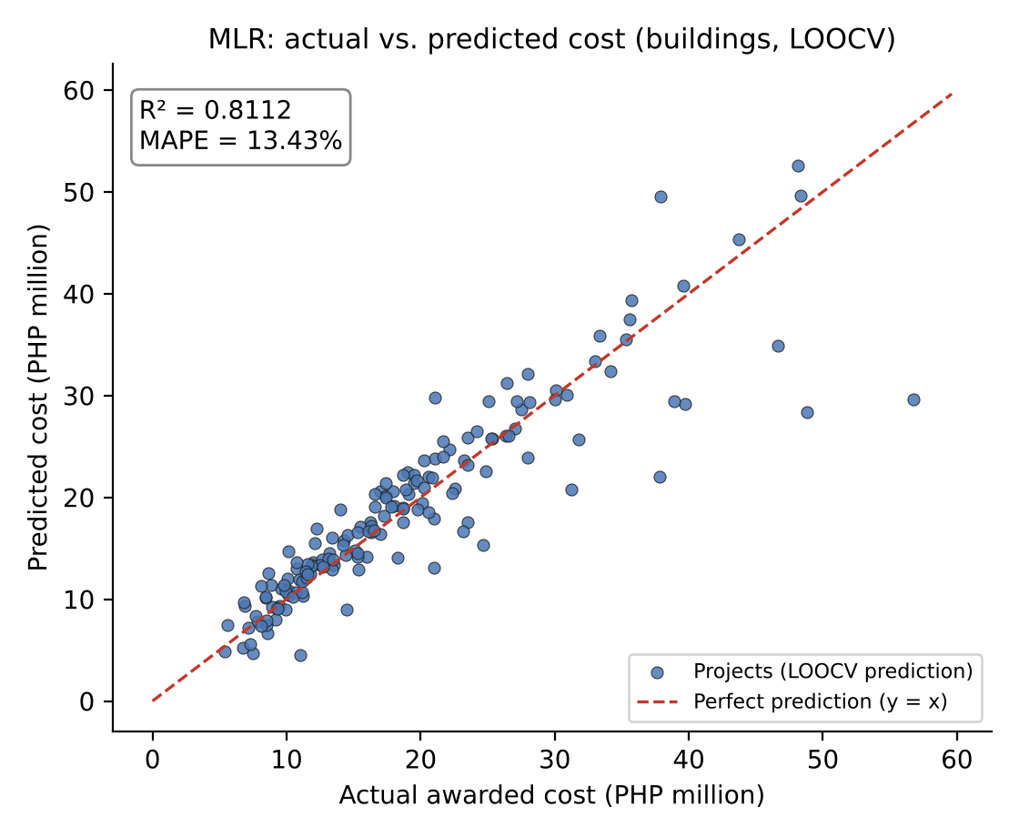

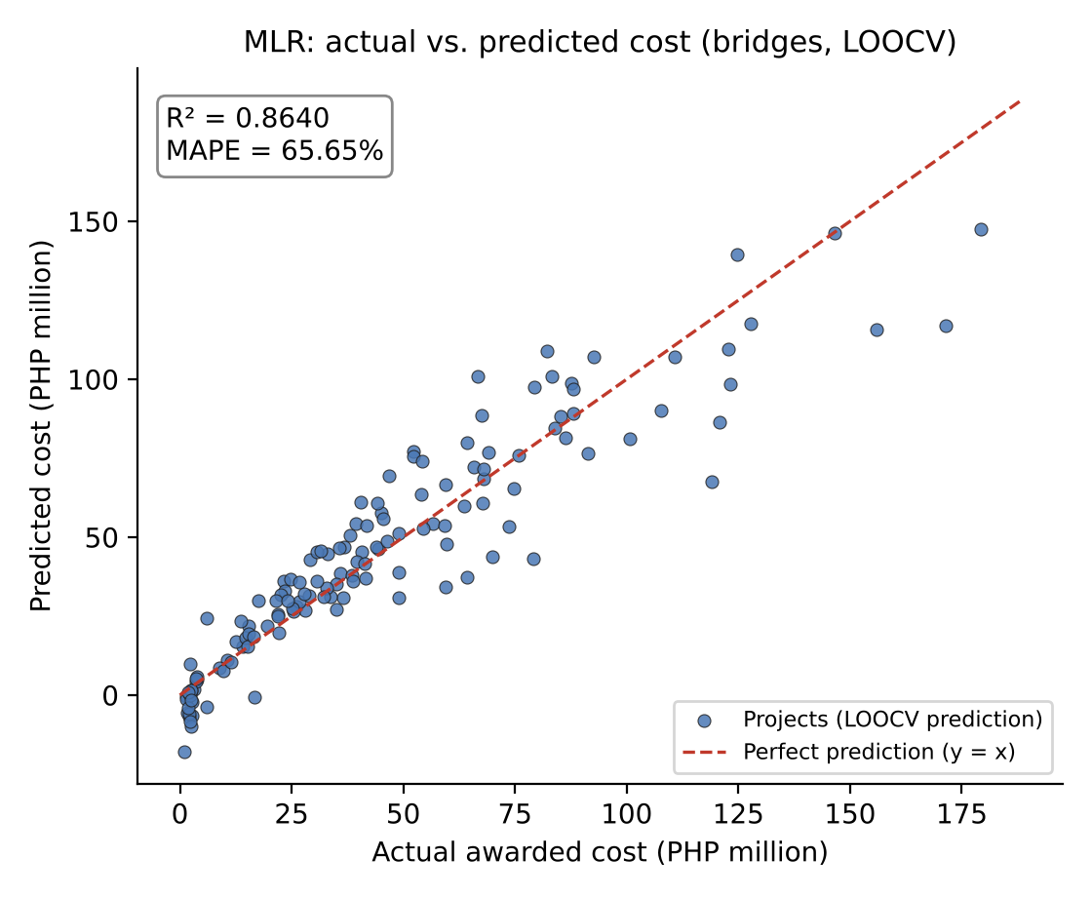
Appendix G. Multiple Linear Regression: Actual vs. Predicted Cost

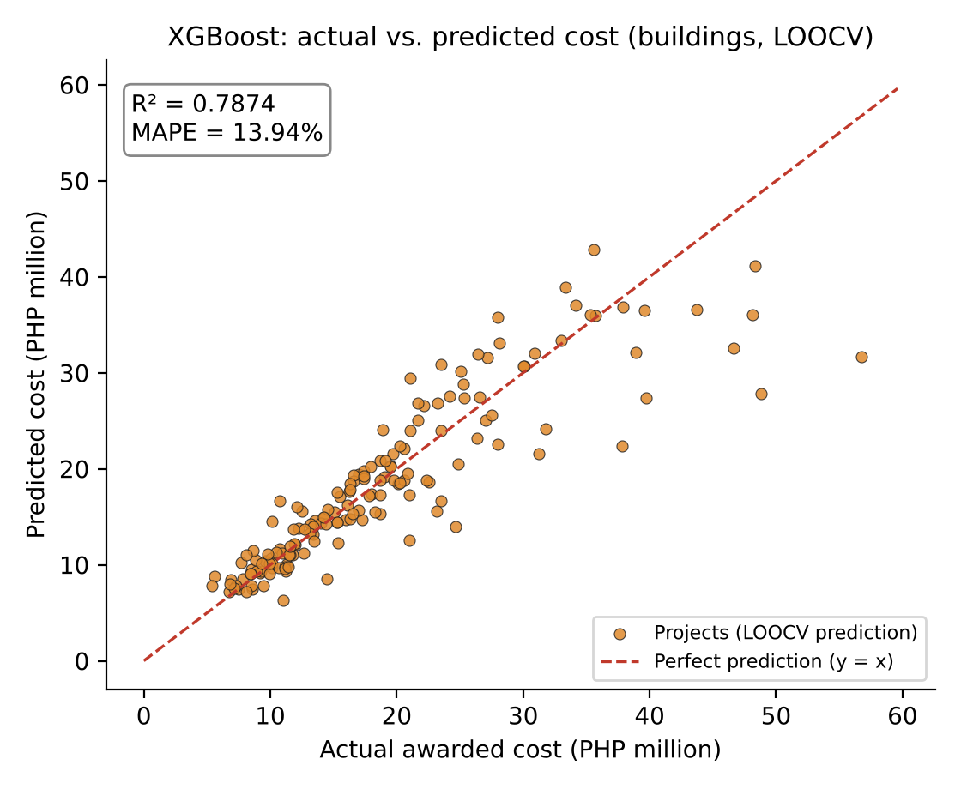

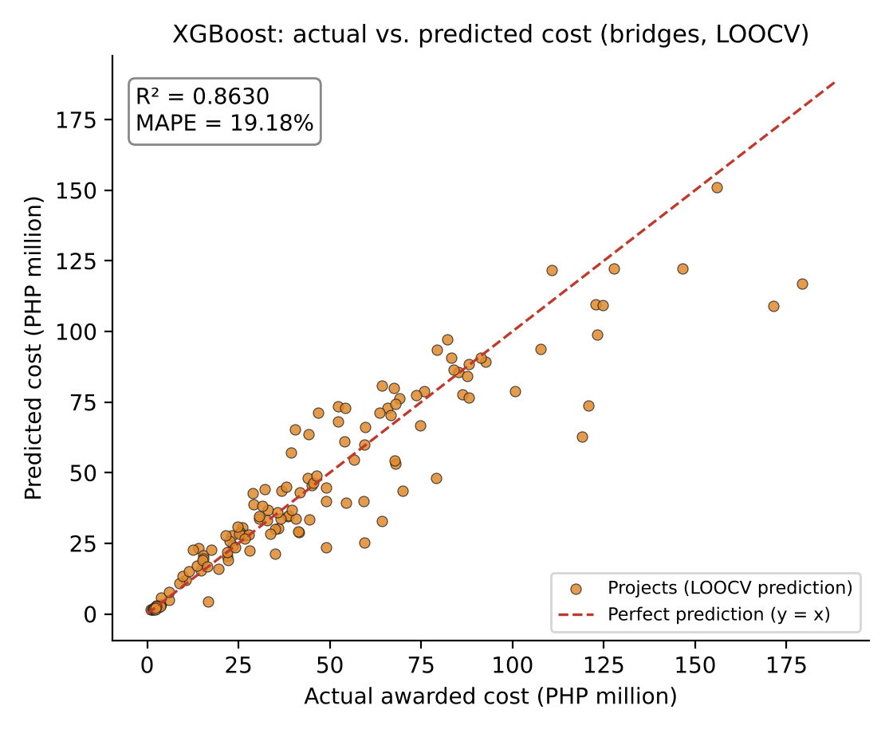
Appendix H. Extreme Gradient Boosting: Actual vs. Predicted Cost

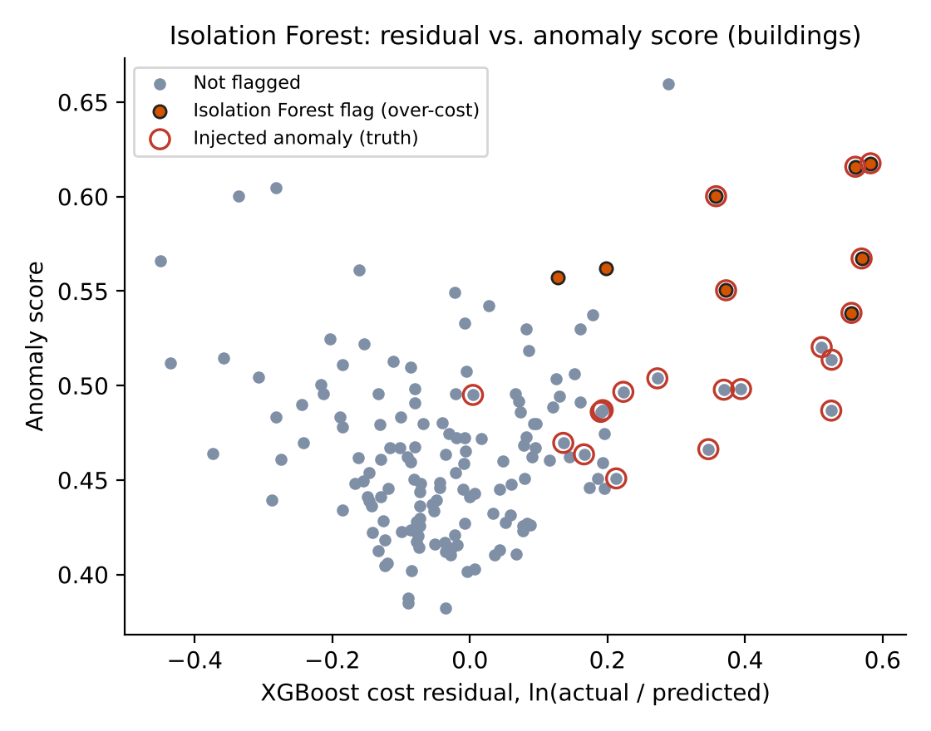

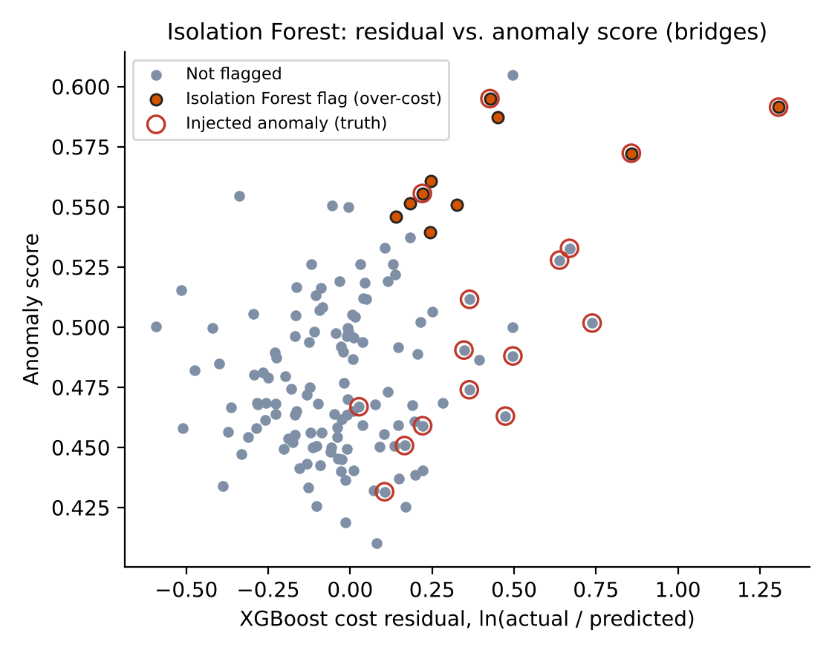
Appendix I. Isolation Forest: Cost Residual vs. Anomaly Score

Appendix J. User Guide of the BUHAY Application
1. Open the website and tap Download for Android, or open the web app and choose Install app (Android, PC) or Share → Add to Home Screen (iPhone).
2. In Quote, choose Building or Bridge, pick a reference plan or import a DXF or plan file, and adjust the plan variables. Read the lean start quotation, the standard estimate and the ceiling.
3. Open the Bill of quantities tab to review or export the items. Save the plan to the Library.
4. In Check, enter the contract amount (and optionally the submitted EDC, OCM, profit and VAT). Read the verdict, risk index, drivers and SHAP explanation.
5. Paste or upload the contractor's BOQ in Line-item check to find overpriced items.
6. Save the check with a latitude and longitude to see it on the Map. Edit unit rates in Library → Unit price book.

