ALAGA
A Low-Cost Soft Inflatable Healthcare Companion Robot with Non-Contact Temperature, Pulse Oximetry, and Pain-Scale Triage for Evacuation Centers
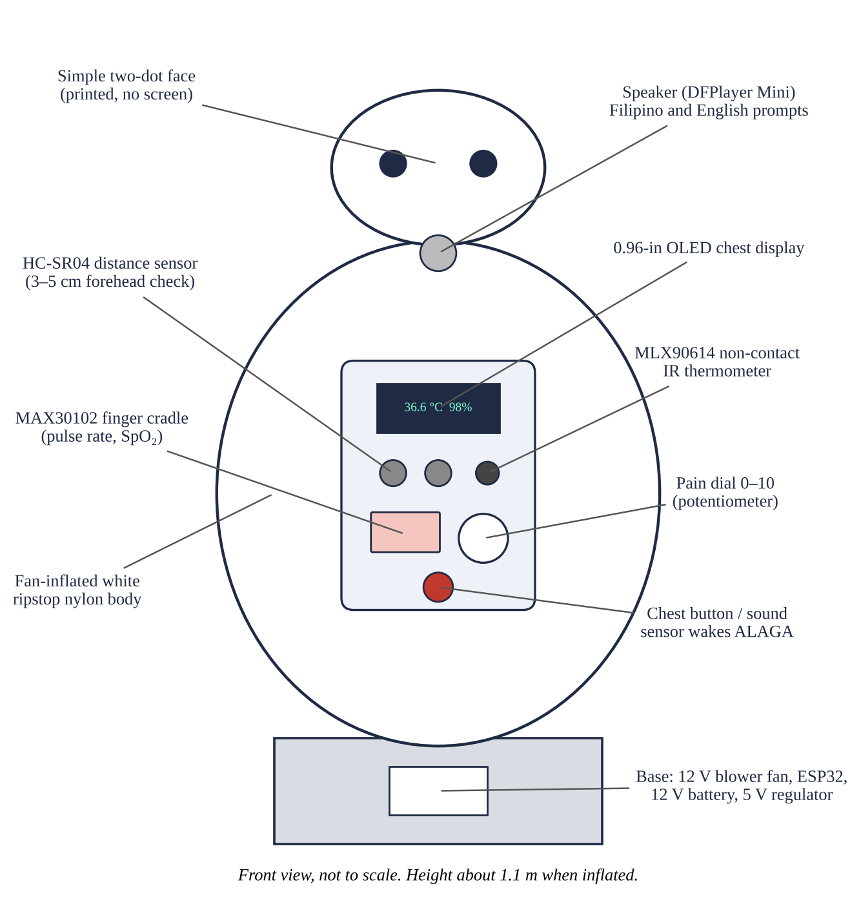
ROBOTICS AND INTELLIGENT MACHINES – TEAM (RIM-T)
RESEARCH MANUSCRIPT
[Surname, Firstname M.]
[Surname, Firstname M.]
[Surname, Firstname M.]
[School Name]

ALAGA: A Low-Cost Soft Inflatable Healthcare Companion Robot with Non-Contact Temperature, Pulse Oximetry, and Pain-Scale Triage for Evacuation Centers
Research Category
Robotics and Intelligent Machines – Team (RIM-T)

Researchers
[Surname, Firstname M.]
[Surname, Firstname M.]
[Surname, Firstname M.]

Research Adviser
[Surname, Firstname M.]

[School Name], [School Address]
Schools Division of [Division], Region V – Bicol, Philippines
October 2026
Abstract
School: [School Name]
Address: [School Address], Region V – Bicol
Evacuation centers in Albay fill quickly when Mayon Volcano is restless, and a few health workers must check many evacuees for fever, low oxygen, and pain. Healthcare robots on the market cost far more than a barangay can pay. Inspired by the soft, inflatable healthcare companion of the animated film Big Hero 6, this study built ALAGA, a low-cost robot with a fan-inflated ripstop nylon body that houses an ESP32 controller, a non-contact infrared thermometer, a pulse oximeter sensor, a distance sensor, a 0–10 pain dial, a chest display, and a speaker that gives instructions in Filipino and English. A state-machine program wakes the robot when a person presses its chest or calls out, guides a short screening, and flags readings outside set limits for a health worker. With ____ consenting volunteers, ALAGA's readings were compared with a clinical forehead thermometer and a reference pulse oximeter. Temperature had a mean bias of ____ °C (95% limits of agreement ____ to ____ °C), pulse rate ____ bpm, and SpO₂ ____% (Arms = ____%). Flagging had a sensitivity of ____% and a specificity of ____%. One screening took ____ s. Users gave a System Usability Scale score of ____ and rated the soft body ____ approachable than a rigid shell (p = ____). The robot cost PHP ____ to build. A low-cost soft robot can share the routine screening load in crowded evacuation centers.
Keywords: healthcare companion robot; soft robotics; inflatable robot; pulse oximetry; non-contact thermometer; evacuation center
TABLE OF CONTENTS
Abstract ii
List of Tables v
List of Figures vi
INTRODUCTION 1
Background of the Study 1
Research Gap and Rationale 1
Objectives of the Study 2
Hypotheses 2
Significance of the Study 2
Scope and Delimitation 3
Definition of Terms 3
FRAMEWORK 5
Review of Related Literature 5
Review of Related Studies 5
Synthesis 6
Theoretical Framework 6
Conceptual Framework 6
METHODOLOGY 8
Research Design 8
Materials and Equipment 8
Specification of the Device 9
Construction and Preparation 10
Experimental Setup 12
Data Gathering Procedure 12
Statistical Treatment 13
Safety and Ethical Considerations 13
FINDINGS 15
Results and Discussion 15
Summary of Results by Objective 17
CONCLUSIONS 18
Assessment of the Findings 18
Limitations 18
Applications 18
RECOMMENDATIONS 19
REFERENCES 20
APPENDICES 22
Appendix A. Materials, Quantity, and Expenses 22
Appendix B. Raw Data Sheets 23
Appendix C. Photographs of the Procedure 24
Appendix D. Risk Register 25
Appendix E. Ethics Statement and Informed Consent 26
Appendix F. ISEF Forms 27
Appendix G. Wiring Diagram and Program 28
Appendix H. Curriculum Vitae 29
LIST OF TABLES
Table 1 Related Studies and Their Relation to the Present Study 5
Table 2 Research Gaps and the Theories or Concepts Used to Address Them 6
Table 3 Variables of the Study 8
Table 4 Materials and Components of ALAGA 8
Table 5 Screening Limits and Triage Levels 11
Table 6 Trials Conducted in the Study 12
Table 7 Bench Test of the Infrared Thermometer Against a Water-Bath Target 15
Table 8 Agreement of ALAGA With the Reference Instruments (Validation Set) 15
Table 9 Confusion Matrix of ALAGA Flags 16
Table 10 Time Taken per Screening Step 16
Table 11 Usability and Approachability Ratings 16
Table 12 Cost of Building and Running ALAGA 17
Table 13 Summary of Results by Objective 17
Table 14 Expense Summary of the Study 22
Table 15 Raw Data Sheet for Volunteer Screenings 23
Table 16 Risk Register of the Study 25
Table 17 Pin Connections of ALAGA 28
LIST OF FIGURES
Figure 1 Conceptual Framework of the Study in Input–Process–Output Form 7
Figure 2 Design and Parts of ALAGA 10
Figure 3 Screening State Machine of ALAGA 11
Figure 4 Flowchart of the Research Procedure 13
Figure 5 Bland–Altman Plots of Temperature, Pulse Rate, and SpO₂ 15

INTRODUCTION
Background of the Study
Mayon Volcano was raised to Alert Level 3 in January 2026, and residents of the 6-kilometer Permanent Danger Zone were evacuated (DZRH, 2026). In early May 2026, ash fell on 87 villages in three towns, and more than 300 families moved to evacuation centers (Khaosod English, 2026). Evacuation centers are crowded, and fine volcanic ash irritates the eyes and airways, so coughs, fevers, and breathing complaints rise during long stays (Horwell & Baxter, 2006).
A barangay health worker must check each evacuee, often hundreds in a day. The basic checks are body temperature, pulse rate, oxygen saturation (SpO₂), and pain. A pulse oximeter finds low blood oxygen before a person looks ill (Jubran, 2015), and a 0–10 numeric pain scale is quick and reliable for adults (Hawker et al., 2011). These checks are simple, but doing them for every evacuee takes time that health workers need for the sick.
Robots that help with care are known as socially assistive robots (Feil-Seifer & Matarić, 2005). Older adults accept them more when they look friendly and are easy to use (Broadbent et al., 2009). The animated film Big Hero 6 (Hall & Williams, 2014) showed a soft, inflatable healthcare companion that scans a person, asks for a pain score from 0 to 10, and cannot hurt anyone because its body is air. Real inflatable robot arms have been built for safe contact with people (Sanan et al., 2011), and soft robots are safer around people than rigid ones (Rus & Tolley, 2015). This study asks whether such a companion can be built from low-cost parts for an evacuation center in Albay.
Research Gap and Rationale
Vital-sign kiosks and healthcare robots exist, but they are rigid, costly, and not made for crowded shelters. Low-cost sensors such as the MAX30102 and MLX90614 are popular in student projects, yet their readings are rarely checked against reference instruments with proper agreement statistics (Bland & Altman, 1986). No low-cost robot found by the researchers combines a soft inflatable body, non-contact temperature, pulse oximetry, pain-scale triage, and spoken instructions in Filipino. It is also not known whether a soft body makes people, especially children and older adults, more willing to be screened than a rigid machine.
Objectives of the Study
This study aims to design, build, and evaluate ALAGA, a low-cost soft inflatable healthcare companion robot that screens temperature, pulse rate, SpO₂, and pain and flags evacuees who need a health worker. Specifically, it seeks to answer the following questions:
1. How closely do ALAGA's temperature, pulse rate, and SpO₂ readings agree with a reference clinical forehead thermometer and a reference fingertip pulse oximeter (mean bias, 95% limits of agreement, mean absolute error, and Arms)?
2. How accurately does ALAGA flag readings outside the screening limits (sensitivity, specificity, and accuracy)?
3. How long does ALAGA take to complete one screening, from wake-up to spoken result?
4. How do users rate the usability of ALAGA, and is there a significant difference in perceived approachability between its soft inflatable body and a rigid shell?
5. How much does ALAGA cost to build and to run for one day?
Hypotheses
The following null hypotheses were tested at the 0.05 level of significance:
• H₀1: There is no significant difference between ALAGA's readings and the reference readings for temperature, pulse rate, and SpO₂.
• H₀2: There is no significant difference in perceived approachability ratings between the soft inflatable body and the rigid shell.
Significance of the Study
The results of this study will be useful to the following:
Evacuees. Children and older adults can be screened by a friendly, soft robot without waiting in a long line.
Barangay health workers and nurses. Routine checks are shared with the robot, so more time goes to evacuees flagged YELLOW or RED.
LGUs and the PDRRMO. A screening aid that costs a few thousand pesos can be placed in every evacuation center.
Schools used as shelters. The same robot can serve the school clinic between disasters.
Future researchers. A tested, open design and an agreement method for low-cost health sensors.
The study supports SDG 3 (good health and well-being), SDG 9 (industry, innovation, and infrastructure), and SDG 11.5 (fewer people affected by disasters).
Scope and Delimitation
This study covers the following:
• One stationary prototype, about 1.1 m tall when inflated, with a fan-inflated ripstop nylon body.
• Screening of forehead temperature, pulse rate, SpO₂, and self-reported pain (0–10).
• Spoken prompts in Filipino and English, a chest display, and a log stored in the robot's memory.
• Tests with healthy volunteers aged 15 years and above in a school setting, after IRB approval and informed consent.
• A bench test of the infrared thermometer with a temperature-controlled water-bath target.
The study does not cover the following:
• Walking, arms, or lifting; ALAGA does not move or touch the person.
• Diagnosis or treatment; ALAGA only screens and refers. It is not a registered medical device.
• Blood pressure, respiratory rate, and ECG.
• Real patients with low SpO₂ or fever; abnormal values are covered by the water-bath bench test and by logic test cases.
• Use in an actual evacuation center, which is left for a pilot study.
Definition of Terms
ALAGA. From the Filipino word for care; the robot built in this study.
Healthcare companion robot. A robot that keeps a person company while it checks basic health signs and gives simple advice.
Soft inflatable body. A sewn fabric shell kept full of air by a small fan, so it gives way when touched.
Non-contact infrared thermometer. A sensor that reads skin temperature from the infrared light the skin gives off (MLX90614).
Pulse oximetry. Measuring SpO₂ and pulse rate from red and infrared light passed through a fingertip (MAX30102).
SpO₂. The percentage of hemoglobin carrying oxygen in arterial blood.
Numeric Rating Scale (NRS). A 0–10 pain score where 0 is no pain and 10 is the worst pain imaginable.
Mean bias and limits of agreement. The average difference between ALAGA and the reference, and the range that holds 95% of the differences.
Arms. Root-mean-square error of SpO₂ against the reference; ISO 80601-2-61 accepts 4% or less.
Flag. A YELLOW or RED triage result that tells the person to see a health worker.
System Usability Scale (SUS). A 10-item questionnaire scored from 0 to 100 (Brooke, 1996).
FRAMEWORK
Review of Related Literature
Soft robots are made of materials that bend and give way, which makes them safer around people than rigid machines (Rus & Tolley, 2015). Inflatable links are light and absorb impact; Sanan et al. (2011) built an inflatable arm so that a robot could touch and help people safely. A body kept full of air by a fan is the simplest form of this idea and costs little to make.
Socially assistive robots help people through talk and company rather than physical work (Feil-Seifer & Matarić, 2005). Older adults accept healthcare robots more when the robot is useful, easy to use, and not frightening (Broadbent et al., 2009). Faces that look almost human can feel eerie, an effect called the uncanny valley (Mori et al., 2012), so a simple two-dot face was chosen.
Pulse oximeters shine red and infrared light through a fingertip and compare how much of each is absorbed with each heartbeat (Allen, 2007; Jubran, 2015). The ISO 80601-2-61 standard requires an Arms of 4% or less for SpO₂ from 70% to 100% (International Organization for Standardization [ISO], 2017b). Infrared thermometers estimate temperature from the infrared energy the skin gives off (Fraden, 2016); forehead skin is cooler than the body core, so a calibration offset is needed and clinical thermometers are tested under ISO 80601-2-56 (ISO, 2017a). The 0–10 numeric pain scale is valid and quick for adults (Hawker et al., 2011).
When a new instrument is compared with a reference, correlation is not enough; Bland and Altman (1986) recommend the mean difference and its 95% limits of agreement. Usability can be measured with the 10-item System Usability Scale (Brooke, 1996).
Review of Related Studies
Table 1
Related Studies and Their Relation to the Present Study
Study | What was done | Relation to the present study
Sanan et al. (2011) | Built an inflatable robot arm for safe contact with people. | Supports an air-filled body for ALAGA.
Broadbent et al. (2009) | Reviewed what makes older adults accept healthcare robots. | Guides the friendly look and simple use.
Jubran (2015) | Reviewed how pulse oximeters work and where they fail. | Sets SpO₂ limits and known error sources.
Bland & Altman (1986) | Proposed limits of agreement for comparing two methods. | Method used to test ALAGA's readings.
Note. Table created by the researchers, 2026.
Synthesis
The literature shows that soft bodies are safer and friendlier, that pulse oximetry and infrared thermometry can screen for hypoxemia and fever, and that new instruments must be checked against a reference with agreement statistics. No study found by the researchers joins these into one low-cost robot for evacuation centers or tests whether a soft body makes people more willing to be screened.
Theoretical Framework
The study rests on four ideas, each answering a gap (Table 2). Socially assistive robotics explains how a robot can share routine work with health workers. Soft robotics and the uncanny valley guide the body and face. Photoplethysmography and infrared thermometry explain how the sensors work, and agreement analysis tests whether their readings can be trusted. A state machine with screening limits turns the readings into a simple GREEN, YELLOW, or RED result.
Table 2
Research Gaps and the Theories or Concepts Used to Address Them
Research gap | Description | Theory or concept | How it is used
Too few health workers | Hundreds of evacuees need routine checks (Khaosod English, 2026). | Socially assistive robotics | Robot does routine screening; humans treat.
Machines can scare people | Rigid or almost-human robots can feel unsafe or eerie. | Soft robotics; uncanny valley | Air-filled body and a simple two-dot face.
Cheap sensors may be wrong | Low-cost modules are rarely validated. | PPG, IR thermometry, agreement analysis | Calibrate, then test with Bland–Altman.
Who needs help first | Raw numbers mean little to evacuees. | State machine with screening limits | GREEN, YELLOW, or RED with spoken advice.
Note. Table created by the researchers, 2026.
Conceptual Framework
The study follows the input–process–output model shown in Figure 1. The inputs are the materials, instruments, and volunteers; the process covers construction, calibration, testing, and analysis; and the outputs answer each objective. Results are fed back to tune the calibration offsets and the flag limits.
Figure 1
Conceptual Framework of the Study in Input–Process–Output Form
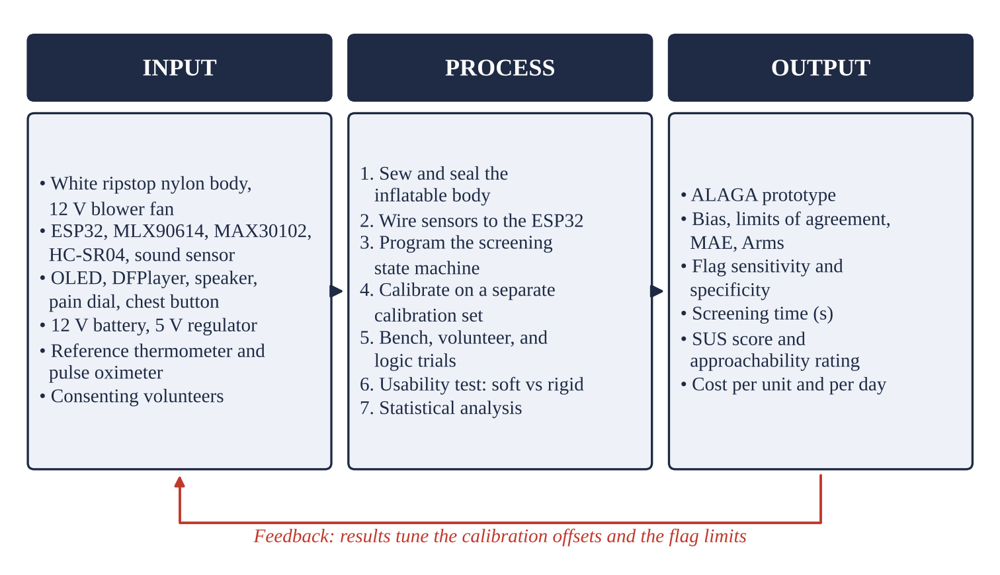
Note. Figure created by the researchers, 2026.
METHODOLOGY
Research Design
This is a quantitative developmental and method-comparison study with a within-subjects usability test. The robot is built and calibrated first; then its readings are compared with reference instruments on volunteers, its flag logic is tested, and users rate it with a soft body and with a rigid shell in counterbalanced order. Every value comes from the researchers' own tests.
Table 3
Variables of the Study
Independent (varied) | Dependent (measured) | Controlled (held fixed)
Measurement method (ALAGA; reference instrument)  Water-bath target temperature (°C)  Body type (soft inflatable; rigid shell) | Bias, limits of agreement, MAE, Arms  Sensitivity, specificity, accuracy  Screening time (s)  SUS score; approachability rating (1–5) | Room temperature 26–30 °C; 5-min rest  Forehead distance 3–5 cm; left index finger  Same prompts, order alternated; same robot shape and size
Note. Table created by the researchers, 2026.
Materials and Equipment
The components were bought from local electronics shops and online stores. The reference clinical forehead thermometer and fingertip pulse oximeter were borrowed from the school clinic. Expenses are listed in Appendix A.
Table 4
Materials and Components of ALAGA
Material / Component | Quantity | Purpose
White 70D ripstop nylon, seam tape, zipper | 3 m; 1 set | Inflatable body and head
12 V DC blower fan with finger guard | 1 | Keeps the body inflated
ESP32 development board | 1 | Controller
MLX90614 (GY-906) infrared thermometer | 1 | Forehead temperature
MAX30102 pulse oximeter module | 1 | Pulse rate and SpO₂
HC-SR04 ultrasonic sensor | 1 | Forehead distance check
0.96-in OLED display (SSD1306) | 1 | Chest display
DFPlayer Mini, microSD card, 3 W speaker | 1 set | Spoken prompts
KY-037 sound sensor, push button, 10 kΩ dial | 1 each | Wake-up and pain score
12 V 7 Ah SLA battery, LM2596 regulator, fuse | 1 set | Power
IRF520 MOSFET module, wires, perfboard | 1 set | Fan switch and wiring
Reference forehead thermometer and pulse oximeter | 1 each | Reference readings (borrowed)
Note. Table created by the researchers, 2026.
Specification of the Device
• Body: white 70D ripstop nylon, sewn and seam-taped, about 1.1 m tall; kept inflated by a 12 V blower fan in the base (Figure 2).
• Sensor panel on the chest: MLX90614 infrared thermometer and HC-SR04 distance sensor at forehead height, MAX30102 in a padded finger cradle, pain dial, chest button, and 0.96-in OLED display.
• Voice: DFPlayer Mini with a 3 W speaker; recorded prompts in Filipino and English.
• Wake-up: chest button or a KY-037 sound sensor that responds to a loud call such as “Aray!”.
• Controller and power: ESP32 with a state-machine program; 12 V 7 Ah sealed lead-acid battery and a 5 V buck regulator; log saved to the ESP32's flash memory as a CSV file.
Figure 2
Design and Parts of ALAGA
Note. Figure created by the researchers, 2026.
Construction and Preparation
Inflatable Body
The body was cut from ripstop nylon in two front and two back panels, sewn with flat seams, and sealed with seam tape. The head was a separate sewn shell joined at the neck. A zippered opening at the chest holds the sensor panel, and the base collar is clamped around the fan outlet with a hose clamp. A small vent lets air leak out so the fan keeps the body firm without bursting it.
Electronics and Sensors
The MLX90614, MAX30102, and OLED share one I²C bus at 100 kHz. The HC-SR04 echo line passes through a 1 kΩ/2 kΩ divider to protect the 3.3 V ESP32. The fan is switched by an IRF520 MOSFET module with a flyback diode. Pin connections are in Appendix G.
Control Logic
The program follows the state machine in Figure 3. In SLEEP the fan is off and the body lies flat. A press on the chest or a loud call starts the fan, and after 20 s ALAGA greets the person and asks for a pain score. It then reads the forehead temperature five times when the distance sensor shows 3 to 5 cm, reads pulse rate and SpO₂ when a finger is on the cradle, applies the limits in Table 5, speaks the result, shows it on the display, and saves it. After 30 s with no one present, the fan stops.
Figure 3
Screening State Machine of ALAGA
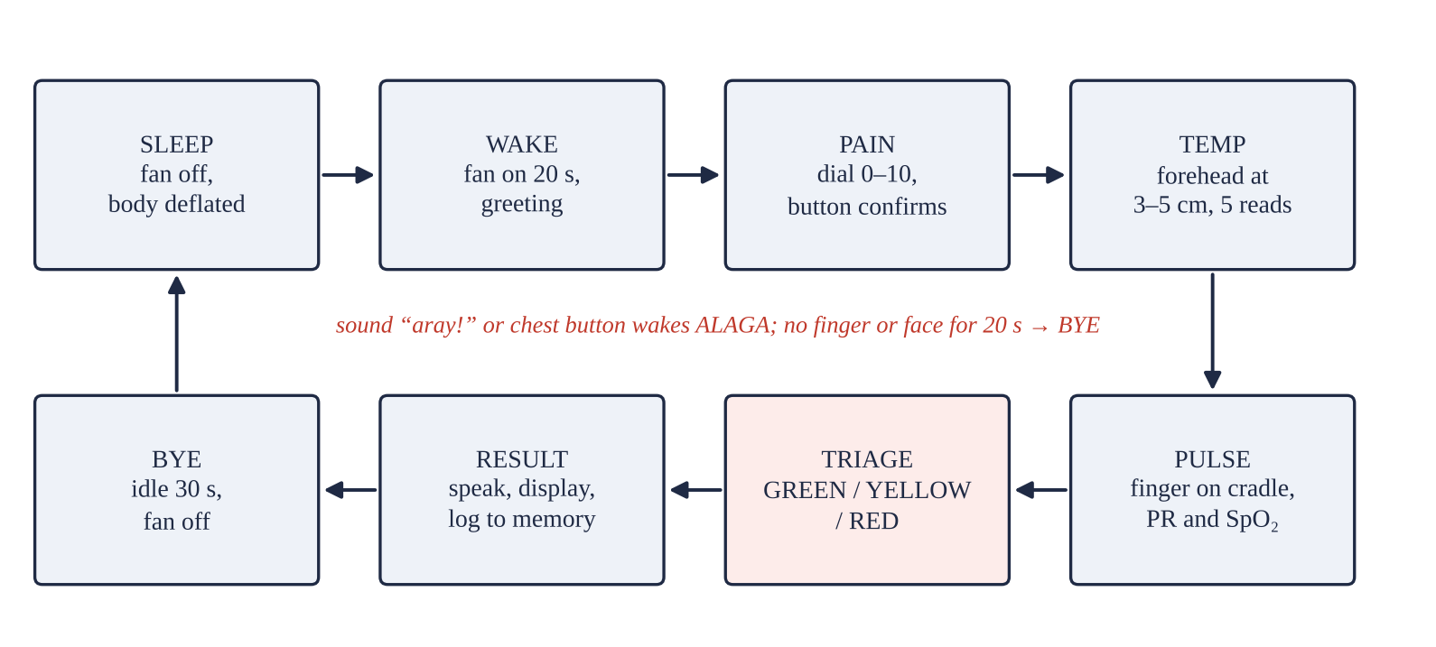
Note. Figure created by the researchers, 2026.
Table 5
Screening Limits and Triage Levels
Measure | GREEN (normal) | YELLOW (see health worker) | RED (see health worker now)
Temperature (°C) | below 37.5 | 37.5 to 38.9 | 39.0 or higher
SpO₂ (%) | 95 to 100 | 92 to 94 | below 92
Pulse rate at rest (bpm) | 60 to 100 | 40–59 or 101–130 | below 40 or above 130
Pain (0–10 NRS) | 0 to 3 | 4 to 6 | 7 to 10
Note. Table created by the researchers, 2026.
Calibration
Forehead skin temperature from the MLX90614 was converted to body temperature with a linear equation fitted to readings from the first 10 volunteers (calibration set). Constant offsets for pulse rate and SpO₂ were found from the same set. These volunteers were not used again in the agreement analysis.
Experimental Setup
All tests were done indoors at a room temperature of 26 to 30 °C, away from fans, air conditioners, and direct sunlight. Volunteers sat and rested for 5 minutes before screening, removed nail polish from the left index finger, and wiped sweat from the forehead. ALAGA and the reference instrument were used one after the other within 1 minute, in alternating order.
Table 6
Trials Conducted in the Study
Trial set | What is measured | Number | Reference
Bench temperature | IR reading of a black target in a water bath, 35.0–40.0 °C | 6 targets × 10 readings | Digital probe thermometer
Calibration set | Temperature, pulse rate, SpO₂ | 10 volunteers × 3 | Clinic instruments
Validation set | Temperature, pulse rate, SpO₂, time | ____ volunteers × 3 | Clinic instruments
Logic test | Triage of set input values around each limit | 60 cases | Table 5 limits
Usability | SUS; approachability, soft vs rigid | ____ volunteers | Counterbalanced order
Note. Table created by the researchers, 2026.
Data Gathering Procedure
The ten steps in Figure 4 were followed. Each volunteer received a code number, and no names were written on the data sheets (Appendix B).
Figure 4
Flowchart of the Research Procedure
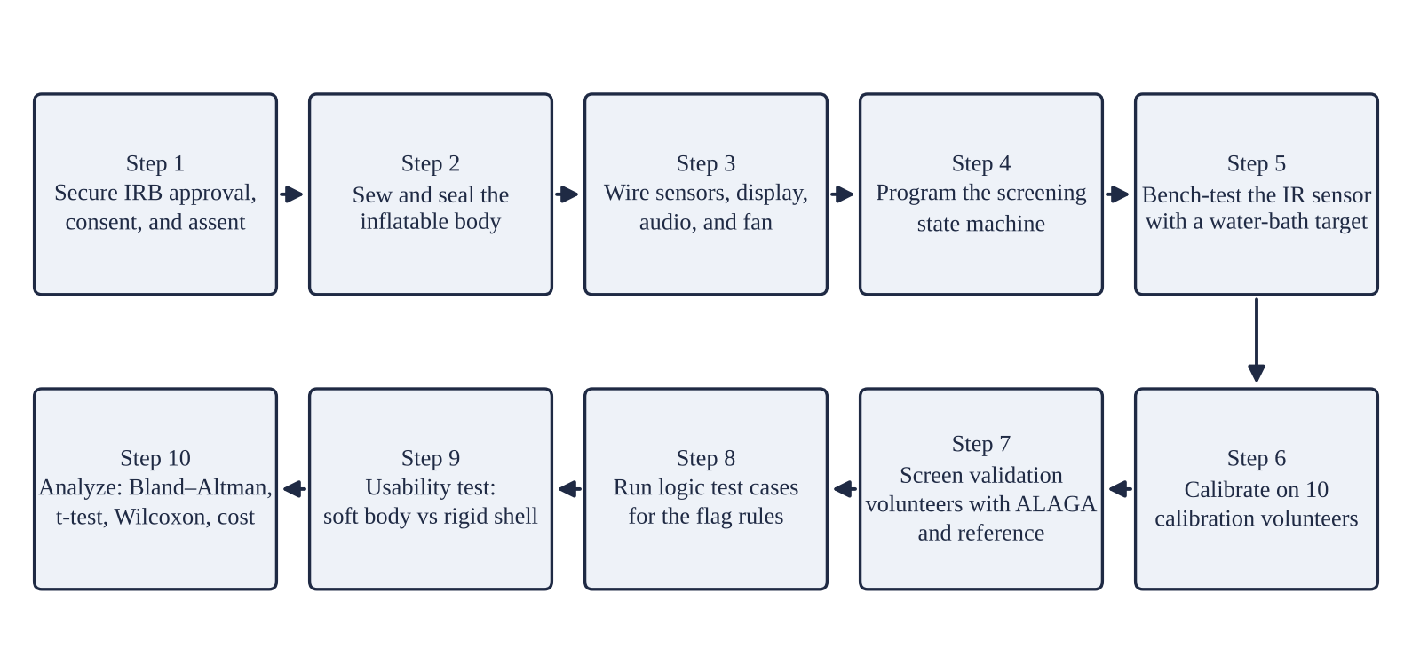
Note. Figure created by the researchers, 2026.
Statistical Treatment
The following formulas were used:
d = ALAGA reading − reference reading | where difference for each paired reading | (1)
Bias = Σd ÷ n; LoA = Bias ± 1.96 × SD(d) | where mean bias and 95% limits of agreement | (2)
MAE = Σ|d| ÷ n; Arms = √(Σd² ÷ n) | where mean absolute error; root-mean-square error | (3)
Sensitivity = TP ÷ (TP + FN); Specificity = TN ÷ (TN + FP) | where flags correctly raised; normal results correctly passed | (4)
Accuracy = (TP + TN) ÷ N | where overall correct triage decisions | (5)
t_s = t_result − t_wake | where screening time (s) | (6)
SUS = 2.5 × [Σ(odd item − 1) + Σ(5 − even item)] | where System Usability Scale score (0–100) | (7)

Agreement was shown with Bland–Altman plots. A paired t-test tested H₀1 for each measure. Flag decisions were summarized in a confusion matrix. Approachability ratings (1–5) for the soft body and the rigid shell were compared with the Wilcoxon signed-rank test (H₀2). The level of significance was 0.05, and Microsoft Excel and JASP were used.
Safety and Ethical Considerations
This study involves human participants, so it followed the ISEF rules for human participants research used by the NSTF. Before any testing:
• The research plan was reviewed and approved by the school's Institutional Review Board (IRB).
• Each volunteer signed an informed consent form; volunteers below 18 years also gave assent, with written consent from a parent or guardian (Appendix E).
• Procedures were non-invasive: a forehead reading from 3 to 5 cm and a fingertip clip. No blood, drugs, or exercise were involved, and anyone could stop at any time.
• Volunteers with readings outside the limits were referred to the school nurse.
• Data were coded, kept on a password-protected computer, and deleted after the fair.
• All sources are cited in APA 7th edition; no data were fabricated.
Electrical and physical risks were controlled as listed in Appendix D: a finger guard on the fan, a fuse on the battery line, low-voltage wiring inside a closed box, wiping of the sensors with 70% alcohol between volunteers, and no small parts within reach.
FINDINGS
Results and Discussion
[NEED: every ____ in this chapter must be replaced with values the researchers measured. No value may be entered that was not measured.]
Results for Objective 1: Agreement With the Reference Instruments
Table 7 shows the infrared thermometer against the water-bath target. Across the targets, the mean error was ____ °C after calibration.
Table 7
Bench Test of the Infrared Thermometer Against a Water-Bath Target
Target (°C) | Probe reading (°C) | ALAGA mean ± SD (°C) | Error (°C)
35.0 | ____ | ____ ± ____ | ____
36.0 | ____ | ____ ± ____ | ____
37.0 | ____ | ____ ± ____ | ____
37.5 | ____ | ____ ± ____ | ____
38.0 | ____ | ____ ± ____ | ____
40.0 | ____ | ____ ± ____ | ____
Note. Table created by the researchers, 2026.
Table 8 shows the agreement of ALAGA with the reference instruments in the ____ validation volunteers. Temperature had a bias of ____ °C with limits of agreement from ____ to ____ °C. Pulse rate had a bias of ____ bpm, and SpO₂ had a bias of ____% with an Arms of ____%, which ____ the 4% limit of ISO 80601-2-61. The paired t-test gave p = ____, ____, and ____, so H₀1 is ____.
Table 8
Agreement of ALAGA With the Reference Instruments (Validation Set)
Measure | n | Bias | 95% LoA | MAE | Arms | p
Temperature (°C) | ____ | ____ | ____ to ____ | ____ | ____ | ____
Pulse rate (bpm) | ____ | ____ | ____ to ____ | ____ | ____ | ____
SpO₂ (%) | ____ | ____ | ____ to ____ | ____ | ____ | ____
Note. Table created by the researchers, 2026.
Figure 5
Bland–Altman Plots of Temperature, Pulse Rate, and SpO₂
[NEED: Bland–Altman plots from the measured validation data: difference (ALAGA − reference) against the mean of the two, with lines for the bias and the 95% limits of agreement.]

Note. Figure created by the researchers, 2026.
Results for Objective 2: Accuracy of the Flags
Table 9 shows the triage decisions against the decisions made from the reference readings, including the logic test cases. Sensitivity was ____%, specificity ____%, and accuracy ____%.
Table 9
Confusion Matrix of ALAGA Flags
 | Reference: flag | Reference: normal | Total
ALAGA: flag | TP = ____ | FP = ____ | ____
ALAGA: normal | FN = ____ | TN = ____ | ____
Total | ____ | ____ | ____
Note. Table created by the researchers, 2026.
Results for Objective 3: Screening Time
One screening took a mean of ____ s (SD ____ s). The longest step was ____ (Table 10).
Table 10
Time Taken per Screening Step
Step | Mean (s) | SD (s)
Wake-up and inflation | ____ | ____
Greeting and pain score | ____ | ____
Temperature | ____ | ____
Pulse rate and SpO₂ | ____ | ____
Result and advice | ____ | ____
Total | ____ | ____
Note. Table created by the researchers, 2026.
Results for Objective 4: Usability and Approachability
The mean SUS score was ____ (SD ____). Approachability was rated ____ for the soft body and ____ for the rigid shell (Wilcoxon z = ____, p = ____), so H₀2 is ____ (Table 11).
Table 11
Usability and Approachability Ratings
Measure | Soft body | Rigid shell | Test | p
SUS score (0–100) | ____ | — | Mean ± SD | —
Approachability (1–5), median | ____ | ____ | Wilcoxon z = ____ | ____
Willing to be screened again (%) | ____ | ____ | — | —
Note. Table created by the researchers, 2026.
Results for Objective 5: Cost
ALAGA cost PHP ____ to build and PHP ____ per day to run (Table 12).
Table 12
Cost of Building and Running ALAGA
Item | Amount
Parts for one unit (Appendix A) | PHP ____
Energy per 12-hour day (Wh) | ____
Electricity per day at PHP ____/kWh | PHP ____
Screenings per battery charge | ____
Note. Table created by the researchers, 2026.
Summary of Results by Objective
Table 13
Summary of Results by Objective
Objective | Result | Decision
1. Agreement | Bias ____ °C, ____ bpm, ____%; Arms ____% | H₀1 ____
2. Flag accuracy | Sensitivity ____%, specificity ____% | —
3. Screening time | ____ s per person | —
4. Usability | SUS ____; soft vs rigid p = ____ | H₀2 ____
5. Cost | PHP ____ per unit; PHP ____ per day | —
Note. Table created by the researchers, 2026.
CONCLUSIONS
Assessment of the Findings
Based on the results of the study, the following conclusions were drawn:
1. ALAGA was built with a fan-inflated soft body, an infrared thermometer, a pulse oximeter sensor, a pain dial, and spoken prompts, all controlled by an ESP32.
2. Its temperature, pulse rate, and SpO₂ readings had biases of ____ °C, ____ bpm, and ____%, with an SpO₂ Arms of ____%; H₀1 is ____.
3. Its flags reached ____% sensitivity and ____% specificity.
4. One screening took ____ s on average.
5. Users gave a SUS score of ____ and rated the soft body ____ approachable than the rigid shell (p = ____); H₀2 is ____.
6. One unit cost PHP ____ to build and PHP ____ per day to run.
Limitations
Only healthy volunteers were screened, so few real abnormal readings were seen; fever was covered by a water-bath target and low SpO₂ only by logic test cases. Low-cost pulse oximeter sensors can read higher in people with darker skin and with cold or moving fingers. The robot was tested in a school, not in a real evacuation center, and was not tested for weeks of continuous use.
Applications
Evacuation centers, barangay health stations, and school clinics in Albay can use ALAGA at the entrance to screen people while health workers attend to those it flags. Between disasters, the same unit can check students in the school clinic.
RECOMMENDATIONS
Based on the findings and limitations of the study, the researchers recommend the following:
1. Run a pilot in an evacuation center with the Albay PDRRMO and the Provincial Health Office.
2. Replace the MAX30102 with a medical-grade oximeter module and test across skin tones.
3. Add blood pressure and respiratory rate, and send flagged results to the health worker's phone.
4. Add voice prompts in Bikol and a simple speech-recognition pain score for people who cannot turn the dial.
5. Test the fabric and fan for dust and ash, and add a washable cover.
REFERENCES
Allen, J. (2007). Photoplethysmography and its application in clinical physiological measurement. Physiological Measurement, 28(3), R1–R39. https://doi.org/10.1088/0967-3334/28/3/R01
Bland, J. M., & Altman, D. G. (1986). Statistical methods for assessing agreement between two methods of clinical measurement. The Lancet, 327(8476), 307–310. https://doi.org/10.1016/S0140-6736(86)90837-8
Broadbent, E., Stafford, R., & MacDonald, B. (2009). Acceptance of healthcare robots for the older population: Review and future directions. International Journal of Social Robotics, 1(4), 319–330. https://doi.org/10.1007/s12369-009-0030-6
Brooke, J. (1996). SUS: A “quick and dirty” usability scale. In P. W. Jordan, B. Thomas, B. A. Weerdmeester, & I. L. McClelland (Eds.), Usability evaluation in industry (pp. 189–194). Taylor & Francis.
DZRH. (2026). Pre-emptive evacuation ordered as Mayon Volcano raised to Alert Level 3. https://www.dzrh.com.ph/post/pre-emptive-evacuation-ordered-as-mayon-volcano-raised-to-alert-level-3
Espressif Systems. (n.d.). ESP32 series datasheet. https://www.espressif.com
Feil-Seifer, D., & Matarić, M. J. (2005). Defining socially assistive robotics. In Proceedings of the 9th International Conference on Rehabilitation Robotics (pp. 465–468). IEEE.
Fraden, J. (2016). Handbook of modern sensors: Physics, designs, and applications (5th ed.). Springer.
Hall, D., & Williams, C. (Directors). (2014). Big Hero 6 [Film]. Walt Disney Animation Studios.
Hawker, G. A., Mian, S., Kendzerska, T., & French, M. (2011). Measures of adult pain. Arthritis Care & Research, 63(S11), S240–S252. https://doi.org/10.1002/acr.20543
Horwell, C. J., & Baxter, P. J. (2006). The respiratory health hazards of volcanic ash: A review for volcanic risk mitigation. Bulletin of Volcanology, 69(1), 1–24. https://doi.org/10.1007/s00445-006-0052-y
International Organization for Standardization. (2017a). Medical electrical equipment — Part 2-56: Particular requirements for basic safety and essential performance of clinical thermometers for body temperature measurement (ISO Standard No. 80601-2-56:2017).
International Organization for Standardization. (2017b). Medical electrical equipment — Part 2-61: Particular requirements for basic safety and essential performance of pulse oximeter equipment (ISO Standard No. 80601-2-61:2017).
Jubran, A. (2015). Pulse oximetry. Critical Care, 19, Article 272. https://doi.org/10.1186/s13054-015-0984-8
Khaosod English. (2026, May 4). More than 300 families evacuate in Philippines due to ashfall from volcano. https://www.khaosodenglish.com/news/asean/2026/05/04/more-than-300-families-evacuate-in-philippines-due-to-ashfall-from-volcano/
Maxim Integrated. (n.d.). MAX30102: High-sensitivity pulse oximeter and heart-rate sensor for wearable health [Data sheet].
Melexis. (n.d.). MLX90614 family: Single and dual zone infra red thermometer in TO-39 [Data sheet].
Mori, M., MacDorman, K. F., & Kageki, N. (2012). The uncanny valley. IEEE Robotics & Automation Magazine, 19(2), 98–100. https://doi.org/10.1109/MRA.2012.2192811
Rus, D., & Tolley, M. T. (2015). Design, fabrication and control of soft robots. Nature, 521(7553), 467–475. https://doi.org/10.1038/nature14543
Sanan, S., Ornstein, M. H., & Atkeson, C. G. (2011). Physical human interaction for an inflatable manipulator. In 2011 Annual International Conference of the IEEE Engineering in Medicine and Biology Society (pp. 7401–7404). IEEE.
World Health Organization. (2011). Pulse oximetry training manual. WHO Patient Safety.
APPENDICES
Appendix A. Materials, Quantity, and Expenses
Prices are estimates from local and online stores in October 2026. Replace them with the amounts on the official receipts.
Table 14
Expense Summary of the Study
Item | Qty | Estimated unit price (PHP) | Subtotal (PHP)
Ripstop nylon 70D, white (per meter) | 3 | 150 | 450
Seam tape, zipper, thread, hose clamp | 1 lot | 200 | 200
12 V DC blower fan with guard | 1 | 250 | 250
ESP32 development board | 1 | 380 | 380
MLX90614 (GY-906) module | 1 | 550 | 550
MAX30102 module | 1 | 180 | 180
HC-SR04 ultrasonic sensor | 1 | 70 | 70
0.96-in OLED display | 1 | 180 | 180
DFPlayer Mini with 8 GB microSD | 1 | 300 | 300
3 W 4 Ω speaker | 1 | 80 | 80
KY-037 sound sensor, button, 10 kΩ dial | 1 set | 160 | 160
12 V 7 Ah SLA battery | 1 | 650 | 650
LM2596 regulator, IRF520 module, fuse | 1 set | 180 | 180
Wires, perfboard, plywood base, box | 1 lot | 550 | 550
Rigid shell for the usability test | 1 | 300 | 300
70% alcohol, wipes, data sheets | 1 lot | 150 | 150
Total (estimated) |  |  | 4,630
Note. Table created by the researchers, 2026.
Appendix B. Raw Data Sheets
Table 15
Raw Data Sheet for Volunteer Screenings
Code | Trial | ALAGA T (°C) | Ref T (°C) | ALAGA PR | Ref PR | ALAGA SpO₂ | Ref SpO₂ | Pain | Time (s)
V01 | 1
V01 | 2
V01 | 3
V02 | 1
V02 | 2
V02 | 3
Note. Table created by the researchers, 2026.
Appendix C. Photographs of the Procedure
[NEED: dated photographs of each step in Figure 4, each with a bold label and the note “Photographs taken by the researchers, 2026.” No faces of volunteers without written permission.]
Appendix D. Risk Register
Table 16
Risk Register of the Study
Hazard | Risk | Control
Blower fan | Finger caught in the blades | Metal finger guard; fan inside the closed base
Battery and wiring | Short circuit, heat | Inline fuse; low-voltage wiring in a closed box; charging only under supervision
Shared sensors | Spread of germs | Wipe with 70% alcohol between volunteers
Infrared and LED light | Eye discomfort | Sensors aimed at the forehead and fingertip only
Wrong reading | Missed fever or low SpO₂ | Reference reading taken for every volunteer; referral to the school nurse
Personal data | Loss of privacy | Code numbers; password-protected files; deleted after the fair
Note. Table created by the researchers, 2026.
Appendix E. Ethics Statement and Informed Consent
This study involved human participants. The research plan, consent form, and data sheets were approved by the school Institutional Review Board on [date] before any volunteer was screened. Participation was voluntary, and volunteers could stop at any time without penalty.
Informed consent (summary read to each volunteer): “You are invited to test ALAGA, a robot that checks temperature, pulse, and oxygen level. A sensor will read your forehead from a short distance, and you will place one finger in a sensor. The same will be done with the school clinic's instruments. It takes about 5 minutes and does not hurt. Your name will not be recorded. If a reading is outside the normal range, we will ask the school nurse to check you.”
[NEED: signed consent forms, parental consent and minor assent forms, and the IRB approval form.]
Appendix F. ISEF Forms
[NEED: signed Checklist for Adult Sponsor (1), Student Checklist (1A), Research Plan/Project Summary, Approval Form (1B), Risk Assessment Form (3), Human Participants Form (4) with IRB approval, and informed consent forms.]
Appendix G. Wiring Diagram and Program
Table 17
Pin Connections of ALAGA
Part | Part pin | ESP32 pin | Note
MLX90614, MAX30102, OLED | SDA / SCL | GPIO 21 / GPIO 22 | Shared I²C bus, 100 kHz, 3.3 V
HC-SR04 | TRIG / ECHO | GPIO 32 / GPIO 33 | ECHO through 1 kΩ/2 kΩ divider; 5 V supply
Pain dial (10 kΩ) | Wiper | GPIO 34 | Ends to 3.3 V and GND
Chest button | One leg | GPIO 27 | Other leg to GND; internal pull-up
KY-037 sound sensor | D0 | GPIO 26 | Threshold set with the onboard trimmer
DFPlayer Mini | TX / RX | GPIO 16 / GPIO 17 | 1 kΩ resistor on RX; speaker on SPK1/SPK2
IRF520 module | SIG | GPIO 25 | Switches the 12 V blower fan
LM2596 regulator | OUT +5 V | VIN (5 V) | Input from the 12 V battery through a fuse
Note. Table created by the researchers, 2026.
The full program (alaga.ino, Arduino IDE, ESP32 Dev Module) is in the project folder firmware/alaga. It uses the Adafruit MLX90614, SparkFun MAX3010x, Adafruit SSD1306, and DFRobotDFPlayerMini libraries. Audio prompts are saved on the microSD card as /mp3/0001.mp3 to /mp3/0010.mp3: greeting, pain question, forehead prompt, finger prompt, GREEN, YELLOW, RED, goodbye, “come closer”, and “try again”.
[NEED: photograph or drawing of the final wiring.]
Appendix H. Curriculum Vitae
[NEED: one-page curriculum vitae of each researcher with a 2 × 2 photo.]

