ENGINEERING NOTEBOOK
KALINGA
Development of a 3D-Printed, Baymax-Inspired Wearable Health Pendant
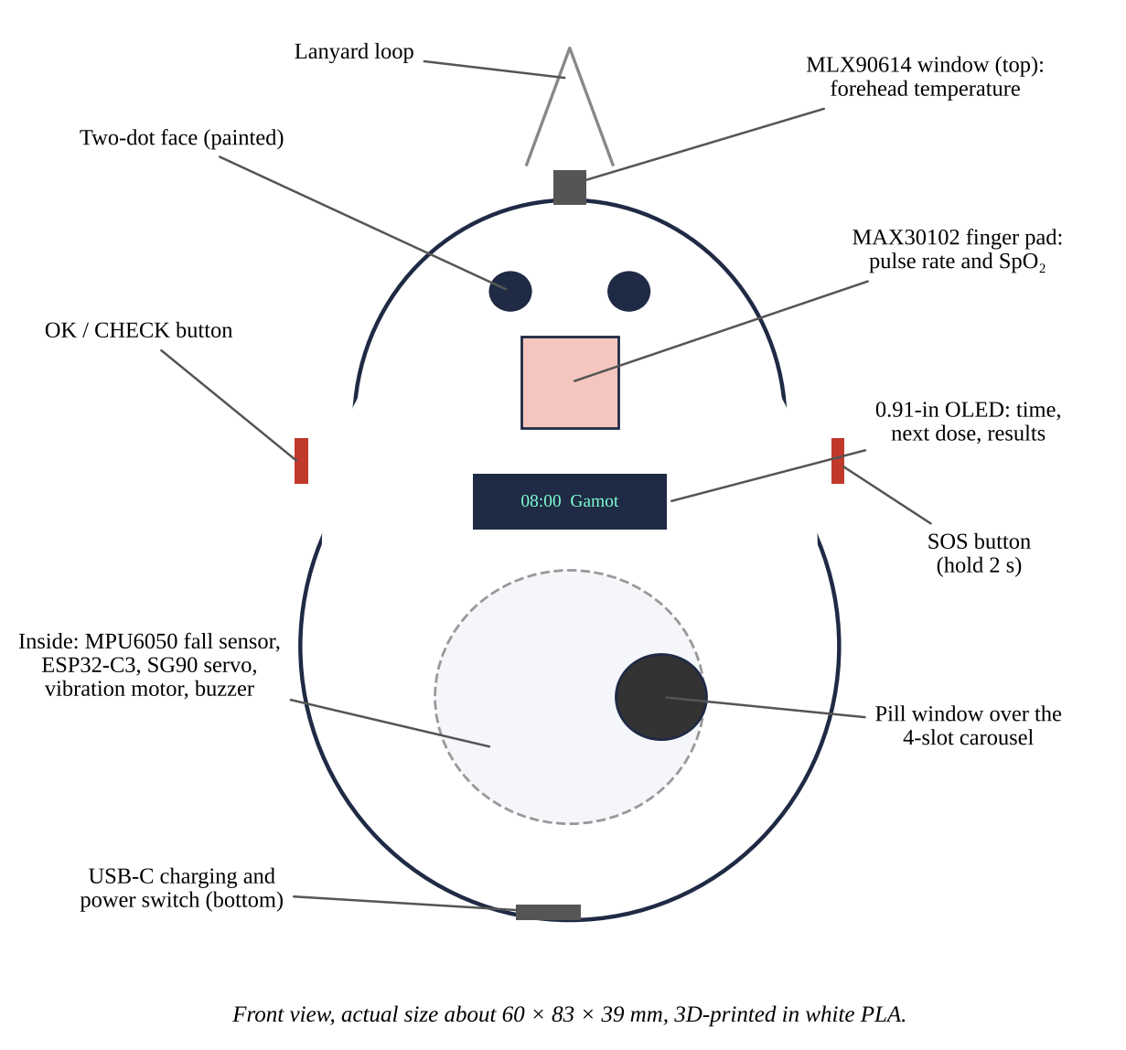
The pendant to be built (front view).
Team: ______, ______, ______ Adviser: ______ School: ______
How to keep this notebook. Write every entry on the day the work is done. Sign and date each entry and have a witness sign. Do not erase or tear pages: cross out mistakes with one line. Paste printouts, photos, and screenshots with the date. Record what failed as carefully as what worked; judges look for the design process, not only the final product.

Entry 1: Problem and Design Criteria
Date: ______ Recorded by: ______ Witnessed by: ______
Problem. Older adults and people with chronic illness are often alone at home while their families work. Falls go unnoticed, doses are missed, and fevers rise unseen. Existing products each do one job and cost more together.
Goal. Build one low-cost wearable that checks vital signs, presents each dose on time, alerts the family, and shows everything in a phone app.
Criterion | Target | How it will be checked
Cost | Below PHP 2,500 for parts | Receipts (Appendix A.3)
Size and weight | Fits in a hand; about 60 × 83 × 39 mm; under 120 g | Ruler and kitchen scale
Temperature accuracy | Bias within ±0.3 °C after calibration | Bland–Altman vs clinic thermometer
SpO₂ accuracy | Arms ≤ 4% (ISO 80601-2-61) | Bland–Altman vs reference oximeter
Fall detection | Sensitivity and specificity ≥ 90% | Mat falls and daily activities
Alert time | Under 60 s to the app | Stopwatch and app time stamps
Doses | Correct slot every time; within 1 min of schedule | 5-day dose log
Battery | At least 16 h per charge | Battery log
Ease of use | SUS above 68 | Questionnaire

Entry 2: Background Research
Date: ______ Recorded by: ______ Witnessed by: ______
• Pulse oximetry: red and infrared light through the fingertip give SpO₂ and pulse rate (Allen, 2007; Jubran, 2015). Readings drop in accuracy with movement, cold fingers, nail polish, and darker skin.
• Infrared thermometry: the MLX90614 reads skin temperature without contact; forehead skin is cooler than the body core, so a calibration equation is needed (Fraden, 2016).
• Falls: free fall (< 0.5 g), then impact (> 2.5 g), then stillness is a simple, proven rule (Bourke et al., 2007).
• Medicine: about half of long-term patients do not take medicines as prescribed; timed reminders help (WHO, 2003).
• Data: the Firebase Realtime Database has a REST interface that a microcontroller can call over HTTPS and a web app can stream live (Google, n.d.). Health data must be protected (Republic Act No. 10173, 2012).
Sources read by the team and notes: ______
Entry 3: Ideas and Decision Matrix
Date: ______ Recorded by: ______ Witnessed by: ______
Each idea is scored 1 (poor) to 5 (best) on each criterion and multiplied by the weight. The scores below are the starting estimates; change them after your own tests and sign the decision.
Option for each function | Cost ×3 | Size ×2 | Ease to build ×2 | Reliability ×3 | Total
Dispensing: 4-slot carousel + SG90 servo | 5 | 3 | 4 | 4 | 41
Dispensing: single lid with servo latch | 5 | 4 | 4 | 3 | 40
Dispensing: sliding drawer + linear servo | 3 | 4 | 2 | 3 | 30
Temperature: MLX90614 non-contact | 3 | 4 | 5 | 4 | 39
Temperature: MAX30205 skin contact | 4 | 5 | 3 | 3 | 37
Link: Wi-Fi + Firebase + web app | 5 | 5 | 3 | 4 | 43
Link: Bluetooth to the older adult's phone | 5 | 5 | 3 | 2 | 37
Link: GSM SMS module | 3 | 2 | 3 | 3 | 28

Chosen design: carousel + SG90, MLX90614, Wi-Fi + Firebase. Team signatures: ______
Entry 4: Bill of Materials and Tools
Date: ______ Recorded by: ______ Witnessed by: ______
Item | Qty | Est. PHP
ESP32-C3 SuperMini | 1 | 220
MLX90614 (GY-906) module | 1 | 550
MAX30102 module | 1 | 180
MPU6050 (GY-521) module | 1 | 120
0.91-in OLED, 128 × 32, I²C | 1 | 150
SG90 micro servo | 1 | 120
LiPo 3.7 V 1000 mAh (503450) | 1 | 220
TP4056 USB-C charger with protection | 1 | 45
Coin vibration motor, 3 V active buzzer | 1 set | 50
AO3400, S8050, 1N4148, resistors | 1 set | 30
Tactile buttons with caps, slide switch | 1 set | 35
Perfboard, wires, headers | 1 lot | 80
PLA filament or print service (about 60 g) | 1 lot | 250
Black acrylic paint, sandpaper | 1 lot | 40
Breakaway lanyard, M2 screws | 1 set | 60
TOTAL (estimated) |  | 2,150

Tools. 3D printer (FDM, 0.4-mm nozzle) or a print shop; slicer (UltiMaker Cura, PrusaSlicer, or Bambu Studio); soldering iron, solder, flux; wire stripper; multimeter; hot-glue gun; small files and sandpaper (220 and 400); flush cutters; laptop with Arduino IDE 2; USB-C cable; placebo candy tablets for testing.
Entry 5: CAD Design of the Shell
Date: ______ Recorded by: ______ Witnessed by: ______
The shell is an egg-shaped body (two spheres joined and flattened) split into a front and a back shell, plus a 36-mm pill carousel. The model is a Python script, so every size can be changed and the STL files regenerated:
pip install manifold3d trimesh then python cad/kalinga_pendant.py
Feature | Size (mm) | Why
Wall thickness | 2.0 | Strong enough for PLA; light
Overall | 60 × 83 × 39 | Fits the SG90 servo and carousel
OLED window | 24 × 8 | 0.91-in OLED active area 22.4 × 5.6
Finger pad window | 13 × 13 | MAX30102 module
Thermometer window (top) | Ø 9.8 | MLX90614 TO-39 can, Ø 9.2
Pill window | Ø 11 | Pocket Ø 9.6 under it
Carousel | Ø 36 × 7, 4 pockets | Pockets at 45°, 90°, 135°, 180°; solid at 0° = closed
Button holes | Ø 6.6 | 6 × 6 mm tactile button caps
USB-C and switch slots | 10 × 4, 9 × 4 | TP4056 port, slide switch
Lip | 3 deep, 1.2 thick | Locates the front shell on the back shell

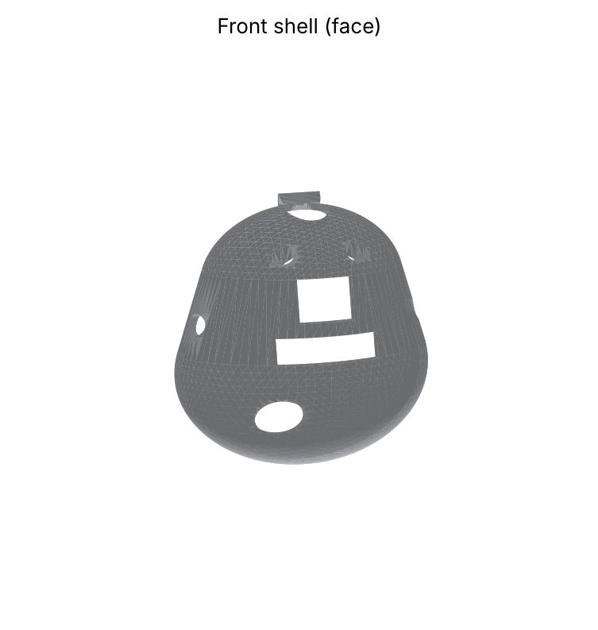
Front shell rendered from front_shell.stl.
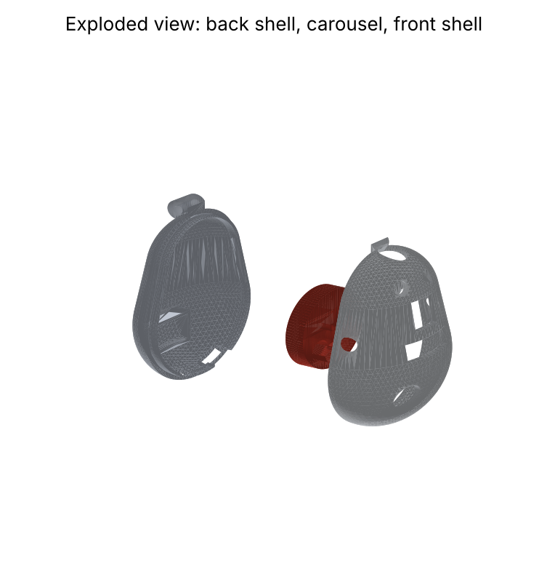
Exploded view: back shell with servo cradle, pill carousel, and front shell.
Changes made to the CAD and why: ______
Entry 6: 3D Printing
Date: ______ Recorded by: ______ Witnessed by: ______
Setting | Shells | Carousel
Material | White PLA | White or red PLA
Nozzle / layer height | 0.4 mm / 0.2 mm | 0.4 mm / 0.2 mm
Walls / top and bottom layers | 3 / 4 | 3 / 4
Infill | 20% gyroid | 30% gyroid
Nozzle / bed temperature | 205 °C / 60 °C | 205 °C / 60 °C
Orientation | Flat split edge on the bed (open side down) | Flat, pockets facing up
Supports | Tree supports, everywhere; 5-mm brim | None
Estimated time and filament (from slicer) | ______ h, ______ g | ______ h, ______ g

1. Print the carousel first as a test: check that a placebo tablet fits each pocket and that the SG90 horn sits flat in its recess.
2. Print the back shell, then the front shell. Watch the first layer; stop and level the bed if lines do not stick.
3. Remove supports with flush cutters and pliers. Sand edges with 220 then 400 grit.
4. Dry-fit the two shells: the lip must slide in with light pressure. If tight, sand the lip; if loose, add one layer of tape.
5. Paint the two eye recesses with black acrylic; let dry for 1 hour. Keep the face design original (two dots, no copied logos) so it can be filed as an Industrial Design.
6. Weigh and measure each part and paste photos here.
Part | Print date | Time (h) | Mass (g) | Problems seen | Fix

Entry 7: Electronics Assembly
Date: ______ Recorded by: ______ Witnessed by: ______
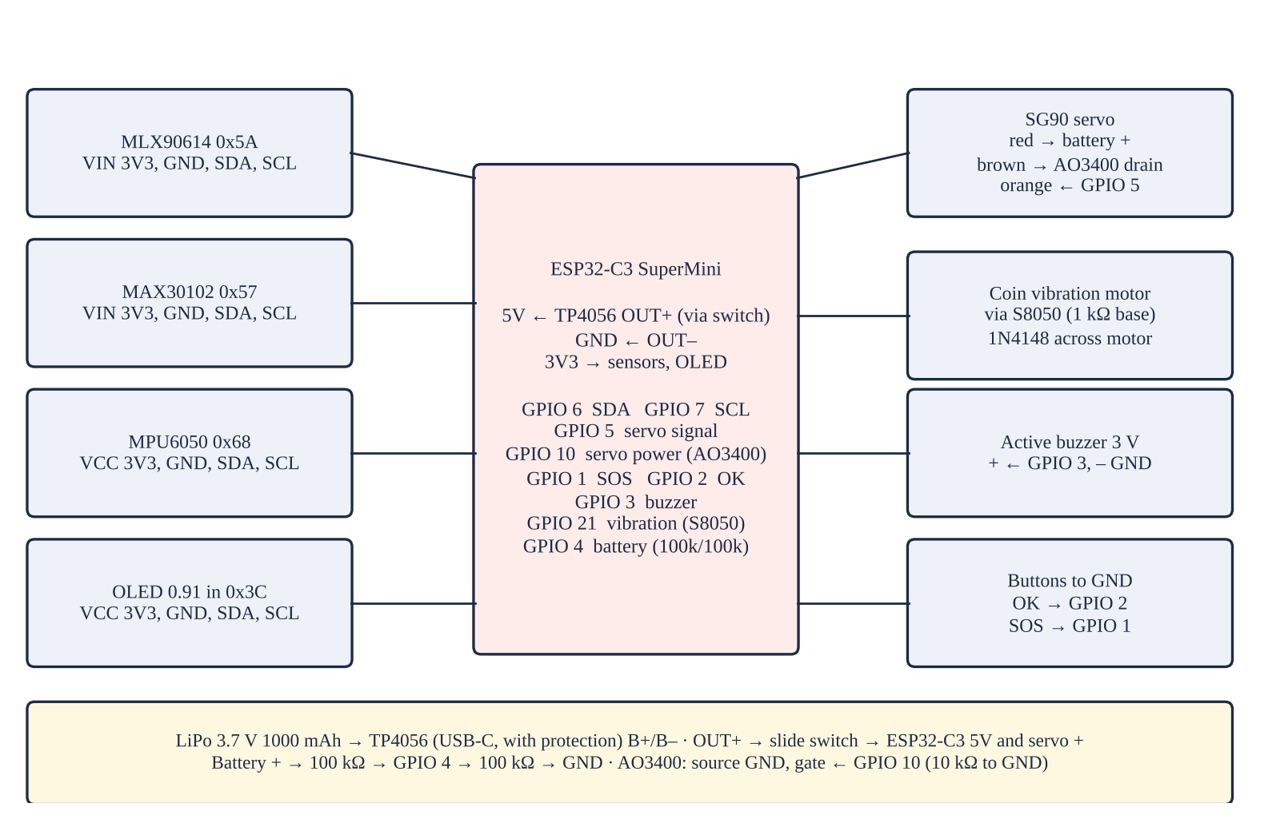
Wiring diagram.
Part | Connects to (ESP32-C3)
MLX90614, MAX30102, MPU6050, OLED | GPIO 6 / 7 — I²C at 100 kHz, 3.3 V
SG90 servo | GPIO 5 / GPIO 10 — AO3400 switches the servo ground
OK and SOS buttons | GPIO 2 / GPIO 1 — Internal pull-ups
Buzzer; vibration motor | GPIO 3; GPIO 21 — 1 kΩ base resistor; 1N4148
Battery divider | GPIO 4 — Reads 0–4.2 V
TP4056 OUT+ / OUT– | 5V / GND — LiPo on B+ / B–

1. Solder headers on each module. Test each module alone with the ESP32-C3 and an I²C scan: expect 0x5A (MLX90614), 0x57 (MAX30102), 0x68 (MPU6050), and 0x3C (OLED).
2. Build the small parts on perfboard: S8050 with 1 kΩ base resistor and 1N4148 across the vibration motor; AO3400 with 10 kΩ gate-to-ground resistor for the servo; 100 kΩ/100 kΩ battery divider to GPIO 4.
3. LiPo safety: connect the battery to the TP4056 B+ and B– only, with the correct polarity, and never short, bend, or puncture it. Charge only under supervision.
4. Wire TP4056 OUT+ through the slide switch to the ESP32-C3 5V pin and the servo red wire; OUT– to GND.
5. Measure with the multimeter before powering: battery 3.7–4.2 V; no short between 5V and GND.
6. Record each test below.
Module | Test | Expected | Result | OK?

Entry 8: Programming the Pendant
Date: ______ Recorded by: ______ Witnessed by: ______
1. Install Arduino IDE 2 and “esp32 by Espressif Systems” in Boards Manager.
2. Install libraries: Adafruit MLX90614, Adafruit SSD1306, Adafruit GFX, SparkFun MAX3010x, ESP32Servo, ArduinoJson.
3. Open firmware/kalinga_pendant/kalinga_pendant.ino. Type the Wi-Fi name and password, the Firebase Web API key and database URL, the pendant's account email and password, and the patient id.
4. Board: ESP32C3 Dev Module; USB CDC On Boot: Enabled. Upload. Open Serial Monitor at 115200.
5. Check: the OLED shows the time and battery; the carousel moves to the closed position; holding SOS for 2 s sends an SOS alert.
Entry 9: Firebase and the KALINGA Monitor App
Date: ______ Recorded by: ______ Witnessed by: ______
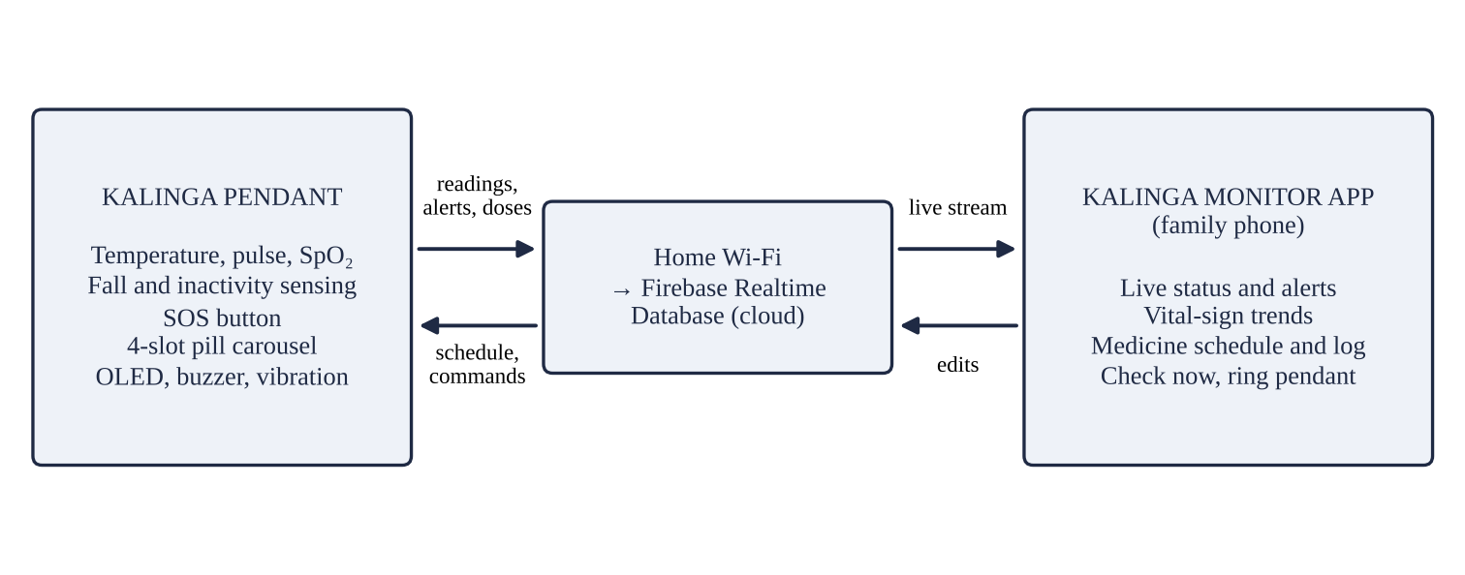
How the pendant, the database, and the app connect.
1. Go to console.firebase.google.com, create a project, and add a Web app. Copy the Web API key.
2. Authentication → Sign-in method → enable Email/Password. Add one user for the pendant and one for each family member. Copy each user's UID.
3. Realtime Database → Create (location: Singapore, asia-southeast1) → start in locked mode. Copy the database URL.
4. Rules: paste app/database.rules.json and publish.
5. Data: add members → <patient id> → <each UID> = true (for the pendant and every family member).
6. Host the app folder on GitHub Pages or Firebase Hosting (HTTPS is needed to install it). Open it on a phone, add it to the home screen, enter the key, URL, patient id, email, and password, and sign in.
7. Use “Try the demo” to show the app to judges without the pendant.
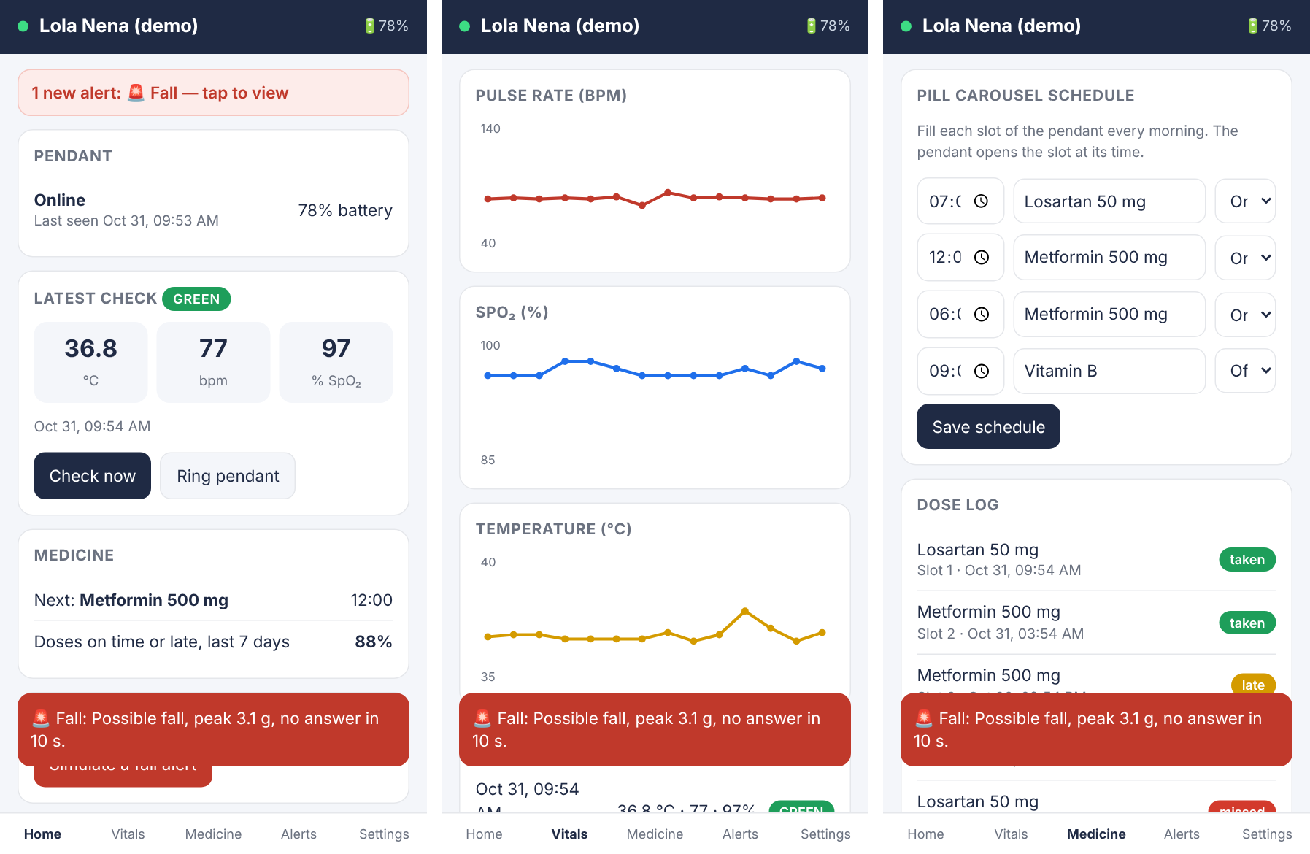
KALINGA Monitor screens (demo mode).
Entry 10: Final Assembly
Date: ______ Recorded by: ______ Witnessed by: ______
1. Set the servo to the closed position (power on once; the program moves it to 0°) before fitting the horn and carousel, so the solid sector sits under the window.
2. Fix the servo in the back-shell cradle with a drop of hot glue; screw the single-arm horn into the carousel recess.
3. Hot-glue the OLED behind its window, the MAX30102 behind the finger window (sensor flush with the surface), and the MLX90614 can in the top hole.
4. Place the ESP32-C3, MPU6050 (flat, near the center), battery, and TP4056 with double-sided foam tape; keep the USB-C port at its slot.
5. Fit the buttons and caps, close the shells, and add two M2 screws or a drop of glue at the bottom.
6. Thread the breakaway lanyard. Fill the four pockets with placebo tablets and run one dose cycle.
Entry 11: Calibration
Date: ______ Recorded by: ______ Witnessed by: ______
1. Bench test of the thermometer with a black-painted can in a water bath at 35.0, 36.0, 37.0, 37.5, 38.0, and 40.0 °C against a probe thermometer.
2. Calibration set (10 volunteers, after IRB approval): TEMP_A = SLOPE(reference, raw), TEMP_B = INTERCEPT(reference, raw); PR and SpO₂ offsets = mean of (reference − pendant).
3. Fall thresholds: 10 mat falls and 10 daily activities by the researchers; adjust FREE_FALL_G and IMPACT_G, then keep them fixed.
Target or volunteer | Reference | Pendant raw | Pendant calibrated | Difference

Entry 12: Test Records
Date: ______ Recorded by: ______ Witnessed by: ______
Falls and daily activities
Trial | Event | Detected? | Cancelled? | Peak g | Alert time (s)

Doses
Date | Slot | Scheduled | Opened at | Recorded as | Observer says

Battery
Charge no. | Full at | Empty at | Hours | Notes

Entry 13: Problems and Iterations
Date: ______ Recorded by: ______ Witnessed by: ______
Write each problem the day it happens, what caused it, what you changed, and what happened after.
Date | Problem | Cause | Change made | Result

Entry 14: Safety Checklist and Reflection
Date: ______ Recorded by: ______ Witnessed by: ______
• Adult supervision for the 3D printer, soldering, and LiPo charging.
• IRB approval and signed consent before any test with people; placebo tablets only.
• Falls simulated only by the researchers on 20-cm mats with pads.
• Breakaway lanyard so the cord cannot strangle the wearer.
• Firebase locked by rules; coded patient id; data deleted after the fair.
What worked: ______
What we would change next: ______

