[SCHOOL SEAL] [DIVISION SEAL] [DepEd SEAL]
Republic of the Philippines
Department of Education
Region V – Division of [PROVINCE]
[SCHOOL NAME IN BOLD CAPS]
[Municipality], [Province]
KALINGA: A LOW-COST BAYMAX-INSPIRED WEARABLE HEALTH PENDANT WITH VITAL-SIGN CHECKS, FALL ALERTS, TIMED PILL DISPENSING, AND A FAMILY MONITORING APP
Submitted to the Scientific Review Committee as an Official Entry to the
2026–2027 National Science and Technology Fair
Science Innovation Expo (SIE) – Team Category
Researchers:
[Surname, Firstname M.]
[Surname, Firstname M.]
[Surname, Firstname M.]

[Adviser Full Name]
Research Adviser
[School Name]
[Full postal address]
Email Address: [address]

PATENT / COPYRIGHT APPLICATION
[INSERT HERE]
The IPOPHL application or certificate (Utility Model, Industrial Design, or Copyright) must already have been applied for and secured before the entry is accepted at the Regional Fair (SIE entries only).
ISEF FORMS
[INSERT HERE]
International Rules for Pre-College Science Research forms, signed by the research adviser and the researchers. The forms that apply to this project are listed below.
Form | Title | Applies?
1 | Checklist for Adult Sponsor | Yes
1A | Student Checklist | Yes
— | Research Plan / Project Summary | Yes
1B | Approval Form | Yes
3 | Risk Assessment Form | Yes
2 | Qualified Scientist Form | Only if done in a research institution
4 | Human Participants Form | Yes (IRB approval and informed consent)
5A / 5B | Vertebrate Animal Forms | No
6A / 6B | Potentially Hazardous Biological Agents | No
7 | Continuation / Research Progression | No
RESEARCH PLAN
A. Rationale
Many older adults and people with chronic illness stay home alone while their families work or live abroad.
Falls are a leading cause of injury and death among adults over 60, and long waits for help make them worse (World Health Organization [WHO], 2021).
About half of patients on long-term medicines do not take them as prescribed (WHO, 2003).
Smartwatches, medical alert services, and pill dispensers each cover only part of the problem, and together they cost more than most families can pay.
Low-cost sensors, 3D printing, and free cloud databases now make it possible to put these jobs into one wearable that the family can watch from a phone.
B. Research Question or Problem
This study aimed to develop and evaluate KALINGA, a low-cost Baymax-inspired wearable health pendant with vital-sign checks, fall alerts, timed pill dispensing, and a family monitoring app.
1. How closely do KALINGA's temperature, pulse rate, and SpO₂ readings agree with reference instruments (mean bias, 95% limits of agreement, mean absolute error, and Arms)?
2. How accurately does KALINGA detect simulated falls and ignore daily activities (sensitivity and specificity), and how fast do fall, SOS, and inactivity alerts reach the app?
3. How accurately and punctually does the pill carousel present each scheduled dose, and how well does it record doses as taken, late, or missed?
4. What share of readings and alerts reach the app, and how long does one battery charge last?
5. How do older adults and family caregivers rate the usability of the pendant and the app?
6. How much does KALINGA cost compared with commercial products that do the same jobs?
C. Goals, Expected Outcomes, and Hypotheses
The project is expected to produce a working pendant and app and to show whether the pendant's readings, alerts, and doses are accurate and timely enough for home monitoring at a lower cost.
• H₀1: There is no significant difference between KALINGA's readings and the reference readings for temperature, pulse rate, and SpO₂.
• H₀2: KALINGA's fall decision is not associated with the true event type (fall or daily activity).
• H₀3: The mean System Usability Scale score of KALINGA is not significantly different from 68, the average score of products in general.
D. Procedures
1. Design the pendant shell in CAD and 3D-print it in PLA.
2. Wire the ESP32-C3, sensors, servo, OLED, buzzer, vibration motor, and battery.
3. Program the pendant; set up the Firebase database and the KALINGA Monitor app.
4. Calibrate the thermometer, pulse oximeter, and fall thresholds on a separate calibration set.
5. Run agreement trials with consenting volunteers against reference instruments.
6. Simulate falls (researchers only, on gym mats) and daily activities; time the alerts.
7. Run five days of scheduled doses, battery tests, and app delivery checks.
8. Run usability sessions with older adults and family caregivers.
E. Risk and Safety
• Human participants: IRB approval and informed consent before testing; non-invasive checks only.
• Simulated falls only by the researchers onto 20-cm gym mats, with pads and adult supervision.
• LiPo battery: protected charger, no puncture or heat; charging only under supervision.
• 3D printer and soldering: adult supervision, ventilation, heat-resistant gloves.
• Health data: private Firebase account, coded ids, deleted after the fair (RA 10173).
• Pills in testing: placebo candy tablets only; no real medicines are dispensed.
F. Data Analysis
• Bland–Altman bias and 95% limits of agreement, MAE, Arms; paired t-test (H₀1).
• Confusion matrix, sensitivity, specificity; chi-square test of independence (H₀2).
• Percentages for correct slot, on-time doses, delivered messages; mean battery life.
• System Usability Scale; one-sample t-test against 68 (H₀3). α = 0.05; Excel and JASP.
G. Bibliography
Bland, J. M., & Altman, D. G. (1986). Statistical methods for assessing agreement between two methods of clinical measurement. The Lancet, 327(8476), 307–310. https://doi.org/10.1016/S0140-6736(86)90837-8
Bourke, A. K., O'Brien, J. V., & Lyons, G. M. (2007). Evaluation of a threshold-based tri-axial accelerometer fall detection algorithm. Gait & Posture, 26(2), 194–199. https://doi.org/10.1016/j.gaitpost.2006.09.012
Jubran, A. (2015). Pulse oximetry. Critical Care, 19, Article 272. https://doi.org/10.1186/s13054-015-0984-8
Sauro, J. (2011). A practical guide to the System Usability Scale: Background, benchmarks & best practices. Measuring Usability LLC.
World Health Organization. (2003). Adherence to long-term therapies: Evidence for action.
World Health Organization. (2021, April 26). Falls [Fact sheet]. https://www.who.int/news-room/fact-sheets/detail/falls
TABLE OF CONTENTS
Title Page i
Patent / Copyright Application ii
ISEF Forms iii
Research Plan iv
Table of Contents vii
List of Tables viii
List of Figures ix
Abstract x
I. INTRODUCTION 1
1.1 Features and Specification 1
1.2 Market Trends and Opportunities 2
1.3 Scientific Basis 2
1.4 Statement of the Problem 3
1.5 Hypotheses 3
II. MATERIALS AND METHODS 5
2.1 Procurement of the Materials 5
2.2 Construction of the Product 5
2.3 Data Gathering 9
2.4 Flowchart of the Procedure 11
III. RESULTS AND DISCUSSION 12
3.1 Agreement of the Vital-Sign Checks 12
3.2 Fall Detection and Alerts 13
3.3 Pill Carousel and Dose Records 13
3.4 Data Delivery and Battery Life 13
3.5 Usability 14
3.6 Discussion 14
IV. CONCLUSION 15
V. ACKNOWLEDGEMENT 16
VI. REFERENCES 16
VII. APPENDICES 18
LIST OF TABLES
1 Cost Comparative Analysis of KALINGA and Commercial Products 2
2 Materials and Components of KALINGA 5
3 Trials Conducted in the Study 10
4.1 Bench Test of the Infrared Thermometer Against a Water-Bath Target 12
4.2 Agreement of KALINGA With the Reference Instruments 12
5.1 Confusion Matrix of KALINGA Fall Decisions 13
5.2 Time for Alerts to Reach the App 13
6.1 Dose Presentation and Records Over Five Days 13
7.1 Data Delivery and Battery Life 14
8.1 System Usability Scale Scores 14
A.1 Raw Data Sheet for Vital-Sign Checks 18
A.2 Raw Data Sheet for Falls and Daily Activities 18
A.3 Expense Summary of the Study 18
A.4 Pin Connections of KALINGA 19
LIST OF FIGURES
1 Bland–Altman Plots of Temperature, Pulse Rate, and SpO₂ 12
Photographs, flowcharts, and schematics carry a bold left-aligned label instead of a numbered caption and are not listed here.
ABSTRACT
Many older adults and people with chronic illness spend the day alone while their families work, and a fall, a missed dose, or a rising fever may go unnoticed for hours. Smartwatches, medical alert services, and pill dispensers each solve one part of the problem and together cost more than most families can pay. Inspired by the soft healthcare companion of the animated film Big Hero 6, this study developed KALINGA, a 3D-printed wearable pendant built around an ESP32-C3 microcontroller. It checks forehead temperature with a non-contact infrared sensor and pulse rate and SpO₂ with a fingertip pad, detects falls and long inactivity with an accelerometer, has an SOS button, and turns a four-slot pill carousel to present each scheduled dose. Readings, doses, and alerts are sent through Wi-Fi to a Firebase database and shown live in the KALINGA Monitor app on the family's phones. Against reference instruments, the pendant's readings had mean biases of ____ °C, ____ bpm, and ____% SpO₂ (SpO₂ Arms = ____%). It detected ____% of simulated falls with ____% specificity for daily activities, and alerts reached the app in ____ s. The carousel presented the correct slot in ____% of ____ doses, ____% on time. The battery lasted ____ h. Users gave a System Usability Scale score of ____ (p = ____ against 68). The pendant cost PHP ____. KALINGA brings health checks, medicine timing, and emergency alerts into one affordable wearable that families can watch from anywhere.
Keywords: wearable health monitor; fall detection; pill dispenser; pulse oximetry; Internet of Things; elderly care

I. INTRODUCTION
Many older adults and people with chronic illness stay home alone while their families work long hours or abroad (Republic Act No. 9994, 2010).
Falls are a leading cause of injury and death among adults over 60, and lying on the floor for a long time makes the harm worse (WHO, 2021).
About half of patients on long-term medicines miss or mistime their doses (WHO, 2003).
Smartwatches check pulse and detect falls, medical alert pendants call for help, and automatic dispensers time pills, but each does only one part and many need monthly fees.
[NEED: the specific family, barangay, or senior citizens' group where the researchers observed the problem, what was observed, and when. Community Connection and Impact is scored in the Science Innovation Expo.]
There is a need for one low-cost wearable that checks basic vital signs, times medicines, and alerts the family from anywhere.
In response to the aforementioned problems, the researchers aimed to develop KALINGA, a 3D-printed, Baymax-inspired health pendant with vital-sign checks, fall and SOS alerts, a four-slot pill carousel, and the KALINGA Monitor app, and to evaluate its accuracy, timeliness, usability, and cost.
Features and Specification
• Product: KALINGA, a white, rounded, Baymax-inspired pendant worn on a breakaway neck cord, with an original two-dot face design.
• Size and weight: about 60 × 83 × 39 mm; ____ g with battery and pills.
• Vital-sign checks: forehead temperature (MLX90614, non-contact), pulse rate and SpO₂ (MAX30102 finger pad); twice a day on schedule, on demand by the OK button, or when the family taps Check now.
• Safety: fall detection and no-movement alert (MPU6050), SOS button, 10-second cancel window for false alarms.
• Medicine: four-slot pill carousel turned by an SG90 micro servo; each slot opens at its scheduled time with vibration, beeps, and a message on the 0.91-in OLED; the user confirms with OK.
• App: KALINGA Monitor, an installable web app showing live status, alerts, vital-sign trends, the medicine schedule, and the dose log; works on Android, iPhone, and computers.
• Power: 3.7 V 1000 mAh LiPo battery charged by USB-C; target of one day per charge.
• Intended use: home monitoring of older adults and people with chronic illness by their families. It screens and alerts; it does not diagnose or treat.
Market Trends and Opportunities
The number of Filipino families with an older member at home grows each year, and more family members work away from home. Smartwatches with SpO₂ and fall detection, medical alert pendants with monitoring services, and automatic pill dispensers are sold online, but a family needs several of them to cover what KALINGA does. Table 1 compares their costs. Prices are to be filled in from the researchers' own canvass of local stores.
Table 1
Cost Comparative Analysis of KALINGA and Commercial Products
Product | Price (PHP) | Vital checks | Fall/SOS | Timed dose | Family app
KALINGA pendant + app | 2,150 (est.) | Yes | Yes | Yes | Yes, free
Smartwatch with SpO₂ and fall detection | ____ | Yes | Some | No | Yes
Medical alert pendant with service | ____ + ____/month | No | Yes | No | Some
Automatic pill dispenser | ____ | No | No | Yes | Some
Pulse oximeter and thermometer | ____ | Yes | No | No | No
Note. Table created by the researchers, 2026.
Scientific Basis
Pulse oximeters shine red and infrared light through a fingertip; the ratio of light absorbed with each heartbeat gives SpO₂, and the beat interval gives pulse rate (Allen, 2007; Jubran, 2015). ISO 80601-2-61 accepts an SpO₂ Arms of 4% or less (International Organization for Standardization [ISO], 2017b).
Every warm surface gives off infrared energy that rises with its temperature (Fraden, 2016). The MLX90614 measures this energy from the forehead; because skin is cooler than the body core, a calibration equation is applied, as in clinical forehead thermometers tested under ISO 80601-2-56 (ISO, 2017a).
A fall shows as a short drop in acceleration (free fall), a sharp peak (impact), and then stillness. Thresholds on these three phases detect falls with high sensitivity and specificity (Bourke et al., 2007).
Timed reminders and pre-sorted doses are among the simplest ways to improve medicine adherence (WHO, 2003). A new measuring device must be compared with a reference using limits of agreement, not correlation alone (Bland & Altman, 1986), and usability can be measured with the 10-item System Usability Scale, whose average across products is 68 (Brooke, 1996; Sauro, 2011).
Statement of the Problem
This study aimed to develop and evaluate KALINGA. Specifically, it sought to answer the following questions:
1. How closely do KALINGA's temperature, pulse rate, and SpO₂ readings agree with reference instruments (mean bias, 95% limits of agreement, mean absolute error, and Arms)?
2. How accurately does KALINGA detect simulated falls and ignore daily activities (sensitivity and specificity), and how fast do fall, SOS, and inactivity alerts reach the app?
3. How accurately and punctually does the pill carousel present each scheduled dose, and how well does it record doses as taken, late, or missed?
4. What share of readings and alerts reach the app, and how long does one battery charge last?
5. How do older adults and family caregivers rate the usability of the pendant and the app?
6. How much does KALINGA cost compared with commercial products that do the same jobs?
Hypotheses
The following null hypotheses were tested at the 0.05 level of significance:
• H₀1: There is no significant difference between KALINGA's readings and the reference readings for temperature, pulse rate, and SpO₂.
• H₀2: KALINGA's fall decision is not associated with the true event type (fall or daily activity).
• H₀3: The mean System Usability Scale score of KALINGA is not significantly different from 68, the average score of products in general.
II. MATERIALS AND METHODS
Procurement of the Materials
Components were bought from local electronics shops and online stores; the shell was printed on a ____ 3D printer [NEED: printer model, or the print shop used]. The reference instruments were borrowed from the school clinic. Expenses are in Appendix A.3.
Table 2
Materials and Components of KALINGA
Material / Component | Quantity | Purpose
ESP32-C3 SuperMini | 1 | Controller, Wi-Fi
MLX90614 infrared thermometer | 1 | Forehead temperature
MAX30102 pulse oximeter module | 1 | Pulse rate and SpO₂
MPU6050 accelerometer | 1 | Falls and inactivity
0.91-in OLED display | 1 | Time, doses, results
SG90 micro servo and printed carousel | 1 | Pill dispensing
Vibration motor and buzzer | 1 each | Reminders and alarms
LiPo 1000 mAh, TP4056 USB-C charger | 1 each | Power
White PLA, black paint | 60 g | 3D-printed shell
Reference thermometer and pulse oximeter | 1 each | Reference readings (borrowed)
20-cm gym mats, knee and elbow pads | 2; 1 set | Simulated falls
Note. Table created by the researchers, 2026.
Construction of the Product
Design and 3D Printing of the Shell
The shell was modeled as two parts, a front shell and a back shell, plus a pill carousel, with a parametric script that outputs STL files (Appendix, Dimensions of the Product). The parts were printed in white PLA with a 0.4-mm nozzle, 0.2-mm layers, 3 walls, and 20% infill, face-down on the bed with tree supports. The eyes were painted with black acrylic in the two recesses, and the edges were sanded.
Design of the KALINGA Pendant
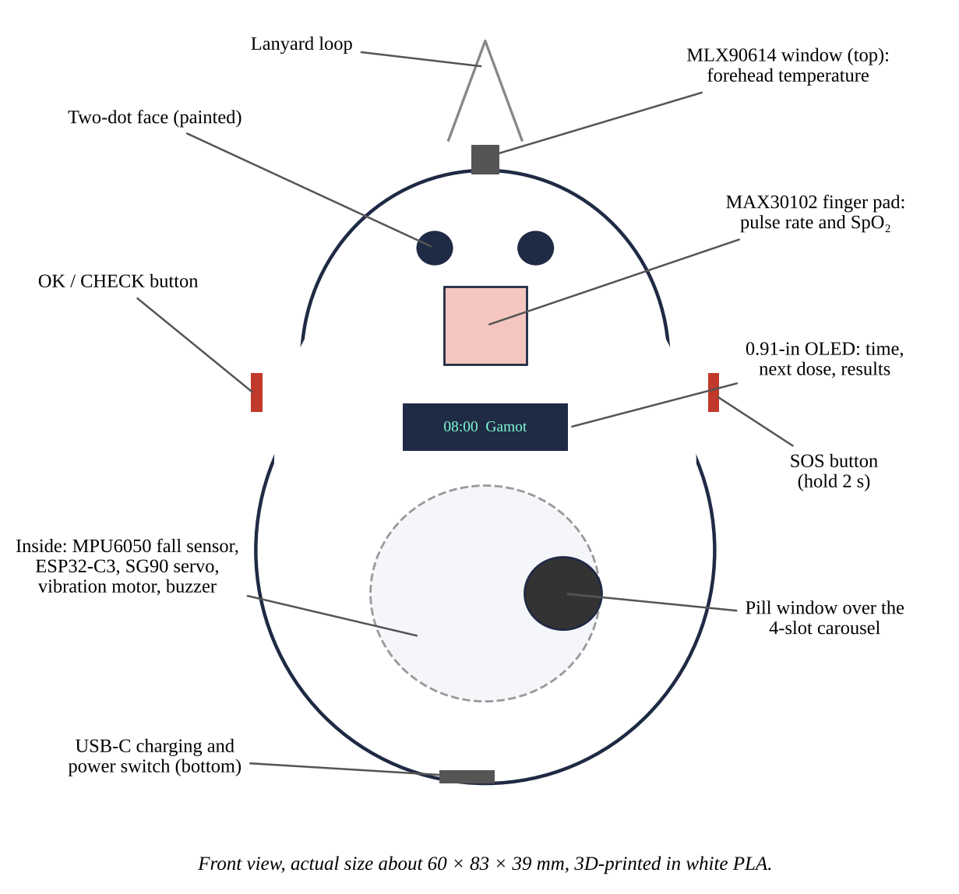
Note. Image created by the researchers, 2026.
3D-Printed Parts: Back Shell, Pill Carousel, and Front Shell
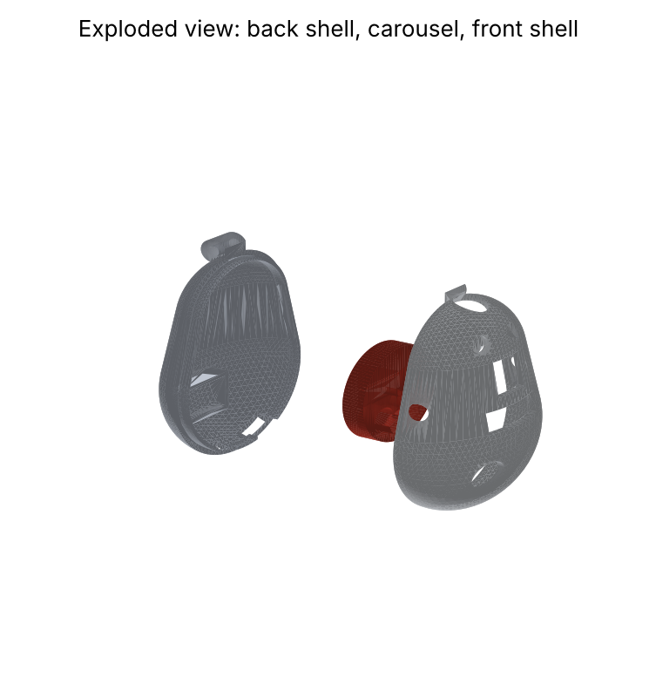
Note. Image created by the researchers, 2026.
Electronics
The MLX90614, MAX30102, MPU6050, and OLED share one I²C bus at 100 kHz on the ESP32-C3. The SG90 servo is powered from the battery through an AO3400 MOSFET that cuts its power between doses. The vibration motor is driven by an S8050 transistor, and a 100 kΩ/100 kΩ divider lets the ESP32-C3 read the battery voltage. Connections are in Appendix A.4.
Wiring Diagram of KALINGA
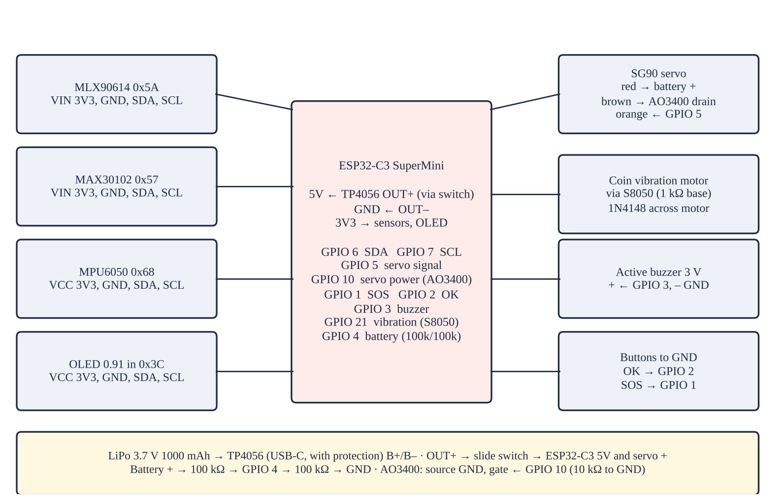
Note. Image created by the researchers, 2026.
Pill Carousel
The 36-mm carousel has four pockets at 45°, 90°, 135°, and 180° and a solid sector at 0°, which closes the window. At each dose time the servo turns the right pocket under the window; the pendant vibrates and beeps every 2 minutes for up to 30 minutes until the user tips the pill out and presses OK. Doses are recorded as taken (within 10 minutes), late, or missed, and a missed dose alerts the family.
Program and App
The ESP32-C3 checks for falls 50 times a second and, once a minute, sends its status and reads the schedule and commands from a Firebase Realtime Database through its REST interface (Google, n.d.). The KALINGA Monitor app signs in with Firebase Authentication and receives changes as a live stream, so new readings and alerts appear within seconds. Database rules let only the family's accounts read or write their patient's data.
How Data Flows Between the Pendant and the App
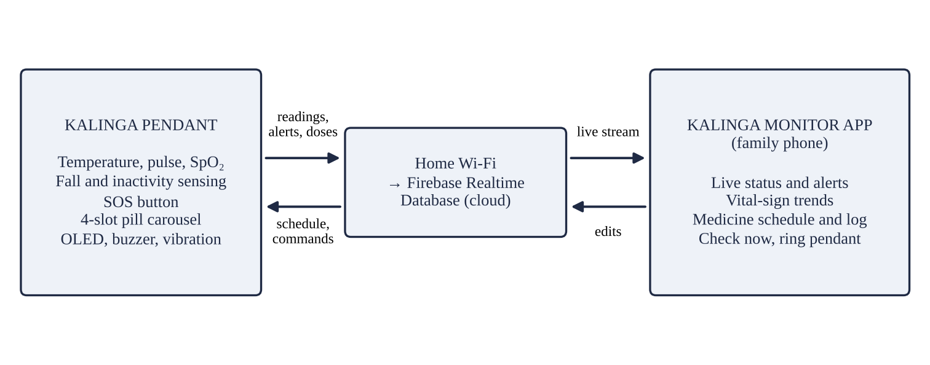
Note. Image created by the researchers, 2026.
KALINGA Monitor App (demo mode): Home, Vitals, and Medicine Screens
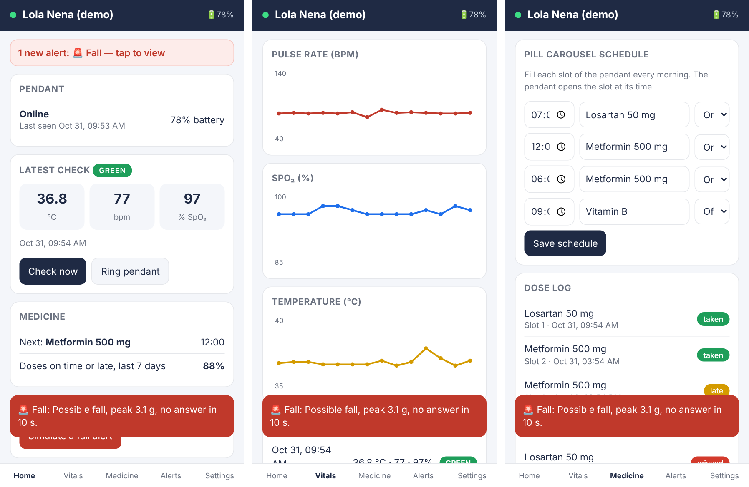
Note. Image created by the researchers, 2026.
Data Gathering
Tests were done indoors at 26 to 30 °C. Volunteers rested seated for 5 minutes before each check, and the pendant and the reference instrument were used within 1 minute of each other in alternating order. The first 10 volunteers formed the calibration set and were not used in the agreement analysis. Simulated falls (forward, backward, sideways, and from a chair) were done only by the researchers onto 20-cm gym mats; daily activities were sitting, lying on a bed, bending, walking, and climbing a step. Placebo candy tablets were used in all dose tests.
Table 3
Trials Conducted in the Study
Trial set | What is measured | Number | Reference
Bench temperature | IR reading of a 35.0–40.0 °C target | 6 × 10 | Probe thermometer
Calibration set | Temperature, PR, SpO₂ | 10 volunteers × 3 | Clinic instruments
Validation set | Temperature, PR, SpO₂ | ____ volunteers × 3 | Clinic instruments
Falls and activities | Fall decision, alert time | ____ falls; ____ activities | Video
Doses | Slot, timing, record | 5 days × 4 slots | Observer log
Delivery and battery | Messages received; hours per charge | 5 days; 3 charges | App log
Usability | SUS | ____ older adults; ____ caregivers | Questionnaire
Note. Table created by the researchers, 2026.
The following formulas were used:
d = KALINGA − reference; Bias = Σd ÷ n | where difference and mean bias | (1)
LoA = Bias ± 1.96 × SD(d); Arms = √(Σd² ÷ n) | where limits of agreement; SpO₂ RMS error | (2)
Sensitivity = TP ÷ (TP + FN); Specificity = TN ÷ (TN + FP) | where falls detected; activities ignored | (3)
t_alert = t_app − t_event | where alert time (s) | (4)
Correct-slot rate = correct slots ÷ doses × 100 | where carousel accuracy (%) | (5)
SUS = 2.5 × [Σ(odd item − 1) + Σ(5 − even item)] | where System Usability Scale score (0–100) | (6)

H₀1 was tested with a paired t-test for each measure, H₀2 with a chi-square test of independence, and H₀3 with a one-sample t-test against 68, at α = 0.05, using Microsoft Excel and JASP.
Flowchart of the Procedure
Steps of the Study
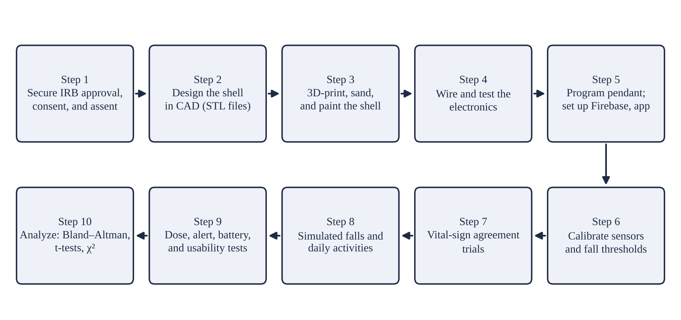
Note. Image created by the researchers, 2026.
III. RESULTS AND DISCUSSION
[NEED: every ____ in this chapter must be replaced with values the researchers measured. No value may be entered that was not measured.]
Agreement of the Vital-Sign Checks
Table 4.1 shows the infrared thermometer against a water-bath target, and Table 4.2 the agreement with the reference instruments in ____ validation volunteers. Temperature had a bias of ____ °C (LoA ____ to ____), pulse rate ____ bpm, and SpO₂ ____% with an Arms of ____%, which ____ the 4% limit. The paired t-test gave p = ____, ____, and ____, so H₀1 is ____.
Table 4.1
Bench Test of the Infrared Thermometer Against a Water-Bath Target
Target (°C) | Probe reading (°C) | ALAGA mean ± SD (°C) | Error (°C)
35.0 | ____ | ____ ± ____ | ____
36.0 | ____ | ____ ± ____ | ____
37.0 | ____ | ____ ± ____ | ____
37.5 | ____ | ____ ± ____ | ____
38.0 | ____ | ____ ± ____ | ____
40.0 | ____ | ____ ± ____ | ____
Note. Table created by the researchers, 2026.
Table 4.2
Agreement of KALINGA With the Reference Instruments
Measure | n | Bias | 95% LoA | MAE | Arms | p
Temperature (°C) | ____ | ____ | ____ to ____ | ____ | ____ | ____
Pulse rate (bpm) | ____ | ____ | ____ to ____ | ____ | ____ | ____
SpO₂ (%) | ____ | ____ | ____ to ____ | ____ | ____ | ____
Note. Table created by the researchers, 2026.
Figure 1
Bland–Altman Plots of Temperature, Pulse Rate, and SpO₂
[NEED: Bland–Altman plots from the measured validation data: difference (ALAGA − reference) against the mean of the two, with lines for the bias and the 95% limits of agreement.]

Note. Figure created by the researchers, 2026.
Fall Detection and Alerts
KALINGA detected ____ of ____ simulated falls (sensitivity ____%) and ignored ____ of ____ daily activities (specificity ____%); χ² = ____, p = ____, so H₀2 is ____ (Table 5.1). Alerts reached the app in a mean of ____ s (Table 5.2).
Table 5.1
Confusion Matrix of KALINGA Fall Decisions
 | True fall | Daily activity | Total
KALINGA: fall | TP = ____ | FP = ____ | ____
KALINGA: no fall | FN = ____ | TN = ____ | ____
Total | ____ | ____ | ____
Note. Table created by the researchers, 2026.
Table 5.2
Time for Alerts to Reach the App
Alert | n | Mean ± SD (s) | Longest (s)
Fall | ____ | ____ ± ____ | ____
SOS | ____ | ____ ± ____ | ____
No movement | ____ | ____ ± ____ | ____
Missed dose | ____ | ____ ± ____ | ____
Abnormal check | ____ | ____ ± ____ | ____
Note. Table created by the researchers, 2026.
Pill Carousel and Dose Records
Over ____ doses, the carousel presented the correct slot ____% of the time, ____% within 1 minute of schedule, and the dose log matched the observers' record in ____% of doses (Table 6.1).
Table 6.1
Dose Presentation and Records Over Five Days
Measure | Count | Result (%)
Correct slot presented | ____ / ____ | ____
Presented within 1 min of schedule | ____ / ____ | ____
Records matching the observer (taken, late, missed) | ____ / ____ | ____
Missed-dose alerts received | ____ / ____ | ____
Note. Table created by the researchers, 2026.
Data Delivery and Battery Life
____% of readings and ____% of alerts reached the app, and one charge lasted ____ h (Table 7.1).
Table 7.1
Data Delivery and Battery Life
Measure | Result
Readings received by the app | ____ / ____ (____%)
Alerts received by the app | ____ / ____ (____%)
Battery life per charge, mean ± SD (h) | ____ ± ____
Charging time (h) | ____
Note. Table created by the researchers, 2026.
Usability
Older adults gave a mean SUS score of ____ and caregivers ____; against 68, t = ____, p = ____, so H₀3 is ____ (Table 8.1).
Table 8.1
System Usability Scale Scores
Group | n | Mean ± SD | t (vs 68) | p
Older adults | ____ | ____ ± ____ | ____ | ____
Family caregivers | ____ | ____ ± ____ | ____ | ____
All users | ____ | ____ ± ____ | ____ | ____
Note. Table created by the researchers, 2026.
Discussion
[NEED: explain the results against the literature: why the SpO₂ and temperature biases are as found (finger movement, skin tone, forehead sweat), which falls were missed and why, what caused late or missed doses, and what users liked or found hard. Compare cost with Table 1.]
IV. CONCLUSION
Summary of Findings
1. Readings had biases of ____ °C, ____ bpm, and ____% SpO₂, with an SpO₂ Arms of ____%; H₀1 is ____.
2. Falls were detected with ____% sensitivity and ____% specificity; alerts arrived in ____ s; H₀2 is ____.
3. The carousel presented the correct slot in ____% of doses, ____% on time.
4. ____% of readings and alerts reached the app; the battery lasted ____ h.
5. Users gave a SUS score of ____; H₀3 is ____.
6. KALINGA cost PHP ____, against PHP ____ for the commercial products in Table 1.
Conclusion
[NEED: one paragraph based on the measured results.] KALINGA joins vital-sign checks, fall and SOS alerts, timed doses, and family monitoring in one low-cost wearable.
Recommendations
1. Shrink the pendant with a custom circuit board and a smaller dispensing mechanism.
2. Add phone push notifications and an LTE module for use outside home Wi-Fi.
3. Test with real falls data and with people of different skin tones and ages.
4. File the shell as an Industrial Design and the carousel as a Utility Model with IPOPHL, keeping the design original rather than copying the film character.
V. ACKNOWLEDGEMENT
[NEED: thank the people and offices that helped: adviser, school clinic, volunteers, family, and any partner who printed the shell.]
VI. REFERENCES
Allen, J. (2007). Photoplethysmography and its application in clinical physiological measurement. Physiological Measurement, 28(3), R1–R39. https://doi.org/10.1088/0967-3334/28/3/R01
Bland, J. M., & Altman, D. G. (1986). Statistical methods for assessing agreement between two methods of clinical measurement. The Lancet, 327(8476), 307–310. https://doi.org/10.1016/S0140-6736(86)90837-8
Bourke, A. K., O'Brien, J. V., & Lyons, G. M. (2007). Evaluation of a threshold-based tri-axial accelerometer fall detection algorithm. Gait & Posture, 26(2), 194–199. https://doi.org/10.1016/j.gaitpost.2006.09.012
Brooke, J. (1996). SUS: A “quick and dirty” usability scale. In P. W. Jordan, B. Thomas, B. A. Weerdmeester, & I. L. McClelland (Eds.), Usability evaluation in industry (pp. 189–194). Taylor & Francis.
Espressif Systems. (n.d.). ESP32 series datasheet. https://www.espressif.com
Fraden, J. (2016). Handbook of modern sensors: Physics, designs, and applications (5th ed.). Springer.
Google. (n.d.). Firebase Realtime Database REST API. https://firebase.google.com/docs/reference/rest/database
Hall, D., & Williams, C. (Directors). (2014). Big Hero 6 [Film]. Walt Disney Animation Studios.
International Organization for Standardization. (2017a). Medical electrical equipment — Part 2-56: Particular requirements for basic safety and essential performance of clinical thermometers for body temperature measurement (ISO Standard No. 80601-2-56:2017).
International Organization for Standardization. (2017b). Medical electrical equipment — Part 2-61: Particular requirements for basic safety and essential performance of pulse oximeter equipment (ISO Standard No. 80601-2-61:2017).
Jubran, A. (2015). Pulse oximetry. Critical Care, 19, Article 272. https://doi.org/10.1186/s13054-015-0984-8
Maxim Integrated. (n.d.). MAX30102: High-sensitivity pulse oximeter and heart-rate sensor for wearable health [Data sheet].
Melexis. (n.d.). MLX90614 family: Single and dual zone infra red thermometer in TO-39 [Data sheet].
Republic Act No. 10173. (2012). Data Privacy Act of 2012. Congress of the Philippines.
Republic Act No. 9994. (2010). Expanded Senior Citizens Act of 2010. Congress of the Philippines.
Sauro, J. (2011). A practical guide to the System Usability Scale: Background, benchmarks & best practices. Measuring Usability LLC.
World Health Organization. (2003). Adherence to long-term therapies: Evidence for action.
World Health Organization. (2021, April 26). Falls [Fact sheet]. https://www.who.int/news-room/fact-sheets/detail/falls
VII. APPENDICES
Appendix A. Raw Data, Expenses, and Connections
Table A.1
Raw Data Sheet for Vital-Sign Checks
Code | Trial | ALAGA T (°C) | Ref T (°C) | ALAGA PR | Ref PR | ALAGA SpO₂ | Ref SpO₂ | Pain | Time (s)
V01 | 1
V01 | 2
V01 | 3
V02 | 1
V02 | 2
V02 | 3
Note. Table created by the researchers, 2026.
Table A.2
Raw Data Sheet for Falls and Daily Activities
Trial | Event | Detected (Y/N) | Cancelled | Peak g | Alert time (s) | Notes
1 | Forward fall
2 | Backward fall
3 | Sideways fall
4 | Fall from chair
5 | Sit down
6 | Lie on bed
7 | Bend
8 | Walk
9 | Climb a step
Note. Table created by the researchers, 2026.
Table A.3
Expense Summary of the Study
Item | Qty | Estimated price (PHP)
ESP32-C3 SuperMini | 1 | 220
MLX90614 (GY-906) module | 1 | 550
MAX30102 module | 1 | 180
MPU6050 (GY-521) module | 1 | 120
0.91-in OLED, 128 × 32, I²C | 1 | 150
SG90 micro servo | 1 | 120
LiPo 3.7 V 1000 mAh (503450) | 1 | 220
TP4056 USB-C charger with protection | 1 | 45
Coin vibration motor, 3 V active buzzer | 1 set | 50
AO3400, S8050, 1N4148, resistors | 1 set | 30
Tactile buttons with caps, slide switch | 1 set | 35
Perfboard, wires, headers | 1 lot | 80
PLA filament or print service (about 60 g) | 1 lot | 250
Black acrylic paint, sandpaper | 1 lot | 40
Breakaway lanyard, M2 screws | 1 set | 60
Total (estimated) |  | 2,150
Note. Table created by the researchers, 2026.
Table A.4
Pin Connections of KALINGA
Part | Pin | ESP32-C3 | Note
MLX90614, MAX30102, MPU6050, OLED | SDA / SCL | GPIO 6 / 7 | I²C at 100 kHz, 3.3 V
SG90 servo | signal / power | GPIO 5 / GPIO 10 | AO3400 switches the servo ground
OK and SOS buttons | to GND | GPIO 2 / GPIO 1 | Internal pull-ups
Buzzer; vibration motor | + ; S8050 base | GPIO 3; GPIO 21 | 1 kΩ base resistor; 1N4148
Battery divider | 100k/100k | GPIO 4 | Reads 0–4.2 V
TP4056 OUT+ / OUT– | via slide switch | 5V / GND | LiPo on B+ / B–
Note. Table created by the researchers, 2026.
Dimensions of the Product
Overall size about 60 mm wide, 83 mm tall, and 39 mm deep, including the lanyard loop; pill carousel 36 mm across with four 9.6-mm pockets. Print files: cad/front_shell.stl, cad/back_shell.stl, and cad/pill_carousel.stl, made by cad/kalinga_pendant.py.
Front Shell, Rendered From the STL File
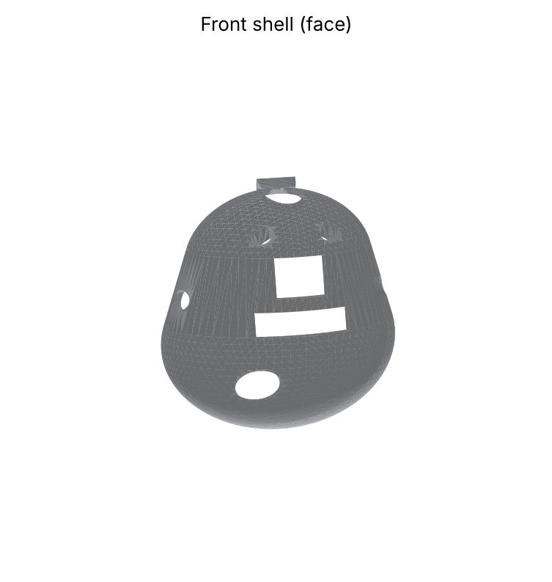
Note. Image created by the researchers, 2026.
[NEED: photographs of the finished pendant with dimension callouts and its weight.]
Program and App
Pendant program: firmware/kalinga_pendant/kalinga_pendant.ino (ESP32C3 Dev Module). App: app/index.html with its manifest and service worker; database rules in app/database.rules.json. The engineering notebook gives every build and setup step.
Photographs of the Procedure
[NEED: dated photographs of each step in the flowchart, each with a bold label and the note “Photographs taken by the researchers, 2026.” No faces of volunteers without written permission.]
Informed Consent
Summary read to each participant: “You are invited to try KALINGA, a pendant that checks temperature, pulse, and oxygen and reminds you about medicine. You will sit while it reads your forehead from a short distance and you place one finger on its pad; the clinic's instruments will be used too. You will answer a short questionnaire. It takes about 20 minutes and does not hurt. You will not be asked to fall or take any medicine. Your name will not be recorded.”
[NEED: signed consent and assent forms and the IRB approval.]
Curriculum Vitae
[NEED: one-page curriculum vitae of each researcher with a 2 × 2 photo.]

