ALAGA
Build Guide: Materials and Step-by-Step Construction
A low-cost soft inflatable healthcare companion robot (RIM-T)
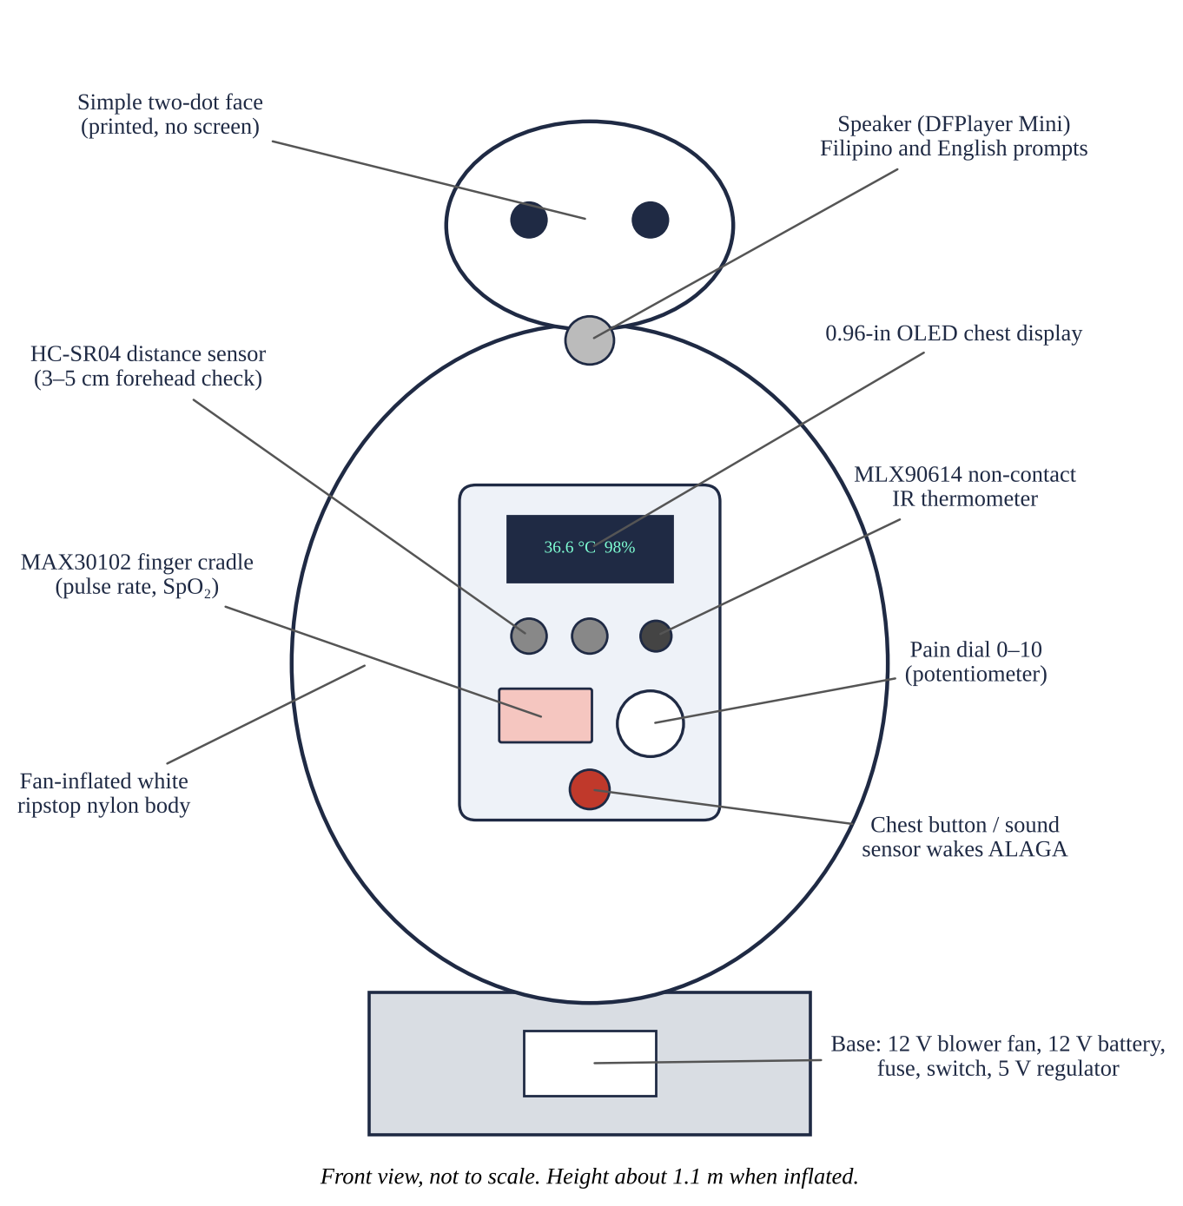
ALAGA when finished: about 1.1 m tall, white, soft, and full of air.
What it does. You press its chest or call out “Aray!”. The fan inflates the body, ALAGA greets you, asks for a pain score (0–10), reads your forehead temperature without touching, reads your pulse rate and oxygen level (SpO₂) from your fingertip, then says GREEN, YELLOW, or RED and tells you whether to see the health worker. After 30 seconds with no one there, the fan stops and the body goes flat.
Time needed. About 4 weekends: sewing (1), base and electronics (1), programming and voice recording (1), assembly and calibration (1). Estimated cost: about PHP 4,600 (Section 1).
Important. ALAGA is a school research prototype, not a medical device. It screens and refers; it never diagnoses. Do not test on any person until your school's Institutional Review Board (IRB) approves the research plan and the volunteers sign consent forms (ISEF Form 4).

1. Materials
Prices are estimates from Philippine electronics shops and online stores (Shopee, Lazada, e-Gizmo, Makerlab) in October 2026. Keep every official receipt; the paper's Appendix A uses the same groups.
Part and specification | Qty | Est. PHP
A. Body
White ripstop nylon, 70D, PU-coated, 150 cm wide | 3 m | 450
Polyester thread (white), 30-cm zipper, fabric glue or seam sealer, black felt or fabric paint | 1 lot | 200
B. Air
12 V DC radial blower fan (e.g., 9733 size, 0.3–0.8 A) with a metal finger guard | 1 | 250
C. Controller and sensors
ESP32 DevKit V1 (30-pin) with USB cable | 1 | 380
MLX90614 non-contact IR thermometer module (GY-906, 3.3–5 V) | 1 | 550
MAX30102 pulse oximeter module (3.3 V I²C pull-ups) | 1 | 180
HC-SR04 ultrasonic distance sensor | 1 | 70
0.96-in OLED display, 128 × 64, I²C (SSD1306, 4-pin) | 1 | 180
D. Voice
DFPlayer Mini MP3 module and 8 GB microSD card | 1 set | 300
Speaker, 3 W, 4 Ω (about 5 cm) | 1 | 80
E. Controls
KY-037 sound sensor, 60-mm arcade push button (red), 10 kΩ potentiometer with knob | 1 each | 160
F. Power
12 V 7 Ah sealed lead-acid (SLA) battery | 1 | 650
LM2596 buck converter, D4184 MOSFET module, fuse holder with 3 A fuse, rocker switch, 1N5819 diode | 1 set | 180
G. Frame, box, and wiring
Jumper wires, 3-core cable (1 m), perfboard 7 × 9 cm, resistors 1 kΩ (×2) and 2 kΩ (×1), heat-shrink | 1 lot | 160
Plastic project box about 20 × 15 × 7 cm (chest box) | 1 | 150
12-mm plywood for a 40 × 40 × 15 cm base box; 3/4-in PVC pipe 1 m, T, end cap, floor flange; screws, Velcro, zip ties, 25-mm grommet kit | 1 lot | 240
H. For the study only
Corrugated plastic (coroplast) sheet for the rigid shell (usability test) | 1 | 300
70% alcohol, wipes, printed data sheets | 1 lot | 150
TOTAL (estimated) |  | 4,630

Tools and equipment (borrow if possible)
• Sewing machine (a hand needle works but is slow), fabric scissors, measuring tape, tailor's chalk, pins
• Soldering iron and solder, wire stripper, small screwdriver, multimeter, hot-glue gun
• Drill with bits, 2.5-cm hole saw or spade bit, jigsaw or hand saw for plywood, PVC cutter
• Laptop with the Arduino IDE 2, and a phone for recording the voice prompts
• 12 V SLA battery charger (1–2 A)
• For calibration and testing: clinical forehead thermometer and fingertip pulse oximeter (borrow from the school clinic), a digital probe thermometer, a pot, a black-painted aluminum can, and hot water
• A sturdy plastic stool or table about 45 cm high to put ALAGA on
Safety rules while building
• Solder only with an adult present, in a ventilated room; unplug the iron when you leave.
• Set the LM2596 output to 5.0 V with a multimeter BEFORE connecting the ESP32; 12 V will destroy it.
• Always put the 3 A fuse on the battery's + wire. Never short the battery terminals.
• Keep fingers away from the fan; the guard goes on the intake side.
• Charge the battery only under supervision, on a non-flammable surface.
2. Sew the Inflatable Body
The body is a “constant-air” inflatable, like an inflatable costume: the fan runs the whole time and air slowly leaks out of the seams. Seams do not need to be airtight, but they must be strong.
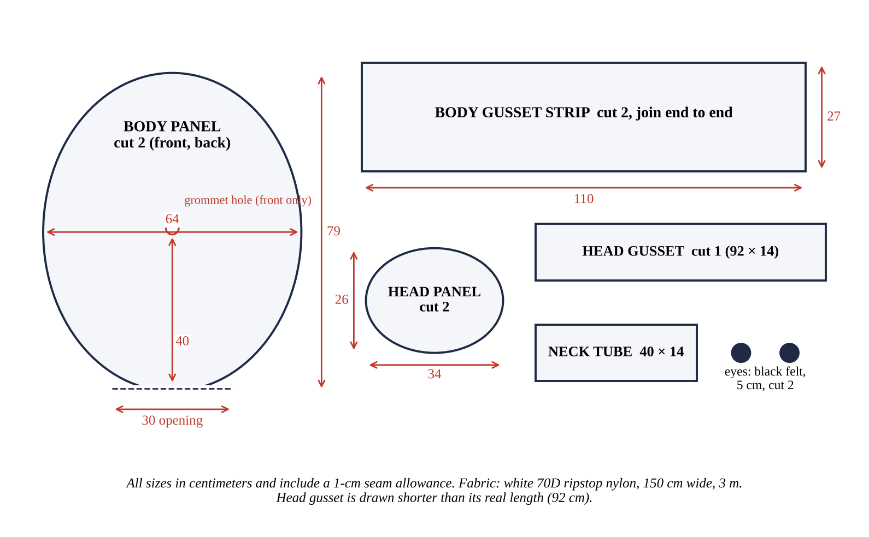
Figure A. Cutting pattern. Draw the ovals by measuring width and height and connecting the points with a smooth curve (use a string as a compass).
1. Lay the fabric flat and mark the pieces in Figure A with chalk: two body panels (64 × 79 cm ovals with a 30-cm flat opening at the bottom), two body gusset strips (110 × 27 cm), two head panels (34 × 26 cm ovals), one head gusset (92 × 14 cm), one neck tube (40 × 14 cm), and two 5-cm black felt eyes.
2. Cut all pieces. Sew the two body gusset strips end to end into one long strip (about 218 cm).
3. Front panel: mark a point on the center line 40 cm above the bottom opening. Iron-on or glue a 10 × 10 cm patch of extra fabric on the inside there, then punch the 25-mm grommet through both layers. The chest box will be bolted through this hole.
4. Pin the gusset strip around the edge of the front panel, right sides together, from one side of the bottom opening, up and over the top, down to the other side. Sew 1 cm from the edge. Trim any extra strip.
5. Sew the back panel to the other edge of the gusset the same way. Turn the body right side out. You now have a thick, pillow-like body with a 30-cm opening at the bottom.
6. Cut a 12-cm circle in the center of the gusset at the very top (the neck hole).
7. Head: sew the head gusset around one head panel, then the other head panel, leaving a 12-cm hole in the middle of the bottom of the gusset. Turn right side out.
8. Neck tube: fold the 40 × 14 cm piece and sew the 14-cm edges together to make a tube 12 cm wide. Sew one end to the body's neck hole and the other end to the head's hole. Air now flows from the body into the head.
9. Sew or glue the two black felt eyes on the head, about 6 cm apart. Keep the face simple (two dots).
10. Bottom opening: fold the edge over 2 cm and sew a hem. You will staple this hem to the base top.
11. Seal the long seams on the inside with seam sealer or fabric glue if the body goes soft too fast.
3. Build the Base Box and Spine
1. Cut 12-mm plywood: top and bottom 40 × 40 cm, four sides 40 × 15 cm (two of them 37.6 × 15 cm so the box comes out square). Screw and glue the sides to the bottom. Keep the top removable (4 screws).
2. Fan hole: in the top board, 8 cm from the center, cut a hole the size of the blower's outlet. Hot-glue the blower under the top board with its outlet pointing up through the hole. Seal gaps with hot glue.
3. Fan air intake: drill about 20 holes of 8 mm in one side of the box near the fan, and put the finger guard on the fan's intake.
4. Spine: screw the PVC floor flange to the center of the top board. Cut a 40-cm PVC pipe, then a T, then a 35-cm pipe above it (total about 78 cm). The T's side outlet points forward at 40 cm, in line with the grommet. Add a 6-cm pipe and end cap to the T's side outlet. Drill a hole through the end cap for the cable.
5. Mount the battery, fuse holder, rocker switch, LM2596, and D4184 module inside the base box with screws or Velcro. Drill the rocker switch hole in a side panel.
6. Feed the 3-core cable (5 V, GND, FAN) from the base, up the spine, and out of the T's end cap.
7. Place the body over the spine so the spine goes inside the body and the end cap meets the grommet. Staple the bottom hem of the body to the edge of the top board (every 3 cm), with the fan hole inside the opening.
8. Push the speaker into the top of the spine pipe and zip-tie it; run its two wires down the pipe to the T.
4. Wire the Electronics
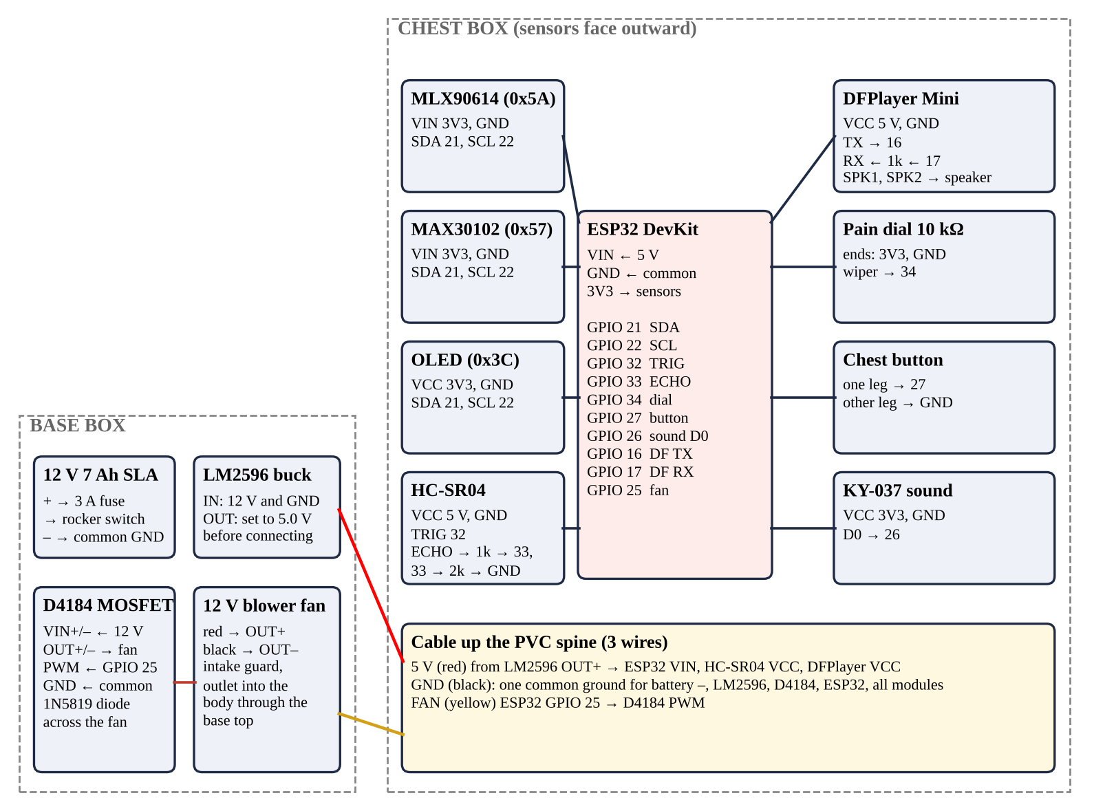
Figure B. Wiring of ALAGA. All grounds (GND) must be connected together.
Base box (power)
1. Battery + → fuse holder (3 A) → rocker switch → “12 V” point. Battery – → “GND” point.
2. 12 V and GND → LM2596 IN+ and IN–. Switch on. Turn the LM2596 screw until the multimeter reads 5.0 V at OUT+ and OUT–. Switch off.
3. 12 V and GND → D4184 VIN+ and VIN–. D4184 OUT+ and OUT– → fan red and black. Solder the 1N5819 diode across the fan wires: stripe (cathode) to the red wire.
4. 3-core cable: red to LM2596 OUT+ (5 V); black to GND; yellow to the D4184 PWM/SIG pin. Also connect the D4184 GND pin to GND.
Chest box (controller and sensors)
1. Cut holes in the lid of the project box: a window for the OLED, two 16-mm holes for the HC-SR04, a 10-mm hole for the MLX90614 (all three near the top edge), a slot for the MAX30102 finger cradle, holes for the dial and the arcade button, and small holes for the sound sensor.
2. Solder the ESP32 onto the perfboard with female headers so it can be removed.
3. Make the HC-SR04 echo divider on the perfboard: ECHO → 1 kΩ → GPIO 33, and GPIO 33 → 2 kΩ → GND.
4. Connect the I²C bus: MLX90614, MAX30102, and OLED all to 3V3, GND, SDA (GPIO 21), and SCL (GPIO 22).
5. Connect the rest using the pin table below. Use red for power, black for GND, other colors for signals.
6. Finger cradle: glue the MAX30102 face-up at the bottom of a 2-cm slot, with a strip of black foam around it to block room light. A clothespin-style flap of foam on top keeps the finger still.
7. Bring the 3-core cable from the spine into the back of the box: red → ESP32 VIN, black → ESP32 GND, yellow → GPIO 25. Connect the speaker wires to DFPlayer SPK1 and SPK2.
8. Screw the chest box to the PVC end cap through the grommet, with the sensors facing out.
Part | Part pin | Connect to
MLX90614, MAX30102, OLED | VIN/VCC, GND, SDA, SCL | 3V3, GND, GPIO 21, GPIO 22
HC-SR04 | VCC, GND, TRIG, ECHO | 5 V, GND, GPIO 32, divider → GPIO 33
DFPlayer Mini | VCC, GND, TX, RX | 5 V, GND, GPIO 16, 1 kΩ → GPIO 17
Pain dial (10 kΩ) | two ends, middle | 3V3 and GND, GPIO 34
Arcade button | two legs | GPIO 27 and GND
KY-037 sound sensor | +, G, D0 | 3V3, GND, GPIO 26
Fan switch (via cable) | D4184 PWM | GPIO 25

5. Program ALAGA
1. Install Arduino IDE 2 on the laptop. In File → Preferences → Additional boards manager URLs, add https://espressif.github.io/arduino-esp32/package_esp32_index.json. In Boards Manager, install “esp32 by Espressif Systems”.
2. In Library Manager, install: Adafruit MLX90614 Library, SparkFun MAX3010x Pulse and Proximity Sensor Library, Adafruit SSD1306, Adafruit GFX Library, and DFRobotDFPlayerMini.
3. Open firmware/alaga/alaga.ino from the project folder.
4. Select Tools → Board → ESP32 Dev Module and the correct port. Click Upload. If uploading stalls at “Connecting…”, hold the BOOT button on the ESP32 until it starts.
5. Open Serial Monitor at 115200 baud. The OLED should show “ALAGA / Press my chest”.
6. Check the I²C parts: upload the Arduino example File → Examples → Wire → WireScan (or any I²C scanner). It must list 0x3C (OLED), 0x57 (MAX30102), and 0x5A (MLX90614). Then upload alaga.ino again.
If 0x57 is missing: some MAX30102 boards pull SDA/SCL up to 1.8 V. Buy the version with 3.3 V pull-ups, or ask the seller before buying. If the sound sensor wakes ALAGA by itself: turn its trimmer until the D0 LED is off in a quiet room. If its D0 goes LOW (not HIGH) when you shout, change HIGH to LOW in the line digitalRead(PIN_SOUND) == HIGH.

Record the voice prompts
Record each line with a phone in a quiet room, save as MP3, and copy to the microSD card (formatted FAT32) in a folder named mp3, with exactly these file names. Ask a classmate with a clear, warm voice.
File | Filipino, then English
mp3/0001.mp3 | Kumusta! Ako si ALAGA, ang kasama mo sa kalusugan. Hello! I am ALAGA, your health buddy.
mp3/0002.mp3 | Gaano kasakit ang nararamdaman mo, mula 0 hanggang 10? Ipihit ang bilog, saka pindutin ang pulang button. How much pain do you feel, from 0 to 10? Turn the dial, then press the red button.
mp3/0003.mp3 | Ilapit ang noo mo sa sensor sa itaas ng aking dibdib. Bring your forehead close to the sensor on my chest.
mp3/0004.mp3 | Ilagay ang hintuturo mo sa butas at huwag gumalaw. Place your index finger in the slot and keep still.
mp3/0005.mp3 | Normal ang mga sukat mo. Uminom ng tubig at magpahinga. Your readings are normal. Drink water and rest.
mp3/0006.mp3 | Pakipuntahan ang health worker para masuri ka pa. Please see the health worker for a check.
mp3/0007.mp3 | Pumunta agad sa health worker ngayon din. Please see the health worker now.
mp3/0008.mp3 | Salamat! Ingat palagi. Thank you! Take care.
mp3/0009.mp3 | Mas lapit pa nang kaunti. A little closer, please.
mp3/0010.mp3 | Hindi ko nabasa. Subukan ulit. I could not read that. Please try again.

6. First Power-Up Checklist
1. Put ALAGA on the 45-cm stool so the chest box is about 1.0–1.1 m from the floor (forehead height of a seated adult; children can stand).
2. Switch on. The OLED shows “ALAGA / Press my chest” and the fan is off.
3. Press the chest button. The fan starts and the body fills in about 20 seconds. If it fills too slowly, seal seams; if it is too hard, leave a 2-cm gap open in a bottom seam.
4. ALAGA greets you and asks for pain. Turn the dial; the OLED shows the number. Press the button.
5. Bring your forehead 3–5 cm from the sensor. ALAGA reads it and asks for your finger.
6. Put your finger in the slot and keep still for about 5 seconds. ALAGA speaks GREEN, YELLOW, or RED and shows the readings.
7. Walk away. After 30 seconds the fan stops and the body goes flat.
8. Check the log: each screening is saved in the ESP32's memory (/log.csv) and printed on the Serial Monitor as RESULT,… lines. Copy these lines into Excel.
7. Calibrate
The MLX90614 reads forehead skin, which is cooler than the body, and low-cost oximeter readings drift. Calibrate before the real tests (only after IRB approval).
1. Bench test: fill a pot with water, put a black-painted can in it, and heat it slowly. With the probe thermometer in the water, take 10 ALAGA readings at 35.0, 36.0, 37.0, 37.5, 38.0, and 40.0 °C. This checks that the sensor is steady and linear.
2. Calibration volunteers (10 people): take three ALAGA readings and three reference readings (clinic thermometer and pulse oximeter) for each person, within 1 minute of each other.
3. Temperature: in Excel, put the raw MLX90614 readings in column A and the reference in column B. =SLOPE(B:B,A:A) gives TEMP_A, and =INTERCEPT(B:B,A:A) gives TEMP_B. To get the raw readings, set TEMP_A = 1 and TEMP_B = 0 in the code during this step.
4. Pulse and SpO₂: average (reference − ALAGA) for each; round to a whole number for PR_OFFSET and SPO2_OFFSET.
5. Type the four values into the top of alaga.ino and upload again. Do not use these 10 volunteers in the validation tests.
Rigid shell for the usability test
Roll a coroplast sheet into a cylinder about 60 cm wide and 75 cm tall, add a 30-cm coroplast dome for the head, and draw the same two-dot face. Cut a window so the same chest box shows through. Volunteers use ALAGA once with the soft body and once inside the rigid shell (in alternating order) and rate how approachable each felt from 1 to 5.
8. Troubleshooting and Care
Problem | Likely cause | Fix
Nothing turns on | Fuse blown, switch off, battery flat | Check fuse with multimeter; charge battery
ESP32 gets hot or dies | LM2596 not set to 5 V | Re-set output to 5.0 V before connecting
Fan never starts | D4184 GND not common; wrong pin | Join all GNDs; check GPIO 25 wire
No sound | Wrong folder or file names; volume | Folder must be mp3, names 0001.mp3 …
Temperature reads too low | Too far, sweat, or not calibrated | Keep 3–5 cm; wipe forehead; calibrate
“Try again” keeps playing | Finger moving, cold, or nail polish | Warm hand, keep still, remove polish
Body goes soft | Big leak at a seam or the hem | Seal seam; re-staple the hem
OLED blank | Wrong address or loose SDA/SCL | Run the I²C scanner; recheck wires

• Wipe the forehead sensor window and the finger slot with 70% alcohol after every person.
• Charge the battery every night; never leave it fully empty.
• Fold the body loosely when stored; keep it away from sharp objects and direct sunlight.
• The robot's results guide people to a health worker; they never replace one.

