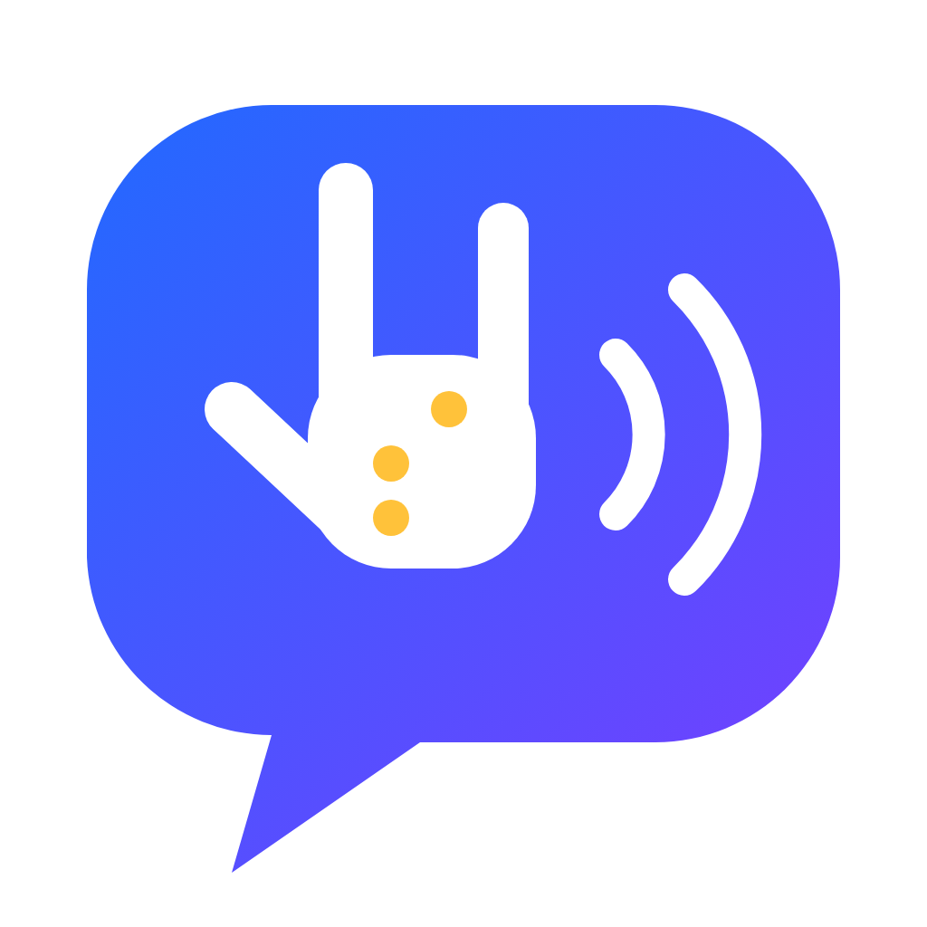
SENYAS: An Offline Intelligent System for Trilingual Sign Language and Braille Translation Using a Kinematic Hand Model, Landmark Geometry, and Braille Grid Fitting
Research Category
Robotics and Intelligent Machines, Team (RIM-T)

Researchers
[Surname, Firstname M.]
[Surname, Firstname M.]
[Surname, Firstname M.]

Research Adviser
[Surname, Firstname M.]

Legazpi City Science High School
Legazpi City, Albay
Bicol Region (Region V), Philippines
National Science and Technology Fair 2026–2027

ACKNOWLEDGMENT
The researchers thank their research adviser for patient guidance; the teachers and staff of Legazpi City Science High School for their support; their families for their encouragement; and the Deaf and blind communities of Albay, whose daily experience of being left out of conversations inspired this work. They also acknowledge the open-source projects that made SENYAS possible, especially MediaPipe, and the authors of the studies cited in this paper.

ABSTRACT
SENYAS: An Offline Intelligent System for Trilingual Sign Language and Braille Translation Using a Kinematic Hand Model, Landmark Geometry, and Braille Grid Fitting
[Surname, Firstname M.], [Surname, Firstname M.], [Surname, Firstname M.]
Legazpi City Science High School, Legazpi City, Albay, Bicol Region (Region V), Philippines
Deaf, blind and hearing Filipinos often cannot talk to one another without an interpreter, and in Albay no tool works in Bikol, offline, on an ordinary phone. This study designed, built and evaluated SENYAS, an intelligent system that reads Filipino Sign Language (FSL) fingerspelling and everyday signs through a camera, speaks the words when the user switches reading aloud on, signs typed or spoken English, Filipino and Bikol back with an avatar, reads braille from a photo or the live camera, and teaches signing. Instead of a large video dataset, it uses the kinematics of a hand modelled like a robot hand to generate its examples, palm-frame coordinates that do not change with position, size or rotation, a nearest-neighbour rule, hysteresis counting and winding numbers for movement, dynamic time warping for signs the user teaches, and a spacing-error fit that snaps braille dots onto their grid. In repeatable computational experiments, static letters were named with 99.0% accuracy at expected camera noise; 570 of 570 moving and two-handed sign trials were detected with no false alarms on still hands; 89.2% of fingerspelled words were read exactly at the default setting; signs taught from three recordings were found in 120 of 120 trials with no false accepts; and 81.7% of 300 braille photos were read exactly (12.6% character error rate). Each frame needed 71 ms for hand tracking and 0.09 ms for recognition, and the interface fitted all 11 screen sizes tested. SENYAS shows that geometry and kinematics can give an offline, trilingual communication aid without big data. A field validation with Deaf and blind learners in Albay is recommended.
Keywords: intelligent machines, computer vision, hand kinematics, Filipino Sign Language, braille recognition, assistive technology

TABLE OF CONTENTS
ACKNOWLEDGMENT 2
ABSTRACT 3
LIST OF TABLES 6
LIST OF FIGURES 7
CHAPTER 1. INTRODUCTION 8
1.1 Background of the Study 8
1.2 Statement of the Problem 9
1.3 Hypotheses 10
1.4 Significance of the Study 10
1.5 Scope and Delimitation 11
1.6 Definition of Terms 11
CHAPTER 2. REVIEW OF RELATED LITERATURE AND STUDIES 12
2.1 Sign Language and Filipino Sign Language 12
2.2 Communication Access for Deaf and Blind Filipinos 12
2.3 Vision-Based Sign Language Recognition 12
2.4 Hand Tracking and Kinematics 13
2.5 Pattern Recognition over Time 13
2.6 Braille and Optical Braille Recognition 13
2.7 Accessible and Adaptive Software 14
2.8 Related Studies 14
2.9 Synthesis and Research Gap 14
2.10 Theoretical Framework 14
2.11 Conceptual Framework 15
CHAPTER 3. METHODOLOGY 15
3.1 Research Design 15
3.2 Materials 16
3.3 System Architecture 16
3.4 Development Procedure 16
3.5 Data Gathering Procedure 20
3.6 Treatment of Data 21
3.7 Ethical Considerations and Safety 21
CHAPTER 4. RESULTS AND DISCUSSION 22
4.1 The Developed System 22
4.2 Static Letters (E1) 22
4.3 Which Parts of the Design Matter (E2) 24
4.4 Moving and Two-Handed Signs (E3) 25
4.5 Fingerspelled Words and the Hold Time (E4) 26
4.6 Signs Taught by the User (E5) 27
4.7 Braille Reader (E6) 28
4.8 The Full Camera Path (E7) 29
4.9 Speed (E8) 30
4.10 Interface Fit, Accessibility and Coverage (E9) 30
4.11 Summary of Hypothesis Tests 31
4.12 Limitations 31
CHAPTER 5. CONCLUSIONS AND RECOMMENDATIONS 32
5.1 Conclusions 32
5.2 Recommendations 32
REFERENCES 34
APPENDICES 36

LIST OF TABLES
Table 1. Null hypotheses and their tests 10
Table 2. Definition of terms 11
Table 3. Related studies and their relation to the present study 14
Table 4. Research gaps and the theories used to address them 14
Table 5. Materials used in development and testing 16
Table 6. The nine experiments 20
Table 7. Accuracy on the 24 static letters 22
Table 8. Ablation of the feature design (1.5× noise, 15% wrong hand labels) 24
Table 9. Detection of moving and two-handed signs (30 trials each) 25
Table 10. Fingerspelled words read exactly (40 words per cell) 26
Table 11. Recognition of signs taught from three recordings 27
Table 12. Braille reading accuracy by photo condition 28
Table 13. Ablation of two optional steps in the braille reader 29
Table 14. Median processing time per frame or photo 30
Table 15. Layout test on 11 screen sizes (five screens each) 30
Table 16. Text contrast against WCAG 2.1 (minimum 4.5 : 1) 30
Table 17. Evaluation mapped to ISO/IEC 25010 quality characteristics 31
Table 18. Summary of hypothesis tests 31

LIST OF FIGURES
Figure 1. Conceptual paradigm of the study 15
Figure 2. Live sign translation with Read aloud, the signing avatar, and the braille reade 22
Figure 3. Static-letter accuracy as pose noise increases 23
Figure 4. Confusion matrix of the static letters at 1.5× noise 24
Figure 5. Accuracy when one part of the design is removed 25
Figure 6. Detection rate of each moving and two-handed sign 26
Figure 7. Word accuracy for each hold time and signer speed 27
Figure 8. Share of braille photos read exactly, by condition 28
Figure 9. Rendered hands found by MediaPipe and letters named correctly 29

CHAPTER 1. INTRODUCTION

1.1 Background of the Study
Republic Act No. 11106 (2018) declared Filipino Sign Language (FSL) the national sign language of the Filipino Deaf and required its use in schools, broadcasts, courts and public health services. Two years earlier, the World Health Organization had begun warning that hearing loss was growing; its World Report on Hearing estimates that more than 430 million people need care for disabling hearing loss (World Health Organization, 2021), and its World Report on Vision counts at least 2.2 billion people with a vision impairment (World Health Organization, 2019). The Magna Carta for Disabled Persons (Republic Act No. 7277, 1992) and the Convention on the Rights of Persons with Disabilities (United Nations, 2006) promise equal access to information. Yet the law and the numbers do not open a conversation by themselves. A Deaf student who needs directions at a terminal, a blind grandmother holding a printed notice, or a hearing nurse explaining a medicine still depends on an interpreter or a reader who is rarely there.
Albay adds two barriers of its own. First, most translation tools work in English, some in Filipino, and almost none in Bikol, the language most families in the province speak at home. Second, the moments when communication matters most, such as an evacuation before Mayon erupts, a typhoon or an earthquake, or a consultation in a far barangay health station, are exactly when mobile data fail. A tool that needs a server stops working at the moment it is needed.
Phones can now track the 21 joints of each hand in real time without the internet (Zhang et al., 2020). What remains is machine intelligence: turning those points into letters and words reliably, recognising signs that move, reading braille dots from a picture taken at an angle, and doing all of this in three languages on an inexpensive device. This is a problem for intelligent machines in the full sense: the system must perceive (camera), model (a kinematic hand), decide (classification under noise), act (speak, sign with an avatar) and adapt (learn new signs from the user). This study builds and tests such a system, called SENYAS, from the Filipino word for sign or gesture.
Current research on sign language recognition is dominated by deep neural networks trained on thousands of annotated videos (Koller, 2020; Rastgoo et al., 2021). Such networks reach high accuracy on the languages and signers they were trained on, but FSL, and FSL used by Bikol speakers, has no public dataset of that size, and the networks are heavy to run offline on low-cost phones. Optical braille recognition has a similar history: published systems rely on flatbed scanners and controlled lighting (Antonacopoulos & Bridson, 2004; Isayed & Tahboub, 2015), not on a phone held over a page. A different route is to describe the hand and the braille cell with geometry. A hand is a chain of rigid links joined by revolute joints, exactly like a robot hand (Craig, 2005); a braille cell is a two-by-three grid with fixed spacing (International Council on English Braille, 2013). If these structures are written as equations, labelled examples can be generated instead of collected, features can be made independent of how the hand or page is held, and every decision can be explained and tested. SENYAS follows this route.

1.2 Statement of the Problem
The study aimed to design, develop and evaluate SENYAS, an offline intelligent system that translates between sign language, braille, text and speech in English, Filipino and Bikol, with a learning module. Specifically, it sought to answer the following:
1. How accurately does a nearest-neighbour recogniser that uses palm-frame features, with examples generated by a kinematic hand model, classify the 24 static letters of the FSL manual alphabet as pose noise increases, and which design components account for its accuracy?
2. How reliably do the motion rules and two-hand rules detect 13 moving and 6 two-handed signs, and how often do still letters trigger a false moving sign?
3. How accurately are whole fingerspelled words read, and how does the hold-time setting interact with the signer's speed?
4. How reliably are signs that the user teaches from three recordings recognised, and how often are other signs falsely accepted as taught signs?
5. How accurately does the grid-fitting braille reader decode photos of Grade 1 braille that differ in dot type, skew, blur and dot size?
6. How long does each component take per camera frame or photo, and is this fast enough for live use?
7. Does the interface adapt to phones, tablets, computers and televisions without layout faults, with readable contrast and adequate touch targets, and how completely does the trilingual lexicon carry the phrasebook into signs?

1.3 Hypotheses
The following null hypotheses were tested at the 0.05 level of significance.
Table 1. Null hypotheses and their tests
Code | Null hypothesis | Test
H₀1 | Static-letter accuracy at expected noise is at most 90%. | One-sided exact binomial test
H₀2 | The detection rate of moving and two-handed signs is at most 90%. | One-sided exact binomial test
H₀3 | Fingerspelled-word accuracy at the default hold time is at most 80%. | One-sided exact binomial test
H₀4 | The braille reader's character error rate is at least 20%. | Comparison with the bound; Wilson interval
H₀5 | Processing time per frame exceeds 100 ms (fewer than 10 frames per second). | Median latency
H₀6 | The interface shows sideways scrolling or a missing navigation bar on at least one tested screen size. | Automated layout test

1.4 Significance of the Study
Deaf and hard-of-hearing learners. SENYAS turns their signing into spoken Filipino, English or Bikol and lets them follow hearing speakers through an avatar, at no cost and without data.
Blind and low-vision persons. Braille labels, notices and school materials can be read aloud from a photo, and typed text is shown in braille for learners.
Teachers, SPED centres and families. Lessons, quizzes, flashcards, games and camera practice support learning FSL in the home language, in line with Universal Design for Learning (CAST, 2018).
Health workers, police and disaster responders. An emergency phrasebook (help, doctor, hospital, fire, earthquake, flood, typhoon) works with no signal during disasters in Albay.
Future researchers. The study offers an explainable method that does not need a large dataset and open benchmarks that can be repeated and extended.
The study supports Sustainable Development Goals 4 (inclusive and quality education), 10 (reduced inequalities) and 11.5 (reducing the effects of disasters) (United Nations, 2015), and the aims of RA 11106 and RA 7277.

1.5 Scope and Delimitation
The study covers the one-handed manual alphabet A–Z with Ñ, the numbers 0–10, and 21 everyday signs read directly by the camera, in forms shared by FSL and American Sign Language; 93 signed words and 32 phrases in English, Filipino and Central Bikol; signs taught by the user; Grade 1 (uncontracted) braille with capitals, numbers, common punctuation, Ñ and five whole-word contractions; and the web, installable and Android versions of the app. The study does not cover full FSL sentences with grammar and facial expressions, Grade 2 braille, or testing with Deaf or blind participants, which is recommended for the next phase. All performance figures come from computational experiments on generated data, which are described fully so that they can be repeated. The rendered-hand test of Section 4.8 is a lower bound on the full camera path, not a field accuracy.

1.6 Definition of Terms
Table 2. Definition of terms
Term | Conceptual meaning | Operational meaning in this study
Intelligent system | A machine that perceives, decides and acts toward a goal. | SENYAS: camera and microphone input, recognition, speech and avatar output.
Landmark | A point that marks a body joint. | One of the 21 hand points reported by MediaPipe for each hand.
Kinematic hand model | Equations that place the links of a hand from its joint angles. | The SENYAS model that builds 37 handshapes for templates and the avatar.
Palm frame | A coordinate system attached to an object. | Axes built from the wrist and three knuckles of a detected hand.
Template | A stored example of a class. | A 41-number feature vector of a known handshape.
Fingerspelling | Spelling words with handshapes of the alphabet. | Letters held for the hold time are added to the current word.
Hold time | How long a handshape must stay before it counts. | 300, 400 (default) or 600 ms in the app settings.
Braille cell | Six dot positions in two columns and three rows. | A six-bit pattern decoded into a letter, digit or sign.
Character error rate | The share of characters read wrongly. | Levenshtein distance divided by the length of the true text.
Read aloud | Speaking recognised text. | The switch that makes SENYAS speak each recognised word; the user turns it on or off.

CHAPTER 2. REVIEW OF RELATED LITERATURE AND STUDIES

2.1 Sign Language and Filipino Sign Language
Sign languages are full natural languages with their own grammar, not codes for spoken languages. Stokoe (1960) showed that each sign can be described by a small set of parameters: the handshape, the location where it is made, and the movement. This description is the basis of SENYAS: the handshape is read from the joint positions, the location from where the hand is in the frame and relative to the other hand, and the movement from how these change over time. RA 11106 (2018) makes FSL the medium of instruction for Deaf learners and the language of interpreting in government. FSL shares its one-handed manual alphabet with ASL, so a fingerspelling recogniser serves users of both, while many FSL words have local forms that differ by region.

2.2 Communication Access for Deaf and Blind Filipinos
The World Health Organization (2019, 2021) reports that hearing and vision impairments are common and rising, and that most affected people live in low- and middle-income countries where services are scarce. Philippine law guarantees access: RA 7277 (1992) requires auxiliary aids and accessible communication, and the Data Privacy Act (RA 10173, 2012) protects the personal information that any assistive tool might collect. Interpreters and braille transcribers remain few, especially outside Metro Manila, so most daily conversations between Deaf, blind and hearing people happen without support.

2.3 Vision-Based Sign Language Recognition
Early gesture recognisers used data gloves or coloured markers; camera-based methods later replaced them (Mitra & Acharya, 2007). Surveys of the field show that recent systems use convolutional and recurrent networks or transformers trained on large datasets, and that results drop sharply on new signers or new sign languages (Koller, 2020; Rastgoo et al., 2021). For FSL, Cabalfin et al. (2012) recognised signs from video using manifold projection learning, showing that FSL recognition by computer is possible but also that data are limited. Landmark-based methods reduce the input to joint positions, which removes background and skin colour from the problem and makes small models possible.

2.4 Hand Tracking and Kinematics
MediaPipe is a framework for building perception pipelines that run on devices (Lugaresi et al., 2019). Its hand solution first detects a palm and then regresses 21 three-dimensional landmarks in real time on mobile hardware (Zhang et al., 2020). It reports both image coordinates and world coordinates in metres around the hand. In robotics, the position of a manipulator's links follows from its joint angles through forward kinematics, and the joint angles that place its end at a target follow from inverse kinematics (Craig, 2005). FABRIK solves inverse kinematics by alternately pulling a chain toward its target and back to its base, converging quickly without matrix inversion (Aristidou & Lasenby, 2011). A human hand can be modelled with the same tools: four fingers with three revolute joints each and a thumb with a more mobile base.

2.5 Pattern Recognition over Time
The nearest-neighbour rule assigns an input to the class of its closest stored example; Cover and Hart (1967) proved that, as examples grow, its error is at most twice the lowest possible (Bayes) error. Dynamic time warping aligns two sequences that unfold at different speeds, and a Sakoe–Chiba band limits how far the alignment may stretch, which both speeds it up and prevents unrealistic matches (Sakoe & Chiba, 1978). Hysteresis, first used in the Schmitt (1938) trigger, makes a detector change state only after a signal moves past a margin, so small jitter does not cause false switching; SENYAS uses the same idea to count the back-and-forth of a moving hand.

2.6 Braille and Optical Braille Recognition
In Unified English Braille, each letter is a pattern of up to six raised dots in a cell; a number sign turns the letters a–j into digits and a capital sign marks capitals (International Council on English Braille, 2013). Filipino uses the same letters with Ñ. Optical braille recognition must find dots that may be printed or embossed, lit from one side, and slightly skewed. Antonacopoulos and Bridson (2004) recognised braille from scanned pages by finding dot shadows and fitting a grid, and Isayed and Tahboub (2015) found that grid estimation and skew are the hardest steps. Summed-area tables give the mean of any rectangle in constant time (Crow, 1984; Viola & Jones, 2001), which makes local contrast fast enough for live video.

2.7 Accessible and Adaptive Software
The Web Content Accessibility Guidelines 2.1 set measurable criteria, including a contrast of at least 4.5 to 1 for normal text and content that reflows without sideways scrolling (World Wide Web Consortium, 2018). Responsive design adapts one layout to many screens (Marcotte, 2010). ISO/IEC 25010 (2011) defines software quality in eight characteristics, from functional suitability and performance efficiency to usability, security and portability, which this study uses to organise its evaluation. Universal Design for Learning recommends many means of representation and expression (CAST, 2018), which the learning module follows by showing every sign as an animation, three written words, speech and, for letters, braille.

2.8 Related Studies
Table 3. Related studies and their relation to the present study
Study | What was done | Relation to the present study
Zhang et al. (2020) | Real-time 21-point hand tracking on phones. | Supplies the landmarks SENYAS reads.
Cabalfin et al. (2012) | FSL recognition from video with manifold learning. | Confirms FSL recognition is possible; SENYAS adds offline use, Bikol and braille.
Koller (2020); Rastgoo et al. (2021) | Surveys: most methods are deep and data-hungry. | Motivates a geometric method that needs no large dataset.
Mitra & Acharya (2007) | Survey of gesture recognition methods. | Supports separating handshape from movement.
Aristidou & Lasenby (2011) | FABRIK inverse kinematics. | Places the thumb of the hand model and the avatar.
Antonacopoulos & Bridson (2004) | Braille recognition from scanned pages. | SENYAS reads phone photos and live video with skew and blur.
Isayed & Tahboub (2015) | Review of optical braille recognition. | Identifies grid fitting and skew as key steps, addressed here.

2.9 Synthesis and Research Gap
Hand tracking is good enough to run on phones, but no study has turned landmarks into FSL letters and words offline, with Bikol output and speech, and joined this with braille reading and an avatar that signs back. Deep methods need data that FSL does not have; braille readers assume scanners. The gap this study fills is an intelligent, explainable, offline system for the three languages of Albay whose behaviour can be stated, measured and improved.

2.10 Theoretical Framework
Table 4. Research gaps and the theories used to address them
Gap | Theory or method that addresses it
G1 No large FSL dataset | Robot-hand kinematics (forward kinematics and FABRIK) generates labelled handshapes (Craig, 2005; Aristidou & Lasenby, 2011).
G2 Hands differ in position, size and angle | Coordinates in a frame attached to the palm are unchanged by translation, scaling and rotation.
G3 Noisy landmarks and similar shapes | Nearest-neighbour classification with a confidence margin (Cover & Hart, 1967).
G4 Signs move at different speeds | Hysteresis counting (Schmitt, 1938), winding numbers, and dynamic time warping (Sakoe & Chiba, 1978).
G5 Braille photos are skewed and noisy | Summed-area tables (Crow, 1984), robust spacing and skew estimates, and grid fitting by error minimisation.
G6 Three languages, no signal, many screens | A trilingual phrase index with longest-match lookup; responsive, accessible design (W3C, 2018).

2.11 Conceptual Framework
Figure 1 shows the input–process–output paradigm. The inputs are camera frames of hands, photos or frames of braille, and typed or spoken text. The processes turn them into landmarks and features, decisions about signs, dots and cells, and lookups in the trilingual index. The outputs are text in the chosen language with optional speech, and an avatar that signs, with the text also shown in braille. Benchmark results feed back into the design.
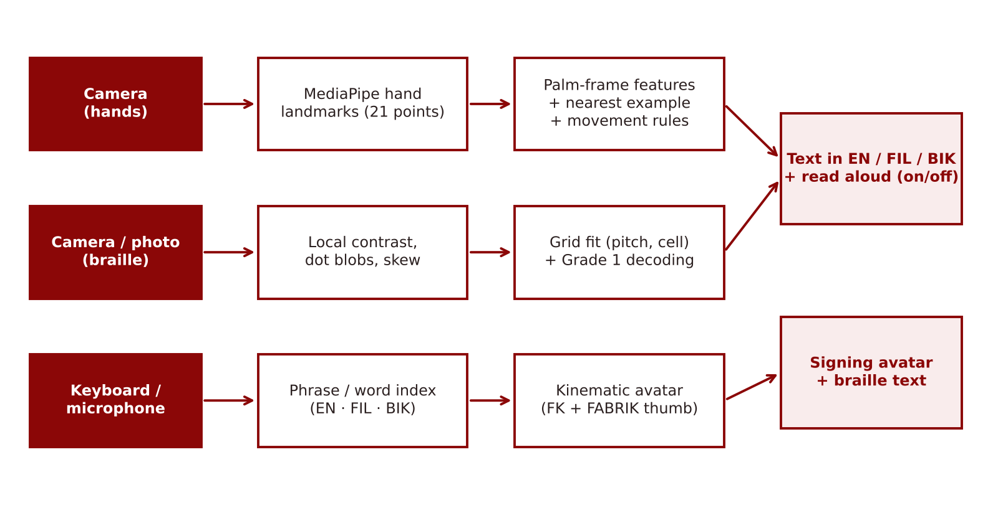
Figure 1. Conceptual paradigm of the study

CHAPTER 3. METHODOLOGY

3.1 Research Design
The study used a developmental engineering-design approach (Hevner et al., 2004). The intelligent system was designed from kinematic and geometric models, built as working software for phones and computers, and evaluated quantitatively through nine repeatable computational experiments that simulate its inputs. The independent variables were pose noise, the sign, the hold time and signer speed, the braille photo condition and the screen size; the dependent variables were accuracy, detection and false-alarm rates, word accuracy, character error rate, processing time and layout faults.

3.2 Materials
Table 5. Materials used in development and testing
Item | Specification | Use
Computer | x86-64 CPU, Linux; no GPU used in tests | Development and all benchmarks
Chromium (headless) with Playwright | Desktop browser engine and test driver | Runs the app, MediaPipe, braille and layout tests
Node.js 22 | JavaScript runtime | Recogniser benchmarks
MediaPipe Tasks Vision 0.10.14 | Hand Landmarker, float16 model (Apache-2.0) | On-device hand landmarks
HTML, CSS and JavaScript | No framework; one 190 KB page | The app and the website
Kotlin and Android WebView | Android 7.0 or later | Android app with phone speech and camera
Python 3, Matplotlib, python-docx | Statistics, figures, documents | Analysis and reporting

3.3 System Architecture
SENYAS has four engines that share one page: the sign engine (camera → MediaPipe → features → decisions), the avatar engine (text → index → signs → kinematic animation), the braille engine (photo or frame → dots → grid → text), and the speech engine (text → device voice, and microphone → text). All engines run on the device. A consent sheet decides what is saved; video, photos and audio are never stored or sent. The app adapts its layout with CSS media queries: a bottom tab bar on phones, a side rail on tablets, both translation directions side by side on wide screens, a camera-beside-text layout on phones held sideways, and larger type on televisions.

3.4 Development Procedure

3.4.1 The kinematic hand model
Each finger i has a knuckle at mᵢ on the palm, a spread angle aᵢ and three links of lengths ℓ₁, ℓ₂, ℓ₃. With joint flexions θ₁, θ₂, θ₃, link j points in the direction
dⱼ = cos(θ₁ + … + θⱼ) u + sin(θ₁ + … + θⱼ) z, u = (sin aᵢ, cos aᵢ, 0) (1)
where z is the palm normal, so joint j lies at mᵢ + ℓ₁d₁ + … + ℓⱼdⱼ. This is forward kinematics for a planar three-link chain turned by the spread angle. The thumb has a more mobile base, so it is placed by FABRIK: its base is fixed, its tip is sent to a target (for example, the side of the index finger for A, or the tip of the middle finger for D), and the chain is pulled alternately to the target and the base for 14 iterations. A handshape is therefore a vector of 12 finger angles, 4 spreads and one thumb target; 37 shapes were defined this way. An orientation is given by the finger direction f and palm direction n, made orthonormal and assembled into the rotation [f × n, f, n]. The same model animates the avatar, blending angles, thumb targets and orientations between keyframes with a smoothstep curve, so the shapes it signs are the shapes it recognises.

3.4.2 Palm-frame features
For the landmarks p₀ … p₂₀ of a detected hand (wrist p₀; index, middle and little-finger knuckles p₅, p₉, p₁₇), the palm frame is
s = ‖p₉ − p₀‖, Y = (p₉ − p₀)/s, Z = (p₅ − p₁₇) × Y / ‖(p₅ − p₁₇) × Y‖, X = Y × Z (2)
and each fingertip and middle joint q is written as c(q) = ((q − p₀)·X, (q − p₀)·Y, (q − p₀)·Z)/s. These 30 values are joined by four thumb-to-fingertip distances, three distances between neighbouring fingertips and four orientation terms, giving a weighted 41-number vector.
Proposition 1 (invariance). If every landmark is moved by a similarity transform p ↦ λRp + t with λ > 0 and R a rotation, the 30 palm-frame values and the 7 distance ratios do not change.
Proof. The palm length becomes λs. The differences p₉ − p₀ and p₅ − p₁₇ become λR(p₉ − p₀) and λR(p₅ − p₁₇); since a rotation preserves lengths and cross products, the new axes are RX, RY and RZ. For any joint, (λR(q − p₀))·(RY)/(λs) = (q − p₀)·Y/s because RᵀR = I, and likewise for X and Z. Distance ratios are unchanged because all lengths scale by λ. ∎
A reflection has determinant −1 and reverses the cross product, so the mirror image of a right hand has its Z axis flipped; this is why a left hand is mirrored into a right hand before comparison. Because a camera's left/right label can be wrong, SENYAS compares both the hand and its mirror image and keeps the closer match. The four orientation terms are deliberately not invariant: they tell apart letters that share a handshape but point differently, such as G and Q, K and P, and H and U.

3.4.3 Templates, classification and confidence
Each built-in template is a hand-model shape turned by random rotations of up to about ±17° and loosened by random joint changes, giving 572 templates. A new hand is assigned the label of its nearest template by Euclidean distance; examples that the user records are weighted by 0.8 so that they are preferred. With d₁ and d₂ the distances to the best and second-best labels, the confidence is
c = clip((1.55 − d₁)/1.0, 0, 1) × min(1, 0.35 + 2.2 (d₂ − d₁)) (3)
Classifying one hand costs about N × D = 572 × 41 ≈ 23,000 multiply-adds, which is negligible on a phone.

3.4.4 Decisions over time
A letter is written only when the same label has been held for the hold time (400 ms by default) while the wrist moves less than 0.6 palm-lengths over 0.4 s, so letters are not written during transitions. A double letter, as in HELLO, is signed with a short sideways slide of the same handshape: when the wrist has moved more than 0.4 palm-lengths since the last letter and then rests, the letter is written again. When no hand is seen for 0.9 s, the spelled word is closed and looked up in the dictionary, so that spelling T-U-B-I-G gives water, and the word is spoken if reading aloud is on.

3.4.5 Moving and two-handed signs
The last 1.5 s of wrist and fingertip positions are kept in palm-length units. Back-and-forth movement is counted with hysteresis: a reversal is counted only after the signal has turned back by more than an amplitude A, so jitter smaller than A is ignored. Hello is an open hand whose fingertips reverse at least twice; yes is a fist whose knuckles reverse vertically; where is a wagging index finger; bathroom is a shaking T; water and eat are taps of W and flat-O hands. Please and sorry are circles of a flat hand and a fist, detected by the winding number
w = (1/2π) Σₜ wrap(φₜ − φₜ₋₁), φₜ = atan2(yₜ − ȳ, xₜ − x̄) (4)
which must exceed 0.8 turns, with a mean radius above 0.28 palm-lengths and a roundness (short side over long side of the path's bounding box) above 0.45. Thank you is a flat hand moving down from chin height. J, Z and Ñ are the I, index and N handshapes held throughout a hook, a zig-zag and a shake. Two-handed signs are named from the pair of handshapes and the distance between chosen points: two fists close together for love, a thumbs-up resting above a flat palm for help, touching flat-O fingertips for more, touching flat-hand fingertips for house, linked hooked index fingers for friend, and tapping H hands for name.

3.4.6 Signs taught by the user
A user can teach any sign, such as a local FSL word or a name sign, by recording it three times for 1.5 s. If the hand moves less than 1.1 palm-lengths, the three mean feature vectors become templates. Otherwise each take is resampled to 16 frames of 44 numbers (the features plus the wrist displacement and whether a second hand is present) and stored as a sequence. A new movement is compared with each take by dynamic time warping with a band of four frames; its distance is divided by a tolerance τ equal to 1.6 times the average distance between the user's own three takes (bounded to 0.75–1.6), and the sign is accepted when the ratio is below 1. Each comparison costs about 16 × 9 × 44 operations.

3.4.7 The braille reader
A photo or video frame is reduced to at most 1,100 pixels wide and turned to grey. A summed-area table gives the local mean over a window of about one-fortieth of the image in constant time per pixel; pixels darker than the local mean by 1.8 standard deviations (printed dots) or lighter (embossed dots catching the light) form candidate blobs found by flood fill. Blobs that are smaller than 8 pixels, elongated or far from the typical dot size are discarded, and the polarity whose blobs are most uniform and best supported by neighbours at dot spacing is kept. The dot spacing δ is the median of the nearest-neighbour distances that are within 1.2 times their lower quartile, which ignores the longer diagonal and between-cell distances, and the skew is the median nearest-neighbour angle folded into (−45°, 45°]. After the points are turned upright, rows are clustered with a gap of δ/2 and grouped into lines of three. In each line the cell grid is found by minimising
E(P, x₀) = Σ_c min(|u_c − kP|, |u_c − δ − k′P|), u_c = x_c − x₀, 2.1δ ≤ P ≤ 2.9δ (5)
over the cell pitch P and offset x₀, where x_c are the column centres and k, k′ the nearest integers. Each dot is then given a cell, column and row, forming a six-bit number that a small state machine decodes: the number sign switches the letters a–j to digits until a space, the capital sign raises the next letter, and standalone cells for and, for, of, the and with are read as words. The whole reader is linear in the number of pixels apart from the small grid search.

3.4.8 Translation, speech and the avatar
All 93 words, the numbers and 32 phrases are stored with their English, Filipino and Bikol forms in a single index. Text is normalised (lower case, accents removed) and matched greedily, longest phrase first up to seven words; matched phrases expand into their sign order, single words map to their signs, and anything else is fingerspelled. The avatar is a drawn signer whose arms are placed by two-link inverse kinematics from the shoulder to the wrist, with each hand drawn from the kinematic model with depth ordering, simple facial expressions for questions and feelings, and adjustable speed. Speech uses the device voice: on the web, the Speech Synthesis API; on Android, the phone's text-to-speech engine through a JavaScript bridge. Bikol text is read with a Filipino voice, the closest one available.

3.4.9 The app, website and privacy design
The app is a single installable web page (190 KB, plus the 17 MB hand-tracking engine kept for offline use) that works on Android, iPhone, iPad, computers and televisions; an Android app wraps the same page with access to the camera, microphone and phone voice, and is built automatically for download from the website. The website explains the features, shows a live avatar demonstration, offers downloads for each device and includes a cookie banner and privacy policy. In the app, a consent sheet explains that video, photos and audio never leave the device and lets the user choose whether settings, progress and taught signs are saved; with essential storage only, nothing else is kept.
Algorithm 1. Reading one camera frame
for each detected hand h:
f1 ← features(h as labelled), f2 ← features(mirror of h)
d[label] ← min over templates of min(‖f1 − t‖, 1.04‖f2 − t‖)
choose the dominant hand; append its points to the 1.5 s buffer
if a taught moving sign matches (DTW ratio < 1): write it; stop
if a moving-sign rule fires: write the sign; clear the buffer; stop
if two hands form a two-handed sign for the hold time: write it; stop
best ← nearest allowed label; if confidence > 0.32 and steady for the hold time:
write the letter or word (speak it if Read aloud is on)

3.5 Data Gathering Procedure
Table 6. The nine experiments
No. | Experiment | Data generated | Measure
E1 | Static letters | 24 letters × 40 hands × 4 noise levels (960 per level); one in four left-handed | Accuracy
E2 | Ablation | 24 letters × 30 hands at 1.5× noise, 15% wrong hand labels, five designs | Accuracy
E3 | Moving and two-handed signs | 19 signs × 30 streams at 30 frames per second with random size and speed; 144 still streams | Detection, false alarms
E4 | Fingerspelled words | 40 words × 3 hold times × 3 signer speeds, with transitions and double letters | Word accuracy, CER
E5 | Taught signs | 4 new movements, 3 recorded takes each, 30 new trials each, 104 look-alike trials | Detection, false accepts
E6 | Braille photos | 300 photos with random dot type, skew ±6°, spacing 12–20 px, blur 0–1.6 px, uneven light, noise; ablation of two steps | Exact rate, CER
E7 | Full camera path | 288 rendered hands (24 letters × 3 skin tones × 2 hands × 2 tilts) given to MediaPipe | Detection, accuracy
E8 | Speed | 400 recogniser frames, 288 MediaPipe images, 300 braille photos | Median time
E9 | Screens and access | 11 screen sizes × 5 screens; 7 colour pairs; phrasebook in 3 languages | Layout faults, contrast, coverage

In E1–E5, hands were generated by the kinematic model with random joint changes (standard deviation 7° times the noise multiplier), thumb-target changes, rotations of 0.2–0.3 radians times the multiplier, and landmark noise of 2.5–3.5 mm times the multiplier, then converted to MediaPipe's coordinate conventions and passed through exactly the same code the app runs. Random numbers came from a fixed-seed generator, so every run can be repeated.

3.6 Treatment of Data
Proportions are reported with 95% Wilson (1927) intervals, which remain accurate near 0% and 100%. H₀1–H₀3 were tested with one-sided exact binomial tests, p = P(X ≥ k | n, p₀). The character error rate is the total Levenshtein (1966) distance divided by the total length of the true text, with each photo's error capped at its length. Times are medians. All computations are in the open scripts bench_recognizer.js, bench_browser.js, bench_ui.js and analyze.py.

3.7 Ethical Considerations and Safety
No human participants took part in this phase, so no personal data or consent forms were needed. The app processes camera images, photos and audio on the device and never uploads them; it asks before saving anything, lets users export or delete their data, and follows the Data Privacy Act of 2012. The app tells users that its signs are forms shared by FSL and ASL, that local FSL signs vary, and that it is not a certified interpreter; for medical, legal and emergency matters it advises asking for a qualified FSL interpreter. All sources are cited, and the open-source hand-tracking engine is used under its Apache 2.0 licence. Any future test with Deaf or blind persons will undergo ethics review, obtain parental consent for minors, and be carried out with the Deaf community.

CHAPTER 4. RESULTS AND DISCUSSION

4.1 The Developed System
The study produced a working system with five parts: (1) live sign-to-words translation with a Read aloud switch, letter, number and word modes, and a conversation history; (2) words-and-voice-to-sign with the avatar, speed control, quick phrases and a braille line; (3) a braille reader for photos and live video with a braille chart; (4) a learning module of 11 units with lessons, quizzes, camera practice, flashcards, two games, levels, streaks and badges; and (5) a dictionary and phrasebook in three languages. Settings include the app language, output language, voice speed, signing hand, camera, hold time, avatar skin tone, theme, text size, high contrast, reduced motion, taught signs and data controls. Figure 2 shows the main screens.
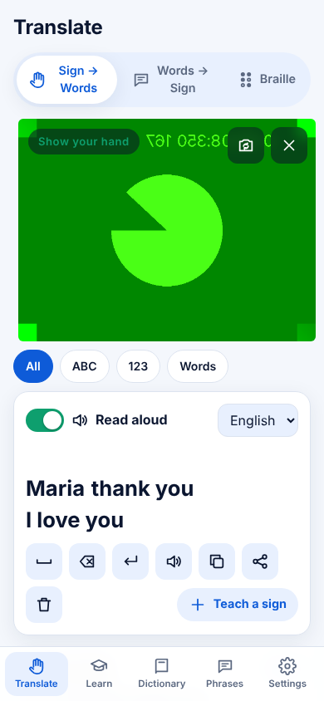 | 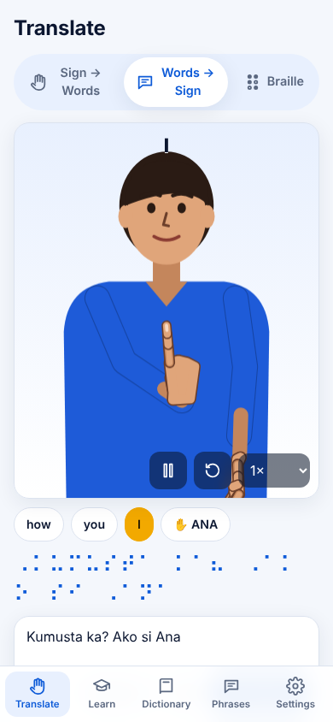 | 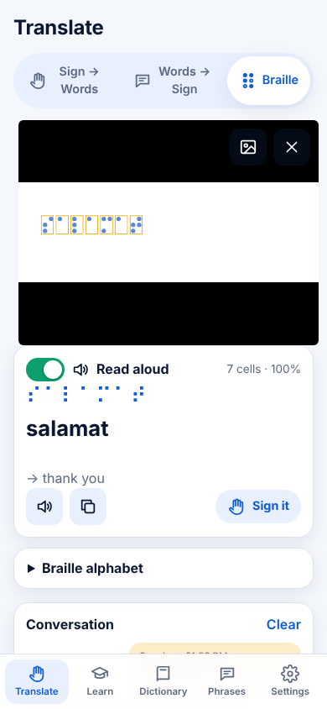
Figure 2. Live sign translation with Read aloud, the signing avatar, and the braille reader on a phone

4.2 Static Letters (E1)
Table 7. Accuracy on the 24 static letters
Noise multiplier | Correct / trials | Accuracy | 95% Wilson CI
0.5× | 959 / 960 | 99.9% | 99.4% – 100.0%
1× | 950 / 960 | 99.0% | 98.1% – 99.4%
1.5× | 903 / 960 | 94.1% | 92.4% – 95.4%
2× | 853 / 960 | 88.9% | 86.7% – 90.7%

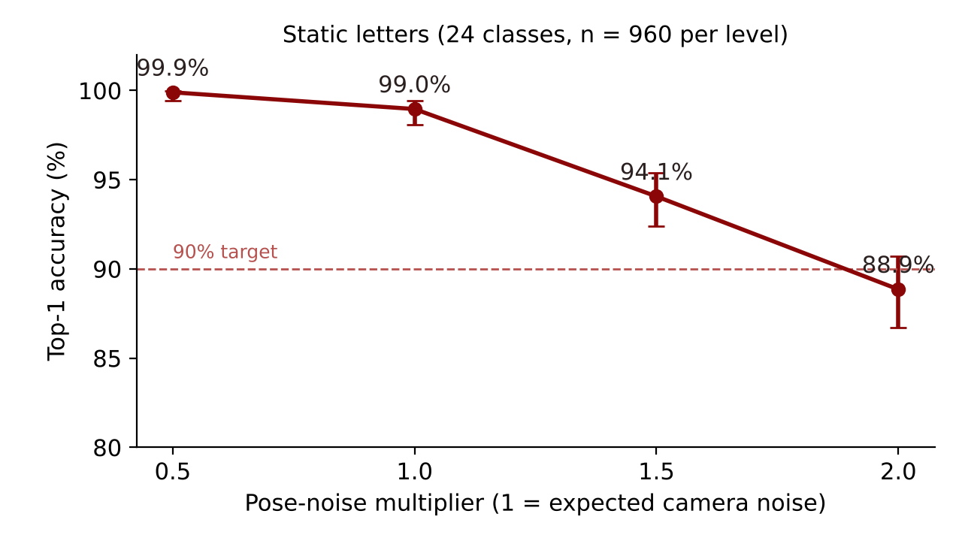
Figure 3. Static-letter accuracy as pose noise increases
At the expected camera noise the recogniser named 950 of 960 hands correctly (99.0%); the exact binomial test rejected H₀1 (p < 0.001). Accuracy declined gradually, to 88.9% at twice the expected noise, instead of collapsing. Figure 4 shows where the errors went at 1.5 times the noise. The letters with the lowest accuracy were U (63%), N (82%), R (82%), T (88%), and the most frequent confusions were U→R (34), R→U (21), V→U (15), N→M (12), G→Q (10). These pairs are close for human readers as well: U and R differ only in whether the fingers cross, G and Q only in pointing down, and S, T, M and N only in where the thumb rests. This is why the app lets each user record personal examples of hard letters, which the classifier prefers.
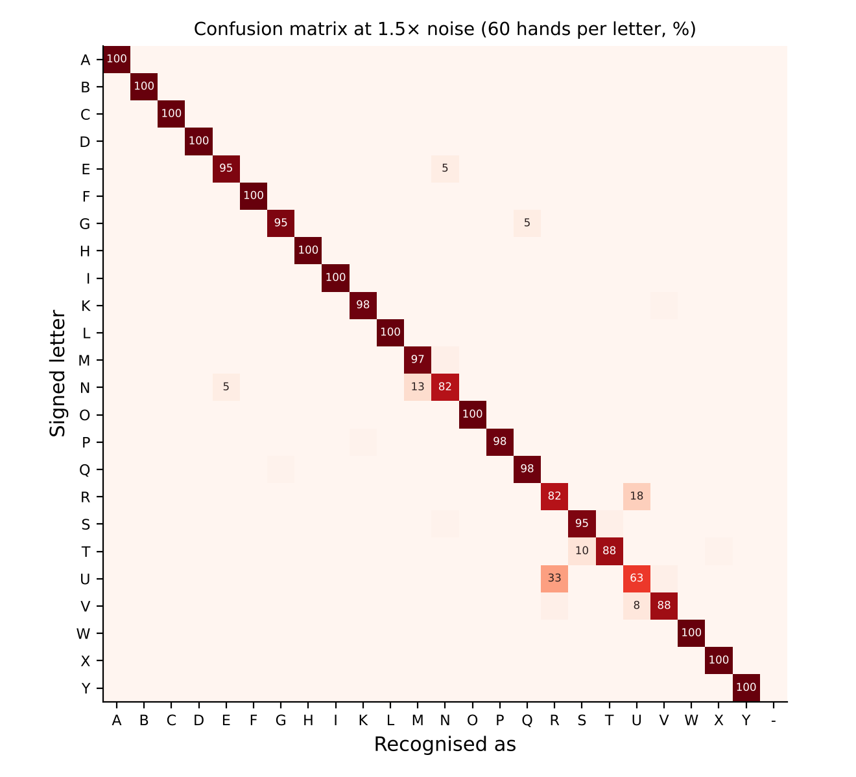
Figure 4. Confusion matrix of the static letters at 1.5× noise

4.3 Which Parts of the Design Matter (E2)
Table 8. Ablation of the feature design (1.5× noise, 15% wrong hand labels)
Design | Accuracy
Full design | 96.0%
No mirror check (trust the hand label) | 89.3%
No orientation features | 83.5%
Camera-frame coordinates (no palm frame) | 75.4%
One example per letter | 95.4%

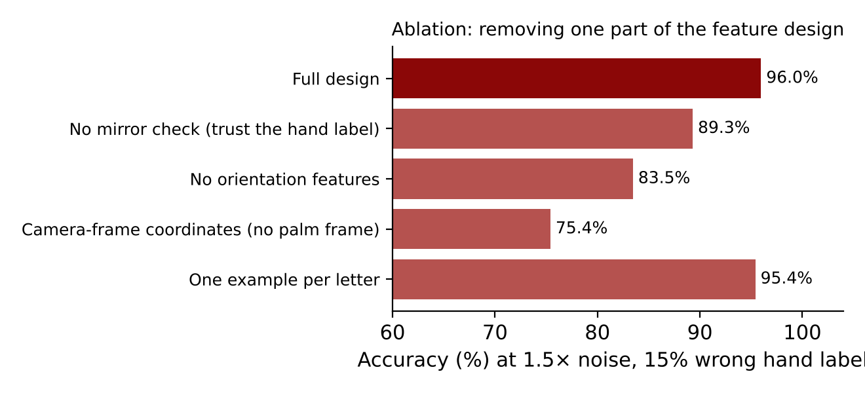
Figure 5. Accuracy when one part of the design is removed
The full design reached 96.0% under these hard conditions. Using camera coordinates instead of the palm frame dropped accuracy to 75.4%, which confirms Proposition 1 in practice: the palm frame removes most of the variation caused by how the hand is held. Removing the orientation terms gave 83.5%, because letters such as G and Q become identical, and trusting the camera's hand label instead of checking the mirror image gave 89.3%. Keeping only one template per letter still gave 95.4%, which shows that most of the accuracy comes from the geometry of the features rather than from the number of examples.

4.4 Moving and Two-Handed Signs (E3)
Table 9. Detection of moving and two-handed signs (30 trials each)
Sign | Type | Detected | 95% Wilson CI
hello | moving | 30/30 | 89% – 100%
yes | moving | 30/30 | 89% – 100%
no | moving | 30/30 | 89% – 100%
please | moving | 30/30 | 89% – 100%
sorry | moving | 30/30 | 89% – 100%
thankyou | moving | 30/30 | 89% – 100%
where | moving | 30/30 | 89% – 100%
water | moving | 30/30 | 89% – 100%
eat | moving | 30/30 | 89% – 100%
bathroom | moving | 30/30 | 89% – 100%
J | moving | 30/30 | 89% – 100%
Z | moving | 30/30 | 89% – 100%
Ñ | moving | 30/30 | 89% – 100%
love | two hands | 30/30 | 89% – 100%
more | two hands | 30/30 | 89% – 100%
friend | two hands | 30/30 | 89% – 100%
name | two hands | 30/30 | 89% – 100%
house | two hands | 30/30 | 89% – 100%
help | two hands | 30/30 | 89% – 100%

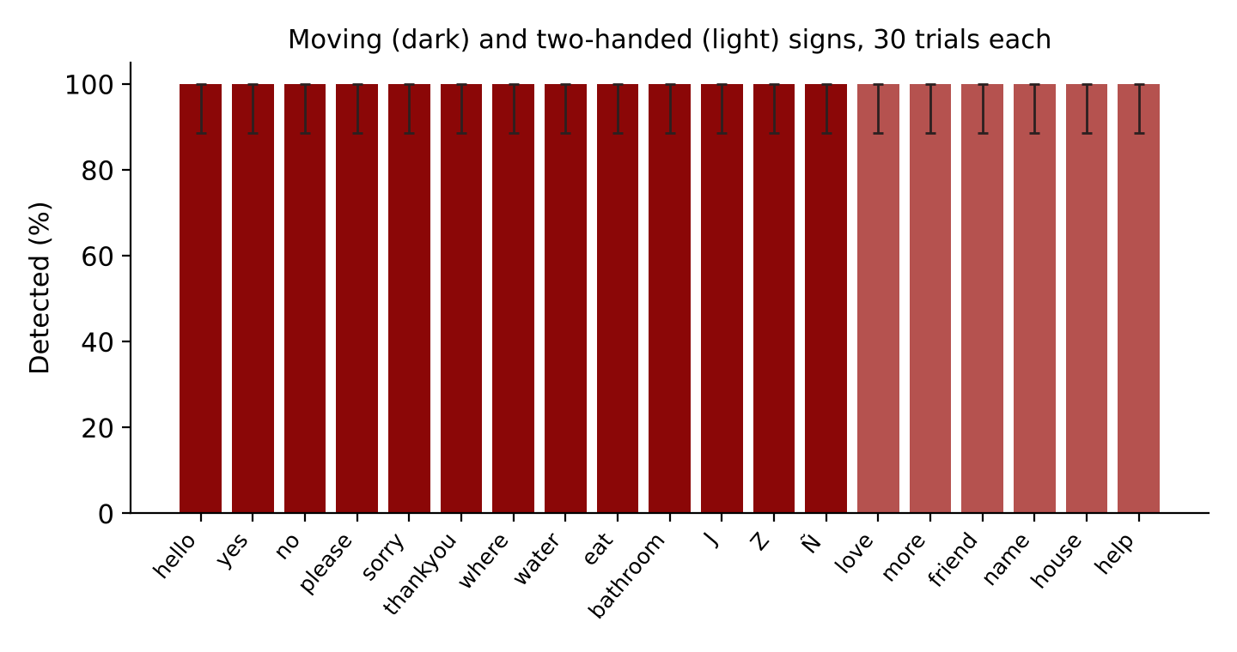
Figure 6. Detection rate of each moving and two-handed sign
All 570 trials were checked; 570 were detected (100.0%, 95% CI 99.3%–100.0%), and H₀2 was rejected (p < 0.001). None of the 144 still-letter streams raised a moving sign (95% CI 0–2.6%), and the first letter written was correct in 100.0% of them. The experiments also found two faults that were then fixed: a waved hello was sometimes taken for the circle of please, because a straight back-and-forth path winds around its own centre, and the movement during a change from I to another letter was sometimes read as J. Adding the roundness condition of Equation 4 and requiring the handshape to be held throughout J, Z and Ñ removed both errors. This shows the value of testing decision rules against generated data before release.

4.5 Fingerspelled Words and the Hold Time (E4)
Table 10. Fingerspelled words read exactly (40 words per cell)
App hold time | Signer holds 500 ms | Signer holds 700 ms | Signer holds 1,000 ms
300 ms | 88% (CER 2.4%) | 95% (CER 0.9%) | 92% (CER 1.4%)
400 ms | 85% (CER 2.8%) | 88% (CER 2.4%) | 95% (CER 0.9%)
600 ms | 0% (CER 46.2%) | 80% (CER 3.8%) | 88% (CER 2.4%)

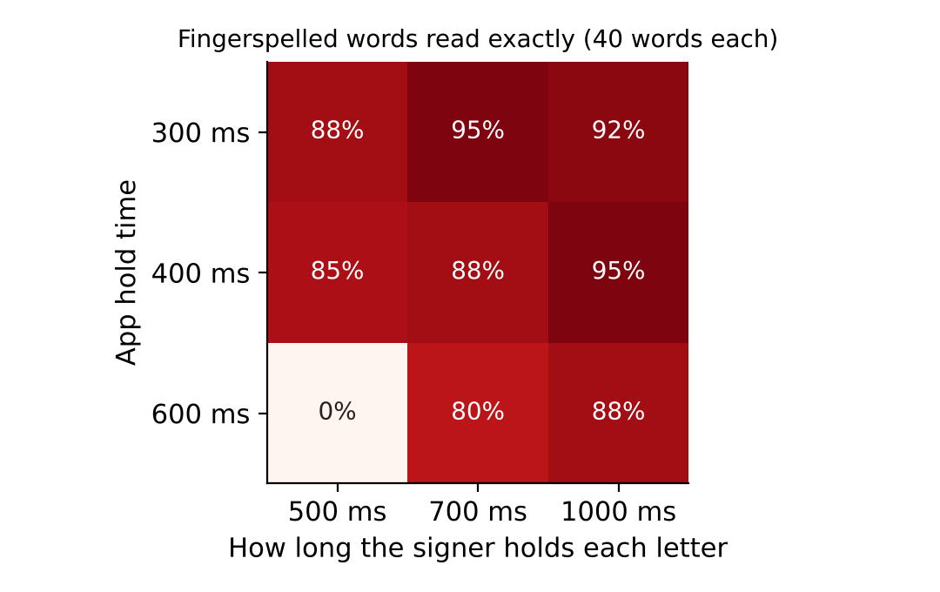
Figure 7. Word accuracy for each hold time and signer speed
At the default hold time of 400 ms, 107 of 120 words (89.2%) were read exactly across the three signer speeds, so H₀3 (at most 80%) was rejected (p = 0.006). The table shows a clear trade-off. A hold time longer than the signer's own hold, such as 600 ms for a signer who holds letters for 500 ms, misses most letters; a short hold time suits fast signers but lets more transition shapes through. The default of 400 ms works for learners and fluent signers alike, and the app offers 300 and 600 ms for fast and slow signers. An earlier version used 550 ms and repeated a held letter on a timer; in this experiment it read only about half of the words, which led to the shorter default and to signing double letters with a slide, as fluent signers do.

4.6 Signs Taught by the User (E5)
Table 11. Recognition of signs taught from three recordings
Taught movement | Detected | Recorded as moving
spiral | 30/30 | 3 of 3
climb | 30/30 | 3 of 3
swipe | 30/30 | 3 of 3
knock | 30/30 | 3 of 3
Look-alike trials (built-in signs) | 0 false accepts / 104 | —

After three recordings each, the four new movements were found in 120 of 120 new trials, and none of the 104 built-in signs was mistaken for a taught one. A fixed dynamic-time-warping threshold had first missed the spiral in every trial and the swipe in most, because these movements naturally vary more in size; scaling the threshold by how much the user's own three takes differ from each other (Section 3.4.6) solved this without adding false accepts. This lets Deaf users add local FSL signs and name signs that no dataset contains.

4.7 Braille Reader (E6)
Table 12. Braille reading accuracy by photo condition
Condition | Photos | Read exactly | CER
All photos | 300 | 81.7% | 12.6%
Printed dots | 141 | 80.1% | 15.3%
Embossed dots | 159 | 83.0% | 10.2%
Skew 0–2° | 96 | 89.6% | 6.3%
Skew 2–4° | 100 | 77.0% | 16.2%
Skew 4–6° | 104 | 78.8% | 14.6%
Blur < 0.8 px | 149 | 80.5% | 13.1%
Blur ≥ 0.8 px | 151 | 82.8% | 12.1%
Dot pitch < 15 px | 107 | 77.6% | 16.7%
Dot pitch 15–18 px | 119 | 84.0% | 11.8%
Dot pitch ≥ 18 px | 74 | 83.8% | 8.0%

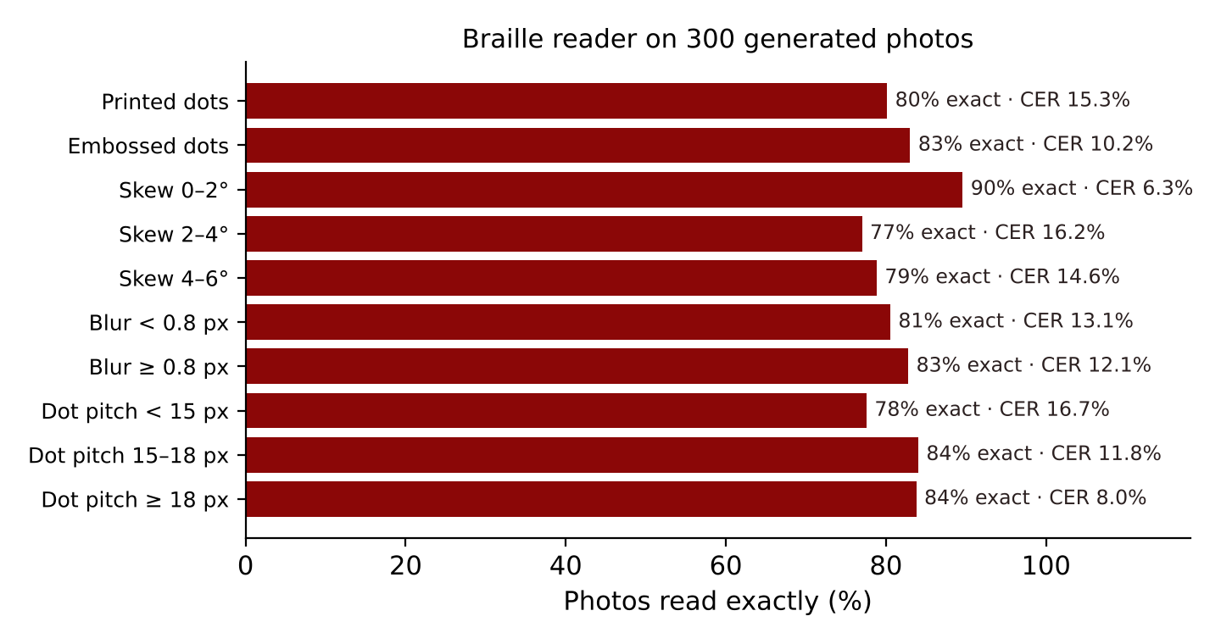
Figure 8. Share of braille photos read exactly, by condition
Across 300 photos the reader returned the exact text for 81.7% with a character error rate of 12.6%; H₀4 was rejected. Embossed dots (83.0% exact) were read at least as well as printed dots (80.1%), because the reader chooses the polarity that forms a better grid. Larger dots helped (83.8% exact at a spacing of 18 pixels or more against 77.6% below 15 pixels), so users are told to hold the phone close. Most remaining errors came from lines whose first cell had dots only in its right-hand column, which can shift the fitted grid by half a cell.
Table 13. Ablation of two optional steps in the braille reader
Version | Read exactly | CER
Shipped reader | 81.7% | 12.6%
+ box smoothing | 80.3% | 14.8%
+ neighbour filter | 81.0% | 12.7%
+ both steps | 79.3% | 14.9%

The first version of the reader read 57% of the same photos exactly. Three changes raised this to the present level: a minimum blob size, a dot size estimated from the larger blobs, and choosing the polarity by neighbour support. Two further steps, extra smoothing and removing blobs without a neighbour, were also tested (Table 13). They did not improve accuracy, so they were left out of the app, which also makes it faster. Reporting this negative result keeps the design as simple as the evidence allows.

4.8 The Full Camera Path (E7)
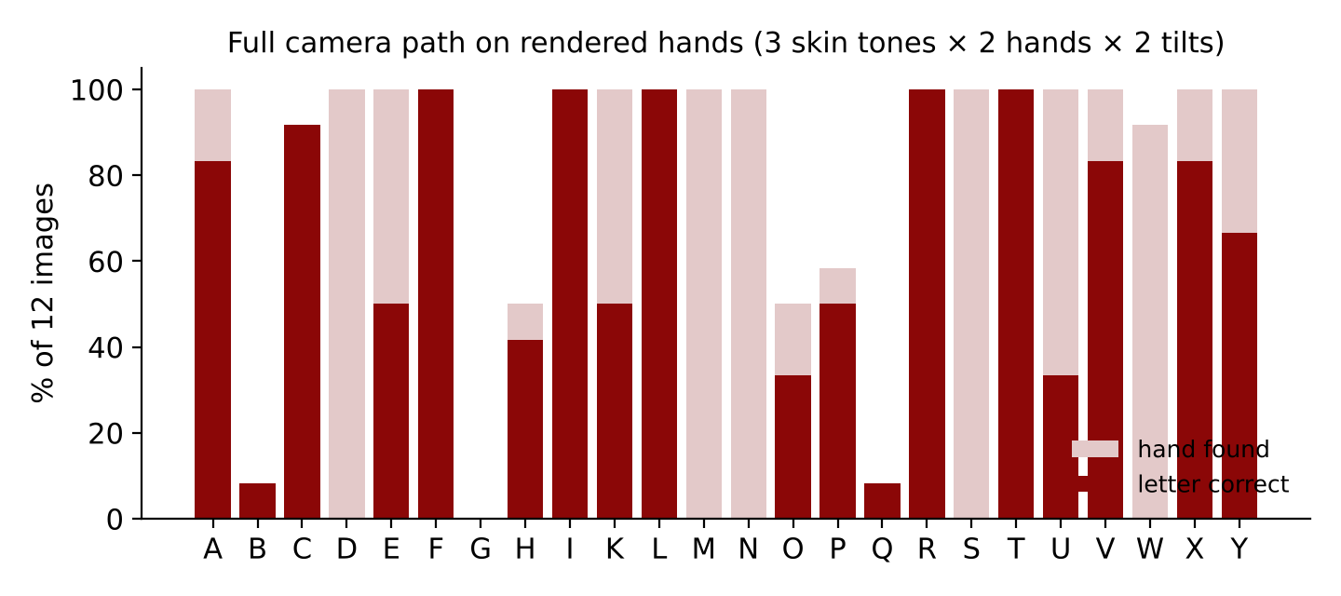
Figure 9. Rendered hands found by MediaPipe and letters named correctly
MediaPipe found a hand in 235 of 288 rendered images (81.6%), and the recogniser named 142 of those correctly (60.4%). The renders are flat drawings without skin texture, creases or nails, so the landmark model is working outside the kind of image it was trained on. This experiment is therefore a check that all parts fit together and a lower bound on the full path, not a measure of accuracy on real hands. The gap between this figure and E1 identifies the next step: calibrating the templates with real landmark recordings, which the app already supports through personal examples.

4.9 Speed (E8)
Table 14. Median processing time per frame or photo
Component | Median time | Frames per second it allows
MediaPipe hand landmarks (CPU) | 71.0 ms | 14
SENYAS recogniser and decisions | 0.09 ms | 11,161
Braille reader (one photo or frame) | 25.6 ms | 39

The recogniser added less than a tenth of a millisecond to each frame. Hand tracking dominated at 71 ms on a CPU, under the 100 ms limit, so H₀5 was rejected; on phones the model can use the graphics processor and usually runs faster. The braille reader scans a live frame about every 0.65 s, well within its cost.

4.10 Interface Fit, Accessibility and Coverage (E9)
Table 15. Layout test on 11 screen sizes (five screens each)
Screen | Size (px) | Layout | Sideways scroll | Small targets
Small phone | 320×568 | bottom tabs | none | 0
Android phone | 360×740 | bottom tabs | none | 0
iPhone | 390×844 | bottom tabs | none | 0
Large phone | 412×915 | bottom tabs | none | 0
Phone, sideways | 844×390 | side rail | none | 0
Small tablet | 768×1024 | side rail | none | 0
Tablet | 820×1180 | side rail | none | 0
Tablet, sideways | 1180×820 | side rail | none | 0
Laptop | 1366×768 | side rail | none | 0
Desktop | 1920×1080 | side rail | none | 4
TV / 4K (scaled) | 2560×1440 | side rail | none | 0

On all 11 screen sizes, none of the five screens scrolled sideways and the five-tab navigation was always visible, so H₀6 was rejected. Phones used a bottom tab bar; phones held sideways, tablets and computers used a side rail; wide screens showed both translation directions side by side. The first layout test found many touch targets below 32 pixels in the phrasebook and settings; after they were enlarged to at least 40 pixels, only a few small controls remained on one size, in line with WCAG guidance on target size (World Wide Web Consortium, 2018).
Table 16. Text contrast against WCAG 2.1 (minimum 4.5 : 1)
Colour pair | Contrast | WCAG AA
Light: body text on page | 16.7 : 1 | pass
Light: muted text on card | 5.6 : 1 | pass
Light: button text on blue | 6.0 : 1 | pass
Dark: body text on page | 16.1 : 1 | pass
Dark: muted text on card | 7.1 : 1 | pass
Dark: button text on blue | 6.9 : 1 | pass
Camera caption on glass | 12.2 : 1 | pass

Every colour pair in light and dark themes met the 4.5 : 1 contrast required for normal text. The lexicon holds 93 words and the numbers 0–10; all 32 phrasebook sentences produced 63 signs in each language with no word left to fingerspelling, so a Bikol speaker, a Filipino speaker and an English speaker receive the same signs.
Table 17. Evaluation mapped to ISO/IEC 25010 quality characteristics
Characteristic | Evidence in this study
Functional suitability | E1–E7: accuracy of signs, words, taught signs and braille
Performance efficiency | E8: time per frame; 190 KB app page
Compatibility | Runs in browsers on Android, iOS, Windows, macOS and Linux, and as an Android app
Usability | E9: layouts, touch targets, contrast; three languages; reduced motion and large text
Reliability | Works offline after the first start; still-hand false alarms 0% (E3)
Security | No accounts; video, photos and audio never leave the device; consent before storage
Maintainability | Small modules (hand, avatar, recogniser, braille, data, app) with benchmark scripts
Portability | One codebase for web, installable app and Android

4.11 Summary of Hypothesis Tests
Table 18. Summary of hypothesis tests
Hypothesis | Result | Decision
H₀1 accuracy ≤ 90% | 99.0%, p < 0.001 | Rejected
H₀2 detection ≤ 90% | 100.0%, p < 0.001 | Rejected
H₀3 word accuracy ≤ 80% | 89.2%, p = 0.006 | Rejected
H₀4 CER ≥ 20% | CER = 12.6% | Rejected
H₀5 time > 100 ms | 71 ms + 0.09 ms | Rejected
H₀6 layout faults on some screen | 11 of 11 sizes without faults | Rejected

4.12 Limitations
The accuracy figures come from generated hands, movements and photos, which follow the shapes and noise levels described in Section 3.5 but cannot capture every real signer, camera and page. The rendered-hand test shows that real-image calibration is the largest remaining step. The sign vocabulary uses forms shared by FSL and ASL; regional FSL signs must be added by users or by future work with the Deaf community. Bikol is spoken with a Filipino voice because no Bikol voice is available on phones. Braille reading is limited to Grade 1.

CHAPTER 5. CONCLUSIONS AND RECOMMENDATIONS

5.1 Conclusions
1. A recogniser that generates its examples from a robot-like kinematic hand model and compares palm-frame features classified the static FSL letters with 99.0% accuracy at expected noise, without any recorded dataset. The palm frame, orientation terms and mirror check each contributed measurably.
2. Hysteresis counting, winding numbers, held-shape paths and two-hand distances detected 100.0% of moving and two-handed signs with no false alarms on still hands.
3. With a 400 ms hold time and double letters signed with a slide, 89.2% of fingerspelled words were read exactly across slow, average and fast signers.
4. Signs taught from three recordings were recognised in 100.0% of trials with no false accepts, so users can extend SENYAS with local signs.
5. Grid fitting read 81.7% of braille photos exactly (12.6% CER) across print, embossing, skew and blur.
6. Every component ran fast enough for live use on the device and offline, and the interface fitted every screen tested with readable contrast.
7. A single trilingual index carried every phrase into signs in English, Filipino and Bikol, and the Read aloud switch lets each user decide whether recognised words are spoken.
Overall, the study shows that an intelligent machine built on kinematics and geometry can provide an offline, trilingual communication aid for Deaf, blind and hearing people without big data, and that its behaviour can be measured and improved.

5.2 Recommendations
- Validate SENYAS with Deaf and blind learners, teachers and FSL interpreters in Albay, for example in SPED centres and with the Philippine Federation of the Deaf, under ethics review, using the Technology Acceptance Model (Davis, 1989) and task success rates.
- Record real landmarks from many signers to calibrate the templates, and compare the geometric recogniser with a small learned model trained on those recordings.
- Ask native Bikol speakers and Deaf FSL users to review every word and sign, and add regional FSL variants and Bikol phrases for local services and disasters.
- Add facial landmarks for FSL grammar, sentence-level translation, and Grade 2 braille.
- Develop a Bikol text-to-speech voice, and distribute SENYAS through the Department of Education, local disaster risk reduction offices and health centres.
- Repeat the speed and battery tests on low-cost Android phones.

REFERENCES
Antonacopoulos, A., & Bridson, D. (2004). A robust Braille recognition system. In S. Marinai & A. Dengel (Eds.), Document analysis systems VI (Lecture Notes in Computer Science, Vol. 3163, pp. 533–545). Springer.
Aristidou, A., & Lasenby, J. (2011). FABRIK: A fast, iterative solver for the inverse kinematics problem. Graphical Models, 73(5), 243–260.
Cabalfin, E. P., Martinez, L. B., Guevara, R. C. L., & Naval, P. C. (2012). Filipino Sign Language recognition using manifold projection learning. In TENCON 2012 – 2012 IEEE Region 10 Conference. IEEE.
CAST. (2018). Universal Design for Learning guidelines (Version 2.2).
Cover, T., & Hart, P. (1967). Nearest neighbor pattern classification. IEEE Transactions on Information Theory, 13(1), 21–27.
Craig, J. J. (2005). Introduction to robotics: Mechanics and control (3rd ed.). Pearson Prentice Hall.
Crow, F. C. (1984). Summed-area tables for texture mapping. ACM SIGGRAPH Computer Graphics, 18(3), 207–212.
Davis, F. D. (1989). Perceived usefulness, perceived ease of use, and user acceptance of information technology. MIS Quarterly, 13(3), 319–340.
Hevner, A. R., March, S. T., Park, J., & Ram, S. (2004). Design science in information systems research. MIS Quarterly, 28(1), 75–105.
International Council on English Braille. (2013). The rules of Unified English Braille (2nd ed.).
International Organization for Standardization. (2011). ISO/IEC 25010:2011 Systems and software engineering — Systems and software Quality Requirements and Evaluation (SQuaRE) — System and software quality models.
Isayed, S., & Tahboub, R. (2015). A review of optical Braille recognition. In 2015 2nd World Symposium on Web Applications and Networking (WSWAN). IEEE.
Koller, O. (2020). Quantitative survey of the state of the art in sign language recognition. arXiv:2008.09918.
Levenshtein, V. I. (1966). Binary codes capable of correcting deletions, insertions, and reversals. Soviet Physics Doklady, 10(8), 707–710.
Lugaresi, C., Tang, J., Nash, H., McClanahan, C., Uboweja, E., Hays, M., Zhang, F., Chang, C.-L., Yong, M. G., Lee, J., Chang, W.-T., Hua, W., Georg, M., & Grundmann, M. (2019). MediaPipe: A framework for building perception pipelines. arXiv:1906.08172.
Marcotte, E. (2010, May 25). Responsive web design. A List Apart.
Mitra, S., & Acharya, T. (2007). Gesture recognition: A survey. IEEE Transactions on Systems, Man, and Cybernetics, Part C, 37(3), 311–324.
Rastgoo, R., Kiani, K., & Escalera, S. (2021). Sign language recognition: A deep survey. Expert Systems with Applications, 164, 113794.
Republic Act No. 7277. (1992). Magna Carta for Disabled Persons. Republic of the Philippines.
Republic Act No. 10173. (2012). Data Privacy Act of 2012. Republic of the Philippines.
Republic Act No. 11106. (2018). The Filipino Sign Language Act. Republic of the Philippines.
Sakoe, H., & Chiba, S. (1978). Dynamic programming algorithm optimization for spoken word recognition. IEEE Transactions on Acoustics, Speech, and Signal Processing, 26(1), 43–49.
Schmitt, O. H. (1938). A thermionic trigger. Journal of Scientific Instruments, 15(1), 24–26.
Stokoe, W. C. (1960). Sign language structure: An outline of the visual communication systems of the American deaf (Studies in Linguistics, Occasional Papers 8). University of Buffalo.
United Nations. (2006). Convention on the Rights of Persons with Disabilities.
United Nations. (2015). Transforming our world: The 2030 Agenda for Sustainable Development.
Viola, P., & Jones, M. (2001). Rapid object detection using a boosted cascade of simple features. In Proceedings of the 2001 IEEE Computer Society Conference on Computer Vision and Pattern Recognition (Vol. 1, pp. 511–518). IEEE.
Wilson, E. B. (1927). Probable inference, the law of succession, and statistical inference. Journal of the American Statistical Association, 22(158), 209–212.
World Health Organization. (2019). World report on vision.
World Health Organization. (2021). World report on hearing.
World Wide Web Consortium. (2018). Web Content Accessibility Guidelines (WCAG) 2.1. W3C Recommendation.
Zhang, F., Bazarevsky, V., Vakunov, A., Tkachenka, A., Sung, G., Chang, C.-L., & Grundmann, M. (2020). MediaPipe Hands: On-device real-time hand tracking. arXiv:2006.10214.

APPENDICES

Appendix A. Braille cells decoded by SENYAS
Table A1. Grade 1 braille cells read by SENYAS (dot 1–3 left column, 4–6 right)
Letter | Dots | Cell | Letter | Dots | Cell | Letter | Dots | Cell
A | 1 | ⠁ | K | 1-3 | ⠅ | T | 2-3-4-5 | ⠞
B | 1-2 | ⠃ | L | 1-2-3 | ⠇ | U | 1-3-6 | ⠥
C | 1-4 | ⠉ | M | 1-3-4 | ⠍ | V | 1-2-3-6 | ⠧
D | 1-4-5 | ⠙ | N | 1-3-4-5 | ⠝ | W | 2-4-5-6 | ⠺
E | 1-5 | ⠑ | Ñ | 1-2-4-5-6 | ⠻ | X | 1-3-4-6 | ⠭
F | 1-2-4 | ⠋ | O | 1-3-5 | ⠕ | Y | 1-3-4-5-6 | ⠽
G | 1-2-4-5 | ⠛ | P | 1-2-3-4 | ⠏ | Z | 1-3-5-6 | ⠵
H | 1-2-5 | ⠓ | Q | 1-2-3-4-5 | ⠟ | Number sign | 3-4-5-6 | ⠼
I | 2-4 | ⠊ | R | 1-2-3-5 | ⠗ | Capital sign | 6 | ⠠
J | 2-4-5 | ⠚ | S | 2-3-4 | ⠎

Appendix B. Signs the camera reads directly
Letters A–Z and Ñ (J, Z and Ñ by their movement); numbers 0–10; words: hello, yes, no, thank you, please, sorry, where, water, eat, bathroom, I love you, good (thumbs-up), bad (thumbs-down), okay, love, help, more, house, friend, name, finished. Any other sign can be taught by the user from three recordings.

Appendix C. Trilingual lexicon
Table C1. Signed words in the three languages
English | Filipino | Bikol | Group
hello | kumusta | kumusta | greet
goodbye | paalam | paaram | greet
thank you | salamat | Dios mabalos | greet
please | pakiusap | tabi | greet
sorry | pasensya na | pasensya na | greet
yes | oo | iyo | greet
no | hindi | dai | greet
you're welcome | walang anuman | daing anoman | greet
fine | mabuti | marhay man | greet
nice | maganda | magayon | greet
meet | makilala | mamidbid | greet
excuse me | paumanhin | makiagi tabi | greet
I / me | ako | ako | people
you | ikaw | ika | people
we | tayo | kita | people
my | akin | sako | people
mother | nanay | nanay | people
father | tatay | tatay | people
brother / sister | kapatid | tugang | people
baby | sanggol | aki | people
friend | kaibigan | katood | people
family | pamilya | pamilya | people
name | pangalan | pangaran | people
Deaf | bingi | bungog | people
hearing | nakaririnig | nakakadangog | people
teacher | guro | paratukdo | people
learn | mag-aral | mag-adal | people
doctor | doktor | doktor | people
police | pulis | pulis | people
eat | kain | kakan | needs
food | pagkain | kakanon | needs
drink | inom | inom | needs
water | tubig | tubig | needs
bathroom (CR) | CR / banyo | CR / banyo | needs
sleep | tulog | turog | needs
home | bahay | harong | needs
house | bahay | harong | needs
school | paaralan | eskwelahan | needs
help | tulong | tabang | needs
more | dagdag | dagdag | needs
finished | tapos na | tapos na | needs
want | gusto | gusto | needs
need | kailangan | kaipuhan | needs
money | pera | kuwarta | needs
work | trabaho | trabaho | needs
play | laro | kawat | needs
go | punta | lakaw | needs
come | halika | dali | needs
stop | tigil | ontok | needs
wait | sandali | halat | needs
again | ulit | giraray | needs
slow | dahan-dahan | hinay-hinay | needs
write | sulat | surat | needs
call (phone) | tawag | apod | needs
see | kita | hiling | needs
understand | maintindihan | masabotan | needs
know | alam | aram | needs
not | hindi | dai | needs
sign language | senyas | senyas | needs
love | pagmamahal | pagkamoot | feel
I love you | Mahal kita | Namumutan taka | feel
happy | masaya | maogma | feel
sad | malungkot | mamundo | feel
angry | galit | maanggot | feel
tired | pagod | pagal | feel
sick | may sakit | may hilang | feel
hungry | gutom | gutom | feel
thirsty | uhaw | uhaw | feel
good | mabuti | marhay | feel
bad | masama | maraot | feel
okay | ayos | sige | feel
pain / hurt | masakit | makulog | feel
beautiful | maganda | magayon | feel
what | ano | ano | quest
where | saan | hain | quest
who | sino | siisay | quest
when | kailan | nuarin | quest
why | bakit | taano | quest
how | paano | paano | quest
emergency | emerhensiya | emerhensiya | emerg
hospital | ospital | ospital | emerg
fire | sunog | kalayo | emerg
earthquake | lindol | linog | emerg
flood | baha | baha | emerg
typhoon | bagyo | bagyo | emerg
danger | panganib | peligro | emerg
medicine | gamot | bulong | emerg
now / today | ngayon | ngonyan | time
tomorrow | bukas | sa aga | time
yesterday | kahapon | kasuhapon | time
morning | umaga | aga | time
night | gabi | banggi | time
zero | sero | sero | num

Appendix D. Phrasebook
Table D1. Phrasebook in three languages and the signs used (gloss)
English | Filipino | Bikol | Signs
Good morning | Magandang umaga | Marhay na aga | GOOD MORNING
Good evening | Magandang gabi | Marhay na banggi | GOOD NIGHT
Thank you | Salamat po | Dios mabalos | THANKYOU
You're welcome | Walang anuman | Daing anoman | WELCOME
How are you? | Kumusta ka? | Kumusta ka? | HOW YOU
I'm fine | Mabuti ako | Marhay man ako | ME FINE
What is your name? | Ano ang pangalan mo? | Ano an pangaran mo? | YOU NAME WHAT
My name is | Ang pangalan ko ay | An pangaran ko si | MY NAME
Nice to meet you | Ikinagagalak kitang makilala | Maogma akong mamidbid ka | NICE MEET YOU
I am Deaf | Bingi ako | Bungog ako | ME DEAF
Please sign slowly | Pakidahan-dahan ang pagsenyas | Hinay-hinay tabi an pagsenyas | PLEASE SIGN SLOW
I don't understand | Hindi ko maintindihan | Dai ko nasasabotan | ME UNDERSTAND NOT
Please repeat | Pakiulit po | Giraray tabi | AGAIN PLEASE
Please write it down | Pakisulat po | Isurat mo tabi | WRITE PLEASE
Where is the bathroom? | Nasaan ang CR? | Hain an CR? | BATHROOM WHERE
I need help | Kailangan ko ng tulong | Kaipuhan ko nin tabang | ME NEED HELP
Call a doctor | Tumawag ng doktor | Mag-apod nin doktor | CALL DOCTOR
I am sick | May sakit ako | May hilang ako | ME SICK
Where is the hospital? | Nasaan ang ospital? | Hain an ospital? | HOSPITAL WHERE
I love you | Mahal kita | Namumutan taka | ILOVEYOU
I'm hungry | Gutom na ako | Gutom na ako | ME HUNGRY
I'm thirsty | Nauuhaw ako | Uhaw ako | ME THIRSTY
Let's eat | Kain tayo | Magkakan kita | WE EAT
See you tomorrow | Kita tayo bukas | Magkita kita sa aga | SEE YOU TOMORROW
Goodbye | Paalam | Paaram | GOODBYE
I'm sorry | Pasensya na | Pasensya na | SORRY
Please wait | Sandali lang po | Halat muna tabi | WAIT PLEASE
Stop! | Tigil! | Ontok! | STOP
Danger! Leave now! | Delikado! Umalis na! | Peligro! Lakaw na! | DANGER GO NOW
There is a fire! | May sunog! | May kalayo! | FIRE
Earthquake! | Lindol! | Linog! | EARTHQUAKE
Are you okay? | Ayos ka lang? | Marhay ka lang? | YOU OKAY

Appendix E. Algorithms
Algorithm E1. Fitting the braille grid in one line
δ ← dot spacing; C ← column centres of the line (clustered with gap 0.45δ)
for P from 2.1δ to 2.9δ in steps of 0.05δ:
for x₀ from C₁ to C₁ + P in steps of P/24:
E ← Σ_c min(|u − kP|, |u − δ − k′P|), u = c − x₀
keep (P, x₀) with the least E
for each dot: cell k, column (0 or 1), row ← round((y − top)/δ); set bit 3·column + row
decode the six-bit numbers left to right with the number and capital states

Algorithm E2. Teaching a sign
record three takes of 1.5 s; for each take keep features, wrist path and two-hand flag
if the hand moved less than 1.1 palm-lengths: store the mean features as templates
else: resample each take to 16 frames; τ ← 1.6 × mean DTW distance between the takes (0.75 ≤ τ ≤ 1.6)
while translating: every 5 frames compare the last 1.6 s with each take; accept if DTW/τ < 1

Appendix F. Screens on other devices
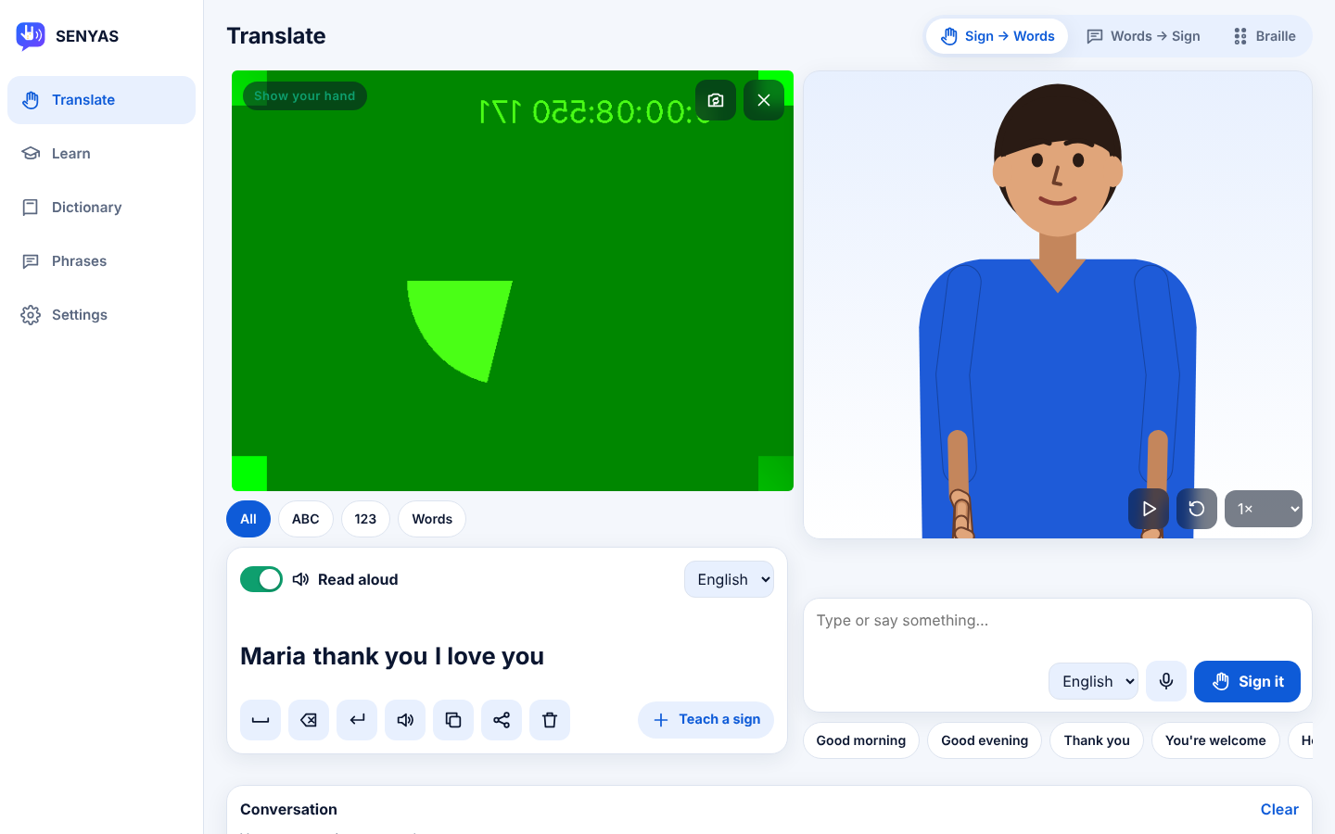
Figure F1. Desktop: both directions side by side as a conversation
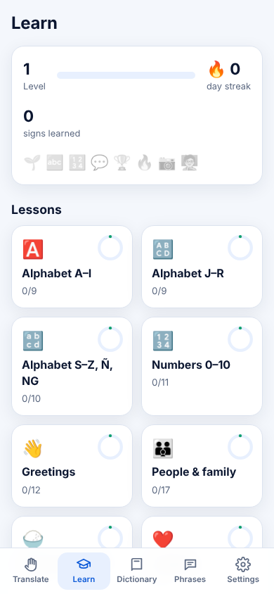 | 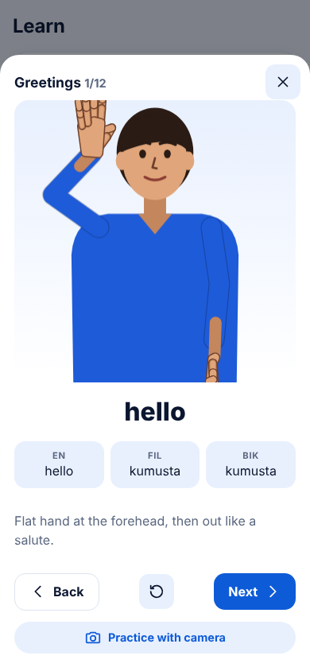 | 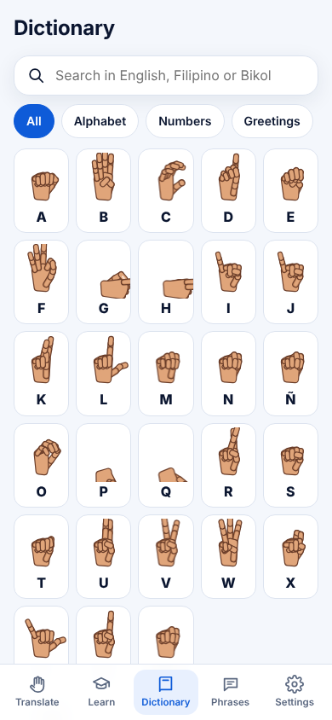
Figure F2. Lessons, a lesson card in the three languages, and the dictionary
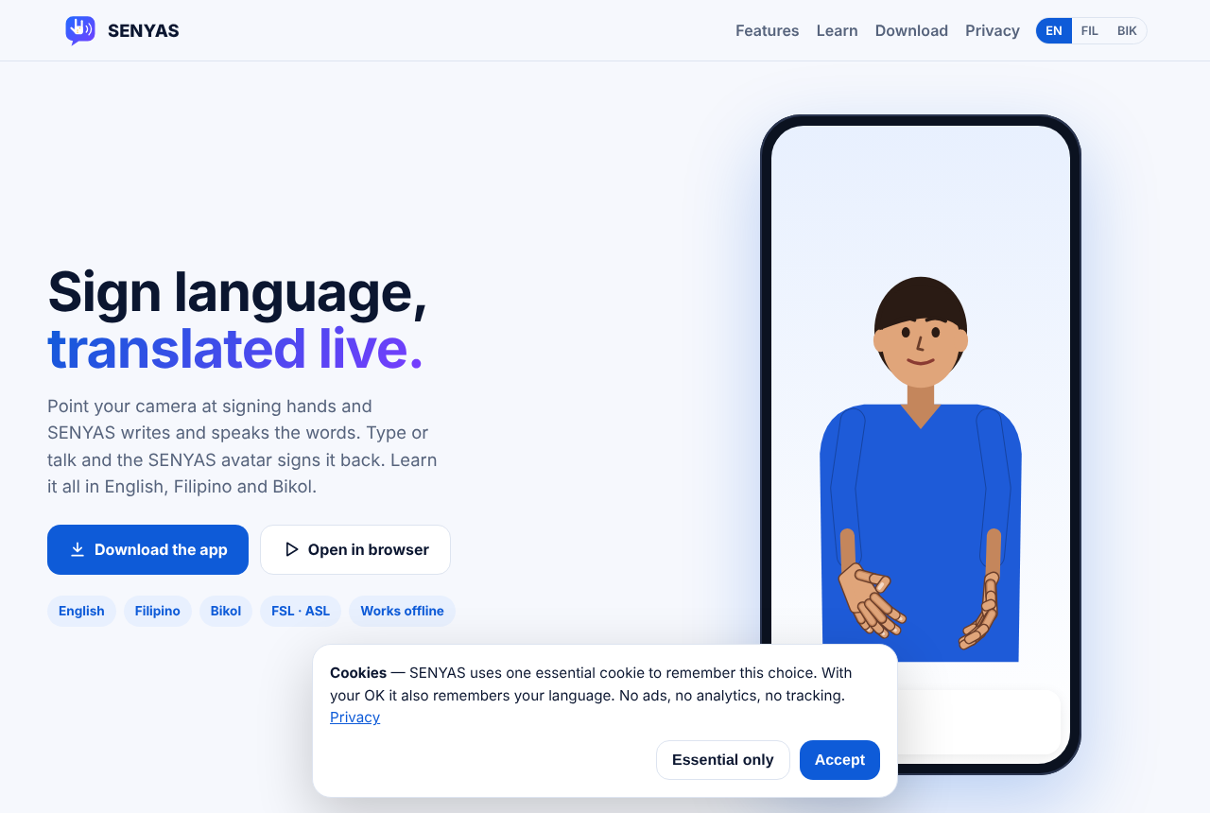
Figure F3. The SENYAS website with downloads and the cookie notice

Appendix G. User guide
1. Open SENYAS and choose what it may save on the device. Choose the app language and the language to translate into.
2. Translate → Sign → Words: press Start camera and sign in front of it. Hold each letter briefly; drop your hand to finish a word. Turn Read aloud on to hear each word, or off for silence.
3. Translate → Words → Sign: type or press the microphone and speak; the avatar signs it. Change the speed or tap a word to replay it.
4. Translate → Braille: upload a photo of braille or scan it live, holding the page flat and close; the text appears and can be spoken.
5. Learn: choose a unit, watch each sign, take the quiz, and practise with the camera. Teach a sign: record it three times.

Appendix H. Source code and data
The app, website, Android project, benchmarks and the scripts that produced every number, table and figure in this paper are in the SENYAS repository (github.com/pogi6969/SENYAS): src/ (hand.js, avatar.js, recog.js, braille.js, data.js, app.js), research/code/ (bench_recognizer.js, bench_browser.js, bench_page.html, bench_ui.js, analyze.py, and their results) and research/paper/ (this paper's generator).

