CHANDIGARH UNIVERSITY
Department of Computer Applications
PROJECT REPORT
ON
FOOD ORDERING SYSTEM
Submitted in partial fulfilment of the requirements for
DATABASE MANAGEMENT SYSTEMS (DBMS)
Submitted By
Name: Harsh Wardhan Raj & Cheshta
UID: 25BCA10394 & 25BCA10404
Semester: 3rd – 25BCA 6 “A”

Under the Guidance -
Faculty: Mr. Arvinder Singh Sir
CERTIFICATE
Project Certification
This is to certify that the project report entitled “Food Ordering System” submitted by Harsh Wardhan Raj & Cheshta, UID 25BCA10394 & 25BCA10404, Chandigarh University, is a record of work carried out by the students under my guidance and supervision as part of the Database Management Systems (DBMS) coursework.
Academic Evaluation
The project demonstrates the design and implementation of a database-driven food ordering application using HTML, CSS, PHP and MySQL. To the best of my knowledge, the work presented in this report is suitable for academic submission and evaluation.
Approval
Faculty Guide: Mr. Arvinder Singh Sir
Signature:
Date:
Department Seal:
DECLARATION
Student Declaration
We hereby declare that the project entitled “Food Ordering System” is our own work, completed as part of the Database Management Systems coursework at Chandigarh University under the guidance of the faculty member named in this report.
Originality
We further declare that this report has not been submitted, either in full or in part, to any other institution or university for the award of any degree, diploma or certificate. Wherever information or concepts from external sources have been used, the sources have been acknowledged in the references.
Signature
Student Name: Harsh Wardhan Raj
UID: 25BCA10394
Signature:

Student Name: Cheshta
UID: 25BCA10404
Signature:

Date:
ACKNOWLEDGEMENT
We would like to express our sincere gratitude to our respected faculty member, project guide, and the Department of Computer Applications, Chandigarh University, for giving us the opportunity to develop this project on a Food Ordering System as part of our Database Management Systems coursework. The project helped us connect classroom concepts with a practical application.
While working on it, we learned how to identify entities and relationships, design relational tables, apply primary keys, foreign keys, unique and check constraints, normalize a schema up to the Third Normal Form, and write SQL queries that use joins, grouping, subqueries, views and transactions. We also gained an understanding of how a web application communicates with a MySQL database through PHP.
We acknowledge the developers and documentation communities of HTML, CSS, PHP, MySQL, MariaDB and Apache, whose freely available resources supported our learning. Finally, we are thankful to our friends, classmates and families for their encouragement and suggestions throughout the planning, development and documentation of this project.
ABSTRACT
The Food Ordering System is a database-driven web application that lets customers browse a restaurant menu, place orders and track their status, while allowing restaurant staff to manage menu items and process orders. Its main objective is to demonstrate the practical use of Database Management System concepts in a real-world scenario that most people use daily.
The system stores its data in a MySQL database named food_ordering made up of six related tables: customers, categories, menu_items, orders, order_items and payments. Primary keys, foreign keys, unique constraints, check constraints, ENUM columns and indexes protect data integrity and support efficient retrieval. The schema is normalized to the Third Normal Form, and the one deliberate departure from it, the stored order total, is explained in the report.
HTML and CSS provide the interface, PHP handles server-side processing, and PDO prepared statements are used for database communication. The report covers the problem statement, scope, system study, feasibility, architecture, ER diagram, normalization, data dictionary, SQL implementation and testing. The SQL scripts and queries in this report were executed on a MariaDB 10.11 server, the MySQL-compatible database bundled with XAMPP, and the outputs shown are the actual results.
TABLE OF CONTENTS
Chapters
1. Introduction
2. Problem Statement and Objectives
3. Scope of the Project
4. Existing and Proposed System
5. System Requirements and Feasibility Study
6. System Architecture and Process Flow
7. Database Design (ER Diagram and Schema)
8. Database Normalization and Data Dictionary
9. SQL Implementation and Queries
10. Testing and Results
11. Conclusion and Future Enhancements
References
List of Figures
Figure 6.1 Three-layer system architecture
Figure 6.2 Order process flow
Figure 7.1 Entity Relationship (ER) diagram

1. INTRODUCTION
Ordering food has moved from telephone calls and paper menus to web and mobile applications. A customer can now see a full menu with prices, choose items, pay and follow the progress of the order from one screen. Behind that simple experience is a database that remembers who the customers are, what the restaurant sells, which items belong to which order and whether the payment was completed. If this data is poorly organized, the result is wrong bills, lost orders and confusion between the kitchen and the customer.
The Food Ordering System developed in this project is a small but complete example of such an application. It is built as a Database Management Systems (DBMS) project, so its focus is on correct database design and the use of SQL, rather than on advanced interface features. The application uses HTML and CSS for the user interface, PHP for server-side logic and MySQL for data storage.

1.1 Background
A restaurant that takes orders manually has to handle many small pieces of information at once: item names, prices, quantities, delivery addresses, payment mode and the current stage of each order. When these are written on paper or kept in separate spreadsheets, the same customer address may be written in different ways, prices may be changed in one place and not in another, and an order that was cancelled may still be counted in the day’s sales.
A relational database addresses these problems by storing each kind of fact only once and linking related facts through keys. A price is stored in the menu table; an order refers to menu items by their identifiers; a payment refers to its order. This is the core idea that the project demonstrates.

1.2 Project Overview
The Food Ordering System allows a customer to register, view the menu grouped by category, add items to a cart, place an order with a delivery address, choose a payment method and later view the order history and bill. Restaurant staff can add or update menu items, mark items as unavailable, and move an order through its stages: Placed, Preparing, Out for Delivery and Delivered. An order can also be cancelled.
All information is stored in six tables of the food_ordering database. PHP scripts receive the form data, validate it, and use PDO prepared statements to read and write the database.

2. PROBLEM STATEMENT AND OBJECTIVES

2.1 Problem Statement
Small restaurants and campus food outlets often take orders over the phone, in person or through chat messages and record them by hand. As the number of orders grows, this approach becomes slow and error-prone. There is no single, reliable record of what was ordered, what it cost, whether it was paid for and where it should be delivered. The problem addressed by this project is to design and implement a database-backed system that records menu items, customers, orders and payments in an organized and consistent way and lets both customers and staff work with that data through a web interface.

2.2 Problems in the Manual Process
- Order mistakes: items, quantities or addresses are misheard or written incorrectly.
- Price inconsistency: the same item may be quoted at different prices, and totals are calculated by hand.
- Poor tracking: neither customer nor staff can easily see whether an order is being prepared, out for delivery or completed.
- Weak payment records: it is difficult to know which orders are paid, pending or failed.

2.3 Objectives
Main objective: to design and implement a web-based food ordering system whose data is managed by a properly normalized relational database.
Functional objectives:
- Store customer, menu, order, order-item and payment data in related tables.
- Display the menu by category and allow only available items to be ordered.
- Create an order with one or more items and calculate its total automatically.
- Record the payment method and payment status for each order.
- Track the order through defined status stages and allow cancellation.
- Reject invalid data (negative prices, zero quantities, duplicate e-mails and similar) at the database level.
Learning objectives: to apply ER modelling, primary and foreign keys, constraints, normalization up to 3NF, joins, aggregate functions, subqueries, views and transactions in one practical project, and to understand how PHP connects a web interface to a MySQL database.

2.4 Expected Outcome
The expected outcome is a working prototype in which a customer can place an order and the stored data stays consistent from the moment the order is created to the moment it is delivered or cancelled. The design should let common questions, such as “which items sell most?” or “which payments are pending?”, be answered with a single SQL query.

3. SCOPE OF THE PROJECT
The scope defines what the system does and what it does not do, so that the report describes only features that are designed and tested. The system is intended for a single restaurant or food outlet and is demonstrated on a local computer using XAMPP.

3.1 Included Features
- Customer registration with a unique e-mail address.
- Menu management: categories and menu items with price and availability.
- Menu browsing by category and keyword search.
- Order placement with multiple items and quantities.
- Payment recording by Cash, UPI or Card, with Pending, Paid and Failed statuses.
- Order status tracking: Placed, Preparing, Out for Delivery, Delivered, Cancelled.
- Order history and bill display for a customer.
- SQL reports: customer spending and pending payments.

3.2 Exclusions
The following are outside the scope of the current academic prototype: integration with a real payment gateway, GPS tracking of delivery staff, multiple restaurants (a multi-vendor marketplace), discount coupons, customer reviews, push notifications and a mobile application. These are listed as future enhancements in Chapter 11.

3.3 Intended Users
User | Responsibilities in the system
Customer | Registers, browses the menu, places orders, selects the payment method, views order status and history.
Restaurant staff / Admin | Maintains categories and menu items, marks items unavailable, updates order status, records payment status and views reports.

4. EXISTING AND PROPOSED SYSTEM

4.1 Existing System
In the existing approach, orders are taken by phone, by message or at the counter. The staff writes the order on a slip or in a register, calculates the total with a calculator and notes the payment in a separate book. Customer addresses are asked again each time. At the end of the day, someone adds up the slips to find the sales figure.
This works for a few orders an hour, but it does not scale. Slips can be lost, handwriting can be misread, the customer cannot check the status without calling, and there is no easy way to find the most popular dish or a customer’s earlier order.

4.2 Proposed System
The proposed system stores every piece of information once in a relational database and exposes it through a web interface. A customer chooses items from the menu stored in menu_items; the system creates one row in orders, one row per chosen item in order_items and one row in payments. Because each order line copies the price at the time of ordering, a later price change in the menu does not alter old bills. Foreign keys make it impossible to create an order for a customer who does not exist, and check constraints stop invalid quantities and prices from being saved.

4.3 Comparison
Aspect | Existing (manual) system | Proposed system
Order entry | Handwritten slip or register | Web form validated by PHP and the database
Bill calculation | Manual, error-prone | Calculated from quantity × unit price with SQL
Customer data | Re-entered with every order | Stored once in the customers table
Order tracking | Customer must call the restaurant | Status column visible to customer and staff
Payment records | Separate notebook | payments table linked to each order
Searching | Turning pages or files | Indexed SQL queries
Reports | Added by hand at day end | Aggregate queries on demand
Data integrity | None enforced | Primary, foreign, unique and check constraints

5. SYSTEM REQUIREMENTS AND FEASIBILITY STUDY

5.1 Functional Requirements
ID | Requirement
FR1 | The system shall allow a customer to register with name, unique e-mail, phone and address.
FR2 | The system shall display menu items grouped by category with their prices.
FR3 | The system shall allow items to be marked unavailable so that they cannot be ordered.
FR4 | The system shall allow a customer to add several items with quantities to one order.
FR5 | The system shall calculate the order total from the quantity and unit price of each item.
FR6 | The system shall record exactly one payment per order with its method and status.
FR7 | The system shall maintain an order status and allow staff to update it.
FR8 | The system shall show a customer’s order history and bill.
FR9 | The system shall allow items to be searched by name or description.
FR10 | The system shall reject incomplete or invalid data.

5.2 Non-Functional Requirements
- Integrity: the database must enforce keys and constraints, not just the application.
- Security: all queries containing user input must use prepared statements; output must be escaped before it is shown in HTML.
- Usability: the interface should be simple enough for a first-time user to place an order without instructions.

5.3 Hardware and Software Requirements
Component | Requirement
Hardware | Dual-core 2 GHz processor, 4 GB RAM, 1 GB free disk space, monitor, keyboard and mouse
Operating system | Windows, Linux or macOS
Local server package | XAMPP (Apache, PHP 8.x with PDO, MariaDB/MySQL, phpMyAdmin)
Front end / Back end | HTML5 and CSS3 / PHP
Database | MySQL 8.x or MariaDB 10.x (InnoDB engine)
Browser and editor | Current Chrome, Edge or Firefox; VS Code or any text editor

5.4 Feasibility Study
Technical feasibility. All required technologies are mature and widely documented. XAMPP installs Apache, PHP and the database server together, and the application uses only standard forms and SQL, so no special hardware is needed.
Economic feasibility. HTML, CSS, PHP, Apache and MySQL/MariaDB are free to use. The development cost is limited to the computer and the time spent on design, coding and testing.
Operational feasibility. The interface follows familiar patterns: a menu list, a cart and a checkout form. Customers need no training, and staff need only to learn the status-update and menu-management screens.
Schedule feasibility. The project has a limited scope of six tables and a small set of operations, which can be designed, implemented and tested within the semester.
The project is therefore feasible as an academic prototype. A real deployment would additionally require user authentication, HTTPS, backups and a payment gateway.

6. SYSTEM ARCHITECTURE AND PROCESS FLOW

6.1 System Architecture
The system follows a three-layer architecture. The presentation layer is the web browser, which shows HTML pages styled with CSS and sends form data to the server. The application layer is PHP running on Apache; it validates input, applies the ordering logic and talks to the database through PDO. The database layer is MySQL/MariaDB, which stores and protects the data. Separating the layers keeps each part simple and lets one layer be improved without rewriting the others.
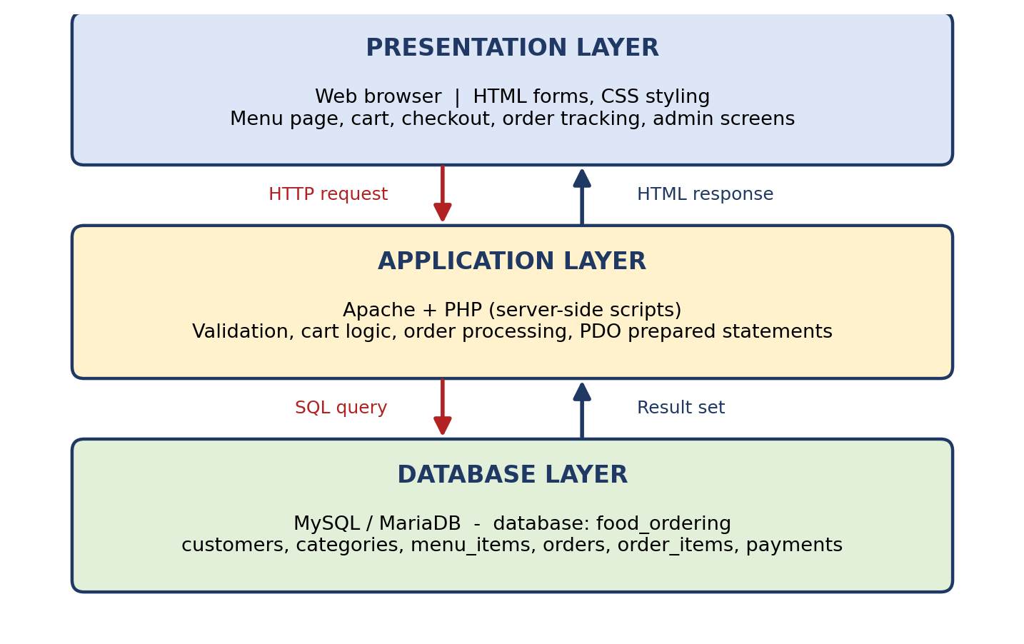
Figure 6.1 Three-layer system architecture

6.2 Application Modules
Module | Responsibility
Connection module | Holds the PDO connection settings (host, database name, user, password) in one configuration file.
Customer module | Registration and profile data stored in the customers table.
Menu module | Displays categories and available items; lets staff add, edit or disable items.
Cart and order module | Collects selected items, creates the order, order lines and payment record inside one transaction.
Payment module | Records the chosen payment method and updates the payment status.
Order tracking module | Shows status to customers and lets staff move an order to the next stage.
Report module | Runs aggregate queries such as top-selling items and pending payments.

6.3 Process Flow
Figure 6.2 shows the path of a single order. The decision step checks that every selected item is still available and that the submitted data is valid. Only if both checks pass are the order, its lines and the payment record written to the database.
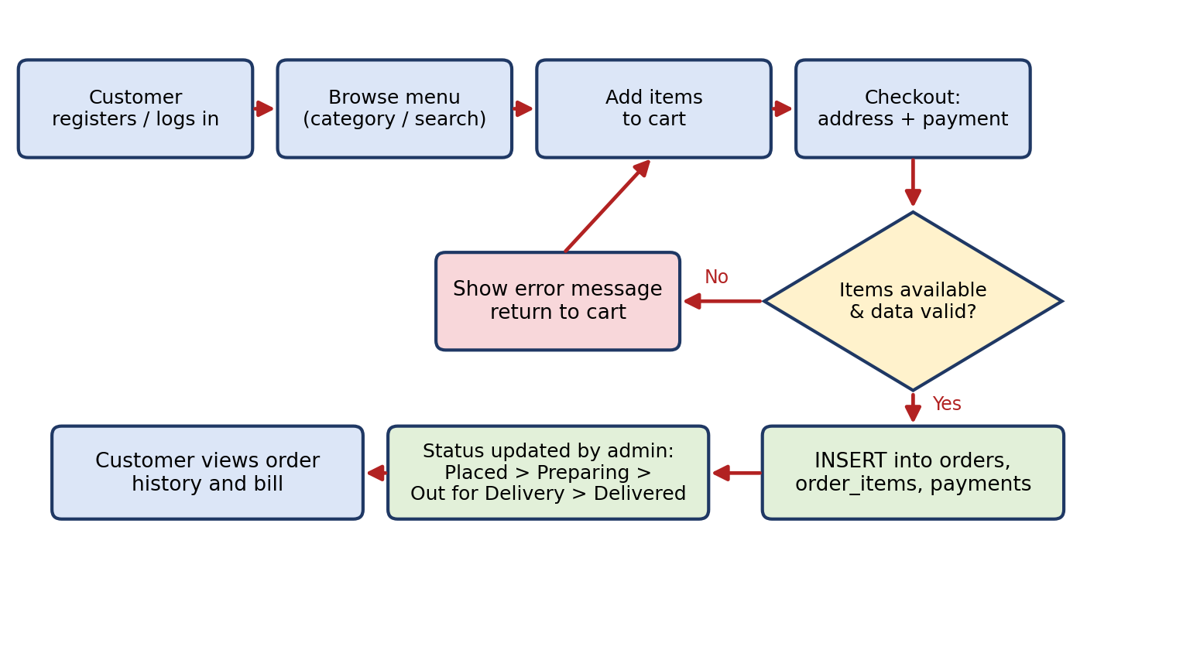
Figure 6.2 Order process flow
- The customer registers or logs in and opens the menu.
- The customer selects items and quantities; they are held in the cart.
- At checkout the customer confirms the delivery address and chooses Cash, UPI or Card.
- PHP validates the data and checks item availability.
- If valid, one transaction inserts the order, the order lines and the payment row; if not, an error message is shown.
- Staff update the status as the order moves through the kitchen to delivery.
- The customer can open the order history to see the bill and the current status.

7. DATABASE DESIGN (ER DIAGRAM AND SCHEMA)

7.1 Design Overview
The database food_ordering has six tables. Two of them describe the menu (categories, menu_items), one describes people (customers), and three describe business transactions (orders, order_items, payments). The order_items table resolves the many-to-many relationship between orders and menu items: one order can contain many items, and one item can appear in many orders.

7.2 ER Diagram
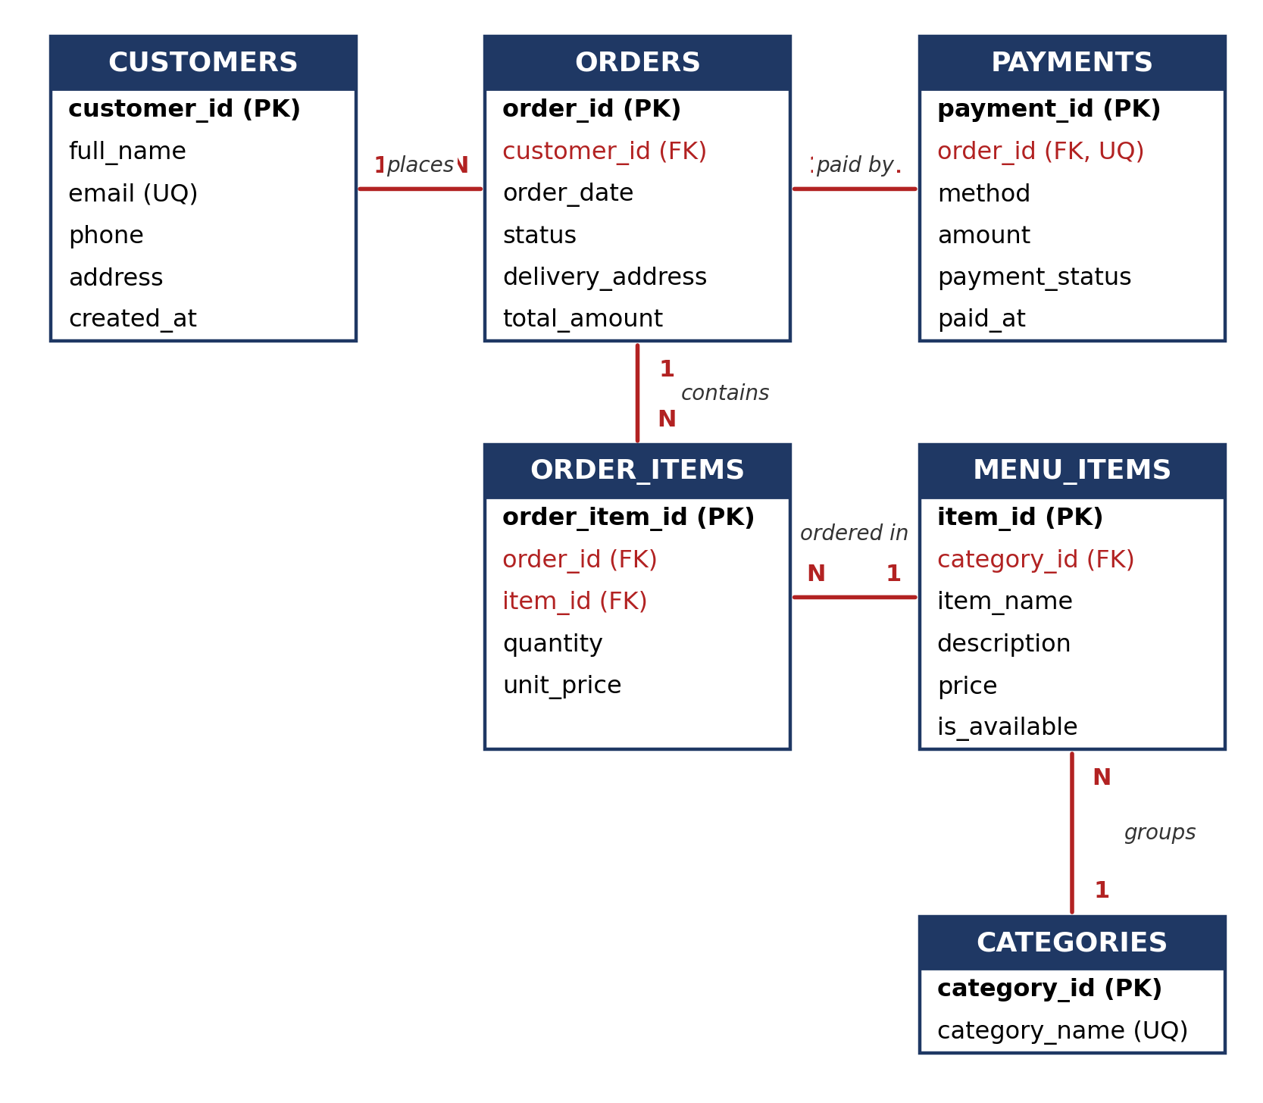
Figure 7.1 Entity Relationship (ER) diagram
In the diagram, PK marks a primary key, FK a foreign key and UQ a unique column. Foreign keys are shown in red.

7.3 Entities
Entity | Purpose | Primary key
customers | People who place orders | customer_id
categories | Menu groups such as Starters, Breads and Beverages | category_id
menu_items | Dishes and drinks with price and availability | item_id
orders | One row per order placed by a customer | order_id
order_items | The items, quantities and prices inside an order | order_item_id
payments | Payment method and status for an order | payment_id

7.4 Relationships
Relationship | Cardinality | Implemented by
Customer places Order | 1 : N | orders.customer_id references customers.customer_id
Category groups Menu item | 1 : N | menu_items.category_id references categories.category_id
Order contains Order items | 1 : N | order_items.order_id references orders.order_id (ON DELETE CASCADE)
Menu item appears in Order items | 1 : N | order_items.item_id references menu_items.item_id
Order is paid by Payment | 1 : 1 | payments.order_id references orders.order_id and is UNIQUE

7.5 Relational Schema
customers (customer_id PK, full_name, email UQ, phone, address, created_at)
categories (category_id PK, category_name UQ)
menu_items (item_id PK, category_id FK, item_name, description, price,
is_available)
orders (order_id PK, customer_id FK, order_date, status,
delivery_address, total_amount)
order_items (order_item_id PK, order_id FK, item_id FK, quantity, unit_price,
UNIQUE(order_id, item_id))
payments (payment_id PK, order_id FK UQ, method, amount, payment_status,
paid_at)

7.6 Design Decisions
- Surrogate primary keys. Each table uses an auto-increment integer key so that rows can be referenced even if a name or e-mail changes.
- Price snapshot. order_items.unit_price copies the menu price at the time of ordering, so changing a menu price later does not change old bills.
- ENUM and CHECK. status, method and payment_status accept only listed values; price > 0 and quantity > 0 are enforced inside the database.
- Cascade and restrict. Deleting an order removes its lines and payment, but customers and categories cannot be deleted while orders or menu items refer to them. Indexes on orders.customer_id and menu_items.category_id speed up common joins.

8. DATABASE NORMALIZATION AND DATA DICTIONARY

8.1 Purpose of Normalization
Normalization organizes data so that each fact is stored in one place. It removes the update, insertion and deletion anomalies that appear when unrelated facts share a table. The design process below starts from a single “flat” order sheet, similar to what a restaurant might keep on paper, and reaches the six-table schema of Chapter 7.

8.2 Unnormalized Form
A paper order sheet holds customer details and a repeating list of items in one row, for example: order 1, Rohan Mehta, rohan.mehta@example.com, 12 Sector 22, “Butter Chicken, Butter Naan ×2, Sweet Lassi”, categories “Main Course, Breads, Beverages”, prices “320, 45, 70”. This layout has repeating groups, repeats customer details for every order, and stores category and price inside the order.

8.3 First Normal Form (1NF)
1NF requires atomic values and no repeating groups. The list of items is split so that each item of an order becomes its own row, identified by (order_id, item_id). Every column in the final design, such as quantity or unit_price, holds a single value.

8.4 Second Normal Form (2NF)
2NF requires that every non-key attribute depends on the whole key. In the 1NF table keyed by (order_id, item_id), attributes such as item_name, category and the current price depend only on item_id, and customer_name and address depend only on order_id. These partial dependencies are removed by creating separate tables: menu_items (and categories) for item data, orders for order data, and leaving only quantity and unit_price in order_items, which truly depend on the pair (order_id, item_id).

8.5 Third Normal Form (3NF)
3NF removes transitive dependencies, where a non-key attribute depends on another non-key attribute. In the 2NF orders table, customer_name, email and phone depend on the customer, not on the order (order_id → customer → name). They are moved to customers, leaving only customer_id as a foreign key in orders. Likewise, category_name depends on category_id, so it lives in categories, and payment details that depend on the payment rather than the order live in payments. In every resulting table, each non-key column depends on “the key, the whole key and nothing but the key”.

8.6 Deliberate Denormalization
Two columns store data that could be derived, and both are intentional:
- order_items.unit_price duplicates the menu price, but it records a historical fact (the price charged at that moment). Without it, a menu price change would silently rewrite old bills.
- orders.total_amount equals the sum of quantity × unit_price of the order’s lines. It is stored so that order lists and payments can be shown without recalculating. The application sets it inside the same transaction that inserts the order lines, and the integrity query in Chapter 10 verifies that no order’s total differs from the sum of its lines.

8.7 Data Dictionary
The data dictionary describes every column of the database. Types are as defined in the SQL script in Chapter 9.
Table 8.1 customers
Column | Data type | Constraints | Description
customer_id | INT | PRIMARY KEY, AUTO_INCREMENT | Unique identifier of the customer
full_name | VARCHAR(100) | NOT NULL | Customer’s full name
email | VARCHAR(120) | NOT NULL, UNIQUE | E-mail address; no two customers may share one
phone | VARCHAR(15) | NOT NULL | Contact number
address | VARCHAR(255) | NOT NULL | Default delivery address
created_at | TIMESTAMP | DEFAULT CURRENT_TIMESTAMP | Date and time of registration

Table 8.2 categories
Column | Data type | Constraints | Description
category_id | INT | PRIMARY KEY, AUTO_INCREMENT | Unique identifier of the category
category_name | VARCHAR(60) | NOT NULL, UNIQUE | Name such as Starters or Beverages

Table 8.3 menu_items
Column | Data type | Constraints | Description
item_id | INT | PRIMARY KEY, AUTO_INCREMENT | Unique identifier of the item
category_id | INT | NOT NULL, FOREIGN KEY | Category to which the item belongs
item_name | VARCHAR(100) | NOT NULL | Name of the dish or drink
description | VARCHAR(255) | NULL allowed | Short description
price | DECIMAL(8,2) | NOT NULL, CHECK (price > 0) | Current selling price
is_available | TINYINT(1) | NOT NULL, DEFAULT 1 | 1 if the item can be ordered, 0 otherwise

Table 8.4 orders
Column | Data type | Constraints | Description
order_id | INT | PRIMARY KEY, AUTO_INCREMENT | Unique identifier of the order
customer_id | INT | NOT NULL, FOREIGN KEY | Customer who placed the order
order_date | DATETIME | DEFAULT CURRENT_TIMESTAMP | When the order was placed
status | ENUM | NOT NULL, DEFAULT 'Placed' | Placed, Preparing, Out for Delivery, Delivered or Cancelled
delivery_address | VARCHAR(255) | NOT NULL | Address for this order
total_amount | DECIMAL(10,2) | NOT NULL, DEFAULT 0.00 | Sum of quantity × unit_price of the order lines

Table 8.5 order_items
Column | Data type | Constraints | Description
order_item_id | INT | PRIMARY KEY, AUTO_INCREMENT | Unique identifier of the order line
order_id | INT | NOT NULL, FOREIGN KEY (CASCADE) | Order that contains this line
item_id | INT | NOT NULL, FOREIGN KEY | Menu item ordered
quantity | INT | NOT NULL, CHECK (quantity > 0) | Number of units ordered
unit_price | DECIMAL(8,2) | NOT NULL | Price per unit at the time of ordering
(order_id, item_id) | - | UNIQUE | An item appears at most once per order

Table 8.6 payments
Column | Data type | Constraints | Description
payment_id | INT | PRIMARY KEY, AUTO_INCREMENT | Unique identifier of the payment
order_id | INT | NOT NULL, UNIQUE, FOREIGN KEY (CASCADE) | Order being paid for (one payment per order)
method | ENUM | NOT NULL | Cash, UPI or Card
amount | DECIMAL(10,2) | NOT NULL | Amount to be paid
payment_status | ENUM | NOT NULL, DEFAULT 'Pending' | Pending, Paid or Failed
paid_at | DATETIME | NULL allowed | Time of successful payment

9. SQL IMPLEMENTATION AND QUERIES
This chapter presents the SQL used to build and use the database. All statements were executed on a MariaDB 10.11 server (the MySQL-compatible server supplied with XAMPP) and the result tables shown are the actual outputs.

9.1 Database and Table Creation (DDL)
CREATE DATABASE IF NOT EXISTS food_ordering;
USE food_ordering;
CREATE TABLE customers (
customer_id INT AUTO_INCREMENT PRIMARY KEY,
full_name VARCHAR(100) NOT NULL,
email VARCHAR(120) NOT NULL UNIQUE,
phone VARCHAR(15) NOT NULL,
address VARCHAR(255) NOT NULL,
created_at TIMESTAMP DEFAULT CURRENT_TIMESTAMP
);
CREATE TABLE categories (
category_id INT AUTO_INCREMENT PRIMARY KEY,
category_name VARCHAR(60) NOT NULL UNIQUE
);
CREATE TABLE menu_items (
item_id INT AUTO_INCREMENT PRIMARY KEY,
category_id INT NOT NULL,
item_name VARCHAR(100) NOT NULL,
description VARCHAR(255),
price DECIMAL(8,2) NOT NULL CHECK (price > 0),
is_available TINYINT(1) NOT NULL DEFAULT 1,
CONSTRAINT fk_item_category FOREIGN KEY (category_id)
REFERENCES categories(category_id)
);
CREATE TABLE orders (
order_id INT AUTO_INCREMENT PRIMARY KEY,
customer_id INT NOT NULL,
order_date DATETIME DEFAULT CURRENT_TIMESTAMP,
status ENUM('Placed','Preparing','Out for Delivery',
'Delivered','Cancelled') NOT NULL DEFAULT 'Placed',
delivery_address VARCHAR(255) NOT NULL,
total_amount DECIMAL(10,2) NOT NULL DEFAULT 0.00,
CONSTRAINT fk_order_customer FOREIGN KEY (customer_id)
REFERENCES customers(customer_id)
);
CREATE TABLE order_items (
order_item_id INT AUTO_INCREMENT PRIMARY KEY,
order_id INT NOT NULL,
item_id INT NOT NULL,
quantity INT NOT NULL CHECK (quantity > 0),
unit_price DECIMAL(8,2) NOT NULL,
CONSTRAINT uq_order_item UNIQUE (order_id, item_id),
CONSTRAINT fk_oi_order FOREIGN KEY (order_id)
REFERENCES orders(order_id) ON DELETE CASCADE,
CONSTRAINT fk_oi_item FOREIGN KEY (item_id)
REFERENCES menu_items(item_id)
);
CREATE TABLE payments (
payment_id INT AUTO_INCREMENT PRIMARY KEY,
order_id INT NOT NULL UNIQUE,
method ENUM('Cash','UPI','Card') NOT NULL,
amount DECIMAL(10,2) NOT NULL,
payment_status ENUM('Pending','Paid','Failed') NOT NULL DEFAULT 'Pending',
paid_at DATETIME NULL,
CONSTRAINT fk_pay_order FOREIGN KEY (order_id)
REFERENCES orders(order_id) ON DELETE CASCADE
);
CREATE INDEX idx_orders_customer ON orders(customer_id);
CREATE INDEX idx_items_category ON menu_items(category_id);

9.2 Sample Data and CRUD Operations
The database was loaded with 4 customers, 5 categories, 10 menu items, 5 orders (11 order lines) and 5 payments. Each order total was then set from its lines with UPDATE orders o SET total_amount = (SELECT SUM(quantity*unit_price) FROM order_items oi WHERE oi.order_id = o.order_id). The four CRUD operations are shown below.
-- CREATE: register a customer
INSERT INTO customers (full_name,email,phone,address)
VALUES ('Priya Sharma','priya.sharma@example.com','9876500044','101, Sector 15');

-- READ: list available menu items
SELECT item_id, item_name, price FROM menu_items WHERE is_available = 1;

-- UPDATE: change an order status
UPDATE orders SET status = 'Preparing' WHERE order_id = 4;

-- UPDATE: mark an item unavailable
UPDATE menu_items SET is_available = 0 WHERE item_id = 2;

-- DELETE: remove an order (its lines and payment are deleted by CASCADE)
DELETE FROM orders WHERE order_id = 5;

9.3 Queries and Results
Query 1: Menu by category (JOIN). Lists all available items with their category.
SELECT c.category_name, m.item_name, m.price
FROM menu_items m JOIN categories c ON c.category_id = m.category_id
WHERE m.is_available = 1
ORDER BY c.category_name, m.item_name;

category_name | item_name | price
Beverages | Masala Chai | 40.00
Beverages | Sweet Lassi | 70.00
Breads | Butter Naan | 45.00
Breads | Tandoori Roti | 25.00
Desserts | Gulab Jamun | 80.00
Main Course | Butter Chicken | 320.00
Main Course | Dal Makhani | 210.00
Main Course | Veg Biryani | 240.00
Starters | Paneer Tikka | 220.00
Starters | Veg Spring Roll | 150.00

Query 2: Bill of an order (multi-table JOIN). Shows each line of order 1 with its line total.
SELECT o.order_id, m.item_name, oi.quantity, oi.unit_price,
(oi.quantity * oi.unit_price) AS line_total
FROM orders o
JOIN order_items oi ON oi.order_id = o.order_id
JOIN menu_items m ON m.item_id = oi.item_id
WHERE o.order_id = 1;

order_id | item_name | quantity | unit_price | line_total
1 | Butter Chicken | 1 | 320.00 | 320.00
1 | Butter Naan | 2 | 45.00 | 90.00
1 | Sweet Lassi | 1 | 70.00 | 70.00

Query 3: Customer spending (GROUP BY and HAVING). Finds customers whose non-cancelled orders total more than 400.
SELECT c.full_name, COUNT(o.order_id) AS orders_placed,
SUM(o.total_amount) AS total_spent
FROM customers c JOIN orders o ON o.customer_id = c.customer_id
WHERE o.status <> 'Cancelled'
GROUP BY c.customer_id, c.full_name
HAVING SUM(o.total_amount) > 400
ORDER BY total_spent DESC;

full_name | orders_placed | total_spent
Rohan Mehta | 2 | 985.00
Simran Kaur | 1 | 560.00

Query 4: Search (LIKE). Finds menu items whose name or description contains a keyword.
SELECT item_id, item_name, price FROM menu_items
WHERE item_name LIKE '%paneer%' OR description LIKE '%paneer%';

item_id | item_name | price
1 | Paneer Tikka | 220.00

Query 5: Pending payments (JOIN with filter). Lists orders whose payment is still pending.
SELECT o.order_id, c.full_name, p.method, p.amount
FROM payments p
JOIN orders o ON o.order_id = p.order_id
JOIN customers c ON c.customer_id = o.customer_id
WHERE p.payment_status = 'Pending';

order_id | full_name | method | amount
3 | Rohan Mehta | Cash | 505.00
4 | Aman Verma | UPI | 380.00

9.4 View for Order Summary
A view hides the join logic and gives the application a simple, read-only summary of every order. A LEFT JOIN is used so that an order without a payment row would still appear.
CREATE OR REPLACE VIEW v_order_summary AS
SELECT o.order_id, c.full_name, o.order_date, o.status, o.total_amount,
p.method, p.payment_status
FROM orders o
JOIN customers c ON c.customer_id = o.customer_id
LEFT JOIN payments p ON p.order_id = o.order_id;

SELECT * FROM v_order_summary ORDER BY order_id;

order_id | full_name | order_date | status | total_amount | method | payment_status
1 | Rohan Mehta | 2026-10-20 13:05:00 | Delivered | 480.00 | UPI | Paid
2 | Simran Kaur | 2026-10-21 20:15:00 | Delivered | 560.00 | Card | Paid
3 | Rohan Mehta | 2026-10-25 19:40:00 | Out for Delivery | 505.00 | Cash | Pending
4 | Aman Verma | 2026-10-26 12:30:00 | Placed | 380.00 | UPI | Pending
5 | Priya Sharma | 2026-10-27 21:00:00 | Cancelled | 320.00 | Card | Failed

9.5 Placing an Order Using a Transaction
Creating an order involves several inserts that must succeed or fail together. A transaction guarantees this: either the order, its lines and its payment are all saved, or none are. The unit price is copied from menu_items at this moment.
START TRANSACTION;

INSERT INTO orders (customer_id, delivery_address)
VALUES (2, '45, Phase 7, Mohali');
SET @oid = LAST_INSERT_ID();

INSERT INTO order_items (order_id, item_id, quantity, unit_price)
SELECT @oid, item_id, 2, price FROM menu_items WHERE item_id = 5;
INSERT INTO order_items (order_id, item_id, quantity, unit_price)
SELECT @oid, item_id, 1, price FROM menu_items WHERE item_id = 8;

UPDATE orders
SET total_amount = (SELECT SUM(quantity * unit_price)
FROM order_items WHERE order_id = @oid)
WHERE order_id = @oid;

INSERT INTO payments (order_id, method, amount)
SELECT order_id, 'UPI', total_amount FROM orders WHERE order_id = @oid;

COMMIT;

The result for the new order (order 6: two Veg Biryani at 240.00 and one Sweet Lassi at 70.00):
order_id | full_name | status | total_amount | method | payment_status
6 | Simran Kaur | Placed | 550.00 | UPI | Pending

9.6 Secure Database Access from PHP
The PHP layer never builds SQL by joining user input into a string. It uses PDO prepared statements, which send the SQL and the values separately and therefore prevent SQL injection. The example below shows the menu search from Query 4 as the application would run it.
<?php
$pdo = new PDO('mysql:host=localhost;dbname=food_ordering;charset=utf8mb4',
$user, $pass, [PDO::ATTR_ERRMODE => PDO::ERRMODE_EXCEPTION]);

$stmt = $pdo->prepare(
'SELECT item_id, item_name, price FROM menu_items
WHERE is_available = 1 AND item_name LIKE :kw');
$stmt->execute([':kw' => '%' . $keyword . '%']);
$items = $stmt->fetchAll(PDO::FETCH_ASSOC);

foreach ($items as $row) {
echo htmlspecialchars($row['item_name']) . ' - ' . $row['price'];
}

10. TESTING AND RESULTS

10.1 Testing Approach
Testing in this report concentrates on the database layer, because it is the layer that guarantees correct data whatever interface is used. Two kinds of tests were carried out. Functional tests check that the normal operations (insert, join, update, transaction, cascade) give the expected data. Validation tests try to store invalid data and confirm that the database rejects it.
Environment: MariaDB 10.11 (MySQL-compatible, as bundled with XAMPP), InnoDB engine, SQL executed through the command-line client against the food_ordering database loaded with the sample data of Chapter 9.

10.2 Functional Test Cases
ID | Test | Expected result | Actual result | Result
F1 | Insert sample customers, categories and menu items | All rows saved with auto-generated keys | 4 customers, 5 categories and 10 items stored with keys 1 to 4, 1 to 5 and 1 to 10 | Pass
F2 | List available menu with category (Query 1) | 10 items grouped by category | 10 rows returned in category order | Pass
F3 | Bill for order 1 (Query 2) | 3 lines; lines add to 480.00 | 320.00 + 90.00 + 70.00 = 480.00 | Pass
F4 | Search for “paneer” (Query 4) | Paneer Tikka is returned | 1 row: Paneer Tikka, 220.00 | Pass
F5 | Place an order in a transaction (9.5) | New order, 2 lines, payment row, correct total | Order 6 created with 2 lines, total 550.00, payment Pending | Pass
F6 | Update status of order 4 to Preparing | Only that row changes | Status of order 4 became Preparing | Pass
F7 | Start a transaction, insert an order, then ROLLBACK | Order count unchanged | Count stayed at 6 after rollback | Pass
F8 | Delete order 5 (has 1 line and 1 payment) | Lines and payment deleted by CASCADE | Before: 1 line, 1 payment. After: 0 lines, 0 payments | Pass
F9 | Check that every stored total equals the sum of its lines | No mismatching orders | Query returned 0 rows | Pass

10.3 Validation and Constraint Tests
ID | Invalid action attempted | Constraint tested | Error returned by the database | Result
V1 | Insert a customer with an existing e-mail | UNIQUE (email) | ERROR 1062: Duplicate entry for key 'email' | Rejected
V2 | Insert a menu item with price −10 | CHECK (price > 0) | ERROR 4025: CONSTRAINT menu_items.price failed | Rejected
V3 | Insert an order line with quantity 0 | CHECK (quantity > 0) | ERROR 4025: CONSTRAINT order_items.quantity failed | Rejected
V4 | Create an order for customer 999 (does not exist) | FOREIGN KEY | ERROR 1452: Cannot add or update a child row | Rejected
V5 | Set order status to “Shipped” | ENUM list | ERROR 1265: Data truncated for column 'status' | Rejected
V6 | Add the same item twice to one order | UNIQUE (order_id, item_id) | ERROR 1062: Duplicate entry '1-3' for key 'uq_order_item' | Rejected
V7 | Add a second payment to order 1 | UNIQUE (payments.order_id) | ERROR 1062: Duplicate entry '1' for key 'order_id' | Rejected
V8 | Delete a customer who has orders | FOREIGN KEY (restrict) | ERROR 1451: Cannot delete or update a parent row | Rejected
V9 | Delete a category that has menu items | FOREIGN KEY (restrict) | ERROR 1451: Cannot delete or update a parent row | Rejected
V10 | Insert a customer without an address | NOT NULL | ERROR 1364: Field 'address' doesn't have a default value | Rejected

Error numbers are those returned by MariaDB 10.11. MySQL 8 reports the same situations with the same messages except for check-constraint violations, which it reports as error 3819.

10.4 Results Summary
All 19 tests passed: 9 functional tests (F1–F9) gave the expected data, and in all 10 validation tests (V1–V10) the database rejected the invalid data as intended.

10.5 Observations
- The database alone is enough to stop the most common data errors: duplicates, negative prices, zero quantities, orphan orders and invalid statuses.
- The ENUM check relies on the server’s strict SQL mode, which is the default in current MySQL and MariaDB versions. With strict mode off, an invalid value would be silently stored as an empty string.
- The stored total_amount is not enforced by a constraint. It is kept correct by the transaction in Section 9.5; a trigger could enforce it automatically in a future version.

11. CONCLUSION AND FUTURE ENHANCEMENTS

11.1 Conclusion
The Food Ordering System shows how a familiar real-world service can be modelled with a relational database. The six-table schema captures customers, menu, orders, order lines and payments with proper keys and constraints, and it is normalized to the Third Normal Form. The two deliberate denormalizations, the price snapshot in the order line and the stored order total, are documented and verified.
The SQL implementation covers table creation, CRUD operations, joins, aggregation, subqueries, a view and a transaction. All 19 database tests passed: normal operations produced the expected data, and every invalid operation attempted was rejected by the database.

11.2 Limitations
- The prototype serves a single restaurant and is intended for a local demonstration environment.
- There is no password-protected login or role-based access.
- Payments are recorded, not processed; no payment gateway is integrated.

11.3 Future Enhancements
- Authentication and roles: secure login with hashed passwords (password_hash) and separate customer, staff and admin roles.
- Multi-restaurant support: a restaurants table so that menu items and orders belong to different outlets.
- Delivery management: a delivery_partners table with assignment and live status.
- Payment gateway and reviews: a UPI/card gateway with stored transaction references, and ratings linked to orders.
- Analytics and triggers: sales reports, plus triggers that calculate totals and log status changes automatically.

REFERENCES
- R. Elmasri and S. B. Navathe, Fundamentals of Database Systems, 7th ed., Pearson, 2016.
- A. Silberschatz, H. F. Korth and S. Sudarshan, Database System Concepts, 7th ed., McGraw-Hill, 2019.
- Oracle Corporation, MySQL Reference Manual, https://dev.mysql.com/doc/
- MariaDB Foundation, MariaDB Knowledge Base, https://mariadb.com/kb/
- The PHP Group, PHP Manual: PHP Data Objects (PDO), https://www.php.net/manual/en/book.pdo.php
- OWASP Foundation, SQL Injection Prevention Cheat Sheet, https://cheatsheetseries.owasp.org/

