Pub and Eatery Point of Sale (PEPS) Software

Software Development Plan (SDP)

Jacob Owens, Chris Pohlman,

Ryan Rock, Chris Rock

< Team leader >

Advisor: Ben Geisler

Submitted in partial fulfillment

Of the requirements of a

Software Engineering *course project*

February 26, 2014

Table of Contents

1. Product Description
   1. Work for hire:
      1. Need to finalize what interactions the software will need to be able to handle with regards to external sources (i.e. with cash drawer, bar code reader, email client, text-message service such as Remind101, interaction with credit card services, receipt printer).
      2. Once interactions required have been finalized, will need to find ways to tie in functionality with VB code.
      3. Need to research viability of networked model for use at multiple stations in Bar/Pub as well as via tablet version of product.
      4. Product will need to be able to connect to a database for interaction with inventory as well as individual tabs.
      5. Team Org Chart:  
         
   2. Non-work for hire:
      1. Potential audience includes any Bar, Pub, or other like establishment serving any combination of food and/or drinks that is or will become computerized. System will be able to, with slight retooling, operate on a stand-alone station or be deployed on multiple server stations simultaneously. The Software is intended to be compatible with Windows operating systems including Windows tablets.
      2. Software will keep tabs for various tables and bar patrons (by default tables 1-40 and bar guests 70-90) totaling both food and drink orders. Upon closing of tab, Software will then apply proper sales tax (by default 5.5%) to tab. Parties of 8 or more will also be charged a 15% gratuity.
      3. Software will, upon tab item entry, query the existing inventory and, when a threshold limit is reached, email or text (based on preference and ability to integrate technology) establishment proprietor regarding inventory levels.
      4. Software will generate charge to debit or credit card, accept payment by gift card, or generate change required based on cash payment.
      5. Software will include option of emailing receipt to patron instead of printing additional receipt.
2. Team Description
3. See team org chart in A.i.e above. All team members’ expertise in web development will be needed for integration of email system into Software, their knowledge of various databases will be leveraged in Software’s inventory control functionality as well as its order control system, and their abilities in other languages will be leveraged, as necessary, to help incorporate any external, non-VB scripts needed for Software integration and functionality. Chris Pohlman’s knowledge of user interfaces (GUIs), Jacob Owen’s experience in unit testing, and Chris Rock’s and Ryan Rock’s experience with development/design experience in a team environment will be used for the benefit of this project.
4. Software Process Model Description
5. Team will operate on a modified iterative Scrum model. As all members have different schedules to accommodate as well as different specialties, a Scrum approach will allow the greatest flexibility to members while building the Software as well as during the various phases (Sprint, Plan, Release, etc.) involved. Team members will modify the traditional Scrum approach by checking in via email/GitHub documents at least weekly. As this is a software project, each team member will take a two-week rotation as Scrum master, helping to facilitate those two weeks’ activities.
6. Project Definition
7. Software high points defined in A.ii above will be fleshed out in multiple releases.
8. Initial Software Interface design
9. Entry Interface/Login Screen

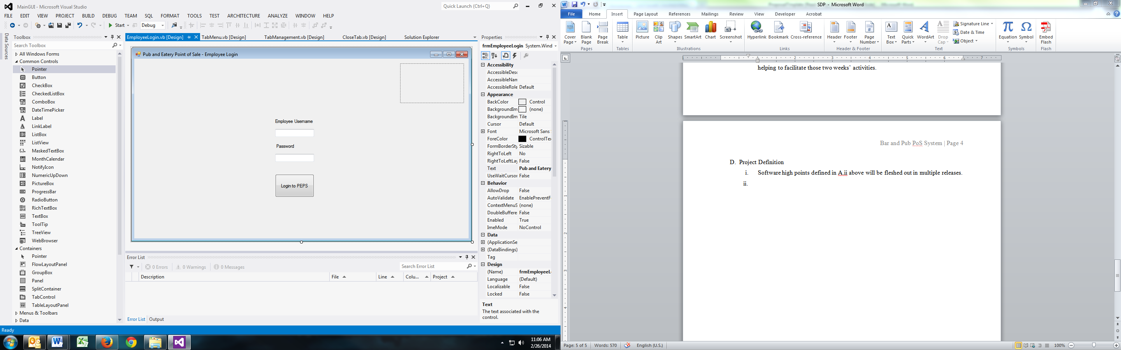

1. Tab Management Screen

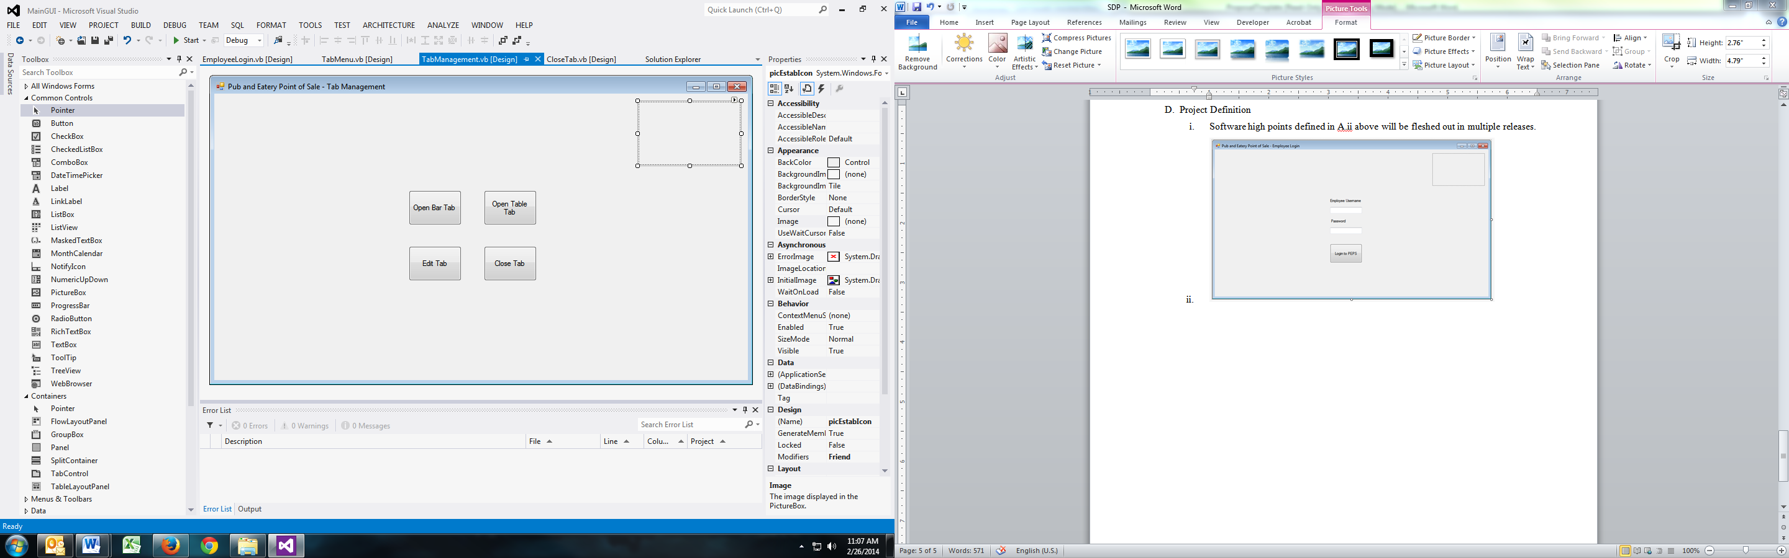

1. Tab Menu (Add items to tab)

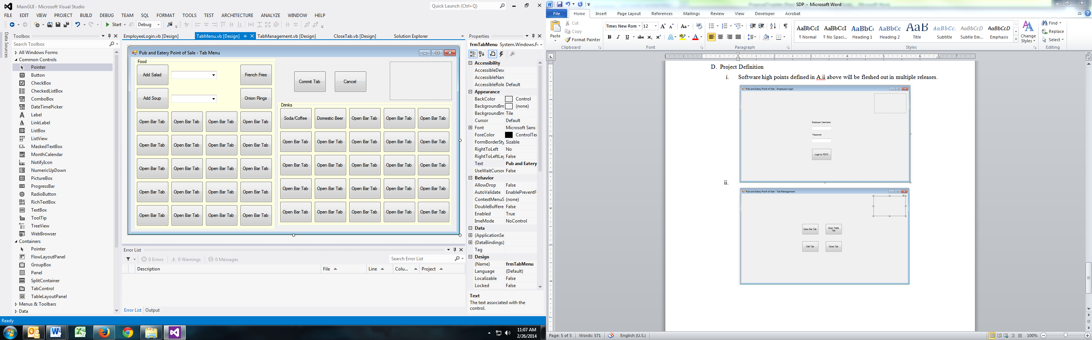

1. Close Out Tab

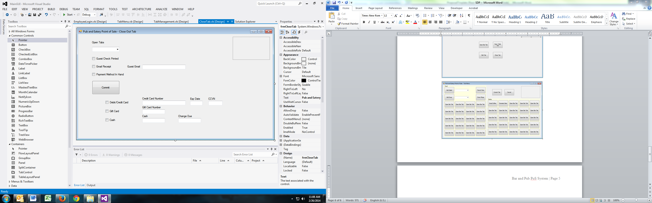

1. Use Cases
2. Bar tab –
   * + 1. Employee logs into Software,
       2. Employee is taken to Tab Management Screen
       3. Employee selects “Open Bar Tab”
       4. Software initializes new bar tab in database with appropriate code/number to indicate patron at bar
       5. Employee is taken to Tab Menu
       6. Employee selects various drinks for patron
       7. Employee selects Commit
       8. Drinks are added to patron’s tab in database
       9. Employee is returned to Tab Management Screen
       10. Employee selects Close Tab
       11. Employee is taken to Close Out Tab screen
       12. Employee selects open tab from combo box
       13. Employee selects Commit – receipt is printed
       14. Employee receives payment and checks both Guest Receipt Printed and Payment Method in Hand boxes and selects Commit
       15. Payment option check boxes appear
       16. Employee selects cash – Cash and Change boxes appear
       17. Employee enters payment, change is displayed.
       18. Employee selects Commit, cash drawer ejects, receipt is printed, tab is closed in database.
       19. Employee is returned to Tab Management Screen
3. Food and bar tab
   * + 1. Employee logs into Software,
       2. Employee is taken to Tab Management Screen
       3. Employee selects “Open Table Tab”
       4. Software initializes new table tab in database with appropriate code/number to indicate patron at table
       5. Employee is taken to Tab Menu
       6. Employee selects various drinks and food for patron
       7. Employee selects Commit
       8. Drinks and food are added to patron’s tab in database
       9. Employee is returned to Tab Management Screen
       10. Employee selects Close Tab
       11. Employee is taken to Close Out Tab screen
       12. Employee selects open tab from combo box
       13. Employee selects Commit – receipt is printed
       14. Employee receives payment as well as patron’s email on receipt - employee checks Guest Receipt Printed, Email Receipt and Payment Method in Hand boxes
       15. Patron Email text box appears – employee enters patron’s email
       16. Payment option check boxes appear
       17. Employee selects credit – Credit/Debit card boxes appear
       18. Employee enters card information
       19. Employee selects Commit, patron is emailed copy of receipt, tab is closed in database.
       20. Employee is returned to Tab Management Screen
4. Software flow Description: Employee logs into screen D.ii.a, is taken to screen D.ii.b, and depending on selection is either taken to D.ii.c or D.ii.d. From D.ii.c employee is returned to D.ii.b from where employee can navigate to D.ii.d to close out tab.
5. Project Organization
6. Project Timeline via Microsoft Project

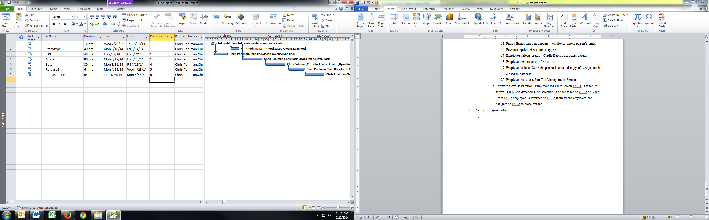

1. Validation Plan
2. See D.ii above
3. Configuration/Version Control
4. …???
5. Tools
6. Printing to a PoS Printer: <http://www.dreamincode.net/forums/topic/55765-printing-to-a-pos-printer/>
7. Opening cash drawer in VB – forums with multiple threads: <http://www.bigresource.com/VB-Receipt-printer-control-codes-to-open-attached-cash-drawer-8EVPkDMqXs.html>
8. Printing to PoS Printer in VB (non-VB code): <http://www.youtube.com/watch?v=ToRXCw91r-c>
9. Developing PoS System in VB.NET (multi-part video tutorial series): <http://www.youtube.com/watch?v=Of9mS6sotsw>
10. Opening cash drawer in VB.NET: <http://www.sourcecodester.com/tutorials/visual-basic-net/3726/how-open-cash-drawer-using-vbnet.html>
11. Open cash drawer from connected USB printer: <http://stackoverflow.com/questions/12045413/open-cash-drawer-with-printer-connected-to-usb-in-vb-net>
12. Open cash drawer via VB.NET: <http://www.freevbcode.com/ShowCode.asp?ID=8444>
13. Send SMS text message from VB.NET: <http://stackoverflow.com/questions/18035583/how-to-implement-sms-sending-in-vb-net>
14. Walkthroughs for sending SMS via SQL and HTTP: <http://www.ozekisms.com/index.php?owpn=585>
15. Send email from within VB.NET: <http://social.msdn.microsoft.com/Forums/en-US/f040bf19-6474-421c-958b-7aa19973b328/vbnet-send-email>
16. System.Net.Mail Namespace in .NET 4.5: <http://msdn.microsoft.com/en-us/library/system.net.mail.aspx>
17. Resource for validating and processing credit cards in VB.NET: <http://social.msdn.microsoft.com/Forums/en-US/88fcc95b-dea9-4748-b193-034ed855321e/credit-card-processing-in-vbnet-windows-application?forum=netfxbcl>