Battleship  
Configuration Management Plan

Chris Hoorn  
Cody Plungis  
Tiffany Pohl

Table of Contents

Software Configuration Management Plan 3

Executive Summary 3

Reference Documents 3

Management 3

Organization and Responsibilities 3

Policies, Directives, and Procedures 3

Activities 3

Configuration Identification 3

Configuration Control 3

Resources 3

Schedules 3

Resources 4

Plan Maintenance 4

References 5

Appendix 6

Appendix A 6

Appendix B 7

Index 8

Glossary 9

# Software Configuration Management Plan

## Executive Summary

This handy little document covers everything we need in milestone 2. Our tentative schedule is in Appendix A. Our class diagram is in Appendix B.

## Reference Documents

We are using the code conventions for Java as defined by Oracle. [1]

## Management

### Organization and Responsibilities

We are using a github account to share and organize documents. This account can be accessed at <https://github.com/pohltm/Battle>. The repository is split into two different folders. The folder containing the documents is further divided up into individual folders for each milestone. There is also a folder that contains our Java code.

### Policies, Directives, and Procedures

## Activities

### Configuration Identification

#### Identifying Configuration Items

#### Naming Conventions

#### Acquiring Configuration Items

### Configuration Control

#### Requesting Changes

#### Evaluating Requested Changes

#### Approving or Disapproving Changes

#### Implementing Changes

## Resources

### Schedules

A tentative schedule for this project is outlined in Appendix A. The given outline is relative to project milestones and other class activities.

### Resources

The tools used for the configuration management will be github.

## Plan Maintenance

# References

|  |  |
| --- | --- |
| [1] | Oracle, "Code Conventions for the Java Programming Language," Sun Microsystems, Inc., 20 April 1999. [Online]. Available: http://www.oracle.com/technetwork/java/javase/documentation/codeconvtoc-136057.html. [Accessed 13 April 2012]. |

# Appendix

## Appendix A

|  |  |
| --- | --- |
| **Week** | **Task(s)/Feature(s) – Implementer(s)** |
| 0 | Configuration Management Plan  Initial Class Diagram  Milestone 2  Week 1 Test Cases |
| 1 | Game Board and Ships  Research GUI  Week 2 Test Cases |
| 2 | Menu System  Basic GUI  Simple AI  Milestone 3  Week 3 Test Cases |
| 3 | Localization(German/English)  Connect Game Functions and GUI  Improved AI  Week 4 Test Cases |
| 4 | Full Game Functionality  Week 5 Test Cases  Milestone 4 |
| 5 | Finalize Project  Add Extra Features  Milestone 5 |

## Appendix B

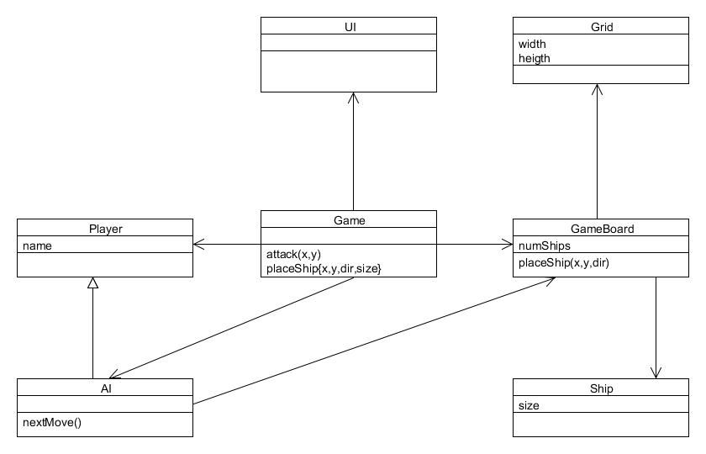

# Index

**No index entries found.**

# Glossary