What is JDK,JRE,JVM?

* JDK is the Java Development Kit that contains all the Java compiler, debugger and Javadoc.
* JRE is the Java Runtime Environment contains the JVM and all the files and libraries needed to run java codes.
* JVM is the Java Virtual Machine that is like the operating system to execute java code.

Is JVM, a compiler or interpreter ?

* An interpreter

Why Java don't use pointers ?

* So that it’s easier to understand and memory safety

What are various types of Class loaders used by JVM ?

* They are Bootstrap, Extension and Applications/System

How are classes loaded by JVM ?

* By using the Bootstrap loader to load all classes from rt.jar

Which memory areas does instance and static variables use ?

* Stack

What is PermGen or Permanent Generation ?  
- PermGen is some set memory space in the memory heap but no longer used in Java8

What is metaspace ?

* Metaspace is what Java8 used instead of PermGen and have unlimited space

Describe what happens when an object is created in Java.

* When an object is created in Java, a constructor is call and a new memory address is assigned to the object

Different types of memory used by JVM ?

* RAM, stack,

Does Java Pass by Value or Pass by Reference

* Since Java does not use pointers, so Java must Pass by Value.

What are native methods?

* They are written in a different language
* They are supposed to help with performance

Lab work:

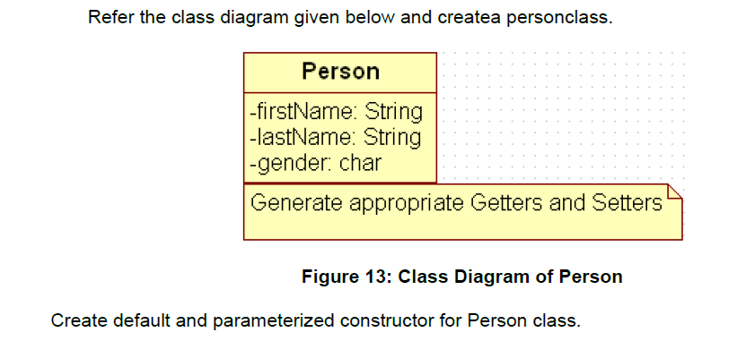

Also Create “PersonMain.java” program and write code for following operations:

a) Create an object of Person class and specify person details through constructor.

b): Modify to accept phone number of a person. Create a new method to implement the same and also define method for displaying persondetails.

c): Modify the above program, to accept only ‘M’ or ‘F’ as gender field values. Use Enumeration for implementing the same

--After spring--

d) Add a method called calculateAge which should accept person’s date of birth and calculate age of a person.

e) Add a method called getFullName(String firstName, String lastName) which should return full name of a person

f) Display person details with age and fullname.

.

|  |
| --- |
| Write a program to accept a number from user as a command line argument and check whether the given number is positive or negative number. |
|  |
|  |