**Requirement from project description:**

Week 6 (10/1)–Data Preparation (10%-6745, 5% 4745)

* Analysis-ready dataset with all missing and erroneous values removed
* A Jupyter notebook illustrating how to read your data into Python and demonstrating that it does not contain erroneous values

**Expected outcome:**

* A 41*5 matrix??

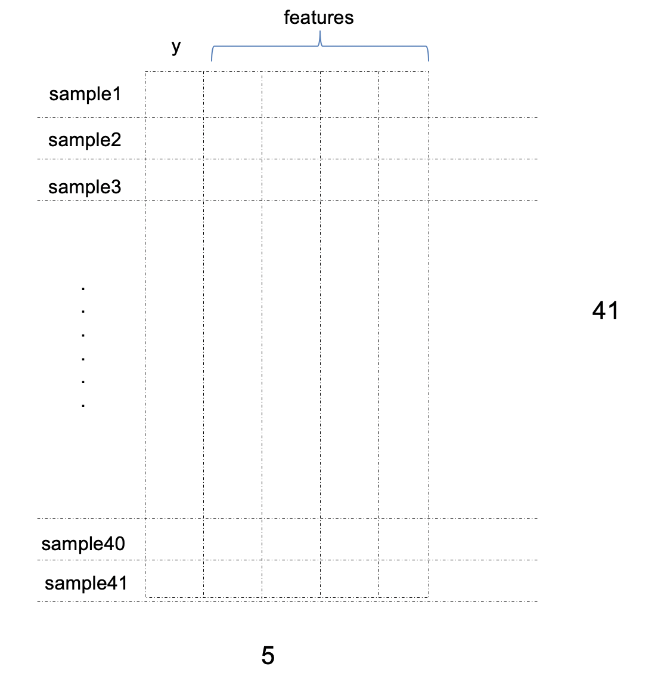

* Jupyter notebook description

**Parameters required from MCC data:**

* **Area under the curve (HRR)**
* **Peak (Burning temp)**
* **First div=0 (ignition temp)**

**Other parameters required for calculating features:**

**Heating rate (from csv) -> HRC**

**Standard temp (25C)**

**Plans to achieve the goal:**

1. Import data from excel to python

* Input: temperature/HRR
* Output: FR result (0/1)

1. Baseline correction

* Change of axes?
* <https://stackoverflow.com/questions/29156532/python-baseline-correction-library>

1. Fit the curve to obtain features

* *Total Heat Release Rate*

Area under the MCC curve

<https://stackoverflow.com/questions/13320262/calculating-the-area-under-a-curve-given-a-set-of-coordinates-without-knowing-t>

* *Ignition temperature*

Turning point of first peak

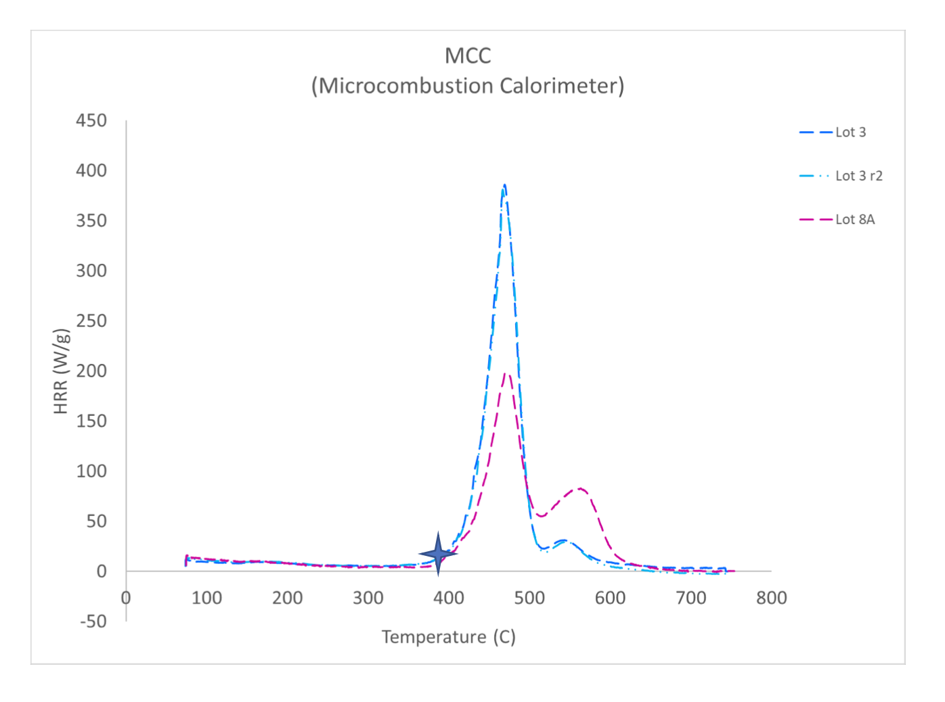

* *Fire Growth Capacity (FGC)*

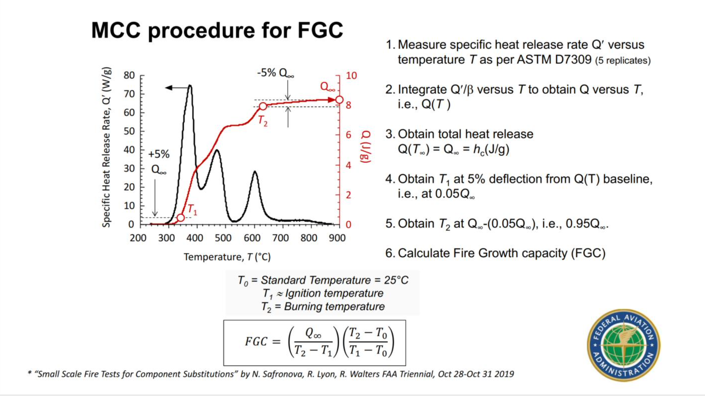

* *Heat Release Capacity*

Need HRC/Ignition temp (already done) + Heating Rate

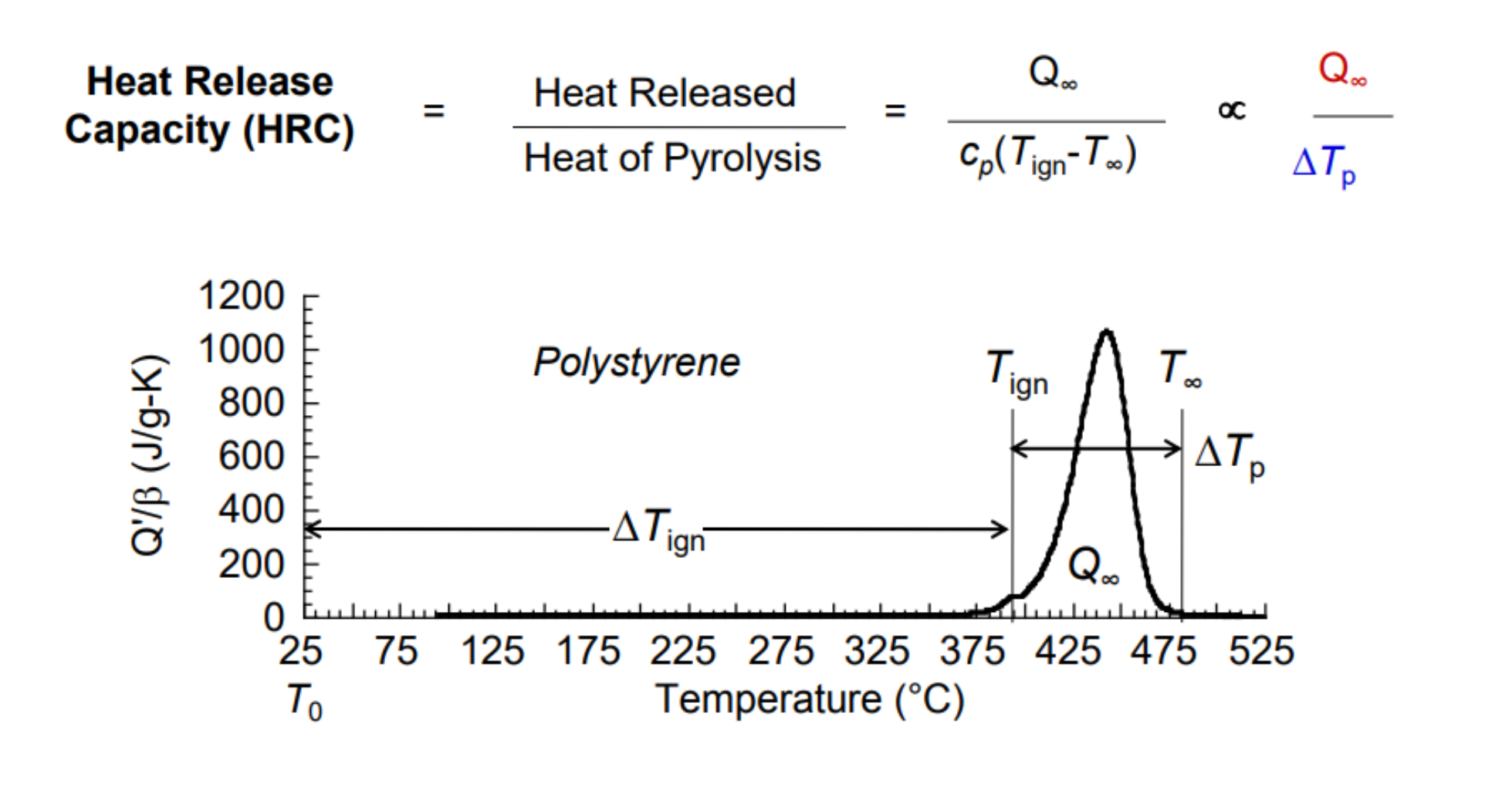

1. Save the results in a matrix

**TASKs:**

1. Organize the original CSV files and combine the useful information (Temperature + HRR) in one CSV file ---(Liyun)
2. Read the new CSV file and store data in python array --- (Po Hsien)

Ff

1. Build the baseline correction model --- (Ziheng)
2. Read baseline corrected data and grab parameters from the curve --- (Christian)

* Area under the curve (HRR) --- ( )
* Peak (Burning temp) --- ( )
* First div=0 (ignition temp) --- ( )

1. Use the extracted parameter data and constants to calculate FGC & HRR --- ( )

Please have the models ready by Sunday (9/27)