**Practical 9**

**Aim:- Simulating Virtual Routing and Forwarding (VRF)**

**Topology:-**

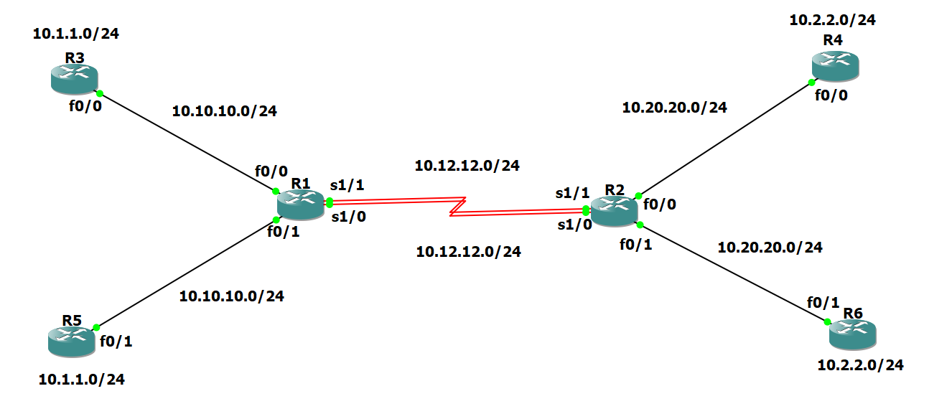

**Step 1:- Prepare the routers for the lab.**

Cable the network as shown in the topology diagram. Erase the startup configuration and reload each router to clear previous configurations.

**Step 2:- Configure Virtual Routing and Forwarding.**

**Router R1 Console**

ip vrf cust-A

exit

ip vrf cust-B

exit

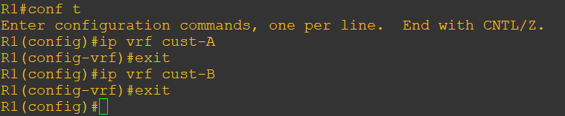

**Step 3:- Configure interface addresses.**

**Router R1 Console**

interface f0/0

ip vrf forwarding cust-A

ip address 10.10.10.1 255.255.255.0

no shutdown

exit

interface S1/1

ip vrf forwarding cust-A

ip address 10.12.12.1 255.255.255.0

no shutdown

exit

interface f0/1

ip vrf forwarding cust-B

ip address 10.10.10.1 255.255.255.0

no shutdown

exit

interface S1/0

ip vrf forwarding cust-B

ip address 10.12.12.1 255.255.255.0

no shutdown

exit

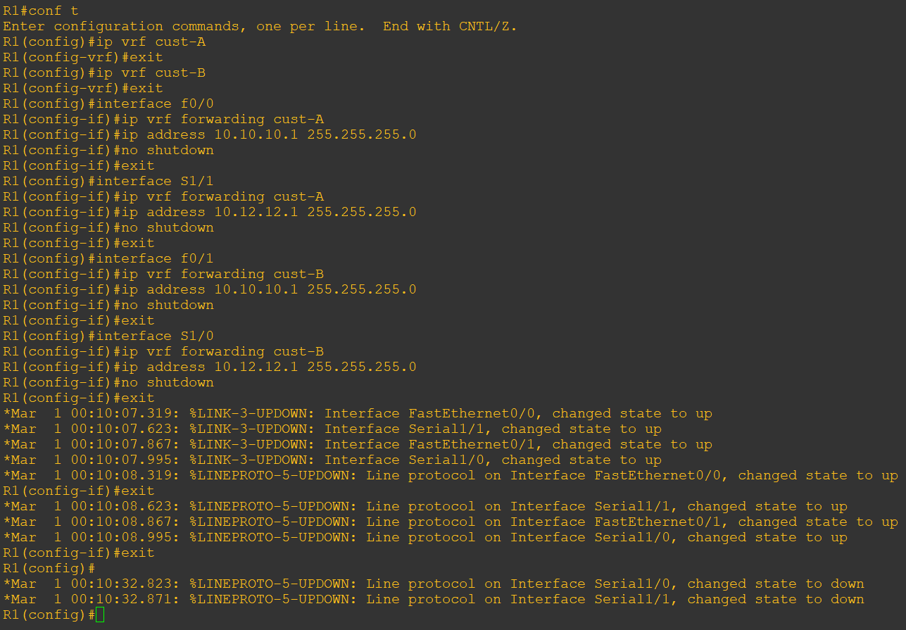

**Router R2 Console**

ip vrf cust-A

exit

ip vrf cust-B

exit

interface f0/0

ip vrf forwarding cust-A

ip address 10.20.20.2 255.255.255.0

no shutdown

exit

interface S1/1

ip vrf forwarding cust-A

ip address 10.12.12.2 255.255.255.0

no shutdown

exit

interface f0/1

ip vrf forwarding cust-B

ip address 10.20.20.2 255.255.255.0

no shutdown

exit

interface S1/0

ip vrf forwarding cust-B

ip address 10.12.12.2 255.255.255.0

no shutdown

exit

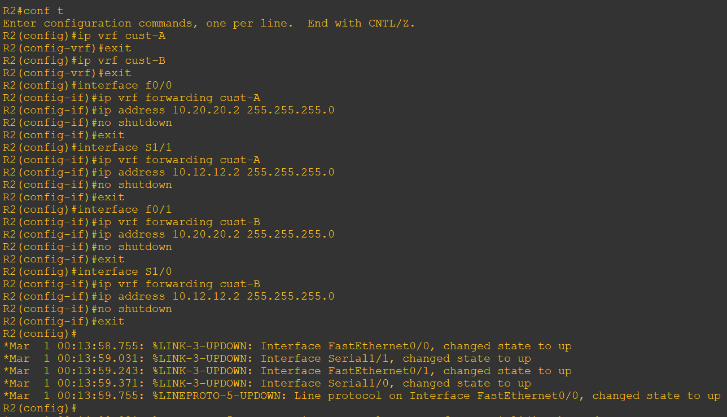

**Router R3 Console**

interface Loopback0

ip address 10.1.1.3 255.255.255.0

no shutdown

exit

interface f0/0

ip address 10.10.10.3 255.255.255.0

no shutdown

exit

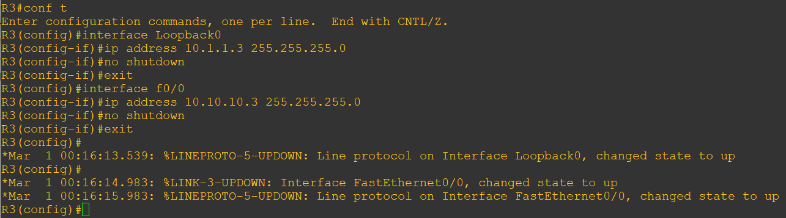

router eigrp 100

no auto

net 10.0.0.0

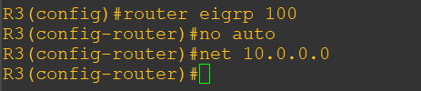

**Router R4 Console**

interface Loopback0

ip address 10.2.2.4 255.255.255.0

no shutdown

exit

interface f0/0

ip address 10.20.20.4 255.255.255.0

no shutdown

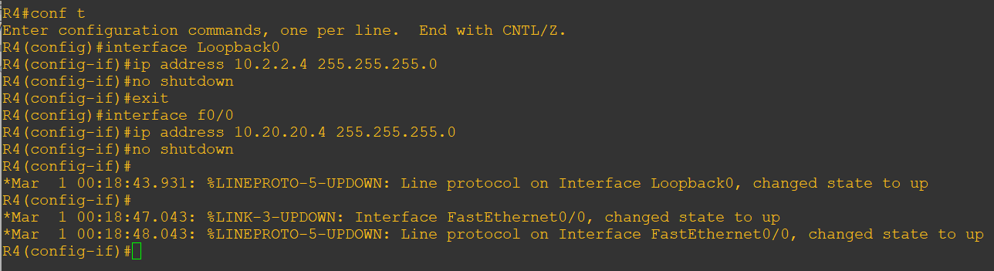

router eigrp 100

no auto

net 10.0.0.0

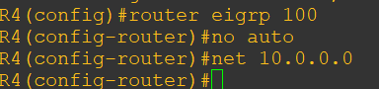

**Router R5 Console**

interface Loopback0

ip address 10.1.1.5 255.255.255.0

no shutdown

exit

interface f0/1

ip address 10.10.10.5 255.255.255.0

no shutdown

exit

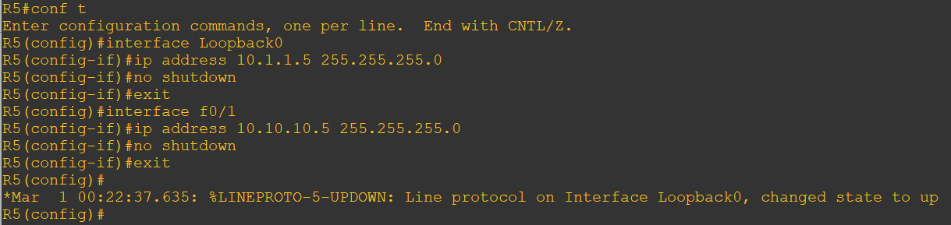

router eigrp 100

no auto

net 10.0.0.0

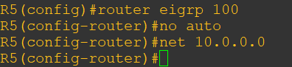

**Router R6 Console**

interface Loopback0

ip address 10.2.2.6 255.255.255.0

no shutdown

exit

interface f0/1

ip address 10.20.20.6 255.255.255.0

no shutdown

exit

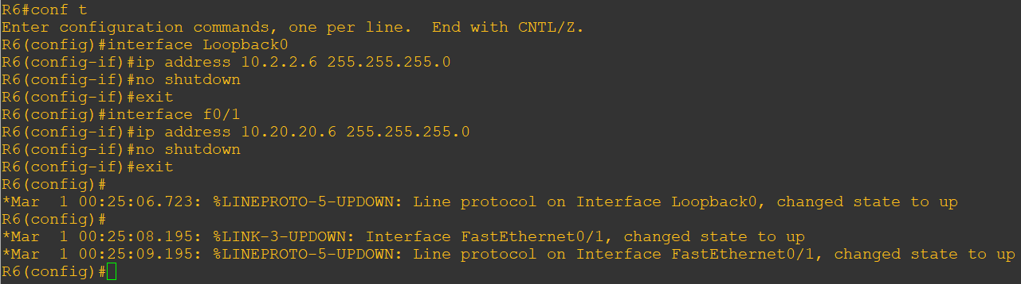

router eigrp 100

no auto

net 10.0.0.0

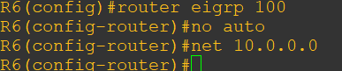

**Router R1 Console and R2 Console**

router eigrp 1

address-family ipv4 vrf cust-A

autonomous-system 100

no auto

network 10.0.0.0

exit

address-family ipv4 vrf cust-B

autonomous-system 100

no auto

network 10.0.0.0

exit

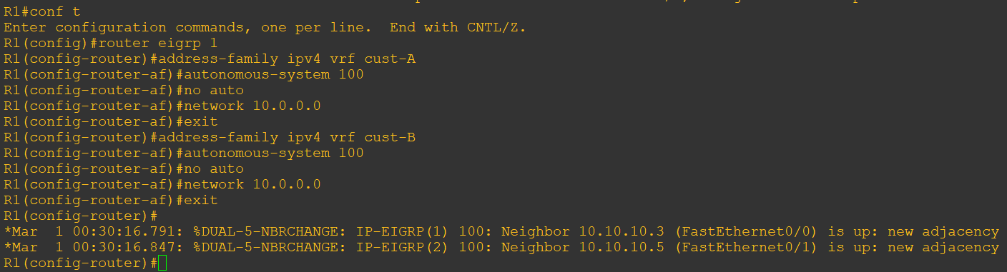

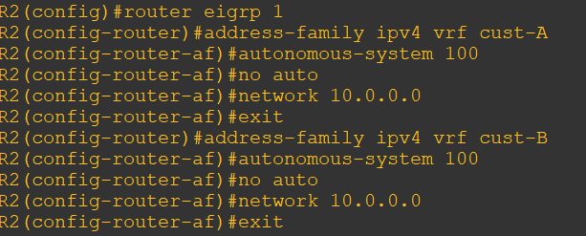

**Router R1 Console**

show ip route

Note:- Since we have configured virtual routing and forwarding it will not display the connections.

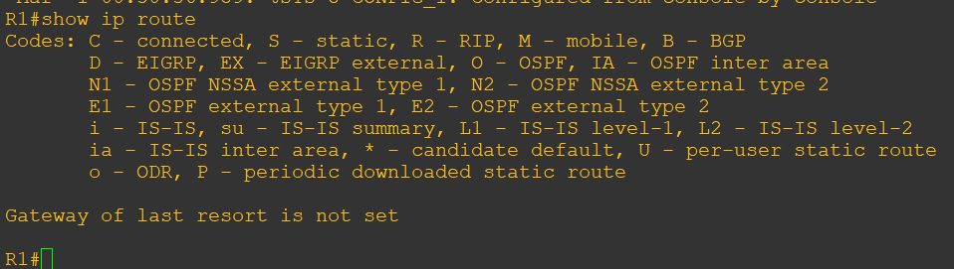

To check the routes we have to write the following command on R1 and R2.

show ip route vrf cust-A

show ip route vrf cust-B

Note:- Now it will display all the connections.

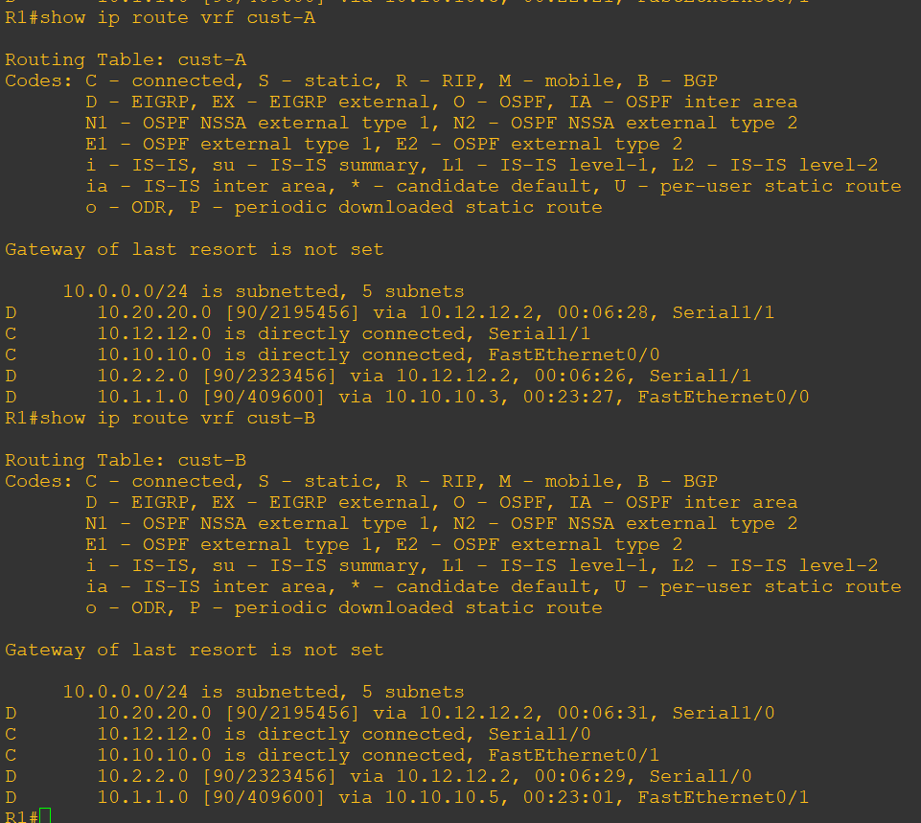

Since we have configured virtual routing and forwarding on R1 and R2, to ping we have to write the following command.

ping vrf cust-A 10.1.1.3

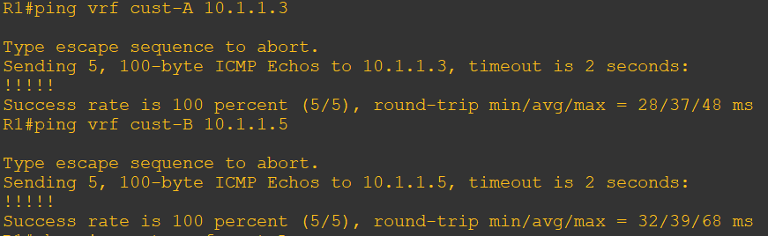

**Router R3 Console**

Since we have not configured virtual routing and forwarding on R3,R4,R5 and R6, to ping we simply have to write the following command.

ping 10.2.2.4

