Expert System:

An expert system is a computer program that is designed to solve complex problems and to provide decision-making ability like a human expert. It performs this by extracting knowledge from its knowledge base using the reasoning and inference rules according to the user queries.

Components of Expert System

An expert system mainly consists of three components:

* **User Interface**:

**it is an interface that helps a non-expert user to communicate with the expert system to find a solution**.

* **Inference Engine**

The inference engine is known as the brain of the expert system as it is the main processing unit of the system. It applies inference rules to the knowledge base to derive a conclusion or deduce new information. the system extracts the knowledge from the knowledge base.

* **Knowledge Base**

The knowledgebase is a type of storage that stores knowledge acquired from the different experts of the particular domain. It is considered as big storage of knowledge. The more the knowledge base, the more precise will be the Expert System.It is similar to a database that contains information and rules of a particular domain or subject.

Bayes Theorm:

* Bayes' theorem is also known as **Bayes' Rule** or **Bayes' law**, which is used to determine the probability of a hypothesis with prior knowledge. It depends on the conditional probability.
* **It is used to find the probability of an event, based on prior knowledge of conditions that might be related to that event.**
* The formula for Bayes' theorem is given as:

Naïve Bayes Classifier Algorithm

**Where,**

**P(A|B) is Posterior probability**: Probability of hypothesis A on the observed event B.

**P(B|A) is Likelihood probability**: Probability of the evidence given that the probability of a hypothesis is true.

**P(A) is Prior Probability**: Probability of hypothesis before observing the evidence.

**P(B) is Marginal Probability**: Probability of Evidence.

Conditional Probability and joint probability

Conditional

Conditional Probability (P(A|B)): Conditional probability is a measure of the likelihood of event A occurring given that event B has occurred. In mathematical terms, it's defined as:

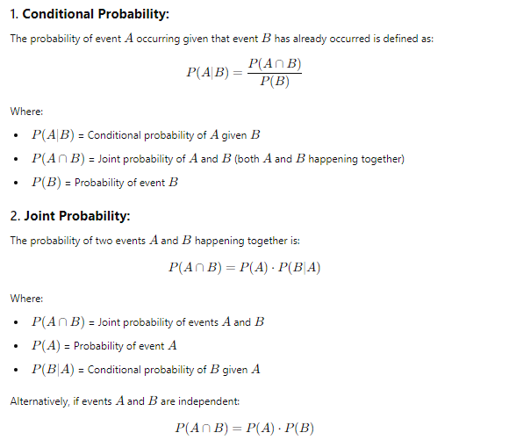

Joint

The joint probability of two events A and B is a measure of how likely it is that both events will occur simultaneously.