Estimating the Impact of Population Ageing and Migration to the Spanish Aggregate Labour Supply
Gilbert Montcho
Alejandro Steven Fonseca-Zendejas
Marcel Mérette
Abstract
Population ageing has raised concerns about the future of aggregate labour supply, as it is expected to slow down the growth rate of- and even reduce- the working age population. However, its actual effects depend not only on the number of working age individuals (native and immigrants), but also on the labour market preferences regarding participation rates and hours worked. This article estimates aggregate labour supply in Spain using Labour Force Survey microdata and assesses the contribution of each component to changes between 2005 and 2025, using a continuous change decomposition framework. Over this period, aggregate labour supply increased by 2.18 million full-time equivalent (FTE) workers. Population ageing among the Spanish-born population contributed to a reduction in labour supply by 2.55 million, a decline that was more than compensated for by immigration, which added 3.04 million FTE workers. Moreover, higher labour-market participation among prime-age and older Spanish-born individuals increased the number of FTE workers by +2.82 million, even though declining hours worked mitigated the gain (-1.60 million). In contrast, behavioural changes among the foreign-born population were consistently weak (activity rate: +0.01 million; hours worked: -0.39 million) and unstable. Overall, the results show that ageing does not mechanically reduce labour supply, and neither does immigration provide a stable long-run offset. This underscores the need for complementary policies—such as supporting longer and healthier working lives and women activity rates—to address ageing pressures more sustainably.
Keywords: Labour Supply, Immigration, Population Ageing, Decomposition Models.

Introduction
Across Western Europe, Spain is a strong case of the demographic pressures currently facing developed economies. Population ageing, driven by baby-boom cohorts reaching retirement age, increasing life expectancy, and falling fertility rates, are more pronounced in Spain than in the rest of Europe and old population is expected to grow at a faster rate than in the European Union according to the Banco de Espana (2019 and 2023). The demographic shift in Spain looks like a permanent rather than a temporary trend as the dependency ratio -65+ over 15-64- is expected to remain above 50% from 2045 (Banco de Espana 2023, p.2). Severe population ageing as in Spain engenders important disturbances for aggregate supply and demand in an economy, consequently affecting several economic and social outcomes. Ageing affects saving, consumption patterns, investment, international capital inflows, and potential growth, in addition to raise intergenerational equity issues through pressures on pay-as-you-go (PAYG) pension systems (Dıiaz-Giménez and Dıiaz-Saavedra 2009; Boeri et al. 2024) and on public expenditure on health and long-term care services (Cristea et al. 2020; Aiyar and Ebeke 2016; Bijak et al. 2007). While social security and other fiscal challenges often make the headlines, there is little doubt that the labour market is the first point of impact from which most supply and demand effects cascade.
Individuals' behaviour with respect to labour supply evolves over the life cycle. Participation rates and work intensity (working hours) are usually higher among middle-aged relative to younger or older ones. Consequently, changes in the relative size of the age groups due to ageing affect the number of potential workers, participation rates, hours worked, and ultimately the labour supply contribution that finances pensions, health care, and other public services. In this sense, the fiscal consequences of ageing are partly the downstream result of labour-market changes generated by population ageing. This article integrates the main demographic and behavioural components into a unified framework that isolates the contribution of each factor to changes in effective labour supply. The method measures aggregate labour supply as total potential annual hours worked, combining population size, age structure, labour-force participation, and hours worked by age group and birthplace status. Changes in labour supply are then decomposed into demographic, participation, and work-intensity components using a continuous-change decomposition model (Horiuchi et al. 2008).

Ageing and Labour-Supply Pressure
In Spain, this demographic pressure operates within a labour market already marked by structural unemployment, institutional segmentation, high sensitivity to economic cycles, a large informal economy, and the internal redistribution of human capital between natives and immigrants. Bentolila and Dolado (1990) and Bentolila et al. (2012 and 2020) explain the above features of the labour market in Spain by the presence of a dual labour market economy characterized by the highest share of fixed-term or temporary contracts in OECD. The high volatility in employment observed in Spain is the result of the high protection for workers in permanent jobs according to Costain et al. (2010). In addition, the labour market duality tends to affect human capital accumulation and early careers (García-Louzao et al. 2022). These features matter because they shape how demographic change is translated into labour supply. Ageing does not only affect the labour market by increasing the number of older individuals; it also changes the relative weight of age groups with different participation rates, employment prospects, and hours worked.
Previous estimates for Spain confirm this composition effect. The study of Cuadrado et al. (2023) for Banco de España estimates that population ageing reduced Spain’s aggregate participation rate by about 3.4 percentage points in 2022. Without the demographic shifts observed since 2012, the participation rate would have been 62.1% rather than 58.7%, equivalent to roughly 790,000 additional potential workers. The authors project a further decline of about 2.8 percentage points by 2030 due to ageing, with a larger fall expected in the absence of net immigration. CaixaBank Research (2017) reaches a similar conclusion: because participation follows an inverted-U pattern over the life cycle, the shift of the Spanish population toward older ages lowers the aggregate activity rate even when age-specific participation rates remain stable. It further projects that Spain’s labour force could decline by around 1.7 million people between 2016 and 2029, with the activity rate falling to 53.8%, although higher educational attainment among younger cohorts may partly offset the decline.
More generally, international evidence shows that population ageing affects labour supply through both demographic composition and older-worker behaviour. Maestas, Mullen, and Powell (2023) show that ageing reduces labour-force growth and productivity growth in the U.S., thereby lowering economic growth. In the Spanish context, the OECD emphasizes that the effect of ageing depends not only on the number of older individuals but also on their ability and incentives to remain active in the labour market. Although participation among older workers has improved recently, Spain continues to face low employment rates among older individuals and institutional barriers to longer working lives (OECD 2025). Together, these studies suggest that the labour-market effect of ageing has two intertwined consequences: it reduces the relative size of high-participation age groups while making aggregate labour supply increasingly dependent on the participation, employability, and working conditions of older workers.

Labour force and immigrant inflows
In Western political and economic cultures, few questions are as contested, and yet as consequential, as immigration. For Spain, this debate is not abstract: immigration has become one of the key factors shaping the future of the labour market. After shifting from a country of emigration to a major destination in the early 2000s, Spain experienced large inflows that substantially rejuvenated its working-age population. Amuedo-Dorantes and De La Rica (2009) report that in 1991, only 1.2 percent of the Spanish adult population (about 300,000 individuals) was foreign-born. Ten years later, this percentage quadrupled to 4.0 percent (1,370,000 individuals) and, by 2008, it had roughly reached 11 percent (5,200,000 individuals). According to the authors, Spain has displayed one of the largest rates of immigration in the world, up to three to four times as large as the average immigration rate in the U.S. Foreign born population represented in 2025 more than 20% of the total population. These large inflows expand the labour force at precisely the moment when population ageing is narrowing it. In this sense, immigration is not simply a demographic fact, but one of the central channels through which Spain may sustain labour supply, competitiveness, and economic growth in an ageing society (Stepanek 2022; Okamoto 2021; UN 2000).
However, the compensating role of immigration is not automatic, since immigrant labour supply is highly exposed to economic and political cycles. The 2008 financial crisis illustrates this vulnerability: foreign workers bore a disproportionate share of job losses, immigrant employment declined, and immigration inflows from abroad fell by more than 50% between 2008 and 2013 (Rodrı́guez-Planas and Nollenberger 2016). By 2013, the immigrant share of the labour market had fallen to around 11%, and Spain experienced net migration outflows. Although immigration recovered after 2014 and foreign arrivals continued to rise after the COVID-19 crisis, these fluctuations show that immigration cannot be treated as a stable or automatic offset to population ageing at least in the case of Spain. In addition, by expanding the population, migration may increase demand for public services and affect welfare spending (Fiorio et al. 2024; Naumann and Hess 2021). Its net effect therefore depends on migrants’ age composition, labour-market attachment, employment stability, and use of public services.
The key question is thus not simply whether immigration increases the size of the labour force, but whether it sufficiently increases labour supply through age composition, participation, and hours worked. On the one hand, immigration can help offset population ageing by enlarging the working-age population and increasing the number of potential contributors. On the other hand, its net contribution depends on migrants’ labour-market integration, exposure to economic cycles, age profile, and use of public services. The key question is thus not simply whether immigration increases population size, but whether it increases effective labour supply through age composition, participation, and hours worked.

The missing link: an integrated framework
Spain offers a timely and policy-relevant context for studying how demographic ageing, individual behavioural change, and immigration jointly shape aggregate labour supply. Existing studies establish that ageing and immigration are central to Spain’s labour-market dynamics, but they often examine these forces separately. Research on ageing tends to emphasize pensions, health spending, social security, or the shrinking labour force. Maestas et al. (2023) claim that population ageing of the 1980-2010 period slows down economic growth in the U.S. mostly because each 10% increase in the fraction of the population aged 60 and over implies a drop in per-capita GDP by 5.5%. The drop in GDP comes from two parts: one-third of the reduction arose from slower employment growth and two-thirds from slower labour productivity growth (that is, GDP per hour of work). For Spain, as discussed above, Cuadrado et al. (2023) and CaixaBank Research (2017) focus on the decline of participation rates. Other studies focus on migration flows, employment outcomes, integration, or fiscal effects (Rodrı́guez-Planas and Nollenberger 2016; Gonzalez and Ortega 2011; Preston 2014). Less attention has been given to how ageing, immigration, participation behaviour, and hours worked jointly shape aggregate labour supply.
This void cannot be ignored because demographic change alone does not determine labour supply. Ageing may reduce labour supply by increasing the relative weight of older-age groups, but immigration can change the size and age composition of the working-age population, while behavioural responses can alter participation and work intensity. These channels are especially relevant to Spain, where labour-market volatility has produced different responses across groups. During the Great Recession, for example, female participation increased through the added-worker effect (Congregado et al. 2014; Sanz-de-Galdeano and Terskaya 2020), while immigrant employment declined and reduced the foreign workforce (Rodrı́guez-Planas and Nollenberger 2016). Such patterns show that behavioural responses can either reinforce or offset demographic trends.
This article addresses that issue through an integrated framework that links age structure, participation behaviour, hours worked, and migration-driven population change. It contributes by providing a more precise measure of aggregate labour supply, based on participation rates and hours worked by age group and residence status for the population aged 15 and over, and by decomposing changes in aggregate labour supply into demographic and behavioural components. This approach is important because it identifies whether observed labour-supply changes are driven mainly by structural demographic shifts, behavioural responses, or immigration inflows, thereby moving beyond broad claims about “ageing” or “migration” and providing evidence more valuable for policy design.

Data sources and descriptives
The dataset is built from Spain’s Labour Force Survey microdata (EPA), published by INE. Quarterly microdata files are downloaded for 2006–2025 and processed into annual estimates by age group and birthplace status for individuals aged 16 and over. Individuals are classified as Spain-born when their reported place of birth corresponds to a Spanish province, and as foreign-born otherwise. Population totals are computed using EPA survey weights. Labour-force participation is measured as the weighted share of individuals who are employed or unemployed, while working hours are measured as weighted usual weekly hours among employed workers. Annual labour input is then calculated by combining population, participation, and weekly hours, assuming a 50-week working year.
The original EPA microdata report age in grouped intervals—16–19, 20–24, and successive five‑year bands up to 65+. These groups are kept when computing annual estimates and decomposition effects. However, in summary tables and plots, labour supply and contributions to change, estimates are aggregated into three broader categories: 16–34 (young), 35–54 (adult), and 55+ (older). The annex contains a description of the above variables related to the survey questionnaire.
Table 1 reports summary indicators by birthplace status for Spain in 2005 and 2025, including population, activity rates, average weekly hours, and the share of the population aged 55 and over. The estimates are calculated from EPA microdata using survey weights, so they represent weighted population estimates rather than official population totals. They may therefore differ from official residency statistics because of differences in definitions and methodology. One important distinction is that official residency estimates are commonly reported by nationality, whereas this analysis classifies individuals by place of birth.
Note: Population is in millions; activity rate and the share aged 55+ are percentages; weekly hours are average hours worked per week; Combined activity rate and weekly hours are computed as population‑weighted means of the age‑group measures.
 |  | Birthplace status
3-5 |  | Spanish | Foreign | Combined
Population
 |  | 32.79 | 3.79 | 36.58
 |  | 33.58 | 8.53 | 42.11
Change |  | 0.79 | 4.74 | 5.53
Activity rate
 |  | 55.83 | 74.77 | 57.79
 |  | 55.79 | 71.44 | 58.96
Change |  | -0.04 | -3.33 | 1.17
Weekly hours
 |  | 42.63 | 42.69 | 42.64
 |  | 39.16 | 40.11 | 39.35
Change |  | -3.47 | -2.58 | -3.29
Share aged 55+
 |  | 34.11 | 11.01 | 31.71
 |  | 45.02 | 23.85 | 40.73
Change |  | 10.91 | 12.84 | 9.02
Table 1 shows that foreign-born individuals became a much larger part of Spain’s labour force between 2005 and 2025. Their population more than doubled, from 3.79 to 8.53 million, while the Spain-born population changed little. Foreign-born individuals also maintained higher activity rates than Spain-born individuals, although their average weekly hours declined slightly. Both groups aged over the period, with the share aged 55+ rising especially among the foreign-born population. As a result, the foreign-born share of the total population increased from 10.36% in 2005 to 20.26% in 2025.

The labour supply in Spain

Measuring the aggregate labor supply
This article measures aggregate labour supply as the potential annual labour input available in the population, rather than as observed in employment alone. The measure combines demographic composition, labour-force participation, and hours worked, allowing changes in labour supply to be linked separately to population ageing, immigration, participation behaviour, and work intensity. Let $L$ denote aggregate labour supply. It is computed as the weighted sum of annual hours worked by age group $a$ and birthplace status $r$, where $r=(\text{foreign-born, Spanish-born})$. For each birthplace group, total labour supply depends on four components: the size of the population $pop_{r}$, the age structure of that population $str_{ar}$, the labour-force participation rate $wpx_{ar}$, and annual hours worked among employed individuals $whx_{ar}$. Formally:
L=r​a​(popr×strar×wpxar×whxar)=f(popr,strar,wpxar,whxar)
This formulation has two main advantages. First, expressing labour supply in hours captures changes in work intensity that are missed by measures based solely on population size or labour-force counts. Second, using participation rates rather than employment alone includes both employed and unemployed individuals who remain attached to the labour market. The approach relies on the assumption that unemployed individuals are willing and able to work the same average annual hours as employed individuals of the same age group and birthplace status. While this assumption is reasonable for the purpose of demographic decomposition and accounting, it is not trivial from an economic perspective, especially in the Spanish context, where long-term unemployment and skill mismatch are structural features of the labour market. Consequently, the estimate derived from equation [eq:pclab] should be interpreted as a measure of potential labour supply, not as a welfare-relevant or market-clearing concept. Table 2 summarises the size of the population aged 16 and over and the corresponding aggregate labour supply in 2005 and 2025.
Note: Population is reported in millions. Aggregate labour supply is reported in millions of full-time equivalent (FTE) workers, where one FTE corresponds to 2,000 annual hours worked.
 | Spanish | Foreign | Combined
Population in 2005 | 32.79 | 3.79 | 36.58
Population in 2025 | 33.58 | 8.53 | 42.11
Change, 2005–2025 | 0.79 | 4.74 | 5.53
Labour supply in 2005 | 19.35 | 3.03 | 22.38
Labour supply in 2025 | 18.49 | 6.07 | 24.56
Change, 2005–2025 | -0.86 | 3.04 | 2.18
Table 2 provides a first overview of population and aggregate labour supply by birthplace status, comparing levels in 2005 and 2025 with the net change over the period. Between 2005 and 2025, Spain’s population aged 16 and over increased by $5.53$ million, from $36.58$ to $42.11$ million. This growth was driven mainly by the foreign-born population, which increased by $4.74$ million, compared with only $0.79$ million among the Spanish-born. Aggregate labour supply rose by $2.18$ million FTE workers over the same period. This increase came entirely from the foreign-born population, whose labour supply grew by $3.04$ million FTE workers, while Spanish labour supply declined by $0.86$ million.
These measures capture potential labour supply, as it is based on labour-force participation rather than employment alone. Since foreign-born individuals typically face higher unemployment rates than natives, an employment-only measure would imply a smaller and more cyclical foreign-born contribution, especially during downturns. The present approach therefore abstracts from short-run labour-demand constraints to isolate demographic and behavioural drivers of aggregate labour supply. The next subsection examines how these aggregate changes are reflected in the age composition of the population.

Age composition and labour-supply
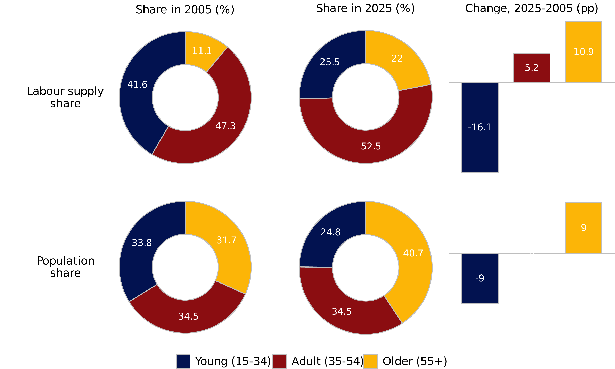
Relative weight of major age groups in the population aged 16 and over and in the aggregate labor supply, and change in percentage points (pp), Spain 2005-2025
Between 2005 and 2025, Spain’s labour supply shifted strongly away from young workers and toward older and prime-age workers. The young group, aged 15-34, declined from 41.6% to 25.5% of aggregate labour supply, a fall of 16.1 percentage points. This drop is much larger than their population-share decline of 9.0 percentage points, suggesting that demographic change alone does not explain the fall. Older workers, aged 55+, moved in the opposite direction. Their population share increased by 9.0 percentage points, from 31.7% to 40.7%, but their labour-supply share increased even more, from 11.1% to 22.0%, a rise of 10.9 percentage points. This implies that older individuals are contributing more to labour supply not only because they are more numerous, but also because they are more attached to the labour market than before. This behavioural change regarding labour attachment is even more prevalent among the prime-age adults whose contribution to employment has increased by 5 percentage points despite no change in their population share.
In short, Spain’s ageing population does not mechanically reduce aggregate labour supply. The figure shows that behavioural changes, especially higher labour-market contribution among older and prime-age adults, partly offset demographic ageing, while the sharp decline among young workers reflects both demographic shrinkage and weaker labour-supply attachment. And to this, immigration has played a decisive role, as the next figure will show.

Labour-supply growth by age and birthplace
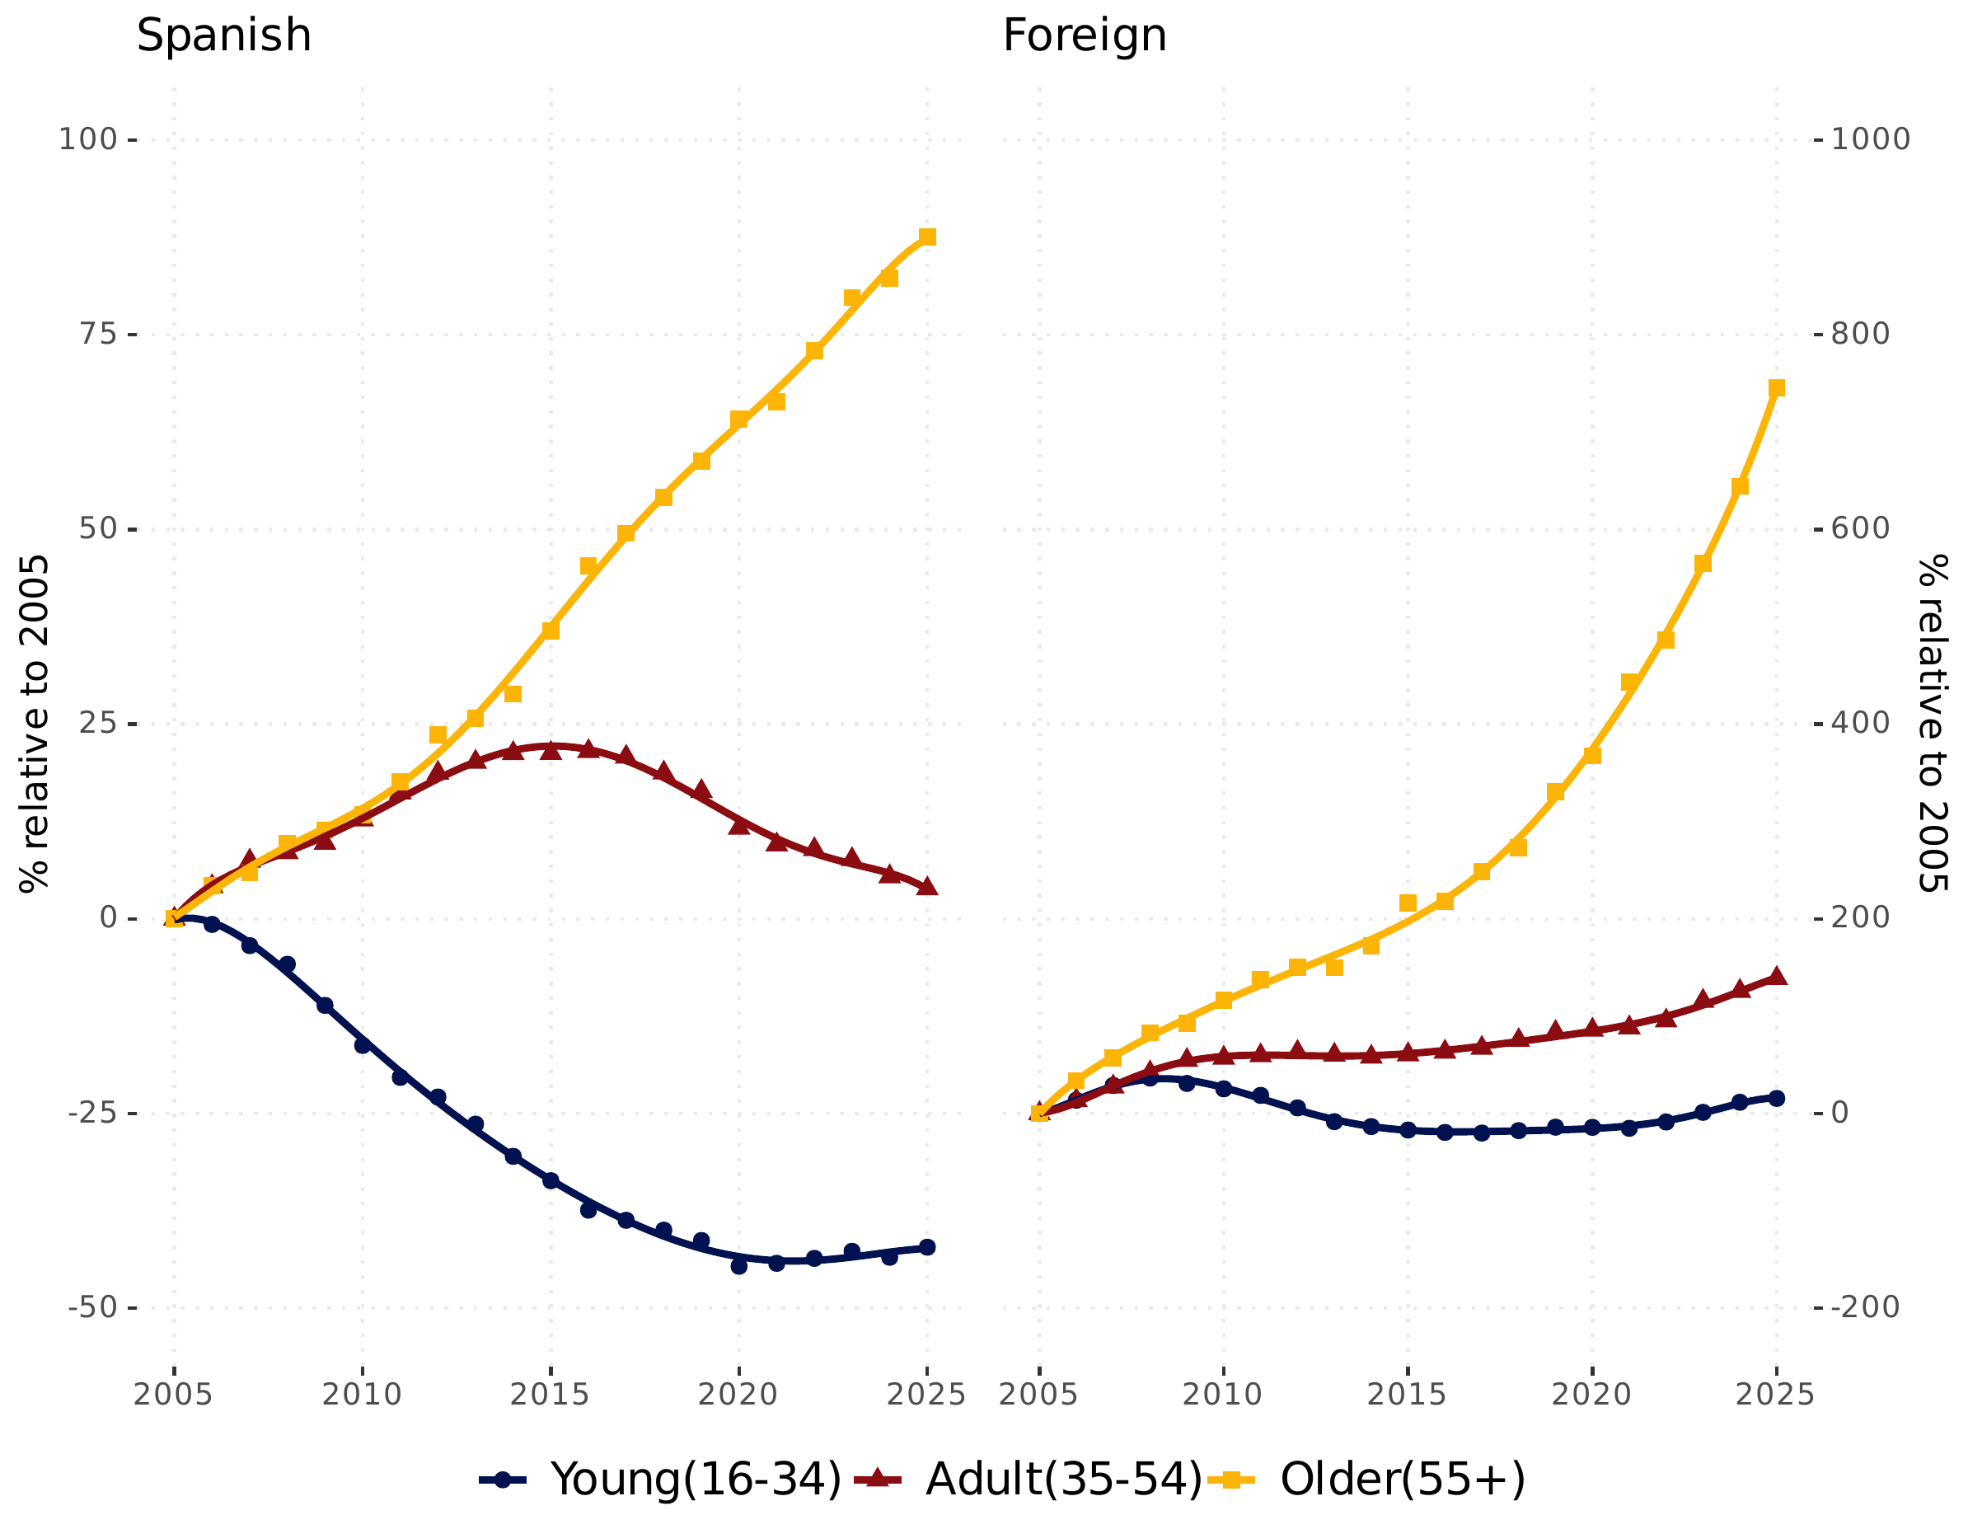
Trend of the aggregate labor supply as a percentage of its level at the beginning of the period, by age group for Spanish and immigrants, Spain 2005-2025
The figure shows that immigration is the main source of labour-supply growth, especially among older and prime-age workers. For Spanish, young workers aged 15-34 show a persistent decline in labour supply, falling about 42.2% below their 2005 level by 2025. Prime-age Spanish aged 35-54 increased until the mid-2010s but returned close to the 2005 level by 2025, only 3.9% higher. The only strong sustained increase among Spanish is for older workers aged 55+, whose labour supply rose by 87.6%. For foreigners, the pattern is much more expansionary. Foreign prime-age labour supply increased by 138.9% relative to 2005, and foreign older labour supply rose by 745.9%. Young foreign workers are more volatile: they rose before the financial crisis, declined after 2008, and recovered to 15.5% above the 2005 level by 2025. During the crisis, Spain faced a high job destruction, especially temporary employment (García Pérez and Osuna, 2014.)
In short, the figure suggests that Spain’s aggregate labour-supply adjustment is not driven only by ageing among natives. Immigration plays a decisive role by expanding the labour contribution of foreign adults and, especially, older foreign workers, while young native labour supply continues to contract.

Decomposition of labour-supply change

The model of continuous change: an overview
To measure the isolated effect of demographic ageing on aggregate labour supply, this article uses the continuous-change model (Horiuchi et al. 2008). A technical summary of the method is provided in the annex.
For each pair of consecutive years between 2005 and 2025, the decomposition allocates the change in aggregate labour supply using a nested three-level structure. The first level separates contributions by birthplace status, distinguishing Spanish and foreign-born populations. Within each birthplace group, the contribution is divided into four components: total population growth (tpop), age structure (stx), labour-market participation or activity rates (wpx), and hours worked (whx). Finally, within each component, the contribution is split across age groups. Each contribution piece therefore represents the change in labour hours attributable to a specific age group within a specific component and birthplace group.
A potential concern with the continuous-change model (CCM) is that it assumes smooth transitions between states, whereas Spain’s labour market was marked by sharp regime changes during the Great Recession, the migration reversal after 2008, and the COVID–19 shock. Although these episodes clearly violate economic smoothness, the CCM remains appropriate for the present analysis for two main reasons.
First, the CCM does not impose continuity in economic outcomes or behavioural adjustments; continuity applies only to the accounting path used to allocate observed changes across factors. Abrupt movements in employment, migration, or participation are therefore fully captured in the underlying data, and the decomposition integrates these discrete changes mechanically over time without smoothing or averaging shocks. Moreover, the decomposition is implemented on a year-by-year basis and reported over sub-periods that closely correspond to major regime shifts (2005–2009, 2010–2014, 2015–2019, and 2020–2025). This effectively yields a piecewise application of the CCM, allowing crisis-period dynamics to be identified explicitly rather than diluted within longer trends.
Second, a central property of the CCM is its additivity, which is held by construction even in the presence of structural breaks. As illustrated in Table 3: the sum of the contribution pieces across all consecutive-year decompositions equals the corresponding contribution obtained from a decomposition between the first and last years. In addition, the sum of all contribution pieces equals the observed difference in aggregate labour supply between the two years before decomposition. During crisis periods, this additivity should be interpreted strictly as an accounting identity rather than as evidence of economically smooth adjustment mechanisms. The CCM is thus used as a descriptive tool to attribute observed changes in labour supply across demographic and behavioural components, not as a model of adjustment dynamics.
Taken together, these features make the CCM a transparent and internally consistent framework for assessing how ageing, migration, participation, and hours worked contribute to labour-supply change, even in periods marked by pronounced labour-market disruptions.

Demographic and behavioural contributions
Table 3 shows the contribution of each component by birthplace and period, expressed in millions of full-time equivalent (FTE) workers, where one FTE corresponds to 2,000 annual hours worked. Positive values indicate contributions that increase aggregate labour supply; negative values indicate contributions that reduce it. The table shows that Spain’s aggregate labour supply increased by $2.18$ million FTE workers between 2005 and 2025, but this net gain hides a strong contrast by birthplace. The foreign-born contribution was strongly positive, adding $3.04$ million FTE workers, while the Spanish contribution was negative, reducing labour supply by $0.86$ million FTE workers.
Note: Values are expressed in millions of full-time equivalent (FTE) workers.
 |  | Period
3-7 |  | 2005–2025 | 2005–2009 | 2010–2014 | 2015–2019 | 2020–2025
Spanish
Age structure |  | -2.55 | -0.26 | -0.42 | -0.76 | -1.11
Activity rate |  | 2.82 | 0.86 | 0.55 | 0.46 | 0.96
Hours worked |  | -1.60 | -0.53 | -0.31 | -0.22 | -0.54
Population size |  | 0.46 | 0.23 | 0.15 | -0.05 | 0.14
Period total |  | -0.86 | 0.30 | -0.04 | -0.58 | -0.54
Foreign
Age structure |  | -0.14 | 0.05 | -0.08 | -0.04 | -0.08
Activity rate |  | 0.01 | 0.08 | -0.05 | -0.06 | 0.05
Hours worked |  | -0.39 | -0.16 | -0.12 | -0.00 | -0.10
Population size |  | 3.56 | 1.37 | -0.29 | 0.63 | 1.84
Period total |  | 3.04 | 1.34 | -0.54 | 0.53 | 1.70
Combined
Age structure |  | -2.69 | -0.21 | -0.50 | -0.80 | -1.19
Activity rate |  | 2.84 | 0.94 | 0.50 | 0.39 | 1.00
Hours worked |  | -1.98 | -0.69 | -0.43 | -0.22 | -0.64
Population size |  | 4.02 | 1.60 | -0.14 | 0.58 | 1.99
Period total |  | 2.18 | 1.64 | -0.57 | -0.05 | 1.17
The main negative force is age structure among Spanish. For Spanish, the age-structure component reduced labour supply by $2.55$ million FTE workers over 2005–2025 and the impact is increasingly negative over the period. This confirms that population ageing among Spanish exerted a large and increasing downward pressure. However, this was more than offset by higher Spanish activity rates, which added $2.82$ milion FTE workers, while Spanish population size added $0.46$ million. Declining hours worked reduced Spanish labour supply by another $1.60$ million. For foreigners, the main positive contribution comes from population size, which added $3.56$ million FTE workers. By contrast, foreign age structure slightly reduced labour supply by $0.14$ million, foreign activity rates contributed almost nothing over the full period, at $0.01$ million, and foreign hours worked reduced labour supply by $0.39$ million. This means immigration’s contribution came mainly through foreign population growth, not through higher participation or longer hours.
Across periods, the strongest positive aggregate change occurred in 2005–2009, at $1.64$ million FTE workers, and 2020–2025, at $1.17$ million FTE workers. The period 2010–2014 was negative, at $-0.57$ million, reflecting crisis-era weakness, while 2015–2019 was also slightly negative, at $-0.05$ million. Overall, foreign population growth offset much of the negative age-structure effect among Spanish, but declining hours worked remained a drag across both groups. The relative contribution of these components across the major age groups is summarized in Figure 3.

Contribution of ageing and labour components
Figure 3 contains three panels distinguishing Spanish, foreign-born, and combined contributions to total labour-supply change between 2005 and 2025. Within each panel, the four bars correspond to the decomposition components: total population growth (tpop), age structure (stx), activity or participation rates (wpx), and hours worked (whx). The age-group contribution pieces are grouped into three major age groups: young workers aged 16–34, adults aged 35–54, and older workers aged 55 and over. These age-group contributions are divided by the total change in aggregate labour supply, so each bar represents the percentage of total change attributable to a specific age group within a specific component and birthplace group. For the Spanish and foreign panels, the age-group contributions across all components sum jointly to 100%, because these two panels add up to the total change in aggregate labour supply. In contrast, the combined panel aggregates Spanish and foreign contributions first; within this panel, the age-group contributions across all components also sum to 100%. Positive values indicate contribution pieces that increased labour supply, while negative values indicate contribution pieces that reduce it.
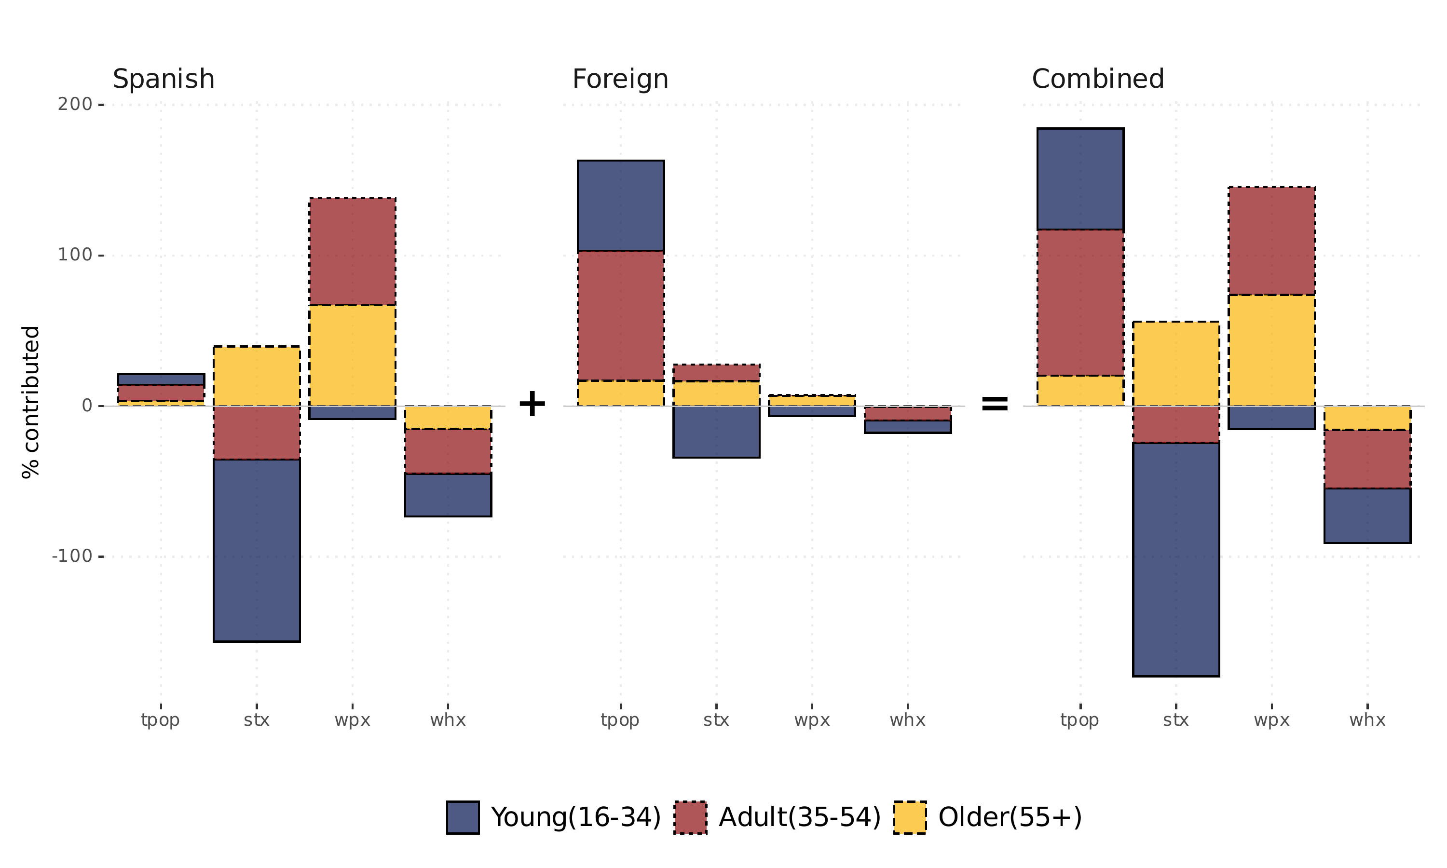
Contribution of demographic and behavioural factors expressed as a percentage of the total variation in aggregate labour supply, Spain 2005–2025
By far, the largest negative contributions come from age-structure changes among younger and prime-age groups. The strongest drag is the age-structure effect for young Spanish aged 16–34, which contributes $-120.8\%$ of the total change, followed by the age-structure effect for Spanish adults aged 35–54, at $-35.6\%$. The age-structure effect for young foreigners is also negative, at $-34.2\%$. In contrast, the largest positive contributions come from foreign population growth among adults aged 35–54, which contributes $86.3\%$, and from higher activity rates among Spanish adults and older workers, contributing $70.9\%$ and $67.1\%$, respectively. Thus, the main offset to demographic ageing within the Spanish-born population comes from foreign prime-age population growth and stronger labour-market attachment among Spanish adults and older workers.

Implication discussion
The results show that immigration has played a decisive role in offsetting the labour-supply losses associated with population ageing, but they also point to the limits of relying on immigration alone. Ageing affects labour supply not only through population structure, but also through behavioural responses, health, hours worked, and exposure to labour-market shocks. The following subsections therefore discuss three implications of the results: the extent to which immigration compensates for ageing, the potential role of healthy ageing as a complementary strategy, and the risks created by future economic and technological disruptions.

Compensating for ageing and the volatility trap
The age-structure effect among Spanish reduced aggregate labour supply by $2.55$ million FTE workers over 2005–2025. Immigration more than compensated for this loss: the total foreign-born contribution added $3.04$ million FTE workers, equal to about $119.4\%$ of the negative Spanish age-structure effect. In short, without immigration, Spanish ageing would have reduced labour supply substantially; with immigration, the aggregate effect becomes positive. However, this migratory buffer exhibits significant pro-cyclical volatility. As evidenced in the 2010–2014 sub-period (Table 3), the foreign-born contribution turned sharply negative ($-0.54$ million FTE). This reveals a “volatility trap”: the primary mechanism for offsetting long-term ageing tends to stall or reverse precisely when the economy faces structural stress (Gálvez-Iniesta 2022; FUNCAS 2024).
The role of immigration should also be assessed considering alternative adjustment mechanisms, especially the behavioural changes induced by ageing. Contrary to migratory buffers, behavioural adjustments among the Spanish-born population proved more resilient to economic cycles. Higher activity rates added $2.82$ million FTE workers, which, despite a reduction of $1.60$ million due to declining hours, resulted in a net positive behavioural contribution of $1.23$ million FTE. Thus, behavioural adjustment helped offset about $48.1\%$ of the negative age-structure effect among Spanish. While immigration remains the dominant quantitative offset, its reliability as a stabilizer is contingent on economic growth. Policy makers may want to target future immigration policies towards sectors or occupations featuring labour shortages and where immigrant skills complement native skills. Migration to balance ageing could be complemented by policy supporting extending working lives for men and women, and hence the more stable margin of healthy ageing, potentially decoupling labour supply from the boom-bust cycles of migratory flows (Strzelecki et al. 2025 I did not find this paper?). Lopez et al. (2025) find that individual’s work capacity is relatively stable with age. According to the findings of the authors, the age-related declines in abilities are modest until age 70. Extending healthy working life can have a huge impact on many fronts. Diaz-Rodriguez and Diaz-Saveedra (2009) show that delaying three years the statutory retirement ages in 2010 would solve the sustainability problems of the pension system of Spain.

The importance of healthy ageing as a stabilizer is underscored by recent cross-country evidence. Using data for populations aged 50+ in 41 countries from 2000–2022, Gruss et al. (2025) find that a decade of cognitive health gains raises labour-force participation by about 20 percentage points, weekly hours worked by around 6 hours, labour productivity by roughly 30%, and annual labour earnings by about 35%. In the Spanish context, such investments are increasingly critical not just for the native population, but for a foreign-born population that is ageing more rapidly than in previous decades.
The transition from the “exceptional” migratory wave of the early 2000s (Arango 2013) to a more settled demographic has altered the foreign-born contribution profile in the 2020s (Cuadrado et al. 2023; CaixaBank Research 2017). Between 2005 and 2025, the share of foreigners aged 55+ increased from $11.01\%$ to $23.85\%$, a rise of $12.84$ percentage points. This demographic maturation has led to a decline in labour-market intensity: the foreign activity rate fell by $3.33$ percentage points (from $74.77\%$ to $71.44\%$), and average weekly hours dropped by $2.58$ hours. Without targeted investments in healthy ageing for this settled population, the “migration buffer” may become increasingly inefficient, as the volume of new arrivals would need to rise exponentially just to compensate for the declining intensity of the existing, ageing foreign-born stock (Cuadrado et al. 2023; CaixaBank Research 2017).

Disruption on the horizon and the labour supply
Immigrants are not only ageing more rapidly than the Spanish-born population, but they are also more exposed to labour-market volatility. Foreign workers were disproportionately affected by the 2008 financial crisis: immigrant employment declined, immigration inflows fell by more than 50% between 2008 and 2013, and Spain experienced net migration outflows (Rodrı́guez-Planas and Nollenberger 2016). During COVID-19, the unemployment gap between foreign-born and native workers increased from 6.7 to 10 percentage points by late 2020 (CentAUR 2021; Fasani and Mazza 2023; Fundación "la Caixa" 2021). These facts do not contradict the positive demographic contribution of immigration; rather, they show that immigration is more vulnerable to labour-market disruption. Existing evidence suggests that there are large differences between immigrant and native populations, such as cyclical responses to economic downturns that may therefore affect their participation in the labour market. This outcome is explained by higher job separation rates among immigrants that shapes greater unemployment rates in comparison to natives (Dustmann et al. 2010). This vulnerability also raises a broader question about how ongoing AI disruption may affect labour-market outcomes for immigrants and for the population more generally. At this stage, the evidence remains fragmented and inconclusive (Pizzinelli et al. 2023). Some studies find only small effects, or no clear effect, on labour demand in AI-exposed occupations (Hartley et al. 2024; Ghosh et al. 2025). However, because AI has been shown to raise productivity in several work settings (Dell’Acqua et al. 2024; Noy and Zhang 2023), future increases in output may require fewer additional workers than in the past. If so, Spain may not need to rely on immigration to expand labour supply to the same extent as it did over the last two decades.

Conclusion
Our results indicate that population ageing has declined the aggregate labour supply as the age composition has changed the structure of the labour market. This outcome is consistent with the literature of demographic ageing. Besides the age structure, another important result highlights the loss of the relative share of the young population, either native or immigrant, in the components associated with their activity rates and hours worked. Consequently, for the case of Spain, the demographic weight of the older population has compensated the negative effect of ageing. This implies that, recent growth in the Spanish aggregate labour supply is increasingly driven by retaining older workers rather than incorporating young labour force. Thereby, the contribution to the aggregate labour supply becomes elderly dependent as older workers stay in the workforce. Additionally, we have shown that the foreign-born population was strongly positive in terms of the population size, indicating that foreign activity rates contribution is low and poor to sustain the ageing effect on the labour market, which implies an underutilisation of the foreign labour force.
All the aforementioned factors are closely linked to the inherent features of the Spain’s labour market as there is evidence of a strong workforce segmentation that induces higher turnover rates with a higher propensity for unemployment, balanced by short-term unemployment durations (Barceló and Villanueva, 2016). Spain presents the highest job turnover in the OECD economies and higher temporary employment (Conde-Ruiz et al. 2025). As a result, labour market dynamics and demographic change may therefore impact labour force contribution and the participation of age groups to the aggregate labour supply. Temporal and seasonal work among youth and immigrants might have limited aggregate labour supply growth. The latter group of individuals remain more vulnerable because they are overrepresented in temporary employment and cyclical sectors (Gil-Alonso and Vidal-Coso, 2015). These structural conditions have led some scholars to shift their focus on improving labour market assimilation and minimising workers’ vulnerability to unemployment risk (Amuedo‐Dorantes and De la Rica, 2007; Gálvez, 2022).
Overall, population ageing substantially reduced Spain’s potential labour supply, but behavioural adjustment offset much of this loss. Higher participation, especially among Spanish adults, women, and older workers, helped cushion the demographic shock, although declining hours worked limited the size of this compensation. Immigration filled the remaining gap by expanding labour supply mainly through population growth and age composition. However, this contribution depends on migrants’ labour-market integration, sectoral exposure, and employment stability (Preston 2014; Fiorio et al. 2023; Naumann and Hess 2021), making it vulnerable to economic and technological disruptions. For the coming decades, alongside policies aimed at reducing temporary employment, complementary strategies may therefore be needed. Investment in healthy ageing appears promising because it can support longer working lives and strengthen labour‑market attachment among older workers in both the Spanish‑born and foreign‑born populations.

Annexes

Decomposition by continuous change
The model of continuous change (Horiuchi et al. 2008) is used to decompose the change in aggregate labour supply between 2005 and 2025 (the dependent summary measure) into additive effects associated with changes in demographic and behavioural components (the covariates). The model decomposes the difference between two summary measures generated by the same process into several components, each representing the contribution of an underlying factor. The process is defined as a function $f$, which takes the values of the factors as arguments and returns a summary measure.
Horiuchi et al. (2008) demonstrates that as the factors transition from values $x_{i}(t_{1})$ to $x_{i}(t_{2})$ between two times $t_{1}$ and $t_{2}$, the summary measure changes from $f(x_{i}(t_{1}))$ to $f(x_{i}(t_{2}))$, and the difference between these two measures can be decomposed into additive components $c_{i}$ representing the contribution of changes within each factor to this difference. This is expressed by equation [eq:hofr].
f(xi(t2))-f(xi(t1))=i​ci
With $i=1,2,...,n$ being the factors involved. The decomposition is based on the assumption that the change in the covariate $x_{i}$ occurs continuously or gradually over a real or hypothetical time dimension $t_{1}→t_{2}$. This provides a reasonable justification for the additivity of the effects of the factors and the elimination of interaction terms even if the process in question is a non-additive function of the covariates (Horiuchi et al. 2008, 786).
In other words, the continuous change model (CCM) introduces a decomposition function $g$ which, using a process function $f$, transforms two series of covariates, the vectors $X(t_{1})$ and $X(t_{2})$ representing the values of the covariates $X=(x_{1},...,x_{i},...,x_{n})$ at times $t_{1}$ and $t_{2}$, into a series of contributions or effects, the vector $C=(c_{1},...,c_{i},...,c_{n})$. Thus, we can write:
$$C=g(X,f)$$
The series $X$ and $C$ having the same lengths, results in a perfect correspondence between the factors and the effects, which can be grouped for analysis purposes. Furthermore, the idea of continuity implies that each element $c_{i}$ of the series $C$ is obtained by integration according to the equation:
$$c_{i}=\int_{x_{i}(t_{1})}^{x_{i}(t_{2})}{\frac{∂f(t)}{∂x_{i}(t)}}dx_{i}(t)$$
In practice, equation [eq:mxfr] is estimated by numerical integration where $\int_{x_{i}(t_{1})}^{x_{i}(t_{2})}{d}(t)$ is approximated by $\sum_{x_{i}(t_{1})}^{x_{i}(t_{2})}{δ}(t)$, with $x_{it}=x_{i}(t)$ being the value of a factor $i$ at a moment $t$. Adapting the continuous change model to measure equation [eq:pclab] allowed the total variation in the aggregate labor supply between 1981 and 2016 to be distributed not only among these three components but also by age group and residence status (immigrants and natives). For this article, the decomposition was performed by creating an auxiliary function $g$ around the R package (R Core Team 2018) DemoDecomp (Riffe 2018). The code and data used are available upon request.
The CCM model is a better alternative to the standardization method often used in demography to account for differences in population structure when comparing demographic measures. Indeed, standardization requires a third population to serve as a standard, making it somewhat less robust as different standards can lead to different results. The CCM model solves this problem and allows for direct decomposition without interaction terms between the different factors.
Interaction effects in regression analysis refer to situations where the impact of one variable on a dependent variable is not constant or additive but depends on the values of other variables. In traditional decomposition methods, such as standardization, any discrepancy between the overall change and the sum of the individual effects of the variables is also called an interaction effect. In such cases, the interaction represents an incomplete separation of the contributions of individual covariates to the overall change or difference in a dependent variable.

Data Source and Variables
The analysis uses microdata from the Encuesta de Población Activa (EPA), Spain’s quarterly Labour Force Survey produced by the National Statistics Institute (INE). The EPA is a nationally representative household survey covering the population aged 16 and over. It follows a stratified, two-stage sampling design, with census sections as primary sampling units and dwellings as secondary units. Each quarterly wave includes approximately 46,000 dwellings and more than 100,000 individuals. INE provides calibrated survey weights to ensure consistency with population totals by sex, age, and region. The microdata contain detailed demographic characteristics, labour-force status, employment conditions, hours worked, and place of birth. The original variables used from the microdata files are:
- FACTOREL (survey weight): Expansion factor assigned to each respondent, derived from the sampling design and calibrated to external population benchmarks. It is used to compute weighted totals and representative aggregates.
- EDAD1 / EDAD5 (age group): Age information is provided in grouped intervals. Across releases, the relevant age-group variable appears as either EDAD1 or EDAD5, but both use five-year age groups for the analytical period. The analysis uses whichever variable is available and standardises it into a single age-group variable.
- AOI (labour-force status): Constructed by INE from responses on work activity, job search, and availability. AOI classifies individuals as employed, unemployed, or inactive. It is used to identify employed persons and the active population.
- HORASH (effective weekly hours worked): For employed respondents, the EPA records actual hours worked in the reference week, including overtime and excluding absences. These responses are coded into HORASH and used to compute average hours and total hours supplied.
- PRONA1 (province or country of birth): Respondents report their place of birth, which INE codes as Spanish provinces or foreign countries. This variable is used to distinguish Spanish-born from foreign-born individuals.

Trend in labour force components
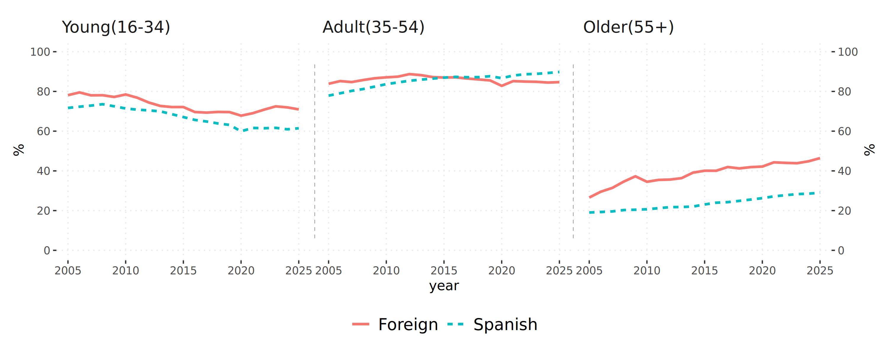
Average participation rate by major age groups for immigrants and natives, Spain 2005-2025
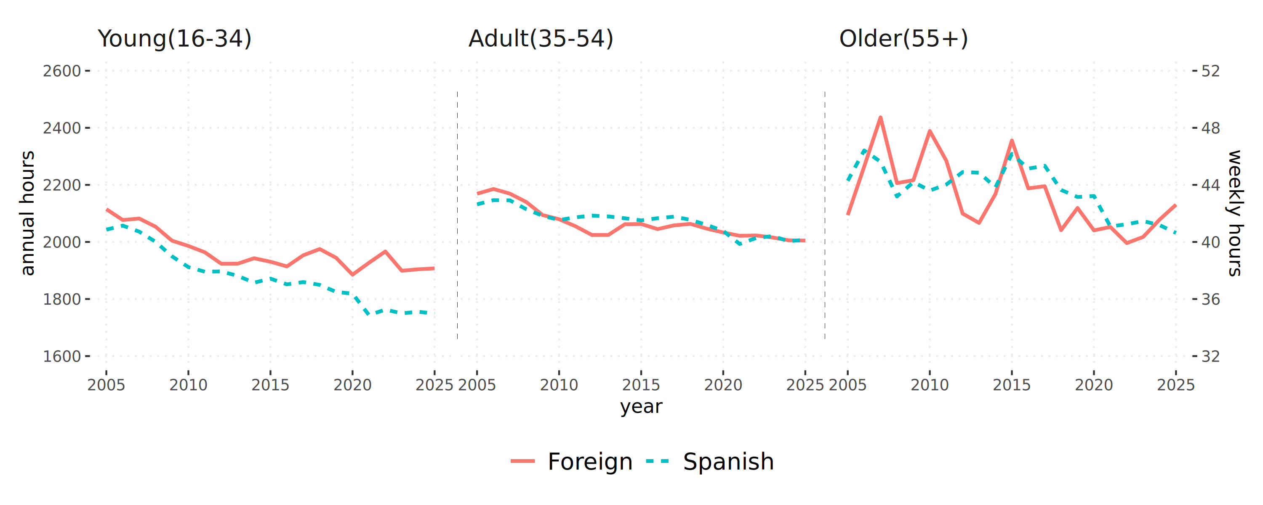
Average worked hours by major age groups for immigrants and natives, Spain 2005-2025
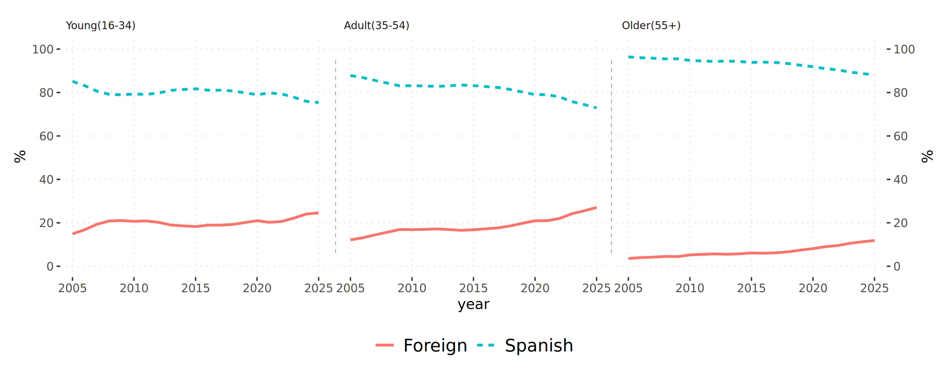
Percentage of total population by major age groups for immigrants and natives, Spain 2005-2025
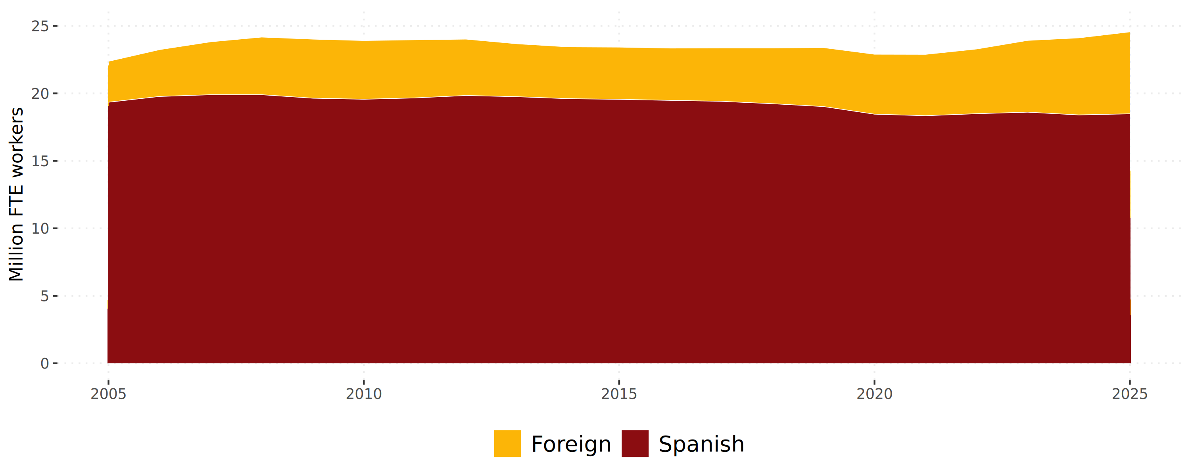
Total population aged 16+ in full-time equivalent (FTE) by birthplace, Spain 2005-2025

References
Aiyar, Mr Shekhar, and Mr Christian H Ebeke. 2016. The Impact of Workforce Aging on European Productivity. International Monetary Fund.
Amuedo-Dorantes, Catalina, and Sara De La Rica. 2009. The Immigration Surplus and the Substitutability of Immigrant and Native Labor: Evidence from Spain, INSIDE Paper No. 11, July, 31 p. Arango, Joaquı́n. 2013. Exceptional in Europe? Spain’s Experience with Immigration and Integration, Migration Policy Institute, March, 22 p.
Amuedo‐Dorantes, C., and De la Rica, S. (2007). Labour market assimilation of recent immigrants in Spain. British Journal of Industrial Relations, 45(2), 257–284. https://doi.org/10.1111/j.1467-8543.2007.00614.x
Barceló, C., and Villanueva, E. (2016). The response of household wealth to the risk of job loss: Evidence from differences in severance payments. Labour Economics, 39, 35-54.
Bentolila, Samuel; Cahuc, Pierre; Dolado, Juan J. and Thomas Le Barbanchon (2012), “Two-Tier Labour Markets in the Great Recession: France versus Spain”, The Economic Journal, 122 (August), F155-F187.
Bentolila, Samuel, Juan J Dolado, and Juan F Jimeno. 2020. “Dual Labor Markets Revisited.” In Oxford Research Encyclopedia of Economics and Finance.
Bentolila, Samuel, and Juan José Dolado. 1990. Mismatch and Internal Migration in Spain, 1962-1986. Banco de España, Servicio de Estudios.
Bijak, Jakub, Dorota Kupiszewska, Marek Kupiszewski, Katarzyna Saczuk, and Anna Kicinger. 2007. “Population and Labour Force Projections for 27 European Countries, 2002-052: Impact of International Migration on Population Ageing: Projections de Population Et de Population Active Pour 27 Pays Europeens 2002-052: Impact de La Migration Internationale Sur Le Vieillissement de La Population.” European Journal of Population/Revue Européenne de Démographie 23: 1–31.
Boeri, Tito, Matteo Gamalerio, Massimo Morelli, and Margherita Negri. 2024. “Pay-as-They-Get-in: Attitudes Toward Migrants and Pension Systems.” Journal of Economic Geography 24 (1): 63–78.
CaixaBank Research. 2017. Spain’s Labour Force: Ageing and Educational Level. CaixaBank Research. https://www.caixabankresearch.com/en/economics-markets/labour-market-demographics/spains-labour-force-ageing-and-educational-level.
Casares, Miguel, and Jesús Vázquez. 2018. “Why Are Labor Markets in Spain and Germany so Different?” Economic Modelling 75: 320–35.
CentAUR. 2021. The Impact of the Covid-19 Pandemic on the Immigrant Population in Spain. University of Reading. https://centaur.reading.ac.uk/121676/.
Conde‐Ruiz, J. I., García, M., Puch, L. A., and Ruiz, J. (2025). Reforming Dual Labor Markets:“Real” or “Contractual” Temporary Rates?. Labour, 39(2), 162-187.
Congregado, Emilio, Monica Carmona, Antonio A Golpe, and Andre Van Stel. 2014. “Unemployment, Gender and Labor Force Participation in Spain: Future Trends in Labor Market.” Romanian Journal of Economic Forecasting 17 (1): 53–66.
Costain, J. S., Jimeno, J. F., and Thomas, C. (2010). Employment fluctuations in a dual labor market. Documento de trabajo 1013. Banco de España.
Cristea, Mirela, Gratiela Georgiana Noja, Petru Stefea, and Adrian Lucian Sala. 2020. “The Impact of Population Aging and Public Health Support on EU Labor Markets.” International Journal of Environmental Research and Public Health 17 (4): 1439.
Cuadrado, Pilar, Alejandro Fernández Cerezo, José Manuel Montero, and Francisco José Rodrı́guez. 2023. The Impact of Population Ageing on the Labour Force Participation Rate in Spain. Economic Bulletin 2023/Q3, Article 12; Banco de España. https://www.bde.es/wbe/en/publicaciones/analisis-economico-investigacion/boletin-economico/2023-t3-articulo-12--el-impacto-del-envejecimiento-poblacional-sobre-la-evolucion-de-la-tasa-de-actividad-en-espana.html.
Dell’Acqua, Francesco et al. 2024. The Impact of AI on Worker Productivity. Working Paper. Harvard Business School.
Dı́az-Giménez, Javier, and Julián Dı́az-Saavedra. 2009. “Delaying Retirement in Spain.” Review of Economic Dynamics 12 (1): 147–67.
Dustmann, C., Glitz, A., and Vogel, T. (2010). Employment, wages, and the economic cycle: Differences between immigrants and natives. European Economic Review, 54(1), 1–17. https://doi.org/10.1016/j.euroecorev.2009.04.004
Faı́lde Garrido, JM, MD Dapı́a Conde, MA Vázquez Vázquez, L Ruı́z Soriano, and L Vázquez Rodrı́guez. 2021. “The Perspective of Different Age Groups Regarding Old Age and Aging in Highly Aged Contexts.” The Social Science Journal 58 (1): 77–90.
Fasani, Francesco, and Joan Mazza. 2023. “Being on the Frontline? Immigrant Workers in Europe and the COVID-19 Pandemic.” ILR Review 76 (5): 842–71. https://doi.org/10.1177/00197939231154564.
Fiorio, Carlo V, Tommaso Frattini, Andrea Riganti, and Michael Christl. 2024. “Migration and Public Finances in the EU.” International Tax and Public Finance, 1–50.
FUNCAS. 2024. “The Spanish Labour Market: Cyclical Behaviour and Structural Vulnerabilities.” Spanish Economic and Financial Outlook. https://funcas.es.
Fundación "la Caixa". 2021. The Covid-19 Crisis Affects Employment Inequality Between Immigrants and Natives. Social Observatory of the "la Caixa" Foundation. https://elobservatoriosocial.fundacionlacaixa.org/en/-/the-covid-19-crisis-affects-employment-inequality-between-immigrants-and-natives.
Gálvez-Iniesta, Ismael. 2022. “The Cyclicality of Immigrant Wages and Labour Market Flows: Evidence from Spain.” Economics: The Open-Access, Open-Assessment Journal 16 (1): 90–122.
Garcia-Louzao, J., Hospido, L., and Ruggieri, A. (2023). Dual returns to experience. Labour Economics, 80, 102290.
García-Pérez, J. I. G., and Osuna, V. (2014). Dual labour markets and the tenure distribution: Reducing severance pay or introducing a single contract. Labour Economics, 29, 1-13.
Ghosh, D., R. Ghosh, S. Roy Chowdhury, et al. 2025. “AI-Exposure and Labour Market: A Systematic Literature Review on Estimations, Validations, and Perceptions.” Management Review Quarterly 75: 677–704. https://doi.org/10.1007/s11301-023-00393-x.
Gil-Alonso, F., and Vidal-Coso, E. (2015). Inmigrantes extranjeros en el mercado de trabajo español: ¿Más resilientes o más vulnerables al impacto de la crisis? Migraciones, 37, 97–123. https://doi.org/10.14422/mig.i37.y2015.005
Gonzalez, Libertad, and Francesc Ortega. 2011. “How Do Very Open Economies Adjust to Large Immigration Flows? Evidence from Spanish Regions.” Labour Economics 18 (1): 57–70.
Gruss, Bertrand, Eric Huang, Andresa Helena Lagerborg, Diaa Noureldin, and Galip Kemal Ozhan. 2025. The Labor Market Implications of Healthy Aging. IMF Working Paper 2025/229. International Monetary Fund. https://doi.org/10.5089/9798229030236.001.
Güell, Maia, Cristina Lafuente, Manuel Sánchez, and Hélène Turon. 2021. “So Different yet so Alike: Micro and Macro Labour Market Outcomes in Germany and Spain.” SERIEs, 1–23.
Hartley, Jonathan, Filip Jolevski, Vitor Melo, and Brendan Moore. 2024. The Labor Market Effects of Generative Artificial Intelligence. SSRN Working Paper. Social Science Research Network. https://doi.org/10.2139/ssrn.5136877.
Horiuchi, Shiro, John R Wilmoth, and Scott D Pletcher. 2008. “A Decomposition Method Based on a Model of Continuous Change.” Demography 45 (4): 785–801. https://doi.org/10.1353/dem.0.0033.
Lopez Garcia, Italo; Maestas, Nicole and Kathleen J. Mullen (2025) “Aging and Work Capacity”, The Journal of the Economics of Ageing, 31 (2025) 100576
Maestas, Nicole, Kathleen J Mullen, and David Powell. 2023. “The Effect of Population Aging on Economic Growth, the Labor Force, and Productivity.” American Economic Journal: Macroeconomics 15 (2): 306–32.
Naumann, Elias, and Moritz Hess. 2021. “Population Ageing, Immigration and the Welfare State: The Political Demography in Western Europe.” Chapter 14 in n Global Political Demography: The Politics of Population Change. Springer International Publishing Cham., p. 351-371
Noy, Shakked, and Whitney Zhang. 2023. “Experimental Evidence on the Productivity Effects of Generative AI.” Science, ahead of print. https://doi.org/10.1126/science.adj0390.
OECD. 2025. Better Harnessing the Labour Market Potential of Older Workers and Migrants. OECD Economic Surveys: Spain 2025; OECD. https://www.oecd.org/en/publications/oecd-economic-surveys-spain-2025_abc5c435-en/full-report/better-harnessing-the-labour-market-potential-of-older-workers-and-migrants_7c035025.html.
Okamoto, Akira. 2021. “Immigration Policy and Demographic Dynamics: Welfare Analysis of an Aging Japan.” Journal of the Japanese and International Economies 62: 101168.
Pizzinelli, Carlo, Augustus J. Panton, Marina Mendes Tavares, Mauro Cazzaniga, and Longji Li. 2023. Labor Market Exposure to AI: Cross-Country Differences and Distributional Implications. IMF Working Paper 2023/216. International Monetary Fund. https://doi.org/10.5089/9798400254802.001.
Preston, Ian. 2014. “The Effect of Immigration on Public Finances.” The Economic Journal 124 (580): F569–92.
R Core Team. 2018. R: A Language and Environment for Statistical Computing. R Foundation for Statistical Computing, released. https://www.R-project.org.
Riffe, Tim. 2018. DemoDecomp: Decompose Demographic Functions. Released. https://CRAN.R-project.org/package=DemoDecomp.
Rodrı́guez-Planas, Núria, and Natalia Nollenberger. 2016. “Labor Market Integration of New Immigrants in Spain.” IZA Journal of Labor Policy 5: 1–15.
Sanz-de-Galdeano, Anna, and Anastasia Terskaya. 2020. “The Labor Market in Spain, 2002-2018.” IZA World of Labor.
Stepanek, Martin. 2022. “Sectoral Impacts of International Labour Migration and Population Ageing in the Czech Republic.” Computational Economics 60 (2): 375–400.
Garcia Guzman, Pablo; Coelli, Federica and Emily Nillson. 2025 G. “The Scale and Limits of Migration in Offsetting Population Ageing.” VoxEU.org, Centre for Economic Policy Research, December 5. https://cepr.org/voxeu/columns/scale-and-limits-migration-offsetting-population-ageing
UN. 2000. Replacement Migration: Is It a Solution to Declining and Ageing Populations? ([New York]), March, viii, 143 p. http://digitallibrary.un.org/record/412547.

Failde Garrido et al. (2021) found that knowledge about ageing is low, specially amoung younger age groups, and that a mostly negative attitudinal biases are observed towards ageing making the implementation of policies more difficult.
Congregado et al. (2014), Caixabank Research (2017), Cuadrado et al. (2023) study ageing and labour force participation but do not have a full and integrated analysis of the contribution of each factor that we offer in this article.
That is, contracts of fixed duration with negligible firing costs. Guell et al. (2021) also report that Spain is among the most generous countries of the OECD for unemployment insurance. Casares and Vazquez (2018), in a comparison with Germany, blame higher wage rigidity and lower elasticity of hours per worker in Spain for lasting high unemployment rates.
For instance, Congregado et al. (2014) demonstrate that women labour market participation in Spain increases (decreases) when the unemployment rate is lower (higher) than a certain threshold.
Gonzalez and Ortega (2011) find that the relatively unskilled immigration flows did not affect the wages or employment rates of unskilled workers in the receiving regions of Spain. Instead, the growth of the unskilled labour force led to increases in total employment. This may explain why, from a political perspective, Arango (2013) observes that in contrast to many European countries, Spain has not seen a significant backlash against immigration.
In addition, immigrants who arrived after 2008 struggled to find jobs according to the authors.
Fiorio et al. (2024) find that, in Europe for the period 2014-2018, migrants were net contributors to public finances. Naumann and Hess (2021) extends the analysis by discussing the effects of migration on solidarity and political conflict.
Preston (2014) provides an exhaustive survey on the issue and its complexities.
The immigration policy may also need to take into consideration regional differences as suggested by Cuadrado et al. (2023)
Garcia Guzman et al. (2025) find that the scale of immigration required to fully offset the expected ageing populations substantially exceeds historical numbers in most European countries, including Spain. Moreover, future targets of immigration will be facing stricter global supply constraints.

