Comparing Public Transfers to Immigrants and Natives in Canada: A National Transfer Accounts Approach

Gilbert MONTCHO[1]   
Department of Demography, University of Montreal  
gilbert.montcho@umontreal.ca  
Julien Navaux  
Research Chair in Intergenerational Economics, HEC Montreal  
julien.navaux@hec.ca  
Yves CARRIERE  
Department of Demography, University of Montreal  
yves.carriere@umontreal.ca  
Marcel MERETTE  
Department of Economics, University of Ottawa  
mmerette@uottawa.ca

In Canada, immigration constitutes the primary response to population aging. While extensive research has covered the impact of immigration on various aspects of the labor supply, the financial aspect has received less attention. In this study, we apply the National Transfer Account (NTA) method and demographic decomposition to estimate the net fiscal cost of immigration in Canada between 1997 and 2015. Results show that, on average, immigrants received about $\sVal more in Net transfer per capita than natives between 1997 and 2015. However, this cost is mainly the result of labor market imbalances, which, after removing the effect of demographic differences, account for \sVal% of the surplus.

**Authors**

**Declaration**

Authors’ contributions: Gilbert MONTCHO designed and carried out the study, including the manuscript’s writing. JN contributes methods and descriptions for calculating and allocating public transfers to immigrants and natives. Yves Carrière and Marcel Mérette contribute with proofreading and suggestions for improvement. All authors read and approved the final manuscript.

Conflict of Interest: None of the authors has a potential conflict of interest regarding this submission.

Funding: Not applicable

Acknowledgments: Not applicable

Availability of data and materials: The datasets used and/or analyzed during this study are available from the corresponding author upon reasonable request.

**Title**: Comparing Public Transfers to Immigrants and Natives in Canada: A National Transfer Accounts Approach

**Keywords:** Immigration, Public Finances, National Transfer Accounts

# Introduction

Migration has always been a hot topic and one of the most controversial in industrialized countries (Marois, Bélanger, and Lutz 2020). More often than not, and especially during the second half of the 20th century, studies on immigration have focused on its effect on the labor market outcome of native workers (Piché 2013; Fusaro and López-Bazo 2018; Castles 2012). Although these considerations have continued till the current decade, they have somehow faded into the background of a new threat: population aging, characterized by the increasing share of older persons in a population resulting from declining fertility rates and rising life expectancy.

Population aging has become a dominant policy concern in advanced economies for its far-reaching effects on the labor market and public finances. It directly reduces the growth of the labor supply and increases the risk of a labor shortage. In Canada, between 2007 and 2016, the population aged 15 and older increased by 3.1 million people, but the number of labor market participants increased only by 1.6 million (Fields, Uppal, and LaRochelle-Cote 2017). As the relative (to the population size) number of labor market participants decreases, government expenditures (relative to public revenue) increase, all else remaining equal.

These prospects put heavy pressure on public finances and call for complex policies (Godbout, St-Cerny, and St-Amant 2012; St-Maurice et al. 2018; Lee and Ryan 2001; Zokalj 2016; Kudrna, Tran, and Woodland 2015; Clavet et al. 2013). For instance, St-Maurice et al. (2018) estimated that the province of Quebec would witness its budgetary balance decreasing from 0.2% of GDP in 2022 to -2.8% in 2058. This shift would primarily result from an increase in health expenditure, rising from 39.5% of government revenues in 2022 to 62.9% in 2058. In the case of the United States, Lee and Ryan (2001) calculated that population aging would raise the tax costs of the current benefits package by approximately 50%, even without changes in the per-recipient costs of programs. Moreover, budgetary projections in Europe anticipate an average increase of 24.07% in public health care expenditures across all countries by 2060, compared to 2013 levels (Zokalj 2016). Additionally, Kudrna, Tran, and Woodland (2015) suggested that to finance the significant increase in old-age-related government expenditure programs, the Australian government would need to either cut non-age-related expenditures by 32% or increase the consumption tax rate by 28% to balance the government budget by 2050.

As the pressure brought by population aging on various aspects of the economy builds up, immigration increasingly appears as a source of additional labor supply and a possible solution to alleviate the pressure on public finances. For this reason, recent decades have seen a subtle but significant change within the immigration debate from policies that harden *undesirable* immigration to policies that welcome *selected* immigrants. Indeed, population aging has given new vitality to the immigration debate. However, while selected immigrants are tailored to and absorbed by the labor market, their costs to taxpayers have been less documented (Dustmann and Preston 2007).

Public opinion on immigration has traditionally been negative. Most people believe that immigrants do not pay their fair share to the tax system or receive more than they contribute to public finances. A 2008 European Social Survey reveals that 44% of European citizens responded that immigrants receive more than they contribute, with only 15% believing that they receive less (Dustmann and Frattini 2014). Much empirical research also supports the idea that immigration is costly for receiving countries. This message is at the core of Borjas’s latest book, Immigration Economics, the 30-year summary of the author’s work on immigration (Card and Peri 2016). In Canada, Grubel and Grady (2012) found that in the fiscal year 2005/2006, the average immigrant cost $6,051, while Javdani and Pendakur (2013) reported about $500. Outside Canada, Chojnicki (2011) found that even though the long-term effect of immigration on the French public finances is slightly positive, the life cycle net contribution is negative for 2005. Fehr, Jokisch, and Kotlikoff (2003) stated that even doubling the number of immigrants, an extreme measure by most policy standards, will do little to mitigate the upcoming financial pressure in developed countries.

As the immigration debate continues, so does immigrant intake in most developed countries (Card and Peri 2016). In Canada, for example, the number of landed immigrants has remained relatively high since the early 1990s, with an average of approximately 235,000 new immigrants per year (Canada 2016). In 2017, the country welcomed more than 286,000 permanent residents. Still, the government adopted a historical multi-year plan to grow its annual immigration levels to 340,000 by 2020 (2018 Annual Report to Parliament on Immigration). These policies suggest that, contrary to Borjas (2014) and others, skilled migrants significantly contribute to public finances. Even unskilled migrants may be net contributors if they eventually depart or make few claims on government expenditures while in the country (Rowthorn 2008). Akbari (1989) found a positive net fiscal transfer of $500 using data from the Canadian census in 1981, while results from İleri (2019) and Dungan, Fang, and Gunderson (2013) also suggest that immigration is likely to positively impact the Canadian economy, including lowering wages inequality and improving overall welfare.

In the US, Storesletten (2000) found that selective immigration policies involving an increased inflow of working-age high and medium-skilled immigrants can remove the need for future fiscal reform. For instance, an annual intake of 1.6 million immigrants (an increase from 0.44% to 0.62% of the population) would be equivalent to an alternate policy to increase tax revenue by 4.4 percentage points in the US. Akin (2012) for Germany and Dustmann and Frattini (2014) for the United Kingdom also provide strong evidence that immigrants, especially recent ones, have made substantial contributions to public finances.

Despite being intensely debated as a policy response to population aging, immigration has yet to receive enough fiscal analysis to support current policies. The reasons are twofold. First, different studies make different assumptions about the consumption of public goods (Grubel and Grady 2012) and most studies only account for costs and contributions that are directly related to the individual, while those from and through the family are left out (d’Albis et al. 2019). Second, the scope of the immigrant population is not consistent across studies, and results vary for different cohorts (Grubel and Grady 2012), subgroups and methodology (Chojnicki 2011). As an illustration, Lee and Miller (1998) found that the overall fiscal impact (taxes paid minus costs generated) is, on average, $1,400 for first-generation immigrants, -$400 for first and second generations, and $600 if extended to all descendants of living immigrants.

Not only have Lee and Miller (1998) distinguished the fiscal impact of immigration by the generation of immigrants, but they have also included many costs and benefits, including public goods. Such a comprehensive approach is infrequent and almost nonexistent in Canada. This study fills the gap by using the National Transfer Account (NTA) method to measure the costs and contributions of immigration between 1997 and 2015. The NTA method takes an intergenerational perspective that accounts for costs and contributions involving the family and the state (Mason and Lee 2011; Nations 2013). This article builds on Mérette and Navaux (2019), splits inflow and outflow transfers between immigrants and natives, measures the differences between the two populations, and attempts to uncover the sources of these differences using demographic decomposition.

# Methods, data and measures

This study compares immigrants and natives regarding their cost and contribution to the public finances. Doing so allows assessing the extent to which immigration has contributed to public finances and supports its policies in Canada. This article defines an immigrant as a person born outside Canada but residing as a citizen or permanent resident. The 2016 Census enumerated about 7.5 million immigrants in Canada, accounting for about 22% of the total population. About 61% of immigrants in Canada live in the three metropolitan areas of Toronto, Montreal, and Vancouver. Recent immigrants who arrived between 2011 and 2016 are mainly from Asia and belong to the economic class, those selected for their ability to contribute to Canada’s economy through their employment, entrepreneurship, or investment.

Per-capita costs and contributions for immigrants and natives are estimated using the National Transfer Accounts (NTA) method. The NTA terminology refers to costs and contributions as inflow transfers and outflow transfers, respectively, or transfers to denote both. Age-adjusted transfers are estimated using the model of continuous change. This section presents an overview of the two methods and the indicators of comparison.

## The National Transfer Account Method

National Transfer Accounts (NTA) constitute an age-based national accounts methodology that originates from the works of Lee (1980) and Mason (1988). The NTA method introduced age into the System of National Accounts (SNA) by disaggregating national income, consumption, and savings by age and, therefore, accounting for inter-generational transfers made through the state or the family. This article goes further by splitting transfers to and from the state between immigrants and natives.

### Calculating net public transfers for the entire population

NTA measures how individuals produce, consume, save, and share resources at each age through the family and the state. NTA reconciles age profiles calculated from surveys and administrative data with macro-aggregates from national accounts (Nations 2013). As illustrated in d’Albis et al. (2019), the NTA equation [eq:1] decomposes the sources through which individuals fund their consumption :

At each age , consumption is funded by labor income , asset income minus saving , private inflow transfers minus private outflow transfers , and public inflow transfers minus public outflow transfers . Public inflow transfers include public consumption (health, education, other consumption) and public cash transfers (mainly public pensions - Canada Pension Plan, Quebec Pension Plan, Old Age Security pension, and Guaranteed Income Supplement -, family allowances, and unemployment benefits). Public outflow transfers include all taxes from individuals (mainly employee contributions, direct taxes from persons, and consumption taxes) and corporations (mainly employer contributions and direct taxes from private and public corporations).

### Allocating public transfers to immigrants and natives

Mérette and Navaux (2019) calculated the NTA profiles for the Canadian population. This paper allocates the components of public inflow transfers and public outflow transfers between immigrants ( ) and natives (). Equation [eq:imm] calculates how much of the aggregate value of a given transfer accounts for immigrants.

In equation [eq:imm] and account respectively for the share of immigrants and the share of natives in the population of age . and represents the crude value of transfers for immigrants and for natives at age , before readjustment on aggregate . As evidenced by equation [eq:nat], crude readjusted public transfer for natives denoted is calculated by subtracting the crude readjusted public transfer for immigrants from the crude readjusted public transfer for the population of age .

### Data sources for public transfers

NTA age profiles for the population at large from 1997 to 2015 are obtained from Mérette and Navaux (2019). Statistics Canada has provided annual population estimates by age and immigration status used to calculate the share of immigrants ( and natives ) at age .

Non-readjusted variables ( and ) come from the following sources. The calculation of Inflows requires four variables: education, health, cash transfers, and other inflow transfers. Public transfer outflows comprise five variables: contributions to social insurance plans, direct taxes from persons, direct taxes from corporations and government business enterprises, taxes on products and imports - mainly consumption taxes - and other taxes. Per-capita age profiles for other inflows and outflows are considered equal for immigrants and natives. These include expenses on public goods such as national defense, public security, and national debt.

We use two surveys to calculate non-readjusted age profiles for cash transfers, contributions to social insurance plans, direct taxes from persons, and direct taxes from corporations and government business enterprises: the Survey of Labor and Income Dynamics (SLID, from 1997 to 2011) and the Canadian Income Survey (CIS, for 2012 and 2015). SLID and CIS include both a status variable that identifies immigrants and natives. Taxes on products are calculated from a single wave of the Survey of Household Spending (SHS), as only the 2010 survey indicates an immigration status for the head of the household. No additional information is available for other household members. Therefore, we assumed the same status for all members of the household. Education profile is estimated from student enrollments by immigration status and 5-year age groups from census samples published by Statistics Canada in Public Use Microdata Files. The school attendance variable is available only for persons aged 15 and over; therefore, we assumed that the education profile is the same for immigrants and natives aged 14 years or less. For constructing the unadjusted age profile of healthcare costs, we use the number of total medical consultations (TMC) from the Canadian Community Health Survey’s (CCHS) annual component.

Using the TMC as a proxy for individual healthcare costs may seem somewhat inappropriate. However, to our knowledge, there is no better proxy for public healthcare expenditure. Studies on health status analysis usually rely on the Health Utility Index (HUI) to measure individual health status. However, the HUI did not win our favor mainly for two reasons. First, HUI is more subjective than TMC since the first is a cognitive evaluation of health status, while the second represents actual usage of health care services. Therefore, TMC is more likely to result in health care expenditure than HUI. Furthermore, Piérard (2016) found that self-rated health statuses, including HUI, are not strongly associated with health care expenditure. The author concludes that these measures are such noisy health status assessments that the magnitude of their relationship with health care expenditure is difficult to estimate.

Second, our investigations show that average TMC and HUI time series are highly correlated (about 93% for natives and 85% for immigrants). The relationship is not that intense at the micro-level (about 33% for natives and 34% for immigrants), perhaps due to the noisy phenomena mentioned by Piérard (2016). To sum up, TMC appears to be a manifestation of genuine health concerns that are more likely to result in healthcare usage and, thus, is a better proxy for healthcare expenses than the HUI. Nevertheless, TMC does not reflect all expenses and may still bias the analysis.

## Measures and analytical strategy

The analytical process includes three phases corresponding to the analysis of age-specific transfers, crude transfers, and age-adjusted differences in transfers between immigrants and natives.

The analysis starts by looking at the age profile of public transfer, the age-specific transfers, in light of the life cycle hypothesis of consumption (Ando and Modigliani 1963; Deaton 2005). For each account and sub-account, equations [eq:imm] and [eq:nat] provide the basis for computing the age-specific transfer time series ( ) for immigrants () and natives (). These profiles are described at the individual and aggregate level for the year 2015 in [sec:life].

The second step of the analysis ([sec:crude]) looks at crude transfers from three perspectives: the Transfer-to-Population ratios, the Net Transfers, and the Immigrant Surpluses. Using the age-specific time series of transfers, crude transfers () is calculated as the per-capita transfer for each account and residency status by dividing aggregated transfer by the total population.

In equation [eq:pc] and the ones that followed, is the total population and is the proportion of the population at age for a residency status .

The Transfer-to-Population ratio compares the proportion of transfer allocated to immigrants with their share in the population for each account. Net Transfer, Immigrant Surplus, and Net Surplus are defined and calculated as follows. For a given year, Net Transfer () is the sum of all transfers (inflows minus outflows) across all ages, all sub-accounts included and for each residence status (immigrants or natives) denoted by . Immigrant surplus () is the difference in transfer between immigrants and natives for a given account or sub-account of inflows and outflows.

Finally, Net Surplus () is the sum of all Immigrant Surplus across all accounts or sub-accounts, or the sum of all Net Transfers (immigrants minus natives). Net surplus is positive when immigrants, more than natives, receive more from public finances than they contribute to it and negative otherwise. Therefore, although a null Net Surplus is a sign of equilibrium in transfers between immigrants and natives, a negative Net Surplus is desirable as a justification for ongoing or increasing immigrant intake on a fiscal basis.

In the third and final step ([sec:decomp]), the model of continuous change (Horiuchi, Wilmoth, and Pletcher 2008) is used to decompose the crude surpluses (Immigrant and Net) and to account for the differences in the age structure of the two populations. In the literature, accounting for such differences usually relies on age-standardized values. Calculating the age-standardized values required adjusting either one population to have the same age structure as the other or both populations to have the same age structure as a third population, called the standard population (Statistics Canada 2017). Standardization removes the bias caused by an eventual difference in the age structure of two populations by giving the same age distribution to the two populations. It thus provides a much more accurate representation of the difference in the feature in comparison. However, a disadvantage of this approach is that it requires choosing an arbitrary standard, which usually leads to different results for different standards. Therefore, Prskawetz et al. (2005) proposed decomposing the crude measure change into a direct change in the characteristic of interest and the change attributable to a change in the structure or composition of the population.

This study applies the model of continuous change (Horiuchi, Wilmoth, and Pletcher 2008) to decompose the differences in transfer between immigrants and natives into demographic and fiscal components.

## The model of continuous changes

The model of continuous change (MCC) allows extracting age-adjusted transfers from the surpluses for each transfer account. The age-adjusted transfer represents the fiscal components, while the difference between the crude and the age-adjusted transfer is the demographic component. Considering the analogy with concepts used in epidemiology, age-specific and age-adjusted transfers relate to the crude transfer in the same way that age-specific and age-adjusted mortality rates relate to crude mortality rates. The age-adjusted transfers are analyzed alongside crude transfer and the demographic component for all sub-accounts in [sec:decomp].

MCC allows decomposing the difference between two summary measures resulting from the same process into components, each representing the contribution of the process’s factors. The process is a function that takes values of the factors (the covariates) and returns a summary measure (the dependent variable). Horiuchi, Wilmoth, and Pletcher (2008) demonstrate that, as covariates change from states to , so does the summary measure change from to and the difference between and can be decomposed into additive components representing the contribution of the change within each co-variate toward the difference .

The decomposition assumes that changes in the covariables happen continuously or gradually along a dimension rather than discretely. This assumption makes sense for phenomena where change occurs naturally over time, but it equally applies when the changes occur over a hypothetical underlying dimension (Horiuchi, Wilmoth, and Pletcher 2008, 790). In this study, summary values change over a hypothetical immigrant-to-native dimension. Therefore equation [eq:nt] can be rewritten as:

where is the matrix of components of transfer and population structure over A ages and C accounts for a given residency status , and represents the function in equation [eq:pc] that transform the covariates into . The difference is decomposed by creating a wrapper function around the R (R Core Team 2018) package DemoDecomp (Riffe 2018).

The results is a matrix representing the contributions of the change of each element of , with the demographic components and the fiscal or adjusted components of transfers. Following the decomposition, the fiscal component of the immigrant surplus for a given account is obtained by summing the elements of across ages, . Similarly, the elements of would add up to the associated demographic components . Therefore, immigrant surpluses for various accounts and the Net Surplus for all accounts are obtained with the following equations:

# Public transfer in Canada for 2015

## Age profile of public transfer

Like other advanced economies, public transfers in Canada are a significant component of inter-generational transfers, complementing transfers between family members. Through public transfers, individuals transfer wealth from their productive ages to finance consumption during the ages of dependency. In that sense, the NTA method represents a cross-sectional implementation of the life-cycle hypothesis (Ando and Modigliani 1963; Deaton 2005). According to that hypothesis, Net Transfer is positive at younger ages when the individual depends significantly on inflows for consumption and outflows are at their lowest levels. In adulthood, outflows surpass inflows, and Net Transfer becomes negative as the individual engages in income-producing activities. Finally, in retirement, the individuals return to the government to finance (partially) the remaining years of their lives. The net transfer becomes positive again and increases to reach its maximum in the final years of life. [fig:txAge2015]-A shows the age profile of public transfer in Canada for 2015 at the individual level.

Per-capita inflows are pretty similar for natives and immigrants of almost all ages. They average $\sVal between birth and age 19, decrease to about $\sVal between age 20 and 59, and increase by $\sVal for each birthday from age 60 to reach a maximum of $\sVal just before death. Despite this similarity, there are slight differences between immigrants and natives, first from age 60 to 70 in favor of immigrants (i.e., they cost less) and then from age 80 to 90 in favor of natives. While the reasons for the latter are less evident, the former is probably related to later retirement among immigrants as they tend to retire about two years later than natives (Statistics Canada 2006, p 284).

Like inflows, the age profile of outflows overlaps for immigrants and natives before age 15, as individuals from both groups have almost no income-producing activity during that period. Beginning at age 15, however, outflows are much lower for immigrants than natives. From $\sVal for immigrants and $\sVal for natives at age 15, outflows increase rapidly, and the trends diverge for the two groups. Between age 35 and 59, contributions stabilized around $\sVal for immigrants and $\sVal for natives. However, the gap slightly reduces while outflows decrease steadily between ages 55 and 69. Thereafter, till the end of life, contributions stabilized around $\sVal for immigrants and $\sVal for natives.

While the per-capita profiles are different but pretty close for immigrants and natives in 2015, the aggregate profile illustrated in [fig:txAge2015]-B shows different patterns for the two populations, mainly due to the difference in their population size. For instance, natives are responsible for most public transfers at all ages, especially for the sub-population under ten and between 60 and 70 years old. These are the ages where the size gap between the two populations is the largest.

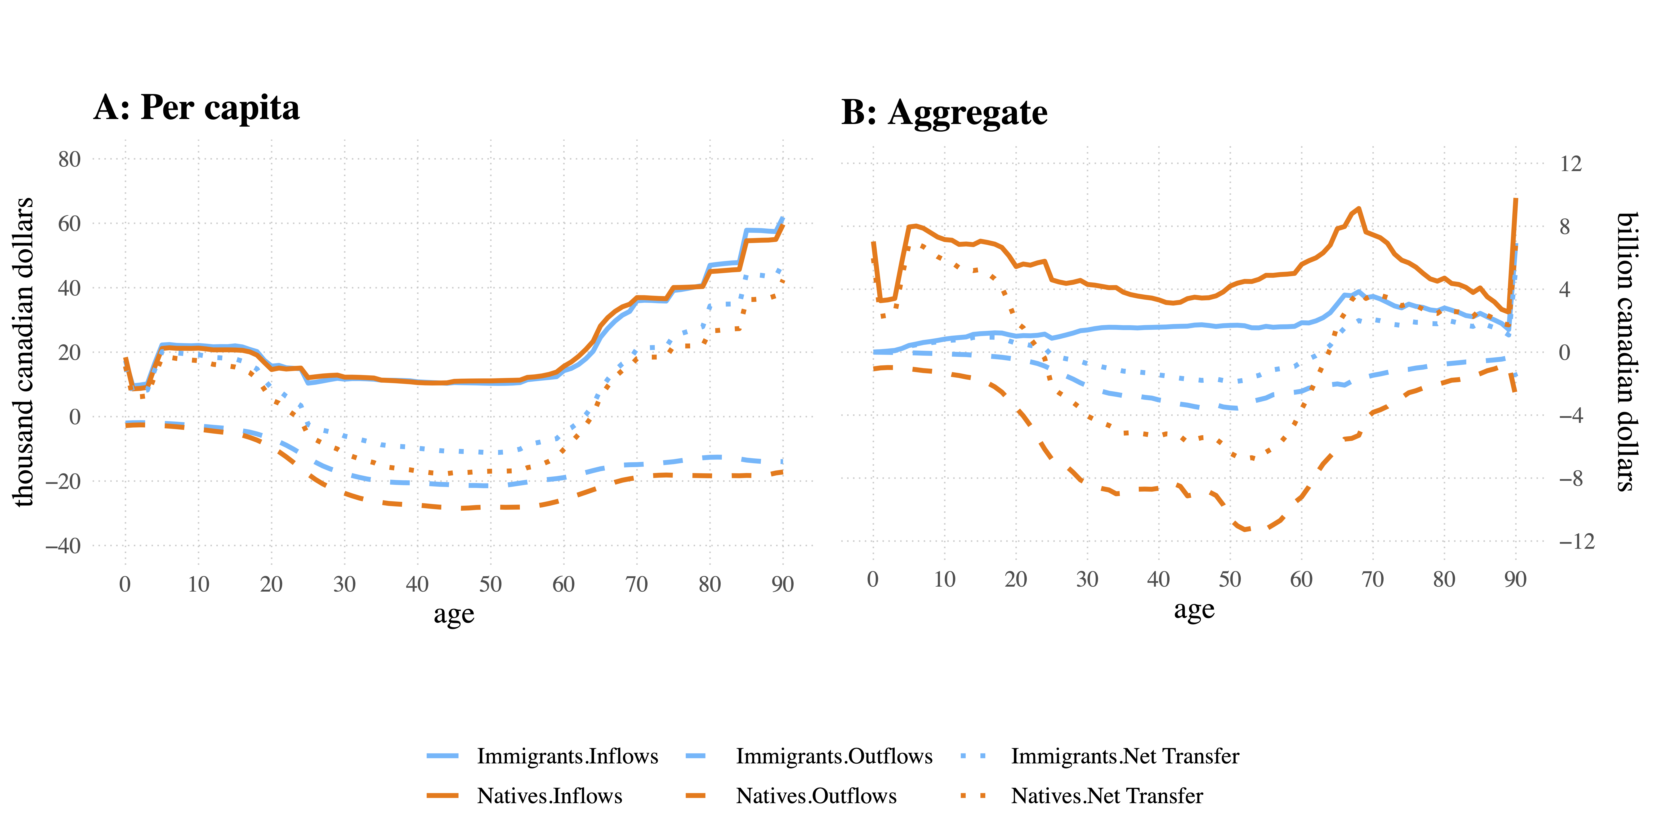

Figure 1: Alt text: In 2015, per capita inflows were nearly identical for immigrants and natives. However, a noticeable difference in outflow occurs, especially in adult and older age groups, with immigrants contributing less than natives

## Public transfers in sub-accounts

Results from [fig:txAge2015] suggest that immigrants are responsible for a relatively small part of public transfers compared to natives. However, they account for a disproportionate share of transfer in various sub-accounts compared to their population share. [tab:tx2015] splits the Inflow and Outflow transfers for 2015 into their respective sub-accounts along with the population shares for immigrants and natives. It shows that immigrants represent about 24.2% of the Canadian population but contribute to 22.7% of outflows. Furthermore, while their share in inflow transfers (25.2%) is much closer to their share in the population, there is a significant gap between inflow sub-accounts. For instance, immigrants are only responsible for 14.5% of education costs but account for 29.5% of health expenses. For outflow accounts, the share ranges from 21.7% for sales taxes at one end and 25.4% for social insurance contributions at the other end. In dollar values, Net Transfer to public finances in 2015 is positive ($ 19004 million or 0.96% of GDP) for immigrants but is slightly negative ($7120 million or 0.36% of GDP) for natives. However, as the benefits of immigration become visible only in the medium and long term (Goldin, Cameron, and Balarajan 2011), a more accurate analysis requires a comparison over many years.

# Trends in public transfers from 1997 to 2015

## Transfer-to-Population ratio

While the aggregate Net Transfer is positive for immigrants and negative for natives for 2015, this trend is relatively recent as it only became apparent from 2012. [fig:aggTrend] shows that the opposite trend prevailed before 2002, with immigrants contributing about 5% more than their population share.

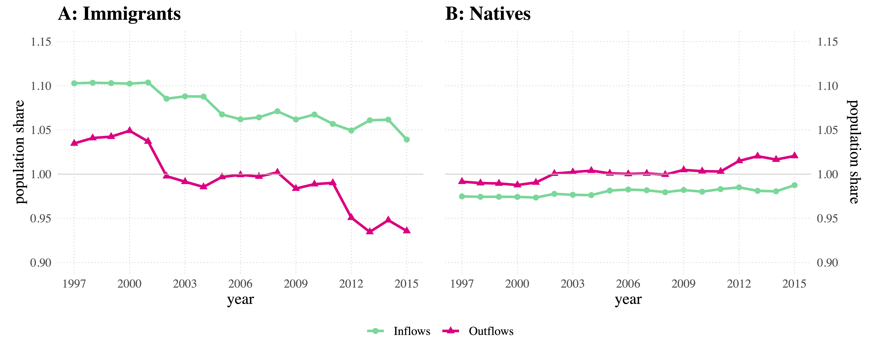

Figure 2: Alt text: Until 2001, immigrants contributed more to public finances than their population share, but the situation reversed from 2002 and worsened from 2012.

Between 2002 and 2011, immigrants and natives contributed to public finances roughly in the same proportion as their population share. While the trend in outflows has reversed throughout the studied period for the two populations, the trend in inflows has been much more stable, especially for natives who received between one and two percent less public transfer than their population share. For immigrants, the cost was about 10% more until 2001 but decreased gradually to about 5% more than their share in the population.

Although aggregate measures provide exciting insights about the relative cost of immigration in Canada, crude per-capita values are better indicators for comparing immigrants and natives, as they remove the effect of the population size. [fig:netDiff] shows the trends in crude per-capita values for Net Transfers (A) on one hand and Immigrant Surpluses (B) on the other hand between 1997 and 2015.

## Net Transfer of immigrants and natives

Excluding the sudden increase from 2011, which increased it to $\sVal, the average Net Surplus of transfer has fluctuated only slightly around $1400 since 1997. A positive Net Surplus of transfer implies that the average immigrant has cost the state more than the average native. However, this overall unfavorable cost says little about the origins of these costs, as it hides significant differences in trends within each group and transfer components.

Looking at the trend in Net Transfer ([fig:netDiff]-A) separately for immigrants and natives, it can be observed that immigrants have had a positive Net Transfer over the studied period. This positive Net Transfer implies that immigrants have consistently received more transfers from the state than contributed to its revenues. Between 1997 and 2011, the average Net Transfer for immigrants fluctuated around $1400 per year. However, it rose rapidly between 2011 and 2013 to surpass $2100. Although at a much lower level, natives have also seen a positive Net Transfer between 1997 and 2002. However, Net Transfer among natives has dropped and become negative since 2003. Between 2005 and 2015, Net Transfer among natives mostly has been negative with a slight fluctuation around $280, a sign that they contributed more to the public purse than they received from it.

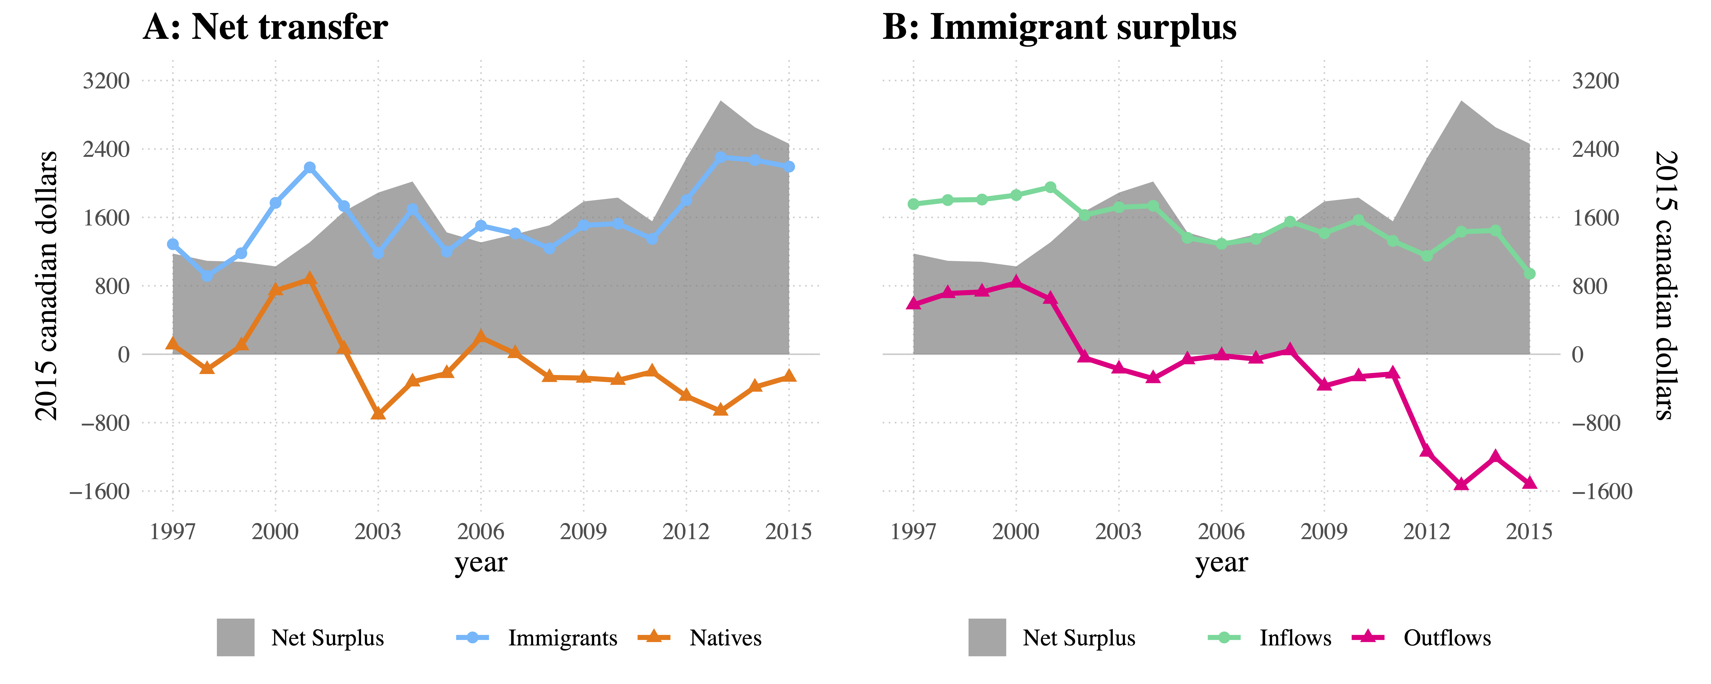

Figure 3: Alt text: Compared to natives, immigrants received more from public finances than they contributed. The per capita net surplus averaged $1400 between 1997 and 2011, but surged beyond $2100 in 2013.

These observations suggest that immigrants have consistently received more than they contributed. In contrast, natives have received slightly less than they contributed, leading to a consistently positive Net Surplus between 1997 and 2011. However, it is still unclear how surpluses in inflows and outflows have trended during the studied period and which contributed most to the sudden increase in the Net Surplus from 2012. [fig:netDiff]-B analyzes the trend in Immigrant Surplus for inflows and outflows, which may provide further clarification.

## Immigrant Surplus for Inflows and Outflows

Over the studied period, the Immigrant Surplus for inflow has been positive, with immigrants receiving about $1400 more than natives on average. However, the trend is downward, suggesting that transfers to immigrants have been decreasing compared to natives. For instance, the surplus has dropped by about $700 between 1997 and 2015 for inflows. Along with this trend, if the surplus for outflows maintained its early 2000s level, the Net Surplus between immigrants and natives would be close to null by 2015. Instead, while the surplus for inflow decreased slowly and steadily, the surplus for outflow increased drastically between 1997 and 2015. For instance, before 2002, the average immigrant contributed about $700 more than native in outflow transfer. From early 2000, however, the surplus in outflow dropped significantly. As a result, immigrants and natives contributed about the same amount between 2002 and 2008. The situation reversed between 2009 and 2011, with immigrants contributing less than natives but only slightly. From 2012, however, the gap in outflow transfer deepened, with natives contributing about $1400 more than immigrants.

Although Net Transfer and Immigrant Surplus result in the same Net Surplus, they illustrate different aspects of the transfer dynamic and reveal two crucial imbalances. First, the increase in Net Surplus between 2000 and 2004 is mainly due to outflows increasing for natives but stagnating among immigrants. Second, the increase in Net Surplus between 2011 and 2013 resulted from outflows decreasing for immigrants while stagnating for natives. As outflows are solely dependent on individual labor outcomes, these results suggest that the labor prospects of immigrants have degraded compared to natives during the studied period, especially during and after the 2008-2009 economic crisis. However, the crude values used to generate these results do not account for the difference in the age structure of the two populations. Therefore, properly isolating demographic effects is necessary to compare transfer differences between immigrants and natives without bias.

# Decomposing the Immigrant Surplus

## Age structure and public transfers

Public transfers are inter-generational; this involves collecting resources from the working-age population (the outflow transfers) and reallocating them to the dependent population, mostly the young and old (the inflows transfers). The immigrant and native populations are different not only in their size but also in their age structure. By dividing total (across all ages) transfer by the total population, per-capita comparison between immigrants and natives accounts for the difference in the population size but not for the difference in age structure. It follows that a comparison based on per-capita values is biased to the extent that the two populations have different age structures. To account for this bias, the decomposition discussed earlier is applied to the surpluses in each account and sub-account separately. The decomposition function takes the age-specific transfer and the population size as inputs for a given transfer account. It then applies the decomposition algorithm and returns the two components representing the respective contributions of the inputs to the per capita crude surplus. Doing so allows extracting the share of crude surplus accrued by a difference in age-specific transfer rather than a difference in the age structure of the two populations.

Age-adjusted surpluses are the components associated with age-specific transfers and represent the difference between an immigrant and a native of the same age. We will also refer to these as fiscal components On the other hand, demographic components are associated with the population size by age. However, they express only the portion of the surplus that results from a difference in the age structure between the two populations because the per-capita calculation cancels out the effect of the total population size. Also, as Net Surplus is the sum of all Immigrant Surpluses across all accounts (inflows minus outflow), the age-adjusted Net Surplus is computed similarly as the sum of all age-adjusted Immigrant Surpluses. [fig:DEcomp] presents the trend in the crude and age-adjusted surpluses as well as the demographic components for each sub-account throughout the studied period. Account names are simplified as per [tab:tx2015]

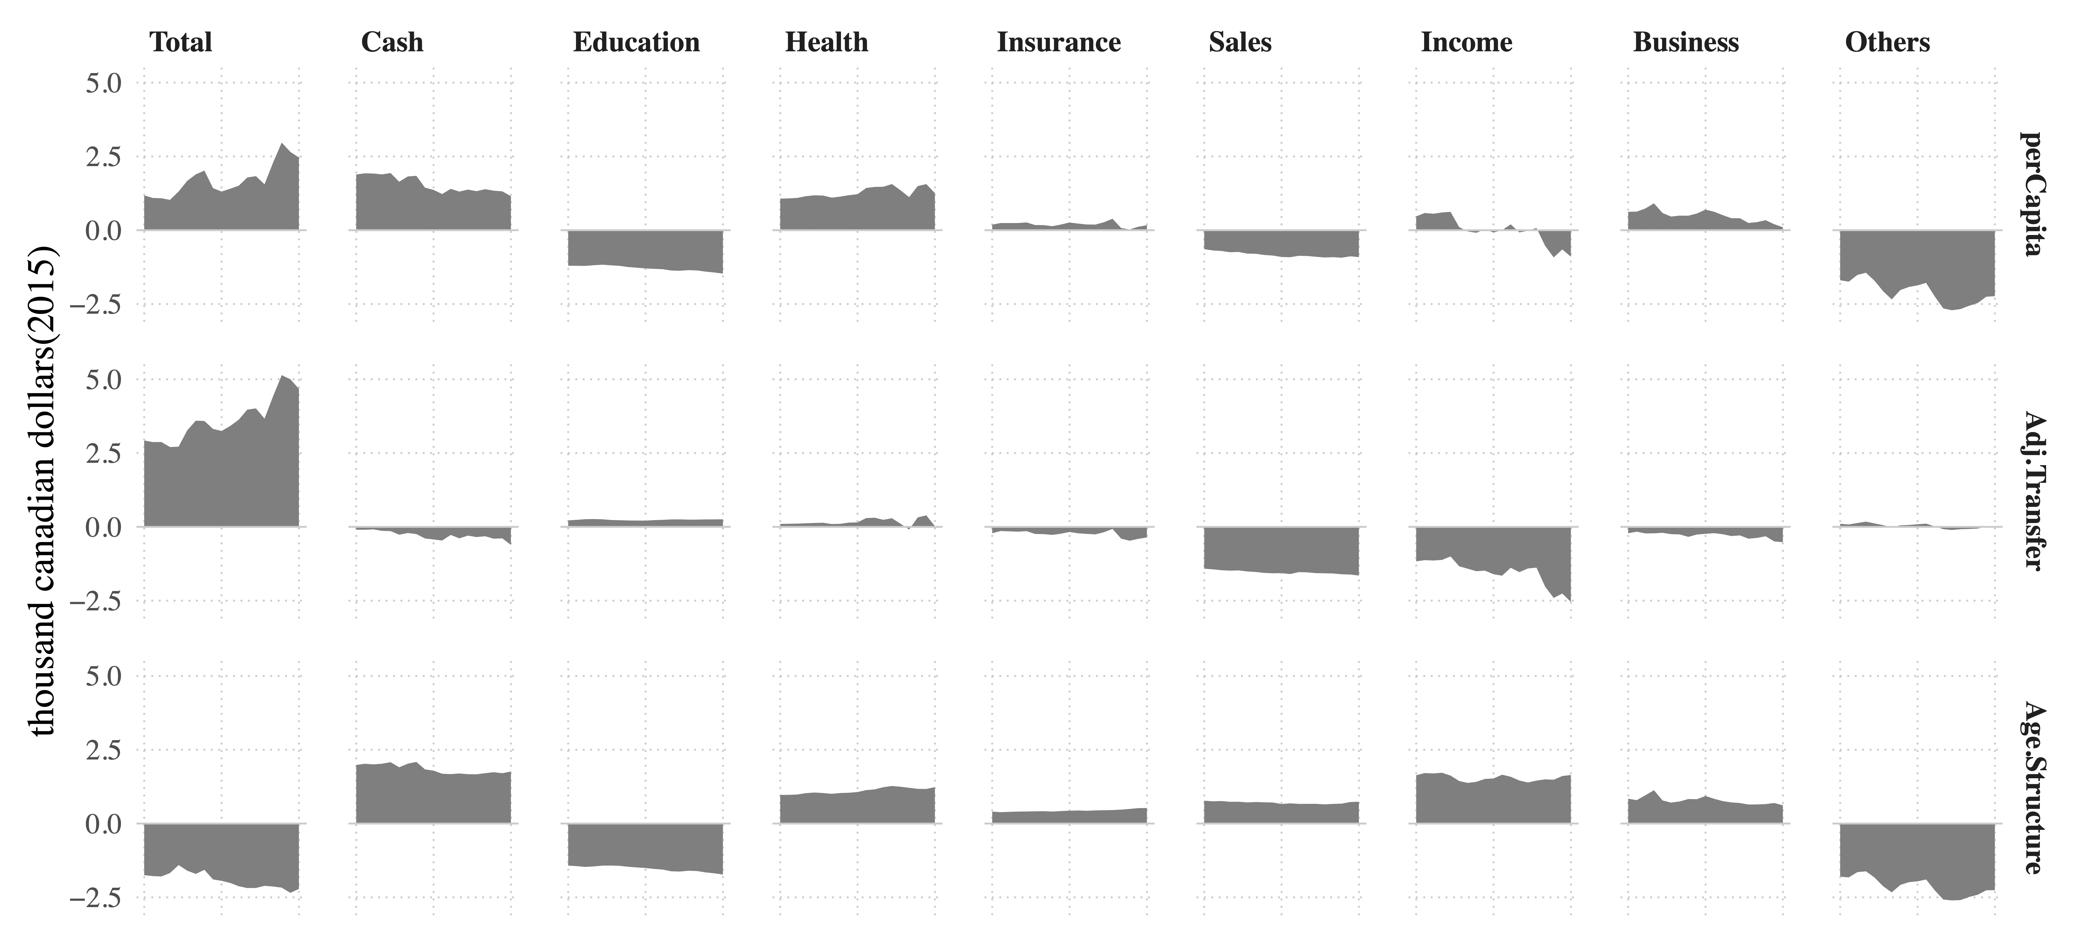

Figure 4: Alt text: Demographic differences hide and confuse public transfer disparities between immigrants and natives. When removed, the net surplus averaged $\sVal between 1997 and 2015.

## Age-adjusted Net Surplus

Results show that age-adjusted Net Surplus followed the same pattern as per-capita Net Surplus, but the levels are much higher in absolute values. Furthermore, the overall negative sign for demographic components of Net Surplus indicates that age structure is much more favorable to immigrants, as it reduced the difference between immigrants and natives from the adjusted value to the per-capita value. In other words, the per-capita difference would have been much higher than its current (crude) value if the immigrant and native populations had the same age structure. In dollar value, at equal age, the average immigrant has cost to the state about $\sVal per year, more than the average native, between 1997 and 2016. However, a favorable population structure reduced this surplus by about $\sVal, leading the $\sVal in per-capita Net Surplus. While the demographic effect has increased steadily during the studied period from $\sVal to $\sVal, the trends in Adjusted Net Surplus were much more abrupt, with increases every few years (early 2000, late 2000, early 2010) from $\sVal in 1997 to $\sVal in 2015. The steady increase of the demographic components over the years reflects the faster aging of the native population, as the immigrant population has been purposefully kept young through various economic immigration programs.

These results imply that the difference in age structure between immigrant and native populations accounts for much of their difference in crude surpluses. Therefore, not accounting for the demographic effect leads to conflicting results that confuse our understanding of the transfer differential between immigrants and natives, create unnecessary discord in the immigration debates, and lead to inappropriate public policy. The confusion goes even further when comparing the sub-account of inflows and outflows, as we shall see in the following section.

## Age-adjusted surpluses in sub-accounts

Looking at the adjusted surplus for the sub-accounts, income and sales taxes appear to be the primary sources of the Net Surplus. This result makes sense because the other sub-accounts tied to public programs are less likely to increase social inequality to the size of the Immigrant Surplus. On the other hand, the sub-accounts of Income and Sales taxes directly relate to individual revenue, which is more subjected to labor market outcomes than public policy. However, this pattern is not observable from the crude values, and crude Net Surplus shows opposite results, with inflows appearing as the primary sources of disparities in Net Transfers. For example, most contributions to public finances represent a given proportion of the individual’s income. Therefore, it is intuitive that the sub-account of income taxes reflects the difference between immigrants and natives to a large extent. On the contrary, the crude Net Surplus for income taxes shows conflicting results: positive between 1997 and 2003, null till 2012, and negative afterward.

These results illustrate the mitigating effect of demographic components in the differences in transfer between immigrants and natives. Demographic differences are also why the high per-capita healthcare cost is close to zero in the age-adjusted surplus. In other words, the high difference in health care transfer between immigrants and natives implies that there are relatively more immigrants in the age groups with the highest health care costs. This implication may be unexpected since the average age of new immigrants entering Canada is lower than that of the native population. However, as shown by Malenfant et al. (2011, p 244), the immigrant population in Canada is older than the population as a whole because immigrants are over-represented above the age of 30 and under-represented below.

Not only have demographic differences affected the size of the Immigrant Surplus, but they have also changed its direction and trend. For example, looking at the per-capita surplus, immigrants seem to have paid, on average, more business taxes than natives. However, after adjusting for demographic effects, the situation reverses, with immigrants paying fewer business taxes than natives. Moreover, contrary to the per-capita measure, the trend in Immigrant Surplus is increasing. The low business taxes immigrants pay suggest that they operate smaller businesses than natives. They also contributed toward social security and received cash transfers, slightly less than natives. The opposite applies to education and health care costs, where immigrants consume slightly more than natives.

The Other sub-account of transfer includes public goods, services, deficits, and debts. The NTA method distributes these costs evenly, making no difference between immigrants and natives by design. As a result, the age-adjusted surplus for the other sub-accounts is close to zero and has the lowest absolute value among all sub-accounts. Therefore, the significant negative effect (in favor of natives) seen in the per-capita surplus is mainly due to the difference in age structure between immigrants and natives. When adjusted for these differences, the surpluses in these other sub-accounts compensated each other, revealing the sub-account of sales and income taxes as the two most important sources of disparities between immigrants and natives.

Immigrants receive similar benefits from public programs, but their low revenue does not contribute equally to public finances, leading to a positive Net Surplus. As a result, the difference in sales and income taxes added up to an age-adjusted surplus of $\sVal, which represents \sVal% of the $\sVal in total age-adjusted surplus. As these taxes come from income mainly earned from labor, the labor market stands out as a significant source of inequality between immigrants and natives. Furthermore, while both income and sales taxes are the main contributors to Net Surplus, income taxes alone drive its trends. These results stand against the expectations of a positive impact of immigration on public finances, especially for recent immigrants for whom economic factors have motivated admission. However, these are not revealed until demographic differences between immigrants and natives are accounted for. Therefore, how the labor market has become the source of so many imbalances, especially since 2011, is a crucial question to discuss and address should Canada intend to benefit from its immigrants. In particular, understanding how hiring and wage discrimination affect immigrants’ contribution to society and government revenues will be essential.

# Limitations and Conclusion

## Improvements for future research

This study contributes new results to the immigration debates using new datasets and advanced methods. However, there is room for improvement in various areas, including the effects of a changing demographic structure, an extended scope of the immigrant population, the age at arrival, and the healthy immigrant effect. As we have seen, omitting the demographic difference between immigrants and natives results in significant bias in analyzing the transfer differential between the two populations.

This study addressed the bias resulting from a difference in the age structure between immigrant and native populations. However, the changes in the age structure from one year to another may also introduce bias in the trend comparison. The bias may be slight for consecutive years but significant over many years as the population ages and immigration continues. The logic for such bias is the same that justifies accounting for inflation when comparing the price difference of two baskets of products over time.

Demographic effects may also arise from a different composition of the immigrant population. For instance, although this study has gathered data over many years, the cross-sectional nature of these data makes it applicable only to the first generation of immigrants. As pointed out by previous studies (Lee and Miller 1998), defining the immigrant population is particularly challenging, and enlarging the immigrant population by including more generations may lead to different results. The first generation refers to people born outside Canada but now residing as citizens or permanent residents. Those born in Canada but have at least one parent born outside the country belong to the second generation, while those with both parents and themselves born in Canada belong to the third generation. With such variants in the immigrant population, their effect on the Immigrant Surplus would be worth investigating.

Even for the first generation of immigrants, the age at arrival could be a source of difference in transfers. For instance, there is a general assumption that immigrants arriving at working age represent a saving in childhood and education expenses, which primarily occur in the country of origin. For example, Dustmann and Frattini (2014) found that between 1995 and 2011, European and non-European immigrants endowed the UK labor market with human capital that would have cost £14 and £35 billion respectively if produced through the British education system. Unfortunately, this study has not accounted for the age of arrival. However, the results suggest that immigrants have made a similar contribution in Canada, as they represent about 24.2% of the Canadian population but are responsible for only 14.5% of education costs in 2015.

If arriving later implies saving in education costs for the host country, departing earlier is also expected to reduce age-related expenses. Health care, for example, could see some savings if some immigrants return to their home country to spend the last and most cost-intensive part of their life (Bratsberg, Raaum, and Røed 2014). This expectation does not seem to apply in Canada, as our research shows that immigrants accounted for 24.2% of the population but 29.5% of health care expenses in 2015. This result may be related to using total medical consultation as a proxy for health care expenses and, therefore, will require further investigation, especially given the other expectation that immigrants are healthier than natives (Ichou and Wallace 2019; Vang et al. 2016). This foreign-born health advantage is usually called the Healthy Immigrant Effect (HIE). It is mainly the result of immigration policies that put a relatively high weight on health status and disqualify applicants whose health conditions would cause excessive demand for health care or social services.

## Conclusion

Overall, the average immigrant contributed for about $\sVal per year while receiving about $\sVal per year on average between 1997 and 2017. A native, on the other hand, has contributed $\sVal but received $\sVal. In net, immigrants received about $\sVal more than natives on average, and this surplus is increased to $\sVal when comparing immigrants and natives at the same age. Therefore, labor market imbalances are the primary sources of this difference, accounting for \sVal% of the Net Surplus.

These results lie somewhere between the results from Grubel and Grady (2012) and Javdani and Pendakur (2013) who reported $6051 and $500 respectively for the fiscal year 2005/2006. Although reducing this divergence alone contributes to a healthier immigration debate, a more significant contribution from this study lies in using the NTA method, which is more englobing than previous methods regarding the type of transfers included. Moreover, stripping out demographic disturbances through effect decomposition has highlighted effects that would stay hidden otherwise. These methods clearly show the cost of immigration to public finances and point to labor market imbalances as the primary source of this cost. Therefore, rather than debating whether or not immigrants’ intake should be increased or reduced, it would be beneficial to debate how to enable immigrants to achieve their full potential in the labor market. The solution to such questions may involve adjusting the selection criteria. However, it also calls for more research and policies to address the labor market imbalances, especially the sudden degradation of the Immigrant Surplus since 2011.

# References

Akbari, Ather H. 1989. “The Benefits of Immigrants to Canada: Evidence on Tax and Public Services.” *Canadian Public Policy / Analyse de Politiques* 15 (4): 424–35. <https://doi.org/10.2307/3550358?refreqid=search-gateway:e06f2788af7ba3d6e1a58176814efff9>.

Akin, Serife Nuray. 2012. “Immigration, Fiscal Policy, and Welfare in an Aging Population.” *The B.E. Journal of Macroeconomics* 12 (1): 587. <https://doi.org/10.1515/1935-1690.2352>.

Ando, Albert, and Franco Modigliani. 1963. “The "Life Cycle" Hypothesis of Saving: Aggregate Implications and Tests.” *The American Economic Review* 53 (1): 55–84. <https://doi.org/10.2307/1817129?ref=search-gateway:e1e4971441edc0399d2f55db373ff094>.

Borjas, George J. 2014. *Immigration Economics*. Harvard University Press. Cambridge, MA and London, England: Harvard University Press. <https://doi.org/10.4159/harvard.9780674369900>.

Bratsberg, Bernt, Oddbjørn Raaum, and Knut Røed. 2014. “Immigrants, Labour Market Performance and Social Insurance.” *The Economic Journal* 124 (580): F644–83. <https://doi.org/10.1111/ecoj.12182>.

Canada, Statistics. 2016. “150 Years of Immigration in Canada.” *Canadian Megatrends*, June, 1–6.

Card, David, and Giovanni Peri. 2016. “Review: "Immigration Economics" by George J. Borjas: A Review Essay.” *Journal of Economic Literature* 54 (4): 1333–49. <https://doi.org/10.2307/26303162?refreqid=search-gateway:67c6cef3946c768129338a2c6b6e2703>.

Castles, Stephen. 2012. “Migration and Minorities in Europe: Perspectives for the 1990s Eleven Hypotheses.” In *Ethnicity and Globalization: From Migrant Worker to Transnational Citizen Ethnicity and Globalization: From Migrant Worker to Transnational Citizen ER -*, 80–94. Ethnicity and Globalization: From Migrant Worker to Transnational Citizen Ethnicity and Globalization: From Migrant Worker to Transnational Citizen ER -. Ethnicity and Globalization: From Migrant Worker to Transnational Citizen Ethnicity and globalization: From migrant worker to transnational citizen ER -.

Chojnicki, Xavier. 2011. “Fiscal impact of immigration in France.” *Revue économique* Vol. 62 (3): 531–43. <https://www.cairn.info/revue-economique-2011-3-page-531.htm?contenu=article>.

Clavet, Nicholas-James, Jean-Yves Duclos, Bernard Fortin, Steeve Marchand, and Pierre-Carl Michaud. 2013. “Les dépenses En Santé Du Gouvernement Du Québec, 2013-2030 :projections Et déterminants.” *CIRANO*, December, 333–36. <https://doi.org/10.2307/j.ctv69sv1x.18>.

d’Albis, Hippolyte, Carole Bonnet, Xavier Chojnicki, Najat El Mekkaoui, Angela Greulich, Jérôme Hubert, and Julien NAVAUX. 2019. “Financing the Consumption of the Young and Old in France.” *Population and Development Review* 45 (1): 103–32. <https://doi.org/10.1111/padr.12204>.

Deaton, A. 2005. “Franco Modigliani and the Life Cycle Theory of Consumption.” *SSRN Electronic Journal*, January. <https://doi.org/10.2139/ssrn.686475>.

Dungan, Peter, Tony Fang, and Morley Gunderson. 2013. “Macroeconomic Impacts of Canadian Immigration: Results from a Macro Model.” *British Journal of Industrial Relations* 51 (1): 174–95. <https://doi.org/10.1111/j.1467-8543.2012.00905.x>.

Dustmann, Christian, and Tommaso Frattini. 2014. “The Fiscal Effects of Immigration to the UK.” *The Quarterly Journal of Economics*, November. <https://doi.org/10.1111/ecoj.12181","inLanguage":"en","copyrightHolder":"Royal>.

Dustmann, Christian, and Ian P Preston. 2007. “Racial and Economic Factors in Attitudes to Immigration.” *The B.E. Journal of Economic Analysis & Policy* 7 (1). <https://doi.org/10.2202/1935-1682.1655>.

Fehr, Hans, Sabine Jokisch, and Laurence Kotlikoff. 2003. “The Developed World’s Demographic Transition - The Roles of Capital Flows, Immigration, and Policy.” 10.3386/W10096. Cambridge, MA: National Bureau of Economic Research. <http://www.nber.org/papers/w10096.pdf>.

Fields, Andrew, Sharanjit Uppal, and Sebastien LaRochelle-Cote. 2017. “The Impact of Aging on Labour Market Participation Rates.” *Insights on Canadian Society*, June, 1–12. <https://www150.statcan.gc.ca/n1/en/pub/75-006-x/2017001/article/14826-eng.pdf?st=Vv_Ooy6D>.

Fusaro, Stefano, and Enrique López-Bazo. 2018. “The Impact of Immigration on Native Employment: Evidence from Italy.” *Universitat de Barcelona. Facultat d’Economia i Empresa*, January. <http://diposit.ub.edu/dspace/handle/2445/125156>.

Godbout, Luc, Suzie St-Cerny, and Pier-André Bouchard St-Amant. 2012. “Transition démographique Et Soutenabilité Des Finances Publiques Du Québec.” *Association Internationale Des Démographes de Langue Française (AIDELF), 2012*, June.

Goldin, Ian, G Cameron, and M Balarajan. 2011. “Exceptional People: How Migration Shaped Our World and Will Define Our Future,” January. <https://www.cis.org.au/app/uploads/2015/04/images/stories/policy-magazine/2011-spring/27-3-11-stephen-kirchner.pdf>.

Grubel, Herbert, and Patrick Grady. 2012. “Fiscal Transfers to Immigrants in Canada: Responding to Critics and a Revised Estimate.” 37406. *Munich Personal RePEc Archive*. Munich Personal RePEc Archive. <https://ideas.repec.org/p/pra/mprapa/37406.html>.

Horiuchi, Shiro, John R Wilmoth, and Scott D Pletcher. 2008. “A Decomposition Method Based on a Model of Continuous Change.” *Demography* 45 (4): 785–801. <https://doi.org/10.1353/dem.0.0033>.

Ichou, Mathieu, and Matthew Wallace. 2019. “The Healthy Immigrant Effect: The Role of Educational Selectivity in the Good Health of Migrants.” *Demographic Research* 40 (January): 61–94. <https://doi.org/10.2307/26726993?refreqid=search-gateway:c2b258792583aa86b6898d41383a0b0f>.

İleri, Şerife Genç. 2019. “Selective Immigration Policy and Its Impacts on Canada’s Native-Born Population: A General Equilibrium Analysis.” *Canadian Journal of Economics/Revue Canadienne d’économique* 52 (3): 954–92. <https://doi.org/10.1111/caje.12395>.

Javdani, Mohsen, and Krishna Pendakur. 2013. “Fiscal Effects of Immigrants in Canada.” *Journal of International Migration and Integration* 15 (4): 777–97. <https://doi.org/10.1007/s12134-013-0305-5>.

Kudrna, George, Chung Tran, and Alan Woodland. 2015. “The Dynamic Fiscal Effects of Demographic Shift: The Case of Australia.” *Economic Modelling* 50 (November): 105–22. <https://doi.org/10.1016/j.econmod.2015.05.010>.

Lee, Ronald Demos. 1980. “Age Structure Intergenerational Transfers and Economic Growth: An Overview.” *Revue économique* 31 (6): 1129–56. <https://doi.org/10.2307/3501185?refreqid=search-gateway:0d627ec36df6105cd6709c2e8d25e395>.

Lee, Ronald Demos, and Timothy W Miller. 1998. “The Current Fiscal Impact of Immigrants and Their Descendants: Beyond the Immigrant Household.” In *The Immigration Debate*, edited by James P Smith and Barry Edmonston. The Immigration Debate. Washington, D.C.: National Academies Press. <https://doi.org/10.17226/5985>.

Lee, Ronald Demos, and Edwards Ryan. 2001. “Seismic Shifts: The Economic Impact of Demographic Change,” May. <https://www.bostonfed.org/news-and-events/events/economic-research-conference-series/seismic-shifts-the-economic-impact-of-demographic-change.aspx>.

Malenfant, Éric Caron, Patrice Dion, André Lebel, and Dominic Grenier. 2011. “Immigration Et Structure Par Âge de La Population Du Canada : Quelles Relations?” *Cahiers Québécois de démographie* 40 (2): 239–65. <https://doi.org/10.7202/1011541ar>.

Marois, Guillaume, Alain Bélanger, and Wolfgang Lutz. 2020. “Population Aging, Migration, and Productivity in Europe.” *Proceedings of the National Academy of Sciences of the United States of America* 117 (14): 7690–95. <https://doi.org/10.1073/pnas.1918988117>.

Mason, Andrew. 1988. “Saving, Economic Growth, and Demographic Change.” *Population and Development Review* 14 (1): 113–44. <https://doi.org/10.2307/1972502?refreqid=search-gateway:a2d9c4ae02f0bdcc87bbbf7d4db31381>.

Mason, Andrew, and Ronald Demos Lee. 2011. “Introducing Age into National Accounts.” In *Population Aging and the Generational Economy: A Global Perspective*. Population Aging and the Generational Economy: A Global Perspective. Population aging and the generational economy: A global perspective. <https://www.researchgate.net/profile/Ronald_Lee12/publication/265976493_Introducing_Age_into_National_Accounts/links/555b601f08aec5ac22323760/Introducing-Age-into-National-Accounts.pdf>.

Mérette, Marcel, and Julien Navaux. 2019. “Population Aging in Canada: What Life Cycle Deficit Age Profiles Are Telling Us about Living Standards.” *Canadian Public Policy* 45 (2): 192–211. <https://doi.org/10.3138/cpp.2018-050>.

Nations, United. 2013. “National Transfer Accounts Manual: Measuring and Analysing the Generational Economy.” *United Nations Publication*, September, 1–226.

Piché, Victor. 2013. “Les théories migratoires contemporaines au prisme des textes fondateurs.” *Population* Vol. 68 (1): 153–78. <https://doi.org/10.3917/popu.1301.0153>.

Piérard, Emmanuelle. 2016. “The Effect of Health Care Expenditures on Self-Rated Health Status and the Health Utility Index: Evidence from Canada.” *International Journal of Health Economics and Management* 16 (1): 1–21. <https://doi.org/10.1007/s10754-015-9176-y>.

Prskawetz, Alexia, Barbara Zagaglia, Thomas Fent, and Vegard Skirbekk. 2005. “Decomposing the Change in Labour Force Indicators over Time.” *Demographic Research* 13 (July): 163–88. <https://www.demographic-research.org/Volumes/Vol13/7/>.

R Core Team. 2018. “R: A Language and Environment for Statistical Computing.” Vienna, Austria: R Foundation for Statistical Computing. <https://www.R-project.org>.

Riffe, Tim. 2018. “DemoDecomp: Decompose Demographic Functions.” <https://CRAN.R-project.org/package=DemoDecomp>.

Rowthorn, Robert. 2008. “Fiscal Impact of Immigration on the Advanced Economies | Oxford Review of Economic Policy | Oxford Academic.” *The Quarterly Journal of Economics*, January. <https://doi.org/10.1093/oxrep/grn025","keywords":["migration","taxation","ageing","generational>.

Statistics Canada. 2006. “A Portrait of Seniors in Canada, Catalogue No. 89-519-XIE.” <https://tinyurl.com/2p85ayxr>.

———. 2017. “Age-Standardized Rates.” <https://www.statcan.gc.ca/eng/dai/btd/asr>.

St-Maurice, Yves, Luc Godbout, Matthieu Arseneau, and Suzie St-Cerny. 2018. “La Soutenabilité Budgétaire À Long Terme Du Québec, Édition 2018 Des défis Subsistent.” *Cahier de Recherche 2018/14, École de Gestion, Université de Sherbrooke*, November, 147–67. <https://doi.org/10.1787/eco_outlook-v2002-2-35-fr>.

Storesletten, Kjetil. 2000. “Sustaining Fiscal Policy Through Immigration.” *Journal of Political Economy* 108 (2): 300–323. <https://doi.org/10.1086/262120?refreqid=search-gateway:93d91dfa74ae4ca21c16616fd0abe78a>.

Vang, Zoua M, Jennifer Sigouin, Astrid Flenon, and Alain Gagnon. 2016. “Are Immigrants Healthier Than Native-Born Canadians? A Systematic Review of the Healthy Immigrant Effect in Canada.” *Ethnicity and Health* 22 (3): 209–41. <https://doi.org/10.1080/13557858.2016.1246518>.

Zokalj, Mateo. 2016. “The Impact of Population Aging on Public Finance in the European Union.” *Financial Theory and Practice* 40 (4): 383–412. <https://doi.org/10.3326/fintp.40.4.2>.

1. Corresponding author