**BỘ CÔNG THƯƠNG**

**TRƯỜNG ĐẠI HỌC CÔNG NGHIỆP**

**TP.HCM KHOA CÔNG NGHỆ ĐIỆN TỬ**

BÁO CÁO

VI ĐIỀU KHIỂN VÀ ỨNG DỤNG

**BÀI 5:**

***BÀI THỰC HÀNH V***

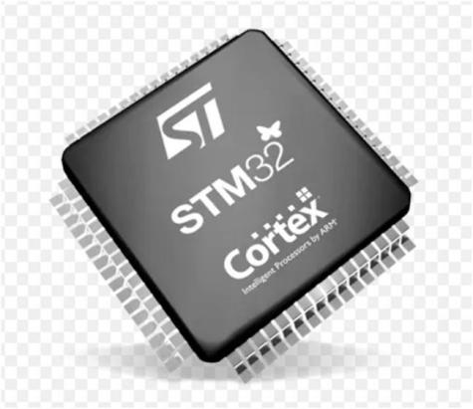

#### Giảng viên hướng dẫn: Phạm Quang Trí

**NHÓM 3:**

**Sinh viên thực hiện:**

**Đoàn Mạnh Tú - 21007261**

**Hồ Bửu Sơn - 21119571**

***Thành phố Hồ Chí Minh, tháng 8 năm 2023***

**Bài tập mức độ 3:Viết chương trình cho STM32 thực hiện yêu cầu sau:**

**-Truyền một gói tin từ máy tính xuống STM32 có định dạng như sau:*|X|DATA|# (bao gồm nhiều byte, trong đó “*” là ký tự bắt đầu; “#” là ký tự kết thúc; “X”(X=1->16) là byte khai báo kích thước của Data; “Data” là các ký tự, có kích thước từ 1 đến 16 byte.Ví dụ:*3ABC#.**

**-Khi nhận đúng ddingj dạng gói tin:hiển thị nội dung gói tin lên LCD 16x2, đồng thời truyền trở về máy tính chữ “OK” thông qua UART.**

**-Khi nhận sau định dạng gói tin:không thay đổi nội dung LCD,đồng thời truyền trở về máy tính chữ “ERROR” thông qua UART.**

**-Minh chứng phải thể hiện đầy đủ các trường hợp gửi đúng và gửi sai định dạng gói tin như sai ký tự bắt đầu, sai ký tự kết thúc,…**

**Báo cáo thực hành**

***Yêu cầu 1:***Vẽ sơ đồ nguyên lý kết nối phần cứng của toàn bộ hệ thống sử dụng vi điều khiển STM32.

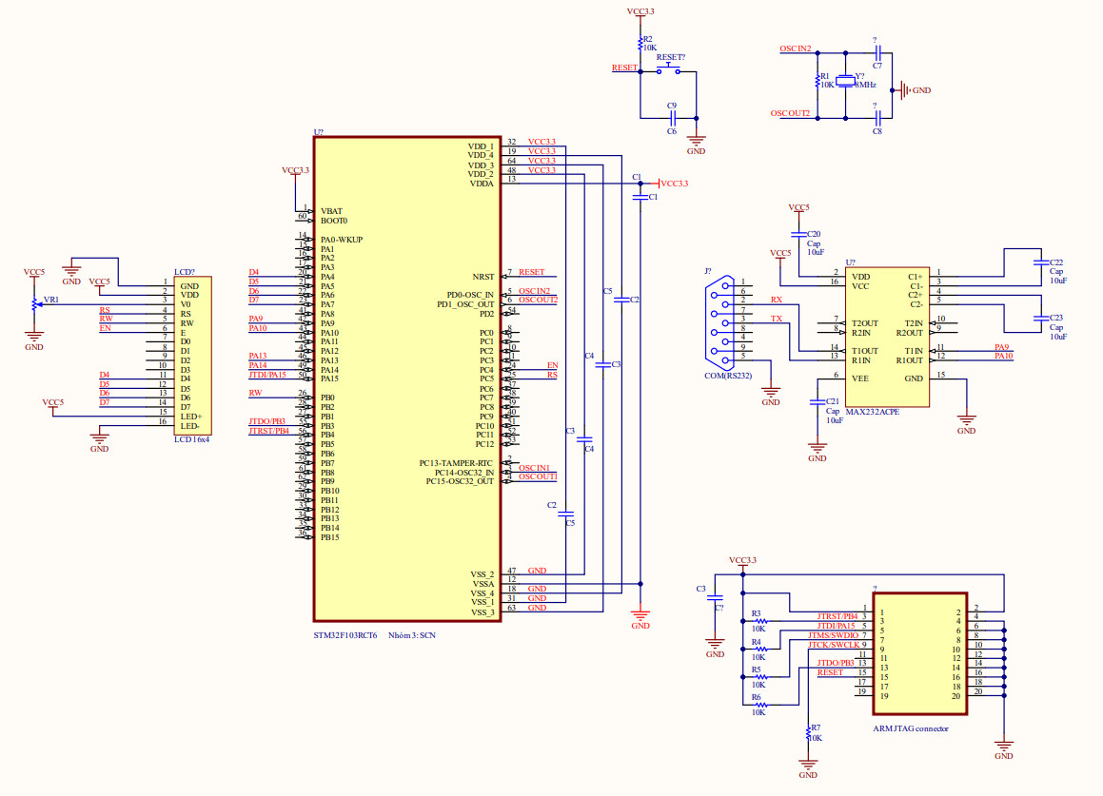

***Yêu cầu 2:***Trình bày lưu đồ giải thuật và mã nguồn của chương trình.

**Mã nguồn:**

**Chương trình main**

/* USER CODE BEGIN Header */

/**

******************************************************************************

* @file : main.c

* @brief : Main program body

******************************************************************************

* @attention

*

* Copyright (c) 2023 STMicroelectronics.

* All rights reserved.

*

* This software is licensed under terms that can be found in the LICENSE file

* in the root directory of this software component.

* If no LICENSE file comes with this software, it is provided AS-IS.

*

******************************************************************************

*/

/* USER CODE END Header */

/* Includes ------------------------------------------------------------------*/

**#include** "main.h"

/* Private includes ----------------------------------------------------------*/

/* USER CODE BEGIN Includes */

/* USER CODE END Includes */

/* Private typedef -----------------------------------------------------------*/

/* USER CODE BEGIN PTD */

/* USER CODE END PTD */

/* Private define ------------------------------------------------------------*/

/* USER CODE BEGIN PD */

/* USER CODE END PD */

/* Private macro -------------------------------------------------------------*/

/* USER CODE BEGIN PM */

/* USER CODE END PM */

/* Private variables ---------------------------------------------------------*/

UART_HandleTypeDef huart1;

/* USER CODE BEGIN PV */

uint8_t OK[3] = {"OK\n"};

uint8_t error[6] = {"ERROR\n"};

uint8_t save[16];

uint8_t data_receive[16];

uint8_t dem;

**int** t = 0;

/* USER CODE END PV */

/* Private function prototypes -----------------------------------------------*/

**void** **SystemClock_Config**(**void**);

**static** **void** **MX_GPIO_Init**(**void**);

**static** **void** **MX_USART1_UART_Init**(**void**);

/* USER CODE BEGIN PFP */

/* USER CODE END PFP */

/* Private user code ---------------------------------------------------------*/

/* USER CODE BEGIN 0 */

**void** **lcd_write_nibble**(uint8_t rs, uint8_t data){

HAL_GPIO_WritePin(RS_GPIO_Port, RS_Pin,rs);

HAL_GPIO_WritePin(RW_GPIO_Port, RW_Pin,0);

HAL_GPIO_WritePin(EN_GPIO_Port, EN_Pin,1);

HAL_GPIO_WritePin(D4_GPIO_Port, D4_Pin, (data>>0) & 0x01);

HAL_GPIO_WritePin(D5_GPIO_Port, D5_Pin, (data>>1) & 0x01);

HAL_GPIO_WritePin(D6_GPIO_Port, D6_Pin, (data>>2) & 0x01);

HAL_GPIO_WritePin(D7_GPIO_Port, D7_Pin, (data>>3) & 0x01);

**for**(uint8_t i=0; i<72; i++) **asm**("NOP");

HAL_GPIO_WritePin(EN_GPIO_Port, EN_Pin,0);

**for**(uint8_t i=0; i<72; i++) **asm**("NOP");

}

**void** **lcd_send_cmd**(uint8_t cmd){

lcd_write_nibble(0, (cmd>>4)&0x0F);

lcd_write_nibble(0, cmd&0x0F);

HAL_Delay(2);

}

**void** **lcd_send_data**(uint8_t data){

lcd_write_nibble(1, (data>>4)&0x0F);

lcd_write_nibble(1, data&0x0F);

HAL_Delay(2);

}

**void** **lcd_init**(**void**){

HAL_Delay(20);

lcd_write_nibble(0, 0x03); HAL_Delay(5);

lcd_write_nibble(0, 0x03); HAL_Delay(1);

lcd_write_nibble(0, 0x03); HAL_Delay(1);

lcd_write_nibble(0, 0x02); HAL_Delay(1);

lcd_send_cmd(0x28);

lcd_send_cmd(0x0C);

lcd_send_cmd(0x01);

lcd_send_cmd(0x06);

}

**void** **lcd_gotoxy**(uint8_t row, uint8_t col){

uint8_t coordinates = 0;

**switch**(row){

**case** 0:

coordinates = 0x80 | col;

**break**;

**case** 1:

coordinates = 0xC0 | col;

**break**;

}

}

**void** **lcd_display**(**char** *data){

**while**(*data){

lcd_send_data(*data++);

}

}

/* USER CODE END 0 */

/**

* @brief The application entry point.

* @retval int

*/

**int** **main**(**void**)

{

/* USER CODE BEGIN 1 */

/* USER CODE END 1 */

/* MCU Configuration--------------------------------------------------------*/

/* Reset of all peripherals, Initializes the Flash interface and the Systick. */

HAL_Init();

/* USER CODE BEGIN Init */

/* USER CODE END Init */

/* Configure the system clock */

SystemClock_Config();

/* USER CODE BEGIN SysInit */

/* USER CODE END SysInit */

/* Initialize all configured peripherals */

MX_GPIO_Init();

MX_USART1_UART_Init();

/* USER CODE BEGIN 2 */

lcd_init();

lcd_display("Nhom 3");

/* USER CODE END 2 */

/* Infinite loop */

/* USER CODE BEGIN WHILE */

**while** (1)

{

/* USER CODE END WHILE */

/* USER CODE BEGIN 3 */

**if**(t==1){

**if**(save[(save[1] + 2)] == 0x23){

**if** (save[0] == 0x2a){

**if**(save[1] == dem - 3){

lcd_send_cmd(0x01);

HAL_Delay(10);

lcd_gotoxy(0,0);

**for** (**int** i = 0; i < save[1]; i++){

lcd_send_data(save[i + 2]);

}

t = 0;

dem = 0;

HAL_UART_Transmit(&huart1, &OK[0],3,10);

}

**else**{

t = 0;

dem = 0;

HAL_UART_Transmit(&huart1, &error[0],6,10);

}

}

**if**(save[0]!=0x2a){

t = 0;

dem = 0;

HAL_UART_Transmit(&huart1, &error[0],6,20);

}

}

**if**(save[(save[1] + 2)]!=0x23){

t = 0;

dem = 0;

HAL_UART_Transmit(&huart1, &error[0],6,20);

}

}

HAL_Delay(500);

}

/* USER CODE END 3 */

}

/**

* @brief System Clock Configuration

* @retval None

*/

**void** **SystemClock_Config**(**void**)

{

RCC_OscInitTypeDef RCC_OscInitStruct = {0};

RCC_ClkInitTypeDef RCC_ClkInitStruct = {0};

/** Initializes the RCC Oscillators according to the specified parameters

* in the RCC_OscInitTypeDef structure.

*/

RCC_OscInitStruct.OscillatorType = RCC_OSCILLATORTYPE_HSE;

RCC_OscInitStruct.HSEState = RCC_HSE_ON;

RCC_OscInitStruct.HSEPredivValue = RCC_HSE_PREDIV_DIV1;

RCC_OscInitStruct.HSIState = RCC_HSI_ON;

RCC_OscInitStruct.PLL.PLLState = RCC_PLL_ON;

RCC_OscInitStruct.PLL.PLLSource = RCC_PLLSOURCE_HSE;

RCC_OscInitStruct.PLL.PLLMUL = RCC_PLL_MUL9;

**if** (HAL_RCC_OscConfig(&RCC_OscInitStruct) != *HAL_OK*)

{

Error_Handler();

}

/** Initializes the CPU, AHB and APB buses clocks

*/

RCC_ClkInitStruct.ClockType = RCC_CLOCKTYPE_HCLK|RCC_CLOCKTYPE_SYSCLK

|RCC_CLOCKTYPE_PCLK1|RCC_CLOCKTYPE_PCLK2;

RCC_ClkInitStruct.SYSCLKSource = RCC_SYSCLKSOURCE_PLLCLK;

RCC_ClkInitStruct.AHBCLKDivider = RCC_SYSCLK_DIV1;

RCC_ClkInitStruct.APB1CLKDivider = RCC_HCLK_DIV2;

RCC_ClkInitStruct.APB2CLKDivider = RCC_HCLK_DIV1;

**if** (HAL_RCC_ClockConfig(&RCC_ClkInitStruct, FLASH_LATENCY_2) != *HAL_OK*)

{

Error_Handler();

}

}

/**

* @brief USART1 Initialization Function

* @param None

* @retval None

*/

**static** **void** **MX_USART1_UART_Init**(**void**)

{

/* USER CODE BEGIN USART1_Init 0 */

/* USER CODE END USART1_Init 0 */

/* USER CODE BEGIN USART1_Init 1 */

/* USER CODE END USART1_Init 1 */

huart1.Instance = USART1;

huart1.Init.BaudRate = 38400;

huart1.Init.WordLength = UART_WORDLENGTH_9B;

huart1.Init.StopBits = UART_STOPBITS_1;

huart1.Init.Parity = UART_PARITY_ODD;

huart1.Init.Mode = UART_MODE_TX_RX;

huart1.Init.HwFlowCtl = UART_HWCONTROL_NONE;

huart1.Init.OverSampling = UART_OVERSAMPLING_16;

**if** (HAL_UART_Init(&huart1) != *HAL_OK*)

{

Error_Handler();

}

/* USER CODE BEGIN USART1_Init 2 */

/* USER CODE END USART1_Init 2 */

}

/**

* @brief GPIO Initialization Function

* @param None

* @retval None

*/

**static** **void** **MX_GPIO_Init**(**void**)

{

GPIO_InitTypeDef GPIO_InitStruct = {0};

/* USER CODE BEGIN MX_GPIO_Init_1 */

/* USER CODE END MX_GPIO_Init_1 */

/* GPIO Ports Clock Enable */

__HAL_RCC_GPIOD_CLK_ENABLE();

__HAL_RCC_GPIOA_CLK_ENABLE();

__HAL_RCC_GPIOC_CLK_ENABLE();

__HAL_RCC_GPIOB_CLK_ENABLE();

/*Configure GPIO pin Output Level */

HAL_GPIO_WritePin(GPIOA, D4_Pin|D5_Pin|D6_Pin|D7_Pin, *GPIO_PIN_RESET*);

/*Configure GPIO pin Output Level */

HAL_GPIO_WritePin(GPIOC, EN_Pin|RS_Pin, *GPIO_PIN_RESET*);

/*Configure GPIO pin Output Level */

HAL_GPIO_WritePin(RW_GPIO_Port, RW_Pin, *GPIO_PIN_RESET*);

/*Configure GPIO pins : D4_Pin D5_Pin D6_Pin D7_Pin */

GPIO_InitStruct.Pin = D4_Pin|D5_Pin|D6_Pin|D7_Pin;

GPIO_InitStruct.Mode = GPIO_MODE_OUTPUT_PP;

GPIO_InitStruct.Pull = GPIO_NOPULL;

GPIO_InitStruct.Speed = GPIO_SPEED_FREQ_LOW;

HAL_GPIO_Init(GPIOA, &GPIO_InitStruct);

/*Configure GPIO pins : EN_Pin RS_Pin */

GPIO_InitStruct.Pin = EN_Pin|RS_Pin;

GPIO_InitStruct.Mode = GPIO_MODE_OUTPUT_PP;

GPIO_InitStruct.Pull = GPIO_NOPULL;

GPIO_InitStruct.Speed = GPIO_SPEED_FREQ_LOW;

HAL_GPIO_Init(GPIOC, &GPIO_InitStruct);

/*Configure GPIO pin : RW_Pin */

GPIO_InitStruct.Pin = RW_Pin;

GPIO_InitStruct.Mode = GPIO_MODE_OUTPUT_PP;

GPIO_InitStruct.Pull = GPIO_NOPULL;

GPIO_InitStruct.Speed = GPIO_SPEED_FREQ_LOW;

HAL_GPIO_Init(RW_GPIO_Port, &GPIO_InitStruct);

/* USER CODE BEGIN MX_GPIO_Init_2 */

/* USER CODE END MX_GPIO_Init_2 */

}

/* USER CODE BEGIN 4 */

/* USER CODE END 4 */

/**

* @brief This function is executed in case of error occurrence.

* @retval None

*/

**void** **Error_Handler**(**void**)

{

/* USER CODE BEGIN Error_Handler_Debug */

/* User can add his own implementation to report the HAL error return state */

__disable_irq();

**while** (1) {

}

/* USER CODE END Error_Handler_Debug */

}

**#ifdef** USE_FULL_ASSERT

/**

* @brief Reports the name of the source file and the source line number

* where the assert_param error has occurred.

* @param file: pointer to the source file name

* @param line: assert_param error line source number

* @retval None

*/

**void** assert_failed(uint8_t *file, uint32_t line)

{

/* USER CODE BEGIN 6 */

/* User can add his own implementation to report the file name and line number,

ex: printf("Wrong parameters value: file %s on line %d\r\n", file, line) */

/* USER CODE END 6 */

}

**#endif** /* USE_FULL_ASSERT */

**Chương trình ngắt**

/* USER CODE BEGIN Header */

/**

******************************************************************************

* @file stm32f1xx_it.c

* @brief Interrupt Service Routines.

******************************************************************************

* @attention

*

* Copyright (c) 2023 STMicroelectronics.

* All rights reserved.

*

* This software is licensed under terms that can be found in the LICENSE file

* in the root directory of this software component.

* If no LICENSE file comes with this software, it is provided AS-IS.

*

******************************************************************************

*/

/* USER CODE END Header */

/* Includes ------------------------------------------------------------------*/

**#include** "main.h"

**#include** "stm32f1xx_it.h"

/* Private includes ----------------------------------------------------------*/

/* USER CODE BEGIN Includes */

/* USER CODE END Includes */

/* Private typedef -----------------------------------------------------------*/

/* USER CODE BEGIN TD */

/* USER CODE END TD */

/* Private define ------------------------------------------------------------*/

/* USER CODE BEGIN PD */

/* USER CODE END PD */

/* Private macro -------------------------------------------------------------*/

/* USER CODE BEGIN PM */

/* USER CODE END PM */

/* Private variables ---------------------------------------------------------*/

/* USER CODE BEGIN PV */

/* USER CODE END PV */

/* Private function prototypes -----------------------------------------------*/

/* USER CODE BEGIN PFP */

/* USER CODE END PFP */

/* Private user code ---------------------------------------------------------*/

/* USER CODE BEGIN 0 */

/* USER CODE END 0 */

/* External variables --------------------------------------------------------*/

**extern** UART_HandleTypeDef huart1;

**extern** uint8_t save[16];

**extern** uint8_t data_receive[16];

**extern** uint8_t dem;

**extern** **int** t;

/* USER CODE BEGIN EV */

/* USER CODE END EV */

/******************************************************************************/

/* Cortex-M3 Processor Interruption and Exception Handlers */

/******************************************************************************/

/**

* @brief This function handles Non maskable interrupt.

*/

**void** **NMI_Handler**(**void**)

{

/* USER CODE BEGIN NonMaskableInt_IRQn 0 */

/* USER CODE END NonMaskableInt_IRQn 0 */

/* USER CODE BEGIN NonMaskableInt_IRQn 1 */

**while** (1)

{

}

/* USER CODE END NonMaskableInt_IRQn 1 */

}

/**

* @brief This function handles Hard fault interrupt.

*/

**void** **HardFault_Handler**(**void**)

{

/* USER CODE BEGIN HardFault_IRQn 0 */

/* USER CODE END HardFault_IRQn 0 */

**while** (1)

{

/* USER CODE BEGIN W1_HardFault_IRQn 0 */

/* USER CODE END W1_HardFault_IRQn 0 */

}

}

/**

* @brief This function handles Memory management fault.

*/

**void** **MemManage_Handler**(**void**)

{

/* USER CODE BEGIN MemoryManagement_IRQn 0 */

/* USER CODE END MemoryManagement_IRQn 0 */

**while** (1)

{

/* USER CODE BEGIN W1_MemoryManagement_IRQn 0 */

/* USER CODE END W1_MemoryManagement_IRQn 0 */

}

}

/**

* @brief This function handles Prefetch fault, memory access fault.

*/

**void** **BusFault_Handler**(**void**)

{

/* USER CODE BEGIN BusFault_IRQn 0 */

/* USER CODE END BusFault_IRQn 0 */

**while** (1)

{

/* USER CODE BEGIN W1_BusFault_IRQn 0 */

/* USER CODE END W1_BusFault_IRQn 0 */

}

}

/**

* @brief This function handles Undefined instruction or illegal state.

*/

**void** **UsageFault_Handler**(**void**)

{

/* USER CODE BEGIN UsageFault_IRQn 0 */

/* USER CODE END UsageFault_IRQn 0 */

**while** (1)

{

/* USER CODE BEGIN W1_UsageFault_IRQn 0 */

/* USER CODE END W1_UsageFault_IRQn 0 */

}

}

/**

* @brief This function handles System service call via SWI instruction.

*/

**void** **SVC_Handler**(**void**)

{

/* USER CODE BEGIN SVCall_IRQn 0 */

/* USER CODE END SVCall_IRQn 0 */

/* USER CODE BEGIN SVCall_IRQn 1 */

/* USER CODE END SVCall_IRQn 1 */

}

/**

* @brief This function handles Debug monitor.

*/

**void** **DebugMon_Handler**(**void**)

{

/* USER CODE BEGIN DebugMonitor_IRQn 0 */

/* USER CODE END DebugMonitor_IRQn 0 */

/* USER CODE BEGIN DebugMonitor_IRQn 1 */

/* USER CODE END DebugMonitor_IRQn 1 */

}

/**

* @brief This function handles Pendable request for system service.

*/

**void** **PendSV_Handler**(**void**)

{

/* USER CODE BEGIN PendSV_IRQn 0 */

/* USER CODE END PendSV_IRQn 0 */

/* USER CODE BEGIN PendSV_IRQn 1 */

/* USER CODE END PendSV_IRQn 1 */

}

/**

* @brief This function handles System tick timer.

*/

**void** **SysTick_Handler**(**void**)

{

/* USER CODE BEGIN SysTick_IRQn 0 */

/* USER CODE END SysTick_IRQn 0 */

HAL_IncTick();

/* USER CODE BEGIN SysTick_IRQn 1 */

/* USER CODE END SysTick_IRQn 1 */

}

/******************************************************************************/

/* STM32F1xx Peripheral Interrupt Handlers */

/* Add here the Interrupt Handlers for the used peripherals. */

/* For the available peripheral interrupt handler names, */

/* please refer to the startup file (startup_stm32f1xx.s). */

/******************************************************************************/

/**

* @brief This function handles USART1 global interrupt.

*/

**void** **USART1_IRQHandler**(**void**)

{

/* USER CODE BEGIN USART1_IRQn 0 */

/* USER CODE END USART1_IRQn 0 */

HAL_UART_IRQHandler(&huart1);

/* USER CODE BEGIN USART1_IRQn 1 */

save[dem]=data_receive[0];

HAL_UART_Receive_IT(&huart1,&data_receive[0],1);

dem++;

t = 1;

/* USER CODE END USART1_IRQn 1 */

}

/* USER CODE BEGIN 1 */

/* USER CODE END 1 */

**Lưu đồ:**

Chương trình con gửi 8 bit dữ liệu sang LCD chế độ 4 bit:

Chương trình con gửi lệnh điều khiển sang LCD:

Chương trình con cho phép hiện thị 1 ký tự trên mô-đun LCD:

Chương trình con khởi động LCD chế độ 4 bit:

Chương trình con cho phép hiển thị 1 chuỗi trên mô-đun LCD:

Chương trình con định vị con trỏ trên LCD:

Chương trình main

***Yêu cầu 3:***Video bài làm

https://youtu.be/eL3s2LXHyFY